**Estimating the nonlinear refractive index of 10W30 oil using visible low power laser beam**

Qusay M. A. Hassan, H. A. Sultan, H. Bakr,Isra, a M. Ali, R. M. Hassan, C. A. Emshary

Department of Physics, College of Education for Pure Sciences, University of Basrah, Basrah, Iraq

E-mail address: qusayali64@yahoo.co.in

**Abstract:** Estimating the nonlinear refractive index, n2, of 10W30 oil using diffraction ring pattern and Z-scan techniques is given. And as high as 1.664 x 10-7 cm2/W value is obtained. Experimental ring patterns are calculated numerically using Fresnel-Kirchhoff diffraction integral where good agreements are obtained.

[Qusay M. A. Hassan, H. A. Sultan, H. Bakr,Israa M. Ali, R. M. Hassan, C. A. Emshary. **Estimating the nonlinear refractive index of 10W30 oil using visible low power laser beam.** *Researcher* 2018;10(2):46-51]. ISSN 1553-9865 (print); ISSN 2163-8950 (online). <http://www.sciencepub.net/researcher>. 8. doi:[10.7537/marsrsj100218.08](http://www.dx.doi.org/10.7537/marsrsj100218.08).

**Key words:** Self-phase modulation, Diffraction ring pattern, Z-scan technique.

**1. Introduction**

During the past years a large number of materials which exhibit nonlinear behaviors [1-15] i.e., nonlinear refractive index have been found. But the search for new materials has not stopped. The changes in nonlinear refractive index usually described by the equation n = no + n2I where no is the background refractive index which usually measured at low intensities, n2 is nonlinear refractive index and I is the input light intensity. To evaluate the change in nonlinear refractive index two powerful techniques have been used viz., diffraction ring pattern which was discovered in 1967 by Callen et al. [16] and the Z-scan technique which was discovered by Sheik-Bahae et al. in 1990 [17].

In this article we are presenting the experimental results of estimating the nonlinear refractive index, n2, by the diffraction ring pattern and the Z-scan of the oil 10W30. Numerical calculations of n2, are presented too.

**2. Experiment**

**2.1 UV- visible spectroscopic study**

Fig. 1 is a photograph of 10W30 oil. The linear absorption spectra of 10W30 oil is shown in Fig. 2. The UV-visible absorption spectra was recorded at room temperature using a (Jenway-England-6800) UV- visible spectrophotometer in the spectral range (375 – 900 nm).

**2.2 Diffraction rings technique**

The experimental setup comprised a CW a solid state laser (SDL) emitting light at 473 nm and a positive 5 cm focal length glass lens to focus the laser beam at the entrance of the sample cell of thickness 1 mm. A 30 x 30 cm semitransparent screen was used to cast the diffraction ring patterns. The input power was measured using a digital multi-wavelength multi-range meter. The far field diffraction patterns of the laser beam as it pass through the 10W30 oil was recorded using a digital camera. The experimental arrangement is shown in Fig. 3.

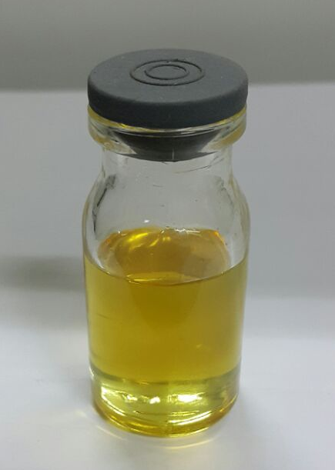

Fig. 1 A photograph of the 10W30 oil.

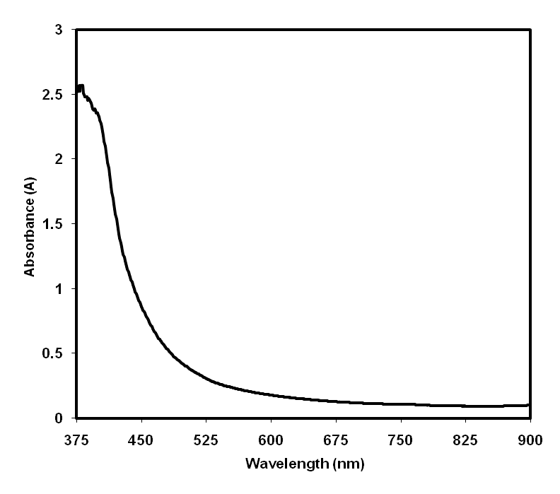

Fig.2. UV-visible absorbance spectrum of 10W30 oil.

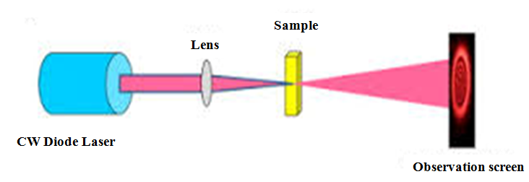

Fig. 3. Experimental set-up for diffraction rings technique.

**2.3 Z-scan technique**

The single beam Z-scan technique usually used to measure the nonlinear refractive index of samples. The 10W30 oil was placed in a 1 mm glass cell, for nonlinear optical (NLO) measurements. The nonlinear refraction was measured with a CW laser light with 473 nm from a solid state laser (SDL). The spatial profile of the optical beam was Gaussian. The laser beam was focused by the lens of 5 cm focal length. The radius of the beam waist was measured to be 19.23 μm (half-with at 1/e2 maximum). The incident and transmitted powers were measured simultaneously by photo detectors fed to digital power meters (Field Max II-To+OP-2 Vis Sensor). The NLO properties of the samples were manifested by moving the samples along the axis of the incident beam (z-direction) with respect to the focal point. An aperture of 2.5 mm in radius was placed in front of the detector to assist the measurement of the self-defocusing effect.

**3. Results and discussion**

**3.1 The absorption coefficient (α)**

To obtain the absorption coefficient, α, of the 10W30 sample we made use of the absorbance (A) spectrum curve (Fig.2) and the following relation [18]

(1)

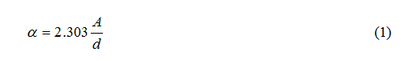

where *d* is the sample thickness and A is the absorbance.

The calculation of absorption coefficient (α) at wavelength 473 nm for 10W30 oil led to the value given in Table 2.

**3.2 Diffraction ring patterns measurement**

For the experimental set-up mentioned above and using input powers (30 mW, 41 mW, 51 mW, 66 mW) diffraction ring patterns appeared instantaneously post irradiation where the number of rings in each pattern increases with the increase of input power as can be seen in Fig. 3. It was noted too that the diameter of outermost ring in each pattern increases with the increase of input power.

**3.4 Estimation of the nonlinear refractive index**

For each ring appeared in each pattern, the phase of the beam traversing the sample increase by (2π) radian so that for each pattern of N rings the total phase shift of the laser beam passing through that sample cell, φ, can be written as [19].

φ=2πN (2)

For a sample thickness, L, and total path length,∆ = ∆nL, where ∆n is the change in refractive index of the sample so that

φ**=**k**∆** (3)

∆ncan be written as n2I**,** I is the laser beam input intensity(=2P/πω2(P is the laser light power and ω is the beam spot size at the entrance of the sample cell which is related to the beam spot size, ωo, of the laser beam falling on the positive lens by ω=1.22fλ/ ωo, f is the positive lens focal length f=5cm)). For λ=473 nm, ωo=0.15 cm**,** ω=19.235μm. From equations (2) and (3) one can arrive at the following equations for ∆n and n2i.e

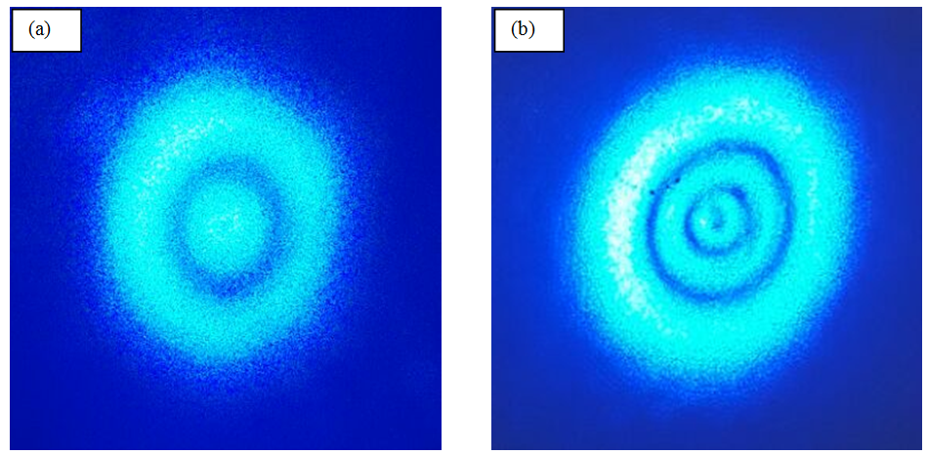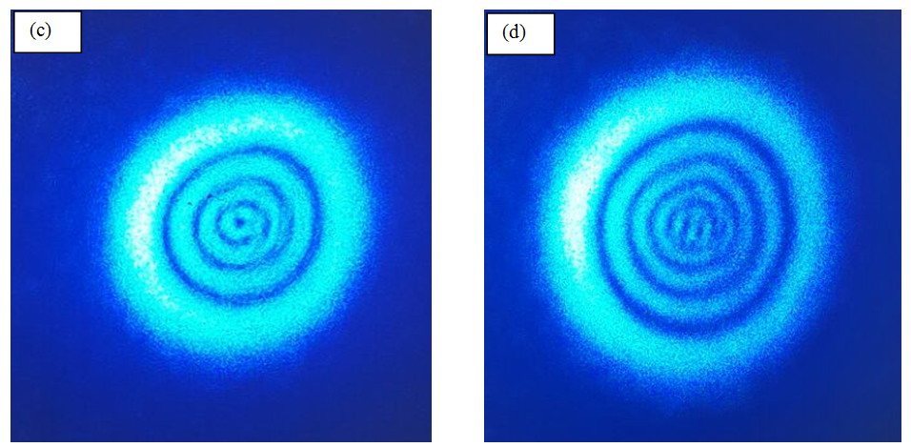

Fig. 3. The far field diffraction rings patterns observed at input laser power passing through the sample cell of (a) 30 mW, (b) 41 mW, (c) 51 mW, (d) 66 mW in the 10W30 sample.

Table (1): Change of refractive index**,** ∆n, and nonlinearrefractive index, n2, for 10W30 oil using four input powers.

|  |  |  |  |
| --- | --- | --- | --- |
| I (W/cm2) | Number of rings, N | ∆n x10-6 | n2 x10-7 (cm2/W) |
| 5167 | 1 | 473 | 0.915 |
| 7062 | 2 | 946 | 1.339 |
| 8785 | 3 | 1419 | 1.615 |
| 11369 | 4 | 1892 | 1.664 |

∆n=λN/d (4)

n2=∆n/I (5)

From the numericals given and input power of 30 mW, 41 mW, 51 mW and 66 mW, the magnitudes of ∆n and n2are given in Table (1)

**3.5 Simulating the diffraction ring patterns**

The experimentally observed ring patterns are simulated theoretically using a well-known model based on the Fresnel-Kirchhoff diffraction [20]. As a result of using a laser beam with Gaussian distribution (TEM00), the electric field of the laser beam at the entrance of the medium can be written as



(6)



where r is the radial coordinate, is the medium coordinate position, k is the free space wave vector, is the air surrounding the medium refractive index, is the beam waist at the medium entrance, and R is the radius of curvature of its wave-front in the position. So that the intensity of the beam passing through the medium and falling on a screen D=74 cm from the sample cell relative to the radial coordinate (ρ) (see Fig. 4) can be written as



(7)



where is zero order Bessel function of the first kind, is the far field diffraction angle, is the radial coordinate in the far field plane of observation and the intensity can be written as [5]:



(8)



D is related to the radial coordinate, , by as can be seen in Fig. 4. α is the absorption coefficient of the sample at the wavelength λ.

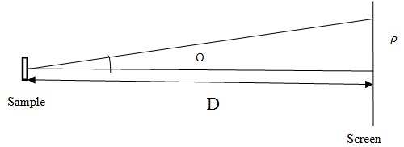

Fig.4. Definition of experimental , D and used in the theoretical analysis of the diffraction patterns.



The results are shown in Fig.5 for one (a) and three (b) dimensional where a reasonable agreement can be seen between theory and experiment (Fig.5 and 3).

**3.3 Z-scan**

In a Z-scan experiment, the normalized transmittance is measured as a function of sample position. Closed-aperture Z-scan transmittance curve of the 10W30 oil is shown in Fig. 6 at incident intensity 4306 W/cm2. The peak to-valley structure of the closed-aperture Z-scan curve in Fig. 6 obviously implies that the 10W30 oil possesses negative nonlinear refraction property (defocusing).

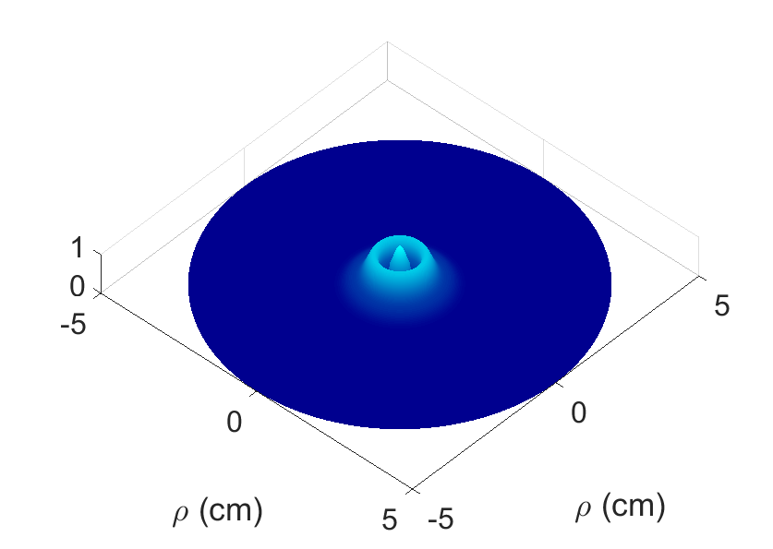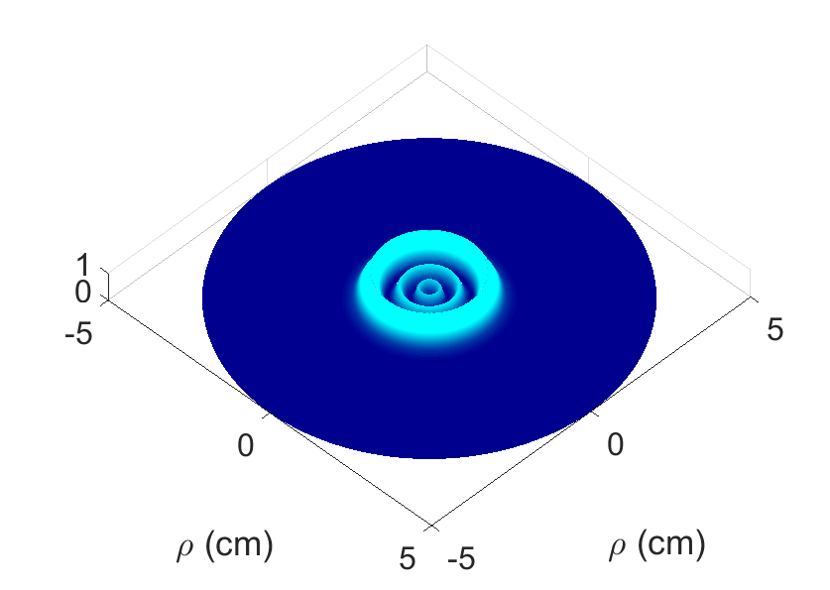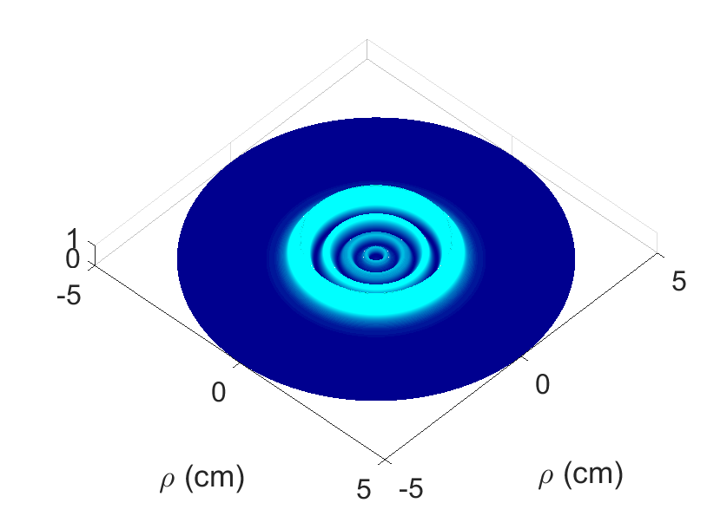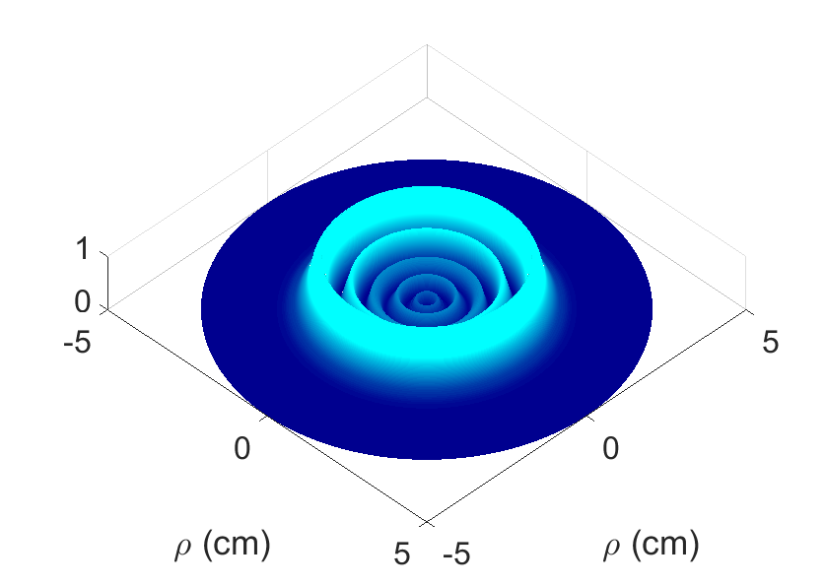

(a)

(b)

Fig.5: Calculated (a) 1D and (b) 3D intensity distributions in ring patterns in the far field.

The fact that the laser light is CW, suggests that the origin of the nonlinear refractive index is thermo-optic [21]. Therefore to calculate nonlinear refractive index, n2, thermal-lens model (TLM) of Z-scan developed by Cuppa et al [22] is used. In thermal-lens model (TLM) the peak to valley transmittances difference, ΔTp-v,corresponds to a nonlinear phase shift of

(11)



The difference in the transmittances between peak and valley, *∆T* *p-v*, of the Z-scan trace is related to the nonlinear refractive index, n2, by

(12)

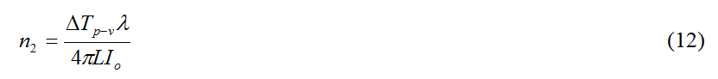

where λ is the laser wavelength and Io is the incident intensity.

The nonlinear refractive index, n2, (cm2/W) for 10W30 oil is calculated from the closed aperture normalized transmittances in Figs.6, the value are listed in Table 2.

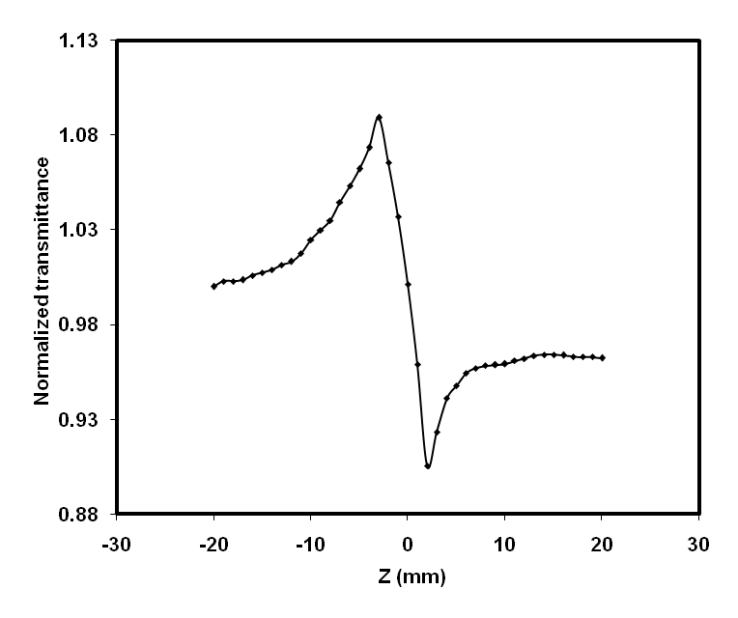

Fig. 6. Closed aperture Z-scan data of 10W30 oil at 25 mW incident power.

Table (2): Nonlinear optical parameters for 10W30 oil using Z-scan techniques at W/cm2 incident intensity.

|  |  |  |
| --- | --- | --- |
| Sample | α (cm-1) | n2 x 10-9 (cm2/W) |
| 10W30 oil | 13.61 | 1.6 |

**4. Conclusion**

In conclusion, multiple diffraction rings of a CW laser light post passing through a 10W30 oil are obtained. The number of diffraction rings in each pattern linearly increased with intensity. Large value of nonlinear refractive index n2= 1.664 x 10-7 cm2/W in 10W30 oil by self-diffraction technique is obtained. The nonlinear refractive index was also obtained in 10W30 oil using the Z-scan technique at the wavelength of 473 nm. The results indicate that 10W30 oil exhibits self-defocusing nonlinearities. This large nonlinearity is attributed to a thermal effect resulting from linear absorption. These results show that 10W30 oil has potential applications in nonlinear optics.

**References**

* 1. Qusay M. A. Hassan, "Investigation on the nonlinear optical properties and optical power limiting of parsley oil," *International Journal of Photonics and Optical Technology*, vol.3, no. 2, pp: 17-20, 2017.
  2. Q. M. Ali, H. A. Badran, A. Y. AL-Ahmad, and C. A. Emshary, “Physical origin of observed nonlinearities in Poly (1-naphthyl methacrylate): Using a single transistor–transistor logic modulated laser beam,”*Chin. Phys.* B, vol. 22, no. 11, pp. 114209-114214, 2013.
  3. Qusay Mohammed Ali, P.K. Palanisamy, "Investigation of nonlinear optical properties of organic dye by Z-scan technique using He–Ne laser," *Optik*- *International Journal for Light and Electron Optics*, vol.116, no. 11, pp.515-520, 2005.
  4. Hussain A. Badran, Abdulameer Imran, Qusay Mohammed Ali Hassan, "Thermal diffusivity of 2,3-Pyridinediamine determination by thermal blooming," *Optik*- *International Journal for Light and Electron Optics*, 127, no.5, pp.2659-2665, 2016.
  5. M. F. Al-Mudhaffer, A. Y. Al-Ahmad, Q. M. Ali, and C. A. Emshary, “Optical characterization and alloptical switching of benzenesulfonamide azo dye,”*Optik - International Journal for Light and Electron Optics*, vol.127, pp. 1160-1166, 2016.
  6. Qusay M. Ali and P. K. Palanisamy, "Z-scan determination of the third-order nonlinearity of organic dye nile blue chloride," *Modern Physics Letters B*, vol.20, no.11, pp. 623-632,2006.
  7. Qusay Mohammed Ali Hassan · R. KH. Manshad, "Optical limiting properties of sudan red B in solution and solid film," *Opt. Quant. Electron*, vol. 47, no.2, pp. 297-311 2015.
  8. Hussain A. Badran, Riyadh Ch. Abul‑Hail, Hussain S. Shaker. Abdulameer I. musa, Qusay M. A. Hassan, "An all-optical switch and third-order optical nonlinearity of 3,4-pyridinediamine," *Appl. Phys. B*, vol. 123, pp. 31-9,2017.
  9. Hussain A. Badran, Qusay M. Ali Hassan, Abdulameer Imran, Large third order optical nonlinearity and optical limiting properties of a 3,4-diaminopyridine, *J Mater Sci: Mater Electron*, vol. 26, no.8, pp. 5958-5963, 2015.
  10. Q. M. Ali, A. Y. Taha, M. F. Al-Mudhafer, and H. A. Bdran, “Third-Order Optical Nonlinearities and Optical Limiting Properties of Phloxine B Dye Doped PMMA Films Investigated by Z-Scan Technique”, *Rom. J. Phys*., vol.58, pp. 962-969, 2013.
  11. Q. M. A. Hassan, “Optical properties of vanadyl phthalocyanine thin films and nonlinear refractive index of vanadyl phthalocyanine doped PMMA by using thermal lens spectrometry technique,” *J. of Natural Sciences Research*, vol.4, no.5, pp.97-108, 2014.
  12. A. I. Musa, H. A. Badran, and Q. M. A. Hassan, “Self diffraction and nonlinear optical properties for 2, 3-Diaminopyridine under cw illumination,” *IOSR Journal of Engineering,* vol.4, no. 5, pp.27-33, 2014.
  13. Qusay Mohammed Ali Hassan, "Two-photon absorption-based optical limiting in 2-(2-methoxybenzyllideneamino)-5-methylphenylmercuric chloride-doped PMMA film," *Modern Physics Letters B*, vol. 28, no. 10, pp. 1450079-10, 2014.
  14. A. Y. Al-Ahmad, Q. M. A. Hassan, H. A. Badran, and K. A. Hussain, “Investigating some linear and nonlinear optical properties of the azo dye (1-amino-2-hydroxy naphthalin sulfonic acid-[3-(4-azo)]-4-amino diphenyl sulfone),” *Optics & Laser Technology*, vol. 44, no. 5, pp. 1450-1455, 2012.
  15. Q. M. A. Hassan, H. Bakr, H. A. Sultan, Raed M. Hassan, C. A. Emshary," Evolution of far-field diffraction patterns and nonlinear optical properties of SAE 70 oil,**",** *International Journal of Applied and Natural Sciences*,vol. 6, pp. 181-188,2017.
  16. W. R. Callen, B. G. Huth, and R. H. Pantell, "Optical patterns of thermally self-defocused light, "*Appl. Phys. Lett*., vol. 11, pp. 103-105,1967.
  17. M. Sheik-Bahae, A.A.Said, T. Wei, D.J.Hagan and E.W. Van Stryland, "Sensitive measurement of optical nonlinearities using a single beam," *IEEE J. Quant. Electron.* vol. 26, pp. 760-769, 1990.
  18. A. Abu. El-Fadl, G. A. Mohamad, A.B. Abd. El-Moiz, and M. Rashad," Optical constants of Zn1_xLixO films prepared by chemical bath deposition technique," *Physica B*, vol. 366, pp. 44-54, 2005.
  19. K. Ogusu, Y. Kohtani, and H. Sao, "laser induced diffraction rings from an absorbing colution," *Opt. Rev.*, 3, pp. 232-234,1996.
  20. S. Chavez-Cerda, C. M. Nascimento, M. A. R. C. Alencar, M. G. A. de Silva, M. R. Meneghetti, and J. M. Hickmann, "Experimental observation of the far field diffraction patterns of divergent and convergent Gaussian beans in a self-defocusing medium,". *Annals of optics*, XXIX ENFMC (2006).
  21. K. Sendhil, C. Vijayan_and M.P. Kothiyal, "Low-threshold optical power limiting of cw laser illumination based on nonlinear refraction in zinc tetraphenyl porphyrin," *Opt. & Las. Tech.*, 38, pp. 512–515, 2006.
  22. F. L. S. Cuppo, A. M. F. Neto, and S. L. G´omez and P. Palffy-Muhoray,"Thermal-lens model compared with the Sheik-Bahae formalism in interpreting Z-scan, experiments on lyotropic crystals," *J. Opt. Soc. Am. B 19*, pp. 1342- 1348, 2002.

2/25/2018