Development and validation of method for analysis of ceftiofur hydrochloride and ceftiofur sodium by using high performance liquid chromatography

Elham A. Mobarez, Hanan A. Azoz, Maha S. Abd-Elhafeez

Biochemistry, Toxicology and Feed Deficiency Dept. (Pharmacology & Pyrogen Unit), Animal Health Research Institute –Dokki- Egypt
Elham_pharmacology@yahoo.com

Abstract: An isocratic high-performance liquid chromatographic (HPLC) method has been developed for assay of ceftiofur hydrochloride and ceftiofur sodium in drug substance and in sterile powder for injection. Chromatography was performed on a 250 mm, 4.6 mm, 5 µm particle, C₁₈ column with a (25:75) 0.1% mixture of (Acetonitrile: de-ionized water) trifloroacetic acid as mobile phase, at a flow rate of 1.0 ml/min. at 35ºC. The separation was monitored by UV detection at 292 nm. Validation of the method for linearity and range, intra and inter-day precision, accuracy, specificity, recovery, robustness, and limits of quantification and detection yielded good results. The calibration plot was linear from 0.5–50µg/mL and the correlation coefficient was 0.9999 for both ceftiofur hydrochloride and ceftiofur sodium. Limit of detection (LOD) for ceftiofur hydrochloride was 0.03µg/ml and for ceftiofur sodium was 0.02µg/ml. Limit of quantification (LOQ) for ceftiofur hydrochloride was 0.1µg/ml and for ceftiofur sodium was 0.06µg/ml. The proposed method is highly sensitive, accurate and precise and could be used for routine analysis of ceftiofur hydrochloride and ceftiofur sodium in drug substance and in sterile powder for injection.
[Elham A. Mobarez, Hanan A. Azoz, Maha S. Abd-Elhafeez. Development and validation of method for analysis of ceftiofur hydrochloride and ceftiofur sodium by using high performance liquid chromatography. Researcher 2018;10(2):7-15]. ISSN 1553-9865 (print); ISSN 2163-8950 (online). http://www.sciencepub.net/researcher. 2. doi:10.7537/marsrsj100218.02.

Key words: ceftiofur hydrochloride, ceftiofur sodium, HPLC, validation

Introduction
Ceftiofur, a third-generation cephalosporin, is active against gram-positive and gram-negative pathogens of veterinary importance, including β -lactamase-producing strains ( Annapurna et al., 2009; Arrioja, 2001; Beconi and Smith, 1996; Tyczkowska et al.,1994; Watts et al.,1994 and Samitz et al., 1996). Classification of cephalosporins is based on their antibacterial spectrum, on their metabolic stability, against hydrolysis by the β-lactamases of different organisms, or on their chemistry (Dalhoff, 1998).
As well as other cephalosporins, ceftiofur is bactericidal in vitro, resulting from inhibition of cell wall synthesis of susceptible multiplying bacteria. It has a broad range of in vitro activity against a variety of pathogens, including many species of Pasturella, Streptococcus, Staphylococcus, Salmonella, and Escherichia coli (Keerthisikha et al., 2013). Ceftiofur can be synthesized in different salt forms.
Ceftiofur sodium is injected intramuscularly for treatment of some respiratory diseases in beef cattle, dairy cattle (Young-Hee et al., 2011), swine, and chickens, and to treat interdigital dermatitis in cattle (Salmon et al., 1995). It has also been assessed for treatment of mastitis and other septic conditions in cattle (Erskine et al., 1995 and Stanek et al., 1998). The hydrochloride salt of ceftiofur was developed as a sterile oil suspension which is more stable form and approved for treatment of swine and bovine respiratory disease (BRD) (Brown et al., 1999).
The presence of methoxyimino side chain and aminothiazole group of third-generation cephalosporins lead to good activity against Gram-positive bacteria and which is resistant to many β-lactamases (Neu, 1992 and Yancey et al., 1987), so that ceftiofur is typically active against Gram negative bacteria as well as Gram-positive bacteria.
Ceftiofur, (6R,7R)-7-[ [ (2Z)-2-(2-amino-1,3-thiazol-4-yl)-2-methoxyiminoacetyl]amino]-3-(furan-2-carbonylsulfanylmethyl)-8-oxo-5-thia-1-azabicyclo [4.2.0]oct-2-ene-2-carboxylic acid (Merck 2001) (Figure 1).
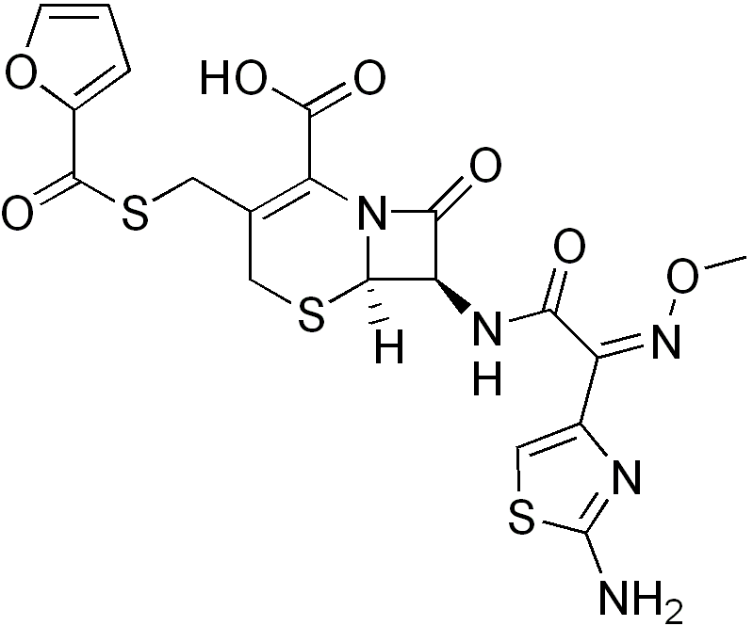
(Figure 1) The chemical structure of ceftiofur

Ceftiofur was analysed by several analytical HPLC methods, with different detection modes, have been published for the determination of its residues in bovine milk and biological fluids (Tyczkowska et al.,1993; Keever et al., 1998; Sorensen and Snor, 2000; Bruno et al., 2001; Makeswaran et al., 2005; Jacobson et al., 2006 and Keerthisikha et al., 2013).
Our study was performed to develop and validate a simple isocratic HPLC method with UV detection for analysis of ceftiofur sodium and ceftiofur hydrochloride in injectable suspension drug and in sterile powder for injection and to evaluate the stability of the drug by use of multi wave detector. The method used a simple mobile phase, UV–visible detection which is performed at room temperature, and does not require complicated sample preparation.

Material and methods
Experimental:
Samples:
Ceftiofur reference substances (ceftiofur sodium and ceftiofur hydrochloride) were kindly supplied by Sigma-Aldrich Co.
Pharmaceutical product containing ceftiofur sodium (Kenafur®) was obtained commercially; according to the label claims the products contained 1 gm ceftiofur sodium powder for injection.
Pharmaceutical product containing ceftiofur hydrochloride (Excenel ®) was obtained from Pharmacia & Upjohn Co. a division of Pfizer, Inc. (50 mg ceftiofur/ml).
Reagents and Solvents:
Acetonitrile was HPLC grade (Honeywell Co, Germany,).
De-ionized water (DW) was obtained from a Milli-Q-system (Millipore, Molsheim, France).
Trifluoroacetic acid and dimethylformamide ( analytical grade).
Instrument and Analytical Conditions:
The HPLC system consists of quaternary pump, model 1200, an autosampler injector and UV-Vis detector (Agilent). The detector was set at 292 nm and peak areas were integrated automatically by computer by use software. Compounds were separated on a pre-packed 250 mm, 4.6 mm i.d., 5 µm particle size, C₁₈ column from Agilent.
The mobile phase a (25:75) 0.1% mixture of (Acetonitrile: de-ionized water) Trifluoroacetic acid; the flow rate of 1.0 ml/ min. The injection volume was 20 µl. The column was performed at a temperature of (35ºC). Before use the mobile phase was filtered through a 0.45 µm nylon membrane filter and degassed with ultrasonic bath for 15 min. Quantitative analysis was performed and calculated from area under curves extrapolated automatically by the software.
Procedure:
Reference Standard
An amount of each reference standard equivalent to 10 mg was accurately weighted and transferred to a 10 ml volumetric flask. De-ionized water was added to volume, to give a final concentration of 1 mg/ml (stock solution). 1 ml of this solution were transferred to 10 ml volumetric flask and diluted to volume with DW, giving a final concentration of 100 µg/ml (intermediate solution) from which the working standards was prepared (0.5, 1, 2, 5, 10, 20 and 50 µg/ml).
Assay of Ceftiofur Sodium (Kenafur ®)
Ceftiofur sodium powder 10 mg was accurately weighed and transferred to a 10 ml volumetric flask and DW was added, to volume, to give a final concentration of 1 mg/ml (stock solution). One ml of this solution were transferred to 10 ml volumetric flask and diluted to volume with De-ionized water, giving a final concentration of 100µg/ml (intermediate solution).
Assay of Ceftiofur hydrochloride (Excenel ®)
Ceftiofur hydrochloride suspension 10 ml was transferred to a 10 ml volumetric flask and Dimethylformamide was added, to volume, to give a final concentration of 1 mg/ml (stock solution). 1 ml of this solution were transferred to 10 ml volumetric flask and diluted to volume with De-ionized water, giving a final concentration of 100 µg/ml (intermediate solution).
Method Validation:
It is the process which established by laboratory studies to ensure that the performance characteristics of the method meet the requirements for the intended analytical application according to International conference on harmonization of technical requirements for registration of pharmaceuticals for human use ( ICH, 2005).
1-Linearity and range:
Linearity is performed by preparing 7 different concentrations of drug standard. Linearity is defined by the squared correlation coefficient, which should be 0.999 (r²).
2-Method Precision:
It is conducted using 5 replicates of Ceftiofur standard solutions. Acceptance criteria: Relative standard deviation (RSD) ≤ 2%.
3-Selectivity and specificity:
Verification of selectivity is conducted by evaluating the standard addition on each drug. Acceptance criteria: there is no interference between the pure standard and peaks of any impurities or extracted solvents.
4-Accuracy and recovery:
The standard additions at different concentrations are prepared by adding known quantities of ceftiofur on each drug. Those samples are analyzed against standard solutions of same concentrations. The accuracy is then calculated from the test results as a percentage recovery.
5-Limit of Detection (LOD) and Quantification (LOQ):
They were calculated from Based on standard deviation (S) of intercept and slope (b)
LOD = 3.3×S/b
LOQ = 10×S/b
6-Robustness:
The robustness of an analytical procedure is an extent of its ability to remain unaffected by small, but deliberate changes in method parameters and provides a clue of its reliability during normal usage. The factors chosen for this study were detection wavelength (nm), temperature (°C), flow rate (ml/min) and mobile phase percentage. Acceptance criteria: pooled RSD is not more than 2% in every change item.
7- System Suitability Test:
Relative standard deviations of the retention time, tailing factor, number of theoretical plates, peak area, and capacity factor were measured to test system suitability (United States pharmacopeia, 2017)

Results and Discussion
Choice of an analytical method depends on factors such as the nature of the drug, the complexity of the sample, and the intended use. In this study, the chromatographic conditions were affected by the physicochemical properties of ceftiofur sodium and ceftiofur hydrochloride, for example solubility, polarity, and UV absorption.
The objective of the study was to develop an HPLC assay for analysis of ceftiofur hydrochloride and ceftiofur sodium as the injectable suspension substance and as the powder for injection. Mobile phase selection was based on peak properties (symmetry, number of theoretical plates and capacity factor), run time, ease of preparation, and cost. This method uses a simple mobile phase, which can be regarded as more useful in routine analysis. Retention time repeatability during the precision studies was found to be excellent for all the solutions. The retention time of ceftiofur hydrochloride and ceftiofur sodium 7.8 min, was satisfactory. Ceftiofur gave a sharp and symmetrical peak when chromatographed under the conditions described above (Figure 2).
Method Validation
Linearity and range:
The calibration plots for ceftiofur hydrochloride and ceftiofur sodium were constructed by plotting peak area against concentration. The linearity of the proposed method was investigated in the range of 0.50–50.0 µg/ml of test concentration for Ceftiofur hydrochloride and ceftiofur sodium with a correlation coefficient (r²) of 0.9999. A representative linear regression equation for Ceftiofur hydrochloride (Tables, 1 & 2 and figure 2) was y = 126.22x + 4.8679 and for Ceftiofur sodium (Tables, 3 & 4 and figure 3) was y = 102.1x + 8.9445.

Table (1): The concentrations of ceftiofur hydrochloride (µg/ml) and their corresponding peak response automatically using HPLC.
RT | Amount (µg/ml) | Area
7.89 | 0.5 | 62.5
 | 1 | 125.66
 | 2 | 251.16
 | 5 | 625.67
 | 10 | 1265.88
 | 20 | 2574
 | 50 | 6299.6

Table (2): Assay validation sheet for ceftiofur hydrochloride.
Parameters | Value
Linearity range | 0.5 ˗ 50 µg/ml
Correlation coefficient (r²) | 0.9999
Slope (a) | 126.22
Intercept (b) | 4.8679
Regression equation | Area = 126.22 × Amount + 4.8679
Table (3): The concentrations of ceftiofur sodium (µg/ml) and their corresponding peak response automatically using HPLC.
RT | Level | Amount (µg/ml) | Area
7.89 | 1 | 0.5 | 52.304
 | 2 | 1 | 97.612
 | 3 | 2 | 193.57
 | 4 | 5 | 520.28
 | 5 | 10 | 1007.8
 | 6 | 20 | 1989.3
 | 7 | 50 | 5112.5

Figure (2) Standard curve of ceftiofur hydrochloride

Table (4): Assay validation sheet for ceftiofur sodium.
Parameters | Value
Linearity range | 0.5 ˗ 50 µg/ml
Correlation coefficient (r²) | 0.9999
Slope (a) | 102.1
Intercept (b) | 8.9445
Regression equation | Area = 102.1 × Amount + 8.9445

Figure (3): Standard curve of ceftiofur sodium

Method Precision:
The repeatability (intraday precision) of the method was calculated as the RSD of assays of ceftiofur in the same concentration range. The RSD was 0.03% for ceftiofur hydrochloride and 0.24% for ceftiofur sodium. The experimental results obtained from determination of ceftiofur hydrochloride and ceftiofur sodium are listed in Table 1. The relative standard variation (%) for intermediate precision determined by assay of the samples on six different days was 0.27% and 0.49% for ceftiofur hydrochloride and for ceftiofur sodium, respectively.

Table (5): Intraday and interday precision data for estimation of ceftiofur hydrochloride.
Ser. No. | Conc. (µg/ml) | Peaks areas in the same day | Peaks areas in six days
1 | 2 | 251.16 | 251.16
2 | 2 | 251.11 | 250.11
3 | 2 | 250.998 | 250.998
4 | 2 | 251.12 | 251.92
5 | 2 | 250.998 | 250.998
6 | 2 | 251.14 | 250.14
Mean |  | 251.0877 | 250.8877
SD |  | 0.071548 | 0.682348
RSD% |  | 0.028495 | 0.271974

Table (6): Intraday and interday precision data for estimation of ceftiofur sodium.
Ser. No. | Conc. (µg/ml) | Peaks areas in the same day | Peaks areas in six days
1 | 2 | 192.75 | 193.75
2 | 2 | 192.62 | 192.62
3 | 2 | 191.62 | 191.62
4 | 2 | 192.55 | 191.55
5 | 2 | 192.58 | 193.58
6 | 2 | 192.98 | 192.98
Mean |  | 192.5167 | 192.6833
SD |  | 0.466676 | 0.943285
RSD% |  | 0.242408 | 0.489552

Selectivity and specificity:
The chromatograms of ceftiofur sodium pure standard ( 2 µg/ml) and Ceftiofur Sodium (2 µg/ml) (Kenafur®) acquired by developed method is indicated in figures (4 & 5). Also, representative chromatograms of ceftiofur hydrochloride pure standard (2µg/ml) and Ceftiofur hydrochloride (Excenel®) at a concentration of 2µg/ml are shown in figures (6 & 7). No matrix interferences were observed on the chromatograms and no interfering peaks were obtained with the same retention time (RT) of ceftiofur sodium peak and ceftiofur hydrochloride. The retention time (RT) of ceftiofur sodium and ceftiofur hydrochloride were 7.89 minutes.

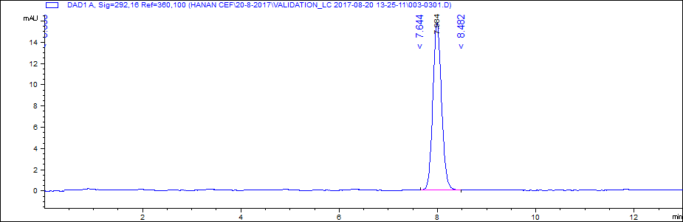
Figure (4): Chromatogram of ceftiofur sodium pure standard at a concentration of 2 µg/ml.

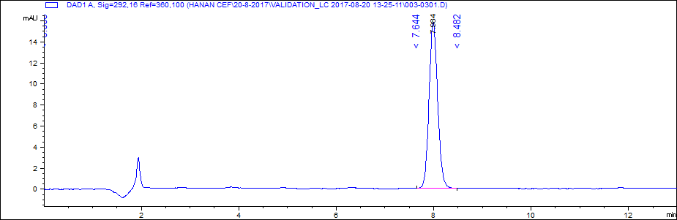
Figure (5): Chromatogram of Ceftiofur Sodium (Kenafur®) at a concentration of 2 µg/ml.

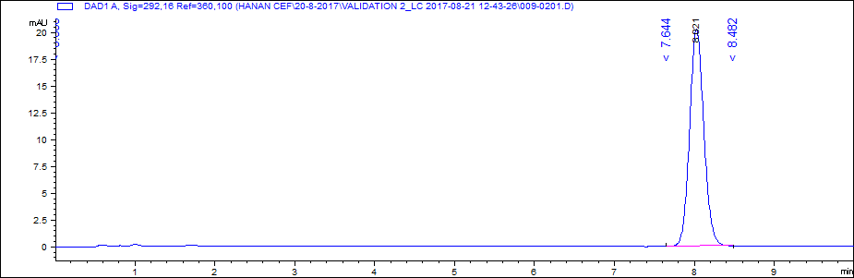
Figure (6): Chromatogram of Ceftiofur hydrochloride pure standard at a concentration of 2 µg/ml.

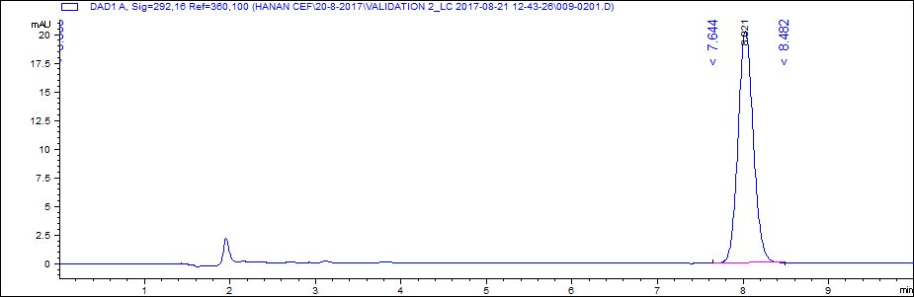
Figure (7): Chromatogram of Ceftiofur hydrochloride (Excenel®) at a concentration of 2 µg/ml

Accuracy and recovery:
The standard additions at different concentrations are prepared by adding known quantities of ceftiofur on each drug. Those samples are analyzed against standard solutions of same concentrations. The accuracy is then calculated from the test results as a percentage recovery. The results were illustrated in tables (7 & 8).

Table (7): The percentage recovery of ceftiofur sodium standard addition
Level Conc. µg/ml | Found conc. µg/ml | Mean | SD | RSD% | Recovery % | Average recovery ±SD%
0.5 | 0.497 | 0.4997 | 0.003 | 0.61 | 99.4 | 99.9 ± 0.611
 | 0.499 |  |  |  | 99.8
 | 0.503 |  |  |  | 100.6
1 | 0.992 | 0.998 | 0.006 | 0.601 | 99.2 | 99.8 ± 0.6
 | 1.004 |  |  |  | 100.4
 | 0.998 |  |  |  | 99.8
2 | 2.03 | 2.01 | 0.016 | 0.805 | 101.5 | 100.57 ± 0.81
 | 2.003 |  |  |  | 100.15
 | 2.001 |  |  |  | 100.05

Table (8): The percentage recovery of ceftiofur hydrochloride standard addition
Level Conc. µg/ml | Found conc. µg/ml | Mean | SD | RSD% | Recovery% | Average recovery ±SD%
0.5 | 0.5001 | 0.5 | 0.0002 | 0.04 | 100.02 | 100.007 ± 0.04
 | 0.4998 |  |  |  | 99.96
 | 0.5002 |  |  |  | 100.04
1 | 0.998 | 1 | 0.0015 | 0.15 | 99.8 | 99.97 ± 0.16
 | 1.0002 |  |  |  | 100.02
 | 1.001 |  |  |  | 100.1
2 | 2.002 | 2.0019 | 0.002 | 0.1 | 100.1 | 100.1 ± 0.11
 | 2.004 |  |  |  | 100.2
 | 1.9998 |  |  |  | 99.99

Limit of detection (LOD):
Based on standard deviation (S) of response and slope (b) (LOD=3.3S/b). LOD for ceftiofur hydrochloride was 0.03 µg/ml and for ceftiofur sodium was 0.02 µg/ml.
Limit of quantification (LOQ):
Based on standard deviation (S) of response and slope (b) (LOQ =10S/b). LOQ for ceftiofur hydrochloride was 0.1 µg/ml and for ceftiofur sodium was 0.06 µg/ml.
Robustness:
As documented in the ICH guidelines, robustness should be considered early in the development of a method. If the results are susceptible to variations in method conditions, these conditions must be adequately controlled. The effect of variations in some experimental conditions was tested. The robustness of an analytical method is a measure of its capacity to remain unaffected by small but deliberate variations in method parameters and provides an indication of its reliability during normal usage. Robustness of the method was studied by changing the experimental conditions like flow rate, Different mobile phase, and Different wavelength. The system suitability parameters are passed for all the conditions and the results for assay were evaluated.
System Suitability Test:
The system-suitability test is an important part of an analytical method, and it ascertains the suitability and effectiveness of the system used. The criteria used for system-suitability tests at each stage of method development will vary with the requirements of the method and its intended application. System-suitability studies were conducted as specified in USP (United States Pharmacopeia, 2017). The characteristics measured were retention time, tailing factor, column efficiency, peak area, and capacity factor. The values obtained are listed in Tables (9 & 10).

Table 9: Results from system-suitability study on 10 µg/ml ceftiofur sodium
 | Retention Time | Tailing Factor | Theoretical Plates | Peak area
Mean (n = 6) | 7.89 | 1.15 | 9512.167 | 1005.85
RSD (%) | 0.36 | 0.11 | 0.1 | 0.18

Table (10) Results from system-suitability study on 10 µg/ml ceftiofur hydrochloride
 | Retention Time | Tailing factor | Theoretical plates | Peak area
Mean (n = 6) | 7.897 | 1.204 | 9295.333 | 1246.067
RSD (%) | 0.52 | 0.065 | 0.055 | 0.84

The availability of this new simple highly sensitive and selective method will be very useful for determination of ceftiofur. The method, which was validated in accordance with the specifications of the International Conference on Harmonization (ICH, 2005) and the USP Pharmacopeia (United States Pharmacopeia, 2017), can also be used for stability studies.

Conclusion
We could conclude that, the method is applicable to monitoring of ceftiofure levels, as it provides simple mobile phase composition for chromatographic separation, simple sample preparation as well as improved sensitivity. Therefore, the developed HPLC method can be conveniently adopted for the routine quality control analysis and leads to a simple, precise, cost effective, rapid method with high accuracy to quantify simultaneously ceftiofur hydrochloride and ceftiofur sodium in pharmaceutical formulations with HPLC.

Corresponding Author:
Elham A. Mobarez
Animal Health Research Institute, Dokki, Giza, Egypt
Elham_pharmacology@yahoo.com

References:
  - Arrioja- Dechert A. Naxcel sterile powder in compendium of veterinary products, ED 6. Port huron, MI, North American compendiums, 2001; P1747.
  - Annapurna V, Jyothi G, Rambabu C and Sailaja BV. Spectrophotometric Determination of Ceftiofur Hydrochloride Using N-Bromosuccinimide and p-Dimethylaminobenzaldehyde. Journal of Chemistry, 2009; 6(3): 763-769.
  - Beconi-Barker MG and Smith EB. Metabolism of different salt forms of ceftiofur in target. Proc. Euro. Residue III Congr, 1996; 233-237.
  - Brown SA, Hanson B J, Mignot A, Millérioux L, Hamlow PJ and Hubbard VL. Comparison of plasma pharmacokinetics and bioavailability of ceftiofur sodium and ceftiofur hydrochloride in pigs after a single intramuscular injection. J. Vet. Pharmacol. Ther., 1999; (22): 35–40.
  - Bruno F, Curini R, Di Corcia A, Nazzari M and Samperi R. Solid-phase extraction followed by liquid chromatography–mass spectrometry for trace determination of betalactam antibiotics in bovine milk. J. Agric. Food Chem., 2001; 49:3463–3470.
  - Dalhoff A. Antibiotics and chemotherapy. Karger, New York, 1998; pp 148.
  - Erskine RJ, Wilson RC, Tyler JW, McClure KA, Nelson RS and Spears HJ. Ceftiofur distribution in serum and milk from clinically normal cows with experimental Escherichia coli induced mastitis. American Journal of Veterinary Research, 1995; 56: 481–485.
  - ICH. International conference on harmonization of technical requirements for registration of pharmaceuticals, validation of analytical procedures; methodology, harmonized tripartite guideline. ICH, Geneva, 2005.
  - Jacobson GA, Martinod S and Cunningham CP. Determination of ceftiofur in bovine plasma by HPLC-DAD. J. Pharm. Biomed. Anal., 2006; 40: 1249– 1252.
  - Keerthisikha P, Sreenivasa CA, Nagamallika L, Ranganayakulu D, Rajasekhar KK and Shankarananth V. RP-HPLC method for the estimation of ceftiofur hydrochloride in bulk form. Journal of Pharmacy Research, 2013; 7: 246 - 2 51.
  - Keever J, Voykner RD and Tyczkowska KL. Quantitative determination of ceftiofur in milk by liquid chromatography electrospray mass spectrometry. Journal of Chromatography A, 1998; 794: 57–62.
  - Makeswaran S, Patterson I and Points J. An analytical method to determine conjugated residues of ceftiofur in milk using liquid chromatography with tandem mass spectrometry. Anal. Chem. Acta., 2005; 529: 151-157.
  - Merck. The Merck index, 13th ed. Whitehouse Station, New Jersey, 2001; pp 334. Neu HC. Clinical uses of cephalosporins. The Lancet, 1992; 2(8292): 252–255.
  - Salmon SA, Watts JL, Case CA, Hoffman LJ, Wegener HC and Yancey RJ. Comparison of MICs of ceftiofur and other antimicrobial agents against bacterial pathogens of swine from the United States, Canada, and Denmark. Journal of Clinical Microbiology, 1995; 33: 2435–2444.
  - Samitz EM, Spencey SJ and Hirsh Dc. In vitro susceptibilities of selected obligate anaerobic bacteria obtained from bovine and equine sources to ceftiofur. J Vet. Diagn. Invest., 1996; 8:121-123.
  - Sorensen LK and Snor LK. Determination of cephalosporins in raw bovine milk by high-performance liquid chromatography. J. Chromatogr. A, 2000; 882:145–151.
  - Stanek C and Kofler J. On the treatment of complicated septic disorders of the bovine digit, using a combination of surgical therapy and application of Sodium-Ceftiofur. Tierarztliche Praxis Ausgabe G: Grosstiere/Nutztiere, 1998; 26: 314– 317.
  - Tyczkowska KL, Voyksner RD, Straub RF and Aronson AL. Simultaneous multiresidue analysis of beta-lactam antibiotics in bovine milk by liquid chromatography with ultraviolet detection and confirmation by electrospray mass spectrometry. Journal of AOAC International, 1994; 77:1122–1131.
  - Tyczkowska KL, Voyksner RD, Straub RF, Anderson KL and Aronson AL. Determination of ceftiofur and its metabolite desfuroylceftiofur in bovine serum and milk by ion-paired liquid chromatography. Journal of Chromatography B: Biomedical Sciences and Applications, 1993; 614:123–134.
  - United States pharmacopeia. United States pharmacopeia, 40th ed. USP, physical tests/ (621) Chromatography, Rockville, 2017; pp 508–520.
  - Watts JL, Yancey RJ, Salmon SA and Case CA. A four year survey of antimicrobial susceptibility trends for isolates from cattle with bovine respiratory disease in north America. J. Clin. Microbiol., 1994; 32(3):725-731.
  - Yancey RJ, Kinney ML, Robert BJ, Good enough KR, Hamel JC and Ford CW. Ceftiofur sodium, a broad-spectrum cephalosporin: evaluation in vitro and in vivo in mice. Am. J. Vet. Res., 1987; 48: 1050–1053.
  - Young-Hee L, Deok-Hie P, Yeu-Young Y, Kyung-Hoon K and Hye-Sung C. Identification of Ceftiofur Oxidation Products by High-Performance Liquid Chromatography/Electrospray Ionization/Tandem Mass Spectrometry. Mass Spectrometry Letters, 2011; 2 (1): 16-19.

2/6/2018

