Diagnosis, Symptoms and therapy of autism: A Moroccan research online survey

Tahar Hazzaz Abouamal, Zineb Choukairi, Halim Khalid, Taoufiq Fechtali

Department of Biology, Laboratory of Biosciences University Hassan 2 Casablanca, Morocco
thazzaz@gmail.com

Abstract: Objectives: Autism spectrum disorder, is a condition characterized by abnormal development of social, relational, and communicational skills; some repetitive behaviors, and a lack of interests. Activities are manifested by stereotyped, repetitive speech, motor movement; and also social communication deficits that include impairments in aspects of joint attention and social interaction, the age of diagnosis in different cultural and areas and effective therapies are the areas that we start to work. The other important question for our future genetic and physiologic research in Morocco was about belief in scientific research to find pharmaceutical drugs and /or physical therapies that will surely treat this pathology. Methods: To carry out this research, we developed an Internet survey to identify symptoms detected and the treatments used by parents of children with autism. The survey listed 9 symptoms and was distributed via social media and redirected to an URL link in Google Online forms, through the association of Autism in Morocco. A total of 62 parents submitted usable returns during the 2-month survey period. On average the parents reported using 12 different therapies. Results: The results showed that Moroccans are increasingly informed about the disease and that they already use a several known methods to overcome autism. The number of therapies used varied with age and culture of the child. Behavior therapy was the most commonly reported intervention, followed by Psychotherapist and Alimentary Diet. Conclusion: Given this lack of data, it is important to document the number and types of symptoms and treatments used by parents of children with autism. This type of data may enable professionals to provide parents with the information needed to make more informed choices about treatment selection and promote evidence-based practice. By documenting therapies used for each symptoms, the research community may also be alerted to test used treatments that have yet to be examined in controlled scientiﬁc studies. The present study represents a preliminary attempt to present the diagnosis age mean in Arabic and Berber Moroccan community and types of interventions, programs, and therapies used by parents in the two populations.
[Tahar Hazzaz Abouamal, Zineb Choukairi, Halim Khalid, Taoufiq Fechtali. Diagnosis, Symptoms and therapy of autism: A Moroccan research online survey. Researcher 2018;10(1):69-78]. ISSN 1553-9865 (print); ISSN 2163-8950 (online). http://www.sciencepub.net/researcher. 11. doi:10.7537/marsrsj100118.11.

Keywords: Autism, Diagnosis age, Behavior therapy, ASD

Introduction:
Autism spectrum disorders (ASDs) are a group of neurodevelopmental disorders characterized by qualitative impairment in communication and social interaction and by restricted, repetitive behaviors and interests. With an estimated global prevalence of 61/10,000. (Elsabbagh ET et al. 2012).
Autism is the association of two disorder criteria, a social and a behavioral one that are defined by:
- Qualitative Disorders of verbal and nonverbal communication,
- Qualitative impairments in social interaction,
- Behavior with activities and restricted interests, stereotyped and repetitive.
Parents can see the first signs of autism during the first two years of their child at eye level and lack communication attempt of it by gestures or babbling. The signs usually develop gradually, though some children first develop normally and then suddenly regress [8].
Moving to education, it's crucial to note that the associations have always taken the initiative to open inclusive classes for Autistic students across Morocco. The Ministry of National Education also opens integrated classes for students with disabilities, but Autistic children remain largely marginalized because of the misunderstanding of Autism as well as the weakness of technical and educational tools adapted by the teaching staff.
In Morocco, there is a lack of official data, and with the absence of field studies, we rely on the global prevalence of autism which is on average one case per 100 births (in some countries, the rate is as high as: 1 birth out of 80), considering the total number inhabitants of Morocco, there are approximately 300,000 to 350,000 people with Autism in Morocco in 2014 [5], it can be roughly said that prevalence is 1 every 100 births today in morocco in 2016.
In Morocco, the patients and their families continue to suffer the almost total ignorance of this handicap by the general public, ignorance that applies stigma and discrimination. The parents of the child are always the target of blame from society and some professionals who refuse to break with outdated explanations still used by some psychiatric currents.
The aim of this study is to highlight in Morocco, the best-notified population about autism, Our sample is roughly warned, since it is people connected on Facebook or by email, so they are quite grown and people who have probably read things on the internet about autism.
The most important objective of this study was to highlight methods used for the diagnosis of autistic individuals, and to assess the type of symptoms noticed by parents of children affected by this disease and also to emphasize the therapies used, this will allow us to invest for the coming years in the right research field to improve. In addition, we sought to determine whether certain parent trust on scientific research for autism.
The essential question of my research concerns the ignorance of Moroccan about autism and how they are facing with this disease, for symptom and therapy.
And also sort out what Moroccan use as therapy for each symptom, and the issue that is very important also is to see how these families are willing to participate in scientific research especially for genetic project that leads our team will lead in the coming years.

- Method:
To achieve this study, we developed an Internet survey and distributed to parents via a national autism organization (Collectif Autisme Maroc).
To carry out this research, we questioned several autistic children parents with the help of the collective autism Morocco (group of associations in Morocco), the diffusion method was made exclusively online via social networks official Facebook page (Collectif Autisme Maroc), and by email. The questionnaire was anonymous, it revolves around ethnic origin, diagnosis age, symptoms, health care, and opinion of parents towards scientific research on autism; the survey is available online (Arabic [21] French [23] English [22]).
  - Survey Development:
The survey presented parents with a comprehensive list of options for each question, type of symptoms, type of therapies used.
For symptoms, the result of survey listed 123 symptoms, which were grouped under 9 categories for organizational purposes. The categories included: General behavioral problems, Delay in talking or other language problems, Abnormalities in social development, Concerns about hearing and viewing, Ritualistic and obsessional behavior, Problem or Delays in motor skills, Other (including toileting and eating and sleeping problems), Symptom problems Trisomy 21, Symptom problems Epilepsy.
For therapy question, parents were asked to indicate whether they treat their child; 4 types of treatment have been proposed: (a) Behavioral therapy, (b) Psychotherapist, (c) Diet, (d) Pharmaceutical drugs. An additional spaces were provided for parents to add additional treatments and make comments. The two populations surveyed were mostly Arabs and Berbers and show different results especially concerning diagnostic age, symptoms observed and therapies used.
  - Survey Distribution:
The survey was distributed via Facebook page “Collectif Autisme Maroc” and by email to the database of parents of autistic child. We were in direct contact with the President of the associations and she send the email and share the URL link of google form on its network.
In total, there is 66 people that answer the survey in two months. Once the survey was launched, it remained open for a 2-month period. Following the initial distribution of the survey, we began to receive numerous results from parents who complete the survey.
The survey contained an introductory paragraph which provided information about the study; including details about our aim. Once a parent completed a survey, the ﬁle was automatically entered into a database Google sheet for each language, we receive answers only from Arabic form and French one. When the 2-month period expired, the complete set of ﬁles was exported into Microsoft Excel for data reordering and analysis.

- Results:
  - Number of submissions:
A total of 66 surveys were submitted (52 answer from Arabic form and 14 from French one) to the survey during the 2-month data collection period. However, only 62 were considered usable.
  - Characteristics of the respondents:
    - Geographic location of respondents:
When asked to indicate their origin of culture. Most of these 62 respondents are from Arabic population of morocco (n = 74, 19%), and only (n=25, 81%) were Berber.
    - Age of diagnosis:
The age of diagnosis of the children for whom the surveys were completed was indicated on all 62 submissions. Roughly the half of autistic children (n = 52, 46%) was diagnosed between 24 and 48 months, one-third (n = 32, 79%) were diagnosed under 24 months, only (n = 9, 84%) were diagnosed between 48 and 72 months and fortunately just (n= 4, 92%) after 72 months. The Table 1 below describes this data, we detailed the average age for each origin and the variation in the table1 and we performed two graphs showing the difference between the values of each population (Fig.1A and Fig.1B).

Table 1. Diagnosis age parameters
Diagnosis age | % (N) |  | Mean |  | SD
Under 24 months | 32,79% | Arab: 22,95% | 18,50 | Arab: 20.7 | 5,0 | Arab: 3.06
 |  | Berber: 9,84% |  | Berber: 18,0 |  | Berber: 6
From 24 to 48 months | 52,46% | Arabs: 37,70% | 36,29 | Arabs: 36,4 | 8,6 | Arabs: 8.88
 |  | Berber: 14,75% |  | Berber: 34,5 |  | Berber: 7.19
From 48 to 72 months | 9,84% | Arabs: 8,20% | 66,00 | Arabs: 63 | 6,0 | Arabs: 4.4
 |  | Berber: 1,64% |  | Berber: 72,0 |  | Berber:
After 72 months | 4,92% | Arabs: 4,92% | 126,00 | Arabs: 126 | 59,4 | Arabs: 59.40
 |  | Berber: 0% |  | Berber: |  | Berber:

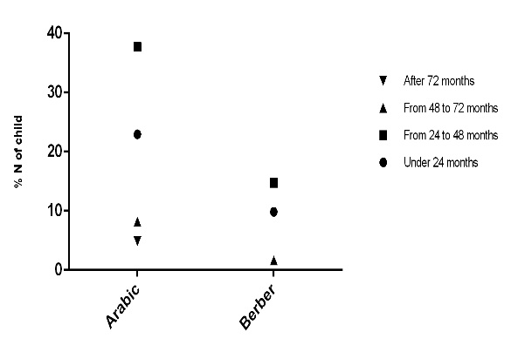 | 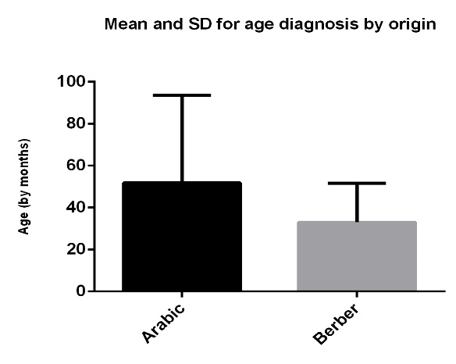
Fig 1A. Distribution of diagnosis age by Origin | Fig 1B. Mean and SD for age diagnosis by origin

There is to date no specific tests to screen for autism at birth, the diagnosis of autism and other pervasive developmental disorders (PDD) is clinic and is based on a dual approach [7].
- Depth interviews with parents to clarify best the different stages of child development and take stock of their current behaviors and interactions;
- Observation of the child and interactive scenarios referred to, to assess the various manifestations of the autistic syndrome that can present, and the degree of his ability to forge social ties, communicate and interact with an environment given.
The diagnosis have been generally supervised by a medical specialist (psychiatrist or neurologist) and must include the elimination of conditions that can manifest in a similar to that of autism way, we also can add:
- A neurological examination to detect a neurological disease or related epilepsy;
- If deemed necessary by the neurologist, an IRM to look for visible abnormalities of the brain;
- A genetic survey to detect certain known genetic conditions that may cause ASD.
The specialist (psychiatrist or neurologist) synthesizes thesis Elements by adding His Own clinical observations to deliver the diagnosis, must be made according to the nomenclature of ICD-10.
In Morocco, given the lack of professionals trained in this subject, it is recommended in case of suspicion of ASD, making the diagnosis in child psychiatric services in big hospital in major cities (Casablanca, Rabat, Fes, and Tangier).
We take the answer of exactly 61 parents, the results that we obtained are quite satisfactory since it has an average diagnostic age reaching 39 months, (3 years and 3 months) which means that we became an informed country about this disease and that parent can distinguish autistic traits at an early age, maybe the knowledge of the disease was through the media (TV, Radio and Internet).
  - Type of Symptoms:
Parents were asked to indicate the type of symptoms of their child’s disability by indicating if the child had a diagnosis of (a) Autistic Disorder, (b) Asperger’s syndrome, (c) Rett Syndrome, or (d) Autistic spectrum disorder not otherwise specified (e) Childhood disintegrative disorder, but most parents provided information in a free box on the survey, and it was obvious to reorganize symptoms into 9 categories, listed below.
General behavioral problems (n=39,81%), Delay in talking or other language problems (n=21,36%), Abnormalities in social development (n=12,62%), Concerns about hearing and viewing (n=9,71%), Ritualistic and obsessional behavior (n=7,77%), Problem or Delays in motor skills (n=5,83%), Other (including toileting and eating and sleeping problems (n=0,97%), Medical problems Trisomy 21 (n=0,97%), Medical problems Epilepsy (n=0,97%). Fig.2 show the distribution of symptoms by origin, the result show that there is no significant difference between Arab and Berber, they see for most of them, the same type of symptoms, except some parents that have child with other disorders like Epilepsy or Trisomy 21.

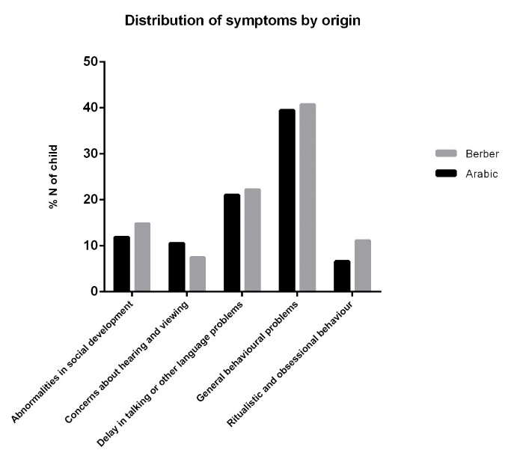
Fig 2. Distribution of symptoms by origin

For qualitative answer also, we have several case reports, sometimes very detailed and we share below the most relevant comments for each symptom:
- General behavioral problems: it is the aspect most found in autistic and most fined, it is either alone or linked to speech problems and concerns the following attitudes:
The child are agitated and hyperactive and stay planted in one place longer active. They maybe do self-mutilation and many movement and incomprehensible tantrums, they cries a lot and are fortunately genius for some.
For some they does not point the finger and play without purpose or meaning, and other child are nervous and crying for no reason and have an interest in some objects more than people they do strange voices and can laugh without reason.
The interests of autistic children are restricted, their activities tend to be stereotyped and repetitive. There are stereotypes: repetitive movements such as rocking or turn on themselves. People with autism may also exhibit self-injurious behavior and self-harm.
All of these behaviors are more or less invasive, and can persist or otherwise diminish. They can also be strengthened or reappear at certain times of life. It will be important to try to understand the factors that could cause such aggravation.
- Delay in talking or other language: this aspect is also found in children with autism and is a precursor to the arrival of an anomaly, we retained these remarks from parents:
The child begins to speak very late and the appearance of other developmental delays, the parents observe also a loss of words or phrases already acquired; he does not look at his interlocutor when addressing someone and shows an inability to initiate or sustain a conversation and speaks with a rhythm or abnormal tone (a singing or "mechanical" voice) and may repeat words but do not understand the meaning.
- Abnormalities in social development: These individuals have cognitive deficits and lack of attention to people around them, they mostly have problems in social interactions and sometimes a lack of communication, for some they do not play with children, It should be noted an introversion and a particular life in their own world.
- Concerns about hearing and viewing: This category includes children with autism that have problems in hearing and looking:
They have a weakness in visual communication and sometimes a lack of regard or deviation, or outright they shall avoid the look. Their eyes lack focus and when they speak they do not look their interlocutor; some of the surveyed people had a case of deaf with hearing shell, and they not answer when calling.
- Ritualistic and obsessional behaviour: Many obsessional appearance accompany autism and present major problems for the families:
They repeat words and have stereotypes behavior Similar and repetitive movements they also repeat gestures and behaviors and do some strange excessive movement.
- Problem or Delays in motor skills: this aspect is also found in children with autism and is a signal of ASD, this remarks comes from parents:
They observe a lot of movement and a hyper-activity and also epilepsy crisis and motor skills, Excessive movement, Repeated gestures and maybe repeat some similar movements and vibration.
  - Type of therapies:
Parents were asked to list, the therapies that they use to take care of their child, they use Behavior Therapy, Alimentary Diet, Psychotherapist, Pharmaceutical drugs, for some child we observed more than one therapy and for this reason we combined some therapies with others, for example Behavior Therapy and alimentary diet; sport and also Alimentary Diet and Music.
This question concerning autism treatment method was also asked in a free box to let the parents share some unknown therapy as Sport, music, occupational and physical treatment.
In the figure (Fig.3A) we made a graph about our proposed therapies in the survey, and we find that the most used by Arab and Berber are behavioral therapy and psychotherapists and then diets and finally pharmaceutical drugs.

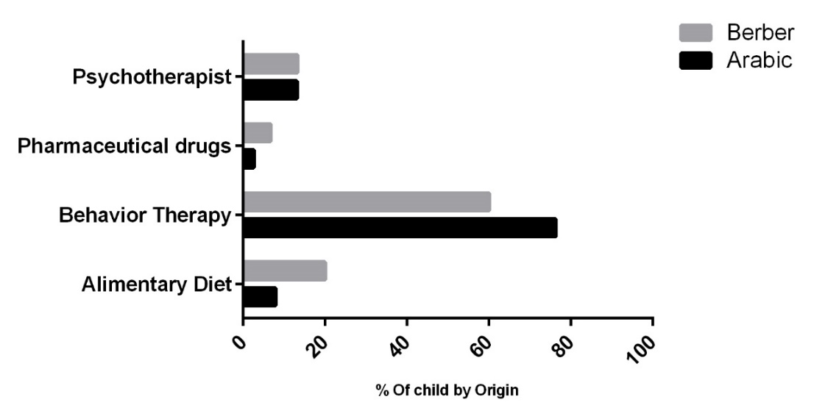
Fig.3A Distribution of therapies by origin

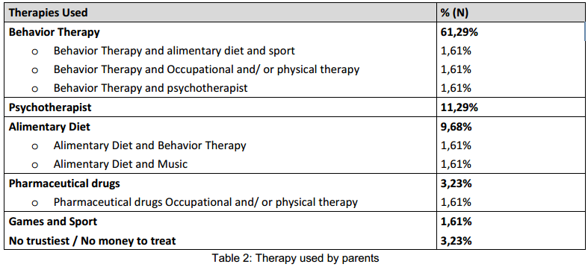

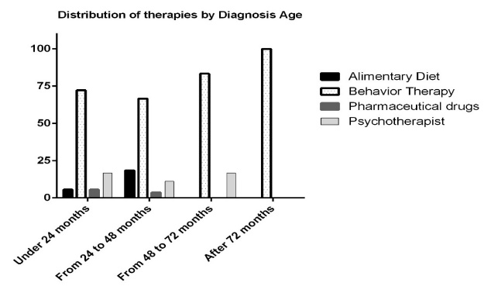
Fig.3B Distribution of therapies by Diagnosis Age

Concerning age and therapy children who were diagnosed before 24 months practice behavioral therapy with a psychotherapist specialist, those between 24 and 48 months are treated with behavioral therapy and diet. For children diagnosed after 72 months use multiple therapies including. (Fig.3B)
Nearly, all (n = 85, 49 %) of the therapies listed in the survey are used by parents. A number of ‘‘other therapies” were added to the survey by individual parents. Most of these therapies are accompanied by another alternative medications or speciﬁc activities (e.g., Sports, Music therapy, Games) that their child attended. A small number of parents listed procedure that they were using and that had not been included in our original list of therapies. Occupational and/ or physical therapy were also on result of the survey and (n=6, 44%) parents said they were currently using one of these two therapies.
The table 2 in Fig.3 provides a rank ordering the 12 therapies according to the percentage of parents indicating that they use and also shows the percentage of parents who indicated that they use more than one treatment. After Behavior therapy, the next most commonly used current treatments is Psychotherapist followed by Alimentary Diet and then pharmaceutical drugs.
For comparison Arabic use behavior therapy more than Berber and there is equality for consulting a psychotherapist, and this is an evolution given the culture and beliefs in our country but there's still a lack in the number of child psychiatrist. Also, we noted an important use of alimentary diet in Berber population.
Many of other therapies, were only used by a small percentage of the respondents, for qualitative answer we have several information about used therapies, sometimes detailed and we share below the most relevant comments for each therapy:
- Behavior Therapy:
Approach and behavioral intervention is effective for treating behavioral disorders present in autism. This approach aims to replace inappropriate behavior with a more adequate. It operates on the behavior itself and / or on the causes of the behavior. People with autism who received a formal education are more autonomous, less medicated and more integrated in society than those who do not had this therapy [10]. A 2009 study found that 79% of patients receiving CBT experienced a decrease in their anxiety [20], [21].
Some parents detailing the use of certain methods such as:
- The Individual Educational Plan (IEP): or that is an individual care plan, it is a written plan, developed and reviewed with the person and their representatives through continuous assessment. It is based on the inventory of strengths and individual needs, he mentions the goals, objectives, resources, strategies, timelines and responsibilities of partners.
- The Applied Behavior Analysis (ABA): is a field of study and outcome management of behavioral psychology that is based on direct observation, accurate measurement and functional analysis, it is especially applied in autism, but also addiction, or other pathologies.
- Alimentary Diet:
Special diet:
Some parents report having observed noticeable improvements with some dietetic plans. Some studies suggest that it may be effective in some cases [13], [14], although no diet makes consensus.
Casein and gluten free diet:
Current scientific evidence does not suggest a beneficial effect of casein and gluten free diet on the development of autism. It is impossible to say if this diet is free of harmful consequences in the short, medium or long term or not, some side effects are cited in scientific publications [24] (constipation irregular bowel, diarrhea, stomach aches, nausea / vomiting and decreased appetite) these effects are not supported by validated facts in all autism cases. Therefore there is not much argument that support the use of this type of régime [15].
- Psychotherapist:
The goal of the psychotherapist is to help the child to control his anxiety and emotions, there are different types of psychotherapies: it can be individual or in a group; for mother-child, families and for a group of autistic children.
The individual psychotherapies are performed by specialized therapists in autism. The sessions last in average 45 minutes and are at least 2 times a week. Parents receive a parallel support to help them keep track of their child. The support is the language when it is possible; otherwise the dough, drawing, toys are the means of communication between the therapist and the child.
Collective psychotherapies are varied: mother-child therapy, especially with very young children. They can be practiced at home. Family therapies include the whole family and allow to globally managing all the problems of a disabled child within the family unit. Group therapy through psychodrama, puppets or collective drawings allows improvements.
- Pharmaceutical drugs:
The Notice No 102 of CNCE states that there is no curative treatment [16], and there is also no drug treatment recommended officially [17]. Nevertheless, some imbalances often associated with autism, such as oxytocin and melatonin rate, can be treated. For example melatonin prescription could significantly improve the total sleep time [18], [19].
- Speech therapist:
The help of a speech therapist can increase the rehabilitation time of communication learning. Some speech therapists practice one or more methods of communication that involve the family assistance, they become partners of the educational team, and must be combined with IEP (Individualized Education Programs). [20]
The speech therapist may be involved in three other areas:
- The dysfunctional (dyslexia, dyscalculia,) to help a child already well in school learning to overcome blockages / difficulties of this order.
- The dysphasia: a specific rehabilitation "oral motor skills," praxis (movements) necessary for speech, can help in reset the mechanics of language.
- Method PADOVAN. Halfway between psychomotor and speech therapy, it aims to reprogram the steps of neuro-motor and sensory-motor development needed to develop oral language.
- Occupational /Physical Therapy:
Traction sessions, although conducted with a practitioner who knows the autistic disorders, are a useful reinforcement of global support, to improve the overall motor skills (walking, jumping, rolling, catching, some... coordinate complex movements) or actions delicate (hold small objects and perform complex manipulations to thread, pinch, draw, draw,....).
The best methods is to take advice from several therapists to form an opinion based on the programs that they offer [20].
- Sport:
People with autism have very often a motor clumsiness and sometimes delayed in their psychomotor development. They sometimes have difficulties to run, make moves complex like roulades and may have coordination problems. They often exhibit significant latency in the implementation of movements. Sport proves to be an indispensable activity for their proper functioning. It will have the task of helping them to duct their energy in a positive way (rather than through behavioral problems) and make them more aware of their bodies. The moment of sports may also be the only time when the person with autism will mingle with ordinary people of his age without problems. Indeed, most of them are generally supported in the specialized agencies and they have very few opportunities to create interactions with non-autistic people.
Parents says that the most important benefit of sport is having fun and personal success. Autistic people feel defeated in many areas and can, through sport, gain a better self-esteem.
  - Interaction between Therapies and Symptoms:
The interaction between symptoms and therapy is very important, to help us to see what is the methods to prioritize for cure or at least calm the crises of autistic children.
The interaction was carried out on a diagram, we calculated the percentage of therapy used for each Symptom (Fig 4).
The behavioral therapy comes almost for all the symptoms followed by diet and then intervention of specialists, and psychotherapist.
This information is very important and allows us to say that the field of behavioral therapy is becoming more and more known in our Moroccan society, this is a good news because this therapy reveal no risk for children with autism, unlike drugs that may be administered in overdose and have several effects on cerebral functions and mood.
Also, this type of therapy is done by specialists who are not necessary doctors, and this can open a job field for multiple profiles with a passion for this activity.

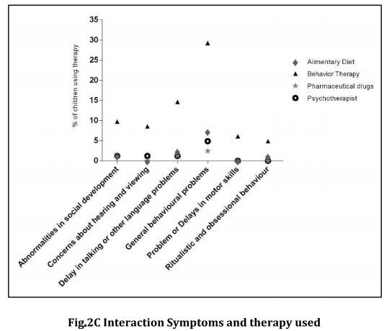
Fig 4: Interaction between symptoms and therapy

  - Scientific research about autism
The issue of science and scientific research in Morocco remains very late but it happens, our team today as several other people lean towards scientific research which obviously begins by screening, understanding and to be closer with autistic families. We have always struggled to explain the meaning of scientific research for autism, parents just waiting for therapy and outcomes (which is perfectly legitimate).
It is important before doing research to check that parent belief and are ready to engage the scientific community to do research, which is why we asked them and the great satisfaction was that they believed like us to science for autism, and reveal a result of (90% trust in scientific research for autism).
  - Evolution of Autism in Morocco:
In Morocco autism is becoming known, and more progress will be made in future years due to the mobilization of families and autistic associations.
The question of changing status of autistic was also asked to parents in this sample and the results were not always positive, since many parents still suffer poor conditions of health care in some areas of the country. There is still lack of competence on this pathology in hospitals especially in smaller towns in which minimum conditions are not available, 68% of survey participants responded positively to this question and believe that autism in Morocco is on evolution; it's not enough to say that the situation is better than before.

- Discussion:
For this study we discussed with families knowledgeable about autism and association member, they want to make a battle to make known the disease in Morocco especially in cities were people do not have access to internet and information and for illiterate people.
This kind of study will allow to raise the opinion of the people, care methods, the problems like the small number of autism specialists in Morocco, and also the lack of careers for autistic and lack of government investment in the cause of autism in Morocco.
We have set up this research also to study many aspects of autism in Morocco, the analysis reveals several interesting results for diagnosis, and support therapies used.
People perceive this disease at an advanced age (a 3 year average), it is already excellent for a country that has no structure, no medical means to treat autism, people were able to move through the media and especially to internet, some parents that we met were diagnosed their children through questionnaires, internet videos and also with questions on search engine: why my son does not speak? Why my son cry for no reason? Why my son does not look at me when I talk to him?
Web forums in French, Arabic but also in English help parents to doubt the pathology and go to the few specialist in Morocco.
The survey was, in our case, sent to people who know the disease, they are members of association, and they are using different methods for diagnosis, and therapy.
The Berber and Arab are almost at an equal situation, which allows us to say that maybe this is not the origin or culture, but above their living city, their intellectual level that will act on the age of diagnosis or therapy used.
Unfortunately there are many illiterate people in Morocco and the internet is not accessible everywhere, so people from other cultures and other small villages are misinformed and maybe use traditional methods, that can be dangerous for their children.
By comparing Morocco to other countries like Canada or the US, In Canada, for example, in every neighborhood, police have cards with autism present in their area and they have badges or bracelets with the name of the attending. An example that shows the enormous delay in Morocco on this site. Being born with autism and living in Morocco is a nightmare. The children with autism and especially his family should have a daily battle in a country that does not recognize the status of autistic population. Thankfully now we can make the diagnosis of autism in Morocco, but in some regions where the pathology is still unknown there is no medical specialists, and the treatment is still random and related to the family education, and financial resources.
We still have a problem in the difference between cities, for example for Rabat and Casablanca people are informed and can even collaborate with specialist in US or France.

Conclusion:
This type of survey and research allowed us to take stock of several aspects of autism in Morocco, Especially for the diagnosis that is made in early age nowadays, since parents come to identify autism in their children, but this fact is not applied to non-urban cities where autism is not/not well known. The objective of this study was achieved, it appears that a certain part of the Morrocan population knows well the autism pathology, the methods of diagnosis and therapy used, but this knowledge must be communicated to all other parts of the country, and it is crucial to follow model countries that succeed in inclusion of autistic people naturally in society and reached a high level of healthcare.
The other most important results that we have after this study is that autistic families are ready to work with us in a scientific research field of autism; we are working with some Moroccan, French and Tunisian laboratories about: genetics of autism, and the electrophysiology around autism, toxicology of autism.
All this brings us back to open several calls for projects and thesis subjects by doing some cooperation with the beneficiaries countries already had success in the treatment of this pathology.

Abbreviations:
ASD: Autism spectrum disorder
DSM: Diagnostic and Statistical Manual of Mental Disorders
ICD: International Classification of Diseases
ADOS: Autism Diagnostic Observation Schedule
ADI-R: Autism Diagnostic Interview Revised

Consent Statement:
The survey [22] was accompanied by a presentation of our research and involve members of the association “Collectif autism Morocco” who answered as they wish to the questions; also another consent was signed by the president of the association of autistic individuals and parents, this consent allows TH to collect testimonials from them. The survey was voluntary, anonymous, confidential and only for research purposes to protect privacy and ensure data integrity.

Competing Interests:
The authors declare that they have no competing interests.

Acknowledgement:
There is no funding sources for this work,
This work have been achieved with the help of Ms Soumia AMRANI and Ms. Mina MAAD who work for the cause of autism in Morocco and representatives of Moroccan associations for autism.

References:
- Autism Spectrum Disorder DSM V (www.dsm5.org).
- CIM-10 section F84 (apps.who.int/classifications/icd10/browse/2008/fr#/F84).
- Autisme et autres troubles envahissants du développement (Haute autorité de santé).
- Janvier 2010.
- 1983 avec E. Burgoine, Identical triplets with Asperger's Syndrome, British Journal of Psychiatry, 143, p. 261-265.
- Blogspot website: http://autisminmorocco.blogspot.fr published December 7, 2014.
- Rachida Bami, « Entretien avec le professeur Afaf Amarti, membre du bureau de l’association Miroir pour enfants autistes «L’intégration de l’enfant autiste nécessite une lourde prise en charge» », Le Matin (Maroc),‎ 4 avril 2013.
- GA Stefanatos, « Regression in autistic spectrum disorders », Neuropsychol Rev, vol. 18,‎ 2008, p. 305–19 (PMID 18956141, DOI 10.1007/s11065-008-9073-y).
- F Volkmar, K Chawarska et A Klin, « Autism in infancy and early childhood », Annu Rev Psychol, vol. 56,‎ 2005, p. 315–36 (PMID 15709938, DOI 10.1146/annurev.psych.56.091103.070159).
- Lundström et al. 2012, Arch. Gen. Psychiatry, basée sur 11535 jumeaux).
- Schopler, E. (1997a). Naissance du programme TEACCH Principes, mise en pratique et évaluation. In R. Misès et Ph. Grand (Eds.), Parents et professionnels devant l'autisme (pp. 191-207). Paris: C.T.N.E.R.H.I.).
- Sophie Parent et Lyse Turgeon, Intervention cognitivo-comportementale auprès des enfants et des adolescents: Troubles de comportement, vol. 2, Presses universitaires du Québec,‎ 2012 (ISBN 2760534103 et 9782760534100), p. 128-132.
- J. Andanson, F. Pourre, T. Maffre et J.-P. Raynaud, « Mise au point: Les groupes d’entraînement aux habiletés sociales pour enfants et adolescents avec syndrome d’Asperger: revue de la littérature », Archives de pédiatrie, vol. 5, no 18, 2011, p. 589-596 (ISSN 0929-693X).
- Ashwood P, Anthony A, Torrente F, Wakefield AJ. Spontaneous mucosal lymphocyte cytokine profiles in children with autism and gastrointestinal symptoms: mucosal immune activation and reduced counter regulatory interleukin-10. J Clin Immunol (2004) 24:664–73.10.1007/s10875-004-6141-6.
- Thomas RH, Meeking MM, Mepham JR, et al. The enteric bacterial metabolite propionic acid alters brain and plasma phospholipid molecular species: further development of a rodent model of autism spectrum disorders. Journal of Neuroinflammation. 2012; 9:153. doi:10.1186/1742-2094-9-153.
- L'AFSSA rapport public en 2009 Document sur le site de l'AFFSA.
- Rapport No 102 du Comité consultatif national d'éthique « Sur la situation en France des personnes, enfants et adultes, atteintes d’autisme » .
- www.autisme.qc.ca/TED/programmes-et-interventions/traitements/autisme-et-medicaments.html.
- Wright B, Sims D, Smart S et al. Melatonin versus placebo in childrenwith autism spectrum conditions and severe sleep problems notamenable to behavior management strategies: a randomizedcontrolled crossover trial. J. Autism Dev. Disord. 2010; 41:175–84.
- Andersen IM, Kaczmarska J, McGrew SG, et al. Melatonin for insomnia in children with autism spectrum disorders. J Child Neurol. 2008;23:482-485.
- www.agir-vivre-autisme.org/causes-diagnostics-traitements/les-autres-approches-des-troubles.
- Arabic Survey: https://docs.google.com/forms/d/1yFGiKzDPQtl5chStvpmSD-vjXLNbgmZ9gCOweCuaWp8/viewform.
- English Survey: https://docs.google.com/forms/d/1joe9FIHP9HXJib5V5NeFYi8Dge4jrEhP8ExS7OyWBWU/viewform.
- French Survey: https://docs.google.com/forms/d/1u8ey3wUVz1Kt8Fg9oykdTYrFRAZ1WQr7UnaUb7ijIwE/viewform.
- C. R. Johnson, B. L. Handen, M. Zimmer, K. Sacco, and K. Turner, “Effects of gluten free/Casein free diet in young children with autism: a pilot study,” Journal of Developmental and Physical Disabilities, vol. 23, no. 3, pp. 213–225, 2011. View at Publisher View at Google Scholar View at Scopus.

1/25/2018

