Eccentric Rotary Engine

Sun Chunwu

Address: Room 805, Building 20, Shuxiu Garden, Xihu Town, Yangzhou City, Jiangsu Province
Contact information: QQ458669609; Tel18652544068; Email: yzscw0514@163.com

Abstract: When hollow rotating shaft rotates, this practical new eccentric rotary engine will save/release energy by utilizing eccentric rotating assembly inside the shell, and convert the energy to the shell by utilizing the gravity action of eccentric rotating assembly during releasing the energy. So that the energy can be used effectively, and the energy consumption of the engine can be reduced.
[Sun Chunwu. Eccentric Rotary Engine. Researcher 2018;10(1):17-21]. ISSN 1553-9865 (print); ISSN 2163-8950 (online). http://www.sciencepub.net/researcher. 4. doi:10.7537/marsrsj100118.04.

Keywords: Eccentric rotary engine, oval diagram

The practical new machine belongs to the field of engine technology, specifically speaking, it is eccentric rotary engine.
Background technology
The existing engine takes a mass of energy during external work. Therefore, with the progress and development of social science and technology, how to reduce energy consumption of engine has attracted extensive attention and became the important direction of scientists.
Practical new content
In order to resolve the above problems, the purpose of this practical new machine is to provide one type of eccentric rotary engine and reduce the energy consumption of engine.
The technical proposal adopted by this practical new machine is:
Eccentric rotary engine consists of two bearing blocks and hollow rotating shaft; the mentioned hollow rotating shaft includes hollow- shaped shell and hollow-shaped spindle noses which are installed at two ends of end face of the above shell. One end of the mentioned spindle nose is equipped with circular disk along the circumference, and connected with the mentioned shell through the above circular disk. Meanwhile, the said spindle nose is connected with the inner part of the shell. The swivel plate lies in the same axis with the so-called shell, and the radius of the swivel plate is less than that of the shell. The above two bearing blocks are set oppositely, and the said spindle nose of the shell coordinates with the first bearing on bearing block through rotary movement.
Eccentric rotating assembly is equipped inside the said shell, and the assembly include center shaft, besides, two unilateral bearing is installed in the middle hole of two working disk, and there are several hinge irons are installed on working circular disk, of which centripetal iron and hanging iron are included. These two said working circular disks are covered outside of unilateral bearing, which rotate under the effect of down force through the said unilateral bearing and center shaft. The said centripetal iron is set between two working disks, and the bottom of the centripetal iron is hinged with the said two working disks, and the top of the said centripetal iron is hinged with the hanging iron.
The both ends of the said center shaft pass through the spindle nose of both ends of the shell respectively, and connect with the first location hole of supporting structure of center shaft. The said center shaft is parallel to the axes of the said shell, and partial to one side of the axes of the said shell; the said working disk connects with the inside wall of the shell at the eccentric direction of the center shaft.
Further, double hole shaft is set inside the inner ring of two unilateral bearing, one hole of double hole shaft is covered outside, and the other hole has locating shaft, which connects with the second location hole of the supporting structure. The said double hole shaft shall be away from one end of center shaft and said working disk is at eccentric state, coordinating under the effect of down force and through rotary movement.
Further, the top of the said centripetal iron is equipped with groove for accommodating hanging iron, and the said groove includes hinge pin which can coordinate with one end of hanging iron through rotary movement.
Further, the said first bearing is self-aligning bearing.
Further, the above working disks are equipped with self-aligning bearing, which is covered on the hollow shaft.
Furthermore, the spindle nose at the end of the shell connects with the transmission mechanism.
Moreover, the said transmission mechanism has transmission gear, transmission belt, or multi disk clutch.
Moreover, the said eccentric rotary engine includes workbench, the said supporting structure and two bearing blocks are installed on the workbench.
This practical new eccentric rotary engine utilizes eccentric rotating assembly in shell to restore/release the energy when hollow rotating shaft rotates. Meanwhile, the gravity action of eccentric rotating assembly will be utilized completely during energy releasing, so as to press the shell, and convert the energy to the shell, and therefore, the energy can be used efficiently, and the energy consumption of engine can be also reduced.
Instruction with pictures
In order to explain the technical proposal of practical new machine or the current technology clearly, the drawings used in the description of the machine or the current technology shall be introduced as follows. Obviously, the attached drawings in the following description are only some examples of this practical new machine. As for the ordinary technician of this field, other attached drawings can be obtained according to these drawings under the premise of lacking of creative work.
Figure 1: Inside construction schematic drawing of the said hollow rotating shaft in the examples.
The mark number in the figure:
1: Circular disk; 2. Shell; 3. Working disk; 4. Hanging iron; 5. Centripetal iron; 6. Self-aligning bearing; 7. The first unilateral bearing; 8. Center shaft; 9. Bearing block; 10. Multi disk clutch; 11. Flywheel; 12. The second unilateral bearing.
Specific implementation mode:
In order to make the purpose, technical proposal and advantages of this practical new machine clearer, the detailed description of the technical proposal is shown as follows. Obviously, the described examples is a part of examples of this practical new machine. On the basis of the examples of this practical new machine, other methods of mode of execution obtained under the premise of no creative work for the ordinary technicians in this field belong to the protective range of practical new machine.
Examples
As shown in Figure 1, this example provides one type of eccentric rotary engine, including two bearing blocks (9) and hollow rotating shaft; the said hollow rotating shaft consists of hollow shaped shell (2) and spindle nose which is set on the end face of both ends of the shell (2). Besides, a circular disk (1) is set on one end of the spindle nose along the circumference, which connects with the said shell (2), and the above spindle nose connects with the shell (2) internally. In addition, the said swivel plate and the shell (2) lie in the same axes. The radius of the swivel plate is less than that of the shell (2). The above two bearing blocks (9) are set oppositely, and the said spindle nose of the shell coordinates with the first bearing on bearing block (9) through rotary movement.
Eccentric rotating assembly is equipped inside the said shell (2), and the assembly include center shaft (8), two working disks (3), and two unilateral bearings (7) and some hinge irons. The above hinge irons contain centripetal iron (5) and hanging iron (4). Besides, the above two unilateral bearings (7) are covered on the center shaft (8), and the two working disks (3) are covered outside of the unilateral bearings (7) respectively, and coordinate with eccentric center shaft (8) through one side hole on the double hole shaft and rotary movement, and the double hole shaft is inside the unilateral bearings (7). The said centripetal iron (5) is set between two working disks, and the bottom of the centripetal iron (5) is hinged with the said two working disks (3), and the top of the said centripetal iron (5) is hinged with the hanging iron (4).
The both ends of the said center shaft (8) pass through the spindle nose of both ends of the shell (2) respectively, and connect with the first location hole of supporting structure of center shaft (8). The said center shaft (8) is parallel to the axes of the said shell (2), and partial to one side of the axes of the said shell (2). The said working disk (3) connects with the inside wall of the shell (2) at the eccentric direction of the center shaft (8).
As for the engine based on the above structure, the eccentric rotating assembly inside the shell (2) shall rotate continuously when the hollow rotating shaft rotates under the effect of downward turning force of working disk. When the hanging iron (4) of eccentric rotating assembly moves from up to down, the centripetal iron (5) and hanging iron (4) which is at the downward state will open and expand naturally under the acting of gravitational centrifugal force, so that the working disk (3) presses the shell (2) and rotates with the shell (2) in the accelerated state. Meanwhile, the energy of eccentric rotating assembly can be converted to the shell (2) and drive the shell (2) to rotate, thereby the gravity acting of eccentric rotating assembly is utilized adequately. When the hanging iron (4) of eccentric rotating assembly moves from down to upward, the centripetal iron (5) and hanging iron (4) which is at the upward state will be astringed and shrank to the center, and placed on the hanging iron which is working at the bottom, then it will provide force for the working hanging iron. Moreover, the smaller arm of force can store energy, and the hanging iron (4) can prepare for the next working through moving to the top.
Therefore, the eccentric rotary engine can utilize the eccentric rotating assembly in the shell (2) to store and release the energy, and convert the energy to the shell (2) through the pressure of the gravity action of eccentric rotating assembly on the shell (2) during releasing the energy. So that the energy can be used effectively, and the energy consumption of the engine can be reduced.
Preferably, the double hole shaft is set inside the inner ring of the first unilateral bearing (7) of the two bearings, one hole of the double hole shaft is set outside the center shaft (8). The other hole is equipped with the locating shaft, which connects with the second location hole of supporting structure; the double hole shaft is away from one end of center shaft (8) and supports the inner ring of the first unilateral bearing (7), the working disk (3) presents eccentric state, thus the working disk (3) is inclined to the center shaft and presses the shell (2) downward for movement under the acting of gravity.
Specifically, the centripetal iron (5) is corresponding to the hanging iron (4) one by one, there are eight components. Besides, the groove which accommodates hanging iron (4) is set on the top of centripetal iron (5), and one hinge pin which is set in groove coordinates with one end of hanging iron (4) through rotary movement. So the hinge pin can be drew in the groove during the process of moving from down to up, and the rotational energy storage of eccentric rotating mechanism shall be maintained perfectly.
Preferably, the self-aligning bearing (6) is set between two working disks (3), and the self-aligning bearing (6) shall be covered on the said hollow shaft; the first shaft is self-aligning bearing. Of which the self-aligning bearing can not only bear radial load but also bear the axial load from either direction, which is especially suitable for working under heavy load or vibration load. Hence, the rotation of eccentric rotating assembly can be guaranteed preferably.
In order to facilitate the external function of the hollow rotating shaft, multi disk clutch (10) is set on one end of the shaft of the shell (2), so that it is convenient for connecting with the driven shaft through multi disk clutch (10). So that the driven shaft can be driven for external work. In addition, the triangular belt can be set on the large shell to drive other mechanical rotation directly.
In examples, the above eccentric rotary engine still include workbench, in order to set supporting structure, two bearing blocks (9) and hollow rotating shaft. Besides, the supporting structure and two bearing blocks (9) are set on workbench, in order to install and fax.
In examples, each component of eccentric rotary engine can adopt stainless steel material, and plastics or glass fiber reinforced plastics and other unique magnetic materials, which can be used for power plant of special equipment.
In examples, the edge of circular disk (1) is equipped with mounting hole, and the circular disk (1) can connect with the end face of the shell (2) through disassembly, which is convenient for assembly/disassembly of circular disk (1) and shell (2). In addition, it is also convenient for installation, repair and other operations of the components inside the shell (2).
Its principle is to set hollow round end face (see Figure 2) of large shaft disc on both ends of large shell (see Figure 2) of sleeve-shaped cavity. Then the shell of sleeve-shaped cavity and shaft disk shall be fixed uniformly with location bolt (Figure 17), forming a specially-made hollow shaft. 212 bearing (Figure 8) and 1012 self-aligning bearing shall be installed at the both ends of hollow shaft, and the bearing shall be set in the shell of bearing block on the workbench (see Figure 15). The upper end of the shaft which exceeds the shell of the bearing block shall be equipped with belt pulley, or gear or multi disk clutch (see Figure 13) according to the production demand, to rotate other machines. See attached Figure I.
The large shell, and inner part of the thick sleeve-shaped cavity at the middle of hollow shaft can be divided into three cavities. The first cavity is inside the large shell, and all the parts used for working are set inside.
Secondly, the space which is made of two working disk (see Figure 3) is equipped with cavity which is enclosed by several components. Hence the energy can be formed and duplicated, namely system of force, which is called the second large cavity. See attached figure II.
Eight groups of centripetal iron shall be equipped with two working disk (See Figure 4), namely the larger hole at one end of centripetal iron shall be covered on working disk which is close to eight small columns of the bearing, (see Figure 28).
Besides, a hanging iron in the groove at the upper end of eight groups of centripetal iron (see Figure 5), [there are eight hanging iron, according to the Ba gua which can forecast the future, it is called as Yang, the symbol is trigram I]. The thin long axis can penetrate it from centripetal iron hole (see Figure 18), then it will pass through the hole of hanging iron, and finally it will pass through the hole of upper end of centripetal iron. Since the hole of hanging iron is large, the hanging iron can move freely under the acting of gravity, centripetal force or centrifugal force.
The third part is regulating device of workbench covering on the center shaft in the cavity. Both ends of another shaft also pass through the cavity in the middle of two large shaft disks of sleeve-shaped cavity respectively, and fixed on the hole next to the regulating device of workbench. In addition, the angle of axis of rotation can be regulated artificially, furthermore, the force of gravity eccentric engine can be also regulated.
When the installed gravity eccentric engine is regulated, the weight of eight hanging iron can be set on working disk, which is just as the blade on turbine. However, it can be the dynamic condition of living body, for instance, the eight round columns around the center of working disk shall be equipped with the hole at one end of eight centripetal iron. Besides, the hanging iron on this side presses the centripetal iron, the middle part of centripetal iron is placed at the sleeve of bolting pad, namely fulcrum. The centripetal iron is like the arm of force or oscillating bar of horizontal lever. When the hanging iron drops downward, the pressure can make working disk rotating a quarter of a circle. However, eight hanging irons on the working disk works downward by turn, it will take one-eighth time to complete a force for working disk through rotation.
Therefore, the hanging iron on high drops at high speed as parabola. Hence, the thrust of centrifugal force can be generated. Meanwhile, the middle hole of the centripetal iron shall be equipped with hinge iron after dropping, which is away from the center shaft, and the eccentric space enclosed by hinge iron will be larger on this side.
However, the space field is on the other side of the working disk, the energy consumption and force will be large when moving upward. The weight of hanging iron will drop under the acting of centripetal force and frictional force when moving upward at slow speed, namely it is shrank and bended to the center, and moves to the center shaft. The hinge iron at the middle hole of centripetal iron will be closer to the center shaft. And the oval cavity formed by hinge iron will be smaller. The eccentric cavitation field will be formed by hinge iron. Meanwhile, the adjustable large bearing which and double hole shaft can be stored, the pressure of the weight during eccentric motion can press the working disk, that is one side of large shell.
Meanwhile, the center shaft is lower than the rotation center of special hollow shaft. When it is closer to the center shaft gradually, the force needed will be lower to zero, and when the hanging iron passes through the center shaft during upward movement, the centripetal force can be obtained, it is crashed to the middle section of inner shell of the large shell as the speed increases, and then it will press downward. The function of the eight hanging iron is just like two feet of the human being, which works on the working face of axes ceaselessly. On the other side, it is at neutral position, only the frictional force will exert little influence.
The perpetual motion machine invented by others has no center shaft under the acting of spinning and decentration of the large shell. Meanwhile, the center shaft is lower than the rotation center of special hollow shaft, which can save the energy and change the dropping direction of working disk.
Therefore, the working disk drives two mutually utilized centers of rotation the rotation of large shells. When the speed of the host is increased to above 600r, the weight of hanging iron is unchanged, so it cannot resist the large centrifugal force converted by working disk and host. When the hanging iron stops moving upward, and begins to move downward, shrink and bend to drop for less energy consumption, so the eccentric structure is also lost, the large bearing and double hole shaft cannot duplicate the pressure force, and the host can reduce the speed.
However, the weight of large shell of host is forty times of that of hanging iron, which can rotate to 600r through working and acceleration of hanging iron. It shall be changed into one that has larger inertia energy as flywheel, the large shell of host can be stopped and the speed can be reduced to 400r. So the time of internal movement structure adjustment and energy structure adjustment process can be prolonged, and the up moving hanging iron can form exocentric construction after shrinking and bending to the center, meanwhile, the energy consumption of the host is also reduced. Meanwhile, the weight of large bearing and double hole shaft is duplicated to the pressure by eccentric action. So the machine can rotate at high speed. [It is just like the people earn a lot of money, when he or she losses the job, he or she can utilize the money to live or find job for earning money.]
It is a group of conversion systems, which is different from the fuel engine, for instance, the conversion of gasoline into thermal energy, so it is difficult to copy, which shall be dissipated, and hence the energy is conserved. It is also different from the motor, of which only the rotor works after charged with electricity, and the stator of the shell has mechanical work without rotation. Although the work principle of eccentric rotary engine is like electromotor, but its eccentric system on the sleeve-shaped cavity and large bearing and disk rotates when driven by the resultant force of the system.
However, all the parts and components set on the center shaft are not rotate relatively. The rotor is changed into stator, which is not convenient for rotation. But the advantages of both is to work for spinning, so the machine can rotate under the acting of pressure.
Operation and application can only switch clutch or hand brake, and foot brake, in order to control the speed of the machine or starting up or halting.
Of course, it can begin non-uniform motion as movement of cosmic inventory after auto-rotation. Hence its rotational energy cannot violate law of conservation of energy.
The following figure is for reference only.
Map of eccentric rotary engine

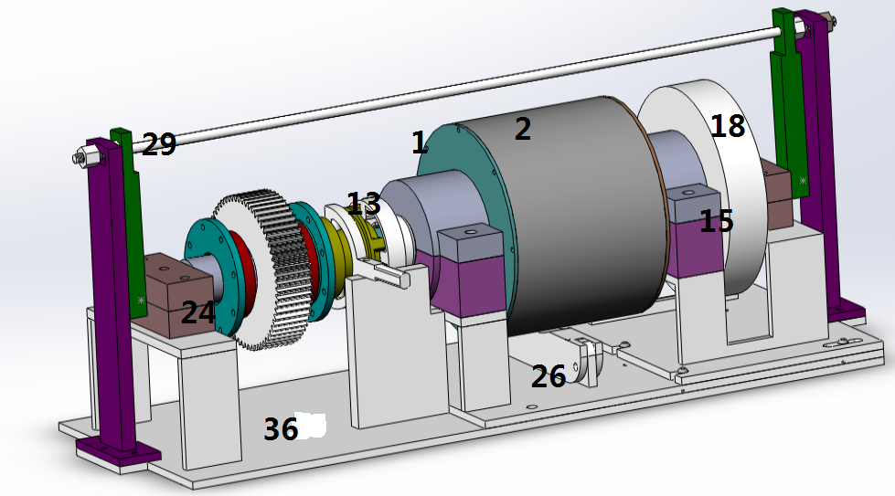

1: Large shaft disk; 2: large shell; 13: clutch; 15: bearing block; 18: flywheel; 20: bearing block; 24: adjust equipment cover; 26: locating shaft 29: regulating stem of force; 36: workbench, locating shaft; 36: workbench.
The following is the speech and instruction of engineer Wang Yiping about Gauge Field on international mathematical conference.
The World's First “Vacuum Energy Engine” Made by Chinese Inventor Sun Chunwu.
Project: eccentric rotary engine Maximum power generation 7000KW.
First manufacture a prototype generator to prove the universality of “parity conservation” and the feasibility of “vacuum excitation”.
China jiangsu yangzhou chun-wu sun invention patent "eccentric rotary engine".
(ZL201720832656.9) patent of Eccentric Rotary Engine invented by Sun Chunwu coming from Yangzhou, Jiangsu, China.

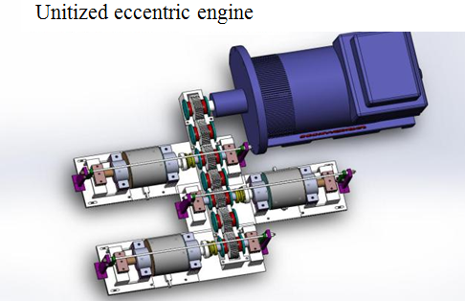
造实物时更具体数据

Sun Chunwu
Address: Room 805, Building 20, Shuxiu Garden, Xihu Town, Yangzhou City, Jiangsu Province
Password: Compile
Password: ******
Contact information: QQ458669609 Tel18652544068 Compile
Email: yzscw0514@163.com

References
- Baidu. http://www.baidu.com. 2017.
- Google. http://www.google.com. 2017.
- Ma H, Cherng S. Nature of Life. Life Science Journal 2005;2(1):7-15.
- Ma H. The Nature of Time and Space. Nature and science 2003;1(1):1-11. Nature and science 2007;5(1):81-96.
- National Center for Biotechnology Information, U.S. National Library of Medicine. http://www.ncbi.nlm.nih.gov/pubmed. 2017.
- Wikipedia. The free encyclopedia. http://en.wikipedia.org. 2017.
- Marsland Press. http://www.sciencepub.net. 2017.

1/1/2018

