**Determination of moisture indexes in sugarcane harvesting season by remote sensing in cane fields**

Y. Pourreza1, S. Boroomand Nasab 2, A. Naseri 3

1M. Sc. Student of Irrigation and Drainage, Faculty of Water Sciences Engineering, Shahid Chamran University of Ahvaz, Ahvaz, Iran. Y_pourreza@yahoo.com

2Professor of Irrigation and Drainage, Faculty of Water Sciences Engineering, Shahid Chamran University of Ahvaz, Ahvaz, Iran. Boroomand@scu.ac.ir

3Professor of Irrigation and Drainage, Faculty of Water Engineering, Shahid Chamran University of Ahvaz, Ahvaz, Iran. Abdalinaseri@scu.ac.ir

**Abstract:** Soil moisture parameters are one of the most important parameters that they use in the fields for management and planning. There are various indicators for expressing the soil moisture state that SWI and WDI are among the indicators studied in this study. Using Landsat 8 satellite imagery, Erdas software and Split Window algorithm, the mapping maps of these two indexes were obtained and compared with soil moisture values ​​manually measured. The correlation coefficient for these indices was 0.58, which is acceptable. By applying this coefficient, indicators can also be used to map the moisture map.

[Y. Pourreza, S. Boroomand Nasab, A. Naseri. **Determination of moisture indexes in sugarcane harvesting season by remote sensing in cane fields.** *Researcher* 2018;10(1):13-16]. ISSN 1553-9865 (print); ISSN 2163-8950 (online). <http://www.sciencepub.net/researcher>. 3. doi:[10.7537/marsrsj100118.03](http://www.dx.doi.org/10.7537/marsrsj100118.03).

**Keywords:** soil moisture, Remote Sensing, Moisture index

**1. Introduction**

Soil moisture is one of the important components of climatic and hydrological models (Robinson et al., 2009; Zieh et al., 2010; Zi et al., 2013), which also has a significant part of drought studies. This parameter varies greatly in different times and places and its value in each region relative to time and place (Rosenbaum et al., 2012). Because of the difficulty in continuous measurements of soil moisture, spatially, temporally, cost-effective and time-consuming field measurements that make it practically impossible to do, especially in mountainous and vast areas, have so far been widely used in water models and Air is not used (Wilson et al., 2003; Baba Zade et al. 2012).

If satellite data and soil moisture can be correlated, satellite imagery will be able to facilitate the estimation of soil moisture in area and provide access to remote or out-of-reach locations. This research seeks to find out this connection. Remote sensing data that is based on a high contrast between the dielectric properties of water and drought and the widespread view, regular imaging, observation of the inaccessible areas, and high speed access to information are their important features, high potential for estimation. The soil moisture region has a point relative to the measurements (legates 2000).

Soil water index is one of the indicators used in soil moisture assessment. Also, the Water Deficit Index is always used alongside this index and complements the information obtained and the conclusions. Indicators are usually the result of addition, subtraction or division of different spectral regions. Experimental and theoretical evidence suggests that these indices are related to several plant parameters such as land cover, leaf area index,

spectral absorption and the ability of canopy photosynthesis and soil cover. These indicators provide a rapid processing of the large amount of remote sensing data. Different research studies have been carried out in the field of agriculture. The results of these studies have led toNormalized Difference Vegetation Index(NDVI), Soil Water stress index (CWSI), Soil Water Index (SWI) and Water Deficit Index (WDI)... Has been. In agriculture in the field of remote sensing algorithms, we can extract the zoning map of each indicator. In this study, the zoning of soil moisture indexes is extracted and compared with ground results in Salman Farsi field of Khuzestan province during harvest season.

**2. Material and Methods**

The soil water index for each pixel is calculated as follows:



In which the index i represents the pixel number. LST (i) is the same pixel surface temperature i and LSTmin (i) is the minimum observed temperature and LSTmax (i) is the maximum observed temperature corresponding to the desired pixel, which is based on the variable NDVI value.



In these relations a, b, c, d are the coefficients that are extracted from the equations for the triangular diagram NDVI-LST, which is shown in the following figure as an example of this graph.

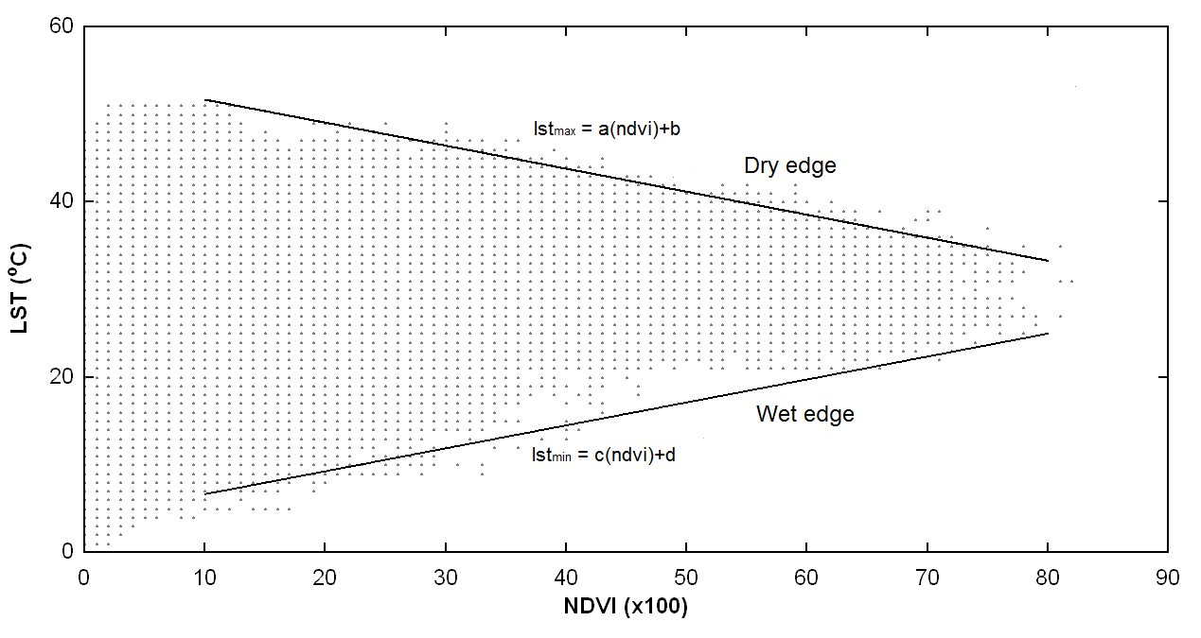

Soil moisture and vegetation ratios depend heavily on surface temperature. However, no direct relationship between soil temperature and soil moisture has been reported so far. Many researchers have shown the physical relationship between a plant profile, such as NDVI and LST, in the form of a point distribution diagram, in which the concept of triangular space is used to extract soil moisture (Wang et al., 2006).

The concept of the triangular space LST-NDVI and the relationship between LST (y diagram) and NDVI are shown in the following figure. The upper side of the triangle representing the dry edge (warm) contains a group of points that are in zero amounts in different amounts of NDVI. Unlike the lower (cold), which represents the maximum soil moisture in different NDVI values.

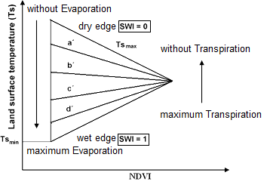

In the region called the dry edge, there are maximum temperature values (LSTmax), which assumes a dry soil state (minimum humidity) assuming the linearity of temperature variations in this region. In contrast, at least the temperature values (line LSTmin) also form an oblique line, which is called the edge and displays the saturated or very wet soil (maximum moisture content). It is assumed that moisture changes linearly between the dry and wet edges. It should be noted that soil moisture index is actually a percentage of the maximum available moisture content that is filled with water (Keshavarz et al. 2011).

(Moran et al. 1994) for the first time introduced the wdi index for estimating evapotranspiration in areas where their vegetation is poor or their vegetation is not complete. Their results showed that they were completely covered with vegetation. The index is the same as the water stress index of the plant, and the diagram is a trapezoidal, which is the relationship between the temperature difference between the temperature of the earth and the temperature of the air against the vegetation index. The value of this indicator also changes between zero and one. Which is zero for wet level and one for dry surfaces. The relation between the water deficit index and the parameter Ta is the value of the temperature of each pixel.



The most important parameter mentioned in the indexes is the soil temperature, which in this study is derived from split window algorithm.

**3. Results and Discussion**

Using the equations in the previous section, an algorithm for soil moisture indexes was implemented in Erdas2014 software and the zoning map for these indicators for the day of satellite passing on January 5, 2017 was extracted as follows. It should be noted that in this research Lands at 8 satellite imagery has been used.

In the charts that are used to calculate the correlation coefficient of terrestrial and satellite data, it is observed that the moisture content taken on the satellite's day has an acceptable correlation with the values of the indices and is suitable for analysis and surveys.

Due to the fact that this research was in the sugarcane harvest season, we saw weak vegetation in agricultural land. It is expected that if this research is carried out in the plant growth season, more accurate results and higher correlation coefficients will be observed.

As we know, in satellite images of each pixel represents a value for the index, and in order to bring this map closer to the moisture values, it is necessary to apply the correlation coefficient of the new zoning map as the soil moisture zoning map. These maps can be a good guide to planning and managing agriculture in agricultural lands.

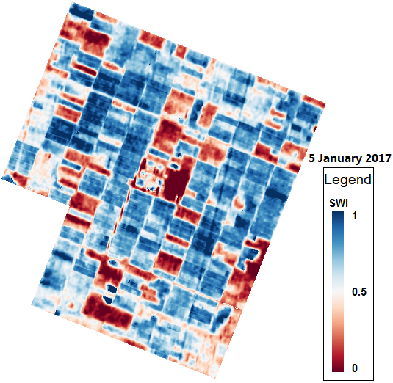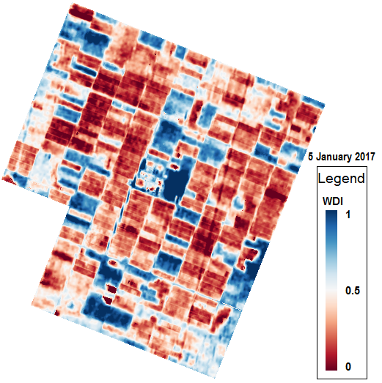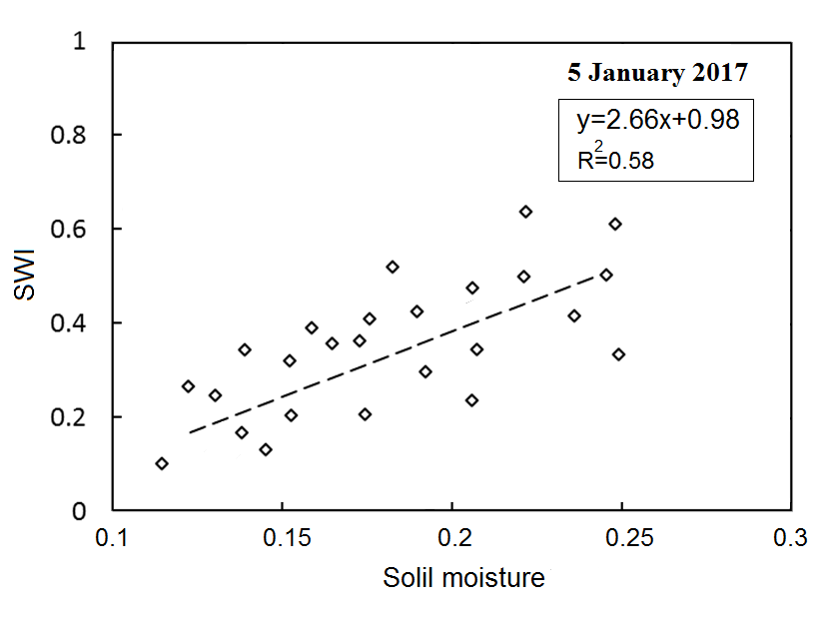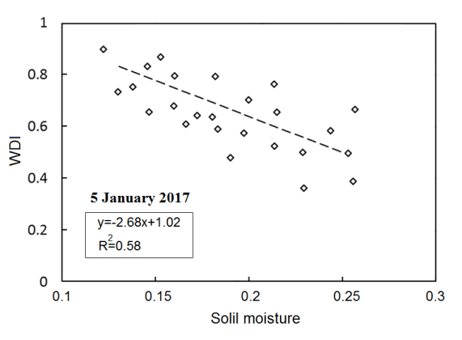

**4. Conclusion**

With regard to the extracted results, it can be concluded that in the study area, the indexes of the grade will be taken in this test. But there should be more study in the same areas or with other indicators on this topic so that more accurate conclusions can be drawn from this topic.

**Corresponding Author:**

Yousef Pourreza,

M. Sc. Student of Irrigation and Drainage, Faculty of Water Sciences Engineering, Shahid Chamran University of Ahvaz, Ahvaz, Iran.

E-mail: [y_pourreza@yahoo.com](mailto:y_pourreza@yahoo.com)

**References**

1. Babazadeh, Hossein, Elnaz, Norouzi Aghdam, Elnaz, Hossein Aghighi, Sayed Amir, Shamsnia, and Davood Khodadadi Dehkordi (2012). Estimation of surface soil moisture in arid and semi-arid lands using temperature index and Vegetation Coverage, Case Study: Khorasan Province, Journal of Rangeland and Desert Researches of Iran, Volume 19, Number 1 Page 120-132.
2. Keshavarzas, Mohammad Reza, Majid Tasbifood, Amin, Alizadeh, and Ali Asadi (2011). Extracting and Routing of Soil Moisture Using Satellite Data of Madis Sensor, Case Study: Isfahan Province, Irrigation and Drainage Journal of Iran, Volume 5, Number 2 209-219.
3. Legates, D.R. (2000). Remote sensing hydro climatology: An introduction. The professional Geographer, 52(2): 233-234.
4. Moran, M.S., Clarke, T.R., Inoue, Y., and Vida, A., (1994). Estimating crop water deﬁcit using the relation between surface-air temperature and spectral vegetation index. Remote Sens. Environ. 46, 246–263.
5. Robinson, D.A., Campbell, C.S. Hopmans, J.W., Hornbuckle, B.K., Jones, S.B., Knight, R., Ogden, F., Selker, J. & Wendroth, O. (2008). Soil moisture measurement for ecological and hydrological watershed-scale observation. A review, Vadose Zone J., 7: 358–389.
6. Wang, X., H. Wie, H. Guan and X. Zhou. (2006). Different response of MODIS-derived NDVI to root-zone soil moisture in semiarid and humid regions. Journal of Hydrology 340: 12-24.
7. Wilson, D., Western, A.W., Greyson, R.B., Berg, A.A., Lear, M.S., Rodell, M., Famiglietti, J.S., Woods, R.A. & McMahon, T.A. (2003). Spatial distribution of soil moisture over 6 and 30cm depth, Machurangi river catchment, New Zealand. Journal of Hydrology, 276: 254-274.
8. Zhao, S., Yang, Y., Qiu, G., Qin, Q., Yao, Y., Xiong, Y. & Li. C. (2010). Remote detection of bare soil moisture using a surface-temperature-based soil evaporation transfer coefficient. International Journal of Applied Earth Observation and Geoinformation, Volume 12, Issue 5: 351–358.
9. Zhe, Y., Tingwu, L., Qinghong, Y., Zhanpneg, C. & Yuequn, D. (2013). A near-infrared reflectance sensor for soil surface moisture measurement. Computers and Electronics in Agriculture, vol, 99: 101-107.

12/27/2017