Acute and Sub-Chronic Studies of Ethylacetate Leaf Extract of Mitracarpus villosus (Sw.) DC in Wistar Rats

John-Africa, L. B.,^{1, 2} Danjuma, N. M.,² Anuka, J. A.,² Chindo, B. A. ^{1, 2, 3}

¹Department of Pharmacology and Toxicology, National Institute for Pharmaceutical Research and Development (NIPRD), Idu Industrial Area, P.M.B 21 Garki, Abuja, Nigeria.
²Department of Pharmacology and Therapeutics, Faculty of Pharmaceutical Sciences, Ahmadu Bello University, Zaria, Kaduna State.
³Department of Pharmacology and Toxicology, Faculty of Pharmaceutical Sciences, Kaduna State University, Kaduna, Nigeria.
Corresponding Author: L. B. John-Africa Department of Pharmacology and Toxicology, National Institute for Pharmaceutical Research and Development (NIPRD), Idu Industrial Area, P.M.B 21 Garki, Abuja, Nigeria.
Corresponding Author: lbjafrica@yahoo.com

Abstract: Herbal medicines originate from nature; thus the perception that they are safe. However, herbs contain bioactive compounds that may potentially cause toxicity. This therefore requires medicinal plants to be subjected to safety investigations. Mitracarpus villosus is an herb used for management of diverse disorders in ethno-medicine that include painful and infective conditions, thus the need to determine the safety profile of the plant. The toxicity of the ethylacetate leaf extract of Mitracarpus villosus (MVEA) was investigated by acute and sub-chronic toxicity studies. Acute toxicity studies were carried out following OECD 423 guidelines. The sub-chronic toxicity (OECD 407) test was examined using albino rats by daily oral administration of MVEA (312, 625 and 1250 mg/kg) for 28 days during which mortality, toxicity symptoms, feed consumption and body weights were monitored. Subsequently, organ weights, haematological, biochemical and histological parameters were assessed. The dose of 2000 mg/kg produced no mortality in the acute toxicity test. In the sub-chronic toxicity studies, no significant difference was recorded in food and water intake, body or organ weights. Treatment with MVEA caused increased serum creatinine levels at 1250 mg/kg in female rats but did not cause alterations in other diagnostic haematological and serum biochemical parameters. Histological evaluation showed mild alterations of cellular structures of kidneys and hepatocytes. No remarkable changes were observed in the tissues of other organs. The extract produced no toxicity effects in the acute toxicity test and in sub-chronic administration the no-observed-adverse-effect-level (NOAEL) is 625 mg/kg/day for 28 days.
[John-Africa, L. B., Danjuma, N. M., Anuka, J. A., Chindo, B. A. Acute and Sub-Chronic Studies of Ethylacetate Leaf Extract of Mitracarpus villosus (Sw.) DC in Wistar Rats. Rep Opinion 2017;9(12):83-90]. ISSN 1553-9873 (print); ISSN 2375-7205 (online). http://www.sciencepub.net/report. 12. doi:10.7537/marsroj091217.12.

Keywords: Phytomedicine, Mitracarpus villosus, Herbal toxicity

Introduction
Medicinal herbs make up part of the natural environment thus widely believed to be non-toxic. However, there is no scientific rationale to assume the intrinsic safety of plants and/or their derivatives, because while they are capable of curing ailments, they may also produce deleterious effects on humans (Ekor, 2013). Therefore, there is the need to subject herbal medicines to safety investigations before recommendation for use. Persons with chronic conditions that may not have responded well to conventional medicine seek alternative medical services of which herbal medicines are a key component thus paving way for the increase in popularity of use of herbs. These maybe used in their natural form either as medicines or dietary supplements which may be used alone or concurrently with orthodox medicines (Metalfe et al., 2010; Tulunay et al, 2016). Herbal medicines, however are not without side effects or adverse reactions thus presenting a situation that calls for caution in the administration of herbs because inappropriate use of this group of medicines can cause serious consequences (Oreagba et al., 2011). Furthermore, many medicinal plant treatments are readily available largely obtainable without restrictions and are frequently self-prescribed; also the proliferation of substandard herbal medicines in the trade of traditional medicine poses a threat to an uninformed consumer (Azila-Gbettor et al., 2014) hence the need to determine the safety/toxicity profile of medicinal plants is fundamental.
Mitracarpus villosus (Sw.) DC (Rubiaceae) with the synonym Mitracarpus scaber zucc. ex schult. & schult.f. is an herb commonly used in traditional medicine for the treatment of several ailments that include toothaches, headaches, amenorrhoea, hepatic, skin and venereal diseases, diarrhoea and dysentery administered orally or topically (Jegede et al, 2005; Abere et al., 2007). Studies carried out demonstrate that the plant possesses hepatoprotective properties (Germano et al, 1999). Despite its widespread use, toxicological information regarding the safety of repeated exposure to Mitracarpus villosus is inadequate. This study is aimed at determining the acute and sub-chronic toxicity profile of ethylacetate leaf extract of Mitracarpus villosus and identifying the potential target organ(s) of toxicity. The study was carried out using single and 28 day repeated oral dosing of the extract of Mitracarpus villosus leaf in Wistar rats. Haematological, biochemical and histopathological indices were then evaluated to establish the potential toxicity of the extract.

Materials and Methods Plant material
The plant Mitracarpus villosus was collected in the month of September 2015, around Idu Abuja, Nigeria. The plant was identified and authenticated by Dr. G. Ugbabe of the Department of Medicinal Plant Research and Traditional Medicine, National Institute for Pharmaceutical Research and Development (NIPRD) Idu, Abuja where a voucher specimen (NIPRD/H/6606) was prepared and deposited for future reference.

Plant extraction
The aerial parts were cleaned of debris, air-dried and pulverized to obtain a coarse powder using a pestle and mortar. The powdered plant material (250 g) was subjected to Soxhlet extraction using 2 L ethyl acetate. The filtrate was concentrated under reduced pressure using a rotary vacuum evaporator and the concentrate was evaporated to dryness on a water bath to give Mitracarpus villosus ethylacetate extract (MVEA); a semi-solid (the extract) with a yield of 4.75 % w/w. Animals
Forty (20 males; 20 females) Wistar rats weighing 120 – 160 g bred and maintained at the Animal Facility Centre of NIPRD were used in these studies. They were housed in polypropylene cages with saw dust as beddings, under ambient conditions. The animals were fed on standard rodent feed (CAPS Plc. Ibadan) and had free access to clean drinking water ad libitum. All Animals were handled according to the institutional animal care guidelines for regulation of animal studies. as recorded in the Standard Operating Procedure of the Department of Pharmacology and Toxicology (SOP No 05:03:02).

Pharmacological tests

Acute toxicity studies
The evaluation was done using 9 adult female nulliparous, non-gravid rats. The extract was administered orally in a single dose using an oral cannula. The animals were weighed and randomly placed into 3 groups of 3 rats each. A single oral dose (300 mg/kg) of the extract was administered to one group of animals and the group was observed for any toxic symptoms, behavioural changes, locomotion, convulsions and mortality. The mice showed decreased activity but had no other signs of toxicity in the first group tested and hence higher doses of 2000 mg/kg was administered to another group by single oral administration and the animals were observed initially for any behavioural signs/changes and symptoms of toxicity which included abdominal constriction, salivation, hyperactivity, sedation, convulsion, tremors, diarrhoea, lethargy and coma for the first 30 min after acute drug administration, and then periodically during the first 24 h with special attention given during the first 4 hours and subsequently for toxic symptoms and mortality for a period of 14 days. The behavioural pattern and mortality was recorded for each animal. The animals were weighed on day 0, 7 and 14. Tween 80 (5 %) in distilled water was used as vehicle because the extract has low solubility in water. A control group was included which received an equivalent volume of the vehicle (OECD, 2001).
Sub-chronic toxicity tests
Rats of both sexes were randomly assigned into four groups of control and three treatment groups (n = 10; 5 males, 5 females). The extract was freshly prepared each day and orally administered as single daily dose of 312 mg/kg, 625 mg/kg and 1250 mg/kg of extract respectively while the control was given the vehicle. MVEA was suspended in a vehicle consisting 5 % Tween 80 in distilled water. The behavioral patterns of the animals were observed on a daily basis, daily feed consumption and water intake were assessed and rats were weighed once a week. At the end of the experiment, all animals were anaesthetized by diethyl ether inhalation and blood samples were collected by cardiac puncture in a 5 ml syringe using a 21G needle into non heparinized and ETDA–containing tubes for biochemical and haematological analysis.

Studies on effect of MVEA on haematological indices
The blood samples transferred into EDTA containing tubes were evaluated for haematological parameters such as White Blood Cells, Red Blood Cells (RBC), haemoglobin concentration (Hb), platelet count using the Automated Sysmex haematology analyzer (KX-21N, Sysmex, Japan). Studies on effect of MVEA on serum biochemical indices
The serum was separated from non-heparinized blood and the serum biochemical parameters which include alanine amino transferase (ALT), aspartate amino transferase (AST), alkaline phosphatase (ALP), creatinine, urea, albumin, bilirubin, total protein, sodium, potassium, chloride and bicarbonate were analysed using automated biochemical analyser (VITROS DT 60 II chemistry systems). Histopathological studies of the effect of MVEA in rats
After blood collection all the animals were euthanized for gross pathological examination of all major internal organs. Organs such as liver, kidney, brain, lungs, spleen, stomach, small intestine, gonads were excised blotted of blood, weighed and observed macroscopically. The relative organ weights were calculated. The organs were preserved in 10 % neutral buffered formalin. The tissues were embedded in paraffin, sectioned at approximately 5 µm, stained with hematoxylin and eosin and examined with an optical microscope.

Statistical analysis
Results are expressed as mean ± SEM. Data were analysed using Two-Way ANOVA followed by Bonferroni’s post hoc test and P<0.05 was considered as statistically significant.

Results and Discussion
In the acute toxicity study of the ethylacetate leaf extract of Mitracarpus villosus no mortality was observed in all treated animals thus oral LD₅₀ was therefore estimated to be greater than 2000 mg/kg. No immediate sign of toxicity was detected as abdominal constriction, salivation, hyperactivity, convulsion, tremors, diarrhoea and coma were not observed. There was also no eye, skin and fur change however reduced activity was observed in the animals which may be due to the presence of CNS depressant constituents in the plant extract (Bulbul et al, 2016, John-Africa et al, 2014). The LD₅₀ suggested that the MVEA is non-toxic when given acutely via the oral route, and substances with LD₅₀ values greater than 5 g/kg are considered of relatively low acute toxicity thus having low potential to cause toxic effects on acute administration (OECD, 2001). This result agrees with that reported by Abere et al, 2012; but the safety profile of the extract may be better assessed when animals are subjected to repeated administration of different doses for a longer period in which case the subchronic toxicity study was conducted.
In the sub-chronic toxicity, all the female rats in the 1250 mg/kg treatment groups exhibited hunchbacked posture and piloerection. The reason piloerection and hunched posture were observed only in females is not clear but may be because females are generally more sensitive and tend to exhibit toxicological effects slightly more than males as has been earlier reported (OECD, 2001).
Oral treatment with the extract for 28 days did not produce any significant differences in the food and water consumption between control and treated groups; likewise, no significant differences were observed in the final body weights of treated rats when compared to control animals. There was also no significant difference in the relative organ weights of the internal organs though, an increase in the relative weight of the liver of rats in both male and female rats was observed. This increase was significant (p<0.05) only in female rats (Table 1).
An increase in the weight of the liver after administration of a substance has been associated with toxicity effect of that agent (Imafidon and Okunrobo, 2012). Exposure of liver cells to hepatotoxic agents may result in an initial insult followed by a phase of regenerative hyperplasia, the cycle of necrosis and regeneration can occur following repeated administration, resulting in liver enlargement associated with histopathological and clinical chemistry findings (Andrew, 2005). Comparison between treatment and control groups may be complicated by differences in body weights of the animals. Consideration should be given to residual blood that may have remained in the liver at the time of sacrifice which may differ from one animal to another. Nevertheless, it is advised that organ weight data should be assessed in context of the entire study which includes consideration of body weight changes, the state of the animals, clinical pathology data and the overall pharmacological action of the test agent (Nirogi et al, 2014).
The MVEA produced a significant (p<0.05) increase in the levels of MCV in both male and female rats at 1250 mg/kg. The extract however did not produce any significant difference in the values of the other haematological parameters analyzed (Table 2). The haematological indices such as mean corpuscular volume (MCV), the mean corpuscular haemoglobin (MCH) and the mean corpuscular haemoglobin concentration (MCHC) give indication of haemoglobin deficiency thus may be used for the categorization of different types of anaemias (Zheng et al., 2015). In this experiment the extract produced a significant increase of the mean corpuscular volume (MCV). Increased MCV may not be sufficient to reach a diagnosis as it is not usually considered as a single factor; it is frequently considered along with the values of other haematological indices e.g MCH and MCHC but in this study, there is no significant change of both MCH and MCHC values.
Liver function may be determined by assessing the concentrations of hepatic enzymes that include aspartate aminotranferases (AST), alanine aminotransferaces (ALT) and alkaline phosphatase (ALP) (Namjoo et al., 2013). Liver enzymes are released into the blood when liver cells are injured therefore, alteration in the levels of these enzymes reveal compromise in the functional integrity of the hepatic cells and can thus be used in detection of liver diseases such as liver inflammation (Adebiyi and Abatan, 2013).
In this study the extract produced an increase in the level of ALP in treated female rats (p<0.05) at 1250 mg/kg. No significant change was observed in males or in levels of AST and ALT in both male and female rats. Similarly, the levels of the total serum proteins, albumin, direct and total bilirubin measured were not significantly affected when compared to the control (Table 3). AST and ALT levels are increased to some level in almost all liver diseases and are specific indicators of hepatocellular necrosis and hepatitis; therefore, serum levels of AST and ALT are the most frequently used indicators for determination of liver injury (Thapa and Walia, 2007, Kang, 2016). An isolated elevation of one of the value of the parameters of the liver function tests is suggestive of a source other than the liver (Murali and Carey, 2014). Elevation of only ALP levels in this study probably indicates that the enzyme may have been released from non-hepatic sources such as bones or intestines (Hoffman et al, 1994) thus, the observed increase may therefore not be due to liver injury.
In the liver, there are a limited number of morphologic changes that can be discerned using conventional light microscopy. These morphologic alterations are often characterized as either adaptive which consists of exaggerated normal physiological response, pharmacologic consisting of expected alteration in response to the desired actions of the test article or adverse changes that involves morphologic alterations that are generally undesired, progressive and deleterious to the normal function of the cells involved; often the differentiation between these responses is the magnitude of change rather than a completely different mechanism or pathway (Hardisty and Brix, 2005). In this study, histological analysis of liver cells after repeated oral administration of the extract caused mild distortion of radial arrangement of hepatocytes and enlargement of nuclei in the 1250 mg/kg treated group. Since the morphological alterations observed in the liver are mild, it may be possible that the liver cells are in a phase of adaptation to the presence of the extract or its metabolites considering that Ekpendu et al., 1994 reported the presence of active principles with hepatoprotective potentials. It has also been suggested that the significance of histopathological changes should be considered in the context of other study results as well as other information known about the plant or extract (Hayes, 2014). No remarkable changes were observed in the tissues of other vital organs which include stomach, small intestine, spleen, lungs, heart, gonads.

Table 1. Effect of ethylacetate leaf extract of Mitracarpus villosus on relative organ weight of Wistar rats following 28 days of oral administration
Organ | Treatment (mg/kg)
 | Vehicle |  | MVEA 312 |  | MVEA 625 |  | MVEA 1250
 | m | f | m | f | m | f | m | f
Stomach | 1.36 ±  0.095 | 1.44 ± 0.10 | 1.50 ± 0.08 | 1.53 ± 0.06 | 1.40 ± 0.18 | 1.46 ± 0.06 | 1.38 ± 0.04 | 1.46 ± 0.05
Brain | 0.79 ± 0.13 | 0.84 ± 0.06 | 0.76 ± 0.08 | 0.83 ± 0.06 | 0.89 ± 0.04 | 0.99 ± 0.45 | 0.90 ± 0.04 | 1.00 ± 0.06
Liver | 2.98 ± 0.10 | 2.83 ± 0.08 | 3.13 ± 0.08 | 3.29 ±  0.04 | 3.23 ± 0.17 | 3.85 ±  0.17* | 3.32 ± 0.05 | 3.51 ± 0.14
Spleen | 0.58 ± 0.10 | 0.42 ± 0.04 | 0.47 ± 0.03 | 0.48 ± 0.06 | 0.43 ± 0.04 | 0.47 ± 0.01 | 0.46 ± 0.04 | 0.49 ± 0.05
Lung | 0.83 ± 0.05 | 0.77 ± 0.04 | 0.74 ± 0.54 | 0.95 ± 0.09 | 0.77 ± 0.51 | 0.84 ± 0.08 | 0.73 ± 0.03 | 0.93 ± 0.08
Small  Intestine | 3.56 ± 0.05 | 0.46 ± 0.04 | 0.32 ± 0.02 | 0.40 ± 0.04 | 0.41 ± 0.07 | 0.50 ± 0.05 | 0.31 ± 0.04 | 0.42 ± 0.06
Kidneys | 0.70 ± 0.04 | 0.71 ± 0.03 | 0.70 ± 0.03 | 0.72 ± 0.03 | 0.71 ± 0.03 | 0.75 ± 0.07 | 0.76 ± 0.03 | 0.68 ± 0.01
Ovaries/testis | 1.49 ± 0.07 | 0.60 ± 0.08 | 1.58 ± 0.08 | 0.62 ± 0.15 | 0.16 ± 0.02 | 0.67 ± 0.13 | 1.54 ± 0.09 | 0.64 ± 0.17
Heart | 0.35 ± 0.01 | 0.37 ± 0.03 | 0.33 ± 0.03 | 0.32 ± 0.01 | 0.33 ± 0.01 | 0.43 ± 0.07 | 0.36 ± 0.02 | 0.36 ± 0.01
Values are presented as mean ± SEM (n = 5), *P<0.05 significant when compared to control (Two-way ANOVA followed by Bonferroni’s post hoc test). m = male; f = female

Table 2. Effect of ethylacetate leaf extract of Mitracarpus villosus on haematological parameters of Wistar rats
Parameter |  |  |  | Treatment (mg/kg)
 | Vehicle |  | MVEA 312 |  |  | MVEA 625 |  | MVEA 1250
 | m | f | m |  | f | m | f | m | f
RBC (x 10/L) | 5.39 ± 0.10 | 6.16 ± 0.32 | 5.04 ± 0.39 |  | 5.60 ± 0.19 | 5.36 ± 0.30 | 5.87 ± 0.07 | 5.32 ± 0.46 | 5.73 ± 0.09
HB (g/dL) | 14.18 ±  0.73 | 10.88 ±  0.45 | 12.80 ±  0.61 |  | 10.60 ±  0.08 | 12.82 ±  0.75 | 10.40 ±  0.07 | 14.60 ±  0.98 | 10.48 ±  0.05
PVC (%) | 37.86 ±  0.43 | 37.50 ±  1.41 | 40.34 ±  1.76 |  | 37.55 ±  0.71 | 39.26 ±  1.04 | 37.20 ±  0.49 | 38.20 ±  0.64 | 37.96 ±  0.24
MCV (fl) | 58.82 ±  0.67 | 59.03 ±  1.55 | 59.24 ±  0.86 |  | 63.65 ±  2.30 | 63.00 ±  1.32 | 64.5 ± 4.02 | 69.24 ±  1.99* | 69.50 ±  1.85*
MCH (Pg) | 18.02 ±  0.17 | 17.60 ±  0.21 | 17.10 ±  0.19 |  | 18.78 ±  0.51 | 17 24 ±  0.30 | 17.68 ±  0.27 | 17.05 ±  0.13 | 17.52 ±  0.18
MCHC (g/dL) | 28.44 ±  0.24 | 29.78 ±  0.11 | 28.86 ±  0.15 |  | 28.25 ±  0.34 | 28.50 ±  0.26 | 28.68 ±  0.29 | 28.63 ±  0.27 | 28.60 ±  0.24
Plts (x100/L) | 54.12 ±  4.85 | 50.67 ±  2.74 | 58.24 ±  2.52 |  | 54.48 ±  3.64 | 57.92 ±  1.86 | 55.40 ±  0.58 | 59.13 ±  4.09 | 53.30 ±  3.29
WBC (x10/L) | 6.28 ± 0.72 | 8.10 ± 2.89 | 6.46 ± 1.13 |  | 9.43 ± 2.23 | 6.78 ± 0.31 | 7.63 ± 1.24 | 7.25 ± 0.28 | 9.76 ± 0.94
Neutrophils (%) | 7.74 ± 1.44 | 9.28 ± 3.04 | 9.14 ± 1.19 |  | 8.34 ± 1.44 | 7.78 ± 1.39 | 7.70 ± 0.97 | 7.13 ± 0.10 | 7.62 ± 1.10
Lymphocytes (%) | 80.90 ±  2.88 | 78.73 ±  4.16 | 79.60 ±  2.53 |  | 79.75 ±  4.64 | 80.58 ±  2.75 | 80.75 ±  3.84 | 83 40 ±  1.07 | 82.66 ±  1.98
Monocytes (%) | 6.36 ± 1.15 | 6.20 ± 1.01 | 5.70 ± 0.75 |  | 7.10 ± 2.31 | 6.46 ± 0.66 | 3.40 ± 0.07 | 5.05 ± 0.47 | 4.84 ± 0.55
Eosinophiles (%) | 0.32 ± 0.16 | 0.40 ± 0.15 | 0.22 ± 0.07 |  | 0.18 ± 0.04 | 0.22 ± 0.10 | 0.20 ± 0.04 | 0.10 ± 0.04 | 0.16 ± 0.04
Basophiles (%) | 4.38 ± 0.89 | 5.40 ± 0.93 | 5.34 ± 0.81 |  | 4.63 ± 1.20 | 4.86 ± 1.08 | 2.95 ± 0.35 | 3.98 ± 0.25 | 4.62 ± 0.76
Values are presented as mean ± SEM (n = 5), *p<0.05 significant when compared to control. (Two-way ANOVA followed by Bonferroni’s post hoc test); m = male; f = female

Table 3. Effect of orally administered ethylacetate leaf extract of Mitracarpus villosus on hepatic indices of Wistar rats.
Parameter |  |  |  |  |  | Treatment (mg/kg)
 | Vehicle |  | 312 |  | 625 |  | 1250
 | m | f | m | f | m | f | m | f
TB  (umol/L) | 28.96 ±  2.99 | 32.35 ±  1.86 | 28 90 ±  1.24 | 32.80 ±  0.53 | 31.16 ±  0.85 | 31.83 ±  1.66 | 32.20 ±  0.46 | 31.30 ±  1.33
DB  (umol/L) | 14.12 ±  0.10 | 14.35 ±  1.37 | 11.40 ±  0.73 | 13.86 ±  1.56 | 12.38 ±  0.80 | 12.85 ±  1.36 | 13.68 ±  1.63 | 15.12 ±  1.49
ALP (u/c) | 119.88 ±  4.36 | 115.80 ±  4.92 | 113.00 ±  1.73 | 117.00 ±  4.68 | 113.00 ±  1.76 | 123.20 ±  4.77 | 114.60 ±  1.96 | 127.40 ±  3.26*
AST (u/c) | 9.60 ± 1.21 | 13.40 ±  1.54 | 9.60 ± 0.60 | 12.00 ±  2.61 | 9.20 ± 0.58 | 14.80 ±  2.24 | 8.80 ± 0.58 | 15.80 ±  2.97
ALT (u/c) | 9.00 ± 0.71 | 7.60 ± 0.51 | 11.20 ±  1.01 | 8.60 ± 1.60 | 11.40 ±  0.87 | 8.00 ± 2.07 | 11.40 ±  0.60 | 8.60 ± 1.50
TP (g/dl) | 66.00 ±  2.84 | 64.20 ±  2.80 | 69.60 ±  2.77 | 61.00 ±  1.48 | 70.20 ±  1.96 | 59 40 ±  1.74 | 67.80 ±  2.54 | 61.60 ±  2.94
Al (g/dl) | 42.8 ± 3.12 | 41.20 ±  3.65 | 47.4 ± 2.64 | 40.40 ±  3.30 | 41.6 ± 2.29 | 41.00 ±  3.37 | 49.8 ± 2.58 | 39.80 ±  3.09
Alkaline phosphatase (ALP), Aspartate aminotranferases (AST), Alanine aminotransferaces (ALT), Total Bilirubin (TB), Direct Bilirubin (DB), TP (Total protein), Al (Albumin), m = male; f = female Values are mean ± SEM; n = 5, ANOVA followed by Bonferroni’s post hoc, *p<0.05 vs control.

Table 4. Effect of ethylacetate leaf extract of Mitracarpus villosus on renal parameters of Wistar rats.
Parameter (mmol/L) |  |  |  |  | Treatment (mg/kg)
 | Vehicle |  | 312 |  | 625 |  | 1250
 | m | f | m | f | m | f | m | f
Sodium | 137.60 ±  1.40 | 139.20 ±  1.32 | 137.80 ±  1.62 | 136.20 ±  1.16 | 138.40 ±  1.21 | 138.20 ±  132 | 136.40 ±  0.51 | 137.20 ±  2.51
Pottassium | 10.52 ±  0.76 | 6.85 ± 0.54 | 9.82 ± 0.49 | 7.33 ± 0.58 | 10.38 ±  0.52 | 7.00 ± 0.63 | 9.95 ± 0.51 | 9.26 ± 0.35
Chloride | 100.40 ±  0.51 | 101.00 ±  1.26 | 101.20 ±  1.36 | 99.40 ±  0.68 | 99.00 ±  0.63 | 101.20 ±  0.20 | 100.60 ±  1.08 | 100.00 ±  0.71
Bicarbonate | 25.50 ±  1.81 | 28.60 ±  1.40 | 27.00 ±  2.07 | 28.00 ±  1.45 | 25.40 ±  2.11 | 30.20 ±  0.20 | 26.2 ± 2.01 | 30.00 ±  0.63
Urea | 8.04 ± 0.65 | 7.26 ± 0.59 | 7.20 ± 0.54 | 7.60 ± 0.35 | 7.02 ± 0.42 | 7.80 ± 0.61 | 7.40 ± 0.55 | 8.32 ± 0.65
Creatinine | 64.40 ±  3.31 | 50.50 ±  6.59 | 69.00 ±  2.45 | 62.25 ±  2.87 | 67.80 ±  3.35 | 71.75 ±  8.74 | 67.75 ±  1.54 | 83.60 ±  13.70*
Values are presented as mean ± SEM (n = 5); *p<0.05 significant when compared to control; (Two-way ANOVA followed by Bonferroni’s post hoc test). m = male; f = female

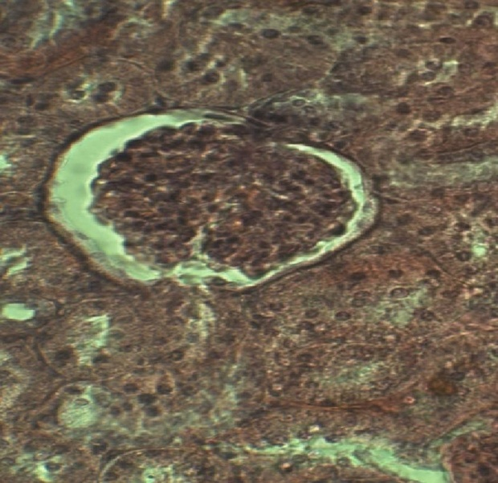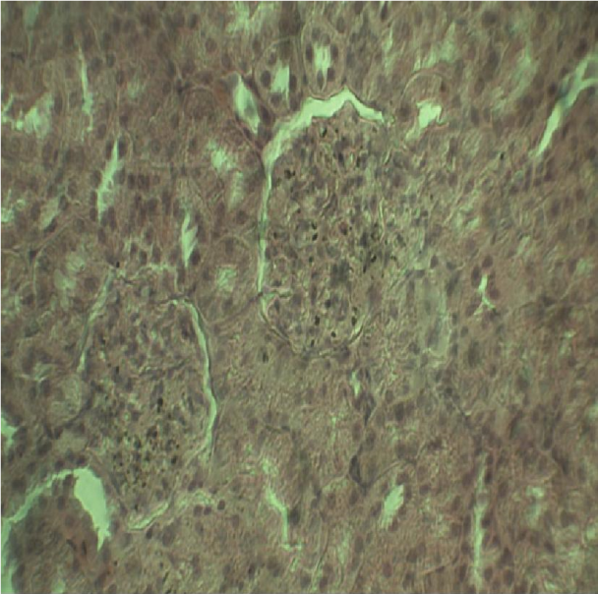
A Control B MVEA 1250 mg/kg
Figure 1. Pictomicrographs of kidney sections showing A - Control and B - 1250 mg/kg (H & E; X400).

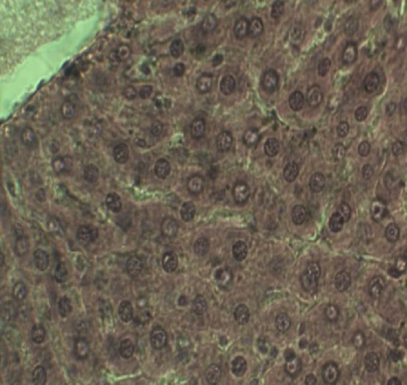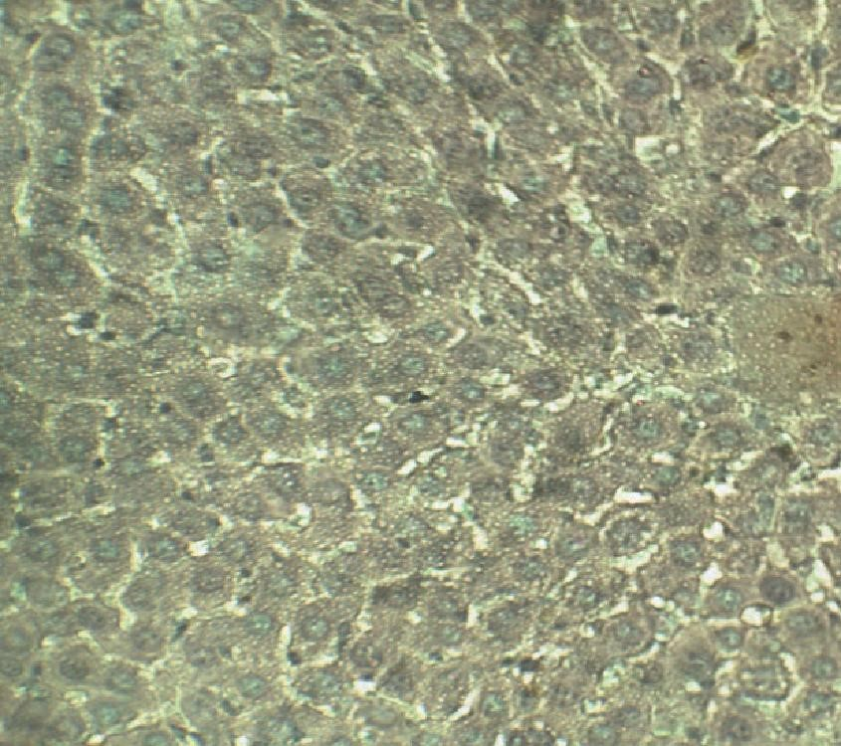

A Control B MVEA 1250 mg/kg
Figure 2 Pictomicrographs of sections of the liver A – Control and B - 1250 mg/kg (H & E; X400).

Kidney function was evaluated by means of creatinine, urea, potassium, sodium, chloride and bicarbonate levels in serum. These biomarkers used for routine assessment of kidney function are determined as indicators of normal biologic, pathologic processes or pharmacologic responses to a therapeutic intervention in management of renal, endocrine, acid-base, water balance conditions (Gowda et al., 2010). The result obtained showed that MVEA caused no significant change in renal indices of male rats. However, a significant (p<0.01) increase in the levels of serum creatinine was observed in female animals. The levels of urea and electrolytes were comparable to the control group (Table 4). Serum creatinine levels do not increase significantly until kidney function is considerably compromised (Castro et al., 2015). Histological evaluation after repeated administration of extract revealed normal glumerulei but with some alteration of some cellular structures of the kidney such as disruption of the epithelial lining and distortion of the arrangement of nuclei within the collecting duct as well as interstitial inflammation in the 1250 mg/kg treated groups. The kidneys are some of the major organs of excretion, the observed changes from histological examination of the kidney sections, may have occurred due to tissue reaction to the constituents of the extract or it may have resulted from the processes of excretion of the extract or metabolites by the organs which are the primary sites for these processes; the susceptibility of the kidneys to drug toxicity can be attributed to their function thus conforming with the principle of target organ toxicity (Bonventre et al., 2010, Aderonke et al., 2014) as there were no changes observed in the structural integrity of the other organs of the animals.

Acknowledgement
The authors wish to acknowledge the technical assistance of S. Dzarma and S. Fidelis.

References
- Abere TA, Onwukaema DN, Ozolua RI. Antidiabetic and Toxicological evaluation of aqueous ethanol leaf extract of Mitracarpus scarber Zucc (Rubiaceae) in Rats. African Journal of Pharmaceutical Research Development 2012;4(2):1 – 7.
- Abere TA, Onwukaeme DN, Eboka CJ. Pharmacognostic evaluation of the leaves of Mitracarpus scaber Zucc (Rubiaceae). Tropical Journal of Pharmaceutical Research., 2007;6(4): 849 - 853.
- Adebiyi OE, Abatan MO. Protective effects of Enantia chlorantha stem bark extract on acetaminophen induced liver damage in rats. Jordan Journal of Biological Sciences 2013;6(4):284 – 290.
- Aderonke SO, Oluranti EO, Wolfe OO, Minakiri SI. The effect of acetone extract of Crinum jagus on the histology of the kidney, liver and testis of albino rats. Peak Journal of Medicinal Plant Research 2014;2(4): 38 – 44.
- Andrew D. 2005. Interpretation of Liver Enlargement in Regulatory Toxicity Studies. Pesticide Safety Directorate Guidance Document: 10.
- Azila-Gbettor EM, Atatsi EA, Adigbo ED. Hawking of medicinal drugs: The perspective of the Ghanaian consumer. Research on Humanities and Social Sciences 2014;4(11): 37 – 43.
- Bonventre JV, Vaidy VS, Schmouder R, Feig P, Dieterle F. Next-generation biomarkers for detecting kidney toxicity. Nature Biotechnology. 2010;28(5):436 – 440. Doi:10.1038/nbt0510-436. PMID 20458311.
- Bulbul IJ, Khan MF, Rashid MA. Analgesic and central nervous system depressant activities of methanol extract of Zizipus rugosa Lam. Leaves. African Journal of Pharmacy and Pharmacology 2016;10(40):819 – 853.
- Castro BBAD, Colugnati FAB, Cenedeze MPGDA, Pinheiro HS. Standardization of renal function evaluation in wistar rats (Rattus norvegicus) from the Federal University of Juiz de Fora’s colony. Jornal Brasileiro de Nefrologia 2014;36(2): 139 – 149 Doi.org.10.5935/01012800.20140023.
- Ekor M. The growing use of herbal medicines: issues relating to adverse reactions and challenges in monitoring safety. Frontiers in Pharmacology 2013; 4:117. Doi.10.3389/fphar.2013.00177. PMCID: 3887317.
- Ekpendu TO, Akah PA, Adesumoju AA, Okogun JI. Anti-inflammatory and antimicrobial activities of Mitracarpus scaber extracts. Pharmaceutical Biology 1994;32(2):191-196.
- Germano MP, Sanogo R, Costa C, Fulco R, D'angelo V, Torre EA, Viscomi MG, De Pasquale R. Hepatoprotective properties in the rat of Mitracarpus scaber (Rubiaceae). Journal of Pharmacy and Pharmacology 1999;51(6): 729–734. Doi:10.1211/0022357991772871.
- Gowda S, Desai PB, Kulkarni SS, Hull VV, Math AAK, Vernekar SN. Markers of renal function tests. North American Journal of Medical Sciences 2010;2(4):170 – 173.
- Hardisty FJ, Brix AE. Comparative hepatic toxicity: Prechronic/chronic liver toxicity on rodents. Toxicology Pathology 2005; 33:35 – 40.
- Hayes WA, Kruger CL. Principles of pathology for toxicology studies. In: Hayes WA, Kruger CL, eds. Hayes’ Principles and methods of toxicology 6th Edn, Taylor and Francis group, CRC Press, 2014;585.
- Hoffman WE, Everds N, Pignatello M, Solter PF. Automated and semiautomated analysis of rat alkaline phosphatase iso-enzymes. Toxicology Pathology 1994;22(6):633 – 638.
- Imafidon KE, Okunrobo LO. Study on Biochemical Indices of Liver Function Tests of
- Albino Rats Supplemented with Three Sources of
- Vegetable Oils). Nigerian Journal of Basic and Applies Sciences 2012;19(2):105-110.
- Jegede IA, Kunle OF, Ibrahim JA, Ugbabe G, Okogun JI. Pharmacognostic investigation of leaves of Mitracarpus vilosus (S.W.) D.C. African Journal of Biotechnology 2005;4(9): 957-959.
- John-Africa LB, Danjuma NM, Anuka JA, Chindo BA. Sedative properties of Mitracarpus villosus leaves in mice. International Journal of Biological and Chemical Sciences 2014;8(5): 2132 – 2142.
- Kang K-S. Abnormality on liver function test.
- Pediatric gastroenterology, Hepatology and Nutrition 2016;16(4): 225 - 232
- Metalfe A, Williams J, McChesney J, Patten SB, Jette N. Use of complementary and alternative medicine by those with a chronic disease and the general population – results of a national population based survey. BMC Complementary and Alternative Medicine 2010;10:58. Doi: 10.1185/1472-6882-10-58.
- Murali AR, Carey WD. Liver test interpretation - Approach to the patient with liver disease: A guide to commonly used liver tests. Disease Management. http://www.clevelandclinicmeded.com/medicalpubs/disease management/hepatology/guide-to-common-livertests/#evaluation 2014.
- Namjoo A, MirVakili M, Shirzad H, Faghani M. Biochemical liver and renal toxicities of Melissa officinalis hydroalcoholic extract on balb/C mice. Journal of Herbmed Pharmacology 2013; (2):35 – 40.
- Nirogi R, Goyal VK, Jana S, Pandey SK, Gothi A. What suits best for organ weight analysis: Review of relationship between organ weight and body/ brain weight for rodent toxicity studies. International Journal of Pharmaceutical Sciences and Research 2014:5(4):1525.
- Doi:10.13040/IJPSR.0975-8232.5(4).1525-32.
- OECD Guidelines for the testing of chemicals/section 4: Health effects test No. 423. Acute oral toxicity - Acute toxic class method. Organization for Economic Co-operation and development. 2001.
- Oreagba IA, Oshikoya KA, Amachree M. Herbal medicine use among urban residents in Lagos Nigeria. BMC Complementary and Alternative Medicine 2011;11:117. DOI: 10.1186/14726882-11-117.
- Thapa BR, Walia A. Liver function tests and their interpretation. Indian Journal of Pediatrics 2007;74: 633–671.
- Tulunay M, Aypak C, Yikilkan H, Gorpelioglu S. Herbal medicine use among patients with chronic diseases. Journal of Ethnopharmacology 2016;4(3):217–220. Doi: 10.5455/jice.20150623090040. PMID 26401410.
- Zheng Y, Castro D, Gay D, Cai D. Mean corpuscular hemoglobin concentration in hemoglobin CC, SC and AC. The North American Journal of Medicine and Sciences 2015;8(1): 1 – 4. Doi: 10.7156/najms.2015.0801001.

12/25/2017

