Micromorphological Studies On Rhizome Of Corallocarpus Epigaeus Benth. ex Hook. f.

Poonam Sethi

Assistant Professor, Guru Nanak College, Chennai India.
poonam123.73@rediffmail.com

Absract: Rhizome of Corallocarpus epigaeus Benth ex Hook. f, Cucurbitaceae were studied and detailed pharmacognostical evaluation was done. The synonym of this plant is Bryonia epigaea. It is commonly called as Indian Bryonia and in tamil it is called as Karutan kilangu, Kollan kovai or Akasagarooda Morphology of the rhizome have been studied to aid pharmacognostic and taxonomic species identification using camera lucida diagrams, parameters presented in this paper may be proposed to establish the authenticity of this plant and can possibly help to differentiate the drug from its other. The alkaloid Bryonine from this plant is used in syphilis, chronic dysentery, chronic mucus enteritis and rheumatism. Plant has antirespiratory, anticancer and antimalarial properties also. It is used for external application in conjunctivitis and chronic veneral complaints. Tuber boiled with coconut oil is used to cure leprosy in siddha system of medicine.
[Poonam Sethi. Micromorphological Studies On Rhizome Of Corallocarpus Epigaeus Benth. ex Hook. f.. Researcher 2017;9(12):71-73]. ISSN 1553-9865 (print); ISSN 2163-8950 (online). http://www.sciencepub.net/researcher. 9. doi:10.7537/marsrsj091217.09.

Key words: akasagaroodan, camera lucida, Corallocarpus, Krutan Kilangu. leprosy, pharmacognostical, phytochemical, rhizome.

Introduction
India is one of the mega diversity countries in the world and medicinal plants form the backbone of traditional systems of medicine in India, thousands of tribal communities still use folklore medicinal plants for the cure of various diseases. Indian medicinal plants have been studied for potential source of bioactive compounds. The great interest in the use and importance of medicinal plants in many countries has led to intensified efforts on the documentation of ethnomedical data of medicinal plants Dhar et al. (1968). Earlier there were a few or no synthetic medicine and species of higher plants were the main sources of medicines for the world Duke (1990). Medicinal plants are the rich source of novel drugs that forms the ingredients in traditional systems of medicine, modern medicines, nutraceuticals, food supplements, folk medicines, pharmaceutical intermediates, bioactive principles and lead compounds in synthetic drugs Ncube et al. (2008) Many plants synthesize substances that are useful to the maintenance of health in humans and animals. This experimental plant is a prostrate monoecious plant found in tropical and temperate regions of India, Ceylon, Deccan and Maharashtra Kirtikar and Basu (1996). Decoction of rhizome is useful in cases of chronic mucous enteritis and also used as anthelmintic. This plant is used by tribals of Rajasthan to cure various ailments indigestion, constipation, abdominal pain, dysentery and typhoid. In the Deccan and Mysore the root acts as antidote for snakebite. It is also used to cure skin diseases like wounds, tumors, boils, sunburns, cuts and injury Sara Oldfield (1997). It is a siddha remedy for chronic eczema Choudhary; Singh; and Pillai, (2008). Rhizome boiled with coconut oil is used to cure leprosy in siddha system of medicine Anitha; Kamakshamma; Prasad and Sundarsanam (2008). Hence the present investigation was undertaken The uses of this plant as traditional medicine confirms that it may possess some important biological activities.

Materials And Method
The rhizome of Corallocarpus was collected from Kolli hills of Tamilnadu, India, identified by botanist of CSMDRIA Chennai, Tamil Nadu. Fresh hand sections were taken and treated with chloral hydrate and phloroglucinol and HCl. Microscopical characters were studied Evans and Trease and Evans (1997). Camera lucida diagrams were drawn. The dried powdered was treated with Jeffereys reagent, ruthenium red.

Results
I) Botanical Description
Corallocarpus epigaeus belonging to Cucurbitaceae family is a prostrate climbing perennial plant in tamil it is called as karutan kilangu, Kollan kovai or Akasagarooda. Leaves tri or pentaangular, pubescent, apex acute, base cordate, dentate; petiolate. Flowers monoecious, yellow male flowers in racemes, stamens 3, erect female flowers solitary, ovary oblong, beaked. Fruit ellipsoid, beaked, circumscissile at base.
Ii) Macroscopic Characters
Rhizome are of various sizes length and width, surface rough, colour brown externally Cork hard, many layered, It has a bitter and sub-acid taste.

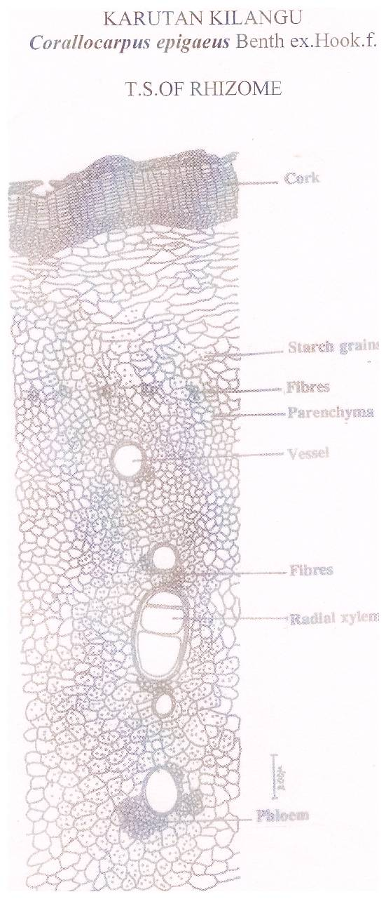
Figure I: A Transverse Section Of Rhizome Of Corallocarpus Epigaeus

Iii) Microscopical Characters
A transverse section of the rhizome shows a compact tangentially oblong periderm phellem cells with suberised walls and a few layers of less couspicuous phelloderm, continuous periderm is present. Parenchymatous cortex several radiating rows of compact, rectangular xylem cells with compact ray cells and fibres, phloem dispersed. Major portion of the tuber has compact, thin walled parenchymatous tissue with starch grains.
Powder microscopy shows parenchymatous cells are filled with simple or compound type of starch grains. Simple starch grains are 20μm wide, circular and concentric with central hilum, The compound starch grains are 25μm in size. The above parameters help in identifying the species and to establish the authenticity of this plant and can possibly help to differentiate the drug from its other adulterants.

References
  - Dhar, ML., Dhar, MM., Dhawan, BN. and Ray, C. (1968). Screening of Indian plants for biological activity – Part I. Indian J. Ex. Bio. 6: 232-247.
  - Duke, JA. (1990). Promising phytomedicinals Advances in newcrops Janick J and
  - Simon JE (eds.) Timber Press Portland 491-498.
  - Evans, WC., Trease and Evans. (1997). Pharmacognosy (14th Ed), Harcourt Brace and Company. Asia Pvt. Ltd. Singapore 343.
  - Ncube, NS., Afolayan, AJ. and Okoh, A. (2008). Assessment techniques of antimicrobial properties of natural compounds of plant origin: current methods and future trends. African journal of Biotechnology 7 (12): 1897 – 1806.
  - Kirtikar, K.R. & Basu, B.D. (1996). Indian Medicinal Plants (2nd ed., Volume II: 1664.
  - Sara Oldfield, (1997) Cactus and Succulent Plants: Status survey and Conservation action plan, IUCN/SSC Cactus and Succulent specialist group, IUCN Publications Services Unit, Cambridge: 188.
  - Choudhary, K., Singh, M., and Pillai, U. (2008). Ethnobotanical Survey of Rajasthan - An update, American – Eurasian Journal of Botany 1 (2): 38-45.
  - Anitha, G., Kamakshamma, J., Prasad Babu, G., and Sundarsanam, G (2008). Phytochemical investigation and antimicrobial activity in selected medicinal plants, Proce: International seminar on medicinal plants and herbal products.: 34.

12/25/2017

