Obtaining NDVI zoning map of SEBAL model during harvesting season in Salman Farsi sugarcane cultivation fields

Sh. Kooti¹, A. Naseri ², S.Boroomand Nasab ³

¹M. Sc. Student of Irrigation and Drainage, Faculty of Water Sciences Engineering, Shahid Chamran University of Ahvaz, Ahvaz, Iran. Shila.kt.1992@gmail.com
²Professor of Irrigation and Drainage, Faculty of Water Sciences Engineering, Shahid Chamran University of Ahvaz, Ahvaz, Iran. abdalinaseri@scu.ac.ir
³Professor of Irrigation and Drainage, Faculty of Water Engineering, Shahid Chamran University of Ahvaz, Ahvaz, Iran. Boroomand@scu.ac.ir

Abstract: In order to obtain maps for NDVI from SEBAL model 9 fields has been observed and 7 satellite images were downloaded and by SEBAL algorithm were changed to NDVI maps. The research was carried out at Salman Farsi cultivation and industrial company. The results showed that the values of NDVI given from SEBAL algorithm were near to the standard value of NDVI of the study area.
[Sh. Kooti, A. Naseri, S. Boroomand Nasab. Obtaining NDVI zoning map of SEBAL model during harvesting season in Salman Farsi sugarcane cultivation fields. Researcher 2017;9(12):40-44]. ISSN 1553-9865 (print); ISSN 2163-8950 (online). http://www.sciencepub.net/researcher. 5. doi:10.7537/marsrsj091217.05.

Keywords: SEBAL, Sugar cane, Satellite images, NDVI

1. Introduction
Now a days, due to increase of population and water demand all over the world, the importance of water resources and the shortage of water resources that can be used by human has attracted attentions.
This lack of water resources especially in developing countries and in arid and semi-arid regions has higher level than other countries in the world.
Because of the expenses of measuring the water that has been used in the fields, the best way seems to be forecasting the used and waste water in the fields.
Remote sensing is the science of obtaining information about objects or areas from a distance, typically from aircraft or satellites. It is the acquisition of information about an object or phenomenon without making physical contact with the object and thus in contrast to on-site observation. Remote sensing is used in numerous fields, including geography, land surveying and most Earth Science disciplines (for example, hydrology, ecology, oceanography, glaciology, geology); it also has military, intelligence, commercial, economic, planning, and humanitarian applications. Remote sensors collect data by detecting the energy that is reflected from Earth. These sensors can be on satellites or mounted on aircraft.
In current usage, the term "remote sensing" generally refers to the use of satellite- or aircraft-based sensor technologies to detect and classify objects on Earth, including on the surface and in the atmosphere and oceans, based on propagated signals. It may be split into "active" remote sensing and "passive" remote sensing. Passive sensors respond to external stimuli. They record natural energy that is reflected or emitted from the Earth's surface. The most common source of radiation detected by passive sensors is reflected sunlight. Passive sensors gather radiation that is emitted or reflected by the object or surrounding areas. Reflected sunlight is the most common source of radiation measured by passive sensors.

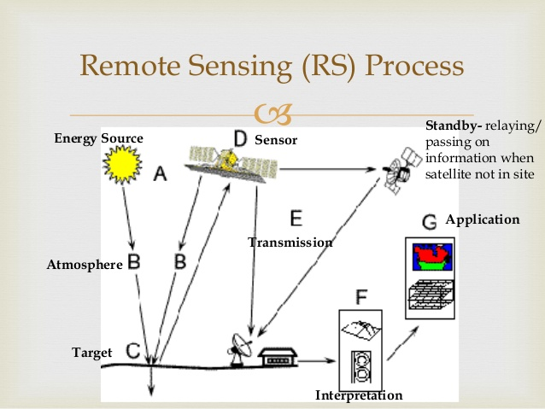

Examples of passive remote sensors include film photography, infrared, charge-coupled devices, and radiometers. Active collection, on the other hand, emits energy in order to scan objects and areas whereupon a sensor then detects and measures the radiation that is reflected or backscattered from the target.
RADAR and LiDAR are examples of active remote sensing where the time delay between emission and return is measured, establishing the location, speed and direction of an object.

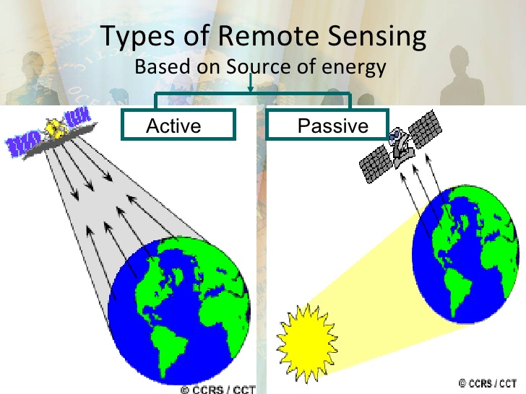

Remote sensing makes it possible to collect data of dangerous or inaccessible areas. Remote sensing also replaces costly and slow data collection on the ground, ensuring in the process that areas or objects are not disturbed. Orbital platforms collect and transmit data from different parts of the electromagnetic spectrum, which in conjunction with larger scale aerial or ground-based sensing and analysis provides researchers with enough information to monitor trends such as El Niño and other natural long and short term phenomena. Other uses include different areas of the earth sciences such as natural resource management, agricultural fields such as land usage and conservation, and national security and overhead, ground-based and stand-off collection on border areas.
Recent developments include, beginning in the 1960s and 1970s with the development of image processing of satellite imagery. Several research groups in Silicon Valley including NASA Ames Research Center, GTE, and ESL Inc. developed Fourier transform techniques leading to the first notable enhancement of imagery data In 1999 the first commercial satellite (IKONOS) collecting very high resolution imagery was launched.
Landsat8
Lands at 8 is an American Earth observation satellite launched on February 11, 2013. During the first 108 days in orbit, LDCM underwent checkout and verification by NASA and on 30 May 2013 operations were transferred from NASA to the USGS when LDCM was officially renamed to Lands at 8.
The OSTP issued a memorandum directing NASA to implement the Lands at 8 in the form of a free-flyer spacecraft carrying an instrument referred to as the Operational Land Imager (OLI). In December 2009, a decision was made to add a thermal infrared sensor (TIRS) to the mission payload.
Lands at 8 consists of three key mission and science objectives:
• Collect and archive medium resolution (30-meter spatial resolution) multispectral image data affording seasonal coverage of the global landmasses for a period of no less than 5 years;
• Ensure that Lands at 8 data are sufficiently consistent with data from the earlier Lands at missions in terms of acquisition geometry, calibration, coverage characteristics, spectral characteristics, output product quality, and data availability to permit studies of land cover and land-use change over time;
• Distribute Lands at 8 data products to the general public on a nondiscriminatory basis at no cost to the user.

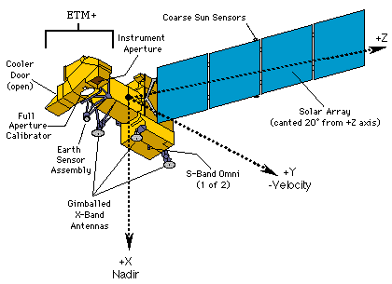
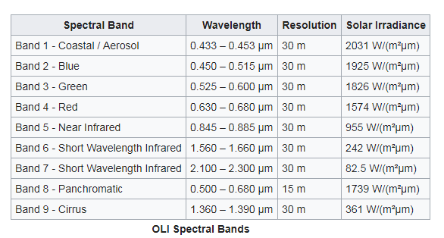
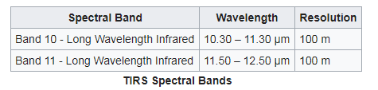

SEBAL
The Surface Energy Balance Algorithm for Land (SEBAL) uses the '''surface''' energy balance to estimate aspects of the hydrological cycle. SEBAL maps evapotranspiration, biomass growth, and water deficit and soil moisture. Its main creator is Prof. Dr. W.G.M. Bastiaanssen.
The Surface Energy Balance Algorithm for Land (SEBAL) is an image-processing model comprised of 25 computational steps that calculate the actual (ETact) and potential evapotranspiration rates (ETpot) as well as other energy exchanges between land and atmosphere. The key input data for SEBAL consists of spectral radiance in the visible, near-infrared and thermal infrared part of the spectrum. Satellite radiances will be converted first into land surface characteristics such as surface albedo, leaf area index, vegetation index and surface temperature. These land surface characteristics can be derived from different types of satellites.
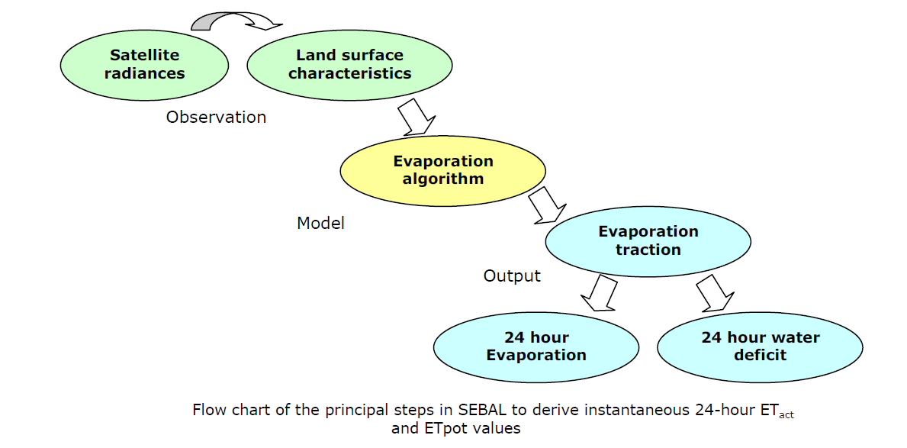
The basis of SEBAL is the energy balance: the energy driving the hydrological cycle is equal to the incoming energy minus:
1. The energy going to heating of the soil and air, and
2. The energy reflected back to space.
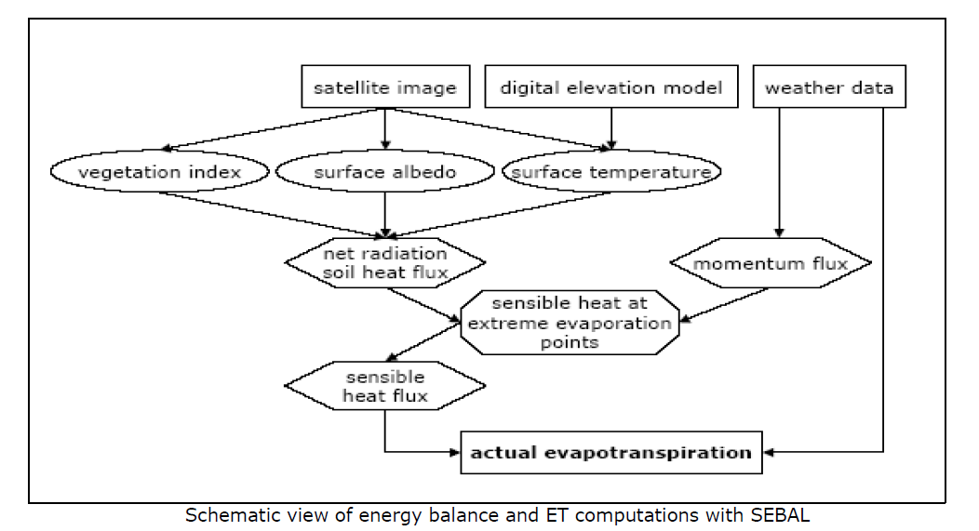

The Preference of SEBAL algorithm in comparison with other algorithms:
1. Less field data requires.
2. It has a physical concept and therefore has the ability to use for different climates.
3. No need for land use map.
4. No need for interference with the required data for hydrologic models.
5. The method of work is staged.
Advantages and disadvantages of SEBAL algorithm:
• Advantages:
1. Less field data requires.
2. It has a physical concept and therefore has the ability to use for different climates.
3. No need for land use map.
4. No need for interference with the required data for hydrologic models.
5. If high spatial resolution data is used, it is possible to obtain the variation graph and the probability density function, which is one of the most important parameters of hydrometallogy.
6. This method is suitable for the use of all visible bands, near infrared, and infrared heat But it can be used in different spatial and temporal resolution (This does not mean that there is a high degree of precision for all combinations of scale and resolution).
7. For high-resolution images, results can be compared with spot-point measurements of flux and soil moisture.
• Disadvantages:
1. No cloud conditions are required.
2. The existence of grasslands (hot pixels) and wet crops (cold pixels) are required.
3. Defining the concept of roughness is too weak.
4. The results in rugged areas are less accurate.

At this article we are focusing on NDVI index of the SEBAL algorithm.
NDVI
The normalized difference vegetation index (NDVI) is a simple graphical indicator that can be used to analyze remote sensing measurements, typically but not necessarily from a space platform, and assess whether the target being observed contains live green vegetation or not. NDVI quantifies vegetation by measuring the difference between near-infrared (which vegetation strongly reflects) and red light (which vegetation absorbs). NDVI always ranges from -1 to +1. But there isn’t a distinct boundary for each type of land cover. For example, when you have negative values, it’s highly likely that it’s water. On the other hand, if you have a NDVI value close to +1, there’s a high possibility that its dense green leaves. But when NDVI is close to zero, there aren’t green leaves and it could even be an urbanized area.
The earliest reported use of NDVI in the Great Plains study was in 1973 by Rouse et al. (Dr. John Rouse was the Director of the Remote Sensing Center of Texas A & M University where the Great Plains study was conducted). However, they were preceded in formulating a normalized difference spectral index by Kriegler et al. in 1969. Soon after the launch of ERTS-1 (Landsat-1), Compton Tucker of NASA's Center produced a series of early scientific journal articles describing uses of the NDVI.
Thus, NDVI was one of the most successful of many attempts to simply and quickly identify vegetated areas and their "condition," and it remains the most well-known and used index to detect live green plant canopies in multispectral remote sensing data.

2. Material and Methods
This research was carried out at Salman Farsi cultivation and industrial company. After downloading the satellite images and writing the SEBAL algorithm, the images were transferred to NDVI maps by the use of ERDAS and ENVI soft wares. Earth data also has been gathered in the study fields.
NDVI (Normalized Difference Vegetation Index)
As shown below, Normalized Difference Vegetation Index (NDVI) uses the NIR and red channels in its formula.
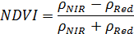
Where red and NIR stand for the spectral reflectance measurements acquired in the red (visible) and near-infrared regions, respectively. These spectral reflectance are themselves ratios of the reflected over the incoming radiation in each spectral band individually, hence they take on values between 0.0 and 1.0. By design, the NDVI itself thus varies between -1.0 and +1.0. It should be noted that NDVI is functionally, but not linearly, equivalent to the simple infrared/red ratio (NIR/VIS).
Healthy vegetation (chlorophyll) reflects more near-infrared (NIR) and green light compared to other wavelengths. But it absorbs more red and blue light.
This is why our eyes see vegetation as the color green. If you could see near-infrared, then it would be strong for vegetation too. Satellite sensors like Landsat and Sentinel-2 both have the necessary bands with NIR and red.
The advantage of NDVI over a simple infrared/red ratio is therefore generally limited to any possible linearity of its functional relationship with vegetation properties (e.g. biomass). The simple ratio (unlike NDVI) is always positive, which may have practical advantages, but it also has a mathematically infinite range (0 to infinity), which can be a practical disadvantage as compared to NDVI.
Overall, NDVI is a standardized way to measure healthy vegetation.
SAVI (Soil-adjusted vegetation index)
Empirically derived NDVI products have been shown to be unstable, varying with soil color, soil moisture, and saturation effects from high density vegetation. In an attempt to improve NDVI, Huete developed a vegetation index that accounted for the differential red and near-infrared extinction through the vegetation canopy. The index is a transformation technique that minimizes soil brightness influences from spectral vegetation indices involving red and near-infrared (NIR) wavelengths.
The index is given as:
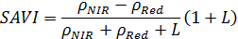
Where L is a canopy background adjustment factor. An L value of 0.5 in reflectance space was found to minimize soil brightness variations and eliminate the need for additional calibration for different soils. The transformation was found to nearly eliminate soil-induced variations in vegetation indices.

3. Results and Discussion
Due to following equations about NDVI, we should make the zoning maps for this index, and check if these data are logical and by correcting NDVI by SAVI equation the results get clearer or not.
In the following, one of the zoning maps of NDVI is shown that its values are between -1 and 1. Negative values show water and positive values up to 0.2 indicate dry and soil levels and positive values higher than 0.2 shows vegetation, which by increasing of freshness and density of sugar cane, the value of this index has reached its highest level. As seen in satellite imagery, NDVI increases as sugarcane grows.

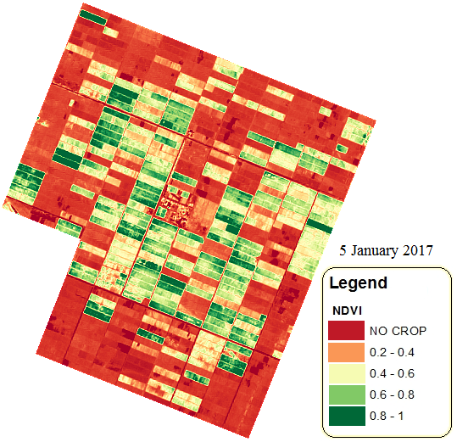
NDVI Zoning Map on Satellite Navigation on 5 January 2017

When you have high NDVI values, you have healthier vegetation. When you have low NDVI, you have less or no vegetation. Generally, if you want to see vegetation change over time, then you will have to perform atmospheric correction.
In general, if there is much more reflected radiation in near-infrared wavelengths than in visible wavelengths, then the vegetation in that pixel is likely to be dense and may contain some type of forest. Subsequent work has shown that the NDVI is directly related to the photosynthetic capacity and hence energy absorption of plant canopies.
By observing this map as we can see, the most values of NDVI are between 0 to 1 but mostly 0 to 0.6, and that’s because of the harvesting season. so that’s a logical value for NDVI which has acquired from SEBAL algorithm.
For more Precision, Correlation between NDVI and plant surface temperature and between NDVI and leaf sheath moisture have been taken.
The correlation results are as shown below:
As it’s shown on the diagram the correlation index value is 0.54 which is an acceptable correlation between NDVI and leaf sheath moisture.
So these correlations, confirm that SEBAL algorithm is a right way to get data from and it’s the best way to furcating due to low expenses and it’s also a non-time consuming way to do researches in the future.
Also it should be noted that wasting less time and money on researches makes the planning more managed and influent.

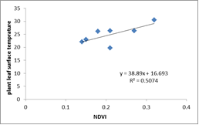

As its obvious there is a good correlation between NDVI and plant surface temperature.

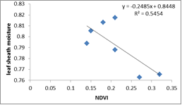

4. Conclusion
One of the best ways for data gathering and analyze them is remote sensing, after getting the satellite images, by the help of algorithm, equations and soft wares, NDVI has been acquired.
There was a good and acceptable correlation between NDVI and some ground data, which this proofs that SEBAL is a great way for gathering and analyzing data from distance.

Corresponding Author:
Shila Kooti, M. Sc.
Student of Irrigation and Drainage, Faculty of Water
Sciences Engineering, Shahid Chamran University of
Ahvaz, Ahvaz, Iran.
E-mail: Shila.kt.1992@gmail.com

References
- Bastiaanssen, W.G.M., & Ali, S. (2002). A new crop yield forecasting model based on satellite measurements applied across the Indus Basin, Pakistan. Agriculture, Ecosystems and Environment, 94, 321-340.
- Huete, A.R., (1988) 'A soil-adjusted vegetation index (SAVI)' Remote Sensing of Environment, vol. 25, issue 3, pp. 259-309. DOI: 10.1016/0034-4257(88)90106-X.
- Kriegler F.J., Malila W.A., Nalepka R.F. and Richardson W., 1969. Preprocessing transformations and their effects on multispectral recognition, in: Proceedings of the Sixth International Symposium on Remote Sensing of Environment, University of Michigan, Ann Arbor, MI, p. 97-131.
- Rouse J.W., Haas R.H., Schell J.A. and Deering D.W., 1973. Monitoring vegetation systems in the great plains with ERTS. In: Third ERTS Symposium, NASA SP-351 I, p. 309-317.

12/25/2017

