Optimal allocation of water resources to increase water use efficiency using genetic algorithm (case study: Hamidiya irrigation network)

P. Kashefi Nezhad¹, A. Hooshmand², S. Boroomand Nasab³

¹M. Sc. Student of Irrigation and Drainage, Faculty of Water Science Engineering, Shahid Chamran University of Ahvaz, Ahvaz, Iran. Peymankashefi17@yahoo.com
²Associate professor of Irrigation and Drainage, Faculty of Water Science Engineering, Shahid Chamran University of Ahvaz, Ahvaz, Iran. Hooshmand_a@scu.ac.ir
³Professor of Irrigation and Drainage, Faculty of Water Science Engineering, Shahid Chamran University of Ahvaz, Ahvaz, Iran. Boroomandsaeed@yahoo.com

Abstract: A model was created to optimally allocate irrigation water in order to increase water use efficiency using genetic algorithm (GA). Results indicated that relative water use efficiency is increased by 3%, however, total cultivated area is increased by 2709.6 hectares and net benefit is also increased by 139.1 billion Rials, while the consumed water under optimal irrigation water allocation is equal to the current irrigation water consumption situation. Furthermore, a model was created to minimize yield estimation by modifying the crops K_{yi} values under deficit irrigation situation using GA in order to minimize yield reduction estimation under deficit irrigation. Results indicated that the Yield reduction values of the K_{yi} are less than those which was proposed by former studies, so the modified values are recommended to be used in estimating yield reduction under deficit irrigation situation.
[P. Kashefi Nezhad, A. Hooshmand, S. Boroomand Nasab. Optimal allocation of water resources to increase water use efficiency using genetic algorithm (case study: Hamidiya irrigation network). Researcher 2017;9(11):27-35]. ISSN 1553-9865 (print); ISSN 2163-8950 (online). http://www.sciencepub.net/researcher. 4. doi:10.7537/marsrsj091117.04.

Keywords: Optimal allocation; water resource; genetic algorithm; case study; Hamidiya irrigation; network

1. Introduction:
Iran is currently under serious drought situation, and also is one of the countries that will face serious water scarcity conditions. Water resources distribution is not uniform either. The harvested water resources per capita is less than 500 cubic meters per year in central and eastern regions of Iran, while the harvested water in southern regions is 4000 cubic meters per capita (Keshavarz and Dehghani, 2012). Therefore, proper water management and water allocation policy is necessary. The optimization technique has been used in former water studies. Khashei Siuki et al. (2013) allocated irrigation water to Neyshabour plain using particle swarm optimization method. Results indicated that total cultivated area should be reduced from 107576 hectares to 77564 hectares to maintain the current water table drop trend. Saffari and Zarghami (2013) used compromise programming to allocate Urmia lake surface water resources to the beneficiary provinces. 1.304, 1.804, and 0.984 billion cubic meters were allocated to East Azerbaijan, west Azerbaijan, and Kurdistan province, respectively. Garg and Dadhich (2014) allocated water to Khairpur east canal of the lower Indus basin using non-linear programming. Results showed that the overall net benefit and the cropping area in increased by 72.9% and 109.7%, respectively. Another study by Garg and Dadhich (2014) was conducted to minimize yield reduction estimation using inverse formulation method by modifying K_{yi} values of the crops that were planted in lower Indus basin and applying deficit irrigation in all of crops growth stages. Results indicated that yield reduction under deficit irrigation using FAO-proposed K_{yi} values for main growing crops of lower Indus basin (cotton, oilseed, rice, sorghum, gram, mustard, wheat, and sugarcane) varies from 7.2% to 121.2%, however, yield reduction of more than 100% is not logic and acceptable while the modified K_{yi} values have less yield reduction estimation error and they are recommended to estimate the actual yield under deficit irrigation. Faghihi et al. (2015) used Genetic algorithms to optimize cropping pattern and irrigation planning. Results demonstrated that the best deficit irrigation percentage to be applied to the crops is 15% which causes the highest water use efficiency value for wheat which is equal to 0.94 Kg/m³. Kalbali et al. (2015) researched on Golestan province of Iran to optimally allocate water to agriculture sector, aquaculture sector, and environmental section. Results showed that net profit in three-year planning horizon reaches 1680 billion Rials under 51 percent irrigation efficiency, while the current benefit is 1620 billion Rials under 37 percent irrigation efficiency. Habibi Divajni et al. (2016) Allocated water to central desserts of Iran. Results indicated that 1096 jobs is created under optimal water resources allocation. Furthermore, net benefit increases from 73 billion Rials to 112 billion Rials. A model was created to optimally allocate irrigation water to Hamdiya irrigation network crops using genetic algorithm. Another model was also created to minimize yield reduction estimation error under deficit irrigation situation.

2. Materials and methods
Hamidiya county is located in Khuzestan province of Iran. The altitude of the city is 21 meters with longitude of 31˚ 29՜ North and latitude of 48˚ 11՜ East. Hamidiya plain is between 31˚ 28՜ and 31˚ 47՜ North. It is also located between 48˚ 10՜and 48˚ 27՜ East. Agriculture is prosperous due to Karkheh river existence. Hamidiya irrigation network is in Hamidiya plain with total cultivable area of 13500 hectares. Planting is possible is fall and summer. Beans, rice, vegetables and sesame is planted in summer, while wheat, barely, cucumber, tomato, canola and cabbage is planted in fall. Table 1 includes information about the crops planted in Hamidiya irrigation network in 2015-2016 water year which is taken from Hamidiya county agriculture bureau. Constant expenses include planting expenses, growing expenses, and harvest expenses.

Table 1. Information about the crops planted in Hamidiya irrigation network in 2015-2016
Crop | Constant expenses (million Rials/hectare) | Water expense (million Rials/hectare) | Crop price (Rials/Kg) | Yield (Kg/ha) | Area (ha)
Wheat | 18 | 1.2 | 13000 | 3200 | 8200
Beans | 26 | 1.8 | 28000 | 1300 | 500
Barely | 17 | 1.1 | 11000 | 2800 | 800
Rice | 20 | 2.8 | 17000 | 3500 | 1800
Vegetables | 70 | 7 | 5000 | 45000 | 1900
Cucumber | 60 | 3.8 | 6000 | 15000 | 700
Tomato | 120 | 4.7 | 2500 | 40000 | 1500
Cabbage | 80 | 1.2 | 6000 | 45000 | 300
Canola | 12 | 1.2 | 2800 | 2000 | 250
Sesame | 9 | 1.2 | 50000 | 1100 | 700

Crop response factors modification model
Dorenboos and Kassam (1979) proposed the following equation to estimate yield reduction under deficit irrigation which is as follows:
Where is seasonal crop response factor, is actual yield (Kg/ha), is potential yield (Kg/ha), is actual evapotranspiration and is potential evapotranspiration.
The following equation could also be used to estimate yield reduction under deficit irrigation which is as follows:
(1-
Where K_{yi} is crop response factor in the i_{th} crop growth stage, and are actual and potential evapotranspiration in ith crop growth stage, respectively (steward et al., 1977).
Both K_{yi} and K_{y} are proposed for each crop in former studies (Garg and Dadhich, 2014; faghihi et al., 2015; Dorenboos and Kassam, 1979). Table 2 includes K_{y} and K_{yi} values for each crop. K_{yi} values are the ones specified for each crop growth stage. Stage 1 is the interval between planting and the time that 10% of farm is covered, Stage 2 is the interval between 10% land cover and 100% land cover, Stage 3 is the interval between 100% land cover and flowering, and Stage 4 is the interval between flowering and harvesting.

Table 2. K_{y} and K_{yi} values of crops proposed by former studies
Crop | Wheat | Bean | Barely | Rice | Canola | Seesame | Cabbage | Tomato | Cucumber | Vegtables
Stage 1 | 0.20 | 0.20 | 0.20 | 1.00 | 0.30 | 0.30 | 0.20 | 0.40 | 0.30 | 0.80
Stage 2 | 0.60 | 1.10 | 0.60 | 1.09 | 0.55 | 0.55 | 0.40 | 1.10 | 0.50 | 0.40
Stage 3 | 0.50 | 0.75 | 0.50 | 1.32 | 0.60 | 0.60 | 0.45 | 0.80 | 0.70 | 1.20
Stage 4 | 0.60 | 0.20 | 0.40 | 0.50 | 0.60 | 0.60 | 0.60 | 0.40 | 0.60 | 1.00
Seasonal | 1.00 | 1.15 | 1.00 | 1.10 | 0.80 | 0.80 | 0.95 | 1.05 | 0.77 | 1.00

The estimated value of crop yield reduction under deficit irrigation applied in all growth stages using stagewise crop response factor is different from the the estimated yield reduction under deficit irrigation applied in different growth stages using seasonal crop response factors. According to Garg and Dadhich (2014), yield reduction under deficit irrigation applied in all growth stages using K_{yi} values of crops could be estimated more than 100% which is not logic. This indicates an estimation error, and there is a need to obtain the K_{yi} values under field conditions for Hamidiya county, but planting all of the crops mentioned in table 1 and obtaining the correct K_{yi} values of them needs a vast and longtime research, so a model was created to minimize yield estimation error under deficit irrigation using K_{yi} values. Genetic algorithm optimization method is used in this model. The objective function is as follows:
Where E is yield reduction estimation error, ND is deficit level number, is the modified stagewise crop response factor in the ith crop growth stage, is the actual evapotranspiration in the ith growth stage under j_{th} deficit irrigation level, is the potential evapotranspiration in the ith growth stage under j_{th} deficit irrigation level, is the actual yield under jth deficit irrigation level which is obtained using K_{y} values, and is the potential yield. Deficit irrigation levels are 10,20,30,40 and 50% and deficit irrigation is applied to all crop growth stages in this model.
Decision making variables are values in this model. As no field research was conducted to determine which stage is more sensitive than the other, the sensitivity trend of crops growth stages were considered according to previously-proposed K_{yi} values by former studies. In other words, the stage with K_{yi} values that was proposed by former studies is more sensitive, so this stage must have bigger values.
Model results assessment
In order to compare the results with the pre-proposed K_{yi} values, RMSR is calculated for each crop using its and K_{yi} values. The values with lower RMSR value is more suitable to be used in yield reduction estimation.
Where RMSR is the root mean square residual, SSR is sum of square residuals, and N is the number of deficit irrigation levels.
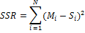
Where M_{i} is the seasonal yield reduction obtained using eq.1, and S_{i} is the relative yield reduction using eq.2. For obtaining RMSR value of K_{yi} values of each crop, SSR should be obtained by substituting them in eq.2. Furthermore, For obtaining RMSR value of K_{yi.adj} values of each crop, SSR should be obtained using K_{yi} and modified K_{yi} values.
Results verification
Particle swarm optimization method (PSO) was used to verify the results obtained by GA, so PSO was also used in the model to compare the results obtained using either one of the mentioned optimization methods results after 20 independent runs. Both GA and PSO parameters were set according to Akbaripour and Masehian (2013) based on Vikor index. values of each crop are decision making variables of this model, so the number of variables are 4. In GA optimization method, population=40, crossover percent=70, mutation probability percent=30, mutation rate=3, and iteration number=200. In PSO method, particle number=40, social factor=2.5, cognitive factor=2.5, constriction factor=0.38, maximum inertia weight=0.9, minimum inertia weight=0.4, and iteration number=200. The mentioned values are the the set values of parameters of GA and PSO method.
Irrigation water allocation optimization model
A model was created to optimally allocate irrigation water to Hamidiya irrigation network. The objective is to maximize relative water use efficiency using genetic algorithm. Relative water use efficiency could be calculated using the following equation:
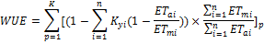
Where WUE is water use efficiency and K is the crop number. Potential evapotranspiration value of the crops for each 10-day period were calculated using Penman-Monteith method by Cropwat 8.0 software according to Allen et.al (1998). Furthermore, the actual evapotranspiration of crops for each 10-day period is calculated using the following equation (Reddy and Kumar, 2007):
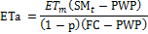
Where p is maximum allowed deficit (MAD), FC is the soil moisture in field capacity situation, and PWP is the soil moisture in permanent wilting point. The values of FC and PWP are 360 and 230 mm/m, respectively. The mentioned values are extracted from Allen et al. (1998). is the soil moisture depth in the t_{th} period which is determined as follows (Reddy and kumar,2007):
Where t is the period number, is root depth in the t_{th} period, RF_{t} is effective rainfall, q_{t} is irrigation depth, DP is deep percolation, SR is surface runoff, is the saturated soil moisture depth which is 0.478 according to Tarboton (2003). The soil moisture amount is assumed equal to the amount of moisture in field capacity point crop planting day in this model.
, , , and p were calculated according to Allen et al (1992). Furthermore, effective rainfall is calculated according to USDA method using Cropwat 8.0 software. Note that if , Eta is equal to ET_{m}. ET_{m} is equal to zero if soil moisture depth is less than PWP.
There are some constraints considered in this model. One of the constraints is that consumed water in optimal allocation should be equal to current water consumption. Planting in Hamidiya irrigation network is conducted in fall and summer, so total cultivated area should not exceed 13500 hectares in each season. Determining cultivation area of each crop is subject to so many policies which is not considered in this model, so maximum area decrease is considered 30%. Furthermore, maximum area increase is considered 50% to force the model to reduce the network fallow area. The amount of net benefit per hectare for any crop must not be reduced more than 30%. Furthermore, total net benefit must not be reduced by more than 30% in comparison to the current total net benefit. Total Net benefit could be estimated using the following equation (Lalehzari et al., 2015):
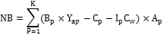
Where NB is net benefit, K is the crop number, B_{p} is crop price (Rials), C_{p} is constant expenses consisting of planting, growing and harvest expenses (Rials), I_{p} is the gross irrigation depth (mm), C_{w} is water price (Rials/m³), and A_{p} is the crop cultivation area (hectares). Note that the mentioned equation could also be used to calculate the net benefit when K=1 or A_{p} =1.
Water expenses data taken from Hamidiya agriculture bureau are based on crop area, so the mentioned data should be converted to (Rials/m³). In order to do that, the volume of gross water needed per hectare were calculated considering 47.8% as application efficiency for each crop.
For any crop, the stage with K_{y} value of more than 0.5 should at least take half of crop water requirement in that stage to prevent severe water stress situation (lalehzari et al., 2015). Yield estimation using equations 1 and 2 is valid up to 50% percent according to Kipkorir and Raez (2002), so no more that 50% deficit irrigation should be applied to the crops. SM_{t} is also one of the constraints added to the model, and soil moisture depth must not be less than the soil moisture depth in permanent wilting point which is equal to 230 mm/m considering soil texture in Hamidiya county and according to Allen et al. (1998). Furthermore, soil moisture depth should not exceed the soil moisture depth under saturation situation. The allocated water should not exceed the network available water in every 10-day period which is 17.1 million cubic meters.
Results verification
Particle swarm optimization method (PSO) was used to verify the results of GA, and to compare the results obtained using either one of the mentioned optimization results after 20 independent runs. Similar to the previous model, Both GA and PSO parameters were set according to Akbaripour and Masehian (2013) based on Vikor index. Irrigation depths of each crop in every 10-day period are the decision making variable of this model, so the number of variables are 155. In GA optimization method, population=310, crossover percent=70, mutation probability percent=30, mutation rate=1, and iteration number=400. In PSO method, particle number=310, social factor=2.05, cognitive factor=2.5, constriction factor=0.4, maximum inertia weight=0.5, minimum inertia weight=0.4, and iteration number=400. The mentioned values are the set parameters values of GA and PSO.

3. Results
Table 3 includes the results of the stagewise crop response factors modification model obtained by either GA method or PSO method. Results were obtained after 20 independent runs. According to table 2, the minimized values of estimation error for each crop using GA are close to the minimized values of estimation error using PSO, so Results obtained by GA are verified. The mean and standard deviation values obtained by PSO method are less than those of GA. This shows better performance of PSO in this model in comparison to GA.
Table 4 includes the modified K_{yi} values. They are significantly less than the K_{yi} values proposed by former studies (Faghihi et al., 2015; Garg and Dadhich, 2014; Dorenboos and Kassam, 1979). Table 5 includes RMSR values for both K_{yi} and modified K_{yi} values. Considering the values, RMSR values for modified K_{yi} values are much lower than RMSR values for K_{yi} values. Furthermore, figures 1 to 10 indicate crop yield reduction using different types of K_{y} values. The yield reduction estimated using K_{yi} values by applying 50% deficit irrigation exceeded 100% percent in Rice, Bean, vegetable, and tomato. The amount of yield reduction under 50% deficit irrigation for other crops is near to 100%, but these amount of yield reduction is not logic and acceptable, however, yield reduction estimation using the modified K_{yi} values is otherwise. As a result, the modified K_{yi} values are recommended to estimate yield reduction under deficit irrigation situation. The findings of this research is in agreement with Garg and Dadhich (2014).

Table 3- Comparison of the minimized values of yield estimation error for each crop
 |  | Wheat | Bean | Barely | Rice(with hulls) | Canola | Seesame | Cabbage | Tomato | Cucumber | Vegtables
Genetic algorithms | Best | 9.3 | 1.4 | 1.6 | 6.9 | 1.1 | 4.4 |  |  | 1.1 | 1.2
 | Worst | 5 | 1.18 | 1.3 | 1.3 | 4.1 | 3.14 | 3.14 | 6.5 | 6.5 | 6.7
 | Mean | 8.7 | 3.5 | 5.6 | 4.8 | 4.8 | 1.35 | 5.12 | 3.72 | 48 | 2.24
 | Standard deviation | 1.57 | 3.2 | 1.2 | 4.5 | 1.6 | 1.17 | 5.66 | 1.96 | 1.41 | 2.44
Particle swarm  optimization | Best | 3 | 3 | 1.8 | 3.8 | 1.9 | 4.6 | 0 | 3.32 | 3.8 | 9.2
 | Worst | 2.6 | 5.4 | 6 | 1.2 | 3.5 | 1.8 | 5.5 |  | 3 | 1.09
 | Mean | 5.2 | 1.08 | 1.2 | 4.2 | 7 | 3.6 | 1.1 | 2 | 6 | 2.18
 | Standard deviation | 1.04 | 2.16 | 2.4 | 8.4 | 1.4 | 7.19 | 2.2 | 4 | 1.2 | 4.36

Table 4- The modified stagewise crop response factors (modified K_{yi} values)
 | Wheat | Bean | Barely | Rice | Canola | Seesame | Cabbage | Tomato | Cucumber | Vegtables
Stage 1 | 0.02 | 0.05 | 0.01 | 0.017 | 0.06 | 0.06 | 0.04 | 0.01 | 0.02 | 0.05
Stage 2 | 0.48 | 0.63 | 0.53 | 0.25 | 0.07 | 0.07 | 0.09 | 0.56 | 0.19 | 0.03
Stage 3 | 0.17 | 0.43 | 0.35 | 0.57 | 0.37 | 0.37 | 0.34 | 0.28 | 0.53 | 0.68
Stage 4 | 0.35 | 0.04 | 0.12 | 0.11 | 0.31 | 0.31 | 0.48 | 0.25 | 0.19 | 0.24

Table 5- RMSR values for K_{yi} and modified K_{yi} values
Crop | Wheat | Bean | Barely | Rice | Canola | Seesame | Cabbage | Tomato | Cucumber | Vegtables
K_{yi} | 0.3505 | 0.3330 | 0.5982 | 1.3403 | 0.5962 | 0.5962 | 0.3339 | 0.7870 | 0.4932 | 0.8899
Modified K_{yi} | 0.01 | 0 | 0 | 0 | 0 | 0 | 0 | 0.02 | 0.06 | 0

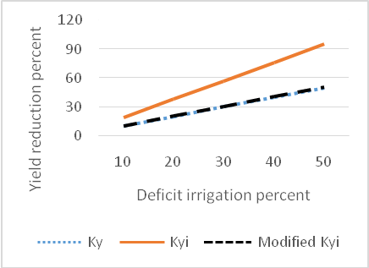
Figure 1. Comparison of wheat yield reduction estimation using different K_{y} types

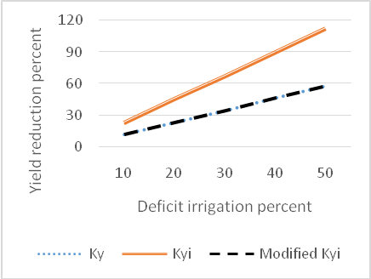
Figure 2. Comparison of bean yield reduction estimation using different K_{y} types
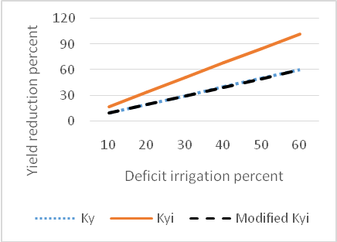
Figure 3. Comparison of barely yield reduction estimation using different K_{y} types

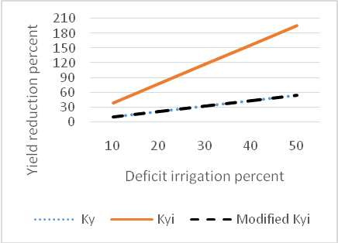
Figure 4. Comparison of rice yield reduction estimation using different K_{y} types

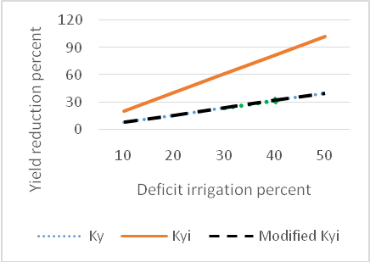
Figure 5. Comparison of canola yield reduction estimation using different K_{y} types

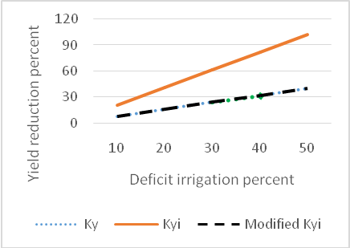
Figure 6. Comparison of sesame yield reduction estimation using different K_{y} types

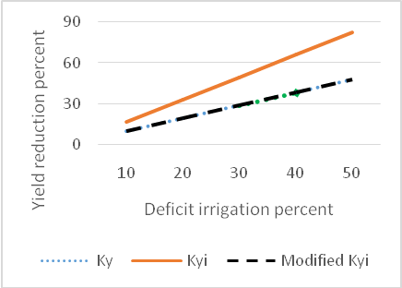
Figure 7. Comparison of cabbage yield reduction estimation using different K_{y} types

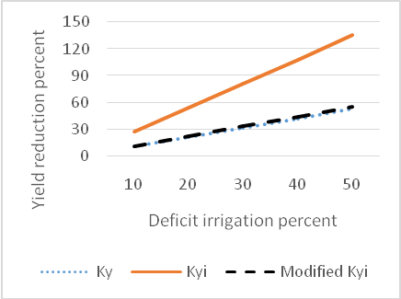
Figure 8. Comparison of tomato yield reduction estimation using different K_{y} types

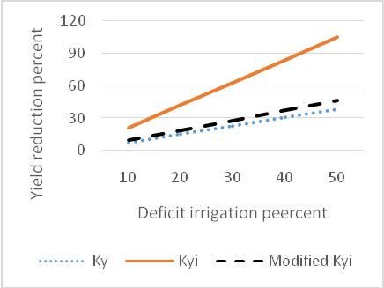
Figure 9. Comparison of cucumber yield reduction estimation using different K_{y} types

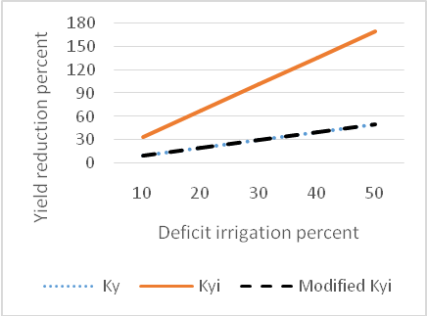
Figure 10. Comparison of vegetables yield reduction estimation using different K_{y} types Optimal irrigation

Optimal water allocation model
In order to verify the obtained results, PSO optimization model was also used to optimally allocate irrigation water to Hamidiya irrigation network. Either GA or PSO results were obtained after 20 independent runs. Table 6 shows the maximized value of relative water use efficiency which were obtained after 20 independent runs. The values obtained using GA and PSO are close, however, mean value in GA is bigger than mean value in PSO method. Furthermore, standard deviation value in GA results is lower than standard deviation of PSO results, so GA have a better performance than PSO optimization method, and its results are verified.

Table 6. Results of maximizing relative water use efficiency in GA and PSO method
 | GA | PSO
Best | 10.48 | 10.5
Worst | 10.25 | 10.1
Mean | 10.34 | 10.3
Standard deviation | 0.07 | 0.12

As previously mentioned, crops are planted in two seasons. Wheat, barely, canola, cabbage, tomato, and cucumber are planted in fall, while the others are planted in summer, so the fall-planted crops area should are optimized separately from summer-planted crops. Figure 11 shows the current crop cultivation area and the optimized crops cultivation area. The values demonstrated in the figure is the difference between the current and the optimized area for any of crops. All of fall-planted crops area are increased except tomato and barely due to their low net benefit in comparison to other crops planted in fall. Net benefit is one of the model constraints and the mentioned crops area should be decreased and should be replaced by a crop with bigger value of water use efficiency and net benefit. Fall-planted crops are is increased by 700 hectares. All of summer-planted crops area are increased. The amount of increase in summer-planted crops area is about 1600 hectares more than the amount of increase in fall-planted crops area. Total cultivation area is increased by 2709 hectares which means to reduce the network fallow area by 26%. Garg and Dadhich (2014) and Khashei siuki et al. (2013) also reported increase in total cultivation area, so the findings of this research is in agreement with them.

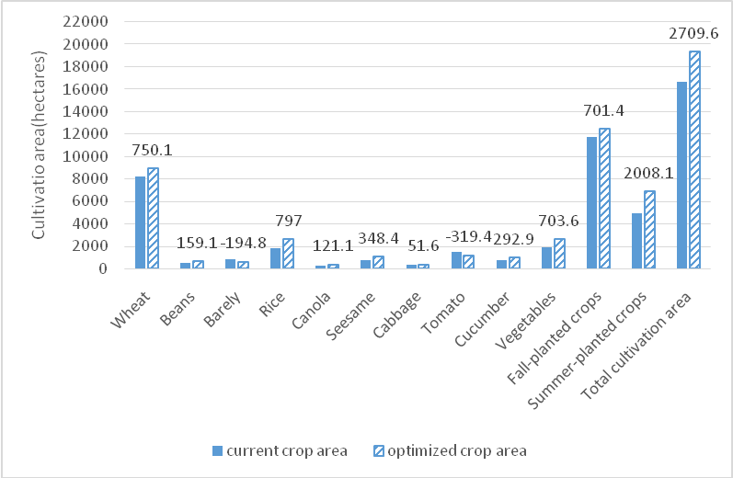
Figure 11. Current and optimized cultivation area

Table 7 shows the percentage of the crops supplied water requirement in the current and optimized irrigation water allocation situation. All of wheat water requirement is supplied because wheat area constitutes most of the network cultivable area and deficit irrigation could reduce the overall net benefit significantly that violates the beneficial constraint of the model. Furthermore, deficit irrigation should be applied to the crops with bigger yield value in order to increase the water use efficiency. All of canola water requirement is supplied because water requirement of canola is low in the study region. Furthermore, rain water and soil moisture supply most of its water requirement. Deficit irrigation is applied to other crops in optimal irrigation water allocation. The highest deficit irrigation level is applied to bean and rice because the ratio of the amount of harvest to irrigation depth is lower than other crops.

Table 7. Crops water requirement supplying percent
 | Current water allocation | Optimal water allocation
Wheat | 100 | 100
Beans | 100 | 87.4
Barely | 100 | 98.2
Rice | 100 | 80.3
Canola | 100 | 100
Sesame | 100 | 90.6
Cabbage | 100 | 93.4
Tomato | 100 | 94
Cucumber | 100 | 97.1
Vegetables | 100 | 95.7

Table 8 shows the amount of net benefit and relative water use efficiency in the current and the optimal irrigation water allocation. Relative water use efficiency is increased by 3% in the optimal irrigation water allocation which is not a big value, but net benefit is increased by 22%. Kashei Siuki et al. (2013) and Garg and Dadhich (2014) reported increase in net benefit, so the net benefit increase in this study is in agreement with them. Furthermore, the amount of consumed water in optimal irrigation water allocation is equal to the current trend, and this means that the model is efficient in optimal water allocation.

Table 8. Relative water use efficiency and net benefit in the current and optimal irrigation water allocation
 | Current water allocation | Optimal water allocation
Relative water use efficiency | 10 | 10.3
Net benefit (billion Rials) | 624 | 763.1

4. Discussion
Two models were created in this study. The first model was to minimize the yield reduction estimation error under deficit irrigation situation, and the second was to optimally allocate irrigation water to Hamidiya irrigation network. Results from the K_{yi} modification model shows that the modified K_{yi} values are better to be used in yield reduction estimation. Furthermore, results of irrigation water allocation model shows that net benefit is increased by 139.1 billion Rials, Relative water use efficiency is increased by 0.3, and total cultivation area is increased by 16% under optimal irrigation water allocation while the consumed water is not reduced and is equal to the current water consumption. As a result, the model is efficient in irrigation water management and water allocation.

Corresponding author:
Peyman Kashefi Nezhad, M.Sc.
Irrigation and Drainage student, Faculty of Water Science Engineering, Shahid Chamran University of Ahvaz, Ahvaz, Iran.
E-mail: Peymankashefi17@yahoo.com

References
- Allen RG, Pereira LS, Raes D, Smith M. Crop Evapotranspiration (guidelines for computing crop water requirements). In: Rome, Italy:1998:1-178.
- Keshavarz A, Dehghani Sanij H. Water Productivity Index and Solutions for Future Agricultural Activities in Iran. Economic Strategy 2012:1(1):199-233.
- Khashei Siuki A, Ghahraman B, Kouchakzadeh M. Application of Agricultur Water Allocation and Management by PSO Optimization Technic (Case study: Nayshabur Plaine). Journal of Water and Soil. 27(2):292-303.
- Faghihi N, Babazadeh H, Sedghi H, Pazira A. Optimization of Irrigation Planning and Cropping Pattern Under Deficit Irrigation Condition Using Genetic Akgorithm. Indian Journal of Fundamental and Applied Life Sciences 2015:5:566-577.
- Garg NK, Dadhich SM. A proposed method to determine yield response factors of different crops under deficit irrigation using inverse formulation approach. Agricultural water management 2014: 137:68-74.
- Garg NK, and Dadhich, SM. Integrated non-linear model for optimal cropping pattern and irrigation scheduling under deficit irrigation. Agricultural Water Management 2014:140:1-13.
- Habibi Divjani M, Banihabib ME, Nadjafzade Anvar A., Hashemi, SH. Optimization model for the allocation of water resources based on the maximization of employment in the agriculture and industry sectors. Journal of Hydrology 2016:533:430-438.
- Kalbali E, Sabouhi Sabouni, M, Ziaee S. Application of Mathematical Programming Model for Optimal Allocation of Voshmgir Dam Water for Various Consumptions (Case Study: Golestan Province). International Journal of Applied Operational Research 2015:5(2):19-33.
- Kipkorir EC, Raes D. Transformation of yield response factor into Jensen's sensitivity index. Irrigation and drainage systems 2002:16:47-52.
- Reddy MJ, Kumar DN. Optimal reservoir operation for irrigation of multiple crops using elitist-mutated particle swarm optimization. Hydrological Sciences Journal 2007:52(4):685-701.
- Saffari N, Zarghami M, Allocating the Surface Water Resources of the Urmia Lake Basin to the Stakeholder Provinces by Distance Based Decision Making Methods. Water and Soil Science 2013:23(1): 135-149.
- Stewart JI, Cuenca RH, Pruit WO, Hagan RM, Tosso J. Determination and utilization of water production functions for principal California crops. In: W-67 California Contributory Project. University of California, California, US. 1977.
- Tarboton D.G. Rainfall-runoff processes. In: Utah state university, Utah, USA:1-155.
- Lalehzari R, Boroomand Nasab S, Moazed H, Haghighi A. Optimal allocation of surface and groundwater resources to cropping pattern in Baghmalek plain by multi-objective planning based on non-dominated sorting algorithm. In: Shahid Chamran University of Ahvaz, Ahvaz, Iran.

10/29/2017

