Response of Some Onion Genotypes to Mineral, Organic and Biofertilizers

El-Hawary, M.A.¹, E.M.A. Abd El-Kader¹, A.M.A. Abo -Dahab², H.M. Allam²

¹Agronomy Department, Faculty of Agriclture, Al-Azhar University, Egypt
²Onion Research Department, Field Crop Research Institute, Agriculture Research Center, Giza, Egypt
hasanallam027@gmail.com

Abstract: This study was carried out at Gemmeiza Agriculture Research Station Farm, Agriculture Research Center, Gharbeia Governorate, in 2014/2015 and 2015/2016 seasons to study response of some onion genotypes to mineral, organic and biofertilizers on vegetative growth, yield and its components. The obtained results showed that there were significant differences among onion genotypes of all studied characters in both seasons. Composite 16 Oblong genotype gave the highest number of leaves/plant at 90 days from transplanting, bulbing ratio at 90 and 120 days from transplanting, bulb weight, marketable and total yield as compared with other onion genotypes tested in both seasons. The obtained results indicated that fertilization treatments had the significant effects on all studied traits in both seasons. Application of 5 ton compost + 67.5 kg N/feddan (75% of recommended) surpassed other studied fertilization treatments and resulted in the highest values of number of leaves/plant at 90 days, bulbing ratio at 90 and 120 days from transplanting, bulb weight (g), culls yield (t/fed), marketable yield (t/fed) and total yield (t/fed) in both seasons. The interaction between onion genotypes and fertilization treatments significantly affected number of leaves/plant at 90 days, bulbing ratio at 90 and 120 days from transplanting, bulb weight, marketable and total yield in both seasons. Fertilized onion plant Composite 16 Oblong genotype with 5 ton compost + 67.5 kg N/feddan gave the highest values of number of leaves/plant at 90 days, bulbing ratio at 90 and 120 days from transplanting, bulb weight (g), culls yield (t/fed), marketable yield (t/fed) and total yield (t/fed) as compared with all other treatments in both seasons.

[El-Hawary, M.A., E.M.A. Abd El-Kader, A.M.A. Abo -Dahab, H.M. Allam. Response of Some Onion Genotypes to Mineral, Organic and Biofertilizers. Researcher 2017;9(11):17-26]. ISSN 1553-9865 (print); ISSN 2163-8950 (online). http://www.sciencepub.net/researcher. 3. doi:10.7537/marsrsj091117.03.

Keywords: Response; Onion; Genotype; Mineral; Organic; Biofertilizers

1. Introduction
Onion (Allimcepa, L.) is one of the most important corps due to its value for local consumption and exportation great attention should be paid towards improving yield keeping quality and maturity date. The first step of Egyptian strategy government is to increasing yield and quality of onion which lead to increase exporting onion, consequently increasing from foreign currency income. These increasing might be achieved by using new and high yielding cultivarsor applied optimum nutrients.
There are wide variations among onion cultivars in bulb yield and bulb quality. Thus choosing and using best onion cultivars is one of the most critical components of onion production. Inthisregard; Soleymani and Shahrajabian (2012) and Abouazoom et al. (2014) stated that number of leaves and bulbing ratiowassignificantly influenced by cultivars and maximum values of these traits were resulted from Cisakht and Morado DeAmpostacultivars. Tesfalegn (2015) and Deepasharma and Kumudjarial (2017) showed that Melkan Red and Agrifound Dark Red cultivars gave the highest bulb weight, marketable and total bulb yield.
Mineral fertilizers are one of the principle factors that affect onion growth and production. Nitrogen fertilizer is essential nutrient for plant growth and yield of onion plant. Since, onion plant take up large amounts of nitrogen, Increasing nitrogen fertilizer addition caused some problems such as increasing soil erosion, soil compaction, environment pollution and public health risk (Top et al., 2002).
Therefore, attempts have been made to solved this problems by instead of part of mineral nitrogen with organic i.e. farmyard manure and compost or biofertilizers i.e. nitrobein as well as microbein as a biofertilizers are considered as an important source of humus, macro and micro elements carrier and increase the activity of the useful micro organism (El-Gizy, 1994). Addition of organic fertilizers improved soil structure, which can encourage root development and lead to encourage plant growth (Singer et al., 1998). Naiket et al. (2014) and El-Dardiry et al. (2015) reported that average number of leaves, bulb weight and bulb yield of onion were significantly higher when added farmyard manure or bio-compost with 50% of recommended NPK. Ganesh and Sureshkumar (2016) and Gebremichael et al. (2017) obtained that application of 75% NPK + 5t/ha vermicompost gave the highest number of leaves, bulbing ratio, mean bulb weight and marketable yield of onion. Shedeed et at. (2014) and Meena et al. (2015) showed that average bulbing ratio and total yield of onion were significantly increasing when added bio fertilizer (Nitrobein or Azosprillium) with 50% of recommended nitrogen.
Therefore, this investigation was carried out to study the response of some onion genotypes to mineral, organic, and biofertilizers under the environmental conditions of Middle Delta, Gharbeia Governorate.

2. Materials and Methods
Field experiments was conducted at the experimental Farm of Gemmeiza Agricultural Research Station, Gharbeia Governorate during the two successive winter growing seasons of 2014/2015 and 2015/2016. This investigation was aimed to study the response of some onion genotypes to mineral, organic and biofertilizers in growth characters, yield and its components of onion bulbs.
The experiment treatments studied were as follows:-
I – Onion genotypes (G):
Four onion genotypes tested, genotypes seed were obtained from Onion Research Section, Agriculture Research Center, Egypt. This studied genotypes were characterized as follows:

Table 1: The name of tested genotypes from onion research Section, their method of development and country in which releases were developed
Genotype | Development method | Releasing country
- Giza 20 | Selection from Egyptian deletion cultivars Behairy. | Egypt
- Giza white | Selection from Egyptian deletion types, bulbs are thick flat, white outer dry scales and flesh total soluble solids (TSS) and dry matter are relatively high and high in good keeping quality. | Egypt
- Composite 16 white | Selected from Composite crosses between 10 American and two Egyptian cultivars. | Egypt
- Composite 16 oblong | new nucleus selected by Onion Research Section from intersingle cross between 10 American cultivars and Giza 20 or Giza 6, bulbs are high thick flat to oblong shape, white fresh, yellow brownish outer dry scales and stored for a long period. | Egypt

II – Fertilization treatment used were as follows:
- Control added 90 kg N/ fed. (100% recommended doses).
- Applied 20m³ farmyard manure/fed (FYM/fed).
- Applied 20m³ FYM/fed. + 67.5kgN/fed. (75% of recommended).
- Applied 20m³ FYM/fed. + 45 kg N/fed. (50% of recommended).
- Applied 5 ton compost/ fed.
- Applied 5 ton compost /fed. + 67.5 kg N/fed. (75% of recommended).
- Applied 5 ton compost /fed. + 45 kg N/fed. (50% of recommended).
- Treated onion seedlings by 4kg nitrobein / fed.
- Treated onion seedlings by 4kg nitrobein / fed. + 67.5 kg N/fed. (75% of recommended).
- Treated onion seedlings by 4kg nitrobein / fed. + 45 kg N/ fed. (75% of recommended).
- Treated onion seedlings by 4kg microbein / fed.
- Treated onion seedlings by 4kg microbein / fed. + 67.5 kg N/ fed. (75% of recommended).
- Treated onion seedlings by 4kg microbein / fed. + 45 kg N/ fed. (75% of recommended).
The experimental desigen was split plot design with four replications. The main plots were designated to the four onion genotypes, whereas fertilization treatments were randomly distributed in sub plots. Each plot contained 6 ridges, 3.5 meters long and 50 cm width, occupying an area of 10.5 m² (i.e 1/400 Fed.).
The chemical analysis of farmyard manure and compost for organic fertilizers were as shown in Table (2). The mechanical and chemical analysis of soil at the experimental site are presented in Table (3). Particle size distribution was carried out using the method of Black (1965). The preceding crop of the experiment soil was maize in both seasons.
The amounts of farmyard manure and compost fertilizers were added at soil preparation directly before ridging and amounts of nitrogen fertilizer was divided into two portions; one half being applied one month after transplanting time before the first irrigation, and the remaining portion was applied before the second irrigation, 60 days from transplanting. The biofertilizers (nitrobein and microbein), which containing active bio-nitrogen fixation bacteria was obtained from Bacterilization Unite, Microbiology Dept., Soil Water Res. Int., ARC, Giza. Seedlings of onion genotypes were dug and inoculated by sooking their roots in the specific aqueous solution of the biofertilizer for 30 minutes just before transplanting at the rate of 4 kg/fed.
Onion seed were sown in the nursery on 10th October while transplanting took place on 15th December in the both seasons.
Characters measured:
1 – Vegetative growth characters:
A representative sample of 10 plants were taken from each plot at 90 and 120 days after transplanting where the following measurement the following trait:
a) Number of leaves/plant.
b) Bulbing ratio (bulb diameter cm/ bulb neck diameter cm): it was calculated according to Mann (1952).
2 – Yield and its components:
Onion plant in the four inner rows of each plot when 50% of tops fell down were harvested. After harvested bulbs were left in the to cure two weeks, then tops and roots were removed and the following data were recorded:
- bulb weight (g)
- culls yield (ton/fad)
- marketable yield (ton/fad)
- total yield (ton/fad).
3 – Economic analysis:
Economic analysis was done to calculate net return and the benefit cost ratio with each treatment.
- Cost of cultivation:
Cost of cultivation was estimated on the basis of local charges for different agro-inputs, i.e. labor, fertilizer, compost, FYM, and other necessary materials. Cast of cultivation of threeteen treatments was calculated separately.
- Gross return:
Total onion bulb yield was converted into gross return (L.E./fed ) on the basis of local market price.
- Net return:
It was calculated by subtracting the cost of cultivation from the gross return.
- Benefit cost ratio:
It was calculated by the formula, B: C ratio = Gross return/Cost of cultivation.
All data of the experiment were statistical analyzed according to the technique of variance (AVOVA) for the split plot design as published by Gomez and Gomez (1984), using "MSTAT-C" computer soft were package. Least Significant Difference (L.S.D) method was used to test the differences between treatment means at 5% level of probability as described Snedecor and Cochran (1980).

Table 2: Chemical analysis of farmyard manure and compost fertilizers in 2014/2015 and 2015/2016 seasons
Organic fertilizer | N % | P % | K % | 0.M % | C/N ratio
2014 / 2015 season
Farmyard manure | 0.42 | 0.48 | 2.18 | 32.10 | 34.42
Compost | 0.80 | 1.50 | 2.30 | 63.68 | 14.68
2015 / 2016 season
Farmyard momure | 0.45 | 0.45 | 1.60 | 26.29 | 29.25
Compost | 0.81 | 1.40 | 1.80 | 61.90 | 11.43

Table 3: Mechanical and chemical analysis of soil at experimental site in 2014/2015 and 2015/2016 seasons.
Parameter | Value
 | First season | Second season
1- Mechanical analysis:  coarse sand  fine sand  silt  clay  CaCo3  Organic matter | 1.60 %  12.91 %  37.23 %  40.82 %  3.90 %  1.57 % | 1.50 %  14.40 %  35.90 %  43.0 %  3.20 %  1.98 %
Texture class | Silty clay loam
2- Chemical analysis:  Available nitrogen  Available phosphorous  Available potassium | 33 ppm  8 ppm  420 ppm | 35 ppm  8.8 ppm  440 ppm
Soil reaction (PH)  {in: 2.5 soil suspention} | 8 | 8

3. Results and Discussion
Number of leaves/plant, bulbing ratio, bulb weight (g), culls yield (t/fed), marketable yield (t/fed) and total yield (t/fed) of some onion genotypes as affected by fertilization treatments in 2014/2015 and 2015/2016 seasons as shown in Tables 4 and 5.
Results presented in Tables 4 and 5 show clearly that the onion genotypes were significantly differed in number of leaves/plant at 90 days from transplanting, while bulbing ratio significantly differed at 90 and 120 days from transplanting in both seasons, in this connection onion genotypes were significantly differed in bulb weight, culls yield (t/fed), marketable (t/fed), and total yield (t/fed) in both seasons. It could be noticed that composite 16 oblong gave the highest number of leaves/plant 8.75 and 8.39 at 90 days from transplanting and bubling ratio 1.98 and 3.17 as well as 1.84 and 3.10 at 90 and 120 days from transplanting in 2014/2015 as well as2015/2016 seasons, respectively. Also, it gave the highest values of bulb weight 125.51 and 123.43 g, marketable yield 13.300 and 12.699 (t/fed) and total yield 14.759 and 14.217 (t/fed), on the other hand, it gave the lowest value of culls yield 1.459 and 1.538 (t/fed) as compared with other tested genotypes in 2014/2015 and 2015/2016 seasons, respectively. The differences in studied onion genotypes of different traits may be attributed to the genetic variation between genotypes. The superiority of composite 16 oblong in marketable yield may be due to it gave the heaviest bulb weight which led to raising total yield and had the lowest culls yield, therefore increased marketable yield per feddan. These results are in agreement with those obtained by Soleymaniand Shahrajabian (2012), Abouazoom et al. (2014), Tesfalegn (2015) and Deepssharma and Kumudjarial (2017).
Data recorded in Tables 4 and 5 indicated that fertilization treatments had significantly affected all studied characters in both seasons. The obtained results illustrated that application of 5 ton compost + 67.5 kg N/fed. (75% of recommended) surpassed other studied fertilization treatments in both seasons. This treatment gave the highest number of leaves/plant 8.60 and 8.54 as well as 8.90 and 8.52, bulbing ratio 2.82 and 3.69 as well as 2.47 and 3.54 at 90 and 120 days from transplanting as compared with other treatments in 2014/2015 as well as 2015/2016 seasons, respectively. Also it gave the highest bulb weight 130.33 and 128.91g, marketable yield 14.858 and 14.454 t/fed and total yield 16.478 and 15.984 t/fed.

Table 4: Average number of leaves/plant, Bulbing ratio and Bulb weight (g) of some onion genotypes as affected by fertilization treatments in 2014/ 2015 and 2015/2016 seasons.
Bulb weight (g) |  | Bulbing ratio |  |  |  | Number of leaves/plant |  |  |  | Characters  Seasons  Treatments
2015/2016 | 2014/2015 | 2015/2016 |  | 2014/2015 |  | 2015/2016 |  | 2014/2015
 |  | 120 | 90 | 120 | 90 | 120 | 90 | 120 | 90
Genotypes (G):
115.25 | 112.35 | 2.88 | 1.75 | 2.98 | 1.82 | 7.70 | 7.80 | 8.05 | 7.29 | Giza 20
105.81 | 106.07 | 2.77 | 173 | 2.87 | 1.70 | 7.68 | 8.12 | 7.89 | 7.98 | Giza white
107.81 | 108.22 | 3.01 | 1.74 | 3.09 | 1.73 | 7.55 | 8.19 | 7.87 | 8.10 | Composite 16 white
123.43 | 125.51 | 3.10 | 1.84 | 3.17 | 1.98 | 7.42 | 8.39 | 7.71 | 8.75 | Composite 16 oblong
3.21 | 3.73 | 0.07 | 0.05 | 0.17 | 0.10 | N.S | 0.28 | N.S | 0.31 | L.S.D at 5%
Fertilization treatments (F):
124.49 | 129.99 | 3.47 | 2.27 | 3.57 | 2.30 | 7.95 | 8.13 | 8.17 | 8.51 | 90kg N/fed. (control) = (100%)
96.66 | 94.83 | 2.10 | 1.25 | 2.49 | 1.26 | 7.33 | 7.71 | 7.68 | 7.98 | 20m³ FYM /fed.
113.16 | 116.16 | 3.16 | 1.91 | 3.16 | 1.96 | 7.66 | 8.72 | 7.94 | 8.44 | 20m³ FYM +67,5kg N/fed. (75%)
110.41 | 112.83 | 3.01 | 1.85 | 3.06 | 1.89 | 7.63 | 8.38 | 7.81 | 8.05 | 20m³ FYM + 45kg N/fed. (50%)
95.74 | 95.08 | 2.62 | 1.59 | 2.73 | 1.62 | 7.60 | 8.40 | 7.51 | 7.79 | 5ton compost /fed.
128.91 | 130.33 | 3.54 | 2.47 | 3.69 | 2.82 | 8.52 | 8.90 | 8.54 | 8.60 | 5ton compost + 67.5kg N/fed. (75%)
118.91 | 120.66 | 3.06 | 1.87 | 3.09 | 1.92 | 7.55 | 7.88 | 7.92 | 8.33 | 5ton compost +45kg N/fed. (50%)
89.08 | 91.24 | 2.69 | 1.25 | 2.77 | 1.29 | 7.22 | 7.41 | 7.11 | 7.32 | 4kg nitrobein /fed
110.33 | 113.99 | 2.99 | 1.88 | 3.07 | 1.92 | 7.44 | 7.91 | 7.81 | 8.08 | 4kg nitrobein + 67.5kg N/fed. (75%)
107.66 | 110.41 | 3.05 | 1.70 | 3.10 | 1.86 | 7.49 | 8.18 | 7.72 | 8.20 | 4kg nitrobein+ 45kg N/fed. (50%)
89.16 | 94.41 | 2.62 | 1.29 | 2.71 | 1.33 | 7.57 | 7.52 | 7.55 | 7.79 | 4kg microbein / fed.
113.41 | 112.49 | 2.88 | 1.82 | 2.97 | 1.90 | 7.70 | 7.91 | 7.97 | 8.13 | 4kg microbein +67.5kg N/fed. (75%)
111.08 | 113.08 | 2.83 | 1.80 | 3.00 | 1.90 | 7.49 | 8.33 | 7.91 | 8.03 | 4kg microbein +45kg N/fed. (50%)
4.10 | 4.03 | 0.10 | 0.09 | 0.21 | 0.08 | 0.40 | 0.51 | 0.48 | 0.55 | L.S.D at 5%
Interaction:
* | * | * | * | * | * | N.S | * | N.S | * | GxF

On the contrary it recorded the lowest average of culls yield 1.620 and 1.530 t/fed in the both 2014/2015 and 2015/2016 seasons, respectively. On the contrary, the lowest means of bulbing ratio 1.26 and 2.49 as well as 1.25 and 2.10 at 90 and 120 days from transplanting and the highest of culls yield 2.798 and 2.889 t/fed were resulted from plants fertilized by 20m³ farmyard manure only in 2014/2015 as well as 2015/2016 seasons, respectively. Also the lowest means of number of leaves/plant 7.32 and 7.11 as well as 7.41 and 7.22 at 90 and 120 days from transplanting and bulb weight 91.24 and 89.08 g were produced from plant treated with 4kg nitrobein/fed. Also treated onion seedling by 4kg microbein/fed gave minimum values of marketable yield 8.045 and 7.610 t/fed and total yield 10.126 and 9.507 t/fed in 2014/2015 as well as 2015/2016 seasons, respectively.
These results suggested that it could be decreasing mineral nitrogen fertilizer rate up to 25% from recommended dose with 5 ton compost to obtained the highest onion yields.

Table5: Average culls yield, marketable yield and total yield of some onion genotypes as affected by fertilization treatments in 2014/ 2015 and 2015/2016 seasons.
Total yield (t/fed ) |  | Marketable yield (t/fed ) |  | Culls yield (t/fed ) |  | Characters  Seasons  Treatments
2015/2016 | 2014/2015 | 2015/2016 | 2014/2015 | 2015/2016 | 2014/2015
Genotypes (G):
12.946 | 13.824 | 10.612 | 11.053 | 2.334 | 2.771 | Giza 20
12.294 | 12.871 | 10.174 | 10.412 | 2.120 | 2.459 | Giza white
12.349 | 13.000 | 10.476 | 10.744 | 1.873 | 2.256 | Composite 16 white
14.217 | 14.759 | 12.679 | 13.300 | 1.538 | 1.459 | Composite 16 oblong
0.629 | 0.586 | 0.505 | 0.688 | 0.201 | 0.380 | L.S.D at 5%
Fertilization treatments (F):
15.353 | 15.615 | 12.823 | 13.502 | 2.530 | 2.113 | 90kg N/fed. (control) = (100%)
10.687 | 10.918 | 7.798 | 8.120 | 2.889 | 2.798 | 20m³ FYM /fed.
13.812 | 14.614 | 11.663 | 12.122 | 2.149 | 2.492 | 20m³ FYM +67,5kg N/fed. (75%)
13.422 | 14.329 | 11.372 | 11.655 | 2.050 | 2.674 | 20m³ FYM + 45kg N/fed. (50%)
9.893 | 10.138 | 8.030 | 8.236 | 1.863 | 1.902 | 5ton compost /fed.
15.984 | 16.478 | 14.454 | 14.858 | 1.530 | 1.620 | 5ton compost + 67.5kg N/fed. (75%)
13.111 | 13.425 | 11.305 | 11.450 | 1.806 | 1.975 | 5ton compost +45kg N/fed. (50%)
10.097 | 10.438 | 8.072 | 8.355 | 2.025 | 2.083 | 4kg nitrobein /fed
13.289 | 14.352 | 11.168 | 11.625 | 2.121 | 2.727 | 4kg nitrobein + 67.5kg N/fed. (75%)
12.535 | 13.233 | 10.504 | 10.950 | 2.031 | 2.283 | 4kg nitrobein+ 45kg N/fed. (50%)
9.507 | 10.126 | 7.610 | 8.045 | 1.897 | 2.081 | 4kg microbein / fed.
12.641 | 13.271 | 10.698 | 11.071 | 1.943 | 2.200 | 4kg microbein +67.5kg N/fed. (75%)
12.959 | 14.004 | 10.913 | 11.400 | 2.046 | 2.604 | 4kg microbein +45kg N/fed. (50%)
0.520 | 1.093 | 0.901 | 1.065 | 0.320 | 0.378 | L.S.D at 5%
Interaction:
* | * | * | * | N.S | N.S | GxF

This treatment may be reduce environmental pollution and decreased production costs. The important role played by the compost plus mineral nitrogen fertilizer provide much higher nitrogen which essential for synthesis of chlorophyll, enzymes and proteins as well as induce cell division and initiate meristematic activity, while organic nitrogen would slowly mineralized through the growing seasons. Similar results were reported by Naik et al. (2014), El-Dardiry et al. (2015), Ganesh and Sureshkumar (2016) and Gebremichael et al. (2017).
Results showed that the interaction effect between onion genotypes and fertilization treatments on number of leaves/plant at 90 days from transplanting, bulbing ratio at 90 and 120 days from transplanting, bulb weight (g), marketable yield (t/fed) and total yield (t/fed) in 2014/ 2015 and 2015/5016 seasons are shown in Tables 6,7,8,9,10 and 11.

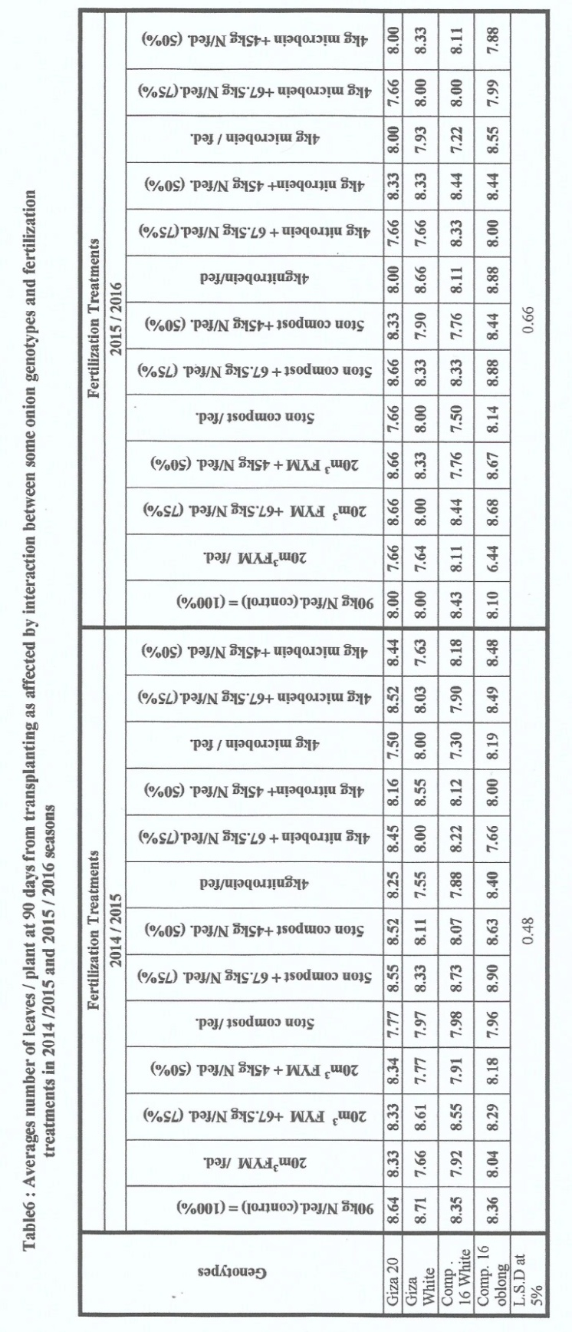 | 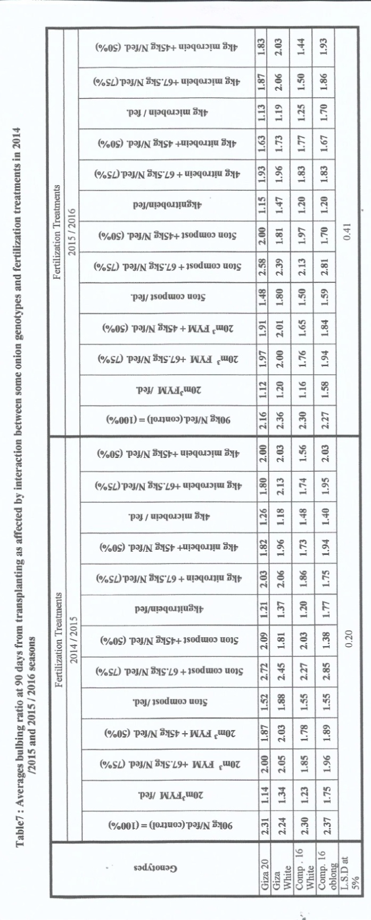

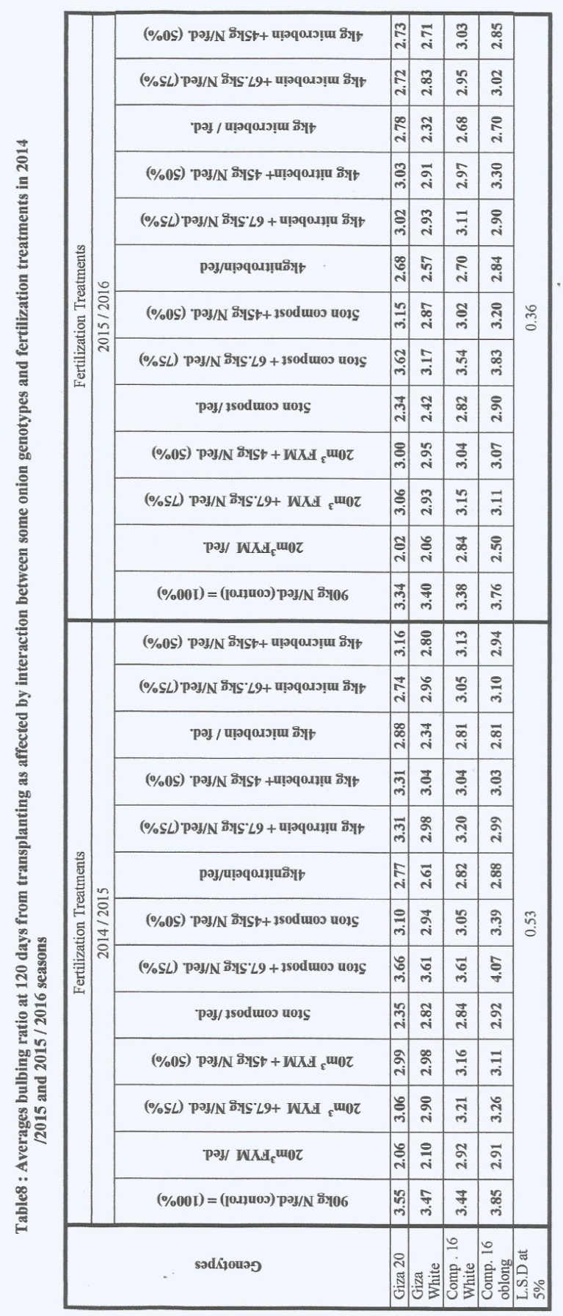 | 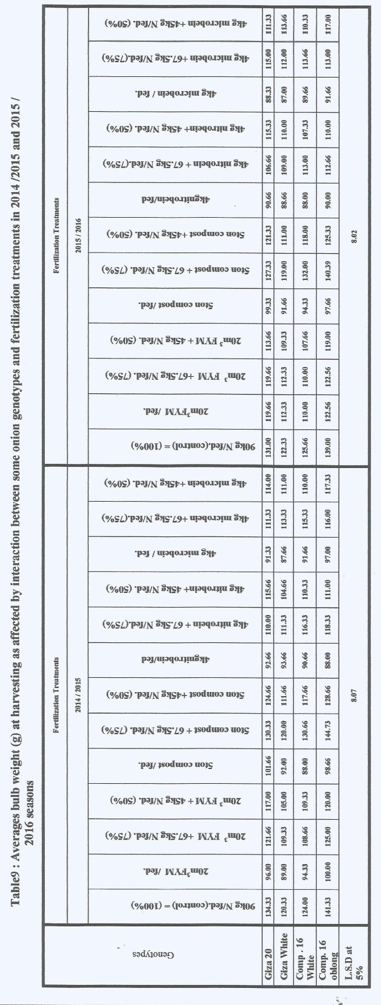

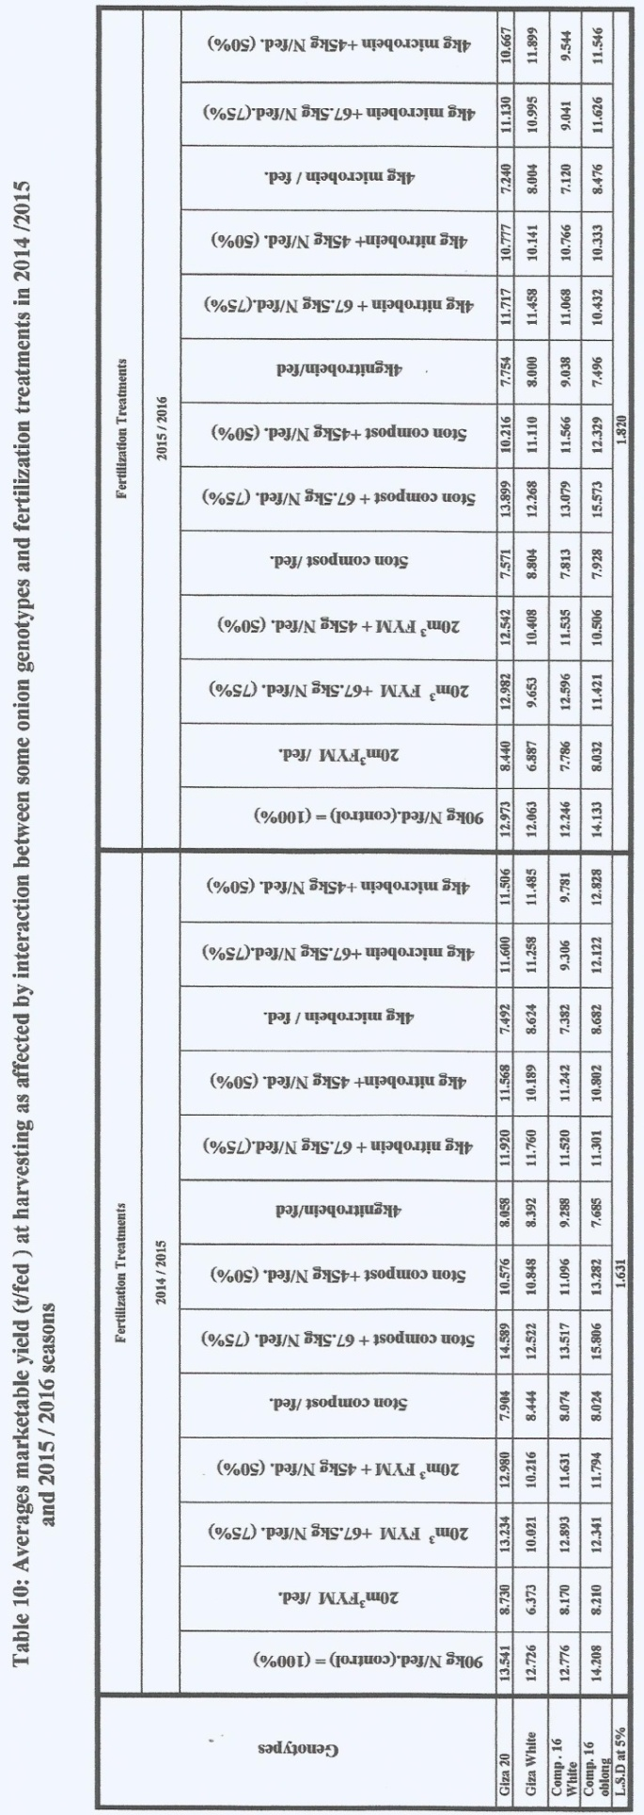 | 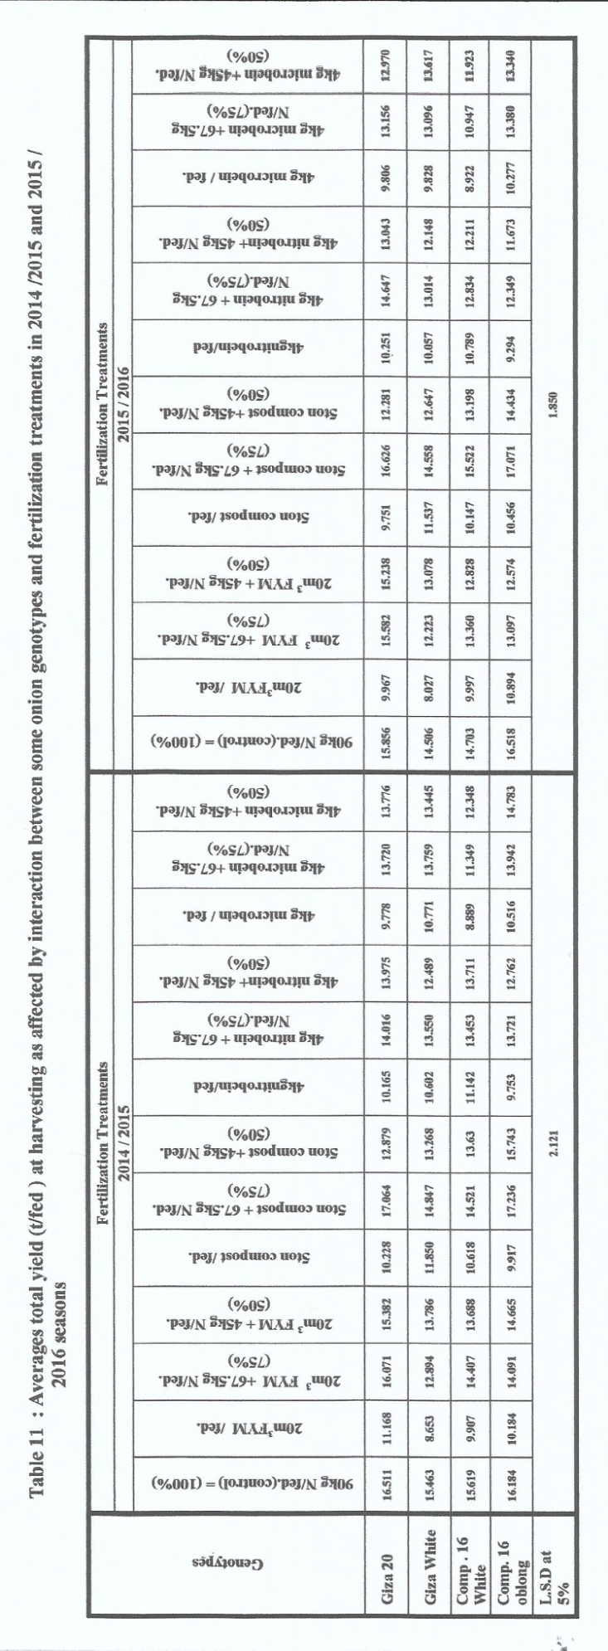

Number of leaves/plant was significantly affected by interaction between onion genotypes and fertilization treatments at 90 days from transplanting in the first and second seasons (Table 6). It is clear from Table 5 that the highest number of leaves/plant 8.90 and 8.88 was recorded with Composite 16 Oblong genotype when received the combination of 5 ton compost + 67.5N/fed. (75% of recommended). on the other hand, the lowest number of leaves/plant 7.30 and 7.22 were resulted from composite 16 white genotype treated onion by 4kg microbein/fed. as compared with all other interaction treatments at 90 days from transplanting in 2014/2015 and 2015/2016 seasons, respectively.
The interaction effect between onion genotypes and fertilization treatments on bulbing ratio was significant at 90 and 120 days from transplanting in both seasons as presented in Tables 7 and 8. The highest bulbing ratio 2.85 and 2.81 as well as 4.07 and 3.83 was obtained when composite 16 oblong genotype fertilized with 5 ton compost + 67.5kgN/fed (75%). On the other hand, Giza 20 genotype fertilized when with 20m³ farmyard manure/fed. gave the lowest bulbing ratio 1.14 and 1.12 as well as 2.06 and 2.02 as compared with all other treatments in this interaction at 90 and 120 days from transplanting In 2014/2015 as well as 2015/2016 seasons, respectively. Results in Tables 9,10 and 11 show that bulb weight (g), marketable and total yield per feddan were significantly affected by the interaction between genotypes and fertilization treatments in the both seasons.
Results in Table 9,10 and 11 indicated that, Composite 16 Oblong genotype onion plants fertilized with 5 ton compost + 67.5kgN/fed. gave the highest bulb weight 144.73 and 140.39 g, marketable yield 15.805 and 15.573 t/ fed. and total yield 17.236 and 17.071 t/fed. as compared with all other this interaction treatments in 2014/2015 and 2015/2016 seasons, respectively. This treatment Composite 16 Oblong genotype onion plants fertilized with 5 ton compost + 67.5kgN/fed. gave 11.25 and 10.19% increase in marketable yield per feddan as compared with fertilized Composite 16 Oblong genotype by 90 kg N/feddan (recommended) in 2014/2015 and 2015/2016 seasons, respectively.
It could be recommended thatfrtilized composite 16 oblong onion genotype by 5 ton compost plus 67.5 kg N/feddan (75% of recommended dose) gave the highest marketable and total yield per feddan at Middle Delta, Gharbeia Governorate as well as decreasing soil erosion, soil compaction, environmental pollution, public health risk and decreased production costs.
Data cited in Table 12 showed that the beneficial cost ratio of application of 5 ton compost + 67.5 kg N/fed (75% of recommended ) could be attributed to the fact that more marketable yield were produced per unit area, higher gross and net returns 32462 and 19824.5 L.E./fed, respectively compared with other treatments. Also, from the economic point of view, the revenue of L.E. is higher when application of 5 ton compost + 67.5 kg N/fed. which give the best benefit cost ratio 2.56.

Table 12: Average cost cultivation gross return and net return (L.E./fed.) as well as benefit cost ratio of onion yield as influenced by fertilization treatments through the two growing seasons.
Fertilization treatments | Cost of cultivation (L.E./fed) | Gross return (L.E./fed) | Net return (L.E./fed) | B.C ration
90kg N/fed. (control) = (100%) | 12610 | 30890 | 18280 | 2.44
20m³ FYM /fed. | 11837.5 | 21534 | 9696.5 | 1.81
20m³ FYM +67,5kg N/fed. (75%) | 12437.5 | 28426 | 15986.5 | 2.28
20m³ FYM + 45kg N/fed. (50%) | 12362.3 | 27751 | 15388.7 | 2.24
5ton compost /fed. | 11937.5 | 20031 | 8093.5 | 1.69
5ton compost + 67.5kg N/fed. (75%) | 12637.5 | 32462 | 19824.5 | 2.56
5ton compost +45kg N/fed. (50%) | 12462.5 | 26536 | 14073.5 | 2.12
4kg nitrobein /fed | 11465.5 | 20520 | 9054.5 | 1.78
4kg nitrobein + 67.5kg N/fed. (75%) | 12165.5 | 27642 | 15476.5 | 2.27
4kg nitrobein+ 45kg N/fed. (50%) | 11995.5 | 25765 | 13774.5 | 2.14
4kg microbein / fed. | 11465.5 | 19633 | 8167.5 | 1.71
4kg microbein +67.5kg N/fed. (75%) | 12165.5 | 25912 | 13746.5 | 2.12
4kg microbein +45kg N/fed. (50%) | 11995.5 | 26963 | 14972.5 | 2.24

References
- Abouazoom, A.A; K. Zhani and C. Hannachi (2014). Performance of eight varieties of onion ( Allim Cepa, L.) cultivared under open field Tunisia. Not. Sci. Biol. 6(2):220-224.
- Black, C.A. (1965). Methods of soil part 1, Amer. Soc. Of Agron. Inc. Madison, Wisconsin, U.S.A.
- Deepasharma and Kumudjarial (2017).Effect of different varieties and planting time on kharif onion production in Lower Shivalik Hills of Himachal Padesh. Curr. Agri. Res.5(1).
- El-Dardiry,E.I; M. Abd El-Hady; M.S.A. Abou –El-Kheirand and A.A. Aboellil (2015). Effect of organic manure sources and NPK fertilizer on yield and water productivity of onion (Allim Cepa, L.). G10. Adv. Res. J. Agric. Sci. 4(11):803-808.
- El-Gizy S.M. (1994). Comparative study for influence of manure sources on growth, yield and pod quality of Pea. Menofiya J. Agric. Res., 19(6):3243-3257.
- Ganesh, P. and R. Sureshkumar (2016). Effect of Coir Pith compost on growth and yield attributes of onion and cassava Inter. J. of App. Res. 2(1):501-506.
- Gomez, K.N. and A.A Gomez (1984). Statistical procedures for agricultural research. John Wiley and Sons, New York, 2nd Ed., 68P.
- Gebremichael, Y.; W.Kebede; C. Arvind and G.F. Yohannes (2017). Effect of integrated nutrient management on growth and bulb yield of onion (AllimCepa, L.) under irrigation at Selekleka, Northern Ethiopia; Int. J. of Leaf Sci. 5(2):151-160.
- Meena, A.K; R. Paliwal, K.K Meena and S.P. singh (2015): Effect of organic manures and bio-ferlilisers on yield attributes and economic of kharif onion (Allium cepa L.) in semi-arid region Indian Res. J. Genet and Biotech 7 (2): 259-261.
- Mann, K.R, (1952).Anatomy of the garlic bulb and factors affecting bulb development. Hilgardia. 21: 195-228.
- Naik, V.R; P.B. Patel and B.K. Patel (2014). Study on effect of different organics on yield and quality of organically grown onion. J. of life Sci. 9(4):1499-1503.
- Soleymani, A. and M.H. Sharhrajabian (2012). Effect of different levels of nitrogen on yield and nitrate contant of four spring onion genotypes. Inter. J. of Agric. And crop Sci., 4(4):179-182.
- Snedecor, G.W.and W.G. Cachran (1980)." Statistical Methods" 7th Ed. The Iowa State Univ. Press, Iowe, U.S.A.
- Singer, S.M.; O.M. Samon; M.M. Abdel-Mouly and S.R. Salman (1998).Study of the effect of Delta max TM and organic matter on growth and productivity of beam plants grown under calcareous soil condition. Egypt. J. Hort., 25(3):335-347.
- Shedeed, S.I; S.A.A El-Sayed and D.M. Abo Bash (2014): Effectivess of bio-fertilizers with organic matteron, the growth, yield and nutrient content of onion (Allium cepa L.) plants. Eiropean International J. of Sci. and Tech. 3 (9): 115-122.
- Top, C.F.; C.A. Watson and E. Stockdale (2002). Utilizing the concept of nutrients as a currency within organic forming system. In: Powell et al. ( eds). Proc. of the COR Conf., 26-28 March, UK, pp: 157-160.
- Tesfalegn, J.A (2015): Response of onion (Allium cepal.) rarieties to intra-row spacing at kobo, Northern Ethiopla. MSc. Thesis. Haramaya Univ.

10/25/2017

