**Simulation Study of Tertiary Gas Injection in Water-wet Naturally Fractured Reservoir with Slab Type Matrix Blocks**

Muhammad Khurram Zahoor1,*, Muhammad Haris1,2

1Department of Petroleum and Gas Engineering, University of Engineering and Technology, Lahore, Pakistan

2Geological Engineering Department, University of Engineering and Technology, Lahore, Pakistan

*Corresponding author: [mkzahoor@yahoo.com](mailto:mkzahoor@yahoo.com)

**Abstract:** Simulation study has been conducted by developing a dynamic model of water-wet naturally fractured reservoir (NFR) having slab type matrix blocks, as a worst case for tertiary gas injection (TGI) in a watered-out reservoir. The comparative study has been conducted by neglecting and then taking into consideration the effect of diffusion on oil production and recovery. Further the study is extended to investigate the effect of capillary pressure existence in fracture network on recovery. The obtained results show the promising results to opt for gas injection as a tertiary recovery method in case of watered-out, slab type matrix block system existing in water-wet naturally fractured reservoir.

[Zahoor M. K., Haris M. **Simulation Study of Tertiary Gas Injection in Water-wet Naturally Fractured Reservoir with Slab Type Matrix Blocks.** *Researcher* 2017;9(10):81-88]. ISSN 1553-9865 (print); ISSN 2163-8950 (online). <http://www.sciencepub.net/researcher>. 13. doi:[10.7537/marsrsj091017.13](http://www.dx.doi.org/10.7537/marsrsj091017.13).

**Keywords:** naturally fractured reservoirs, tertiary gas injection, slab type matrix blocks

1. **Introduction**

Naturally fractured reservoirs represent the complex combination of primary and secondary porosity. These existing porosities can be represented in a simplified form by using a Warren and Root Model, which divides NFR’s in matrix block and fracture network system [1]. This model is also referred to as 2 and 1K model, because of the fact that once the fluid produced from the matrix blocks, will not re-enter into the matrix block and flows through the transporting medium, i.e., fracture network, as shown in the following Figure (1).

Figure 1. Conceptual representation of Warren and Root model

Matrix blocks in fracture reservoirs can be characterized in the form of cubes, elongated parallelopiped and having slab structure [2]. It is comparatively very common to find in the literature that, experimental studies have been done using elongated cores of fracture reservoirs and also the accomplished numerical modeling (simulation studies) by generally using cube type model [3-8].

In this work, simulation study has been conducted for water-wet naturally fractured reservoir model having slab type matrix blocks. Water-wet system has been chosen as the worst case scenario for TGI due to required higher displacement pressures for gas to enter the matrix block. The threshold pressure which needs to be exceeded for displacement process depends on wettability [4]. In addition, as the interfacial tension increases, the required pressure for gas to enter the matrix block also increases. When gas injection is used for tertiary recovery, as in case of this study, the required pressure to enter the matrix block further increases as generally IFT (interfacial tension) between gas and water is higher than IFT between gas and oil, to which it will be preferably contacting in a watered-out situation [9].

1. **Properties of Matrix Blocks and Fracture Network**

Matrix blocks have the same properties and behavior as that of conventional (non-fractured) reservoirs, showing non-linear relationship between capillary pressure and relative permeability against saturation. While in case of fractures, it is mostly assumed that no transition zone exists so the relative permeability curves shows the linear direct relationship with respect to saturation [10].

1. **Gas Injection in Naturally Fractured Reservoirs**

Gas injection is known to displace and further produce the trapped oil present in the matrix blocks. A number of studies [11-17] have been conducted, which involves injecting different gases for increased oil recovery. These studies were conducted by using cores having various wettability conditions and show the potential of gas injection to be used for enhanced oil recovery.

In NFR’s, compositional differences exists between the fluid present in the matrix blocks and fracture network, due to high degree of segregation in fractures. This difference results into diffusion process in the form of gas-gas diffusion, gas-oil diffusion and oil-oil diffusion in case of difference in solution gas-oil ratio [16]. Diffusion can decrease the oil viscosity making it more mobile, which in turn leads to increased oil recovery.

1. **Simulation Study**

The accomplished numerical modeling by using commercial black oil reservoir simulator can be divided into the following cases:

1. Subjecting NFR to water injection and when it is watered-out, using gas injection as tertiary recovery method, without taking into consideration the effect of diffusion.
2. Subjecting reservoir to water injection and when it is watered-out, using gas injection for EOR, while taking into consideration the effect of diffusion.
3. Comparing case (1) with a case in which the same capillary pressure exists within the fracture system as in the matrix blocks.
   1. *Model Description*

Reservoir model having slab like matrix blocks with effective vertical length of 10 feet have been modeled. Model is divided into 6750 grid blocks (based on effective block height). Reservoir depth is at 8250 ft with a formation thickness of 1250 ft. Reservoir is initially undersaturated with a reservoir pressure of 3958 Psi. Water-oil contact lies at 7571 ft and the connate water saturation is 20%. Further details of the reservoir model are given in Table 1, while the relative permeability and capillary pressure data is shown in Figure (2). Moreover, the location of production and injection wells can be represented in the simplified form, as shown in Figure (3).

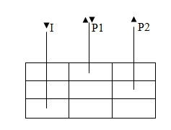

Figure 3. Well locations based on simplified major grid blocks representation

1. **Results And Discussion**

The obtained results of field oil production rate and water cut can be divided into two main parts, for analysis and discussion purposes, i.e.:

* Reservoir is subjected to water injection and,
* When reservoir is subjected to gas injection.

*5.1 Case 1*

In Case 1, during water injection, initially oil is mainly produced from fracture network which resulted in stabilized flow, then production started declining rapidly and becomes stabilized once again, when the effect of imbibition process in matrix blocks is reasonable enough to slow down the production decline as shown in Figure (4). Later, when the flow from matrix block is not enough, decline in field production rate can again be noticed. The reason of delayed effect of imbibition process to produce oil from matrix blocks is their low permeability.

Deflection “A” in the field water cut curve is due to shutting one production well “P2”, when the field water cut was above 60%. Well P2 was shut-in, being a main source of higher water cut as it is located near the water-oil contact as compared to well “P1”.

After shutting in “P2”, the water cut has decreased and starts increasing again with the passage of time. When it has been reached to 83.4 % then the field production was stopped. For gas injection being a source of tertiary recovery in a watered-out reservoir, wells were shut-in, which is the reason for deflection “B”. During tertiary recovery by gas injection, Well “I” was shut-in, while “P2” was opened for production again and “P1” was shifted to gas injection well.

Effect of gas injection can be seen clearly in the beginning of region “C”, after approximately one year of gas injection. In the beginning of region “C”, oil production decreases while water cut increases, which shows the presence of oil in the form of disconnected ganglia. So injected gas have displaced water first (indicted by increase in water cut) and then came in contact with oil, and displaced trapped ganglia of oil. While moving (gas) from larger pores to smaller pores and continuing displacing oil, and reuniting them together, which resulted in the formation of oil banks, has been produced (shows increase in oil production rate in region “C” of the curve). While the oil was being produced, gas is also pushing water, which has also been produced. Sudden decrease in flow rate and water cut (deflection D) is due to gas breakthrough.

Recovery profile is shown in Figure (5). Total oil recovery in this case is 59.6% at the end of water injection which increased to 68.8% as a result of tertiary recovery by gas injection.

*5.2 Case 2*

In this case, during water injection, the production behavior is similar to as in Case 1, but it differs during gas injection, because of diffusion between gas in the fractures and oil in the matrix blocks. Due to diffusion, viscosity of oil have also decreased, so tendency for oil to flow towards wellbore have increased (Fig. 6) and thus leaving behind comparatively lesser residual oil at the end of simulation (Fig. 7), as compared to Case 1. Fig. 7 shows the same recovery after water injection and an increased recovery, i.e., 69.4% at the end of gas injection.

*5.3 Case 3*

In Case 3, during water injection, improper water imbibiton was observed, when capillary pressure also exists within the fracture network. The obtained results are shown in Fig. 8 and 9. The existence of fracture capillary pressure, opposes the entry of water into the matrix block (imbibition) and on the other side water-oil contact rises in the fracture network, which resulted in early breakthrough and hence lower recovery (50.8%) at the end of water injection as compared to Case 1. Improper water imbibition also caused, rapid decline in oil production. In this case, oil was produced under water injection (W.I.) until the field water-cut became higher than 90%, but still the recovery was lower as compared to Case 1. Deflection “A” is due to shutting in the field wells, to subject the reservoir to produce oil under tertiary gas injection, as it has been accomplished in Case 1.

# Effect of gas injection can be clearly seen in the beginning of region “C”, and it has been noticed that due to early water breakthrough and lesser recovery, oil is comparatively more or less still is in continuous phase as compared to Case 1, so injected gas took comparatively lesser time to mobilize oil, once again. After formation of oil bank, oil has been produced and also it can be noticed that during gas injection (G.I.), oil and water have been produced according to their relative permeabilities, i.e, oil having higher relative permeability (Kro), than water have been produced first. Tertiary recovery by gas injection resulted in total recovery of 67.9% at the end of simulation. This recovery is slightly lesser than the total recovery as compared to Case 1. Decline (deflection D) in oil production and water cut is again due to gas breakthrough.

# Conclusions

1. There is a delay to clearly notice the effect of gas injection in watered-out reservoir in the form of increased oil production.
2. In case of TGI, gas will reach to the dispersed oil patches and ganglia, after displacing the surrounding water, in a watered-out NFR. Later, it re-unites the oil which is in the form of disconnected ganglia, thus forming an oil bank, which is produced afterwards.
3. During tertiary recovery, when situation is more or less normalized (watered-out effect is reduced or vanished), then gas will displace oil and water according to their relative permeabilities, in slab type matrix block system.
4. The study shows that existence of capillary pressure in fracture system, has adverse effect on recovery due to water injection (Case 3), while in this situation TGI, has been resulted in obtaining almost the same total recovery as in Case 1.
5. This study shows the potential of implementing TGI in water-wet naturally fractured reservoirs with slab type matrix blocks.

Table 1: Reservoir model description

|  |  |
| --- | --- |
| Number of major matrix blocks in each layer | 9 |
| Number of layers | 6 |
| Length of each slab in x and y-direction | 220 ft |
| Effective block height | 10 ft |
| Fracture permeability | 100-2000 md |
| Matrix porosity | 10% |
| Fracture porosity | 1.5% |
| No. of production wells | 2 |
| No. of injection wells | 1 |



a: Relative permeability curves

b: Capillary pressure curves



Figure 2. Relative permeability and capillary pressure data

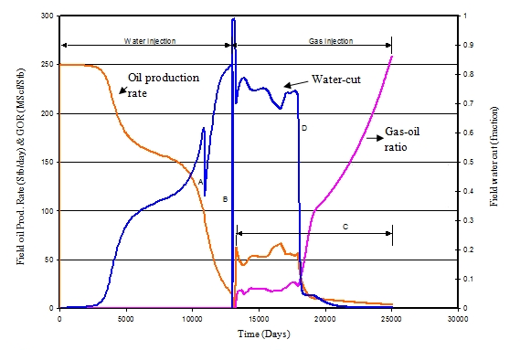

Figure 4. Field oil production rate and water-cut

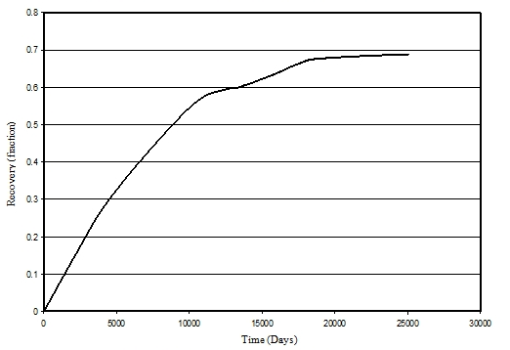

Figure 5. Field oil recovery profile

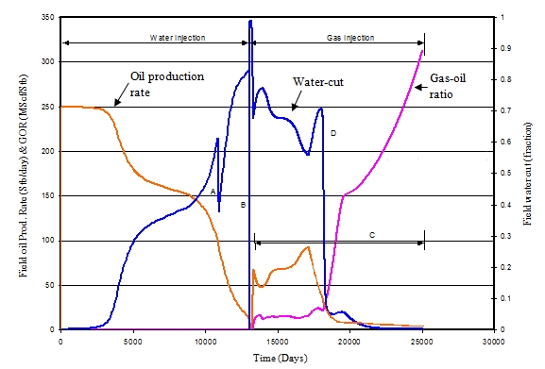

Figure 6. Field oil production rate and water-cut profiles including diffusion effect (Case 2)

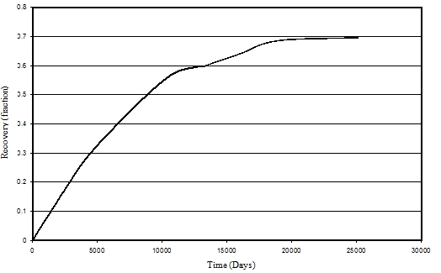

Figure 7. Oil recovery estimation including diffusion effect (Case 2)

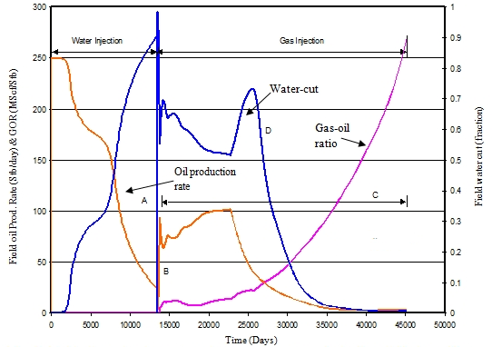

Figure 8. Field oil production rate and water-cut profiles including diffusion effect (Case 3)

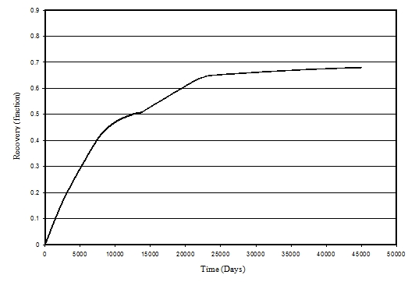

Figure 9. Recovery profile when capillary pressure also exists in fracture network (Case 3)

**Corresponding Author:**

Dr. Muhammad Khurram Zahoor

Department of Petroleum and Gas Engineering .

University of Engineering and Technology, Lahore

Pakistan

E-mail: [mkzahoor@yahoo.com](mailto:mkzahoor@yahoo.com)

**References**

* 1. Warren, J.E., Root, P.J.: The Behavior of Naturally Fractured Reservoirs. SPE Journal 3(3), 245-255 (1963). doi:10.2118/426-pa.
  2. Prat, G.D.: Well test Analysis for Fractured Reservoir Evaluation. Elsevier Science Publishers B.V., Amsterdam (1990).
  3. Akin, S.: Estimation of fracture relative permeabilities from unsteady state corefloods. Journal of Petroleum Science and Engineering 30(1), 1-14 (2001).
  4. Babadagli, T.: Evaluation of EOR methods for heavy-oil recovery in naturally fractured reservoirs. Journal of Petroleum Science and Engineering 37(1-2), 25-37 (2003).
  5. Hatiboglu, C.U., Babadagli, T.: Oil recovery by counter-current spontaneous imbibition: Effects of matrix shape factor, gravity, IFT, oil viscosity, wettability, and rock type. Journal of Petroleum Science and Engineering 59(1-2), 106-122 (2007).
  6. Kiasari, H.H., Kiasari, M.M., Sola, B.S.: Investigation on Effects of Rock-Fluid Properties on the SAGD Production Profile In Naturally Fractured Reservoir (NFR). Petroleum & Coal 52(4), 243-248 (2010).
  7. Qasem, F.H., Nashawi, I.S., Gharbi, R., Mir, M.I.: Recovery performance of partially fractured reservoirs by capillary imbibition. Journal of Petroleum Science and Engineering 60(1), 39-50 (2008).
  8. Tadashi, H., Abbas, F., Koichiro, I.: Laboratory Studies of Capillary Interaction in Fracture/Matrix Systems. SPE Reservoir Engineering 5(3), 353-360 (1990).
  9. Fanchi, J.R.: Principles of Applied Reservoir Simulation, 3rd. ed. ed. Gulf Professional Publishing, New York (2006).
  10. Romm, E.S.: Fluid Flow in Fractured Rocks. Nedra Publishing House. In. Moscow, (1966).
  11. David, S.: Waterflooding and CO2 Injection in the Naturally Fractured Spraberry Trend Area. Journal of Canadian Petroleum Technology 41(10), 10-15 (2002). doi:10.2118/02-10-das.
  12. Gholam Reza, D., Erik, G.B.L., Torleif, H., Jon, K., Svein Arild, U.: Reservoir Conditions Laboratory Experiments of CO2 Injection into Fractured Cores. Paper presented at the SPE Europec/EAGE Annual Conference and Exhibition, Vienna, Austria, 2006.
  13. Hassan, K., Ole, T.: CO2 and C1 Gas Injection for Enhanced Oil Recovery in Fractured Reservoirs. Paper presented at the SPE International Conference on CO2 Capture, Storage, and Utilization, New Orleans, Louisiana, USA, 2010.
  14. Joachim, M., Abbas, F., Mohammad Moravvej, F.: A New Approach to Compositional Modeling of CO2 Injection in Fractured Media Compared to Experimental Data. Paper presented at the SPE Annual Technical Conference and Exhibition, New Orleans, Louisiana, 01/01/2009.
  15. Karimaie, H., Darvish, G.R., Lindeberg, E., Torsæter, O.: Secondary and tertiary gas injection in fractured carbonate rock: Experimental study. Journal of Petroleum Science and Engineering 62(1-2), 45-51 (2008).
  16. Saidi, A.M., Sakthikumar, S.: Gas Gravity Drainage Under Secondary and Tertiary Conditions in Fractured Reservoirs. Paper presented at the Middle East Oil Show, Bahrain, 1993.
  17. Sayyed Ahmad, A., Curtis Hays, W.: Modeling Miscible CO2 Injection in a Fractured-Chalk Experiment. Paper presented at the SPE Annual Technical Conference and Exhibition, Florence, Italy, 2010.

10/18/2017