Evaluation of Different Methods for Estimating the Parameters of the Kostiakov-Lewis Infiltration Equation with SIPAR_ID Model

Reza Mazarei*, Abd Ali Naseri, Amir Soltani Mohammadi, Zahra Izadpanah

Department of Irrigation and Drainage, Faculty of Water Sciences Engineering, Shahid Chamran University of Ahvaz, Iran
reza.mazarei1372@gmail.com

Abstract: Infiltration parameters are one of the most important parameters for surface irrigation. It has an important effect on design and performance while estimation of infiltration parameters is difficult in surface irrigation. SIPAR_ID model is one of the most widely used for estimating infiltration parameters due to its facility. The major problem of this model is the disability to estimate the basic infiltration rate in the soil. In this paper, to estimate the Kostiakov-Lewis parameters by SIPAR_ID model, the basic infiltration rate used in without basic infiltration rate (Z1), by applying the empirical parameter φ = 0.5 (Z2) and by inflow-outflow method (Z3). To evaluate different methods, we compared the volume of water infiltrated and simulated it by the SIPAR_ID model. To find out Kostiakov-Lewis parameters and estimate volume of water infiltrated on furrows, field experiments on sugarcane fields (with length and width of 100 and 83m and 0.04% slope) conducted during September and October 2016 at the Southwest of Iran. Advance times were find out at 10 m intervals at different times. The results showed that SIPAR_ID model accuracy in Z1, Z2 and Z3 were RE of 48.64, 24.64 and 16.63%, and R² of 31, 42 and 46%, respectively. According to the results to increase the accuracy of the model in estimating the infiltration parameters, using the basic infiltration rate with inflow-outflow method is more acceptable than the other methods.
[Reza Mazarei, Abd Ali Naseri, Amir Soltani Mohammadi, Zahra Izadpanah. Evaluation of Different Methods for Estimating the Parameters of the Kostiakov-Lewis Infiltration Equation with SIPAR_ID Model . Researcher 2017;9(10):25-30]. ISSN 1553-9865 (print); ISSN 2163-8950 (online). http://www.sciencepub.net/researcher. 6. doi:10.7537/marsrsj091017.06.

Keywords: Infiltration parameters; Kostiakov-lowies equation; SIPAR_ID model; Basic infiltration rate

1. Introduction
Increasing costs have led to researchers to pay more attention to surface irrigation and consider surface irrigation systems to be a best alternative to irrigation (Walker and Skogerboe, 1987). Which, furrow irrigation widely used in Salman Farsi Agro Industry sugarcane fields located in Khuzestan-Iran. Various reasons such as inability in management, design and apply lead to excessive consumption of water and reduced irrigation performance (Merriam & Keller, 1978; Schwankl & Frate, 2004). Irrigation performance is depend on various features such as inflow, cutoff time, geometric characterized, Manning roughness and infiltration parameters (Eldeiry et al., 2005; Moravejalahkami et al., 2009). Estimate infiltration parameters is necessary and most difficult parameters in the design and irrigation performance (Ebrahimian, 2014). Suitable length and width of the field as well as the flow control (inflow and cutoff time) in the surface irrigation are depend on the current estimation of infiltration parameters (Zhang et al., 2012).
Nowadays, it is necessary to use the mathematical models to estimate infiltration parameters (Mahdizadeh Khasraghi et al., 2015). In recent years, many methods had proposed based on type of irrigation system in order to estimate the infiltration parameters in surface irrigation (Bautista & Walker, 2010), among which these methods can be used as a two-point method (Elliott Walker, 1982); One-point method (Shepard et al., 1993); Multilevel calibration (Walker, 2005); One-point method by Valiantzas et al. (2001); and Computer models such INFILT (McClymont and Smith, 1996); EVALUE (Strelkoff et al., 1999); IPARM (Gilles et al., 2005); and SIPAR_ID (Rodriguez & Martos, 2010). Today, using computer models has a significant effect on saving time and cost. The SIPAR_ID model is one of the most operational models in this field because of its simplicity and high applicability in estimating infiltration parameters and manning roughness coefficients. Etedali et al. (2011) in their research showed that the SIPAR_ID model provides an acceptable performance in estimating the infiltration equation coefficients as well as manning roughness coefficients at the closed-end furrows. Nie et al. (2014a, 2014b) also show the suitable accuracy of the SIPAR_ID model in estimating the infiltration coefficients of furrow irrigation. Nowadays, Kostiakov-Lewis infiltration equation is used because of the increased accuracy in designing irrigation systems in comparison with the Kostiakov equation. Main problem of SIPAR_ID model is weakness in estimate the basic infiltration rate of the soil, which is why it is not possible to estimate the parameters of the Kostiakov Lewis infiltration equation. Sayari et al. (2017) used the SIPAR_ID model to estimate the coefficients of the Kostiakov-Lewis equation. The results of this study showed that this model was accurate in estimating the infiltration equation coefficients to simulate advance and recession times.
The purpose of this research is to evaluate the ability of the SIPAR_ID model to estimate the infiltration parameters of the Kostiakov-Lewis equation using three different method to estimate basic infiltration rate. In this research, three methods were developed to estimate the Kostiakov Lewis infiltration parameters in furrow irrigation with SIPAR_ID model.

2. Material and Methods
The proposed methods for determination of infiltration parameters evaluated in nine furrows under sugarcane field, with length and width of 100 and 83m, and slope of 0.04%. The Dominant soil texture in Salman Farsi cultivation and industry Co. was Clay loam. The furrows irrigated three times on 24 September, 1 October and 31 October 2016.
To irrigate these furrows, three nominal inflow rate of 1, 1.5 and 2 lit/s (each with three repeats) used. Data collected on the farm include:
• Inflow rate
• Runoff data at the end of the field
• Advance time at 10 m. intervals
The field data sets summarized in Table 1.

Table 1: Field Data
9 | 8 | 7 | 6 | 5 | 4 | 3 | 2 | 1 | Furrow N.O.
2 | 1.5 | 1 | 2 | 1.5 | 1 | 2 | 1.5 | 1 | $Q($L/S$)$
.. | .. | .. | 94.91 | 71.15 | 57.35 | 87.68 | 63.99 | 50.75 | V_{in} (m³) | Irri. 1.
.. | .. | .. | 13.39 | 8.29 | 13.34 | 6.6 | 6.57 | 8.79 | V_{ro} (m³)
.. | .. | .. | 157 | 182 | 273 | 140 | 170 | 254 | T_{a} (min)
.. | .. | .. | 827 | 873 | 1053 | 696 | 772 | 913 | T_{co} (min)
82.36 | 71.66 | 94.95 | 149.97 | 121.9 | 74.51 | 84.16 | 70.39 | 60.65 | V_{in} (m³) | Irri. 2.
14.67 | 7.31 | 13.65 | 21.97 | 35.44 | 9.55 | 9.07 | 14.3 | 14.52 | V_{ro} (m³)
131 | 238 | 390 | 262 | 273 | 513 | 153 | 189 | 270 | T_{a} (min)
749 | 856 | 1751 | 1230 | 1310 | 1390 | 780 | 820 | 1100 | T_{co} (min)
112.94 | 87.14 | 94.67 | 119.88 | 94.15 | 135.81 | 121.7 | 76.77 | 122.57 | V_{in} (m³) | Irri. 3.
12.19 | 9.56 | 12.3 | 11.11 | 7.28 | 11.21 | 10.95 | 8.33 | 15.55 | V_{ro} (m³)
154 | 218 | 495 | 177 | 271 | 810 | 180 | 250 | 593 | T_{a} (min)
1100 | 1060 | 1720 | 1174 | 1150 | 2040 | 1095 | 994 | 2300 | T_{co} (min)
SIPAR_ID model

SIPAR_ID model proposed by Rodriguez and Martos (2010) based on Windows, is a model for estimating Kostiakov equation parameters and manning coefficients in surface irrigation under steady and unsteady inflow conditions. To estimate Kostiakov equation coefficients, using a hybrid model that combines a volume-balance model with artificial neural networks. As well as, an artificial neural network is use to reduce the difference between the field and simulated forward curve. Field geometric characterized (furrow length, slope and manning coefficient), inflow hydrograph, advance times and water depth in the furrows sectional area of flow at the field inlet, are the data needed for this model. The Kostiakov equation simplicity has two problems of non-evaluation of field conditions and the inability to simulate the basic infiltration rate during long irrigation times. Nowadays, to overcome these problems, the design of surface irrigation is use in the adjusted Kostiakov-Lewis infiltration equation. The Kostiakov-Lewis equation is one of the most widely used infiltration equations for surface irrigation that suitable for a wide range of soils (Hanson et al., 1993).
Where Z = cumulative infiltration ( ); t = elapsed time of infiltration (min); fo = basic infiltration rate (); and k (), a (dimensionless) empirical parameters. In this research, the SIPAR_ID model used to estimate the infiltration parameters of the Kostiakov-Lewis equation. Therefore, three different strategies considered:
1- Use of the Kostiakov-Lewis equation with basic infiltration rate equal to zero (Z1): The SIPAR_ID model does not have the ability to estimate the basic infiltration rate independently. So, to increase model accuracy, the estimates more in comparison with other methods for fixing the infiltration parameters.
2- Use of the Kostiakov-Lewis equation with the adjusted infiltration rate (Z2): In this case, to control the basic infiltration rate, the nominal flow rate of the inflow hydrograph and steady runoff used. According to Bautista et al. (2012), the actual system is not at steady state runoff, thus the value of f0 should reduce by applying the empirical parameter = 0.5. The basic infiltration rate determined by the Walker and Skogerboe (1987) equation:
3- Using the Kostiakov-Lewis equation with the basic infiltration rate of the inflow-outflow method (Z3): In this case, the assumption is that the runoff and the input hydrograph are uniform. Hence, the Walker and Skogerboe (1987) equation is used to determine the basic infiltration rate:
Performance Evaluation
Infiltration parameters of the Kostiakov-Lewis equation estimated in all three different methods of SIPAR_ID at all irrigation times. To evaluate the accuracy and capacities of different methods of the SIPAR_ID model in estimating the infiltration parameters, the water infiltrated in the field compared to the predicted values by the model. For water infiltrated in the field determined by the difference in volume of inflow and runoff. The predicted water volume estimated by the model using a trapezoidal method:
Where, n is the number of observing stations, is stations spacing (m), Z_{i} and Z_{i+1}, the amount of infiltrated volume (m^3) at stations i and i + 1, respectively.
Statistical indicators
In order to compare the different methods of determining the infiltration equation with each other, the Relative Error of model (RE) and (R²) statistical indicators was used:
Which, V_{p} and V_{m} are predicted and measurment values respectively.

3. Results

Table 2: Parameters of the Kostiakov Lewis Equation
Irri. N.O. | Furr. NO. | a | k | 0.5f₀ | f₀
1 | 1 | 0.4847 | 0.0088 | 0.000243 | 0.000487
 | 2 | 0.6723 | 0.0049 | 0.0004 | 0.0008
 | 3 | 0.7472 | 0.0058 | 0.000556 | 0.001112
 | 4 | 0.881 | 0.0013 | 0.000229 | 0.000458
 | 5 | 0.5966 | 0.0071 | 0.000403 | 0.000806
 | 6 | 0.4782 | 0.0053 | 0.000507 | 0.001015
2 | 1 | 0.6033 | 0.0049 | 0.000198 | 0.000396
 | 2 | 0.5593 | 0.0098 | 0.000362 | 0.000724
 | 3 | 0.7342 | 0.0039 | 0.000529 | 0.001059
 | 4 | 0.98 | 0.0005 | 0.000286 | 0.000572
 | 5 | 0.81 | 0.0027 | 0.000304 | 0.000608
 | 6 | 0.9611 | 0.0016 | 0.000499 | 0.000998
 | 7 | 0.6993 | 0.0038 | 0.00025 | 0.000501
 | 8 | 0.7831 | 0.0028 | 0.000385 | 0.00077
 | 9 | 0.88 | 0.0019 | 0.000513 | 0.001026
3 | 1 | 0.98 | 0.00064 | 0.000256 | 0.000512
 | 2 | 0.99 | 0.00083 | 0.000397 | 0.000794
 | 3 | 0.62 | 0.0088 | 0.000553 | 0.001107
 | 4 | 0.68 | 0.0063 | 0.000247 | 0.000494
 | 5 | 0.64 | 0.0065 | 0.00041 | 0.00082
 | 6 | 0.62 | 0.0071 | 0.000547 | 0.001094
 | 7 | 0.79 | 0.0025 | 0.00025 | 0.0005
 | 8 | 0.79 | 0.0029 | 0.0004 | 0.0008
 | 9 | 0.4626 | 0.018 | 0.00054 | 0.00108

Results of table 2 showed the infiltration parameters of the Kostiakov-Lewis equation in three methods, which determined by the SIPAR_ID model. The results of the infiltrated water volume in the field and simulated with SIPAR_ID model presented in Fig. 1. The results of Fig. 1 showed that R² in Z3 in all irrigation events more compared to the other two methods by 18, 93 and 28%, respectively. In this paper, to estimate infiltration parameters Z3 was best method. According to the results of table 2, because of the inability of SIPAR_ID model to estimate the basic infiltration rate of the soil, the value of was high (0.46-0.99). Finally, Table 3 represents the Relative Error (RE) and R² in three irrigation times.

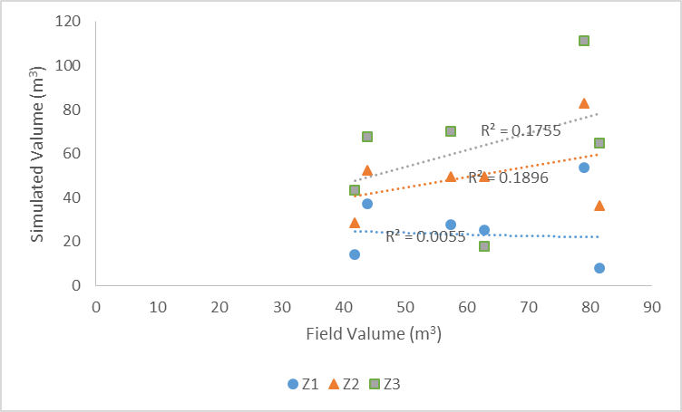
a

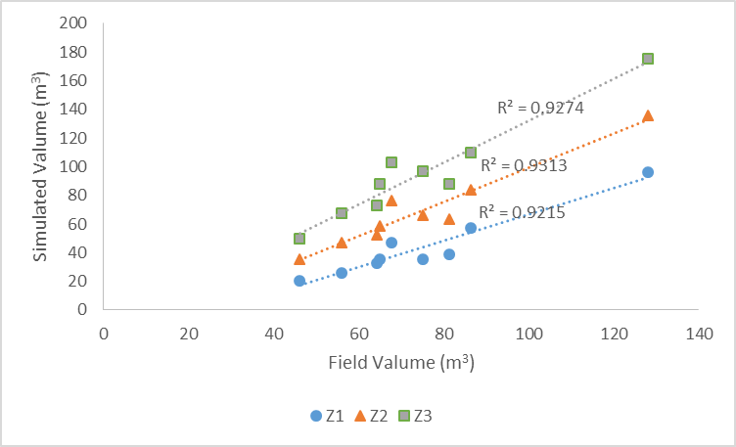
b
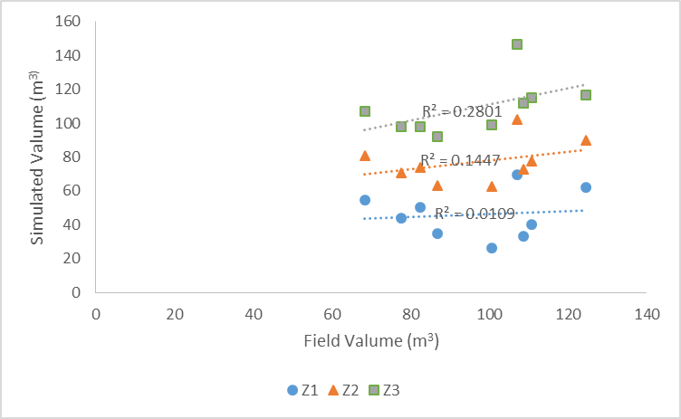
c
Figure 1: Comparison of Farm and Field Infiltration Water Volume (a: First irrigation, b: Second irrigation, c: Third irrigation)

Also, the results from Table 3 and Fig 1 showed that Z1, Z2 and Z3 methods were inability to estimate the volume of water infiltrated on the field. According to the results table 3, RE in Z1, Z2 and Z3 methods were (-90.24 - -15.5%) and (-90.24-18.22%), and (-71.83-56.44%) respectively. However, the results of Sayari et al. (2017); Nie et al. (2014), Showed the high accuracy of the model in estimating the infiltration parameters. One reason for difference results in this research with other research was furrows geometry. Nie et al. (2014) used closed-end furrows to evaluate SIPAR_ID model, while this study conducted in open-end downstream conditions furrows. On the other hand, Sayari et al. (2017) conducted their research on the furrows of 72m in length and 0.7 m in space, while the experiments in this study conducted on the furrows of 100m in length and 1.83m in space. Also, advance time is other important parameter on the SIPAR_ID model performance. According to table 1, the minimum cut-off time for this research is about 800 minutes, while on study by Sayari et al (2017) and Nie et al (2014) was 70 and 8.2 minutes respectively.
Results of table 4 showed that, to estimate the Kostiakov-Lewis infiltration parameters under steady state conditions, Z3 was acceptable performance. In this method, two statistical indicators of RE and the R² were 16.63 and 46% respectively.

Table 3: Results of the statistical index of the relative error coefficient (%)
Irri. NO. | Z1 | Z2 | Z3
1 | -66.04 | -66.04 | 3.03
 | -51.65 | -51.65 | 22.26
 | -32.08 | -32.08 | 40.53
 | -15.50 | -15.50 | 53.83
 | -59.66 | -59.66 | -71.83
 | -90.24 | -90.24 | -20.41
2 | -55.37 | -23.82 | 7.63
 | -53.45 | -16.58 | 20.27
 | -52.88 | -12.11 | 28.66
 | -45.38 | -37.92 | 35.48
 | -33.51 | -3.16 | 27.13
 | -24.96 | 6.09 | 37.13
 | -52.03 | -21.98 | 8.08
 | -49.04 | -18.09 | 12.93
 | -30.57 | 12.65 | 51.93
3 | -34.94 | -4.51 | 36.81
 | -19.99 | 18.22 | 56.44
 | -63.97 | -29.93 | 4.11
 | -50.30 | -27.82 | -6.55
 | -60.22 | -27.20 | 5.78
 | -69.38 | -33.24 | 2.92
 | -39.20 | -10.31 | 18.76
 | -43.56 | -8.82 | 25.93
 | -73.79 | -37.74 | -1.67

Table 4: Statistical indicators
Irri. NO. | Z1 | Z2 | Z3
RE | -48.65 | -24.64 | 16.63
$$R^{2}$$ | 0.31 | 0.42 | 0.46

4. Discussions
In this study, to estimate the infiltration parameters of the Kostiakov-Lewis equation using the SIPAR_ID model, three different methods selected. Because of the inability of the SIPAR_ID model to estimate the basic infiltration rate, in the first case, it considered zero, in the second case, the basic infiltration rate adjusted and eventually the basic infiltration rate of the inflow-outflow method determined. The results of this study showed the SIPAR_ID model has a low ability to simulate the volume of water infiltrated in soil compared to field conditions. Finally, to increase SIPAR_ID performance in estimate the Kostiakov Lewis coefficients, the use of the basic infiltration rate occur from the inflow-outflow method compared to the other two methods had more acceptable performance.

Corresponding Author:
Reza Mazarei
Department of Irrigation and Drainage
Faculty of Water Science, Shahid Chamran University Ahvaz, Iran
E-mail: reza.mazarei1372@gmail.com

References
- Bautista E, Schlegel JL, Strelkoff TS (2012) WinSRFR 4.1: User manual. Arid land agricultural research center. Cardon Lane, Maricopa, AZ, USA.
- Bautista, E. and Walker, W. R. (2010). “Advances in estimation of parameters for surface irrigation modeling and management.” National Decennial Irrigation Conference, Phoenix, Arizona USA.
- Ebrahimian H (2014) Soil Infiltration Characteristics in Alternate and Conventional Furrow Irrigation using Different Estimation Methods. Korean Society of Civil Engineers.18 (6):1904-1911.
- Eldeiry A, García L, Ei-Zaher ASA, Kiwan ME, 2005. Furrow irrigation system design for clay soils in arid regions. Appl Eng Agric 21(3): 411-420.
- Elliott, R. L. and W. R. Walker. 1982. Field evaluation of furrow infiltration and advance functions. Trans. ASAE., 25: 396-400.
- Etedali, H. R., Ebrahimian, H., Abbasi, F., and Liaghat, A. (2011). “Evaluating models for the estimation of furrow irrigation infiltration and roughness.” Spanish Journal of Agricultural Research, Vol. 9, No. 2, pp. 641-649.
- Gillies M H and Smith R J (2005) Infiltration parameters from surface irrigation advance and run-off data. Irrigation Science. 24(1): 25-35.
- Hanson, B. R., Prichard, T. L., and Schulbach, H. (1993). Estimating furrow infiltration. Agricultural Water Management, 24(4), 281–298.
- Mahdizadeh Khasraghi, M., Gholami Sefidkouhi, M.A., Valipour, M., 2015. Simulation of open- and closed-end border irrigation systems using SIRMOD. Arch. Agron. Soil Sci. 61 (7), 929–941.
- Mc Clymont, D. J. and R. J. Smith. 1996. Infiltration parameters from optimisation on furrow irrigation advance data. Irrig. Sci., 17(1): 15–22.
- Merriam JL, Keller J, 1978. Farm irrigation system evaluation: a guide for management. Agricultural and Irrigation Engineering Department, Utah State University, Logan, UT.
- Moravejalahkami, B., Mostafazadeh-Fard, B., Heidarpour, M. and Abbasi, F. 2009. Furrow infiltration and roughness prediction for different furrow inflow hydrographs using a zero-inertia model with a multilevel calibration approach. Biosystems Engineering, 103(3): 374–381.
- Nie W., Fei L J., and Ma X Y. (2014a). Applied Closed-end Furrow Irrigation Optimized Design Based on Field and Simulated Advance Data. J. Agr. Sci. Tech. (2014) Vol. 16: 395-408.
- Nie W., Fei L J., and Ma X Y. (2014b). “Impact of infiltration parameters and Maning roughness on the advance trajectory and irrigation performance for closed-end furrows.” Spanish Journal of Agricultural Research, Vol. 12, No. 4, pp. 1180-1191.
- Rodriguez, J. A. and J. C. Martos. 2008. SIPAR_ID: Freeware for surface irrigation parameter identification. J. Environmental Modelling and Software: 2 p. (In press).
- Sayari, S., Rahimpour, M. & Zounemat-Kermani, M. Paddy Water Environ (2017). Numerical modeling based on a finite element method for simulation of flow in furrow irrigation. Doi: 10.1007/s10333-017-0599-6.
- Schwankl LJ, Frate CA, 2004. Alternative techniques improve irrigation and nutrient management on dairies. Calif Agr 58(3): 159-163.
- Shepard, J. S., Wallender, W. W. and J. W. Hopmans. 1993. One method for estimating furrow infiltration. Trans. ASAE., 36 (2): 395-404.
- Strelkoff, T. S., Clemmens, A. J., El-Ansary, M. and M. Awad. 1999. Surface irrigation evaluation models: Application to level basin in Egypt. Trans. ASAE., 42(4): 1027–1036.
- Valiantzas, J. D., Aggelides, S. and, A. Sassalou. 2001. Furrow infiltration estimation from time to a single advance point. Agric. Water Manag. 52: 17-32.
- Walker, W. R. 2005. Multilevel calibration of furrow infiltration and roughness. J. Irrig. Drain. Eng., 131(2): 129-136.
- Walker, W. R. and Skogerboe, G. V. 1987. The theory and practice of surface irrigation. Logan, Utah, Chapter 8, Vol. Balance field design, 81-87.
- Zhang, Y., Wu, P., Zhao, X., and Li, P. (2012). “Evaluation and modelling of furrow infiltration for uncropped ridge-furrow tillage in Loess Plateau soils.” Soil Research, Vol. 50, No. 5, pp. 360-370.

10/17/2017

