**Optimize irrigation performance Based on Inflow and Cut-off Time (Case Study: Salman Farsi Province Cultivation Farms in Khuzestan-Iran)**

Reza Mazarei, Abd Ali Naseri, Amir Soltani Mohammadi, Zahra Izadpanah

Department of Irrigation and Drainage, Faculty of Water Sciences Engineering, Shahid Chamran University of Ahvaz, Ahvaz, Iran

reza.mazarei1372@gmail.com

**Abstract:** Most important problems in surface irrigation is low efficiency, because of failure in management and design. The purpose of this research is find out the best values of inflow and cut-off time based on performance indicators (application efficiency, distribution uniformity and deep percolation). In this research, winSRFR 4.1.3 software used to simulate and evaluate performance indicators. The needed data such as inflow, advance and recession times, properties of field geometric determined three inflows 1, 1.5 and 2 L/s and three replication. Irrigation of furrow was done at three times on 24 September, 1 October and 31 October 2016. Based on the results, change in the flow management was a significant increase in performance indicators. According to limit the inflow on sugarcane fields within this region, 3 L/s (inflow) and 375.59 min (cutoff time) lead to maximum application efficiency, uniformity distribution and deep percolation, From 61.43, 74.85 and 39.19% to 79.18, 87.65 and 20.82% respectively.

[Reza Mazarei, Abd Ali Naseri, Amir Soltani Mohammadi, Zahra Izadpanah. **Optimize irrigation performance Based on Inflow and Cut-off Time (Case Study: Salman Farsi Province Cultivation Farms in Khuzestan-Iran).** *Researcher* 2017;9(10):7-11]. ISSN 1553-9865 (print); ISSN 2163-8950 (online). <http://www.sciencepub.net/researcher>. 2. doi:[10.7537/marsrsj091017.02](http://www.dx.doi.org/10.7537/marsrsj091017.02).

**Keywords:** Furrow Irrigation; Application Efficiency; Distribution Uniformity; Deep percolation; WinSRFR 4.1.3 Software

**1. Introduction**

Water is the main agricultural demand on the world and therefore, irrigation projects play a significant role in increasing agricultural production worldwide. Surface irrigation is one of the oldest irrigation methods, because of lower cost and energy needs compared to Sprinkler and Drip irrigations; many researchers had carried out to increase its yield (Walker and Skogerboe, 1987). One of the final standard for assessing is efficiency, which is the low uniformity and low application in surface irrigation, including problems of this method (Eliot et al., 1982).

According to Merriam (1977), weakness in management, design and implementation are one reason for the low efficiency as a surface irrigation. Wu et al. (2017) to increase the uniformity and optimization of furrow irrigation used alternate furrow. Gonzales et al. (2016) optimized field topography in surface irrigation, which the results led to provide a curved topographic shape as a field to increase the distribution uniformity and decrease deep percolation. To optimize and design a surface irrigation system, the performance evaluation of this system is necessary. To increase performance, many solutions have been made by Gillies et al. (2010); Koech et al. (2014); Morris et al., (2015). In order to reducing costs and decrease of time in analysis of performance indicators, it is essential to use the mathematical models for simulation of surface irrigation, (Mehdizadeh Khosraqi et al., 2015), which winSRFR 4.1.3 is the most powerful software provided for evaluated of surface irrigation. The American Agriculture Association (USDA) has been presented WinSRFR 4.1.3 to evaluate and simulate surface irrigation systems (Bautista et al., 2012). The software includes two mathematical models of zero inertia (ZI) (Strelkoff and Katopodes, 1977) and kinematic wave (KW) (Walker & Humphrey, 1983), which zero inertia model because of simplicity and low error compared to the full hydrodynamic model in designing and evaluating surface irrigation. Therefore, Compared to the kinematic wave model, it is more widely used. According to Smith et al. (2005); Bautista et al. (2009), inflow and cut-off time are the most important parameters in irrigation system performance. According to Morris et al. (2015), the maximum performances of irrigation systems in southeastern Australia were obtained from inflow discharge 2-7 L/s, and the cut-off time 5-300 minutes. According to the report of Akbar et al. (2016), based on the geometric optimization of by winSRFR 4.1.3 software, the application efficiency in the basin, border and furrow irrigation systems will be 94, 87 and 96%, respectively. According to Anwar et al. (2016), application efficiency and distribution uniformity are the most common performance indicators for to evaluate surface irrigation systems that Gonzales et al. (2011), Chen et al. (2012), to evaluate surface irrigation in their area used these two indicators.

The purpose of this study was to simulate and evaluate the furrow irrigation set up in Salman Farsi Cultivation and Industry in Khuzestan of Iran province using WinSRFR 4.1.3 software. In this paper, to decide the best value of flow management (inflow and cut-off time) with the aim of controlling the maximum application efficiency, distribution uniformity and deep percolation.

**2. Material and Methods**

This research was carried out at R 5-22 farm in the cultivated fields of Salman Farsi - 40 km of Ahvaz-Abadan-located in southeastern Ahvaz in three irrigation times on September 14, October 1, and October 31, 2016. Data required to run the software was in 250m length, width of 83.1m and slope of 0.04%. To evaluate irrigation by winSRFR 4.1.3 software, first inflow and runoff hygrograph measured by wsc flume type 1 & 2. Then to measured advance and recession times, 10 stations selected at 25 m. Intervals. Also, geometric parameters of furrows and other characterized measured in Field. In this research, Manning's roughness coefficient estimated using SIPAR_ID Model. Some of the farm features in three irrigation times shown in Table 1.

Table 1: Fields Data

|  |  |  |  |  |
| --- | --- | --- | --- | --- |
| Irri NO. |  |  | | |
| 1 | 1.5 | 2 |
| 1 |  | 0.04 | 0.08 | 0.17 |
|  | 54.05 | 67.57 | 90.3 |
|  | 983 | 822.5 | 940 |
| 2 |  | 0.15 | 0.08 | 0.07 |
|  | 76.7 | 87.98 | 105.5 |
|  | 1413.67 | 995.33 | 919.67 |
| 3 |  | 0.39 | 0.07 | 0.03 |
|  | 117.68 | 86.02 | 118.17 |
|  | 2020 | 1068 | 793 |

WinSRFR 4.1.3 software

WinSRFR 4.1.3 is a package to evaluate the hydraulic performance of surface irrigation (Bautista et al. 2009). This software includes four worlds, Event Analysis, Simulation, Physical design and Operation Analysis. In this software, the current governing equations solved using an implicit finite-element method. In this software, the performance analysis performed using the minimum infiltration depth ( ) method. The downstream end of the furrows are blocked, therefore; we use the zero-inertia mathematical model (Bautista et al. 2015). In this paper, event analysis used to find out the infiltration parameters, calibration equations and control the performance indicators of the Current irrigation. So, operation analysis used to optimize the flow management variables.

Determination of Infiltration Parameters

In this research, to estimate Kostiakov– Lewis's infiltration parameters were used from inflow hydrograph, advance curves, and the final infiltration rate.



Where Z = cumulative infiltration ( ); t = elapsed time of infiltration (min); fo = final infiltration rate ( ); and k ( ), a (dimensionless) empirical parameters.

In order to determine the infiltration parameters, final infiltration rate from the soil used:



Where L is the furrow length (m), and and  are in and out flow discharge ( ) respectively. In this study, the parameters of the Kostiakov– Lewis's infiltration equations are determined by the Two-Point method (Elliot-Walker, 1982) and used on the world of event analysis in WinSRFR 4.1.3 software.

Farm Performance Evaluation

To evaluate irrigation and find out best conditions for flow control variables, the application efficiency, minimum distribution uniformity and deep percolation used by equation 3 to 5. To find out the irrigation performance, the equations of the simulated performance indicators used by the software and the best combination of the inflow and cutoff time extracted.







In which, Zi, Zd, ZLQ,  and Zp are depth of water added to the root zone (mm), depth of water applied to the furrow (mm), The minimum infiltrated depth (mm), The mean of depths infiltrated over the furrow length (mm) and depth of deep percolated water (mm) determined from root zone water balance, respectively.

Statistical Analysis

In order to compare the observed performance indicators in the field and simulated by WinSRFR 4.1.3 software, the Relative Error (RE) statistical indicator was used:



Which, Vs and Vo are simulated value by software and measured value respectively.

**3. Results**

Calibration of infiltration equations

Because of the infiltration sensitivity in evaluation of surface irrigation, infiltration parameters calibrated by software and using event analysis by the Merriam- Keller (1978) volume method. In this paper, calibration of infiltration equations performed manually by software. In this study, the modified Kostiakov-Lowies equation used to calibrate the infiltration parameters. The infiltration parameters after calibration presented in Table 2.

Evaluation of and simulated performance indicators

In this paper, to evaluate performance used AE (%), DU (%) and DP (%) indicators. Results of Table 3 showed that software simulated the AE, DU and DP with an RE of 8.26, 16.66 and 15.6%, respectively, while the AE was more acceptable, and the DU has low accuracy because of high cutoff time (822.5-2020 minute). In addition, the high volume of inflow lead to more DP on the field. Deep percolation in this irrigation is high; this amount is about 5 to 55% of the inflow volume. This is important reason on low efficiency on the field. Unsuited topographies of the whole surface on inappropriate geometric in some parts on the field are reasons that lead to this decrease in AE and increase DP on the field. Further, long-term irrigation time can increase the deep percolation and decrease the irrigation efficiency. According to the results of Table 3, AE, DU and DP were 85.13, 74.85 and 39.39%, respectively. Previous research such as Anwar et al. (2016), Akbar et al. (2016) estimated The AE around 80% and 96% respectively. Smith et al. (2005); Reddy et al. (2012); Dalton et al. (2001) are consistent than the results from this research.

Table 2: Kostiakov-Lowies Parameters

|  |  |  |  |  |  |  |  |  |  |
| --- | --- | --- | --- | --- | --- | --- | --- | --- | --- |
|  | Irri. N.O 1 | | | Irri. N.O 2 | | | Irri. N.O 3 | | |
| Q (L/S) | a |  |  | a |  |  | a |  |  |
| 1 | 0.29 | 49.38 | 0.85 | 0.17 | 88.34 | 1.52 | 0.17 | 142.60 | 1.00 |
| 1.5 | 0.25 | 68.19 | 1.70 | 0.21 | 97.89 | 1.18 | 0.14 | 99.90 | 2.71 |
| 2 | 0.23 | 94.98 | 2.42 | 0.22 | 108.80 | 1.96 | 0.14 | 149.39 | 2.40 |

Table 3: Values performance indicators

|  |  |  |  |  |  |  |  |  |  |  |
| --- | --- | --- | --- | --- | --- | --- | --- | --- | --- | --- |
|  | Q (L/S) | AE (%) | | | DU (%) | | | DP (%) | | |
| Observ. | Simult. | Ratio | Observ. | Simult. | Ratio | Observ. | Simult. | Ratio |
| Irri. 1 | 1 | 95.50 | 85.50 | -10.26 | 73.40 | 84.45 | 15.00 | 10.00 | 14.50 | 41.21 |
| 1.5 | 74.50 | 69.00 | -7.43 | 73.78 | 87.15 | 18.41 | 25.50 | 31.00 | 21.71 |
| 2 | 56.50 | 56.00 | -1.09 | 74.89 | 84.00 | 14.65 | 43.50 | 44.00 | 0.82 |
| Irri. 2 | 1 | 67.67 | 62.33 | -7.98 | 73.44 | 88.20 | 21.05 | 32.33 | 37.67 | 19.39 |
| 1.5 | 274.67 | 59.33 | -2.50 | 79.13 | 86.47 | 9.26 | 38.67 | 40.67 | 7.44 |
| 2 | 51.67 | 48.33 | -5.09 | 78.57 | 86.60 | 10.25 | 48.33 | 51.67 | 8.77 |
| Irri. 3 | 1 | 43.67 | 34.33 | -18.70 | 71.28 | 89.07 | 24.87 | 56.33 | 65.67 | 16.40 |
| 1.5 | 59.33 | 53.00 | -10.51 | 73.61 | 88.60 | 20.50 | 40.67 | 47.00 | 16.41 |
| 2 | 42.67 | 38.00 | -10.83 | 75.53 | 87.43 | 15.94 | 57.33 | 62.00 | 8.21 |
| AVG. | | 85.13 | 56.20 | -8.26 | 74.85 | 86.89 | 16.66 | 39.19 | 43.80 | 15.60 |

Performance optimization

In this research, we used the flow rate control variables of 1 to 5 L/s. The results of performances optimizing of the irrigation shown in Fig. 1 to 3 in three irrigated times. The results of the Fig. 1 to 3 show that in the first irrigation, the maximum AE, DU and DP were 91.9, 91.5, and 15.83%, respectively, which occur as the inflow of 4.34 L/s and the cutoff time 79.229 minutes. In the second irrigation, AE, DU and DP were 84.48, 84.28 and 15.56%, respectively, which will occur during the inflow of 4.56 L/s, and the time of the cutoff is 69.250 minutes. Finally, in the third irrigation, AE, DU and DP were 73.5, 75.85 and 26.5%, respectively, which occur as the inflow of 4.84 L/s, and the time of the cutoff 23.31 min.

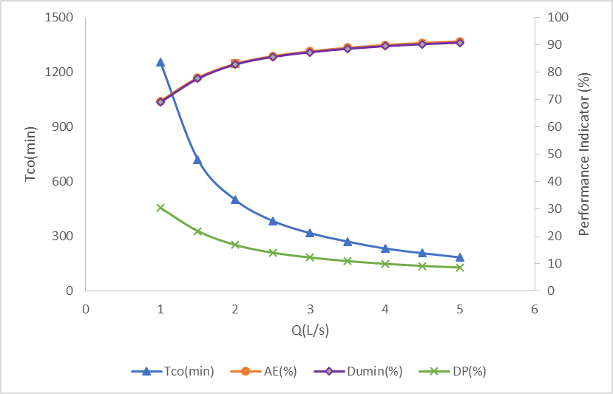

Fig 1: Performance indicators curves (First irrigation)

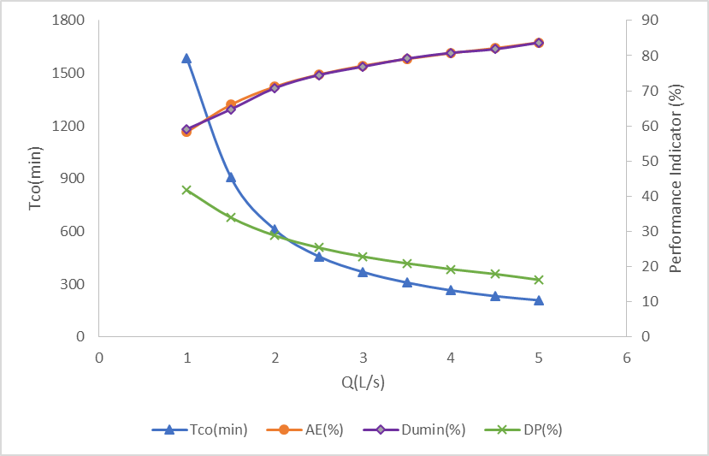

Fig 2: Performance indicators curves (second irrigation)

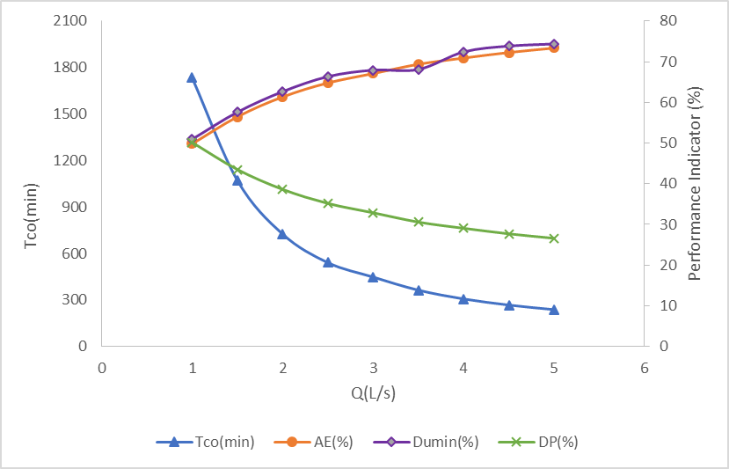

Fig 3: Performance indicators curves (third irrigation)

**4. Discussions**

The results showed that average values of AE, DU and DP for The three data sets for WinSRFR 4.1.3 were 8.26, 16.66 and 15.6% respectively. WinSRFR 4.1.3 software in all performance indicators simulated the AE more accurate than those from the other indicators. In this study, the results showed that WinSRFR 4.1.3 could be successfully used in determined performance indicators for sugarcane fields. According to unsuitable topography in some places, field has acceptable performance. Also, Simulation results by software showed that best performance within the irrigation because of to limit these fields, in the inflow of 3 L/s and the cutoff time of 379.5 minutes carried out.

**Corresponding Author:**

Reza Mazarei

Department of Irrigation and Drainage

Faculty of Water Sciences Engineering, Shahid Chamran University Ahvaz, Iran

E-mail: reza.mazarei1372@gmail.com

**References**

1. Akbar G., Ahmad M M., Ghafoor A., Khan M., & Islam Z. (2016). Irrigation Efficiencies Potential Under Surface Irrigation Farms In Pakistan. J. Engg and Appl. Sci. Vol. 35 No. 1 January-June 2016.
2. Anwar, A. A., Ahmad, W., Bhatti, M. T., and Haq, Z. U. (2016). “The potential of precision surface irrigation in the Indus basin irrigation system.” Irrig. Sci., 34(5), 379–396.
3. Bautista E, Clemmens AJ and Strelkoff TS, 2009. Modern analysis of surface irrigation systems with WinSRFR. Agricultural Water Management 96(7): 1146–1154.
4. Bautista E, Schlegel J.L and Strelkoff T.S (2012) WinSRFR 4.1 User manual. Arid land agricultural research center.
5. Bautista, E., Schlegel, J., and Clemmens, A. (2015). “The SRFR 5 modeling system for surface irrigation.” J. Irrig. Drain. Eng., 10.1061/(ASCE)IR.1943-4774.0000938, 04015038.
6. Chen B., Ouyang Z., and Zhang Sh. 2012. Evaluation of hydraulic process and performance of border irrigation with different regular bottom configurations, Journal of Resources and Ecology, 3 (2), 151-160.
7. Dalton P, Raine SR and Broadfoot K, 2001. Best management practices for maximizing whole farm irrigation efficiency in the Australian cotton industry. National Center for Engimeering in Agriculture Report 179707/2. USQ.
8. Elliot, R. L. and Walker, W. R. 1982. Evaluation of furrow infiltration and advance functions. Trans of the ASAE, Vol, 25(2): 396-400.
9. Gillies M H and Smith R J (2005) Infiltration parameters from surface irrigation advance and run-off data. Irrigation Science. 24(1): 25-35.
10. Gillies MH, Smith R J, Williamson B, Shanahan M (2010) Improving performance of bay irrigation through higher flow rates. australian irrigation conference and exhibition 2010 Sydney, nSW, australia, 8–10 June 2010.
11. Gonzlez, C., Cervera, L., and Fernandez, D.M. (2011). Basin irrigation design with longitudinal slope. Agricultural Water Management, 98, 1516–1522.
12. Gonzlez, C., Cervera, L., and Fernandez, D.M., Buil-Moure I., and Martenez-Chueca V. (2016). Optimization of Topography in Surface Irrigation, DOI: 10.1061/ (ASCE) IR.1943-4774.0001041. © 2016 American Society of Civil Engineers.
13. Koech, R.K., Smith, R.J., Gillies, M.H., 2014. A real-time optimisation system for automation of furrow irrigation. Irrig. Sci., http://dx.doi.org/10.1007/s00271-014-0432-6.
14. Merriam JL, Keller J, 1978. Farm irrigation system evaluation: a guide for management. Agricultural and Irrigation Engineering Department, Utah State University, Logan, UT.
15. Mahdizadeh Khasraghi, M., Gholami Sefidkouhi, M.A., Valipour, M., 2015. Simulation of open- and closed-end border irrigation systems using SIRMOD. Arch. Agron. Soil Sci. 61 (7), 929–941.
16. Morris, M. R., Hussain, A., Gillies, M. H., and Halloran, N. J. (2015). Inflow rate and border irrigation performance. Agricultural Water Management, 155, 76-86.
17. Strelkoff, T.S., Katopodes, N.D., 1977. Border-irrigation hydraulics with zero-inertia. J. Irrig. Drain. Div., ASCE 103 (3), 325–342.
18. Reddy, J.M., Jumaboev, K., Matyakubov, B., Eshmuratov, D., 2013. Evaluation of furrow irrigation practices in Fergana Valley of Uzbekistan. Agric. Water Manage. 117, 133–144.
19. Rodriguez, J. A. and J. C. Martos. 2008. SIPAR_ID: Freeware for surface irrigation parameter identification. J. Environmental Modelling and Software: 2 p. (In press).
20. Walker, W. R., and Humphreys, A. S. (1983). "Kinematic-wave furrow irrigation model." /. Irrig. And Drain. Energy, ASCE, 109(4), 377-392.
21. Walker, W. R. and Skogerboe, G. V. 1987. The theory and practice of surface irrigation. Logan, Utah, Chapter 8, Vol. Balance design, 81-87.
22. Wu, D., Xue, J., Bo, X., Meng, W., Wu, Y., and Du, T. (2017). Simulation of Irrigation Uniformity and Optimization of Irrigation Technical Parameters Based On the Sirmod Model under Alternate Furrow Irrigation. Irrig. Drain. DOI: 10.1002/ird.2118.

10/2/2017