Treatment of Displaced Fractures of the Middle Third Clavicle Using Percutaneous Elastic Stable Intramedullary Nails

Prof. Dr. Kamal Abdelrahman, Prof. Dr. Mahmoud Seddik and Wahid Fathy Mosaed Khalil

Orthopedic Surgery Department, Faculty of medicine-Al-Azhar University, Egypt
wahifathy@gmail.com

Abstract: Treatment of displaced middle third claviclular fractures using percutaneous elastic in tramedullary is an image dependant procedure indicated best for young medically free patients with acute simple 2 part fracture. Delay in surgery may necessitate open reduction. Hammering is not recommended to avoid dorsolateral cortex perforation. The most common complication is medial skin irritation which may end in skin perforation and this is because of the subcutaneous position of the clavicle and the sharp end of the cut nail. Removal of the nail is required after complete radiological union. Most of the cases included in the study had complete union within the follow up period and most of them had early excellent range of motion, strength and superior cosmesis.
[Kamal Abdelrahman, Mahmoud Seddik and Wahid Fathy Mosaed Khalil. Treatment of Displaced Fractures of the Middle Third Clavicle Using Percutaneous Elastic Stable Intramedullary Nails. Researcher 2017;9(10):1-6]. ISSN 1553-9865 (print); ISSN 2163-8950 (online). http://www.sciencepub.net/researcher. 1. doi:10.7537/marsrsj091017.01.

Keywords: Treatment; Displaced Fracture; Middle Third Clavicle; Percutaneous; Elastic Stable Intramedullary Nails

1. Introduction
In this study, Elastic stable intramedullary nailing (ESIN) is used which, is a minimally invasive procedure that provide a three-point fixation within the S-shaped clavicle and aims at exact restoration of the clavicular length with early return to full activity, with a good cosmetic result because of a smaller incision, less soft tissue dissection and relative stability that encourages callus formation. ⁽¹⁾

2. Methods
Methods of examination
Data were collected according to the following sheet.
- History
Personal data
History of the present symptoms
- Mechanism of injury.
- Presence of pain and swelling.
- Clinical examination
- Side affected.
- Dominant or non-dominant side.
- Presence of tenderness.
- Skin condition overlying the fracture.
- Presence or absence of associated vascular or neurological injuries.
- Other associated injuries.
- Radiological evaluation
An antero-posterior radiograph of the shoulder was obtained for all patients to assess the fracture type
Patients
This study was carried out on twenty patients with displaced fractures of the middle third of the clavicle presented to EL Hadra University Hospital and treated by percutaneous elastic intramedullary nails.
All data were collected about the studied patient as follow:
I. Demographic data
60% of patients were found between 20-35 years. The age of the studied sample ranged from 16 – 53 years with a mean of 26.40 ± 8.91years
85% of the patients were males (17 patients) and 15% of the patients were females (3 patients).
50% of the patients were hard duty workers (10 patients), while 50% (10 patients) were light workers.
II. Clinical data
All the patients were right handed, the right side (dominant) was affected in 13 patients (65%), while the left side (non-dominant) was affected in 7 patients.
One patient (5%) had associated ipsilateral fracture distal end radius and another one (5%) had associated ipsilateral fracture humerus and scapula, while the others (90%) were free.
Three patients (15%) had associated medical conditions, the first had hypertension and the second had diabetes mellitus and the third was mentally retarded.
The time lapse before surgery in the studied patients ranged from 1 day to 10 days with a mean 4.60 ± 2.93days.
Mechanism of injury
The commonest mechanism of injury was road traffic accidents (RTA) in 12 patients (60%), followed by falling down in 5 patients (25%), and lastly direct trauma in 3 patients (15%).
Fracture pattern:
According to Robinson classification 16 cases (80%) were type 2b1, 3 cases (15%) were type 2b2 and one case (5%) type 2a1.
Open reduction:
Open reduction was done in 6 cases (30%) out of 20 cases after failed closed reduction of fracture Steps of operation:
All patients were treated using percutaneous elastic stable intramedullary nails.
Anaesthesia and positioning

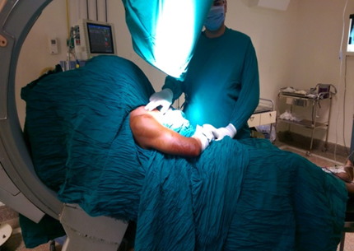
Figure (21): The patient is placed on a radiolucent operating table in the beach-chair position with an image intensifier from behind.

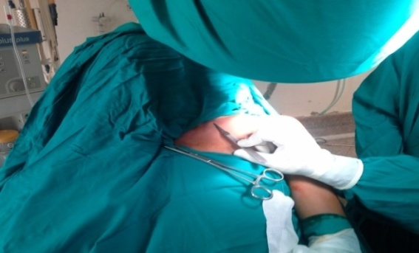
Figure (22): A short skin incision of about 1cm was made just lateral to the sternoclavicular joint.

Surgery was performed with the patient under general anaesthesia. Standard antibiotic single shot prophylaxis (Cefotaxime 1 g iv.) was given. The patient was placed on a radiolucent operating table in the semi setting (beach-chair) position with a small towel roll placed between the scapulae to provide extension of the shoulder girdle. It is important to scrub the whole ipsilateral upper extremity to allow free manipulation of shoulder and arm during surgery and to scrub the chest till the midline for the entry point. An image intensifier was used for the operation (Figure 21).
Skin incision
A short skin incision of about 1cm was made just lateral to the sternoclavicular joint centred above the medial end of the clavicle localised by image intensifier (figure 22,23,24).
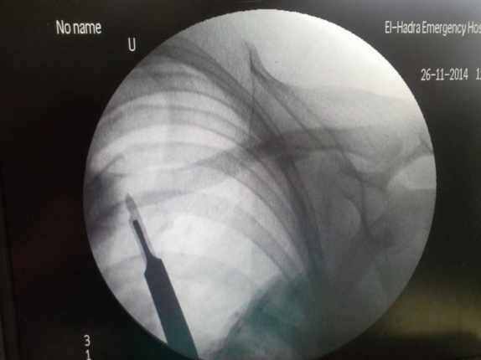
Figure (23): Skin incision localised by image intensifier.

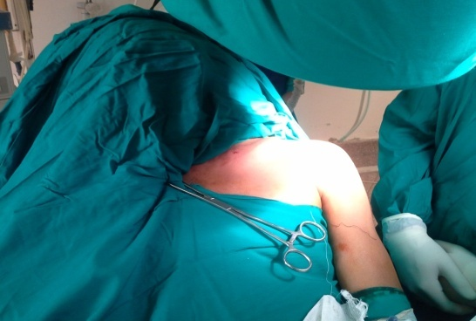
Figure (24): Short skin incision

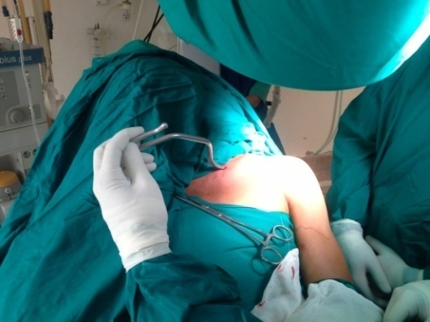
Figure (25): The medullary cavity of the clavicle was opened using an awl.

Procedure
The medullary cavity of the clavicle was opened using an awl about 1cm lateral to the sternoclavicular joint. The awl was pointed laterally in-line with the clavicle and angled at about 30% to the coronal plane. Care was taken not to perforate the dorsal cortex in order to avoid major complications (figure 25).
Once the medullary cavity was opened, a preselected TEN was carefully inserted (The size of the nail was measured using this formula = 0.4 × canal diameter in mm). The implanted nails had diameters between 2.0 and 3.0 mm according to the patient’s dimensions. The nail was fixed in a universal chuck with a T handle and advanced with oscillating movements till reached the fracture site (figure 26).
Once the Ti nail reached the fracture site closed reduction by direct pressure on the fragments combined with manipulation of the arm was performed. Usually reduction was facilitated when a small pointed reduction forceps was applied percutaneously to the lateral fragment (figure 27).

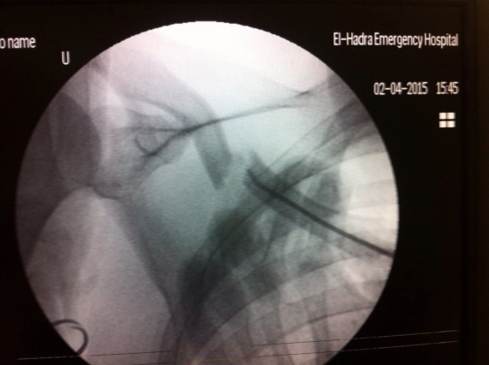
Figure (26): TEN reached the fracture site.

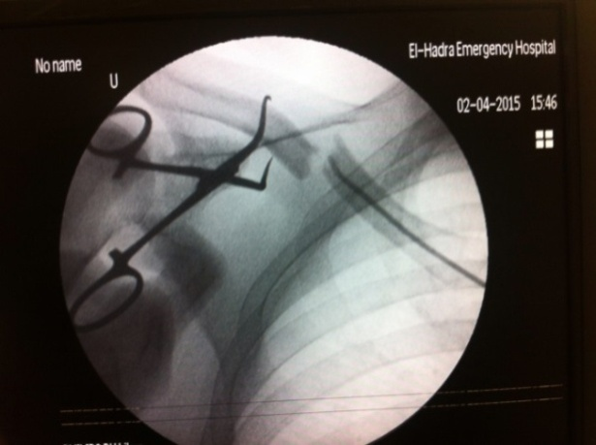 | 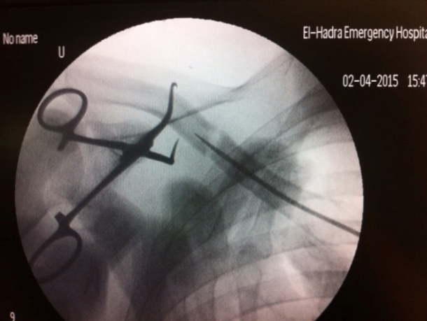
Figure (27): Usually reduction was facilitated when a small pointed reduction forceps was applied percutaneously to the lateral fragment.

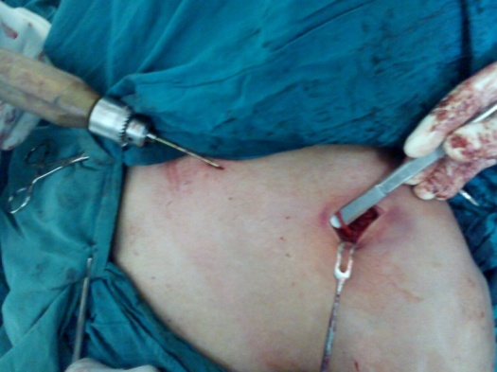
Figure (28): A 2 cm incision over fracture site showing supraclavicular nerve.

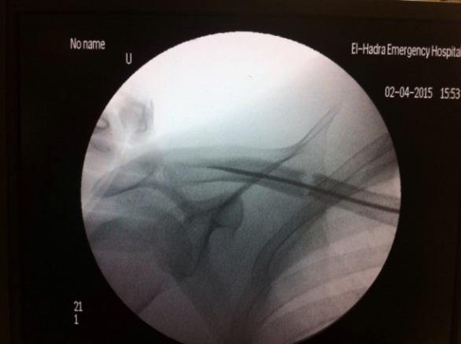
Figure (29): The nail was then pushed into the distal part of the clavicle close to its extremity.

In some cases closed reduction may not be accomplished. In these cases a short incision directly over the fracture site (2 cm) with minimal dissection (to avoid injury of the supraclavicular nerve) is suggested to reduce the fracture (figure 28).
The nail was then pushed into the distal part of the clavicle close to its extremity. Care was taken to avoid perforation of the dorsolateral cortex of the lateral clavicle, particularly when a hammer was used (figure 29).
The protruding medial end of the nail was left out of the cortex and shortened close to its entry point into the bone followed by wound closure (figure 30).

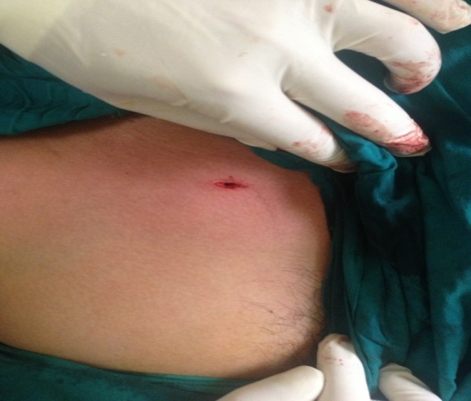
Figure (30): Medial end of nail cut close to its entry point into the bone.

Closure
Closure of skin was performed by single simple interrupted suture using 3-0 prolene or using steri-strips, In case of open reduction a standard closure of the other wound was then performed in layers using 2-0 absorbable sutures for the myofascia and subcutaneous tissue then subcuticular stitch for the skin. After the surgery the patient was placed in a sling.

Follow up
Results were assessed at the end of this period according to Constant and Murley Score (CMS): ⁽⁶³⁾
The CMS is a 100-point functional shoulder-assessment tool in which higher scores reflect increased function. It combines four separate subscales: subjective pain (15 points), ADL; Activity of Daily Living (20 points), objective clinical assessment of range of motion (40 points), and strength (25 points).

3. Results
Final Score
At the end of the follow up period, the mean score was 95.70 ± 13.55 ranging from 48 to 100 according to the Constant and Murley shoulder score. Eighteen patients (90%) had excellent results, one patient (5%) had adequate result, and one patient (5%) had poor result.

Pain
At the end of the follow up period, the mean final constant score for pain was 14.50 ± 2.24 ranging from 5 to 15. all patients had no pain except one had moderate pain.

Activity of Daily living
Activity of daily living was 18.80 ± 3.69 ranging from 8 to 20. Only 2 patients out of 20 didn’t have full work and recreation.

Range of motion
- Active forward flexion
At the end of the follow up period, the mean final Constant score for active forward flexion was9.60 ± 1.39 (145-174○) ranging from 4 to 10. eighteen patient had excellent results, on patient had range bet. 121-150, and one patient had range bet. 61-90.
- Active Abduction
At the end of the follow up period, the mean final Constant score for active abduction was 9.60 ± 1.39 (145-174○ ) ranging from 4 to 10. eighteen patient had excellent results, on patient had range bet. 121-150, and one patient had range bet. 61-90.
- Active external rotation
At the end of the follow up period, the mean final Constant score for active external rotation was 9.60± 1.23 ranging from 6 to 10. only 2 patients had their hand on top of head with elbow held forward.
4-Active internal rotation
At the end of the follow up period, the mean final Constant score for active internal rotation was 9.60 ± 1.23 ranging from 6 to 10. Only 2 patients had their dorsum of hand to waist.

Strength
At the end of the follow up period, the mean final constant score for strength was 24.0 ± 3.08 ranging from 15 to 25.

Union
Time of union in the studied patients ranged from 8 weeks to 12 weeks with a mean 10.0 ± 1.33 weeks with an exception of one case which, presented with hypertrophic non-union.

4. Discussion
Plate osteosynthesis is the standard operative treatment. Currently, the implants most commonly used are either dynamic compression or locking plates. Reconstruction plates have fallen into disfavour, since they are susceptible to deformity at the fracture site, leading to mal-union. Site-specific precontoured locking plates have recently been introduced, and they be less prominent after healing, leading to lower rates of hardware removal after union. ^{(2,3)}.
The complications related to the use of plate fixation are infection, plate failure, hypertrophic or dysesthetic scars, implant loosening, non-union, refracture after plate removal, and very rarely intraoperative vascular injury. ⁽⁴⁾
A variety of intramedullary devices including Knowles pins, Kirschener wires, Hagie pins and Rockwood pins have been used. ⁽⁵⁾ Implant migration with fatal complications, implant failure and mal- and non-unions have been mentioned as complications. ⁽⁶⁾
To overcome the disadvantages of previously described methods minimally invasive ESIN was established as an alternative to plate fixation. Jubel et al. ⁽⁵⁾ showed that the correction of clavicular shortening is a prerequisite of good functional outcome. They did not observe nonunion or poor postoperative outcome. In this study, intramedullary nailing provided early functional recovery in all patients. Patients today have high expectations of the functional outcome. They expect rapid and pain-free functional recovery following a fracture.
In contrast to conservative treatment, minimally invasive techniques can fulfil these objectives with a reduced risk of complications. As a result, the mean period of disability is short.
In our study 20 patients were included with a mean age of 26.40 ± 8.91 years, 17 patients (85%) were males and 3 patients (15%) were females. Three patients (15%) had associated medical conditions, the first had hypertension, the second had diabetes mellitus and the third was mentally retarded. The time lapse before surgery in the studied patients ranged from 1 day to 10 days with a mean 4.60 ± 2.93 day. Open reduction was done in 6 cases (30%) out of 20 cases after failed closed reduction of fracture. Time of union in the studied patients ranged from 8 weeks to 12 weeks with a mean 10.0 ± 1.33 weeks with an exception of one case which presented with hypertrophic non-union. The final Constant score after 6 months was 95.70 ± 13.55. 18 patients had excellent result, 1 patient had adequate result and 1 patient had poor results.
Regarding the age, there was statistically significant relationship between age andthe final score. In comparison to Jubeland Christoph studies were all their patients are young athletes, the mean age in our study for the excellent results was 24.44 years and that for adequate results was 53.0 years, while that for the poor results was 35.0. This concludes that the outcome of young is better than elderly patients.
Also, the associated medical condition showed statistically significant relationship with the final score. In comparison to the other studies were the patients were athletic with no mentioned medical morbidity, patients in our study showed associated medical conditions; the patient with poor result was uncontrolled diabetic, while that with adequate result was hypertensive. As a result, the medical condition has an effect on final score of patients.
There were 5 patients with complications in our study;2 patients (10%) developed medial end skin irritation, one of them had to remove the nail, while the other improved within 2 weeks of medical treatment, 2 patients (10%) presented with dorsolateral migration of the nail which was followed up until removal of the nail and lastly one patient (5%) presented with hypertrophic non-union.
Main advantage of our technique is that itprovides more rapid free movement of the shoulder and an earlier return to daily activities than the conservative treatment. In comparison with plate fixation, the procedure is less invasive and requires smaller incisions with superior cosmesis.
However, this study had some limitations:
- The study was conducted only on twenty cases.
- It was a randomized prospective study with no control group.
- Short duration of follow up.

Conclusion
Treatment of displaced middle third claviclular fractures using percutaneous elastic intramedullary is an image dependant procedure indicated best for young medically free patients with acute simple 2 partfracture. Delay in surgery may necessitate open reduction. Hammering is not recommended to avoid dorsolateral cortex perforation. The most common complication is medial skin irritation which may end in skin perforation and this is because of the subcutaneous position of the clavicle and the sharp end of the cut nail. Removal of the nail is required after complete radiological union. Most of the cases included in the study had complete union within the follow up period and most of them had early excellent range of motion, strength and superior cosmesis.

Authors:
Prof. Dr. Kamal Abdelrahman, Prof. Dr. Mahmoud Seddik and Wahid Fathy Mosaed Khalil
Orthopedic Surgery Department, Faculty of medicine-Al-Azhar University, Egypt
wahifathy@gmail.com

References
- Meier C, Grueninger P, Platz A. Elastic stable intramedullary nailing for midclavicular fractures. Acta Orthop Belg 2006; 72(3):269-75.
- Canadian Orthopaedic Trauma Society. Non-operative treatment compared with plate fixation of displaced midshaftclavicular fractures. A multi-centre, randomised clinical trial. J Bone Joint Surg Am 2007;89(1):1-10.
- Huang JI, Toogood P, Chen MR, Wilber JH, Cooperman DR. Clavicular anatomy and the applicability of precontoured plates. J Bone Joint Surg Am2007;89A:2260-5.
- Bostman O, Manninen M, Pihlajamaki H. Complications of plate fixation in fresh displaced midclavicular fractures. J Trauma 1997;43:778-83.
- Jubel A, Andermahr J, Schiffer G, Tsironis K, Rehm KE. Elastic stable intramedullary nailing of midclavicular fractures with a titanium nail. Clin Orthop 2003; 408:279-85.
- Schwarz N, Leixnering M. Failures of clavicular intramedullary wire fixation and their causes. Aktuelle Traumatol 1984; 14: 159-63.

9/25/2017

