**Preference Of Nesting Material By Village Weaver Birds *(Ploceus Cucullatus)* In University Of Port Harcourt, Nigeria**

1 Efenakpo, O. D., 1 Ijeomah, H. M. And 2 Bunza, M. S.

1 Department of Forestry and Wildlife Management, University of Port Harcourt, P. M. B. 5323 Port Harcourt, Nigeria.

2 Department of Forestry and Environment, Usmanu Danfodiyo University, Sokoto, P. M.B 2346 Sokoto, Nigeria.

[ogaga.efenakpo@uniport.edu.ng](mailto:ogaga.efenakpo@uniport.edu.ng)

**Abstract:** The destructive nesting and feeding behaviour of Village Weavers is worrisome due to the detrimental nature to both agricultural production and scenic beauty of many environments. Preference of nesting material by Village Weaver birds *(Ploceus cucullatus)* in University of Port Harcourt, Nigeria was therefore studied from 2nd January to 31st March, 2017, using on-site surveys and observations, with the aim of investigating the nesting materials, colony size and spatial distribution of the species’ nest in the University of Port Harcourt. Data obtained were presented in frequency of counts and maps. Results showed that a total of 23 trees of 9 species from eight families were colonized by Village Weavers and these trees had a cumulative number of 1414 active nests. *Mangifera indica* (576) was the most colonized tree species, followed by *Terminalia mantaly* (285) and *Casuarina equisetifolia* (272) while *Dypsis lutescens* (12)had the least numbers of nests. Twenty out of the twenty three trees used for nest support were in Human – inhabited areas. Materials for nest - building were sourced from a total of 20 plant species. The leaves and inflorescence were the parts of plants mostly used for nest – making. The survey showed that Village Weaver can use many plant species for nesting and nest support and preferred human – inhabited area as for location. The use of plant species by Village Weavers is based on availability, however preference is made in the presence of many species. *Mangifera indica* is the most preferred nest – building support in Abuja campus, *Casuarina equisetifolia* in Choba campus and *Terminalia mantaly* at Delta campus. Some plant species such as *Azadirachta indica* (50%)and *Terminalia catappa (*24.07%)were neither used for nest building nor support by *Ploceus Cucullatus* but used for roosting. Village Weaver is a generalist feeder and highly adaptive –the species can share nest support with other species of bird.

[Efenakpo, O. D.,Ijeomah, H. M. And Bunza, M. S.. **Preference Of Nesting Material By Village Weaver Birds *(Ploceus Cucullatus)* In University Of Port Harcourt, Nigeria .** *Researcher* 2017;9(9):78-85]. ISSN 1553-9865 (print); ISSN 2163-8950 (online). <http://www.sciencepub.net/researcher>. 11. doi:[10.7537/marsrsj090917.11](http://www.dx.doi.org/10.7537/marsrsj090917.11).

**Keywords:** Aves, Nest, Ornithology, Trees, Vermin control

**Introduction**

The Village Weaver (*Ploceus cucullatus*) is a passerine bird that is endemic to the sub–Sahara African region (Barlow *et al.,* 1997) and was also introduced to Mauritius and Hispaniola regions. *Ploceus cucullatus* is a stout looking black and yellow weaver measuring 15–17 cm with a strong conical beak and dark reddish eyes. The species is a sexually dimorphic weaver bird. The black colour on breeding male’s heads varies in geographical location and breeding season. The breeding males found in northern part of its range have a black head edged by chestnut conspicuous at the nape and chest while the visibility of the black colour and chestnut diminishes for the individuals in the southern part of its range. The breeding males of the southernmost subspecies only have a black face and throat, while the nape and crown are yellow (Borrow and Demey, 2004; Eltahir and Hamed, 2016). The non-breeding male has a lemon-yellow throat with variable under parts (white or yellow). The adult female has yellow-olive head with brownish-olive upper parts, yellow and black wings, and pale yellow under parts. Young *Ploceus cucullatus* are like the adult female but browner on the back (Borrow and Demey, 2004).

Village Weavers are well known for their ability to weave elaborate nest with various plant materials and during the breeding seasons the number of nest increases tremendously. The University of Port Harcourt environment is highly fragmented and the populations of *Ploceus cucullatus* have adapted tremendously to the changing habitat. They are the most abundant birds in the university (Ijeomah *et al.,* 2013), nesting on *Cocos nucifera, Mangifera indica, Polyalthia longifolia, Roystonea regia, Casuarina equisetifolia*, *Mangifera indica, Elaeis guineensis* and *Eucalyptus camaldulensis* (Aiyeloja and Adedeji, 2015). There is dearth of information on Village Weaver nesting behaviour and the nesting materials used for nest making in the University of Port Harcourt. Although the impact of weaver birds’ nesting on the ornamental trees shade management and the ecological survey of avifaunal resources in the University of Port Harcourt have been carried out by Aiyeloja and Adedeji (2015) and Ijeomah, *et al.,* (2013) respectively, none of the work focused on the nesting materials, tree species preference and behaviour of the village weaver in the university. An understanding of the nesting behaviour of the species in terms of plant species used as nest support, and materials harnessed for nest making is very important for effective control of *Ploceus cucullatus* as a vermin in the university*.*

This study therefore seeks to map out the spatial distribution of Village Weaver nest, colony size and nesting materials in the university.

**Materials And Methods**

**Study Area**

The study was conducted at the University of Port Harcourt River state. The university lies on latitude 4 o 53' 14''N through 4 o 54' 42''N and longitude 6 o 54' 00''E through 6 o 55' 50''E and has three campuses: Choba (Latitude 4o 53’ 30’’ and 4o 53’ 55’’N and Longitude 6 o 54’ 20’’ and 6 o 54’ 45’’E), Delta (Latitude 4 o 53’ 55’’ and 4 o 54’ 15’’N and Longitude 6 o 54’ 00’’ and 6 o 54’ 25’’E), and University Park (Latitude 4 o 53’ 25’’ and 4 o 54’ 35’’N and Longitude 6 o 54’ 25’’ and 6 o 55’ 55’’E) which are separated by two main road networks: the east west road and Aluu road (Ijeomah *et al.,* 2013; Aiyeloja and Adedeji, 2015). Figure 1 shows the university map and the three campuses.



Fig 1: Map of University of Port Harcourt

Source: Ijeomah *et al.,* 2013

**Data Collection and Analysis**

Data for the study were collected through observation and counting of the evidence of Villager Weaver’s presence in the study area. Intensive Village Weaver colony searching was carried out in the three campuses of the study area between 6.00 a.m. to 7.30 a.m. for the morning hours and 4.30 p.m. to 6.00 p.m. for the evening hours. The search for Village Weaver and its colonies was conducted from January 2nd to March 31st 2017 being a period of three months. While scanning the study area for colonies of weaver bird (using Binoculars of 10 x 36) moving flocks of the species were closely monitored as that provided clues about the birds’ nesting location and materials. Trees with colonies of Village Weaver were identified for data collection. The numbers of nest on colonized trees were counted (Point count method). Nest of Village Weavers were collected from colonized trees and taken to the laboratory to determine the plant materials used for nesting. The exact geographical location of each tree colonized by village weaver was taken using Garmin etrex GPS and the locations were mapped out to show the spatial distribution of the colonies. Data collected were analysed using descriptive statistics.

**Results**

**Colony size and tree species colonized**

**Table 1: Trees Species supporting nests of Village Weavers in the University of Port Harcourt**

|  |  |  |  |
| --- | --- | --- | --- |
| **Tree species** | **Family** | **No of trees** | **Shared** |
| **Choba Park** |  |  |  |
| *Casuarina equisetifolia* | Casuarinaceae | 3 | **Shared |
| *Eucalyptus camaldulensis* | Myrtaceae | 1 | Not shared |
| *Gmelina arborea* | Verbenaceae | 2 | **Shared |
| **DeltaPark** |  |  |  |
| *Terminalia mantaly* | Combretaceae | 3 | **Shared |
| **University Park** |  |  |  |
| *Mangifera indica* | Anacardiaceae | 6 | **Shared |
| *Terminalia mantaly* | Combretaceae | 2 | **Shared |
| *Delonix regia* | Fabaceae | 1 | Not shared |
| *Elaeis guineensis* | Arecaceae | 2 | Not shared |
| *Dypsis lutescens* | Arecaceae | 1 cluster | Not shared |
| *Bambusa vulgaris* | Poaceae | 1 cluster | Not shared |
| *Gmelina arborea* | Verbenaceae | 1 | Not shared |
| **Total** | **9 families** | **23** |  |

**Shared: Trees that have nest of other bird species

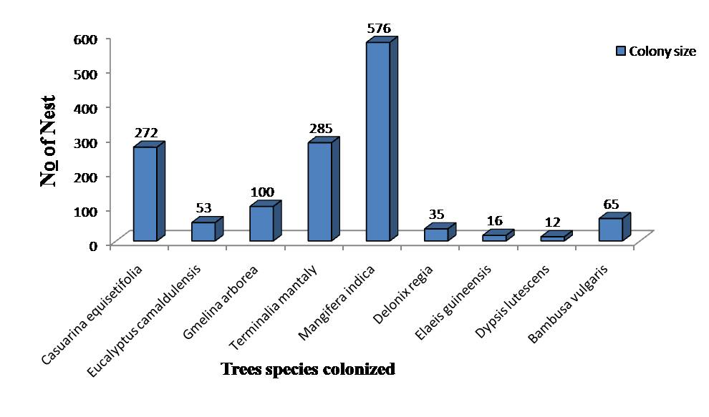

Figure 2: Plants species used for colonies

The results of colony size and tree species colonized by Village Weaver are presented on Table 1 and Figure 2. Table 1 show that a total of 23 trees of nine species from eight families were colonized and these plants had a cumulative number of 1414 active nests of Village Weaver. Five out of the 23 tree species were shared for nesting by other avian species such as the *Milvus migrans, Ploceus nigerrimus,* and *Spermestes cucullatus.* The most colonized plant species was *Mangifera indica* (576), followed by *Terminalia mantaly* (285) while *Dypsis lutescens* was the least (12) (Figure 2).

**Species Used as Nest Building Material (SUANBM)**

The results on species used as nest building material are presented on Table 2, Figure 3 and Plate 1. Table 2 shows that a Village Weaver sources nesting materials from a total of 20 plant species - the leaves and inflorescence are the parts used for nest – making. As presented in Figure 3, the species utilized for nest – making by the species belong to a total of 10 families. Most prominent among the families are Arecaceae (35%) and Poaceae (25%) were the most frequently used plant families while other families such as Verbenaceae, Fabaceae, Musaceae, Myrtaceae, Anacardiaceae, Annonaceae, Casuarinaceae and Combretaceae were represented by a single plant species (Figure 3). Plate 1 shows pictures of some species used for nest – making by the Village Weaver.

**Table 2: Plants species and parts used for Nesting**

|  |  |  |
| --- | --- | --- |
| **S/N** | **NBMS** | **Part Used** |
| 1 | *Elaeis guineensis* | Leaves |
| 2 | *Cocos nucifera* | Leaves |
| 3 | *Mangifera indica* | Leaves |
| 4 | *Polyalthia longifolia* | Leaves |
| 5 | *Caryota mitis* | Leaves |
| 6 | *Roystonea regia* | Leaves |
| 7 | *Casuarina equisetifolia* | Leaves |
| 8 | *Musa paradisiacal* | Leaves |
| 9 | *Terminalia mantaly* | Leaves |
| 10 | *Panicum maximum* | Leaves & Inflorescence |
| 11 | *Dypsis lutescens* | Leaves |
| 12 | *Eucalyptus camaldulensis* | Leaves |
| 13 | *Unknown exotic palm\*\** | Leaves |
| 14 | *Setaria longiseta* | Inflorescence |
| 15 | *Delonix regia* | Leaves & flowers |
| 16 | *Eleusine indica* | Inflorescence |
| 17 | *Gmelina arborea* | New leaves |
| 18 | *Raphia hookeri* | Leaves |
| 19 | *Kyllinga bulbosa* | Leaves & Inflorescence |
| 20 | *Bambusa vulgaris* | Leaves |



Figure 3: Plant families used for Nest making

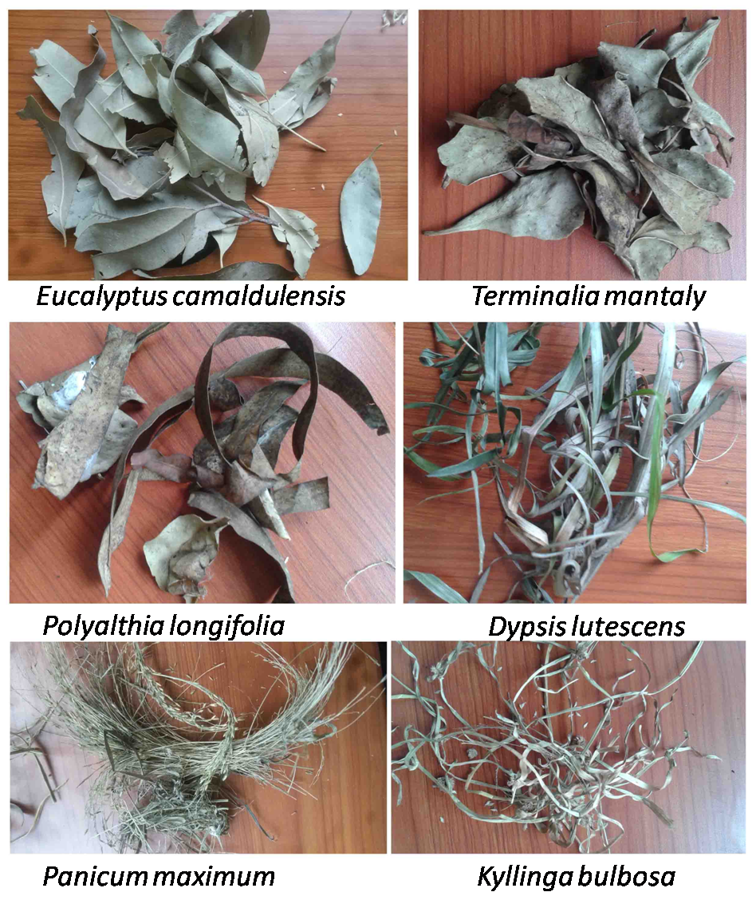

Plate 1: Some of the Nest building Material Species (NBMS)

**Tree species used for roosting**

Result on tree species used for roosting or feeding is presented on Table 3. The results show that Village weaver roost on 6 tree species belonging to 6 families. The most frequently utilized tree was *Azadirachta indica* (50%) while *Chrysophyllum albidum* (3.70%)and *Anacardium occidentale* (3.70%) were respectively the least utilised.

**Table 3: Trees Species used by Village weaver for Roosting or Feeding**

|  |  |  |  |  |
| --- | --- | --- | --- | --- |
| **S/N** | **Tree species** | **Plant Family** | **Frequency** | **Relative frequency** |
| 1 | *Azadirachta indica* | Meliaceae | 27 | 50.00 |
| 2 | *Terminalia catappa* | Combretacea | 13 | 24.07 |
| 3 | *Chrysophyllum albidum* | Sapotaceae | 2 | 3.70 |
| 4 | *Psidium guajava* | Myrtaceae | 7 | 12.96 |
| 5 | *Hura crepitans* | Euphorbiacea | 3 | 5.56 |
| 6 | *Anacardium occidentale* | Anacardiaceae | 2 | 3.70 |

**Spatial Distribution of Trees Supporting Nest of Village Weaver**

Results of the spatial distribution of trees supporting nest of Village Weavers are presented on Table 4 and Figure 5. A total of 23 trees housed colonies of village weaver while 4 *Elaeis guineensis* were abandoned colonies. Twenty of the trees were in areas inhabited by Human while only 3 trees were in non-human inhabited area. No active village weavers’ colonies were found in the secondary forest.

**Table 4: Distributions of Colonized Trees in Human and Non-Human Habitation**

|  |  |  |  |  |  |  |  |
| --- | --- | --- | --- | --- | --- | --- | --- |
| **Human habitation** | | | | | | **Non-Human Habitation** | |
| **SH** | **LH** | **CP** | **WC** | **OB** | **S** | **FL** | **SF** |
| *Terminalia mantaly* (3)*, Elaeis guineensis* (2)*, Mangifera indica* (1)*, Dypsis lutescens* (1 cluster) | *Terminalia mantaly* (1)*, Mangifera indica* (1) | *Casuarina equisetifolia* (3)*, Eucalyptus camaldulensis* (1) | *Mangifera indica* (3) | *Terminalia mantaly* (1)*, Delonix regia* (1) *Gmelina arborea* (1) | *Mangifera indica* (1)*,* | *Gmelina arborea* (2)*, Bambusa vulgaris* (1 cluster) | *Elaeis guineensis* (4)*,* |
| 7 | 2 | 4 | 3 | 3 | 1 | 3 | 4** |

**SH**: Students’ Hostel, **LH:** Lecture Hall, **CP:** Car Parks, **OB**: Office Block, **FL** Farmland, WC: Worship Centre, **S:** Shop**, SF:** Secondary Forest. **Abandoned colonies

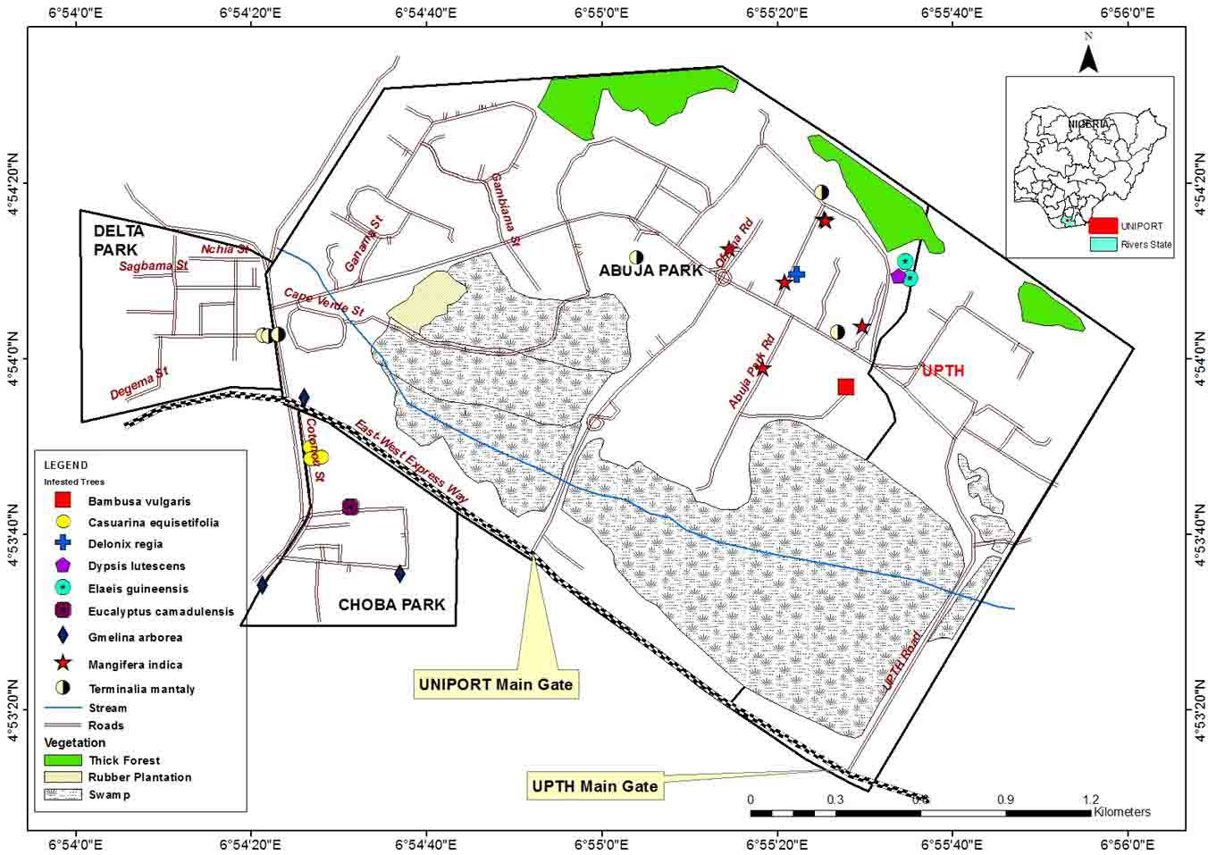

Figure 5: Spatial distribution of trees with active village weaver colonies in University of Port Harcourt

**Discussion**

Village Weavers are highly adaptive birds and they make use of various tree species for nesting support (Table 1). *Mangifera indica* wasthe most used plant species for nest support in the study area. This could be attributed to the fact that *Mangifera indica* is the only edible fruiting tree among the trees used in the study area, and one of the most abundant plant species in the human habitation of the study area. This result agrees with the findings of Aiyeloja and Adedeji (2015) that identified the family, Anacardiaceae as the dominant nest building supporting species (NBSS). It is also worthy to note that *Ploceus cucullatus* exhibited varying preferences for NBSS in the three campuses- *Mangifera indica* is the most preferred species in Abuja campus, *Casuarina equisetifolia* in Choba campus and *Terminalia mantaly* at Delta campus. This reveals that Village weavers are capable of utilizing any available trees. This result varies with that of Aiyeloja and Adedeji (2015), and this difference is due to the felling of trees (such as *Eucalyptus camaldulensis* and *Terminalia catappa* at Choba campus and *Casuarina equisetifolia* at Delta campus that once supported Village Weavers) by the University of Port Harcourt Campus Environmental Beautification and Sanitation Unit (CEBAS).

Village weavers’ ability to quickly colonize other available tree species is evident in *Ploceus cucullatu*s’ growing numbers on *Terminalia mantaly,* a species that were never reported to have been colonized in the study area. The preference for nest supporting trees is made when there are many available species but in the absence of preferred species for nest –building support whatever species that is available could be used by *Ploceus cucullatu*s. Majority of the trees supporting nests of *Ploceus cucullatus* (including all individuals of the most preferred species in the three campuses) were at the same time used as nest supports by other bird species (Table 1). This can be attributed to the fact that Village Weavers co-exist with other bird species – a survival trait for highly adaptive species: Up to three different species of weaver have been frequently observed in colonies in many areas of southern Nigeria. Also, weavers have been frequently observed in colonies with raptors such as the black kite – species that feed on chicks of weavers, and defends the species from snakes (the most frequent predator of weaver birds). Lahti (2003) obtained similar result. Eltahir and Hamed (2016) have confirmed the observation of black kite (*Milvus migrans*) nest around the colony of *Ploceus cucullatus.* Sharing of nest support with many bird species shows that birds as a group have diverse niches (Nason, 1992). Also, it can be due to scarcity of relatively good support in the environment. This is evident in the fact that 6 *Mangifera indica* trees supported 572 active nests (about 100 nests per plant) in Abuja campus alone (Figure 2).

The parts of plant mostly used by Village weavers for nest – making was the leaves and inflorescences (Table 2). These parts are easy to collect in bits and more flexible to work with. These nest - building materials were mostly collected from the families of Arecaceae and Poaceae (in addition to all the plants supporting their nest (Figure 3). The materials are collected based on the nature and structure (Plate 1). This result is in partial congruity with the report of Aiyeloja and Adedeji (2015) that weaver birds showed special preference for Arecaceae and Annonaceae families as NBMS in the study area. The families of Arecaceae and Poaceae always form part of the nest because of their relatively high availability in the study area and the fibrous nature of the leaves to withstand weathering conditions. Family of Poaceae are grass-like in nature and commonly used for building thatch houses (by humans), which is synonymous with nest construction. Some plant species such as *Azadirachta indica* and *Terminalia catappa* were neither used for nest supporting nor NBMS but often visited by flocks of Village Weavers for roosting or feeding (Table 3). Village weavers have been observed feeding on fruits of *Terminalia catappa.* The spatial distribution of the trees colonized by *Ploceus cucullatus* shows their preference for human habitation and agricultural farmlands relative to the secondary forest of the study area (Table 4). This suggests a survival strategy to enable the species feed on human waste and wade off intruders such as snakes. Lahti *et al* (2002) obtained a similar result.

**Conclusion**

Village weaver can use any available species in the University of Port Harcourt especially in human inhabited areas. Although their life activities such as feeding and nest building are capable of causing economic and environmental damage to man and the environment they are also important as food, pollinators and for monitoring changes in environmental conditions as birds are generally good indicators of habitat health and conditions. To effectively manage the pest and vermin nature of Village Weavers the species should be periodically culled as changing plant types in and around the nesting sites could not effectively control the destructive activities of the species.

**References**

1. Aiyeloja, A. A. and Adedeji, G. A. (2015). Impact of weaver birds (*Ploceus cucullatus* Muller) nesting on the ornamental trees shade management in the University of Port Harcourt, Nigeria. *Researcher* 7(4):49-54.
2. Barlow, C., Wacher, T. and Disley, T. (1997). *A Field Guide to the Birds of the Gambia and Senegal.* Pica Books, Mountfield, U.K.
3. Barrow, N. and Demey, R. (2004). *Birds of Western Africa,* Princeton University Press, Princeton, New Jersey. 511pp.
4. Eltahir N. B. and Hamed, D.M. (2016). Breeding habits and nesting success of the Village Weaver *Ploceus cucullatus*, at Khartoum, Sudan*, International Journal of Science and Research* 5 (7): 2236- 2238. DOI: 10.21275/v5i7.ART2016731.
5. Ijeomah, H. M., Chima, U. D. and Okagbare, O. H. (2013). Ecological survey of avifaunal resources in University of Port Harcourt, Nigeria. *Ethiopian Journal of Environmental Studies and Management*, 6(6): 648-660.
6. Lahti, D. C., (2003). A case study of species assessment in invasion biology: the Village Weaverbird *Ploceus cucullatus*. *Animal Biodiversity and Conservation*, 26.1: 45–55.
7. Lahti, D. C., Lahti, A. R. and Dampha, M., (2002). Nesting associations of the village weaver (*Ploceus cucullatus*) with other animal species in the Gambia. *Ostrich*, 73: 59–60.
8. Nason, A (1992). Discovery Birds, Pisces Publication, United Kingdom. 104pp.

9/25/2017