Traditional Herbal Use and Combination with Orthodox Medicine for Health Care Management in Ibadan, South-western Nigeria.

Ogunsola, O.K and Egbewale, S.O

Department of Botany, University of Ibadan, Ibadan, Nigeria
Ogunsola.okay@gmail.com; +2347065335148

Abstract: This present study examines the use of traditional herbs and combination with orthodox medicine through the use of interview and well structured questionnaires among 104 respondents in Ibadan, South-western Nigeria. Major findings include; (1) 85% of the respondents agreed to the use of herbs and related products. The high dependency on herbal medicine is linked to its relative affordability, acclaimed efficacy and perceived safety by users. (2) 50% of respondents consented to combining herbs and orthodox medicine to aid or accelerate recovery. The rise in the prevalence of chronic diseases, high costs of treatments and unlikely cure has led not only to increase in herbs’ patronage but also combination with conventional medicine for health care delivery in this area. The search for cure by all means has led to partial dependency on what conventional medicine has to offer. (3) Occupation was found to significantly influence level of herbal usage and its combination with orthodox medicine. Considering the Minimum wage (Salary) of average Nigerian worker #18,000 (about $50), it is therefore suffice to know why the majority of the populace have embraced the consumption of herbal products which are relatively considered cheap, affordable and not unreachable. Our observations therefore underscore the importance of traditional medicine as a subsystem of the health delivery.
[Ogunsola, O.K and Egbewale, S.O. Traditional Herbal Use and Combination with Orthodox Medicine for Health Care Management in Ibadan, South-western Nigeria.. Researcher 2017;9(9):72-77]. ISSN 1553-9865 (print); ISSN 2163-8950 (online). http://www.sciencepub.net/researcher. 10. doi:10.7537/marsrsj090917.10.

Keywords: Herbs; orthodox medicine; combination; occupation; Nigeria.

1. Introduction
Traditional medicine according to WHO (2003) is described as knowledge and belief systems which use minerals, plants and animal based remedies, spiritual therapies and exercises to prevent, treat and maintain well being. Reports have shown that 80% of world’s population relies on traditional medicines with medicinal plants predominantly (Ernst, 2005). Over 35,000 of plant species medicinal usage have been well documented with a boom in its sales to the tune of US$ 40 billion (Bandaranayake, 2006).
The utilization of medicinal plants is a major part of African heritage. In Nigeria, the majority of citizens still use medicinal plants and visit traditional medicine practitioners for their health care need (Odugbemi, 2006). Lack of medical facilities, poverty, affordability, accessibility and inherent trust in the practice are some of reasons for its continuous usage in this decade. A report by WHO showed Nigerians patronise Traditional Medicine Practitioners (TMPs) for their primary health needs more than orthodox medical doctors as there exists ratio 1:110 of Traditional Health Practitioners to Nigerian population while the ratio of Medical Doctors to the population is 1:16, 400 (African Health Monitor, 2003).
Ibadan, the capital city of Oyo State in the south-western Nigeria is located 128 km inland northeast of Lagos and 530 km southwest of Abuja, the federal capital city. It has a population of 2,338,659 according to the 2006 census and is the largest Nigerian metropolitan geographical area (3080 km²) (FRNOG 2007). This city has a tropical wet and dry climate, with a lengthy wet season and relatively constant temperatures throughout the course of the year with a mean total rainfall of 1420 mm, mean maximum temperature of 26°C (minimum 21°C), and a relative humidity of 75%.
The primary health care sector in the 11 Local Government present in Ibadan is not capable of catering for everyone within this ancient city due to population explosion, poor funding and lack of basic equipments. Thus, makes the demand for herbs to gain a strong acceptance for health care needs. Also, combinations of this “alternative” medicine with orthodox medicine are common practice in the city among those that desire quick recovery (even without professional consultations), which could have an adverse effect on people involved in such practise. This study therefore seeks to assess the rate of demand for herbs and its combined use.

2. Materials and methods
2.1Study area
This study was carried out in Ibadan North local government area of Ibadan city (Figure 1). Ibadan is the capital city of Oyo State in the south-western Nigeria. The city lies in tropical rainforest, latitude 7°23’47”N and longitude 3°55’0”E with bimodal rainfall pattern and lies about 48 km inside the northern boundary of lowland rain forest zone of western Nigeria. The principal inhabitants of the city are the Yoruba Muslims; others are Christians and Yoruba traditional religion disciples. There are 11 Local Governments Areas (LGAs) in Ibadan metropolitan consisting of five urban local governments in the city (Ibadan North, Ibadan North- East, Ibadan North-West, Ibadan South-East, Ibadan South-West) and six semi-urban local governments (Akinyele, Egbeda, Ido, Lagelu, Ona-ara, Oluyole). The LGAs are the third tiers of government in Nigeria (Tomori 2008). The survey was conducted within Ibadan North local government area to capture the urban populace.

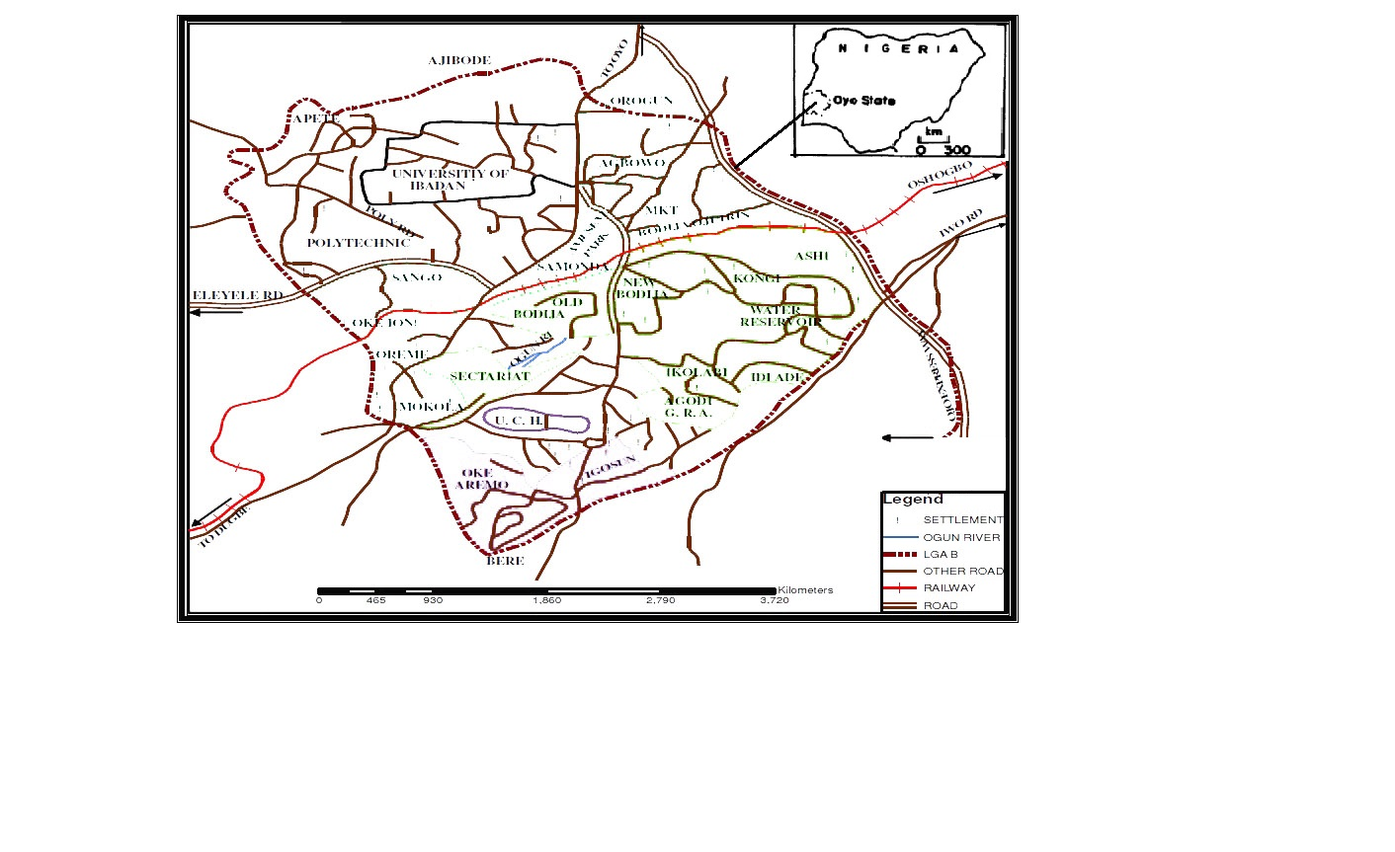
Figure 1: Map of Ibadan North local government

3. Interview
A total of 104 respondents were randomly interviewed in Ibadan North Local Government in February, 2017 through convenience sampling. A free, prior and informed consent was solicited from each respondent. The researcher explained to each respondent the objectives of the study. Information was gathered through face to face interviews guided by a semi-structured questionnaire that asked the following: (a) determining the extent of usage of herbs, and (b.) the frequency of combine usage of herbs and orthodox medicine.

4. Data analysis
Data obtained during the interview were extracted to give a summary description of the subject. The demographic characteristics of respondents were presented in graphical form using windows excel 2007. Chi square was used to establish the relationship between the semi-structured questionnaires and was analyzed using spss version 21.

5. Results
5.1 Demography
The demographic characteristics of the respondents are presented in Figure 2. Among 104 respondents interviewed, major informants were around 20-30yrs with frequent 53 and percentage 51% respectively while age 51 above were the least respondents with frequent 7 and percentage 6.7%. Both sex equally interviewees (male, 50% and female, 50% respectively). Most of the interviewees were Islam (77%). The majority of interviewees were university graduates with frequent 45 and percentage 43.3% while primary school leaving certificate holders and others (Biblical or Quranic school graduates) were the least interviewed with frequent 1. The employed (Herb sellers, traditional medicine practitioners and farmers) are the highest respondents (46%) while the unemployed (age people) are the least respondent.

(i)

(ii)

(iii)

(iv)

(v)

Figure 1: Demographic Characteristics of Informants (i) Age (ii) Sex (iii) Religion (iv) Occupation (vi) Education

Herbal usage and combine medication (Orthodox medicine) as practiced by respondents is shown in Table 1. Majority of the respondents agreed to their use of herbs (52.9%), 32.7% established a strong approval and usage of same while 1.9%, 7.7% and 4.8% were undecided on it use, disapproved its application and strongly opposed its relevance to them respectively. However, while 19.2% confessed strongly to indulge in combine medication, 28.8% agreed to rely on herbs and orthodox medication for quick recovery as 14.4 reserved their opinion, although 27% lightly disagreed while same was greeted by vehement disagreement from about 12% of our respondents.

Table 1: Herbal usage and combination with orthodox medicine as practiced by respondents
S/N | Questions | Strongly agree | Agree | Undecided | Disagree | Strongly disagree | Total
FREQUENCY
PERCENTAGE (%)
1. | I make use of herbs | 34  32.7 | 55  52.9 | 2  1.9 | 8  7.7 | 5  4.8 | 104  100
2. | I combine herbs and orthodox medicine to aid recovery | 20  19.2 | 30  28.8 | 16  14.4 | 27  26.0 | 12  11.5 | 104  100

The relationship between socio-demographic factors and herbal usage is shown in Table 2. Factors such as age, sex, religion, educational status of respondents had no significant relationship (P≤ 0.05) with their use of herbs. But respondents’ occupation had a significant effect on herbal usage.

Table 2: Bivariate Level of Analysis – Relationship between socio-demographic factors and herbal usage
Characteristics | χ2 value | Df | P value | Decision
Age | 16.920 | 12 | 0.153 | ^{ns}
Sex | 7.311 | 4 | 0.120 | ^{ns}
Religion | 3.083 | 4 | 0.544 | ^{ns}
Educational Qualification | 8.753 | 16 | 0.923 | ^{ns}
Occupation | 33.423 | 12 | 0.001 | ^{S*}
S- Significant, ns-Not significant, *(P≤ 0.05)

The relationship between socio-demographic factors and combine-medication (Herbal and modern medication) is highlighted in Table 3. Significant relationship was established between the occupation of respondents and their adopting of combine-medication while other demographic factors are not significant (P≤ 0.05).

Table 3: Bivariate Level of Analysis – Relationship between socio-demographic factors and combine-medication (Herbs and modern medication)
Characteristics | χ2 value | Df | P value | Decision
Age | 13.120 | 12 | 0.360 | ^{ns}
Sex | 4.589 | 4 | 0.332 | ^{ns}
Religion | 3.896 | 4 | 0.420 | ^{ns}
Educational Qualification | 6.828 | 12 | 0.869 | ^{ns}
Occupation | 26.603 | 12 | 0.009 | ^{S*}
S- Significant, ns-Not significant, *(P≤ 0.05)

6. Discussion The use of medicinal plants (herbs) among different, religious affiliations, occupational, and cultural settings reported by WHO (2013), lend credence to this present study where the variables were investigated and confirmed to have influence not only on its use but also in combination with orthodox medications. The agreement to the use of medicinal plants in solving health issues by majority of the respondents could be attributed to its availability and accessibility through gardens, and markets (herb sellers). Also, the reliability of herbs and its relatively low cost during purchase accounts for it usage (Fasola, 2015). The study of Oreagba et al. (2011), further attest to the popularity of herbal medicine usage among people especially in developing countries like Nigeria where 66.8% of respondents in an ethnobotanical survey claimed to depend solely on herbs for their health care. Although, the use of herbs has mostly been condemned by modern medical practitioners. To these professionals, issues such as herbal standardization, regulation, dosage are of great concern (Ekeanyanwu, 2011). This study revealed a high dependence on herbs separately and in combine status with orthodox medication among the respondents which could be linked to the lack of total dependence or trust in either of the two medications in isolation High poverty rate and cost of medical facilities assessment within the local government might not be unconnected to these developments. Similarly, the report of Chukwuma et al. (2016), showed the high dependence on combination medication (traditional medicine and orthodox medicine) with 63.7% out of 200 respondents which suggest imperfect dependence or trust in any of the health care delivery systems.
The occupation of respondents played a major role in their preference for herbs (herb usage) and combine therapy as statistically significant relationships were established. Oreagba et al. (2011) report where profession of respondents determined their usage of herbs and Chukwuma et al. (2016) in which occupation significantly favoured combine use are in agreement with this study. Related occupational factors, most evidently, wages might have a pronounced effect in this regard.
Also, non-association between herbal usage and education as reported by Oreagba et al. (2011) corroborates with the finding in this study. Demographic factors such as; age, sex, and religion had no association with the variables studied. though, various reports suggest that the level of education is a reason why one may embrace herbs but recent development and reality points to its use and in fact the combination with other forms of health regardless of the educational status, sex, age and religion of health seekers. This development is possibly as a result of many disease causing organisms that have defied intervention of modern medicine, thereby opening doors for alternative consultations. Consequently, this study is in contrast with other studies (Adibe, 2009; Bamidele et al., 2009; Aderibigbe et al., 2013; Banwat et al., 2015; Chukwuma et al., 2016), where significant relationships were established between the mentioned variables and herbal or combined use. Drug-herb interaction is not uncommon in combined use. Though, increasing personal responsibility over individual’s health both in prevention and treatment of diseases especially chronic ailments influenced preferences and combination in health care. However, proper use of herbs is not only recommended but also complications due to combined use must be discouraged and avoided. Not all natural products are safe! Institutionalization of both therapies into the national health care scheme is essential as orthodox medicine alone cannot achieve effective health (Elujoba et al., 2005). Before this is achieved, Ekeanyanwu (2011) opined that the prejudices mostly shown by health care professionals, who believed herbal products, are ineffective and reservations by herbalists alike, who boast of superiority of organic products due to non-exposure to extraction and standardization, are one of such problems to be resolved.

7. Conclusion
The use of herbs and its joint usage with orthodox medicine is becoming rampant and thus, been confirmed in this study. While it is imperative to check this phenomenon in order to arrest health disaster among users, this observation also underscores the importance of traditional medicine as a subsystem of the health delivery. Thus, it is imperative for government to encourage its acceptance, control and possible integration of same into the health care delivery system, the cultivation of fast disappearing and endangered medicinal plants by initiating short-term conservation measures, while awaiting longer policies embedded in the realms of legislation. It is therefore evident from this study that the practice of regime cannot be underestimated.

Correspondence to:
Ogunsola Oladele, K.
Department of Botany, University of Ibadan, Oyo State, Nigeria.
Mobile Number: +2347065335148
E-mail: ogunsola.okay@gmail.com

References
- Aderibigbe, S.A., Agbaja, S.R. and Bamidele, J.O. Determinants of utilization of traditional bone setter in Ilorin, North Central Nigeria. J.Prev. Med. HYG 2013;54:35-40.
- Adibe, M.O. Prevalence of concurrent use of herbal and syntheticmedicines among outpatients in a mission hospital in Nigeria.
- International Journal of Drug Development and Research 2009;1:60-66.
- African Health Monitor. Traditional Medicine: Our Culture, Our Future. A magazine of the World Health Organization Regional Office for Africa 2003;4: 1.
- Bamidele, J.O., Adebimpe, W.O. and Oladele, E.A. Knowledge, Attitude, and use of Alternative Medical Therapy Amongst Urban
- Residents of Osun State, Southwestern Nigeria. Afr. J. Trad. CAM 2009;6(3): 281-288.
- Bandaranayake, W. M. “Quality control, screening, toxicity, and regulation of herbal drugs,’’ in Modern Phytomedicine. Turning
- Medicinal Plants into Drugseds Ahmad I., Aqil F., Owais, M., editors. (Weinheim: Wiley-VCH GmbH & Co. KGaA;) 2006;25–57.
- Banwat, M.E., Ejimah, A.A., Adaji, I.I. and Kajo, J.I.. Alternative Medicine use among workers in an Urban setting in North Central
- Nigeria. International Journal of Biomedical Research 2015; 6(04):268-273.
- Chukwuma, B., Duru, K.C., Diwe, K.A., Uwakwe, C.A. Duru, I.A. Merenu, A.C., Iwu, U.R., Oluoha, I.O. Combined Orthodox and
- Traditional Medicine Use among Households in Orlu, Imo State, Nigeria: Prevalence and Determinants. World Journal of Preventive Medicine 2016;4(1): 5-11.
- Ekeanyanwu, C.R. Traditional Medicine in Nigeria: Current Status and the Future, Research Journal of Pharmacology.. 2011; 5(6):90-94.
- Elujoba, A.A., Odeleye, O.M. and Ogunyemi, C.M. 2005. Traditional medicine development for medical and dental primary health care delivery system in Africa. Afr. J. Trad. CAM. 2: 46-61.
- Ernst, E. The efficacy of herbal medicine - an overview. Fundamental Clin. Pharmacol. 2005;19:405-409.
- Fasola, T.R. 2015. An Ethnobotanical Survey of Plants Used in the Management and Treatment of Female Reproductive Health Problems in Ibadan, Southwestern Nigeria. Journalof Biology, Agriculture and Healthcare. 5(3).
- FRNOG (Federal Republic of Nigeria Official Gazette). Legal Notice of Publication of the Details of the Breakdown of the National and State Provisional Totals of 2006 Census. Government Notice Number 2007;94: 21–24. Nigeria.
- Odugbemi, T. (ed.) Outlines and Pictures of Medicinal Plants from Nigeria. 2006;1-85.
- Oreagba, I.A., Oshikoya, K.A. and Amachree, M. 2011. Herbal medicine use among urban residents in Lagos, Nigeria. BMC Complementary and Alternative Medicine 2011; 11:117.
- Tomori, M.A. 2008. Ibadan Metropolitan Area and the Challenges to Sustainable Development. http://macosconsultancy.com/Ibadan%20metropolitan.html Accessed on feburary, 2017.
- WHO. Traditional medicine. Fact sheet No 134. Geneva. 2003.
- WHO. Traditional Medicine Strategy 2013-2023. 2013.

9/25/2017

