Leaves Of Nypa Fruticans Wurmb A Biomaterial Used In Elimination Of Certain Organic Colourants In Aqueous Solution.

Obosi, Ekemini J., Osu, Charles I. and Horsfall Jnr, M.

Department of Pure and Industrial Chemistry, University of Port Harcourt. P.M.B. 5323, Port Harcourt, Nigeria.
charsike@yahoo.com

Abstract: The elimination of some organic colourants in aqueous solutions using biomaterials from nipa palm leaves, a low cost agricultural adsorbent was investigated. Chemical Oxygen Demand (COD) method was used in this research to measure the percentage removal of three colourants in aqueous solution after being treated by biomaterials from leaves of nipa palm. The effect of initial concentrations and adsorbent dosage were determined. The maximum sorption capacities in terms of percent COD reduction of Bromophenol Blue (BP), Congo Red (CR) and Methyl Orange (MO) in aqueous solution were 99.22 %, 99.21 % and 96.58 % respectively for leaves biomass dosage and also maximum adsorption capacity for leaves carbon dosage were 92.85 %, 89.72 % and 81.59 % for BP, CR and MO respectively. Using the correlation coefficient values, the data for leaves biomass was fitted well to Freundlich model for CR and BP while the Langmuir model was best fit for MO. The data shows that the correlation of CR, BP and MO fits in well into the Langmuir model for leaves carbon. The capability of these adsorbents to eliminate colourants from contaminated solutions makes them acceptable for colourant treatment from industrial effluent.
[Obosi, Ekemini J., Osu, Charles I. and Horsfall Jnr, M.. Leaves Of Nypa Fruticans Wurmb A Biomaterial Used In Elimination Of Certain Organic Colourants In Aqueous Solution.. Researcher 2017;9(8):42-47]. ISSN 1553-9865 (print); ISSN 2163-8950 (online). http://www.sciencepub.net/researcher. 8. doi:10.7537/marsrsj090817.08.

Keywords: colorant treatment, biomaterials, chemical oxygen method

1. Introduction
In wastewater, colour is the initial and first contaminant to be recognized (Monika, 2012). Colour is of great significance and relevance in all human existence throughout the universe. Animals and plants are made of different colours even our foods and medicines are decorated with colours (Ratna et al., 2012). Colour impartation on different materials is derived from various colourant techniques and processes being developed and used. The colourants used are derived from nature or sometimes from chemicals that are manufactured (Goetz, 2008; Dada et al., 2012). Close to 50 percent of all colourants comprises of azo colourants. As expected their extensive usage, applications and perseverance in the environment pose an environmental hazard (Negrulescu et al., 2014).
Colourants are mostly engaged in the textiles, carpet, foods, pharmaceutical, cosmetic, plastic, photographic, printing and paper industries (Bafuna et al., 2011; Zollinger, 1987). The adhesion of these colourants onto compatible surfaces by solution is due to formation of bonds covalently formed or formation of complexes along with metals or salts and also through physical adsorption which is also referred to as mechanical retention (Chequer et al., 2013). Man-made colourants are highly soluble and hence, there are frequent water pollutants and they may recurrently be found in industrial effluents. However, when effluent containing colourants is released into natural waterways it becomes a serious problem, because colourants impacts toxicity to marine organisms and these leads all the way to the entry of lethal components into the food chains of humans and animals (Egwuonu, 2013).
The introduction of wastewaters containing organic substances into waterways depletes the dissolved oxygen (DO) present in water; the depletion in dissolved oxygen (DO) levels disrupts the well-being of aquatic microorganisms and also raises much concerns because of potential environmental problems which may lead to the reduction in population of helpful microorganisms (Umpuch et al., 2013; alquaragully, 2014). Note that this gradual depletion in dissolved oxygen (DO) rapidly increases the biological oxygen demand (BOD) and chemical oxygen demand (COD) which directly denotes the limited quantity of oxygen needed to completely oxidise matters that are organic and present in water biologically and chemically respectively. In addition to being toxic, wastewater containing colourants also embodies chemical substances that can sometimes be cancer causing agents to diverse organisms (Umpuch et al., 2013; Metuku, 2013). This is of urgent concern because various chemicals can destroy genetic material without being expressed instantly but in a slow manner (Ratna et al., 2012).
A few processes for removal of colour from industrial wastewater include biological treatment, hyperfiltration, floatation, adsorption, coagulation and oxidation (Patil et al., 2011; Abdullah et al., 2005). The effectiveness of colour removal from wastewaters using adsorption technique has proven to be a perfect option compare to other expensive treatment techniques (Jain et al., 2003). In this study, the effectiveness of leaves of nypa fruticans wurmb biomass dosage in elimination of certain organic colourants in aqueous solution was studied.

2. Material and Methods
Sample Collection and Biomass Preparation
The representative nipa palm (Nypa fruticans) leaves used in this study, was collected from the brackish waterfronts along eastern bypass in Rivers State and transported to the laboratory. The nipa palm leaves were cleansed with water to wash off soil and mud, and then the leaves were dried under the sun to eliminate wetness and moist and after which it was dried in the oven at 80 ⁰C for several days. The sample was ground and sieved with 150µm mesh size sieve to obtain biomass sample and transferred to well-labelled plastic containers.
Preparation of carbonised sample
The Nipa leaves biomass were transferred into a well-sealed ceramic oven and the temperature knob was adjusted gradually to 550 ⁰C and kept at this temperature for 2 hours. The ceramic oven is designed to eliminate every possible intrusion of oxygen. Under these conditions biomass was disintegrated thermally to carbonaceous matter and hydrocarbon compounds. The nipa palm leaves now carbonised was sieved via 150μm mesh size and ratios of carbonised nipa palm leaves less than 150μm was collected in a label plastic container.
Preparation of standard colourant solution
Water soluble colourant crystals (1.0g) was weighed on a top loading electronic weighing balance and dissolved in 300 ml distilled water. The mixture was diluted and made up to 1000 ml, giving a stock solution with concentration of 1000 mg/L. Working aliquot of colourant solutions of concentrations 20, 40, 60, 80, and 100 (mg/L) were prepared from the stock solution.
Standard Potassium Dichromate Reagent - Digestion Solution
Approximately 250 ml of distilled water was poured into 500 ml volumetric flask and 2.4565g of potassium dichromate (K₂Cr₂O₇) dissolved into it. Thereafter concentrated sulphuric acid (83.5 ml) and mercuric sulphate (16.65 g) were added to it. The mixture was allowed to stand overnight to dissolve properly before making up to 500 ml with distilled water.
Sulphuric acid Reagent
Approximately 250 ml of sulphuric acid was poured into 500ml volumetric flask and 2.75 g of silver sulphate (Ag₂SO₄) was dissolved into it. The mixture was stirred to dissolve completely before making up to 500 ml with sulphuric acid.
Adsorption Experiments
Determination of Effect of initial Concentration
For adsorption experiments of initial concentration of colourants, 2 g of adsorbent (biomass and carbonized nipa palm leaves) were separately placed in sequence of 100 ml Erlenmeyer flask with cork stopper containing 50 ml of stock solution with the following concentrations (mg/l): 20, 40, 60, 80, and 100. The suspensions were shaken at room temperature (30ºC) using agitation speed (150 rpm) with a contact time of 30 minutes. After shaking the flask for 30 minutes, the mixtures were allowed to stand for 30 minutes to obtain clear solutions before filtering. The clear solutions were used for determination of COD by the multi-parameter bench photometer with Tungsten light source at 420nm.
Determination of Effect of Dosage
For adsorption experiments of adsorbent dosage, biomass and carbonised samples of nipa palm leaves of 1, 2, 3, 4 and 5 g were added to 100 ml Erlenmeyer flask with cork stopper containing 50 ml of colourants solution at temperature of 30⁰C and stirring at a speed of 150 rpm with contact time of 30 minutes. After shaking the flask for 30 minutes, the mixtures were allowed to stand for 30 minutes to obtain clear solutions before filtering. The clear solutions were also analysed for final COD (COD_{f}) using the multi-parameter bench photometer with Tungsten light source at 420 nm (Adowei et al., 2014).
The quantity of colorant eliminated from aqueous solution at equilibrium by the sample (s) was calculated by the mass balance relationship.
Where = quantity of colorant eliminated from aqueous by sample (mg/g), = initial concentration of colorant contaminated solution before contact with sample, = equilibrium concentration of colorant contaminated solution after contact with sample, = volume of colorant contaminated solution used (L), = weight of the sample used (g) (Chu and Hashim, 2001; Osu and Odoemelam, 2012).
Determination of Chemical Oxygen Demand (COD)
Using a volumetric pipette, sample (2.5 ml) was added to a COD digestion tube (15 ml) that has been pre-washed with H₂SO₄ and Deionised water (2.5 ml) was added into another COD digestion tube to serve as blank. This was followed by addition of Standard dichromate reagents (2.5 ml) slowly into the COD digestion tubes and shaken. Finally, 2.5 ml sulphuric acid reagent was added to the COD digestion tubes at a tilting position to allow it get to the base. The mixture was covered with its cap and shaken together and placed in a COD digester that has been pre-heated to a temperature of 150ºC, the mixture was allowed to digest for two hours. The COD digestion tubes containing mixture was turned upside down several times while still warm and placed on a test tube rack to cool to room temperature.
Each digestion tube was properly fitted into the cuvette holder of the multi-parameter bench photometer including the blank and the COD values read directly from the multi-parameter bench photometer.
Equilibrium Sorption Studies
The experimental data were analysed by the two commonly used adsorption isotherm models of Langmuir and Freundlich.
The Langmuir equation is expressed as;
q_{e} =
Where k_{L} (dm³g⁻¹) is a constant that describes the energy of adsorption/desorption, q_{e} describes the complete adsorption on the surface of the adsorbent.
Linearization of the above equation gives
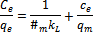
The plotting of C_{e}/q_{e} against C_{e} gives a straight line curve with slope and intercept (Ahalya et al., 2005; Osu and Odoemelam, 2012).
The Freundlich isotherm indicates adsorption intensity of the adsorbate on the adsorbent and has purely emprical formula
Where q_{e} is the adsorption density (mg/g), x is the adsorbed quantity (mg), m is the mass of adsorbent (g), C_{e} is the concentration of the adsorbate in solution at equilibrium (mg/dm³), K_{F} and n are the Freundlich constants. The value of n shows the affinity of the adsorbate towards the adsorbent.
The linearised form of the Freundlich equation is:
Assuming the plot of log q_{e} against log C_{e} yeilds a straight line, then the sorption process obeys a Freundlich adsorption isotherm. The K_{F} value can be gotten from the intercept and value obtained from slope of the straight line (Parvathi et al., 2007; Horsfall and Abia, 2003; Osu and Odoemelam, 2012).

3. Results
Effect of Biomass and Carbon Dosage on elimination of colourant from aqueous solution.
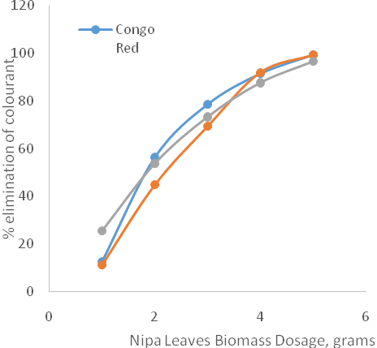
Figure 1: Effect of Nipa Leaves Biomass Dosage on the Percentage elimination of colourant from Aqueous Solution at ambient temperature.

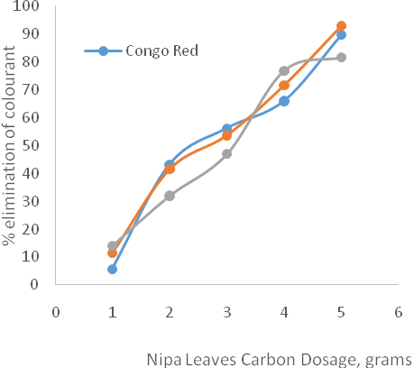
Figure 2: Effect of Nipa Leaves Carbon Dosage on the Percentage elimination of colourant from Aqueous Solution at ambient temperature.

Effect of Initial Colourant Concentration on Elimination of Colorant from Aqueous Solution
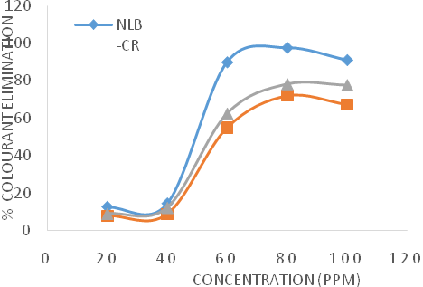
Figure 3: Effect of Concentration on Percentage Colourant Elimination from Aqueous Solution using Nipa Leaves Biomass at ambient temperature.

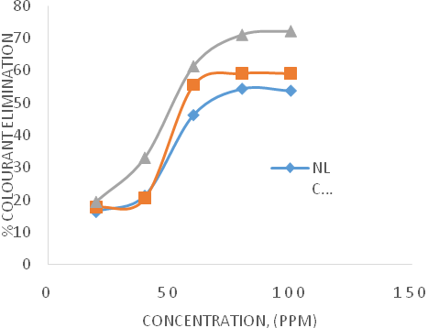
Figure 4: Effect of Concentration on Percentage colourant elimination from Aqueous Solution using Nipa Leaves Carbon at ambient temperature.

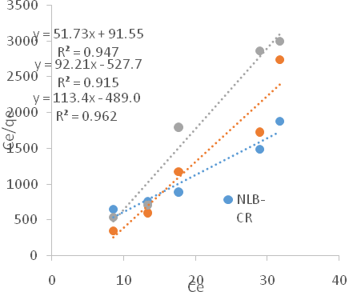
Figure 5: Langmuir Equilibrium Sorption Isotherms for Elimination of colourant from Aqueous Solution using Nipa Leaves Biomass at ambient temperature.
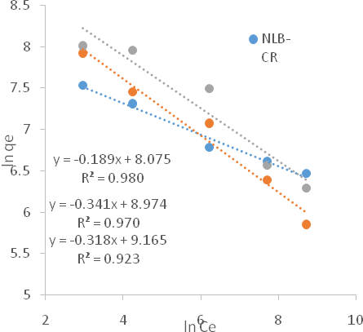
Figure 6: Freundlich Equilibrium Sorption Isotherms for elimination of colourant from Aqueous Solution using Nipa Leaves Biomass at ambient temperature.

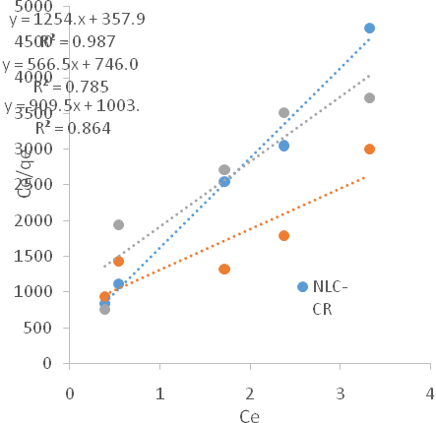
Figure 7: Langmuir Equilibrium Sorption Isotherms for Elimination of Colourant from Aqueous Solution using Nipa Leaves Carbon at ambient temperature.

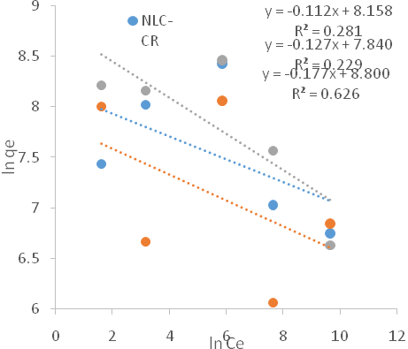
Figure 8: Freundlich Equilibrium Sorption Isotherms for Elimination of Colourant from Aqueous Solution using Nipa Leaves Carbon at ambient temperature.

4. Discussions
The effect of biomass dosage on the percent elimination of the three colourants is presented in Figure 1. The data showed that, increase in biomass dosage from 1.0 gram to 5.0 gram resulted in a dramatic increase in the amount of colourant being removed. At biomass dosage of 5.0 gram, BP and CR were eliminated from aqueous solution at 99.22%, a little more than MO at 96.58%.
The effect of nipa leaves carbon dosage on the percent elimination of Methyl orange (MO), Bromophenol blue (BP) and Congo red (CR) is presented in Figure 2. The data showed that, increased in carbon dosage from 1.0 gram to 5.0 gram results in a significant rise in the amount of colourant being removed. The result in figure 2 shows the colorants elimination percentage was highest at 5.0 gram. BP had the highest percentage elimination at 92.85%, CR followed with 89.71% and MO at 81.59%.
The effect of concentration on percentage colourant elimination from aqueous solution using nipa leaves biomass is presented in figure 3. The optimal percentage elimination of colourant from aqueous solution for Congo red, Methyl orange and Bromophenol blue were 97.53% at an initial concentration of 80mg/L, 78.28% at 80mg/L and 72.03% at 80mg/L respectively. The data showed that nipa leaves biomass was unable to sufficiently reduce the percentage colourant from aqueous solution at lower concentrations.
The effect of concentration on percentage colourant elimination from aqueous solution using nipa leaves carbon is presented in Figure 4. The data showed that, the higher the concentration of colorant in aqueous solution, the higher the percentage colourant elimination. The adsorption capacity of nipa leaves carbon was best for MO, followed by BP and lastly, CR.
The Langmuir and Freundlich Equilibrium Sorption Isotherms for elimination of colourant from aqueous solution using Nipa Leaves Biomass are presented in Figures 5 and 6 respectively. The isotherms revealed that the adsorption was found linear over the entire concentration range with very good regression coefficient for nipa leaves biomass on CR, BP and MO. According to Table 1, the elevated r² values indicate that colourant elimination for CR, BP and MO can fit well into both Langmuir and Freundlich adsorption models.
The result shows that the correlations fit in well into the Freundlich isotherm for CR and BP while the best fit model for MO is the Langmuir isotherm. Furthermore, the maximum monolayer adsorption capacity for NLB is CR (1.9 x 10⁻²), followed by BP (1.1 x 10⁻²) and lastly MO (0.9 x 10⁻²). The apparent energy of sorption for NLB was highest for MO (555.7 x 10²), followed by BP (488.6 x 10²) and CR (56.6 x 10⁻²). The adsorption capacity (K_{f}) for NLB for all three colourants showed that the adsorption potential is high, large K_{f} values enhances adsorption. This study confirms the potential ability of NLB to remove organic colourants contaminants from aqueous solution.
The Langmuir and Freundlich Equilibrium Sorption Isotherms for elimination of colourant from aqueous solution using Nipa leaves carbon is presented are Figure 7 and 8 respectively. The result shows that the correlations fit in well into the Langmuir model for CR, BP and MO than Freundlich model. This shows that the surface of NLC was enveloped by the monolayer of CR, BP and MO molecules and also the homogeneous distribution of an active site on the material. According to Table 2 the maximum amount of colourant adsorbed per unit weight of adsorbent was for BP (0.18 x 10⁻²) followed by MO (0.11 x 10⁻²) and CR (0.08 x 10⁻²) using NLC. The values of K_{f} suggests that the equilibrium partition coefficient representing the bonding energy was highest for MO (94.5 x 10⁻²), followed by CR (91.2 x 10⁻²) and BP (89.4 x 10⁻²) using NLC.

Conclusion
The adsorptive properties of Nipa leaves biomass (NLB) and Nipa leaves carbon (NLC) was studied under the same experimental condition by adsorbing at different doses and initial concentrations of Methyl orange (MO), bromophenol blue (BP) and Congo red (CR). It was observed that colourant elimination increased with increase of initial colorant concentration and increasing adsorbents dosage. At higher initial concentration, the mass transfer driving force is larger and hence, this resulted in more adsorption of colourant ions by adsorbents. The adsorption isotherm models revealed that the data obtained from the adsorption of CR and BP using NLB fitted well into Freundlich model which suggested that distribution of colorant was heterogeneous and adsorption of MO fitted into Langmuir model, suggesting monolayer coverage of colourant onto adsorbent. High values of r² suggest colourant elimination for CR, MO and BP by NLB can fit in well into Langmuir and Freundlich isotherm. The adsorption of CR, MO and BP using NLC fitted in well into the Langmuir isotherm suggesting homogeneous distribution of active sites on the material.

Corresponding Author:
Dr. Osu, Charles I.
Department of Pure and Industrial Chemistry,
University Of Port Harcourt,
P.M.B. 5323, Port Harcourt, Nigeria.
Telephone: +2348037783246
E-mail: charsike@yahoo.com

References
- Abdulllah, A.G.L; Mohd Salleh, M.A.; Siti Mazlina, M.K.; Megat mohd Noor, M.J.; Osman, M.R.; Wagiran, R and Sobri, S. (2005). Azo dye removal by adsorption using waste biomass sugarcane bagasse. International journal of engineering and technology, vol. 2, No. 1, pp 8 – 13.
- Ahalya, N., Kanamadi, R.D., Ramachandra, T.V. (2005). Biosorption of chromium (Vi) from aqueous solutions by the husk of Bengal gram (Cicer arientinum). Electron. journ. Biotechnol. 8(3): 258 – 264.
- Adowei, P.; Spiff, A.I and Abia, A.A. (2014). Evaluation of carbonized and surface modified carbon produced from Nipa (nypa fruiticans wurmb) leaves for the removal of 2-(N, N-dimethyl–4–aminophenyl)-azo-benezene carboxylic acid (DMABA) in aqueous solution. Acta chim pharm indica: 4 (3), 2014, 146 - 156.
- Alqaragully, M.B. (2014). Removal of textile dyes (maxilon blue and methyl orange) by date stones activated carbon. International journal of advanced research in chemical sciences (IJARGS) volume 1, issue 1, Pp. 48 – 59.
- Bafuna, A.; Devi, S.S. and Chakrabarti, T. (2011). Azo dyes: past, present and the future environmental reviews. 19, 350- 370.
- Chequer, F.M.D.; Oliveira, G.A.R.; Ferraz, E.R.A.; Cardoso, J.C.; Zanoni, M.V.B and Oliveira, D.P. (2013). Textile dyes: dyeing process and environmental impact, license inTech. Pub. Pp. 151 -167.
- Chu and Hashim (2001). Desorption of copper from polyvinyl alcohol-immobilized seaweed biomass. Acta biotechnol. 21 (4), 295 – 306.
- Dada, A. O.; Inyinbor, A.A. and Oluyori, A.P. (2012). Comparative adsorption of dyes unto activated carbon prepared from maize stems and sugarcane stems. Journal of applied chemistry. Volume 2, issue 3, Pp 38 – 43.
- Egwuonu, P. (2013). Adsorption of methyl red and methyl orange using different tree bark powder, academic research international. Vol. 4, no. 1.
- Goetz, C. (2008). Textile Dyes: techniques and their effects on the environment with a recommendation for dyers concerning the green effect, liberty university publications, pp 4-5.
- Horsfall, M and Abia, A.A. (2003). Sorption of cadmium (II) and zinc (II) ions from aqueous solutions by Cassava waste biomass Manihot sculenta cranz. Water research. 37 (20):4913-23.
- Jain, A.K.; Gupta, V.K.; Bhatnagnar, A. and Suhas (2003). Utilization of industrial waste products as adsorbents for the removal of dyes. Journal of hazardous materials. B101: 31-42.
- Jumasiah, A.; Chuah, T. G.; Gimbon, J.; Choong, T.S.Y. and Azni, I. (2005). Adsorption of basic dye onto palm kernel shell activated carbon. Sorption equilibrium and kinetic studies. 186, Pp. 57 – 64.
- Krishnakumar Parvathi; Ramachandramurthy Nagendran and Redhakrishnan Nreshkumar (2007) Lead biosorption onto waste beer yeast by-product, a means to decontaminate effluent generated form artery manufacturing industry. Electron. J. of biotehcnol. Vol. 10. No. 92 – 104.
- Mckay, G. (1981). Design models for adsorption systems in wastewater treatment. Journal of chemical technology and biotechnology, 81(3):717-731.
- Metuku, B.E. (2013). Production of activated carbon from palm kernel shell for Gold adsorption using leachates from cocoa husk ash (crude potash) as activating agent. Kwame Nkrumah university of Science and technology, Kumasi, Ghana.
- Negrulescu, A.; Patrulea, V.; Mincea, M.; Moraru, C.; Ostafe, V. (2014). The adsorption of tartrazine, congo red and methyl orange on chitosan beads. Digest journal of nanomaterials and biostructures, vol. 9, No 1, p.45- 52.
- Monika Kharub (2012). Use of various technologies, methods and adsorbents for the removal of dye. Journal of Environmental Research and Development. Vol. 6 No.3a: 879 – 883.
- Osu Charles I. and S.A. Odoemelam (2012). ADSORPTION ISOTHERM STUDIES OF Hg (II), Pb (II), And Cd (II) IONS REMOVAL FROM AQUEOUS SOLUTIONS USING UNMODIFIED AND ESTER MODIFIED (ESTERIFIED) SENILIA SENILUS AND THAIS CORONATA BIOMASS. Journal Of Applied Technology in Environmental Sanitation, 2 (2): 77-86.
- Patil, S.; Renukdas, S. and Patel, N. (2011). Removal of methylene blue, a basic dye from aqueous solutions by adsorption using teak tree (tectona grandis) bark powder, international journal of environmental sciences. vol. 1, no.5.
- Ratna and Padni B.S. (2012). Pollution due to synthetic dyes toxicity and carcinogenicity studies and remediation, integration journal of environmental science, volume 3, No 3, Pg 940 – 955.
- Umpuch, C. and Sakaew, S. (2013). Removal of methyl orange from aqueous solutions by adsorption using chitosan intercalated montmorillonite. Songklanakarin journal of science and technology. 35 (4), 451 – 459.
- Zollinger, H. (1987). Synthesis, properties of organic dyes and pigments in colour chemistry. New York, USA: VCH Publishers; Pp.92 – 102.

8/25/2017

