Effect of time and pH on fluoride release from dental adhesives

Gamal Raghip¹, W.M. Etman², Hussein yhya²

¹Conservative Dentistry Department, Delta University, Egypt
² Operative Dentistry, Tanta University, Egypt
Wonderkindmedo.86@hotmail.com

Abstract: Objective: to measure the amount of fluoride release from dental adhesives and the effect of time and pH on releasing fluoride. Materials and methods: class V cavities were prepared on buccal surfaces of molars with the dimensions 2*3*4 mm. All prepared specimens were stored in 0.01 ml of lactic acid to induce demineralization. These teeth were divided into two main groups according to type of dental adhesives. Fluoride release in artificial saliva was measured using digital microprocessor fluoride meter after one day. One week and one month in two different storage media according to pH (6.8 & 4). Results: fluoride release was maximum after one day and decrease after one week and one month, There is no significance difference between two pH storage media.
[Gamal Raghip, W.M. Etman, Hussein yhya. Effect of time and pH on fluoride release from dental adhesives. Researcher 2017;9(8):22-28]. ISSN 1553-9865 (print); ISSN 2163-8950 (online). http://www.sciencepub.net/researcher. 5. doi:10.7537/marsrsj090817.05.

Keywords: Effect; time; pH; fluoride; release; dental adhesive

1. Introduction
Demineralization is one of the conditions which lead to loss of the tooth structure.. Progression through these stages requires a continual imbalance between pathological and protective factors that results in the dissolution of apatite crystals and the net loss of Calcium, Phosphate and other ions from the tooth ¹.
Remineralization of dental structures:
Remineralization process is not always sufficient to repair lesions, as demineralization and remineralization are cyclical events. To be considered as an efficient remineralizing agent, a product has to increase remineralization, decrease demineralization and be retained on the tooth surface in order to display activity ^{2,3}.
The role of fluoride in caries prevention was reported as three principle forms of fluoride ion reactivity with apatite. Either Iso-ionic exchange of F– for OH– in apatite: Ca₁₀ (PO₄)₆ OH₂ + 2F– _ Ca₁₀ (PO₄)6F₂ + 2OH⁻ Or Crystal growth of fluorapatite from supersaturated solutions,
10 Ca²⁺ + 6 PO₄ ^{3–} + 2 F– _ Ca₁₀ (PO₄)6F₂3)
Or Apatite dissolution with CaF2 formation,
Ca₁₀ (PO₄)₆ OH₂ + 20F– _ 10 CaF₂ +6PO₄ ^{3–} + 2OH
Authors also concluded that the first two reactions may occur during long-term exposure to low fluoride levels in the solution (such as between 0.52 μmol and 0.52 mmol F/L) or (0.01 and 10 ppm F) from either systemic or latent topical sources. These reactions result in fluoride incorporation that, in a traditional sense, would be defined as firmly bound fluoride ⁴.
It has been suggested that firmly bound fluoride is most beneficial for anticaries efficacy due to its lower solubility. Numerous studies have investigated the effects of fluoride on tooth mineral solubility. Chow Chow, L.C. 1990 ²⁴ suggested that fluoride rich mineral is still considerably more resistant to demineralization than fluoride poor mineral. He reported that tooth bound F in the lesion area can produce reduction of tooth mineral solubility and reduction of mineral diffusion from lesion ²⁴,. In all studies, fluoroapatite was found to dissolve appreciably more slowly than hydroxyl apatite. Even at the levels of 1000 -2000 ppm fluoride in teeth there is no measurable protection against acid induced dissolution ²⁵. Based on solubility data, Brown et al. pointed out that this alone is not sufficient to account for the dramatic effects of F on the acidic resistance of enamel and apatite²⁷. The balance between fluoride saturation of oral fluids and apatites was found to be mandatory. Saliva, and also plaque fluid, are supersaturated with respect to both hydroxyapatite and fluoropatite, which explains the permanent presence and stability of these apatite in the oral cavity. However, when the oral fluids become unsaturated with respect to the apatites e.g., caused by a pH drop, a change in apatite composition may occur. In the pH range below about 5.5, the oral fluids thus become unsaturated with fluoride in respect to hydroxyapatite, which therefore may dissolve in an attempt to resaturate the oral fluids. The low concentration of fluoride in the oral fluids will combine with dissolved hydroxuapatite crystals forming fluorohydroxyapatite crystals. This mechanism prevents the loss of minerals and provides additional protection of the mineral crystallites decreasing the liability of lesion formation by increasing tooth bound fluoride content ⁵.
However At very low pH, presumably below 4.5 saliva and plaque fluid will be undersaturated with respect to both hydroxyapatite and fluorapatite. Thus there will be no chance for redepositoin of lost mineral ⁶. This shows that the pH is a significant factor affecting caries prevention. Ten Cate and Duijsters 1983 showed that the amount of mineral loss during demineralization is a function of both pH and fluoride concentration Thus, efforts to increase the fluoride content of dental hard tissues regardless any other factor by systemic or topical fluoride sources is not a logical approach to caries prevention.
With the increasing fluoride concentration such as (5.3 to 530 mmol/L (100–10,000 ppm F) an additional chemical reaction with the formation significant CaF₂ amounts begins to dominate. These concentrations are present in topicals, such as professional gels and varnishes or over the counter toothpastes and mouthrinses. The name loosely bound fluoride has served as an alternative description for calcium fluoride formation ⁴.
In the last few years the general view is that loosely bound F (CaF₂) acts as a potential »reservoir« of F, enhancing remineralization and retarding demineralization processes. Topical treatments with high F concentrations result in the formation of CaF₂-like material on the surface of teeth. It is visible by scanning electron microscope (SEM) as small globules on the surface of fluoridated teeth⁷. It was assumed that formation of CaF₂ on enamel is unfavorable, because CaF₂ is soluble in saliva to the same extent as in wate ⁸. However, several studies have shown that CaF₂ is quite insoluble in saliva at the neutral pH, and that it can persist on the tooth surface for weeks and months after topical application of F ^{9,10}. The resistance to solubility of CaF₂ is presumably caused by adsorption of secondary Pi (HPO₄^{–2}) to Ca sites and by pellicle proteins at neutral pH. At lower pH, as during a caries attack, primary Pi will be the dominant preventing secondary Pi (HPO₄^{–2}) to inhibit the dissolution of CaF₂ ⁹.
Thus F ions released during cariogenic challenges are due to reduced concentration of secondary Pi ions and thus solubility of CaF₂. The released F is subsequently built into HA (hydroxyabatite) through dissolution/re-precipitation reactions (. After caries attack, the CaF₂ globules are again stabilized by adsorption of proteins and secondary P ^{10,} ¹¹.
The Antimicrobial Action of fluoride
In spite of extensive literature on the antimicrobial effects of fluoride on oral microflora, today there is very little consensus that the anticaries effect of fluoride is related to inhibition of oral bacteriaIn spite of these known effects, there is no general agreement that the antimicrobial effects of fluoride contribute to the anti caries effect of fluoride.^{9,10}
In addition, the widespread use of toothpastes, which have been responsible for the decrease in caries prevalence over the last three decades, did not result in a reduction in the number of the mutans streptococci. White et al. suggested that topical fluoride from the over the counter dentifrice affects only minimal reductions in acute plaque metabolic activity (acid production) ⁴.
Van Loveren summarized the antimicrobial action of fluoride and suggested several points⁴. In summary, two theories involving fluoride as caries prevention mechanism were introduced. One stresses the importance of an example supply of fluoride during tooth formation, and the other a lifelong daily supply. Larsen pointed out, that the two theories may complement each other, and neither of the theories excludes the other. However it was suggested that the post-eruptive effect of fluoride is by far the most important. There was considerable evidence for some authors to suggest that low concentrations of fluoride decrease the rate of demineralization and enhance the rate of remineralization ⁹. The most effective caries preventive effect of fluoride is frequent (daily) application of low fluoride from toothpastes and (or) mouthrinses. Thus, this basic fluoride prevention should be encouraged in all patients ⁴.
The need for additional fluoride supplementation depends on caries activity. The formation of intraoral reservoirs capable of supplying ions for a prolonged period is crucial for the success of topical treatments. Fluoride which is retained on the teeth after brief exposure to topical fluoride agents or toothpastes is retained as CaF₂. CaF₂ is most likely the provider of free ions during cariogenic challenges ¹². However, low levels of fluoride may also be reached during the dissolution of fluorhydroxyapatite, thus, again influencing the demineralization¹³. remineralization of enamel. Therefore, one of fluoride’s major contributions is to affect the rate of lesion formation and its progression ^{14,15}.
The quality of oral hygiene is essential in relation to topical fluoride application. The limit of fluoride effect is reached when pH drops so low that even the solubility product of pure fluorapatite is not exceeded. If the oral hygiene is inadequate, accumulation of thick, acidogenic plaque at retention sites will occur. In patients with heavy plaque, the pH reaches, during an acid challenge, values far below the critical pH. In such conditions the beneficial effects of fluoride would also be limited. The combination of proper oral hygiene and the use of fluoride therapy can, in most cases, arrest the caries process ¹⁵.
In addition, improved new remineralizing therapies, using topical treatments to replace lost Ca and Ph mineral from early caries lesions would be a promising additional caries preventive mechanism, supporting and increasing the fluoride effect ¹⁶. To compare the action of any remineralizing agent to fluoride some of these requirements have to be fulfilled to have an ideal remineralization material. These might be proper diffusion into subsurface or it has to deliver an adequate amount of calcium and phosphate into subsurface, must not favour calculus formation, has to work at an acidic pH or xerostomic patients and has to boost the remineralizing properties of saliva¹⁷.

2. Materials and methods:

Table 1:-Tested materials
Material | Manufacture | Composition | Website
Filtec z 250 | 3M Espe company, USA | Zirconia/silica fillers 60% w/v 82% w/w, Bis-GMA, Bis-EMA, UDMA. | www.3mespe.com
Xp Bond (Flouride releasing etch and rinse (2step) adhesive system). | Dentsply company | Carboxylic acid modified dimethacrylate (TCB resin), phosphoric acid modified acrylate resin (PENTA), Urethane dimethacrylate (UDMA), Triethyleneglycol dimethacrylate (TEGDMA), 2-hydroxyethylmethacrylate (HEMA), Butylated benzenediol (stabilizer), Ethyl-4-dimethylaminobenzoate, Camphorquinone, Functionalised amorphous silica, t-butanol | www.dentsply.com
Prime & Bond NT. (Flouride releasing etch and rinse (2-step) adhesive system. | Dentsply company | -di-and trimethacrylae resins.  -Functionalised amorphous silica.  -PENTA (dipentaerythritol penta acrylate monophosphate).  -Photoinitiators.  -Stabilisers.  -Cetylamine hydrofluorid  -Acetone. | www.dentsply.com
Artificial saliva buffered with lactic acid pH 4 | Prepared at  Faculty of Pharmacy  Tanta University | 0.01 ml lactic acid+5 ml artificial saliva
Artificial saliva  pH 6.8 | Medac company,  Germany. | Water, sorbitol, xylitol, eriodictyon crassifolium (yerba), santa naturlches, lemon flavor, ascorbic to acids, sodium benzoate, sodium hydroxide, citric acid. | www.medaccompany.com

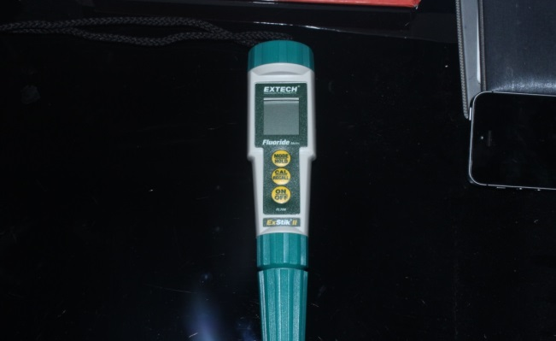

Selection of teeth
Fourty human any molars that had been recently extracted from patients aged 20-30 years old, were selected from the surgery and maxillofacial Department Faculty of Dentistry, Tanta university. The teeth were cleaned manually using a curret, examined by a steriomicroscope at a magnification ×40 to ensure they are sound, free of cracks, non carious lesions or any developmental defects ²¹. The selected teeth were stored in refrigerated 4°C saline solution untill the beginning of the study for maximum period of one month ¹⁸. A written consent was taken from these patients after the approval of the Ethics Committee of Tanta University to ensure their agreement to use their teeth in the current study.
Specimens preparation
Class V cavities were prepared on buccal surfaces using a spherical carbide (4-kg Sorenson, Sao paulo, sp, Brazil.) bur at high speed hand piece with a coolant system ¹⁹, with the dimensions of 2 mm depth,4 mm mesiodistal width and 3 mm occluso gingival height ²⁰ The specimens were coated with 2 layers of nail varnish leaving 1mm uncoated all around the cavo surface margins. All prepared specimens were stored in 0.01 ml of artificial saliva solution buffered with lactic acid (pH 4) in a labeled test tube for 24 hrs at 37ºc in an incubator to induce demineralization ²⁰.

Table 2:- Experimental design
Groups | Subgroups | Divisions
Type of adhesive | Storage Media | Storage period
Gr. I (Xp bond n=20)  - GI-A-1  - GI-A-2  - GI- A-3 | Sub. A (pH=6.8) n=10  Sub. B (pH=4 ) n=10 | Div.1:-one day  Div.2:-one week  Div.3:-one month
Gr. II (Prime & Bond NT.n=20)  - GII- B-1  - GII- B-2  - GII- B-3 | Sub. A (pH= 6.8) n=10  Sub.B (pH=4) n=10 | Div.1:-one day  Div.2:-one week  Div.3:-one month
Total n. Of specimens =40

Assessment of flouride release for all tested specimens was done by the microprocessor fluoride meter device (Microprocessor Fluoride Meter use to assessment of fluoride release. Extech company.
) ⁹⁵ with TISAB tablets.

Results
Fluoride release measurements
Collected data was analysed, concerning the time of testing as a constant the results after one day regarding the amount of released fluoride in the different pH values of artificial saliva there is no significance difference as shown in table 3 and graph 1.

Table 3: Effect of tested pH values after one day on the amount of leached out fluoride
 | pH 6.8 | pH 4 | T statistic | P value
Mean | 0.568 | 0.56 | - 0.208 | 0.836
SD | 0.149 | 0.099
Range (100%) | (0.3-0.8) | (0.3-0.8)

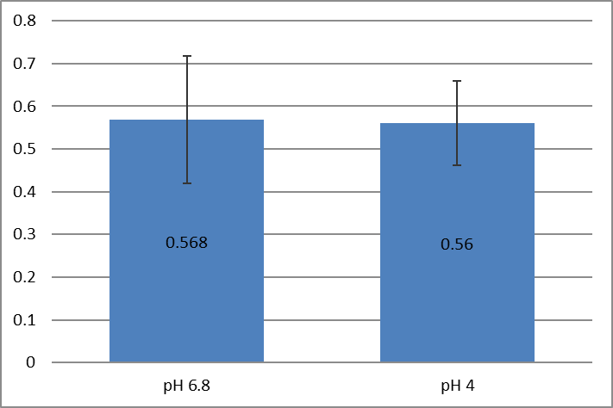
Histogram using mean values of tested pH levels after one day compared their effect on the amount of released fluoride.

Effect of tested pH values after one week on the amount of leached out fluoride ions shown no significance difference as shown in table 4 and graph 2

 | pH 6.8 | pH 4 | T statistic | P value
Mean | 0.33 | 0.38 | -1.51 | 0.139
SD | 0.088 | 0.101
Range (100%) | 0.2-0.6 | 0.2-0.6

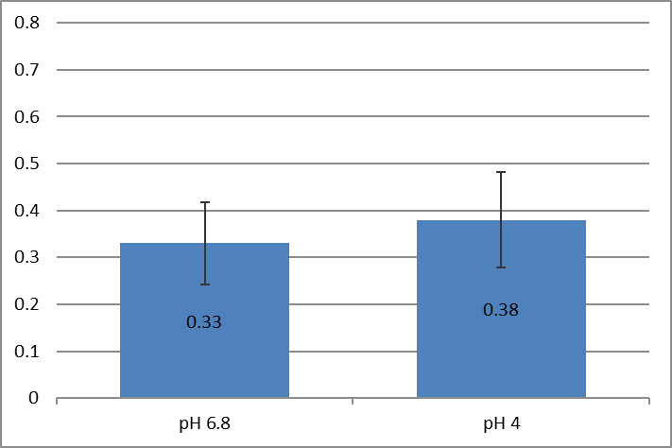
Graph 2: Histogram using mean values of amount of leach out fluoride at different pH values tested pH levels after one week.

After one month immersion, the amount of released fluoride was collected, tabulated and statistically analysed.
Effect of tested pH values was non significance after one month on the amount of leached out fluoride ions as shown in table 5 and graph 3.

 | pH 6.8 | pH 4 | T statistic | P value
Mean | 0.295 | 0.28 | -0.572 | 0.571
SD | 0.1 | 0.06
Range (100%) | 0.1-0.4 | 0.2-0.4

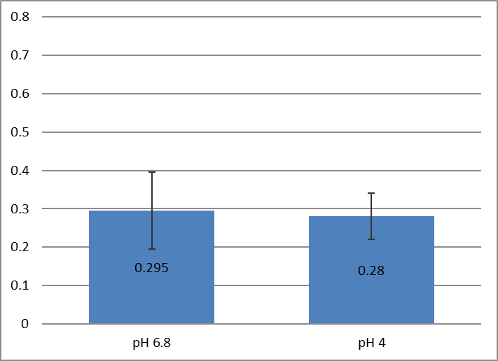
Graph 3 Histogram using mean values of leached out fluoride ions at tested pH levels regardless the type of adhesive tested after one month

Table 6: Amount of released fluoride over time periods
 | day | Week | month | P value
Mean | 0.56 | 0.35 | 0.28 | <0.001*
SD | 0.12 | 0.09 | 0.08
Range (100%) | (0.3-0.8) | (0.2-0.6) | (0.1-0.4)

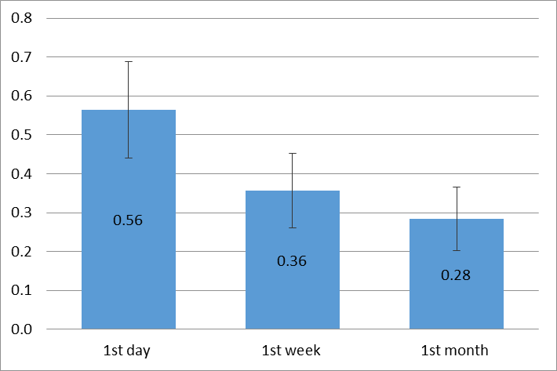
Graph 4 Comparison between the Amount of flouride released through the different tested periods.

A statistical significant effect of time was observed since p ≤0.001 as shown in table 21 and graph (V-21).
Tukey's test was done to find out which time was responsible for this statistical difference recorded at the four tested groups. It was found that the amount of leached out fluoride at one day was responsible for this difference as shown in table (7).

Table 7: Statistical analysis of the mean values of the amount of leached out fluoride at different tested periods using tukey's test.
treatments  pair | Tukey HSD  Q statistic | Tukey HSD  p-value | Tukey HSD  inferfence
day vs week | 13.3026 | 0.0010053 | ** p<0.01
day vs month | 17.4697 | 0.0010053 | ** p<0.01
week vs month | 4.1671 | 0.0107948 | * p<0.05

4. Discussion
In an attempt to simulate a clinical condition for a number of years, the samples in the present study were kept in artificial saliva added to it lactic acid (0.01) to act as a demineralization solution for 24 hrs at 37°c to induce the tested demineralized dentin ²⁰. And this was not a typical clinical oral situation because nothing could be stable in the oral cavity for 24 hrs. This simulation was somewhat more aggressive than what is really occurring in vivo. However this was done to complete the experiments in a reasonable period of time, quickly accumulating the damaging effects of acid attacks which was concluded to correspond to nearly a couple of years of clinical service according to the habits of each patient ²². Healthy human molars that had been recently extracted were selected for this research to be sure that they didn’t undergo dehydration and their physical properties are still resembling vital conditions. Saline was used as a storage media to preserve this condition until time of cavity preparation. Prepared cavities were then stored in artificial saliva to simulate the clinical condition throughout the examination procedures.
This was chosen to overcome the limitations and difficulties of using natural saliva, consuming time of collection and avoiding quick decomposition. In addition it was used to obtain comparable results with other studies ²³.
A recent generation of the microprocessor fluoride meter was used currently involving a flat surface of the lens added to the electrode instead of the traditional. These separated electrodes consist of two electrodes temperature, fluoride and should to be in contact and submerged in the solution. This was manufactured to minimize the amount of artificial saliva used to calculate the amount of released fluoride.
The findings of the current study showed that the mean values of the fluoride leached out were the maximum after a day and it reached to the minimum after a month. These findings followed the previous authors ^{24, 25} who examined the degree of ion diffusion concluding that the fluoride ions released from the adhesives tested could easily penetrate and diffuse into the cavity walls thus increasing remineralization. This was also true with what was found by others ²⁶ stating that the pattern of fluoride release is typically characterized by an initial rapid release, followed by a significant reduction in the rate of release after only a few days of immersion moreover ²⁷ found that the fluoride release was at maximum level after 24 hrs.
In addition ²⁸the amount of fluoride leached out after 1,2, 3,7,14,21, 28,35,42,49,56,63,70,77 and 84 days was measured, using three pH values: 4, 5 and 7. Three resin –modified glass ionomers, one compomer and one composite were used. They concluded that the fluoride release at the 1st day was the maximum, however after 2 – 3 weeks all fluoride release rates at any of the tested conditions were similar. Thus the fluoride – releasing restoratives initially displayed a high fluoride release rate This initial burst of release was followed by a lower, long –term, steady –state release rate. This was confirmed later by Dimitrios et al 2013 ²⁹ who demonstrated that all fluoride containing dental materials released their greatest amounts of fluoride ions on day one. Fluoridated dental adhesives release considerable amount of fluoride ions throughout the tested 86 days, and the time was an effective variable affecting release of fluoride from either adhesives or restorative materials. Also the amount of fluoride release was found to affect remineralization of the dentinal lesions, in the current study as a significance difference was calculated testing the DSR images at day one after one week and month indicating a difference in the given pixels between demineralized dentin surface and those after remineralization at the 3 tested periods. This indicated that any amount of fluoride release seen to affect the remineralization of the tested induced demineralized dentin surface.
On the other hand jacopson et al 1991 ³⁰ reported that to induce remineralization an amount of 3 ppm of fluoride has to be released otherwise lower concentration will not inhibit demineralization. This disagreed with what obtained in the present study and might be attributed to the different substrate tested proved on demineralized enamel. While the current research was performed on demineralized dentin.
Also Han L et al 2002 ³¹ also agreed with these previous studies and presented that Glass ionomer product release more fluoride ions than resin products. Yli –Urpo 2004 ³² found that resin based materials release the lowest amount of fluoride than ionomer materials. Yap all et al 2002 found that a conventional GIC released significantly more fluoride than the other materials. They explained their findings by the mechanisms by which GICs release fluoride into an aqueous environment is proposed comprising two steps. The first is a short term reaction which involves rapid dissolution of fluoride from the outer surface into the solution, while the second process or stage is more gradual and results in a sustained diffusion of fluoride through the bulk cement. Later this was confirmed by a research Dimitrios et al 2013²⁹ evaluating the fluoride release of five fluoride – releasing restorative materials and three dental adhesives and found that different materials exhibited different fluoride release patterns depending on their compositions. In addition reported that glass ionomer materials exhibited greater fluoride release and recharge abilities than resin based materials. This finding was also illustrated by previous authors (Silva 2007) ³³ fluoride containing dental adhesives exhibited low amount of fluoride release and this it might be due to fluoroaluminosilicate filler particles in GICs which are more soluble than SrF2 (strontium fluoride). They also dentified that Quantitive differences in fluoride release among the materials could be attributed to some factors as the Intrinsic composition, added amount of fluoride content or solubility and type of active ingredients.

References
- Selwitz RH, Ismail AI, Pitts NB (2007). Dental caries. Lancet 369: 51-59.
- Lussi A 2009: Dental erosion-novel remineralizing agents in prevention and repair. Adv Dent Res; 21: 13–16.
- Peters MC 2010: Strategies for noninvasive demineralized tissue repair. Dent Clin North Am; 54: 507–525.
- CHOW, L. C. 2010 Tooth bound fluoride and dental caries, J. Dent. Res.69 (Spec Iss) (1990) 595-600.
- RØLLA, G., E. SAXEGAARD, J. (1990) Critical evaluation of the composition and use of topical fluorides, with emphasis on the role of calcium fluoride in caries inhibition Dent. Res., 69 (Spec Iss) 780-785.
- WINSTON, A. E., S. N. BHASKAR, J. Am. (1998) Caries prevention in the 21st century‏ Dent. Assoc., 129 1579.
- Robinson C, Shore RC, Brookes SJ, Strafford S, Wood SR, Kirkham J (2000). The chemistry of enamel caries. Crit Rev Oral Biol Med 11:481-495.
- Ammari JB, Baqain ZH, Ashley PF. (2007). Effects of programs for prevention of early childhood caries. A systematic review. Medical Principles and Practice;16:437–42.
- Øgaard B. (1999) The cariostatic mechanism of fluoride. Compendium of Continuing Education in Dentistry;20:10–34.
- DEAN HT, FRANCIS FA, ELVOVE E. ( 1942): Domestic water and dental caries. V. Additional studies of the relation of fluoride domestic water to dental caries experience in 4425 white children, aged 12 to 14 years, of 13 cities in 4 states. Pub Health Rep 57: 1155.
- DEAN UT, MCKAY FS, ELVOVE E. (1938): A report of a mottled enamel survey of Bauxite (Ark) ten years after a change in the common water supply. Pub Health Rep 53: 1736-1748.
- Rosin-Grget, Lincir I. (2001): Current Concept on the Anticaries Fluoride Mechanism of the Action K. Coll. Antropol. 25 2: 703–712.
- Hamilton IR, Bowden GHW. (1996): Fluoride effects on oral bacteria. In: Fejerskov O, Ekstrand J, Burt BA, editors. Fluoride in dentistry. Copenhagen: Munksgaard; p.230–51.
- Crommelin D.J, Higuchi W.I, Fox J.L, Spooner P.J., Katdare A.V. (1983): Dissolution Rate Behavior of Hydroxyapatite-Fluorapatite Mixtures, Caries Res;17:289–296.
- Fejerskov O, Larsen M.J, Richards A, Baelum V. (1994): Dental Tissue Effects of Fluoride Adv.dent.res. June 8: 15-31.
- Shellis RP, Duckworth RM. (1994):Studies on the cariostatic mechanisms of fluoride. Int. Dent. J., 44 Suppl. 263-273.
- GEROULD, C. H., (1945): Electron Microscope Study of the Mechanism of Fluorine Deposition in Teeth. J.Dent. Res., 24 223-233.
- Greets Sidel L, Albers AI, Gueders AMInter (2010): Microleakage after thermocycling of three self-etch adhesives under resin modified glass ionomer cement restoration. JDent 1-6.
- White SC, Pharoah MJ. (2004): Oral radiology, principles and interpretation. 5th edition, St Louis, Mosby, P:225-45.
- Fross H. (1993): Release of fluoride and other elements from ligh –cured glass ionomer in neutral and acidic conditions: J Dent 72:1257-1262.
- A.Y. Harhash, R.Hafez and O. El-Mowafy (2011): -Flouride release in neutral /acidic solution and surface roughness of esthetic restoration. Egyptian dental journal 4 issue.
- Azarpazhooh A, Limeback H. (2008): Clinical efficacy of casein derivatives: a systematic review of the literature. J Am Dent Assoc. 139(7):915-24, 23-.
- Eberhard J, Hartman B et al (2000):. Digital subtraction radiography for monitoring dental demineralization. An in vitro study, Caries Res;34:219-24.
- Grobler SR, Rossouw RJ, Van Wyk Kotze TJ (1998): A comparison of fluoride release from various dental materials. J Dent; 26: 259-265.
- Ferracane JL, Mitchem JC, Adey JD. (1998): Fluoride penetration into the hybrid layer from a dentin adhesive. Am J Dent; 11: 23-28.
- Itota T, Carrick TE, Yoshiyama M, McCabe JF. ( 2004): Fluoride release and recharge in giomer, compomer and resin composite. Dent Mater; 20: 789-795.
- Tjandrawinata R, Irie M, Suzuki K. (2004) Marginal gap formation and fluoride release of resin-modified glass-ionomer cement: effect of silanized spherical silica filler addition. Dent Mater J; 23: 305-313.
- Jennifer L. Moreau and Hockin H.K. Xu ( 2010): Fluoride Releasing Restorative Materials: Effects of pH on Mechanical Properties and Ion Release Dent Mater. November; 26(11): e227–e235.
- Dimitrios dionysopoulos1, Eugenia koliniotou-koumpia1, Maria Helvatzoglou-Antoniades1 and Nikolaos KOTSANOS2 (2013): Fluoride release and recharge abilities of contemporary fluoride-containing restorative materials and dental adhesives Dental Materials Journal; 32(2): 296–304.
- Itota T, Carrick TE, Yoshiyama M, McCabe JF (2004).: Fluoride release and recharge in giomer, compomer and resin composite. Dent Mater;20:789–795.
- Han L, Cruz E, Okamoto A, Iwaku M. (2002): A comparative study of fluoride-releasing adhesive resin materials. Dent.
- Yli-Urpo H, Vallittu PK, Narhi TO, Forsback AP, Vakiparta M. (2004): Release of silica, calcium, phosphorus, and fluoride from glass ionomer cement containing bioactive glass. J Biomater Appl; 19: 5-20.
- Silva KG, Pedrini D, Delbem ACB, Cannon M. (2007): Microhardness and fluoride release of restorative materials in different storage media. Braz Dent J;18:309–313. Mater J; 21: 9-19.

8/20/2017

