Environmental Pollution in the Niger Delta and Consequential Challenges to Sustainable Development of the Region: the Role of an Individual

Leera Solomon, Okorite George-West and Isetima Kelsy Alalibo

Department of Science Laboratory Technology, School of Science and Technology, Port Harcourt Polytechnic, Rumuola, P. M. B. 5936, Port Harcourt, Rivers State, Nigeria.
sololeera@yahoo.com

Abstract: The changing lifestyle of modern man is not only polluting our environment, but is also over-utilizing our natural resources base, particularly the non-renewable resources, like metals, minerals, and fossil fuels. Such lifestyles, involving excessive consumption of natural resources and the increasing human’s disconnection from nature via their unwholesome environmental practices are likely to deprive our future generations from the availability of such resources, which take millions of years in their regeneration. All such unsustainable human actions are finally likely to cause harmful effects on our environment, human health and may possibly lead to the extinction of man from planet Earth. Public pressure will be developed only when the public knows the values and the importance of the environment, and of the harmful effects being caused by the different types of human activities. The paper discusses environmental pollution in the Niger Delta and its consequential adverse effects on sustainable development, stating the role of an individual in pollution mitigation. The paper argues that environmental pollution is central to the Niger Delta problems, as it has hampered rural economic activities and posed threat to sustainable development. The information provided here can catalyze strategic policies upon how the individuals or group of individuals will function in a way that truly benefits the lives and livelihoods of the communities now and in the near future.
[Solomon, L., George-West, O. and Alalibo, I. K. Environmental Pollution in the Niger Delta and Consequential Challenges to Sustainable Development of the Region: the Role of an Individual. Researcher 2017;9(8):10-15]. ISSN 1553-9865 (print); ISSN 2163-8950 (online). http://www.sciencepub.net/researcher. 3. doi:10.7537/marsrsj090817.03.

Key words: Environmental pollution, human health, harmful effects, sustainable development.

1. Introduction
Pollution started from prehistoric times when man created the first fires. According to a 1983 article in the journal Science, "soot" found on ceilings of prehistoric caves provides ample evidence of the high levels of pollution that was associated with inadequate ventilation of open fires (Spengler and Sexton, 1983).
It has been found to be present widely in environmental media (Carson, 1962). The term pollution can be defined as influence of any substance causing nuisance, harmful effects, and uneasiness to the organisms. Pollution can also be the consequence of a natural disaster. For example, hurricanes often involve water contamination from sewage, and petrochemical spills from ruptured boats or automobiles (Okpokwasili, 2006).
Environmental pollution could simply be defined as any undesirable change in physical, chemical, or biological characteristics of any component of the environment i.e. air, water, soil which can cause harmful effects on various forms of life or property. Pollutant is any substance causing harmful effects or uneasiness to the organisms (Solomon et al., 2016).
Human beings have so far generally been releasing a lot of pollutants into the air, and discharging all kinds of solid and liquid wastes into our water bodies. Urban and industrial solid wastes have also been dumped on land, without caring much for the environmental pollution being caused by such reckless activities. The pollutants are the substances that pollute our environment and primarily affect the living organisms, though may also sometimes affect the non-living components (as in the case of dissolution of marble statues by acidic environment, or rusting of iron).
The pollutants can be broadly divided into (a) biodegradable pollutants; and (b) non-biodegradable pollutants. Biodegradable pollutants or Non-persistent pollutants are those substances that are easily decomposed by microorganisms or bacteria, present in the environment and they include all organic substances of plant and animal origin (Solomon et al., 2016).
Even some synthetic organic chemicals are also biodegradable. While non-biodegradable pollutants are these substances which cannot be decomposed easily by bacteria. They include heavy toxic metals like lead and mercury, nuclear wastes, etc., which can not at all be degraded by natural bacterial activity.
They also include those persistent organic pollutants which cannot be easily degraded by bacteria and may remain in the environment for decades or even longer. Such persistent organic pollutants include: synthetic fibres, pesticides (like DDT), and plastics, etc. even crude oils are generally non-biodegradable, although they become somewhat biodegradable after the addition of small amount of rhamnolipids or glycerol.

2. Causes of Environmental Pollution
Environmental pollution is principally caused by human activities which release pollutants into the air, water and land; in quantities in excess of what can be tolerated by them under their normal self-cleansing capacities and the natural tolerance limits (Ramade, 1997; Solomon et al., 2016). Large scale use of fossil fuels in automobiles and in generation of energy have caused serious air pollution; while discharge of untreated or partially treated sewage and industrial wastewaters supplemented with solid wastes have polluted most of our rivers and lakes. Even the seas and oceans have been polluted to a great extent. The dumping of non-hazardous and hazardous wastes on land has polluted ground waters at several places, and is responsible for spreading diseases of several kinds (Ajayi, 1995; UNEP, 2011).
Increased industrial activities and movement of motorized vehicles have also caused a lot of noise pollution, particularly near the industrial and commercial areas, and near the highways (Polis, 1999). The municipalities have similarly treatment facilities for disposal of their domestic wastewaters (sewage) and solid wastes.
The modern life style and large scale commercial activities have injected huge quantities of non-biodegradable plastic and other similar wastes. Furthermore, modern agricultural practices have injected heavy quantities of pesticides, fertilizers and insecticides, which cause severe pollution of air, water and land (Ezeabasili, 2009).
Unwarranted and over-consumption of finished products like packaging paper, plastic carry bags and colourful toys are also responsible towards pollution, because production of such products causes heavy pollution of environmental media. Common man has generally been ignoring these activities of usually rich and affluent sections of the society, and consequently suffering the impacts of pollution.
Even the very poor and downtrodden people of our society have also been causing environmental pollution of their own making, as they do not care for hygiene and proper disposal of the night soil (feces) produced by them (Costanza et al., 1995).

3. Consequential Challenges to
Sustainable Development
The existence of man will continue to register its effects and impacts on the environment (Ejere, 2003). Introduction of toxic agents into the environment renders it unsustainable. This increasing hostile and unhealthy environment is causing the dislocation, depletion and extinction of biodiversity (Callicott and Mumford, 1997; Akpahwe and Solomon, 2012).
The reasoning in sustainable development concept is to ensure that our environment is safe for human habitation and to check the adverse effect of human activities and emerging environmental challenges (Okpokwasili, 2oo6; Loomis and Hayes, 1996; Ezeabasili, 2009). To maintain the environment at a life sustaining level with attendant economic development and also have a reserve for the future generation, the concept of sustainable development was initiated by the Brundtland Commission.
Sustainable development (SD) could be defined as development that meets the resources and service needs of the present without compromising the ability of the future generation to meet their own needs. These principles aim at reconciling the apparent conflicts between environmental protection, economic development and the quality of life. It’s relevance at the global, national and local levels accounts for its values for setting the context for policy development, environmental sustainability laws and its implementation (Ajayi, 1995).

4. The Nigeria Perspective
Nigeria and especially, the Niger Delta region is perceived as being synonymous with oil producing area, with majority of the oil industries cited in the region. The region incorporates nine states of Akwa Ibom, Cross River, Rivers, Edo, Delta, Bayelsa, Imo, Abia and Ondo (Plate 1).
Delta and Rivers states are the dominant oil producers, with approximately 75% of petroleum (World Bank, 1995). The region harbours a diversity of flora and fauna: mangroves, fresh water swamp forests, and lowland forests. The people of the region are predominantly fishermen and farmers who depend on the ecosystem for survival.
Plate 1: Map of the Niger Delta States

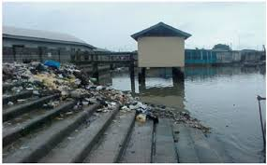
Plate 2: Open defecation in water site areas

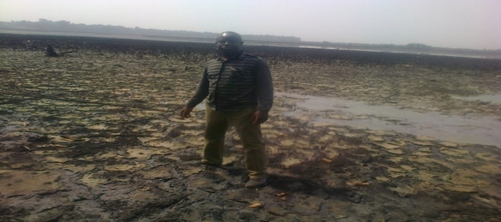
Plate 3: Crude oil polluted soil in Ogoniland

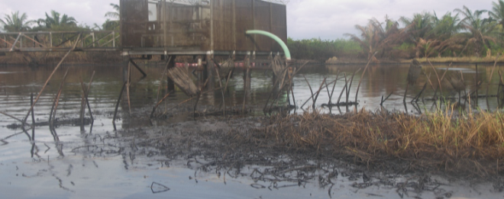
Plate 4: Chevron equipment failure spill site

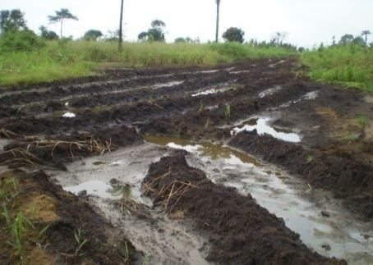
Plate 5: Recent crude oil-contaminated soil

These oil industries consist of mostly European and United States owned companies that are operating in joint venture with the Nigerian National Petroleum Corporation (NNPC). These petroleum industries include Shell Petroleum Development Company (SPDC), Mobil, Chevron, Elf, Agip and Texaco including their numerous subsidiaries.
The negative impact of these multi-national oil companies and allied oil-related activities (e.g. bunkering and illegal refining of crude oil) on environmental media constitutes a serious threat to the entire Niger Delta environment and renders the entire ecosystem unsustainable. The word environment is used broadly to denote everything that surrounds us.
It, therefore, includes all living organisms as well as non-living things. These activities, undertaken by people, who are basically individuals or group of individuals and multi-national oil corporations operating in the region, do not want to spend money on establishing proper treatment facilities and mitigation actions for their personal or financial gains.
While carrying out their industrial activities, sufficient attention has not been paid by individual industrialists and companies to ensure treatment of their wastes, primarily for their monetary gains. Consequently, these wastes generated by their activities are usually released on considerations of their perceived short-term economic gains, and at the cost of causing irreversible damage to the environment.
The nature and concentration of the pollutants released, in fact, determines the severity and their detrimental effects on man and the consequential adverse effects on environment (UNEP, 2011). Plates 2-10 show the impact of industrial and related activities on the Niger Delta environment.

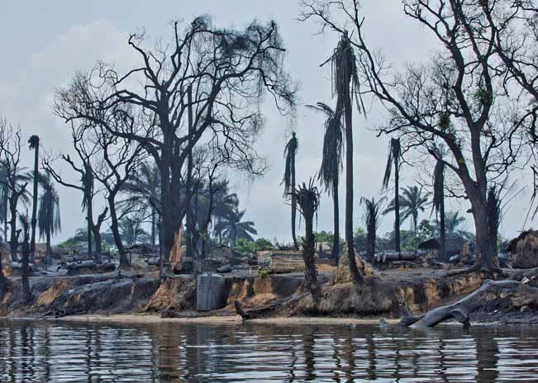
Plate 6: Artisanal crude oil refining of crude

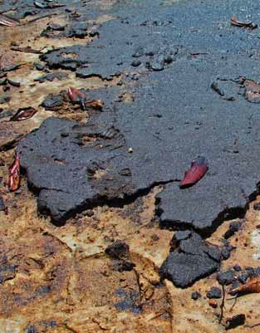
Plate 7: Caked crude oil-contaminated soil

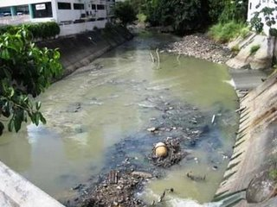
Plate 8: Raw sewage in drinking water

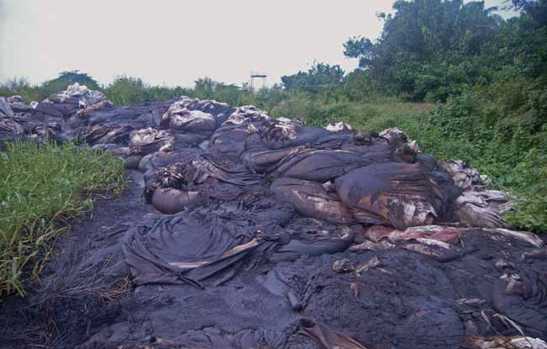
Plate 9: Fly tipping of oilfield waste

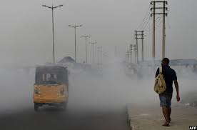
Plate 10: Soot pollution in Port Harcourt

5. Summary
Thousands of toxin-containing waste pits are suspected of being linked to rising cancer rates, while waterborne illnesses such as cholera, typhoid and diarrhoeal from unsafe drinking water present challenges for local communities and the individuals in the Niger Delta region of Nigeria.
Stagnation of water has created breeding grounds for disease-spreading mosquitoes and overt skin infections. Approximately 121,800 Nigerians, including 87,100 children under 5, die each year from diarrhea – nearly 90% of which is directly attributed to poor water and hygiene.
Medical experts report treating patients with ailments and illnesses they believe are related to the products of gas flares, including bronchitis, chest and eye irritation in adults as well as rheumatism, asthma and blurred vision in children.
Soot contain toxic by-products such as benzene, mercury and chromium, which contribute to lowering the immunity of community members, especially children, making them more susceptible to viral diseases such as polio and measles.
Seventy million Nigerians use unsanitary or shared latrines while 32 million have no latrine at all and defecate in the open. This habit of open defecation costs the country US$1 billion per year. Yet, eliminating the practice would require less than 6.5 million latrines to be built and used.
Nigeria’s health system is under-resourced, with government expenditure on health being only US$13 per capita (1.4% of per capita gross national income). The country stands to lose the more, both financially and in manpower resources if she continues to allow unhealthy and unsustainable environmental practices.
Whereas greed and monetary gains are responsible for causing environmental pollution on one hand, lack of environmental awareness, education and poverty are also responsible for poor environmental practices on the other hand.
As earlier explained in the preceding discussion, human activities and the demand for economic growth and development have negatively affected the environment thereby causing land degradation, water pollution, and air pollution, slums in the cities as a result of urbanization, utter neglect and disregard for environmental protection.
The greatest irony of the whole thing is that while the changes brought about by natural causes (such as volcanic eruption, earthquakes, floods, landslides, cyclones, and forest fires) are reversible; the artificial environmental changes brought in by human activities are generally irreversible.

6. Conclusions
Our environment is a very important resource and must be maintained and sustained in a favourable range for life. Environmental sustainability, in this context, could be defined as is a condition of balance, resilience and interconnectedness that allows human society to satisfy its needs while neither exceeding the capacity of its supporting ecosystems to continue to regenerate the services necessary to meet those needs or by our actions diminishing biological diversity.
Remember that all unsustainable and unfriendly environmental practices by humans create ‘irreversible” imbalances and environmental pollution. If such sections of human beings are not checked, then eventually a day may come when the very existence of man may come under serious threat, which possibly, may wipe off the mankind from the planet Earth.
It therefore, becomes extremely important for man to understand the laws of nature and to start living in tune with nature rather than distancing or disconnecting from it on the name of scientific development and/or under the urge to conquer nature.

7. Recommendations
Government should allocate higher investments to environmental sanitation: Current sanitation investment in Nigeria is less than 0.1% GDP which is lower than several estimates for what is required. Increased investments in environmental sanitation and hygiene promotion are required not only to realize health and welfare benefits of sanitation but also to avert large economic losses and raise the standard of living.
Also, there is need to prioritize elimination of open defecation: Open defecation not only has higher costs than any other sanitation practice, it has considerable adverse social impacts. Many pipeline leakages would be avoided if the pipelines are properly buried below the ground and if ageing or damaged sections of pipelines are repaired.

8. The Role of an Individual
The individuals or groups of individuals can help in preventing environmental pollution by embarking on the following:
- Minimize the use of energy by avoiding all kinds of wastages, since production of energy, especially biomass energy, causes a lot of environmental pollution. Reduced consumption of energy will help in reducing pollution.
- Minimize the use of motorized vehicles by sharing car pools or by travelling in public transport or on bicycles, or on foot. Also discard the old automobiles vehicles based on outdated technologies-producing enormous pollution.
- Avoid using aerosol sprays and commercial air fresheners, which use chlorofluorocarbons (CFCs). The old air-conditioners and refrigerators based on CFCs should also be discarded, as CFCs cause damage to ozone layer.
- Advocate and encourage organic farming through buying the organically-grown vegetables, cereals, and fruits.
- Reduce the use of paper products, wherever feasible. Since manufacturing of paper causes large scale air and water pollution, economy in its use will definitely help in reducing pollution. Moreover, since wood pulp based paper mills consume a lot of valuable forests (which release oxygen and absorb carbon dioxide, thereby reducing pollution) paper manufactured from such mills should be avoided. Purchasing paper, made by agro-based-pulp-paper mills and by wastepaper-based paper mills (i.e., recycled paper mills) will certainly help the environment.
- Purchase eco-friendly marked products, if you can afford, even if they are costly.
- To plant and nourish trees, gardens, and forests; besides opposing felling of trees by unscrupulous people.
- Avoid using modern chemical fertilizers and pesticides in your garden.
- Promote buying of rechargeable batteries, to avoid quick and repeated discarding of non-rechargeable batteries.
- Reduce the use of forest wood and timber by promoting the use of aluminum windows and door frames instead of teak and sal wood frames.
- Try to carry your own cloth bag for purchasing vegetables, groceries, or other necessities of daily life, to minimize the use of plastic carry bags.
- Avoid using paper napkins. Use washable cloth napkins/handkerchiefs.
- Set up a compost plant in your garden and use it to produce manure for your plants to reduce the use of fertilizers.
- Try to avoid the use of disposable paper and plastic glasses, plates and cups, when their washable alternatives made of glass or stainless steel are available.
- Get electronic and other appliances repaired, and keep and use them for as long as you can, rather than altogether discarding them at the first go. This will reduce the need of new products, thereby reducing their production and consequential adverse pollution effects.
- Try to buy consumer goods in refillable glass containers instead of in cans or throwaway plastic bottles.
- Make the Pollution Control Board or the Pollution Control Committee of your State to wake up for initiating action against the industrial units or municipalities not complying with the antipollution laws, by asking leading questions under the ‘Right to Information Act, 2005’. This will certainly help in checking and controlling environmental pollution. If necessary and feasible, even complaints can be lodged in competent courts against the polluting industrial units (after giving specified notice to the central Govt.) under section 19(b) of the Environmental Protection Act, 1986.

References
- Ajayi, W. (1995). Achieving environmental protection through the vehicle of human right: some conceptual legal and third world problems. University of Benin Law J. 2 (1): 41.
- Akpahwe, L. and L. Solomon (2012). Crude oil theft and its environmental consequences: the way forward. Paper presented at the 22nd AGM/Annual Conference of the Nigerian Environmental Society (NES) at Conference Hall, Udeme Hotels, Goodluck Jonathan Road, Opolo-Yenagoa, Bayelsa. 6-8th December, p6.
- Callicott, J. B. and K. Mumford (1997). Ecological sustainability as a conservation concept. Conservation Biology, 11.1: 32-40.
- Costanza, R. and C. P. Bernard (1995). Defining and predicting sustainability. Ecological Economics, 15: 193-196.
- Carson, R. (1962). Silent Spring. Cambridg, Mass. Riverside Press.257.
- Ezeabasili, N. (2009). Legal mechanisms for achieving environmental sustainability in Nigeria. African Research Review, 3 (2): 369-380.
- Ejere, O. D. (2003).Sustainable development. A panacea to environmental pollution. Ambrose Alli University Law Journal, 1 (2): 79-93.
- Forbes, V. E. and T.L. Forbes (1994). Ecotoxicology in Theory and Practice. Chapman & Hall Ecotoxicology Series 2: London. 674.
- Okpokwasili, G.C. (2006). Microbes and the environmental challenge. University of Port Harcourt Inaugural Lecture Series, Inaugural Lecture No. 53, 30th November, 2006.
- Loomis, T.A. and A.W. Hayes (1996). Essential of Toxicology. 4th Edition. San Diego, Academic Press. 282.
- Polis, G.A. (1999). Why are parts of the world green? Multiple factors control productivity and the distribution of biomass. Oikos, 86: 3-15.
- Ramade, F. (1997). Assessment of damage to ecosystems: a major issue in ecotoxicoogical research, Qual. Assur. 3: 199-220.
- Spengler, J. D. and Sexton, K. A. (1983). Indoor air pollution: a public health perspective. Sci. 221 (4605): 9–17.
- Solomon, L., Daminabo, V. and Uzor, C.A. (2016). A synoptic review on ecological toxicology and Environmental sustainability. Researcher, 8(12):6-10.
- United Nations Environmental Programme (UNEP) (2011). Environmental Assessment of Ogoniland. 1: 65-66. www.unep.org/nigeria.

8/1/2017

