Geological Assessment Of The Pindiga Limestone For Cement Production, Northern Benue Trough, Northeastern Nigeria

Maimuna Halilu¹, Suleiman Raji^{,1}, Fauziya Rufai Ahmed¹ and Abubakar Maunde¹

¹Modibbo Adama University of Technology, Yola, Nigeria
* Corresponding author: Email: mkmyers45@gmail.com; Tel: +2348051440114

Abstract: Limestone beds of the Pindiga formation are assessed for the suitability for cement production. Cyclic sea movement during the Cretaceous lead to unique basin conditions necessary for the deposition of carbonate rocks. Presence of marine gastropods and foraminifera fossils in the limestone and accompanying shale suggest relatively shallow marine environment of deposition during the period of sedimentation. Chemical analysis of the limestone by X-ray fluorescense analysis reveal a mean composition of CaO (47.134), MgO (0.597), Fe₂O₃ (2.468), Al₂O₃ (3.348), SiO₂ (7.8122) and Na₂O (0.108). The limestone was classified as pure limestone and found suitable for cement production.
[M. Halilu, S. Raji,, F.R. Ahmed and A. Maunde. Geological Assessment Of The Pindiga Limestone For Cement Production, Northern Benue Trough, Northeastern Nigeria. Researcher 2017;9(8):6-9]. ISSN 1553-9865 (print); ISSN 2163-8950 (online). http://www.sciencepub.net/researcher. 2. doi:10.7537/marsrsj090817.02.

Keywords: Limestone, Portland Cement, Northern Benue trough, Pindiga, Mineralization

1. Introduction
The Benue Trough is a 1,000 km long, 50 to 150 km wide NE – SW trending rift depression in Nigeria. The basin is filled with continental and marine sediments (about 6,500 m) resulting from several cyclic sea movements in the Cretaceous. Different models have been proposed for the evolution of this megastructure. However, all the models imply an intraplate rifting for the genesis of Benue Trough with the most accepted theory being the three arm rift model, Grant (1971) presented the structure as a basin which formed from a failed arm (aulacogen) of the triple junction which opened during the Early Cretaceous.
For ease of study, the Benue trough is divided into Northern, Middle and Southern parts (This classification is in contrast to Upper, Middle and Lower Benue more common in literature to actually show the division as strictly geographical and not stratigraphical) The Northern Benue trough (Fig 1) is divided into the Muri-Lar, Gongola and Yola Sub-Basins.

2. Geological Setting
The study area is located in the Gongila sub-basin which is sedimentologically divided into the Bima formation, the Yolde Formation, Pindiga Formation, Gombe Formation, Kerri-Kerri formation and quaternary alluvials (Fig 2).
Sediments in the area were deposited during cyclic sea movement in the early to late Cretaceous with the presence of marine gastropods and foraminifera fossils in the limestone and accompanying shale suggesting relatively shallow marine environment of deposition (Devi and Duarah, 2015) for the Pindiga formation during the period of sedimentation.

3. Sampling and Analytical Technique
The limestone is the major source of raw materials used in the manufacturing of cement. Sampling for limestone beds in the Pindiga formation was conducted carefully so as to give representative samples from different portions of the formation to give an even view.
8 Samples of limestone were collected for geochemical analysis. X- Ray fluorescence is a common technique for geological studies used for analysis of major elements in rocks and minerals (Beckhoff et al., 2006). Eight limestone samples from the Pindiga formation were taken and analysed at the Ashaka Cement Factory Laboratories, Nafada, Gombe State.
Any cement type consists mainly of lime (CaO), silica (SiO2), alumina (Al2O3), and ferric oxide (Fe2O3) compounds which accounts for a large part (90%) of the cement mix. In the cement industry, limestone and shale are mixed in a 4:1 proportion and fired in a furnace to produce clinker which is responsible for cement strengthening. Gypsum is usually added in small quantity during grinding for regulating the setting time of the cement (Duda, 1985; Miller, 2011).
According to the American Society for Testing and Materials (Table 3), specifications that is suitable in limestones for the production of Portland cement is Lime (CaO) 43.12%, Magnesium oxide (MgO) 0.70%, Alumina (Al₂O₃) 3.43%, Iron Oxide (Fe₂O₃) 2.66%, Silica (SiO₂) 13.26% and Loss on Ignition (L.O.I) 35.6%. A comparative look at Table 4 shows the Pindiga limestones have high grade lime and low grades of magnesia making them suitable for cement production (Bouazza et al, 2016).

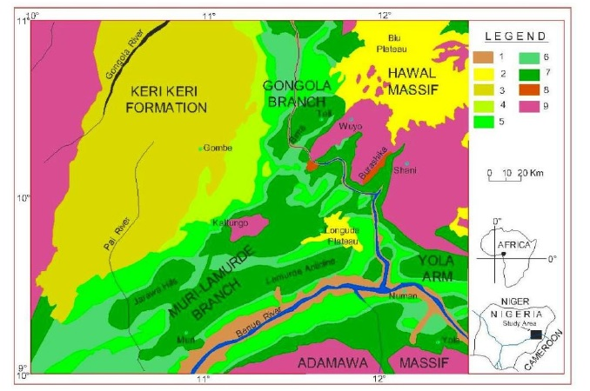
Figure 1. Geological map of the Upper Benue Trough. 1, quaternary alluvium: 2, Tertiary to Recent volcanism: 3, Kerri Kerri formation: 4, Gombe sandstone: 5, Pindiga formation: 6, Yolde formation: 7, Bima sandstone: 8, Burashika group (Mesozoic volcanism): 9, Granitoids precambrian (From Haruna et al., 2012).

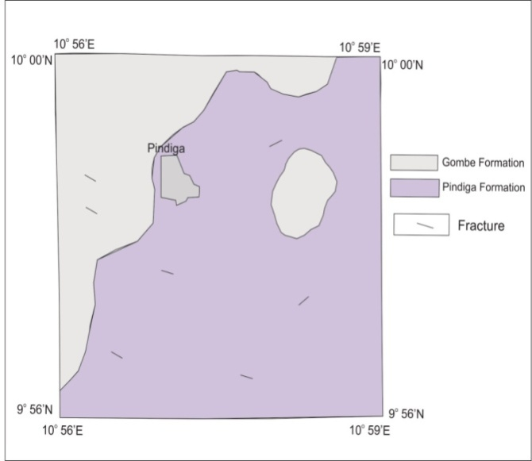
Fig 2. Geologic Map of the Pindiga Area

4. Results and Discussions
Fe₂O₃ ranges from 1.87% to 3.65% with an average 2.46%; some of ferrous (Fe2+) could replace Mg2+ in dolomite (Todd, 1966) although the lack of expansive dolomitic fronts in the study areas shows that any such replacement will have been limited. Low MgO content of the limestone (Table 4) also lends credence to the low replacement levels.
High SiO₂ and Al₂O₃ content of the Pindiga limestone will result in lower clay ratio than otherwise needed during mixing for cement production.
SO₃ ranged from 0.15% to 0.18% with average 0.17%. Its possible source being from gypsum bearing shales of the Pindiga formation (Table, 2012).
Low content (<0.18%) of unwanted elements (SO₃, N₂O and K₂O) also means the raw limestone will not require extensive processing before production can begin.

Table 1: Classification of Limestone (after Todd, 1966)
Expressive name | Average Proportion Ca/Mg | Mutual Proportion Mg/Ca
Pure Limestone | 100.00 – 39.00 | 0.00 – 0.03
Magnesian Limestone | 39.00 – 12.30 | 0.03 – 0.08
Dolomitic Limestone | 12.30 – 1.41 | 0.08 – 0.18

Table 2: Chemical Classification of the Pindiga Limestone
SAMPLE | CaO% | MgO% | Ca/Mg | Mg/Ca | Name
A | 46.662 | 0.478 | 97.200 | 0.010 | Pure Limestone
B | 47.264 | 0.593 | 79.838 | 0.013 | Pure Limestone
C | 47.128 | 0.687 | 64.488 | 0.015 | Pure Limestone
D | 50.775 | 0.589 | 85.757 | 0.012 | Pure Limestone
E | 47.890 | 0.683 | 69.605 | 0.014 | Pure Limestone
F | 46.113 | 0.652 | 70.293 | 0.014 | Pure Limestone
G | 45.036 | 0.609 | 74.079 | 0.013 | Pure Limestone
H | 46.366 | 0.484 | 96.600 | 0.010 | Pure Limestone

Table 3: ASTM standard and Alsop, 2007
Oxide | Alsop, 2007 | ASTM, 2004
CaO | 65-68 | 43.12
SiO₂ | 20-23 | 13.26
Al₂O₃ | 4-6 | 3.43
Fe₂O₃ | 2-4 | 2.68
MgO | 1-5 | 0.70
SO₃ | 0.1-2 | -
Na₂O+K₂O | 0.1-1.5 | -

Table 4: Results of Geochemical Analysis by X.R.F
SAMPLE | A | B | C | D | E | F | G | H | RANGE | MEAN
SiO₂ | 6.885 | 7.677 | 7.608 | 5.396 | 7.962 | 9.601 | 10.030 | 7.418 | 5.396-10.030 | 7.822
Al₂O₃ | 3.353 | 2.985 | 3.052 | 2.712 | 3.415 | 3.515 | 4.234 | 3.520 | 2.712-4.234 | 3.348
Fe₂O₃ | 3.615 | 2.223 | 2.235 | 1.875 | 2.094 | 2.117 | 2.480 | 3.105 | 1.875-3.615 | 2.468
CaO | 46.662 | 47.264 | 47.128 | 50.775 | 47.890 | 46.113 | 45.036 | 46.366 | 45.036-50.775 | 47.154
MgO | 0.478 | 0.593 | 0.687 | 0.589 | 0.683 | 0.652 | 0.609 | 0.484 | 0.478-0.687 | 0.597
SO₃ | 0.186 | 0.178 | 0.185 | 0.153 | 0.162 | 0.173 | 0.165 | 0.174 | 0.153-0.186 | 0.172
K₂O | 0.183 | 0.310 | 0.303 | 0.161 | 0.303 | 0.428 | 0.386 | 0.218 | 0.161-0.428 | 0.287
Na₂O | 0.108 | 0.126 | 0.110 | 0.090 | 0.103 | 0.117 | 0.103 | 0.106 | 0.090-0.126 | 0.106
P₂O₃ | 0.489 | 1.342 | 1.384 | 0.234 | 0.194 | 0.302 | 0.070 | 0.557 | 0.070-1.384 | 0.572
Mn₂O₃ | 0.349 | 0.793 | 0.416 | 0.222 | 0.165 | 0.190 | 0.220 | 0.346 | 0.165-0.793 | 0.338
TiO₂ | 0.163 | 0.148 | 0.160 | 0.139 | 0.171 | 0.180 | 0.204 | 0.174 | 0.139-0.204 | 0.167
LSF | 182.42 | 178.61 | 178.81 | 260.01 | 172.99 | 142.30 | 129.82 | 172.09 | 142.30-260.01 | 177.13
SR | 0.988 | 1.474 | 1.439 | 1.176 | 1.445 | 1.705 | 1.494 | 1.120 | 0.988-1.705 | 1.355
AIR | 0.928 | 1.343 | 1.365 | 1.446 | 1.631 | 1.660 | 1.707 | 1.134 | 0.928-1.707 | 1.402
CaCO₃ | 83.282 | 84.357 | 84.115 | 90.623 | 85.474 | 82.302 | 80.381 | 82.754 | 80.381-90.263 | 84.161
L.O.I | 37.146 | 37.745 | 37.473 | 40.496 | 38.335 | 36.907 | 36.015 | 36.920 | 36.015-40.496 | 37.663

Conclusions:
The geochemical properties of the Pindiga limestone was assessed to determine its suitability for cement production. Individual elements found in the limestone will impact the quality and mixing ratio of raw materials to be used for Portland cement production. Analysis of the individual elements show them to be within ranges suitable for cement production. Comparison of Ca/Mg and Mg/Ca ratios show the limestone to be pure and also suitable for cement production.

Acknowledgements:
This paper is an extract from data gathered by Felix Katty Francis and the authors will like to appreciate the Ashaka Cement Company for providing some analytical assistance.

References
- Alsop, P. A., 2007: Cement Plant Operation Hand Book, for Dry Process. 5th ed., International Cement Review. Tradeship Publications Ltd. UK, 317P.
- Beckhoff, B., Kanngieber B., Langhoff, N., Wedell R. and Wolff H., 2006: Handbook of Practical X-Ray Fluorescence Analysis. Springer-Verlag Berlin Heidelberg. 899P.
- Bouazza, N., El Mirhi A., Maate A. 2016: Geochemical assessment of limestone for cement manufacturing. Procedia Technology 22 211-218.
- Devi, K.R., and Duarah, P.B., 2015: Geochemistry of Ukhrul Limestone of Assam-Arakan Subduction Basin, Manipur, Northeast India. Journal Geological Society of India Vol.85, pp.367-376.
- Duda, W.H., 1985: “Cement-Data-Book” International Process Engineering in the Cement Industry, 3rd edn. Bauveriag, Gmb H, Wiesbaden and Berlin, 636P.
- Grant N.K., 1971: The South Atlantic Benue Trough and Gulf of Guinea Cretaceous triple junction. Geol. Soc. Am. Bull. 82:2295-2298.
- Miller, F. M., 2011: Raw Mix Design Considerations in "Innovations in Portland cement industry". 2nd ed., Portland Cement Association (PCA). Illinois, USA.1734P.
- Tabale, R., 2012: Trace Element Distribution in Gypsum Bearing Shales in Nafada, Gombe State. Unpublished Msc submitted to Modibbo Adama University of Technology, Yola.
- Todd, T.W., Petrogenetic Classification of Carbonate Rocks. Journal of Sedimetary Petrology, Vol. 36, No. 2, pp. 317-340.

7/30/2017

