Field Geology And Gem Potential Of The Fagam Complex, Northeastern Nigeria

M. Halilu¹, H.A Ahmed^{1,2}, F.R Ahmed¹ and M.B Saleh¹

¹Modibbo Adama University of Technology, Yola
² State Key Laboratory of Geological Processes and Mineral Resources, Center for Global Tectonics and School of Earth Sciences, China University of Geosciences, Wuhan 430074, China.
* Corresponding author: Email:maimunadocta@gmail.com/Tel: +2348051440114

Abstract: Field studies of the Fagam complex show the Biotite granites to have some gem potential (Topaz and Beryl). The gems occur within the granite as pegmatitic drusses and as disseminations. The deposition of these gems are related to late-stage effurversence of residual gases (F, Be, H and O) which resulted in metasomatic reactions.
[M. Halilu, H.A Ahmed, F.R Ahmed and M.B Saleh. Field Geology And Gem Potential Of The Fagam Complex, Northeastern Nigeria. Researcher 2017;9(7):111-113]. ISSN 1553-9865 (print); ISSN 2163-8950 (online). http://www.sciencepub.net/researcher. 17. doi:10.7537/marsrsj090717.17.

Keywords: Younger granites, Fagam, Gems, Topaz, Beryl

1. Introduction
Beryl and Topaz occurs principally in granitic pegmatites, but it is also found in topaz rhyolite, associated hydrothermal deposits (e.g., veins, greisens), and other metamorphic rocks (e.g., gneiss), and less commonly in leucogranites (Beus, 1966).
Topaz is a silicate mineral of aluminium and fluorine with the chemical formula Al₂SiO₄(F,OH)₂. It is found in both granitic and rhyolitic with occurences being commonly found granitic pegmatites and in vapor cavities in rhyolite lava flows. Beryl is common in peraluminous granitic rocks in part because lower BeO contents are required to saturate these melts in beryl, and possibly because these melts acquire higher BeO contents by mica melting reactions at their sources. Typically, beryl have low crustal abundance. (2.8ppm) (Taylor, 1964).
The aim of this study is to assess the field geology and occurrence potential of gem-grade topaz and beryl in the Fagam Anorogenic granites.

2. Geologic Setting
The Younger granites of Nigeria refer to anorogenic granites aptly named to differenciate them from Pan-African ‘older’ granites. The granites are part of a 1,600km long chain of ring complexes (Fig 1) extending from the Air Mountains in Niger Republic to North Central Nigeria (Bowden et al., 1976).

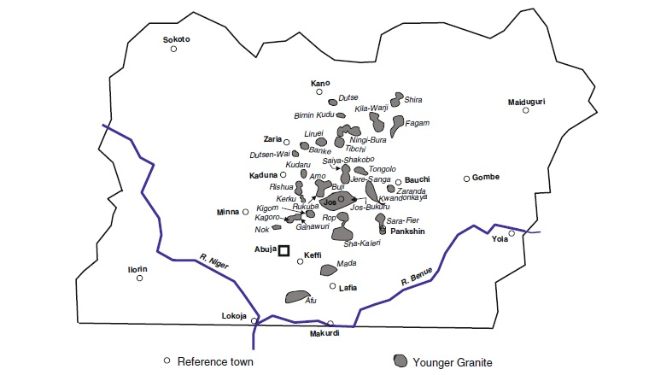
Fig 1. The Younger Granites of Nigeria (From Obaje, 2009)

3. Field Geology and Petrology
The Fagam Complex (Fig 2) is located in the north eastern section of the Younger granites complexes. The formation of the complex started with the eruption of volcanic rocks preserved in the southern part of the complex. Remnants of granite porphyry which could have been part of the ring dyke is also preserved on the southern end with subsequent upwelling of later stage arfvedsonite granite and biotite granite probably oblierating it in giving the complex its oblong shape.

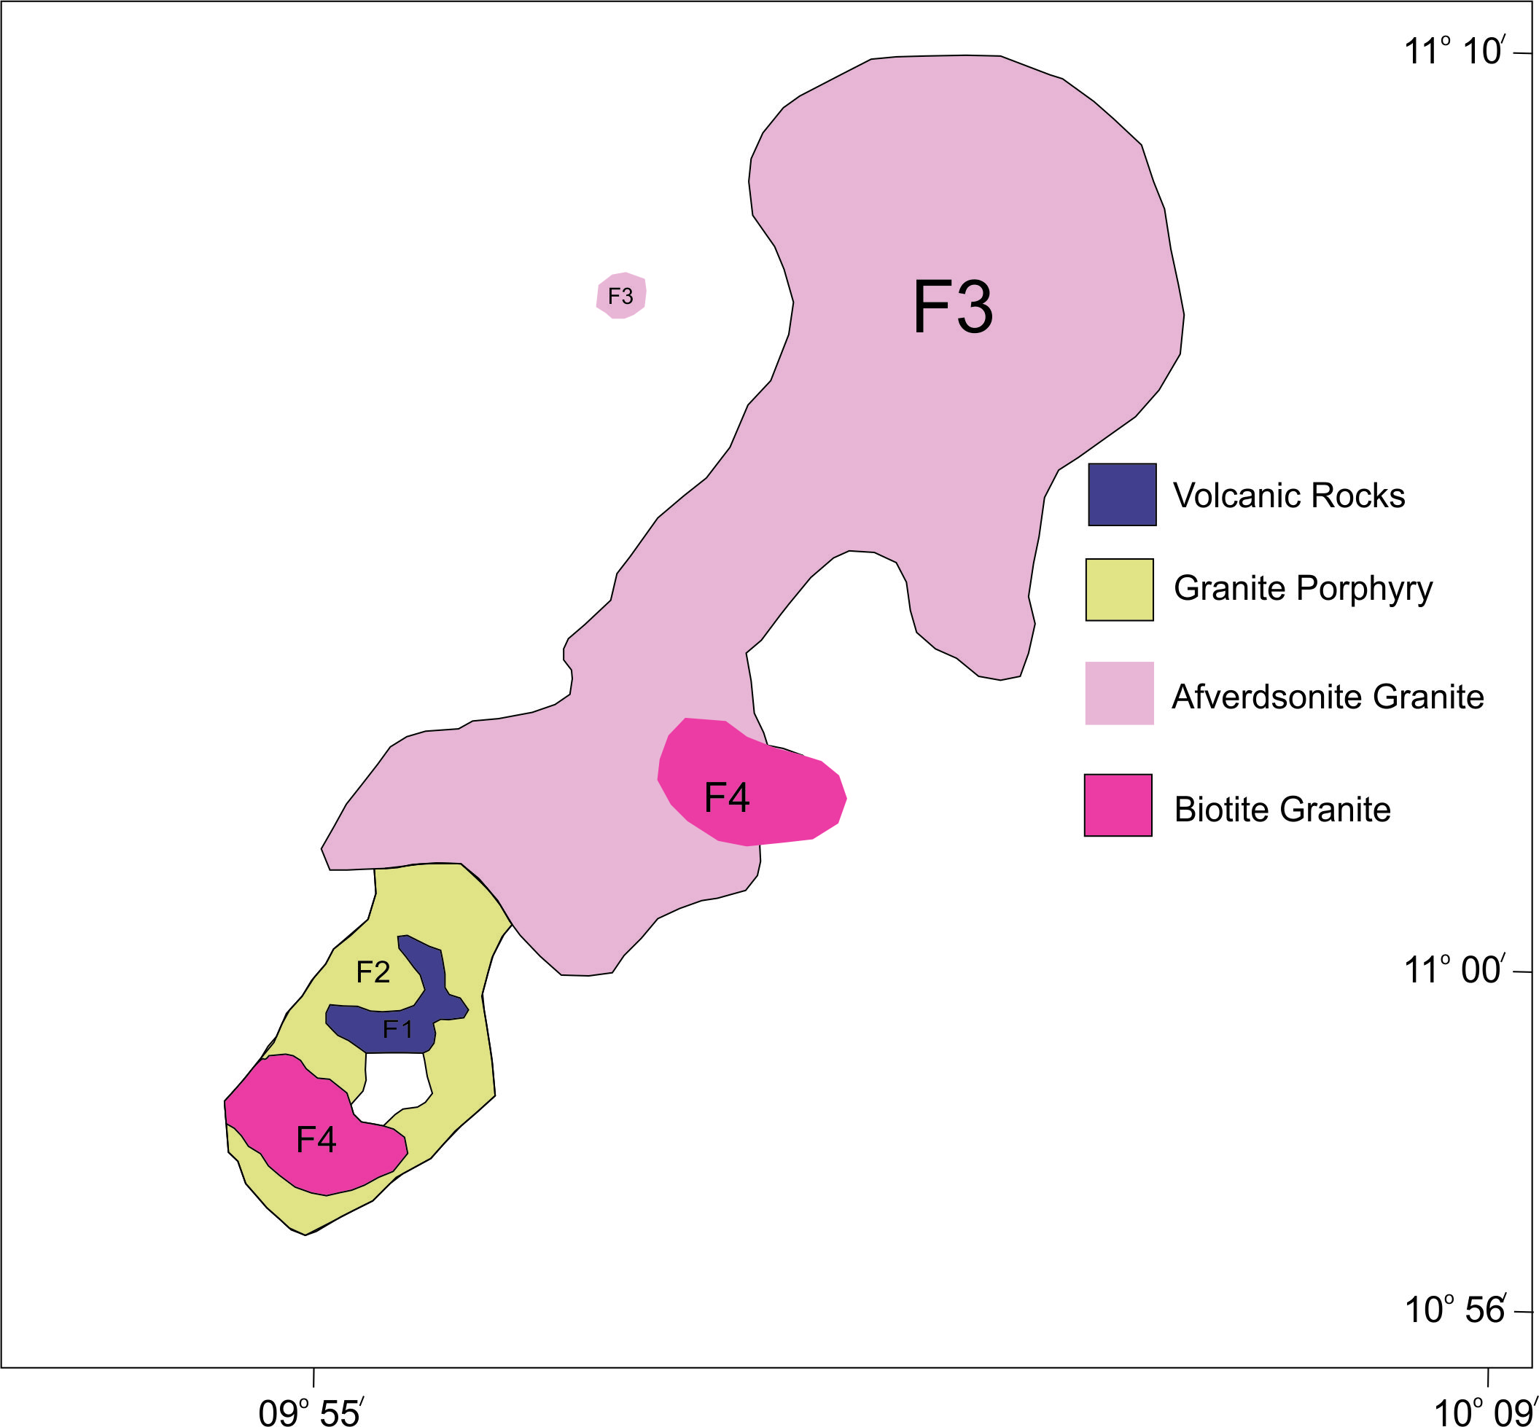
Fig 2. Geologic Map of the Fagam Complex

Descriptions of the field geology and a reconnaisance survey of the complex is given by Bennett et al., 1984 area and they accounted for flourite, topaz and tin mineralization although efforts to trace the source of the tin proved abortive. Rb-Sr dating on the biotite granites gave an age of 191+3Ma (Rahaman, 1984).

4. Discussions
Within mineralized peraluminous granites in the Nigerian Younger Granite complexes, Pegmatitic pods and lenses usually comprise topaz with quartz ± beryl + feldspar. Generally the margins of the granites are not characterized by pegmatitic development. Where this does occur the resultant pods are sporadic and usually only of the order of a few centimetres or less. The pegmatite pods may be composed of clear or smoky quartz with long prism faces, alkali feldspar sometimes twinned, blue-green beryl, often of gem quality, aquamarine and colourless to pale blue topaz, also often gem quality (Kinnaird, 1984). Crystals rarely exceed 8 cm in size but crystals of topaz and beryl are commonly 5 cm. The association of anorogenic granites with Topaz and Beryl mineralizations is well known from Nigeria and elsewhere. (Abdalla 2008, Burke et al., 1964; Kinnaird et al., 1985 and Nyako et al., 2014).
For the Fagam area, Quartz and flourite crystals are quite abundant and in some cases comprise about 95% of mineralized patches (Fig 3).
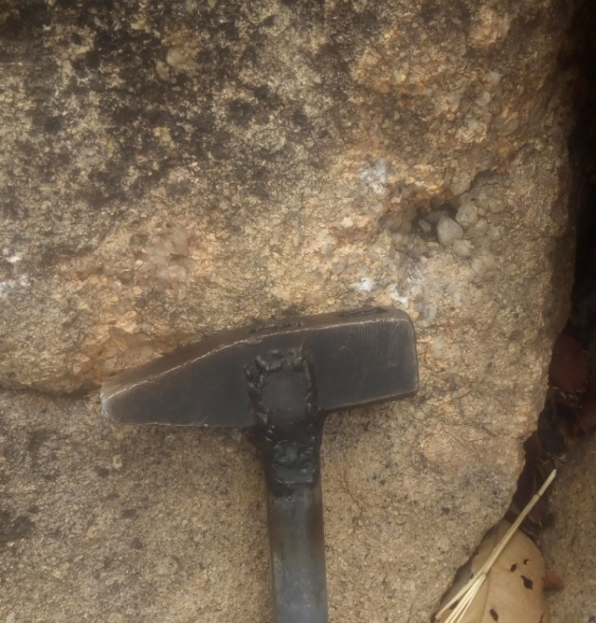
Fig 3. Mineralized vug with quartz and topaz

The quartz vary from smoky to clear variety and crystal sizes reach 8cm. Quartz veins at contact zones between the arfvedsonite granite and the biotite granite are conspiciously barren although exploratory efforts rarely go beyond 1m. Gem grade crystals of topaz and beryl are rare with smaller smoky crystals (1-3cm) more commonly won from the workings.
Gem grade bluish-green beryl of up to 6.5cm have been won from the workings although must of the crystals suffer cracks during extraction reducing its quality. Smokeless gem grade topaz are quite rare with most topaz won contain some impurities giving rise to various colour hints ranging from amber yellow to light brown. Current local workings for gems currently cover an area of about 2km x 2km but field studies have revealed that the mineralization could easily be in excess of a 10km by 10km area as mineralized patches were observed over 5km from present work pits.
Evensen et al, 1998 have shown experimentally that only low BeO contents to form saturated beryl in peraluminous and quartz-saturated magmas of simple composition. These correspond very closely to the beryl-type pegmatites of the LCT family (Cerny, 1991), which are typically found not far beyond the margins of a parental granite (where exposed).

Conclusions:
The ring complex rocks of Fagam show a range of peralkaline and peraluminous suites rocks. Peraluminous biotite granites contain pegmatitic pods which have gem grade topaz and beryl with quartz and florite also found in association as gangue minerals. The area has potential for exporation given gem-grade quality gems currently being worn by local miners and furthering exploratory work to access reserves in the area should be undertaken.

Acknowledgements:
The authors will appreciate Saidu Fagam for providing field guidance and Manu Forster for providing technical support.

References
- Abdalla, H. M. 2008. Mineralogical and Geochemical Characterization of Beryl-Bearing Granitoids, Eastern Desert, Egypt: Metallogenic and Exploration Constraints Resource Geology Vol. 59, No. 2: 121–139.
- Bennett, J.N., Turner, D. C., IKE, E.C., and Bowden, P. 1984: The geology of some northern nigerian anorogenic ring complexes. Overseas Geology and Mineral Resources, 61, 1-65.
- Beus, A.A., 1966. Geochemistry of Beryllium and Genetic Types of Beryllium Deposits, 286 p. Freeman, San Francisco.
- Bowden. P., Breemen, O. van. Hutchinson, J. and Turner, D. C. 1976. Palaeozoic and Mesozoic age trends for some ring complexes in Niger and Nigeria. Nature, Lond. 248, 650-653.
- Cerny, P. 1991. Rare-element granite pegmatites. Part I: anatomy and internal evolution of pegmatite deposits. Geoscience Canada, 18, 49–67.
- Joseph M. Evensen., David London., And Richard F. Wendlandt., 1999: Solubility and stability of beryl in granitic melts. American Mineralogist, Volume 84, pages 733–745.
- Kinnaird, J. A. 1984. Contrasting styles Sn-Nb-Zn-Ta Mineralization in Nigeria. J. Afr. Earth Sci. 2, 81-90.
- Kinnaird, J. A., Bowden, P., Ixer, R. A. and Odling, N. W. A. 1985. Mineralogy, geochemistry and mineralization of the Ririwai complex, Nigeria. J. Afr. Earth Sci. 3, 185-222.
- Nyako, A.A., I. O. Ajigo and E. C. Ashano 2014. Trace Elements as Pathfinders for Gem Deposits: A case study of the Jarawa complex and Eastern Part of Shere complex, Northcentral Nigeria. International Journal of Research In Earth & Environmental Sciences. Vol 1 No 3.
- Obaje, N.G., 2009. Geology and Mining Resourcs of Nigeria. Springer 221p.
- Rahaman, M.A., Van Breemen, O, Bowden, P. And Bennett, J. N. 1984: Age Migrations Of Anorogenic Ring Complexes In Northern Nigeria. Journal of Geology 92, 173-184.
- Taylor, S.K., 1964. The abundance of chemical elements in the continental crust—a new table. Geochimica et Cosmochimica Acta, 28, 1273–1285.

7/25/2017

