Geological and geochemical characteristics of Huangyangshan A-type granites: Implications for Mineral Exploration

H. A. Ahmed^{a,b*}, L.X. Wangª, M. Halilu^{b} , M.B. Girei^{c}

ªState Key Laboratory of Geological Processes and Mineral Resources, Center for Global Tectonics and School of Earth Sciences, China University of Geosciences, Wuhan 430074, China.
^{b}Department of Geology, Modibbo Adama University of Technology, Yola Adamawa State, Nigeria.
Department of Geology, Bayero University, Kano, Nigeria
*Corresponding author: E-mail: hifzullahahmed@yahoo.com/Tel: +8613164690700

Abstract: Geological and geochemical investigation of Huangyangshan A-type granite has been carried out in this study in order to shade more lights on its origin and implications for mineral potentials. The rocks in the study area are found to be associated mainly with riebeckite class of amphiboles and have alkalic affinity. Previous study classified this alkaline complex to be A1-type granite of anorogeic setting. Origin of these rocks is suggested to be from partial melting of the upper crust and assimilation of basaltic magma differentiates. This is supported by the felsic to intermediate nature of the granites and the correlation of Si and Al which are known to be the major composition of earth’s upper crust. Further isotopic analysis is recommended to ascertain the origin of this complex. On the mineralization potentials, some of the trace elements in the study area have background values well above the universal average crustal abundance, but they fall short of the threshold values to be considered anomalous or have potentials of being mineralized, hence, not worthy for exploration of economic mineral deposits.
[H. A. Ahmed, L.X. Wang, M. Halilu, M.B. Girei. Geological and geochemical characteristics of Huangyangshan A-type granites: Implications for Mineral Exploration. Researcher 2017;9(7):94-103]. ISSN 1553-9865 (print); ISSN 2163-8950 (online). http://www.sciencepub.net/researcher. 15. doi:10.7537/marsrsj090717.15.

Keywords: A-type granite, Huangyangshan, Mineral exploration, Dabieshan Orogenic belt

1.0 Introduction
Suizhou-Tongbai region in the Dabieshan Orogenic belt of Central China is famous for its UHP metamorphic rocks and alkaline magmatism. Although a lot of researches on eclogites and other metamorphism have been carried out in the region, however, the petrogenesis and mineralization potentials have not received much attention. Magmatic rocks in the area are very important in understanding the tectonic evolution of the region and the Qinling orogenic belt in general. Available data indicates that the Dabieshan orogenic belt (including the study area) contains different records of Paleozoic magmatic-tectonic association in different tectonic units.
A-type granites are generally characterized by high Na₂O + K₂O, Ga/Al, FeOt/(FeOt + MgO), REE (except Eu), HFSE (i.e., Zr, Nb, Ce, Y) and zircon saturation temperatures, and low CaO and Sr contents (e.g., Loiselle and Wones, 1979; Collins et al., 1982; Whalen et al., 1987; Eby, 1992; Bonin, 2007). They comprise a distinct group of granitoid rocks that are commonly produced in an extensional tectonic setting (e.g., Eby, 1992; Bonin, 2007), but their origins can be different and remains controversial (e.g., Skjerlie and Johnston, 1992; Turner et al., 1992; Wu et al., 2002; Yang et al., 2006). This type of rock is rare in Archean and early-mid Paleoproterozoic but has been identified extensively worldwide since the late Paleoproterozoic (e.g., Whalen et al., 1987; Anderson and Bender, 1989; Dall’Agnol et al., 2012). Their generation is thus likely indicative of a geodynamic transition of the continental evolution of the Earth (e.g., Loiselle and Wones, 1979; Whalen et al., 1987; Eby, 1992; Bonin, 2007).
Previous work in this area only focused on the geochemistry and tectonic activities in the area, and there was no evaluation of possible mineralization. In this paper, the Huangyangshan A-type granite was reviewed based on data from Ma et al, 2005 in addition to recent field and petrographic data from an ongoing research in the same area. The aim of the study is to shade more light on the geological and geochemical characteristic of the alkaline granites and its mineralization potentials.
1.2 Geological Setting
The Dabieshan orogenic belt, hosting the Huangyangshan pluton is located between the North China and Yangtze Cratons (inset in Fig. 1). Based on previous literatures, the orogen can be divided into three fault –bounded tectonic units (Yang et al, 1999): (1) the Beihuaiyang tectonic zone: bounded in the north and the south by Xingyang-Shucheng fault and Tongbai-Mozitan fault, respectively. They consist mainly of the Meso Neoproterozoic Luzhengguan orthogneisses and the Paleozoic Fuziling metaclastic rocks with greenschist facies metamorphic features. In the Mesozoic, the zone is partly covered by Jurassic sedimentary and volcanic rocks, and intruded by Late Jurassic-Early Cretaceous granitoids. (2) The central uplifting zone: aroused much attention by the occurrence of Early Mesozoic high-pressure-ultra high pressure metamorphic rocks and Late Mesozoic voluminous granitoids accompanied by intrusion of minor mafic magma. The wall rocks of the eclogites and plutons are mostly Archean-Proterozoic metamorphic complex (Ma et al, 2000), including granitic gneisses, plagioclase amphibolite and migmatite. (3) The Sui (Suizhou) - Ying (Yingshan) tectonic zone: located to the south of Xincheng-Guangji fault and the north of Xiangfan-Guangji fault. Main exposure in the region is the Meso-Neoproterozoic Wudang Rock Group (the previous Suixian Group), a suit of metamorphosed sedimentary-volcanic formation.

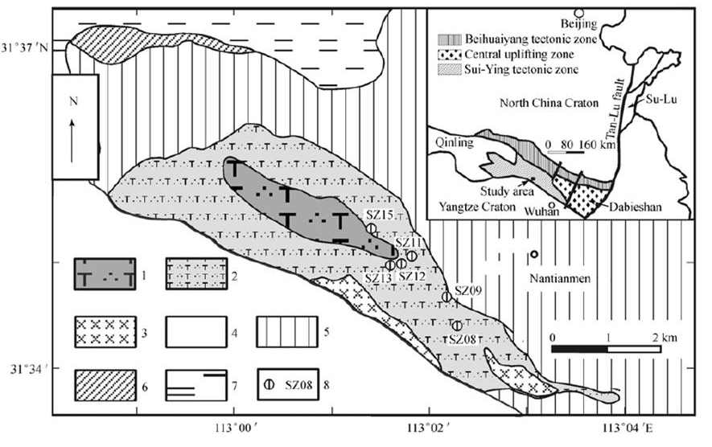
Fig. 1 Geological Map of Huangyangshan from Ma et al, 2005

The Huangyangshan A-type granitic complex is exposed within the Sui-Ying tectonic zone (Fig. 1). The pluton extending about 10 km² is located in Huangyangshan-Yuanjiawan area, 10 km northwest of Sanligang Town. The extension of pluton is NW 320°, consistent with the regional tectonic strike (Ma et al, 2005). In the pluton, joints are well developed whereas ductile deformation is not evident. The pluton is emplaced along the slaty cleavage of the Cambrian Zhuangzigou Formation in most regions, except for in the west part and the southeastern margin where the pluton intruded the Wudang Rock Group. In the southern part, the pluton was covered by Cretaceous sedimentary rocks. Small-scale diabase dykes are present in the southern margin of the pluton. It was once mentioned that the zircon U-Pb age of the pluton was 441 Ma (Niu et al, 1994), whereas Qiu et al. (1993) reported an age of 215 Ma. for the pluton determined by bulk rock Rb-Sr isochron. Most recent dating by Ma et al, (2005) assigned Silurian age of 439± 6Ma to the pluton.

2. Petrography
The Huangyangshan pluton is composed mainly of quartz syenite and alkaline granite. The rocks are mostly medium-fine grained, with a coarsening tendency toward the center of the pluton. Major minerals are K-feldspars (70%― 80%), quartz (5%― 18%) and amphiboles (5%― 20%) (Fig. 3). Amphiboles are sodic and largely black to brown colored with obvious pleochroism. Some of them are deep blue-colored in the marginal part; probably as a result of fluid alteration. K-feldspars include orthoclase and sanidine (Fig. 3).

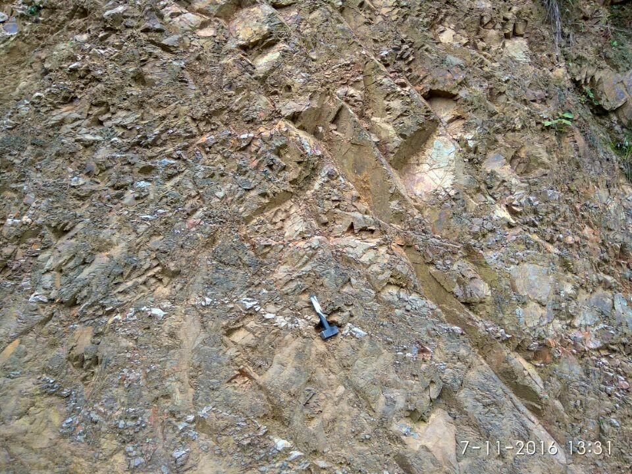
Fig. 2 Showing outcrop of A-type granitoid in Huangyangshan

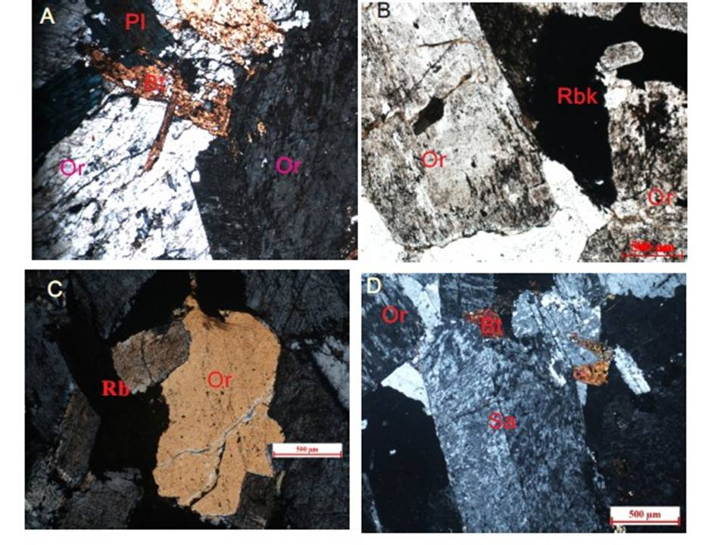
Fig. 3 Microphotograph of rock samples from Huangyangshan showing mineral composition of rocks

Table 1. Results of Amphibole analysis by EMPA
Elements | SZ5-1A | SZ5-1B | SZ5-1C | SZ5-1D | SZ1-1A | SZ1-1B
Si | 3.874 | 3.823 | 3.902 | 3.965 | 3.629 | 3.587
Al | 0.055 | 0.083 | 0.061 | 0.035 | 0.132 | 0.146
Al | 0.000 | 0.000 | 0.000 | 0.074 | 0.000 | 0.000
Fe (iii) | 0.252 | 0.353 | 0.195 | 0.070 | 0.743 | 0.827
Cr | - | - | - | - | -
Ti | 0.079 | 0.062 | 0.038 | 0.003 | 0.101 | 0.086
Fe (ii) | 1.837 | 1.720 | 1.951 | 2.118 | 1.070 | 0.944
Mn | 0.054 | 0.065 | 0.042 | 0.038 | 0.058 | 0.078
Mg | 0.124 | 0.115 | 0.132 | 0.097 | 0.387 | 0.416
Ca | 0.081 | 0.106 | 0.056 | 0.002 | 0.375 | 0.426
Na | 0.976 | 0.972 | 1.015 | 1.055 | 0.594 | 0.578
K | 0.101 | 0.163 | 0.089 | 0.024 | 0.084 | 0.084
Total | 7.432 | 7.464 | 7.483 | 7.481 | 7.172 | 7.171
Mineral | Riebekite | Riebekite | Riebekite | Riebekite | Riebekite | Riebekite

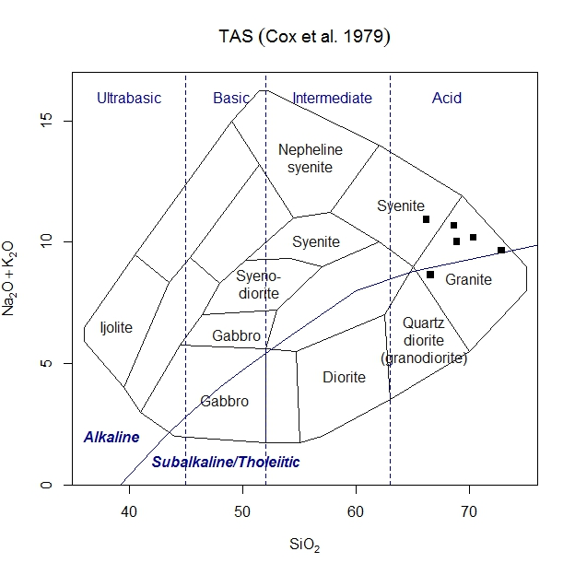
Fig.4 Total silica (TAS) Classification (Cox et al, 1979) for Huangyangshan Pluton

In this study, Amphiboles were analyzed at the Stake Key Lobaratory of Geological Processes and Mineral Resources in China University of Geosciences (Wuhan). Mineral compositions were determined with a JEOL JXA-8100 Electron Probe Micro Analyzer equipped with four wavelength-dispersive spectrometers (WDS). The samples were firstly coated with a thin conductive carbon film prior to analysis. The precautions suggested by Zhang and Yang (2016) were used to minimize the difference of carbon film thickness between samples and obtain a ca. 20 nm approximately uniform coating. During the analysis, an accelerating voltage of 15 kV, a beam current of 20 nA and a 10 µm spot size were used to analyze minerals. Data were corrected on-line using a modified ZAF (atomic number, absorption, fluorescence) correction procedure. The peak counting time was 10 s for Na, Mg, Al, Si, K, Ca, Fe, Cr, Ni and 20 s for Ti and Mn. The background counting time was one-half of the peak counting time on the high- and low-energy background positions. The following standards were used: Sanidine (K), Pyrope Garnet (Al), Diopsode (Ca, Mg), Almandine Garnet (Fe), Jadeite (Na), Chromium Oxide (Cr), Nickel (Ni), Rhodonite (Mn), Olivine (Si), Rutile (T)i.
The results are presented in Table 1. Calculation of structural formula and estimation of the proportion of Fe3+ were conducted after the methods proposed by Schumacher (1997).. Amphiboles in the rocks are proved to be sodic amphiboles and sodic-calcic amphiboles (Table 1) according to the new classification scheme approved by International Mineral Association (Leake et al, 1997).

3. Geochemistry
Geochemical analysis data from Ma et al, 2005 shows that the Huangyangshan pluton is mainly composed of quartz syenite, alkaline granite and syenite base on De La Roche et al, (1980) classification. However, running same data on Cox et al, 1979 reveals that the pluton is dominated by alkaline granite (Fig. 4). The rocks display characteristics of peralkaline alkaline granite (Fig. 5).

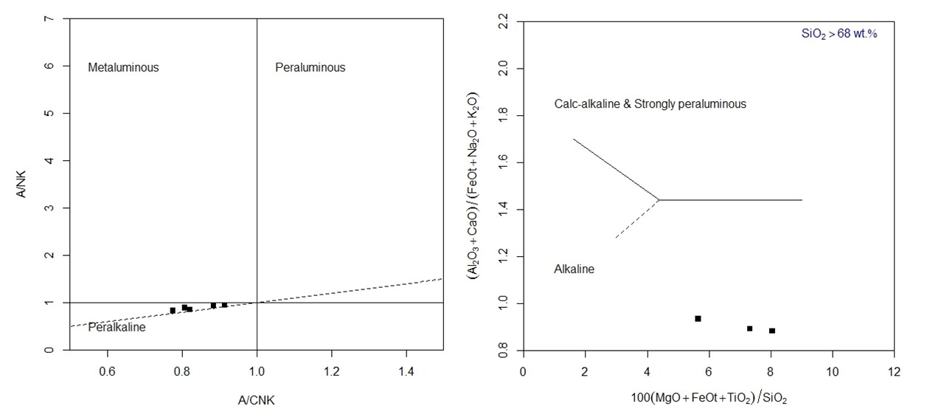
Fig. 5 A/NK Vs A/CNK (Shand 1943) and (Al2O3+CaO)/(FeOT+Na2O+K2O) vs. 100×(MgO+FeOT+ TiO2)/ SiO2 diagram (Sylvester, 1989)

Fig 5 (a) Middle ocean ridge basalt (MORB) normalized trace element patterns and (b) chondrite normalized REE patterns. MORB and chondrite values are from Ma et al, 2005

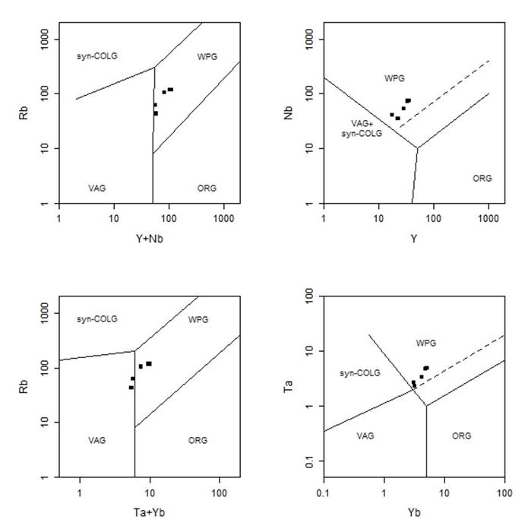
Fig 6. Granite Tectonic discrimination (Pearce et al, 1984). Data from Ma et al, 2005

The rocks are characterized by high abundances of high field strength elements (i.e. Nb, Zr, Ga, Y, Hf) and light rare earth elements, and by Rb/Sr ratios greater than 1. The high Zr, Ce, Y, Yb abundances and Ga/Al ratios are consistent with the features of typical A-type granites, contrary to orogenic granites and their fractionated products. In the MORB normalized spider diagram, most of the samples had obvious Sr, Ba, P₂O5 and TiO₂ negative anomalies, which likely result from differentiation of plagioclase (corresponding with Sr), K-feldspar (Ba), apatite (P₂O₅) and ilmenite or sphene or amphibole (TiO₂) (Ma et al, 2005).
The alkaline granites from Huangyangshan have similar chondrite normalized REE patterns (Fig. 5(b)) to those of typical peralkaline rocks. Generally, the Huangyangshan intrusive rocks display typical features of A-type granitoids. All granites plot within plate granites (Fig. 6). However, Rb Vs Ta+Yb discrimination indicates minor presence of granites from VAG.

4. Statistical Methods
According to Rose et al (1979), univariate statistical methods of analyses of data are good in summarizing large set of reconnaissance data which help to identify regions favorable for mineralization. To identify anomalous zones, it was necessary to establish thresholds above which values are then considered to be anomalous and hence, related to mineralization. Rose et al (1979) further stated that this is usually achieved by plotting the data in the form of histogram or cumulative frequency plot, computing the mean, mode, standard deviation, minimum and maximum distribution of each element. Computation was also done by using the mean plus some multiple of standard deviation to obtain the threshold values. Values above threshold were considered anomalous. Hawkes and Webb (1964) further noted that the mean plus twice standard deviation can be used to establish the threshold.
For the purpose of this work, analyses were accomplished using computer based softwares. SPSS version 16.0 was used for analyzing statistical parameters mentioned above.
4.1 Correlation
Pearson correlation within the data is shown in Table 2. From the table, a strong inverse correlation exists between SiO₂ content and the other oxides CaO, Fe₂O₃, FeO, MnO, TiO₂, P₂O₅ and MgO. (When SiO₂ abundances are low, all other oxides abundances are proportionally higher). SiO2 is however correlating with Al₂O₅, though not strongly. K₂O correlates strongly negatively with, Fe₂O₃, FeO, and TiO₂ but positively with SiO₂ and more strongly with Al₂O₅. FeO, TiO₂ and P₂O₅ strongly correlate with each other. Oxides that strongly correlate with each other indicate similar sources.
For the trace elements, Rb, Ta, Nb, Hf and Zr all strongly correlate with each indicating similar sources. At same time, these elements are wholly inversely correlated with Ba, indicating a distinct source of Ba in the pluton emplacement. Furthermore, apart from the Ba and Sr, all the aforementioned trace elements strongly correlate with Lu and Yb.

Table 2. Correlations for Major Oxides of Huangyangshan
 | SiO2 | TiO2 | Al2O3 | Fe2O3 | FeO | MnO | MgO | CaO | Na2O | K2O | P2O5
SiO2 | 1
TiO2 | -0.672 | 1
Al2O3 | 0.199 | -0.792 | 1
Fe2O3 | -0.494 | 0.509 | -0.63 | 1
FeO | -0.71 | .991** | -0.73 | 0.434 | 1
MnO | -.823* | .919** | -0.571 | 0.38 | .957** | 1
MgO | -0.809 | 0.445 | -0.076 | 0.255 | 0.534 | 0.74 | 1
CaO | -0.658 | 0.248 | 0.152 | -0.036 | 0.352 | 0.605 | .901* | 1
Na2O | -0.602 | -0.14 | 0.609 | -0.09 | -0.046 | 0.203 | 0.707 | 0.735 | 1
K2O | 0.287 | -.884* | .939** | -0.418 | -.859* | -0.721 | -0.207 | 0.005 | 0.494 | 1
P2O5 | -.853* | .825* | -0.44 | 0.327 | .886* | .969** | .856* | 0.692 | 0.374 | -0.617 | 1

Table 3 Correlations for Trace elements of the Study Area
 |  | Rb | Sr | Ba | Ta | Nb | Hf | Zr | Y | Ga | Th
Rb |  | 1
Sr |  | 0.174 | 1
Ba |  | -0.597 | 0.429 | 1
Ta |  | .934** | 0.037 | -0.441 | 1
Nb |  | .911* | 0.124 | -0.321 | .977** | 1
Hf |  | .994** | 0.102 | -0.602 | .959** | .928** | 1
Zr |  | .995** | 0.116 | -0.592 | .961** | .928** | .999** | 1
Y |  | .974** | 0.192 | -0.479 | .973** | .939** | .980** | .986** | 1
Ga |  | 0.641 | -0.443 | -0.51 | 0.72 | 0.746 | 0.671 | 0.661 | 0.598 | 1
Th |  | .962** | 0.038 | -0.585 | .971** | .911* | .981** | .984** | .983** | 0.63 | 1

Table 4. Correlations for Some Trace Elements and REE of Huangyangshan Pluton
 | Rb | Sr | Ba | Ta | Nb | Hf | Zr | Y | Th | Gd | Tb | Dy | Ho | Er | Tm | YB | Lu
Rb | 1
Sr | 0.174 | 1
Ba | -0.597 | 0.429 | 1
Ta | .934** | 0.037 | -0.441 | 1
Nb | .911* | 0.124 | -0.321 | .977** | 1
Hf | .994** | 0.102 | -0.602 | .959** | .928** | 1
Zr | .995** | 0.116 | -0.592 | .961** | .928** | .999** | 1
Y | .974** | 0.192 | -0.479 | .973** | .939** | .980** | .986** | 1
Th | .962** | 0.038 | -0.585 | .971** | .911* | .981** | .984** | .983** | 1
Gd | .864* | -0.083 | -0.391 | .972** | .969** | .904* | .899* | .898* | .912* | 1
Tb | .872* | 0.265 | -0.203 | .957** | .956** | .891* | .898* | .948** | .911* | .919** | 1
Dy | .967** | 0.255 | -0.423 | .963** | .945** | .974** | .976** | .989** | .968** | .904* | .961** | 1
Ho | .930** | 0.35 | -0.327 | .937** | .914* | .929** | .940** | .981** | .938** | .845* | .966** | .980** | 1
Er | .963** | 0.183 | -0.433 | .981** | .964** | .977** | .978** | .987** | .974** | .938** | .965** | .996** | .966** | 1
Tm | .949** | 0.317 | -0.33 | .958** | .960** | .950** | .955** | .981** | .938** | .897* | .975** | .991** | .986** | .986** | 1
YB | .953** | 0.178 | -0.386 | .980** | .990** | .964** | .964** | .970** | .945** | .954** | .961** | .980** | .947** | .990** | .984** | 1
Lu | .839* | 0.158 | -0.201 | .928** | .967** | .846* | .854* | .887* | .831* | .904* | .919** | .873* | .880* | .890* | .915* | .935** | 1

Table 5: Calculated and Estimated threshold values for the elements.
Elements | Minimum | Maximum | Sum | Mean (X) | Background (b) | AUCA | Std. Deviation (S) | Threshold (X+2S)
Rb | 43.37 | 118 | 561.92 | 93.65333 | 110.585 | 90 | 32.47403 | 158.6014
Sr | 4.64 | 28.91 | 85.37 | 14.22833 | 10.405 | 370 | 10.55788 | 35.34409
Ba | 93.17 | 484.89 | 1468.9 | 244.8167 | 193.13 | 340 | 157.5365 | 559.8897
Ta | 2.32 | 4.92 | 22.9 | 3.816667 | 4.045 | 2 | 1.17767 | 6.172007
Nb | 35.07 | 76.31 | 351.92 | 58.65333 | 62.81 | 20 | 17.8109 | 94.27513
Hf | 4.54 | 11.17 | 52.26 | 8.71 | 9.865 | 5.3 | 2.725333 | 14.16067
Zr | 167.21 | 416.55 | 1974.89 | 329.1483 | 374.095 | 190 | 104.4462 | 538.0407
Y | 17.46 | 36.24 | 171.71 | 28.61833 | 30.885 | 30 | 7.339483 | 43.2973
Ga | 34.89 | 40.32 | 224.07 | 37.345 | 36.695 | 18 | 1.97653 | 41.29806
Th | 2.91 | 8.63 | 39.05 | 6.508333 | 7.08 | 12 | 2.2449 | 10.99813

5. Discussion
Debate is still ongoing more than three decades ago since Loiselle and Wones, (1979) proposed the term “A-Type granites” They characterized the rocks as being of alkaline affinity, relatively hydrous and occurring in anorogenic setting. Collins et al, (1982), proposed the modification to the original classification using a geochemical approach and this view has been commonly accepted. Much evidence indicates that A-type granitoids, defined by geochemistry, could occur both in postorogenic and anorogenic settings (Yang et al, 1999, Bonin, 1990, Eby, 1992, Nedelec, et al 1995 and Pitcher, 1997). Whalen (1987), argued that although A-type granitoids could occur in various locations all over the world, however, they are all related to extensional setting. Rogers and Greenberg (1990) suggested that postorogenic suites are richer in CaO and MgO and poorer in total alkalis in comparison with anorogenic suites. Generally the rocks of anorogenic suites are peralkaline and those of postorogenic suites are metaluminous (Nardi et al, 1991). Eby (1990, 1992) divided A-type granitoids into A1 and A2 types according to their tectonic setting. A1 type granitoids are referred to plutons emplaced in anorogenic settings like continental rift or mantle plume or hotspot related settings; while A2 type granitoids are derived from continental crust or underplated mafic crust, and emplaced in a postorogenic setting, after the termination of long-term high heat flow state and granitic magmatism.
Three main modes of origin have been proposed by Frost and Frost (2011) to produce ferroan (A-type) granitic compositions: (1) partial melting of quartzofeldspathic crustal rocks; (2) differentiation of basaltic magma; (3) a combination of the first two models, in which differentiating basaltic magmas assimilate crustal rocks.
Samples of the Huangyangshan A-type granitoids are plotted in the A1 field (Ma et al, 2005). Based on the above proposals of previous workers, Huangyanshang pluton being A1 granite is emplaced in an anorogenic setting. The rocks being peralkaline in nature supports this tectonic setting. Moreover, the presence of sodic amphibole further indicates that the rocks were emplaced in an anorogenic setting, suggesting the beginning of rifting. Similar sodic amphibole bearing granites of peralkaline affinity of anorogenic setting is reported in the younger granites of northern Nigeria.
Although, previous study has identified richterite and arfvedsonites as classes of amphiboles within the granites, the present work has only found riebeckite. More work is required to ascertain the petrogenesis of Huangyangshan pluton. However, based on field observations, rocks in the area are more intermediate than felsic. Hence, the first mode of origin proposed by Frost and Frost, (2011) might be ruled out. Therefore, we speculate that Huangyangshan pluton might have originated from from differentiation of basaltic magma, or from assimilation of differentiating magmas with crustal rocks. This idea can be supported by plots of some samples of Huangyangshan in the region of VAG in the Rb Vs Ta+Yb granite tectonic discrimination plot (Fig 6) as well as the result of statistical analysis in this study.
Interpretations of statistical analysis were adopted in an attempt to explore possibility of anomalous mineralization in the study area. Using the method of Rose et al (1979), the background b, is estimated to be the median which corresponds to 50% ordinate. The values are rounded up (Table 5). The threshold values are calculated using X + 2S, where X= mean and S=Standard deviation. Average Universal Crustal abundance (AUCA) values after Barbalace (2017) and Ahmed et al, (2015) are also given for comparison. Generally, a cluster of high values have a low probability of occurring by chance (according to Rose et al (1979) and may reflect a mineralized area.
Based on the results of correlation analysis, most of the trace elements in the rocks of the study area strongly correlate with each other indicating similar sources, with the exception of Ba, which inversely correlate with all. Further studies are recommended to determine the sources of the elements. It is interesting to note that in the major elements group, SiO₂ inversely correlates with all oxides with the exception of Al₂O and K₂O. Though, the correlation between the SiO₂ and Al₂O₅ is not strong, but it is a very good clue that the granites could be associated with the SiAl composition of the upper crust, which is an important source of anorogenic granites.
In terms of mineralization potentials of Huangyangshan, although, some of the trace elements in the study area (e.g Rb, Ta, Nb, Hf and Zr, Table 5) have background values well above the universal average crustal abundance, but they fall short of the threshold values to be considered anomalous or having any potentials of being mineralized.

6. Conclusion
Field and geochemical investigations from previous and current studies have revealed the nature of magmatism and evolution of the anorogenic rocks in the Huangyangshan area. The riebeckite bearing granites could be originated from partial melting of upper crust and assimilation of basaltic magma differentiation, owing to the felsic and intermediate nature of the plutonic rocks; and the results of statistical analysis. They have alkali affinity and fall in the A1 type granite plot. Further isotope study is required to ascertain the origin of this alkaline complex. Although, some of the trace elements in the study area have background values well above the universal average crustal abundance, but they fall short of the threshold values to be considered anomalous or have any potentials of being mineralized.
Acknowledgements:
This work was financially supported by the National Natural Science Foundation of China (grant: 41272079).
Corresponding Author:
Ahmed H. A.
State Key Laboratory of Geological Processes and Mineral Resources, Center for Global Tectonics and School of Earth Sciences, China University of Geosciences, Wuhan 430074, China.
Telephone: +8613164690700
E-mail: hifzullahahmed@yahoo.com

References
- Anderson, J.L., Bender, E.E., 1989. Nature and origin of Proterozoic A-type granitic magmatism in the southwestern United States of America. Lithos 23, 19–52.
- Barbalace K.L (2017). c Periodic tables of elements (Environmental chemistry.com) https://environmentalchemistry.com/yogi/periodic/
- Bonin, B., From orogenic to anorogenic settings: Evolution of granitoid suites after a major orogenesis, Geol. J., 1990, 25: 61―270.
- Bonin, B., 2007. A-type granites and related rocks: evolution of a concept, problems and prospects. Lithos 97, 1–29.
- Collins, W.J., Beams, S.D., White, A.J.R., Chappell, B.W., 1982. Nature and origin of Atype granites with particular reference to southeastern Australia. Contrib. Miner. Petrol. 80, 189–200.
- Cox, K.G., Bell, J.D. and Pankhurst, R.J. (1979). The interpretation of igneous rocks. London George Allen and Unwin, 450.
- Dall’Agnol, R., Frost, C.D., Rämö, O.T., 2012. IGCP Project 510 ‘‘A-type Granites and Related Rocks through Time”: project vita, results, and contribution to granite research. Lithos 151, 1–16.
- De La Roche, H., Letterier, J., Grandclaude, P. et al., A classification of volcanic and plutonic rocks using R1-R2 diagrams and major element analyses – Its relationship with current nomenclature, Chem. Geol., 1980, 29: 183―210.
- Eby, G.N., 1990. The A-type granitoids: a review of their occurrence and chemical characteristics and speculations on their petrogenesis. Lithos 26, 115–134.
- Eby, G.N., 1992. Chemical subdivision of the A-type granitoids: petrogenetic and tectonic implications. Geology 20, 641–644.
- Frost, C.D., Frost, B.R., 2011. On Ferroan (A-type) Granitoids: their compositional variability and modes of origin. J. Petrol. 52, 39–53.
- Leake, B.E., Woolley, A.R., Arps, C.E.S., Birch, W.D., Gilbert, M.C., Grice, J.D., et al., 1997. Nomenclature of amphiboles: Report of the subcommittee on amphiboles of the International Mineralogical Association, commission on new minerals and mineral names. Am. Mineral. 82, 1019–1037.
- Loiselle, M.C., Wones, D.R., 1979. Characteristics and origin of anorogenic granites. Geol. Soc. Am. Abst. Prog. 11, 468.
- Ma, C. Q., Ehlers, C., Xu, C. H. et al., The roots of the Dabieshan high-pressure and ultrahigh-pressure metamorphic terrane: Contraints from Nd-Sr isotope systematics, Precamb. Res., 2000, 102: 279―301.
- Ma Changqian, She Zhenbing, Xu Pin & Wang Lingyan (2005). Silurian A-type granitoids in the southern margin of the Tongbai-Dabieshan: Evidence from SHRIMP zircon geochronology and geochemistry. Science in China Ser. D Earth Sciences 2005 Vol.48 No.8 1134—1145.
- Nedelec, A., Stephens, W. E., Fallick, A. E., The Panafrican stratoid granites of Madagascar: Alkaline magmatism in a postcollisional extensional setting, J. Petrol., 1995, 36: 1367―1391.
- Niu, B. G., Fu, Y. L., Liu, Z. G. et al., Main tectothermal events and 40Ar/39Ar dating of the Tongbai –Dabie mts, Acta Geoscientia Sinica (in Chinese with English abstract), 1994, 1-2: 20―34.
- Pearce, J.A., Harris, N.B.W., Tindle, A.G., 1984. Trace element discrimination diagrams for the tectonic interpretation of granitic rocks. Journal of Petrology 25, 956–983.
- Pitcher, W. S., The Nature and Origin of Granite, 2nd ed., London: Chapman & Hall, 1997, 386.
- Qiu, J. X., Alkaline Rocks in Qinling-Dabashan Mountains (in Chinese with English abstract), Beijing: Geological Publishing House, 1993.
- Rogers, J. J. W., Greenberg, J. K., Late-orogenic, post-orogenic and anorogenic granites: Distinction by major-element and trace element chemistry and possible origins, J. of Geol., 1990, 98(3): 291―309.
- Rose, A.W; Hawkes, H.E. and Webb, J.S. (1979). Geochemistry in Mineral Exploration (2nd Edt.). Academic Press, London. 657p.
- Schumacher, J. C., The estimation of the proportion of ferric iron in the electron-microprobe analysis of amphiboles, Can. Mineral., 1997, 35: 238―246.
- Shand (1943). Eruptive Rocks. Their genesis, composition, and classification John Wiley and sons. Shaw, D.M. (1972). The origin of the Apsley Gneiss, Ontario. Canadian. Journal of Earth Sciences 9, 18-35.
- Skjerlie, K.P., Johnston, A.D., 1992. Vapor-absent melting at 10 kbar of a biotite- and amphibole-bearing tonalitic gneiss: implications for the generation of A-type granites. Geology 20, 263–266.
- Sylvester, P. J., Post-collisional alkaline granites, J. Geol., 1989, 97: 261―280.
- Turner, S.P., Foden, J.D., Morrison, R.S., 1992. Derivation of some A-type magmas by fractionation of basaltic magma; an example from the Padthaway Ridge, South Australia. Lithos 28, 151–179.
- Whalen, J.B., Currie, K.L., Chappell, B.W., 1987. A-type granites: geochemical characteristics, discrimination and petrogenesis. Contrib. Miner. Petrol. 95, 407–419.
- Wu, F.Y., Sun, D.Y., Li, H.M., Jahn, B.M., Wilde, S.A., 2002. A-type granites in northeastern China: age and geochemical constraints on their petrogenesis. Chem. Geol. 187, 143–173.
- Yang, W. R., Yang, K. G., Liu, Z. M. (1999). Caledonian tectonothermalevent in Tongbai-Dabieorogenic belt and its significance,Earth Sci. Frontiers (in Chinese with English abstract), (64):247―253.
- Yang, J.H., Wu, F.Y., Chung, S.L., Wilde, S.A., Chu, M.F., 2006. A hybrid origin for the Qianshan A-type granite, northeast China: geochemical and Sr–Nd–Hf isotopic evidence. Lithos 89, 89–106.
- Zhang, R.X., Yang, S.Y., 2016. A mathematical model for determining carbon coating thickness and its application in electron probe microanalysis. Microscopy and Microanalysis, 22: 1374-1380.

7/23/2017

