Bone Changes in Dental Implant Combined with Laser Therapy: A Split Mouth Study

Ali Fahd¹, Yousef Abd-El Ghaffar², Hanaa El-Shenawy³, Mohamed Khalifa⁴, and Mushira Dahaba⁴

^{1.} Oral and maxillofacial Radiology department, Faculty of oral and dental medicine, South Valley University, Egypt
^{2.} Periodontology and Oral Medicine, Misr University for Science and Technology, Egypt
^{3.} Oral Surgery and Medicine, National Research Centre, Egypt
^{4.} Oral and Maxillofacial Radiology Department, Faculty of Oral and Dental Medicine, Cairo University, Egypt
dr.hanaa.shenawy@gmail.com

Abstract: Background: Dental implant placement is a good option for teeth replacement. Laser therapy is an additive tool for dental application and can offer a lot of advantages in the field of dental implant. One of the uses of laser therapy is biostimulation which may enhance dental implant osseointegration. This work was undertaken to assess bone changes after dental implant surgery biostimulated with laser therapy in comparison to placebo control in a split mouth study through standardized digital intraoral dental radiographs. Material and Methods: Twenty-one bilateral dental implants were randomly assigned to right or left side lased groups and the outcome was relative bone density changes and relative bone level changes measurd by Digora software for standardized digital intraoral periapical radiographs taken at baseline, three and six months postoperatively. Results: Relative radiographic bone density in the study sample decreased at three months from baseline comparison then increased again to over baseline at six months due to normal bone metabolism and healing mechanism, a finding that is not attributed to the effect of laser intervention. Relative radiographic bone loss occurred around dental implants during the first six months and despite of lower occurrence in the laser group, yet this finding was not statistically significant. Conclusion: Laser therapy may enhance bone-implant interface. A randomized clinical trial is recommended to reach a solid evidence based conclusion.
[Ali Fahd, Yousef Abd-El Ghaffar, Hanaa El-Shenawy, Mohamed Khalifa, and Mushira Dahaba. Bone Changes in Dental Implant Combined with Laser Therapy: A Split Mouth Study. Researcher 2017;9(7):68-74]. ISSN 1553-9865 (print); ISSN 2163-8950 (online). http://www.sciencepub.net/researcher. 11. doi:10.7537/marsrsj090717.11.

Keywords: Digital Imaging - Implant Dentistry - Lasers - Oral Implantology - Osseointegration - Radiology

1. Introduction
Replacement of missing teeth has become one of the most important needs for patients attending dental clinics. Many treatment options are available but the use of endosseous implants has increased dramatically and is regarded as an essential option for tooth replacement [1].
Lasers are proving to be a valuable tool, with multiple applications for dental surgeries. The unique properties of laser may offer a lot of advantages. Lasers may also aid in osseointegration by enhancing adhesion of blood cells, stabilization of the clot at the peri-implant interface and biostimulation [2-4].
Osseointegration is a direct structural and functional connection between the structured vital bone and the surface of an implant of titanium on functional load and is an important factor for implant success [5].
This work was undertaken to assess bone changes after dental implant surgery biostimulated with laser therapy in comparison to placebo control through standardized digital radiographs.

2. Material and Methods
Adult twenty-one dental implants (ROOTT^{R}, TRATE AG, Switzeland) were placed in six patients who are indicated for bilateral dental implant placement in the same jaw with flapless protocol (four females and two males) with an age range from 30 to 50 (average 39). All patients were free from any systemic disease. Informed consent was obtained from all patients and the study protocol was preapproved by the ethics committee, Faculty of Oral and dental medicine, Cairo University. Final preoperative assessment was done by CBCT (Planmeca Pro Max 3D, Planmeca, Finland).
A gallium-aluminium-arsenide diode dental laser unit (SIROLaser advance class IIIb, Sirona, Germany) was used. Emission was in the 970 (+/-15) nm wavelength (0.6 watt, continuous wave, non-contact mode). The first laser application for each patient was done immediately following the surgery. Intraoral irradiation was performed by positioning the laser probe directly on the buccal surface for three minutes and lingual surface for three minutes with motion and without mucosal contact. The application was done only to the randomized chosen left or right side. To ensure that patients were blinded to the study intervention, the hand piece of the laser apparatus was applied to both sides, but the device was turned on only at the assigned site, as determined by the randomization process. The application was repeated once every other day for five applications.
Relative radiographic bone density and relative radiographic bone level changes were evaluated by the Digora software (Soredex, Tuusula, Finland) on standardized digital periapical radiographs done during the first week after surgery as zero point, three months and six months postoperatively. To obtain radiographic images, an x-ray machine MINRAY® (Soredex, Tuusula, Finland) operating with tube voltage 70 kVp and tube current 7 mA at 0.08 second was used. The focal spot object distance was fixed for the same patient in every time of exposure. Direct digital images were obtained with size 2 photostimulable plate (PSP) using the Digora Optime imaging system (Soredex, Tuusula, Finland) by strict standardized imaging technique (Figures 1-2).
Relative radiographic bone density measurements were done at three different sites in relation to each implant to assure total coverage of the whole implant surrounding bone (mesial, distal, and apical) and the mean of the three measurements was calculated. Two of the lines were with the same inclination as the implant, one mesial and one distal while an apical line was drawn between them. The drawn lines were as close to implant as possible without touching the threads. Relative radiographic bone level was evaluated by linear measurements taken just mesial and distal to each implant. A central reference line was drawn with the long axis of the implant while another reference line was drawn perpendicular to the first one at the level of the implant apex. The measurement line was drawn parallel to the first reference line and perpendicular to the second reference line starting from the superior bone level to the second reference line (Figure 3).
Unpaired T test was used for comparison between control and laser groups for each time point. One way ANOVA test was used for comparison between time periods and tukey's test was used for pair-wise comparisons when ANOVA was significant. P value of less than 0.05 is considered significant.

3. Results
Relative radiographic bone density: At baseline, statistical analysis was done for the actual values of the two groups as a test for similarity and there was no statistically significant difference in relative radiographic bone density between the two groups. Atthree andsix months, there was no statistically significant difference between the percentagesof relative radiographic bone density changes of the two groups (Table 1).
For intra-group comparison, there was a non-statistically significant decrease in relative radiographic bone density when comparing between baseline and three months for both groups. Also, there was a non-statistically significant increase in relative radiographic bone density when comparing between base line and six months. The only statistically significant difference in relative radiographic bone density was in density increase between three months and six months (Figure 4).
Comparison between the relative radiographic bone level of the two groups revealed that at three and six months, there was a non-statistically significant decrease in relative radiographic bone level between the two groups (Table 1).
For intra-group Comparisons for both groups, there was a statistically significant decrease in relative radiographic bone level when comparing between baseline and three months. Also, there was a high statistically significant decrease in relative radiographic bone level when comparing between base line and six months. The only non-statistically significant decrease in relative radiographic bone level was between three months and six months (Figure 4).

Table (1): Comparison of relative radiographic bone density and relative radiographic bone level between the two groups at the different time points.
 | Laser  zero time | Control  zero time | Laser  three months | Control  three months | Laser  six months | Control  six months
Relative radiographic bone density | 122.80  ±  14.82  100% | 125.60  ±  29.55  100% | 118.20  ±  15.06  96.2% | 120.60  ±  29.03  96.1% | 127.40  ±  13.76  108% | 129.30  ±  27.31  107.8%
 | P value: 0.7929 |  | P value: 0.9658 |  | P value: 0.8679
Relative radiographic bone level | 12.65  ±  2.65  (0) | 11.90  ±  1.92  (0) | 11.87  ±  2.21  (-0.78) | 10.83  ±  1.85  (-1.07) | 11.40  ±  1.89  (-1.25) | 10.24  ±  2.06  (-1.66)
 | P value: NA |  | P value: 0.5336 |  | P value: 0.0996

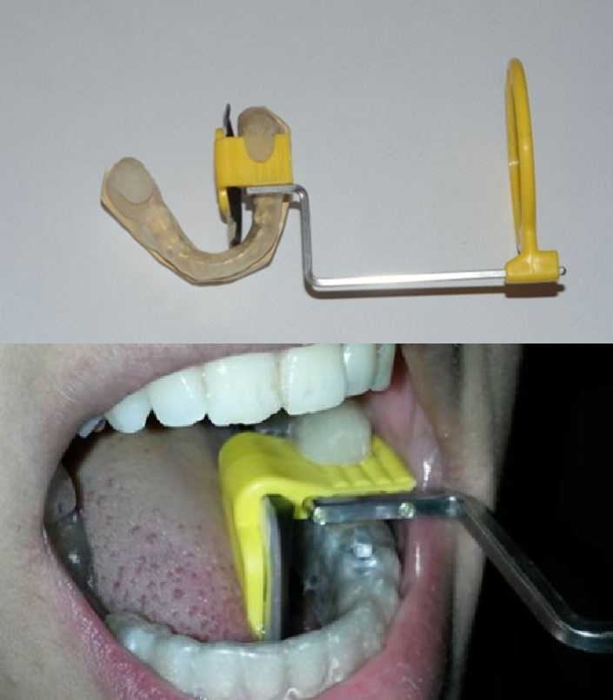
Figure (1): The radiographic stent used for standardized Intraoral digital radiographs

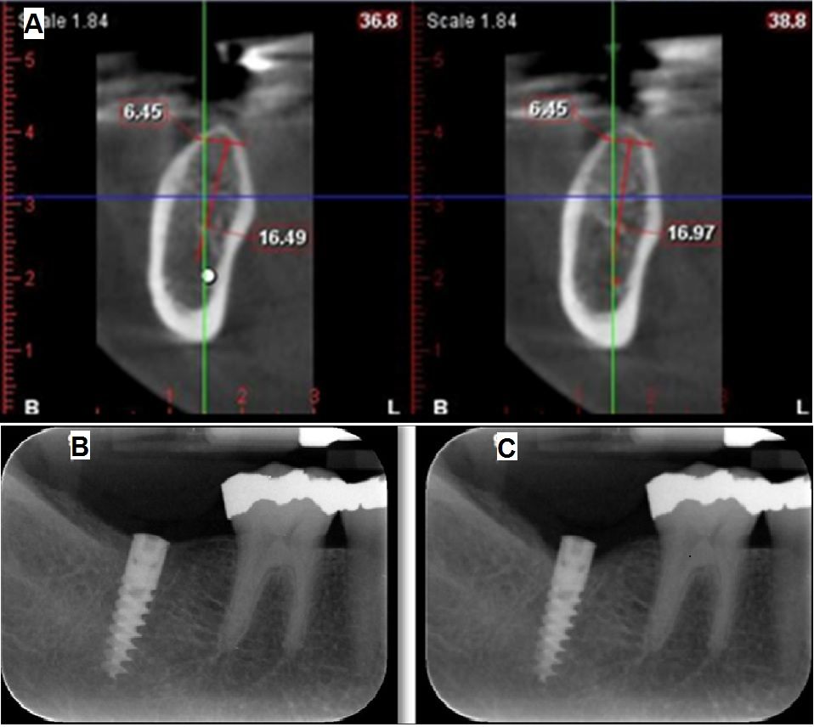
Figure (2): A) Preoperative CBCT for third dimension analysis, B) Digital periapical radiograph for the same case just after implant insertion (baseline) and C) Digital periapical radiograph for the same patient at six months showing the standardized view.

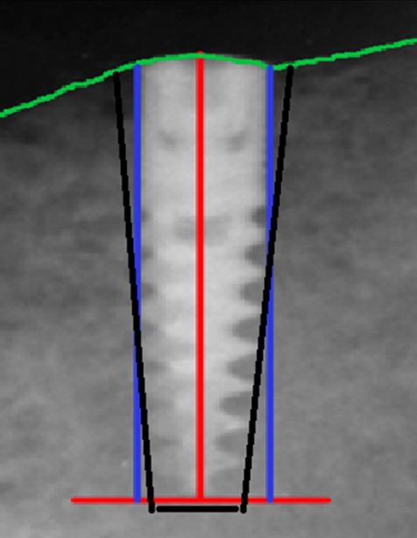
Figure (3): A simulation for measurements where the green line is the reference bone level, the red lines are reference lines, the blue lines for measuring relative bone level and the black lines for relative bone density measurements.

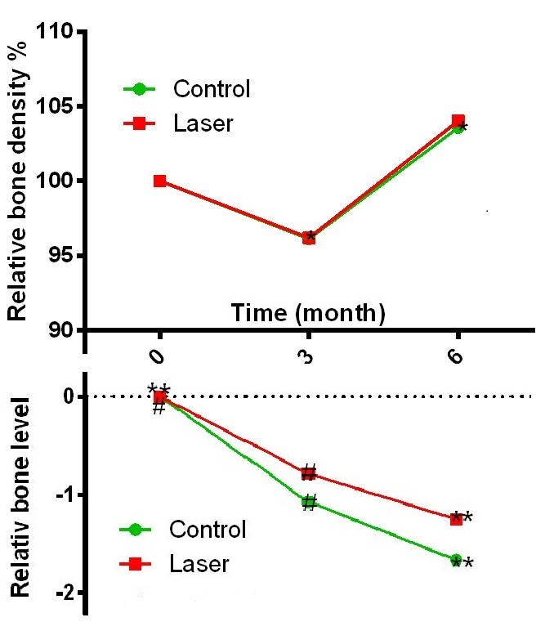
Figure (4): Intra-group comparison by time for both relative bone density (above) and relative bone level (below)

4. Discussion
Despite the long history of dental implants, the development of implant science is still a major research subject. Through research, dental implant methodology has been constantly improving in the recent years, providing higher levels of patient satisfactions [6]. That's why the current study was focused on dental implantology as it is a continuously tempting area of research.
The success of dental implants depends to a large extent on peri-implant bone healing which lead some researchers to target their studies toward methods that could improve and accelerate bone healing, among which is laser therapy [7]. From that point of view comes the research question, what can laser therapy offer for patients requiring dental implants.
Flapless approach was chosen in the current work as the surgical protocol for implant placement because of minimal surgical trauma, less postoperative complications. Furthermore, the intact periosteum reduces bone resorption because of better blood supply [8-10]. Moreover, this technique was accepted by the patients as the procedure was less time consuming, had minimal bleeding, did not require sutures, was less complicated, and had minimal postoperative pain and swelling [11, 12].
The problem with flapless technique is that the true underlying bone topography cannot be observed because of technique blindness, a factor that might increase the risk of implant loss due to perforations [13]. The “blindness” of the technique is not considered a problem if the patient has been appropriately selected with enough safe available bone. Today, thanks to advancement in 3D imaging and surgical planning, 3D radiographic preoperative planning could overcome this blindness. That's why in this study, CBCT was selected as the 3D preoperative imaging modality for assuring fruitful treatment planning.
According to Walsh [14], the maximum benefit with LLLT occurs with repeated dosages, following this recommendation the choice of multiple doses was applied in the current study.
Even though there are several methods to measure bone level, volume and density with a wide range of reliability, only few of them are practically considered in clinical practice(Zamani Naser, Etemadi et al. 2011). Routine radiography is one of them [15]. Being practical and more available with less radiation exposure (in comparison to 3D imaging) were not the sole reasons for choosing digital intraoral radiography for assessing both bone level and density in our work. Accuracy and reliability are essential for any research study. The accuracy and reliability of intraoral radiography for the assessment of marginal bone level around oral implants was confirmed by studies[16, 17].
The use of digital intraoral radiographic technique rather than others is also justified, thanks to the high resolution with both low dose and low cost. Nothing comes without trade off. A limitation of intra-oral radiography is that it only illustrates the mesial and distal bone so that early bone changes on the facial aspect of the implant cannot be detected [18, 19].
The problem with plain radiography is that bone changes around the implants must reach a certain level to be radiographically (qualitatively) detected. The solution for that problem is using digital radiography by applying quantitative means via special softwares for measurements of bone height and density. The efficacy of computer assessed measurements of bone changes around the implant on intraoral digital images was confirmed [20, 21]. Hence, quantitative intra-oral digital radiography was selected as the assessment method in this study.
Base line images were taken in this study to act as the reference start points for comparison with time changes to enhance interpreting the computed measurements as gain or loss. In other words, assessment of the changes in alveolar bone around the implant was done by consecutive images taken at different periods of time. To achieve this crucial goal, standardized imaging and assessing techniques are of high concern and mandatory [15].
A strict ideal geometry between radiation beam, implant axis and the film, may sometimes be difficult to obtain not only because of the inclination of the implant but also due to the anatomy of the patient [16]. For radiographs covering the full length of the implant, the task is more difficult.
For follow up and density measures, the full length of the implant is a must while for bone level a strict ideal geometry is better. The later can be more easily achieved by not covering the full length of the implant. In other words, there is a need to do two radiographs to get the benefits of both techniques but this extra radiation exposure may not be justified for cases with multiple implants and multiple follow up images. That's why; bone level in this study was measured from the radiographs taken for the implant full length with its mentioned limitations. The bone level values in this study are not absolute values and hence the name relative radiographic bone level.
A lot of researches relied on 2D digital radiography for relative bone density measurement based on grayscale values [22-25]. For assuring reliability of collected data, we did not use the measurements as absolute value, but were just used for comparable purposes. Despite the fact that radiographic densitometry may not be the most sensitive method of measuring bone density, yet, it is a practical mean for application in clinical practice as long as it is properly done[26, 27].
In this study, the Digora software was used to assess both linear and density measurements. Manrique et al also used the same software to study the alveolar bone healing process in an experimental animal study[28].
Although panoramic radiographs were done for patients as a postoperative follow up for justified medical and legal issues, bone changes were not measured from panoramic radiographs because of the known technique drawbacks such as magnification, and positioning mismatches beside the absence of gold standard for comparing any conflicting results with the intraoral radiographic measures.
Relative bone density measures in this study decreased when first assessed with a mean of 120.60 ± SD of 29.03. This was followed by their increase with a mean of 129.30 ± SD of 27.31 to a level near or higher than the baseline with a mean of 125.60 ± SD 29.55 supporting the claim that dental implants preserve and enhance alveolar bone. This can be attributed to normal bone metabolism and healing mechanism in association with surgical implant placement [29, 30].
The results of the present study are in match with the study of El Rashedy et al in which standardized periapical radiographs were taken for measuring the alveolar bone density in gray scales and the bone height in pixels for the implants and the residual alveolar ridges. The mean value of bone level changes decreased after three months, and then it increased after six months [30].
As one of the criteria for implant success, stable bone levels are believed to be critical to the long term maintenance of an implant with a mean vertical bone loss should be less than 1.5 mm during the first year and less than 0.2 mm annually following the first year of service [31]. Some cases reached a 1.5 mm of bone loss during the study period in this research. This unmatching can be explained by the report of Åstrand et al who found that the bone loss between implant placement and prosthesis insertion was several times higher than between prosthesis insertion and a 5-year follow-up [32]. Again, bone level in this study is relative and not absolute.
The flapless implant surgical technique used in this study may be a cause of limited laser effect, because of the technique advantages of preservation of blood supply to the bone, less stress to the patient and reduced needed time for healing [11]. Advantages of the flapless technique have reduced the space for action of laser. There is a believe that crestal bone loss in the initial phase of dental implants is promoted by flap reflection [33].

Recommendations
A randomized clinical trial should be done with a sample size calculation based on the results of this preliminary study. A patient relevant outcome should be added and another study group of implants inserted with flap protocol is also recommended.

References
1. Christensen, G.J., Elective vs. mandatory dentistry. J Am Dent Assoc, 2000. 131(10): p. 1496-8.
2. Romanos, G.E., et al., Lasers use in dental implantology. Implant dentistry, 2013. 22(3): p. 282-288.
3. Strauss, R.A. and S.D. Fallon, Lasers in contemporary oral and maxillofacial surgery. Dent Clin North Am, 2004. 48(4): p. 861-88, vi.
4. Núñez, S.C., et al., He‐Ne laser effects on blood microcirculation during wound healing: A method of in vivo study through laser Doppler flowmetry. Lasers in surgery and medicine, 2004. 35(5): p. 363-368.
5. Maluf, A.P., et al., Mechanical evaluation of the influence of low-level laser therapy in secondary stability of implants in mice shinbones. Lasers Med Sci, 2010. 25(5): p. 693-8.
6. Gaviria, L., et al., Current trends in dental implants. Journal of the Korean Association of Oral and Maxillofacial Surgeons, 2014. 40(2): p. 50-60.
7. El-Kholey, K.E. and H. El-Shenaway, Role Of Diode Laser In Preservation Of The Marginal Bone Around Early Loaded Endosseous Implant. Life Science Journal, 2012. 9(3): p. 940-943.
8. Fortin, T., et al., Effect of flapless surgery on pain experienced in implant placement using an image-guided system. International Journal of Oral & Maxillofacial Implants, 2006. 21(2).
9. Hahn, J., Single-stage, immediate loading, and flapless surgery. Journal of oral Implantology, 2000. 26(3): p. 193-198.
10. Lustmann, J., Intraoperative computerized navigation for flapless implant surgery and immediate loading in the edentulous mandible. 2005.
11. Nikzad, S. and A. Azari, Computer‐assisted implant surgery; a flapless surgical/immediate loaded approach with 1 year follow‐up. The International Journal of Medical Robotics and Computer Assisted Surgery, 2008. 4(4): p. 348-354.
12. Ali, I., et al., In vivo evaluation of crestal bone heights following implant placement with ‘flapless’ and ‘with-flap’techniques. Asia Pacific Dental Journal, 2015: p. 35.
13. De Bruyn, H., et al., Clinical outcome and bone preservation of single Ti Unite™ implants installed with flapless or flap surgery. Clinical implant dentistry and related research, 2011. 13(3): p. 175-183.
14. Walsh, L.J., Emerging applications for infrared lasers in implantology. Periodontology, 2002. 23(1): p. 8-15.
15. Zamani Naser, A., et al., Comparison of Conventional and Standardized Bone Densitometry around Implants in Periapical Radiographs during a Three Months Period. Dental Research Journal, 2011. 8(1).
16. De Smet, E., et al., The accuracy and reliability of radiographic methods for the assessment of marginal bone level around oral implants. Dentomaxillofacial Radiology, 2002. 31(3): p. 176-181.
17. Zheng, X. and J.X. Lin, [A system for quantitatively measurement of alveolar bone density and the evaluation of its precision and validity]. Beijing Da Xue Xue Bao, 2008. 40(4): p. 431-6.
18. Spray, J.R., et al., The influence of bone thickness on facial marginal bone response: stage 1 placement through stage 2 uncovering. Annals of Periodontology, 2000. 5(1): p. 119-128.
19. Cardaropoli, G., U. Lekholm, and J.L. Wennström, Tissue alterations at implant‐supported single‐tooth replacements: a 1‐year prospective clinical study. Clinical Oral Implants Research, 2006. 17(2): p. 165-171.
20. Kavadella, A., A. Karayiannis, and K. Nicopoulou-Karayianni, Detectability of experimental peri-implant cancellous bone lesions using conventional and direct digital radiography. Australian dental journal, 2006. 51(2): p. 180-186.
21. Wyatt, C.C., et al., A computer‐assisted measurement technique to assess bone proximal to oral implants on intraoral radiographs. Clinical oral implants research, 2001. 12(3): p. 225-229.
22. Giro, G., et al., Influence of estrogen deficiency and its treatment with alendronate and estrogen on bone density around osseointegrated implants: radiographic study in female rats. Oral Surg Oral Med Oral Pathol Oral Radiol Endod, 2008. 105(2): p. 162-7.
23. Erdogan, Ö., et al., Dental and radiographic findings as predictors of osteoporosis in postmenopausal women. Geriatrics & gerontology international, 2009. 9(2): p. 155-164.
24. Rowshan, H.H., et al., Effect of intermittent systemic administration of recombinant parathyroid hormone (1-34) on mandibular fracture healing in rats. J Oral Maxillofac Surg, 2010. 68(2): p. 260-7.
25. Chugh, N.K., et al., Use of digital panoramic radiology in presurgical implant treatment planning to accurately assess bone density. The Journal of prosthetic dentistry, 2016.
26. Griffith, J.F., K. Engelke, and H.K. Genant, Looking beyond bone mineral density: Imaging assessment of bone quality. Ann N Y Acad Sci, 2010. 1192: p. 45-56.
27. Lucisano, M.P., et al., Radiodensitometric and DXA analyses for the measurement of bone mineral density after systemic alendronate therapy. Braz Oral Res, 2013. 27(3): p. 252-7.
28. Manrique, N., et al., Alveolar bone healing process in spontaneously hypertensive rats (SHR). A radiographic densitometry study. J Appl Oral Sci, 2012. 20(2): p. 222-7.
29. Davies, J.E., Understanding peri-implant endosseous healing. Journal of dental education, 2003. 67(8): p. 932-949.
30. El-Rashedy, W.M., et al., Clinical and radiographic evaluation of implant-supported removable partial overdenture in the lower Kennedy class IV cases. Tanta Dental Journal, 2016. 13(1): p. 1.
31. Smith, D.E. and G.A. Zarb, Criteria for success of osseointegrated endosseous implants. The Journal of prosthetic dentistry, 1989. 62(5): p. 567-572.
32. Åstrand, P., et al., Astra Tech and Brånemark system implants: a 5‐year prospective study of marginal bone reactions. Clinical oral implants research, 2004. 15(4): p. 413-420.
33. Maier, F.-M., Initial Crestal Bone Loss After Implant Placement with Flapped or Flapless Surgery-A Prospective Cohort Study. The International journal of oral & maxillofacial implants, 2016. 31(4): p. 876.

7/16/2017

