Prevalence Of Addiction Among Medical Students

Feriha Fatima ¹, Faiza Shabir ²

¹ Department of Biochemistry, Liaquat University of Medical & Health Sciences (LUMHS), Jamshoro, Pakistan.
² Department of Gynecology and Obstetrics, Liaquat University of Medical & Health Sciences (LUMHS), Jamshoro, Pakistan.
ferihafatima@yahoo.com

Abstract: Objectives: Present study was conducted to find out the prevalence and reasons of different addictions among medical students. Study Setting: Department of Biochemistry, Liaquat University of Medical and Health Sciences, Jamshoro. Study Design: Cross-sectional, questionnaire based. Methodology: This study was conducted among first year and second year MBBS students of Liaquat university of medical and health sciences. 164 students participated in study and filled the structured questionnaire. Data was analyzed on SPSS version 16. Results: Prevalence of addiction was found to be 20.7% with prevalence of 64.7% of males predominantly. The most common addiction among students was eating betel nuts (38.2%) followed by cigarette smoking (23.5%), paan eating (17.6%), sheesha smoking (8.8%), alcohol (6%), whereas 5.9% had other addictions. The most important factor for the initiation of addiction were pleasure, impersonating others and failure in love. The majority of addicted students (47.1%), had motivation from friends to start addiction. Conclusion: Addiction among medical students in spite of having knowledge regarding their hazards is alarming. Awareness, counseling, and proper education can prevent the addiction among future doctors who will have to serve the community.
[Feriha Fatima, Faiza Shabir. Prevalence Of Addiction Among Medical Students. Researcher 2017;9(7):64-67]. ISSN 1553-9865 (print); ISSN 2163-8950 (online). http://www.sciencepub.net/researcher. 10. doi:10.7537/marsrsj090717.10.

Key Words: Addiction, medical students

- Introduction:
Addiction is matter of concern across the globe. Not only it has affected mental, physical and social health of the individual but its social acceptance also remains questionable¹. Its prevalence among students may vary from general population especially among medical students who have to cope with different stresses during their studies.
Most common substances abuse found among medical students are cigarette smoking, sheesha smoking and alcohol^{2, 3}. In certain studies it has been found that majority of addictions begin under 18 years of age when students take substance abuse at school and consider addiction to be source of affection among their friends ⁴.
Study conducted in India shown high prevalence of 44% of addiction among teenagers of medical colleges with male predominance for addiction ⁵. It might be failure of parents and school to provide proper education and counseling to prevent teenagers from addiction.
Different reasons for addiction among medical students include academic pressures, stress, enjoyment, anxiety and pleasure⁶. Majority of studies show the gender difference for type of addiction with increase prevalence among males. It may be due to the social and cultural factors especially in muslim countries where for females, it is considered against norms. Whereas, studies conducted in European countries do not show significant difference among male and females ⁴. Besides, the hazardous effects of substance abuse on individuals it may also affect the personality of future doctors to provide care to the patients and be ideal character for society.
Few studies have been conducted in Pakistan regarding addiction among medical students. The present study was conducted to find out the prevalence and reasons of different addictions among medical students.

- Materials and Methods:
This cross-sectional study was conducted at biochemistry department among first year and second year students of Liaquat university of medical and health sciences Jamshoro between December 2014 and January 2015. 164 volunteer students filled self-administered questionnaire at the end of their lecture after explaining them about purpose of study and how to fill the questionnaire. Confidentiality was assured to students and they were advised not to write their names to maintain anonymity.
Assuming the prevalence of addiction among medical students as 16% from previous studies², the sample size was calculated to be 149 at 95% confidence interval level with alpha= 0.05. Sample size was calculated using Open Epi Version 2.3.1. The questionnaire included information comprising of general information of the student (age, gender, marital status, residence), substance addiction (type of substance addiction, frequency of its use, age of initiation, cause of beginning and continuation of addiction, the most important motivators, financial resources for buying), knowledge of hazardous impact, willingness to quit addiction and information of non-addictors.
Data was analyzed by using the statistical package for social sciences program (SPSS), version 16. Proportion/ percentage and chi-square test were used as statistical methods to analyze data. P-value ≤ 0.05 is taken as significant.

- Results:
Among the 164 participants, 72 were males (43.9%) and 92 were females (56.1%). Mean age of participants were 18.6 years. Mean age of addiction initiation was 14.05 years. Overall prevalence of addiction was found to be 20.7% (Figure I) with prevalence of 64.7% of males predominantly as compare to females 35.3% (p<0.05).

Figure I: Percentage of addictors and non-addictors among medical students.

Addiction was more prevalent in students residing in their own homes (51.5%) followed by university hostel (39.4%), private hostels (6.1%) and relatives place (3%) (p<0.05).
The most common addiction among students was eating betel nuts (38.2%) followed by cigarette smoking (23.5%), paan eating (17.6%), sheesha smoking (8.8%), alcohol (6%), whereas 5.9% had other addictions (Figure II). The most common addiction among female students was eating betel nuts (66.7%), whereas cigarette smoking was common among males (31.8%).

Figure II: Percentage of common addictions among medical students

Table I: Frequency and percentage of various factors that initiates addiction among medical students.
Causes Of Initiation For Addiction (N= 164)
CAUSE | Frequency | Percentage
Curiosity | 5 | 2.9
Pleasure | 53 | 32.4
Failure in love | 19 | 11.8
Maturity | 5 | 2.9
Unintentional | 14 | 8.8
Friends company | 10 | 5.9
Impersonating others | 39 | 23.5
Release of tension | 5 | 2.9
High society trend | 5 | 2.9
Other | 9 | 5.9

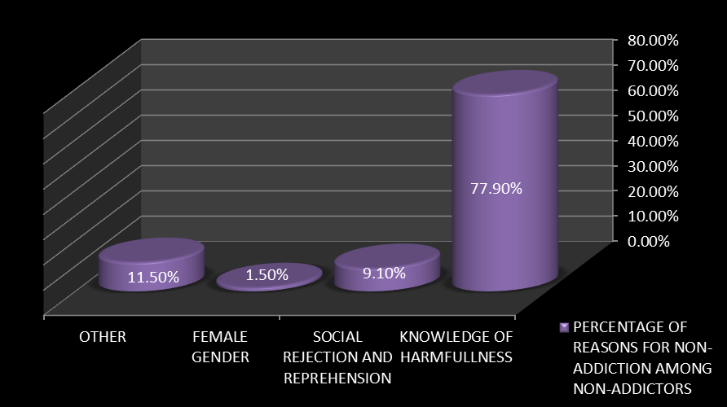
(Figure III): Percentage of various factors for non-addiction.

The most important factors for the initiation of addiction were pleasure, impersonating others and failure in love (Table I). The majority of addicted students (47.1%), had motivation from friends to start addiction. 59.4% students considered pleasure as the reason for the continuation of addiction whereas 21.9% think continuation as unintentional and 18.9% considered it as means for brief relaxation.
66.7% addictors considered that their addiction is hazardous for their health whereas 33.3% consider it as non-hazardous. 50% of students shown desire to quit addiction. The main reasons of non-addiction among non-addictor students were having knowledge of harmful effects of addiction (77.9%), social rejection and being reprehensible (9.1%), female gender (1.5%) whereas 11.5% had other reason for non-addiction (Figure III).

- Discussion:
In particular, prevalence of addiction in our study was found to be 20.7% which is comparatively lower as compared to western countries. Different studies conducted in United States reported from 1973 to 2013 revealed that addiction of different substances among medical students is quite common with substance most abuse are marijuana, alcohol, tobacco and cocaine⁷, whereas in our study we found most common addiction to be consumption of betel nuts followed by cigarette smoking. None of the student reported to be addicted of marijuana and cocaine in our study. It may be due to difference in culture, availability of substance and few studies conducted in Pakistan as compare to other countries.
One study conducted in three institutes of Khyber Pakhtunkhwa revealed the prevalence of addiction to be 68% ⁸, with more prevalence among male students which also coincides with our study. However in their study more prevalent substance abuse was use of tobacco 41.4% whereas in our study we found it to be 23.5%. Betel nuts addiction was not included in their study even though it is one of the common addictions of south-east Asians and studies have revealed its association to carcinoma of oral cavity, esophagus, liver and uterus⁹. More studies should be conducted in other provinces of Pakistan as well to reach to conclusions.
It is important to note that mean age of initiation of addiction found in our study was about 14 years which illustrates that majority begin their addiction during school age. This demonstrates the need of counselling of students from school as majority of students are unaware of adverse effects of these addictive substances and till they get admission in medical institutions they are already addicted to such substances.
It is also worthy to note that majority of students had influence of their friends to start addiction which shows that parental control over children regarding their friendship can also prevent children from addictions.

Conclusion:
High prevalence of addiction among medical students is alarming. Although medical students are aware of the hazardous effects of addictive substances, in spite of that, these future doctors had less concern over their health. As majority of them begin addiction during school age, it is important that proper counselling and preventive as well therapeutic programs should be planned and made effective at schools, colleges and higher institutions.

Acknowledgement:
We are thankful to the students of first year and second year MBBS for their active participation in this study.

Corresponding Author:
Dr. Feriha Fatima
Department of Biochemistry
Liaquat University of Medical & Health Sciences
(LUMHS), Jamshoro, Sindh-Pakistan.
Email: ferihafatima@yahoo.com
feriha.fatima@lumhs.edu.pk

References:
1. Ziaaddini H, Ziaaddini T, Nakhaee N. Pattern and trend of substance abuse in eastern rural Iran: A household survey in a rural community. J Addict. 2013:6.
2. Sahraian A, Sharifian M, Omidvar B, et al. Prevalence of substance abuse among the medical students in southern Iran. Shiraz E medical J. 2010;11(4).
3. Mohammadpoorasl A, Fakhari A, Rostami F, et al. Predicting the initiation of substance abuse in Iranian adolescents. Addict Behav. 2007;32(12):3153-9.
4. Goodarzi F, Karrari P, Eizadi-Mood N, et al. Epidemiology of drug abuse (chronic intoxication) and its related factors in a MMT clinic in Shiraz, southern Iran. Iranian journal of toxicology. 2011;4(4):377-80.
5. Padhy GK, Das S, Sahu T, et al. Prevalence and causes of substance abuse among undergraduate medical college students. Ind Med Gaz. 2014:276-82.
6. Chinawa JM, CManyike P, Obu HA, et al. Substance use among medical students attending two Nigerian universities. Int Neuropsychiatr Dis J. 2015;3(1):27-34.
7. Dumitrascu CI, Mannes PZ, Gamble LJ, et al. Substance use among physicians and medical students. Med Student Res J. 2014;3:26-35.
8. Kalsoom Ue, Azeemi MMu H, Farid K. Substance use among students of professional institutes of Khyber Pakhtunkhwa. J Postgrad Med Inst. 2014;28(1):53-7.
9. Garg A, Chaturvedi P, Gupta PC. A review of the systemic adverse effects of areca nut or betel nut. Indian J Med Paediatr Oncol. 2014;35(1):3-9.

7/9/2017

