Evaluation of Crop Water Stress Index (CWSI) for sunflower under different Irrigation Regimes

Atefeh Nouraki ¹, Samira Akhavan ¹, Yosef Rezaei ²

^{1.} Department of Water Engineering, Faculty of Agriculture, Bu-Ali Sina University, Hamedan, Iran
^{2.} Department of Civil Engineering, Faculty of Engineering, Bu-Ali Sina University, Hamedan, Iran
akhavan_samira@yahoo.com

Abstract: Deficit irrigation is a common practice to cope with limited water availability. The main objective of this research is to evaluate crop water stress index (CWSI) on sunflower under various irrigation regimes in the northern Khozestan, Iran. Canopy temperatures were measured throughout the growing season with an infrared thermometer (IRT), and vapor deficit of air (VPD) was used for calculating empirical the CWSI. The experiment was laid out in a randomized block design with 3 replications. The lower (non-stressed) and upper (fully stressed) base lines for the determination of Crop Water Stress Index (CWSI) of sunflower crop were estimated. A non-water stressed baseline (lower baseline) equation for sunflower was developed using canopy temperature measured from full irrigated plots as, Tc −Ta = -0.1 12VPD + 1.88; R²=0.98 and Tc −Ta = -0.1 34VPD + 1.70; R²=0.97 for September and October respectively. The trends in CWSI values were consistent with the soil water contents induced by the deficit irrigations. The CWSI value was useful for evaluating crop water stress in sunflower and should be useful for timing irrigation.
[Nouraki A, Akhavan S, Rezaei Y. Evaluation of Crop Water Stress Index (CWSI) for sunflower under different Irrigation Regimes. Researcher 2017;9(7):59-63]. ISSN 1553-9865 (print); ISSN 2163-8950 (online). http://www.sciencepub.net/researcher. 9. doi:10.7537/marsrsj090717.09.

Keywords: Infrared thermometry; crop water stress index; irrigation scheduling; sunflower

1. Introduction
Sunflower (Helianthus annuus L.) is an important oilseed crop in Iran and its production has greatly increased with the introduction of hybrids and play an important role in narrowing the wide gap between production of edible oils in the country and its import (Khan et al., 2003; Sarwar et al., 2013). It is a successful crop both in irrigated and in rainfed areas and grow well, when planted in areas with adequate sunlight, light-textured and well drained sandy loam soil (Mokgolo, 2016).
Water is an important factor in agricultural consumes about 80–90% of fresh water worldwide (Morison et al., 2008; Gonzalez-Dugo et al., 2010) and food production yet. It is a highly limited resource and is becoming more and more important over time for optimal crop production (O’Shaughnessy et al., 2011; Wang et al., 2012). Water stress is one of the most critical abiotic stressors during critical stages of growth such as vegetative, flowering or fruit settings (Tuner, 1990; Xie et al., 1999; Jaimez et al., 2000; Kırnak et al., 2002; Sezen et al., 2006; Ferrara et al., 2011), causes limiting plant growth, crop yield and quality concerning food production (Hsiao et al., 1976). Therefore, research on water management and irrigation has focused on crop yield responses to water supply (Chen et al., 2010 a; Koksal, 2011). Application time and quantity of irrigation water are among critical decisions producers frequently have to make to develop site-specific irrigation plans (Wanjura et al., 1992; Alves and Pereira, 2000; Cohen et al., 2005).
Irrigation scheduling methods are generally based on measurement of meteorological parameters or soil water content for modeling or computing evapotranspiration. However, these techniques require a thorough understanding of plant–water relations (Bettina et al., 2007). Canopy temperature measured by infrared thermometry, provides a non-invasive, non- wrecking plant monitoring technique which can be automatically performed at high time resolution (Maas, 2003; Cohen et al., 2005). Very indicators to transform canopy temperature data into information on plant water status have been proposed among these, the crop water stress index (CWSI) is the most common (Leinonen and Jones, 2004; Cohen et al., 2005; Durigon et al., 2013) which is based on canopy-air temperature differences. The CWSI can be determined from the experiential method proposed by Idso et al. (1981) that focuses on the relationship between canopy-air temperature difference (T_{c} − T_{air}) and the air vapor pressure deficit (VPD). Following the Idso et al. (1981) approach, two baselines are determined to estimate CWSI, the water stressed T_{dry} and the non-water stressed T_{wet} baselines. These baselines are specific for a combination of crop and agro climatic zone. Many previous researchers showed that CWSI is a good indicator of sunflower crop water stress in arid and semi-arid conditions (Nielsen and Anderson, 1989; Nielsen, 1994; Orta et al., 2002; Erdem et al., 2006; Taghavaeian et al., 2014; Kovar and Cerny, 2016). Therefore the specific objectives of this study were to (1) determine the upper and lower baselines for calculating CWSI in the northern Khozestan, Iran (2) to evaluate the use of CWSI for irrigation scheduling in sunflower.

2. Material and Methods
The field experiment was conducted during the summer of 2015 at the limited irrigation research farm, located near the city of Shoushtar in northern Khozestan, Iran (32◦ 27ʹ N, 48◦ 53ʹ E, elevation 110 m). A weather station (area Gotvand, Iran) used to monitor daily weather variables: the air temperature, evaporation, relative humidity, rainfall and wind speed. The measured maximum, minimum and average temperature, relative humidity values for the 2015 growing season are presented in Table.1. Some physical and chemical properties of the experimental soil are given in Table. 2. The soil of the experimental site is classified as loam. Sunflower Hysun 25 hybrid was planted in all plots on 3 August 2015 and treatments were laid out in a randomized block design with 3 replications. According to soil analysis, at the time of planting 69 kg N ha⁻¹, 100 kg P ha⁻¹ and 50 kg K ha⁻¹ were applied to avoid nutrient deficiencies on all treatments. 69 kg N ha⁻¹ remaining of fertilizer N at stem elongation stage was added to the ground.

Table 1. Meteorological data during growth period of experimental area
 | Jul | Aug | Sep | Oct | Nov
T_{max} | 49.4 | 48.6 | 46.6 | 44 | 31.5
T_{min} | 47.2 | 41.8 | 39 | 23.4 | 20
T_{ave} | 48 | 46.57 | 42.48 | 35.46 | 25.34
RH | 41.1 | 52.84 | 57.97 | 69.06 | 90.8
Tmax: maximum air temperature; Tmin: minimum air temperature; Tmean: mean air temperature; RH: relative humidity

Treatments were varying levels of regulated deficit irrigation based on cumulative evaporation from class A evaporation pan consisted of control (T₅₀= irrigation after 50 mm evaporation), mild water stress (T₉₀=irrigation after 90 mm evaporation), moderate water stress (T₁₃₀=irrigation after 130 mm evaporation) and severe water stress (T₁₇₀=irrigation after 170 mm evaporation). To ensure seed germination and plant establishment to the entire field during 6 irrigation events from 4 to 27 August, irrigation after 50 mm evaporation was performed. Afterward, the different irrigation treatments were started in late August. Soil water content (SWC) of the 0–60 cm soil profile were measured in the centre of the plots before each irrigation. The amount of irrigation water was calculated based on the pre-irrigation soil moisture (Wi) in measured soil profile according to the following in Eq. (1):
I = (WFC − Wi) • γ • D • A (1)
Where I is the amount of irrigation water (m³); WFC is the soil water humidity at field capacity; γ is the soil bulk density (g cm⁻³); D is the soil depth (0-0.6 m), and A is the surface area of the plot (m²).
The temperature of sunflower canopy was measured with a hand-held infrared thermometer (IRTs, model: testo 830 - T1, KGaA, Inc., Lenzkirch, Germany). Data collection for Tc was initiated from 3 September in the experimental year when the plant cover percentage was nearly 75–80%. The foliage temperature was measured on two plants from four directions (east, west, north, and south) at 0.5- 1 m distance from the canopy and averaged to determine the plot’s canopy temperature. Temperature canopy measurements were made between 12:00 and 14:00 h (local standard time) under clear skies when the sun was undarkened by clouds. The vapor pressure deficit (VPD) was computed using the standard psychrometer equation based on dry and wet bulb temperatures (Monteith and Unsworth, 2013).
In the CWSI method, the difference between measured canopy and air temperatures (dT_{m}) is compared against lower (dT_{LL}) and upper (dT_{UL}) limits of canopy-air temperature differential that can be achieved under non-water-stressed baseline (NWSB) and non-transpiring conditions (NTB), respectively.
CWSI= $\left(\frac{{dT}_{m}- {dT}_{LL}}{{dT}_{UL} - {dT}_{LL} }\right)$ (2)
Jackson et al. (1981, 1988) and Idso et al. (1981) each offered a different approach for estimating dT_{LL} and dT_{UL}, with the former developing a theoretical one and the latter outlining an empirical approach. The empirical approach has received more attention from practitioners due to its simpleness and reliance on only two variables in addition to canopy temperature, namely air temperature and relative humidity. Based on this approach, dT_{LL} for the canopy–air temperature difference (T_{c}–T_{a}) versus the VPD relationship was determined using data collected after irrigation only from the unstressed treatments (Irrigation after 50 mm evaporation) (Eq (3)). The data set was obtained from data collected from 8:00 to 14:00 h at 1-h. dT_{UL} was calculated according to the methods explained by Idso et al. (1981). To verify the upper baseline, canopy temperatures of the quite stressed plants were measured at 13:00 h and 14:00 before irrigation during the growing season of sunflower. dT_{UL} was calculated by Eq (4).

Table 2. Physical and chemical properties of different soil layers of the experimental field
EC (ms cm⁻¹) | pH | Caco₃ (%) | P₂o₄ (ppm) | K₂O (ppm) | Bulk density (g cm⁻³) | Wilting point (%) | Field capacity (%) | Soil dept (cm)
4.54 | 8.23 | 0.6 | 9 | 250 | 1.4 | 10 | 22.02 | 0-30
3.44 | 8.15 | 0.55 | 8 | 250 | 1.45 | 11.5 | 23.10 | 30-60

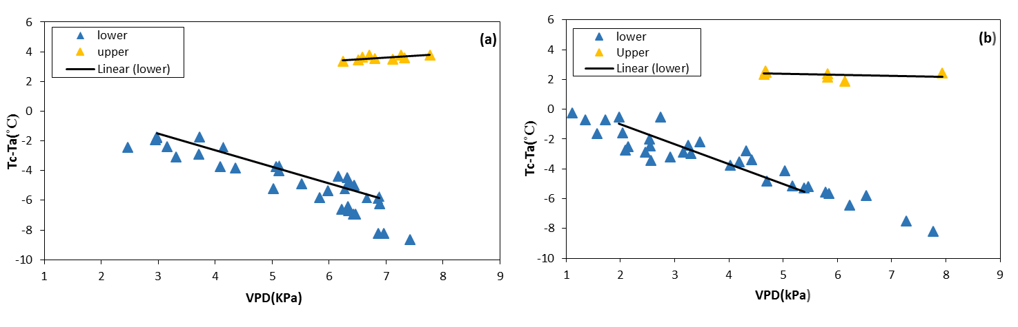
Figure 1. Empirical leaf canopy and air temperature deficit versus VPD for well watered and fully stressed sunflower during (a) September and (b) October.

dT_{LL} = m × VPD + b (3)
dT_{UL} = m × VPG + b (4)
Where b and m are intercept and the slope of linear equations, respectively.
Analysis of variance (ANOVA) was used on all crop using the general procedures of the LSD test at the 5% significance level of the statistical analysis system (SAS) version 9.2.

3. Results and discussion
Leaf canopy and air temperature deficit versus VPD were plotted for the two months of the planting season (Figure.1). Table 3 provides more information about the intercept, slope and coefficients of determination of developed NWSBs that very similar to those developed by Idso (1982) in Arizona and Taghvaeian et al. (2012) in northeastern Colorado. The R² values of the plots in Table 3 shows that a correlation existed between the VPD and the predicted leaf canopy temperature. It was observed, however, that the slope and intercept of NWSB changed in October month, when anthesis was completed and ray flowers were wilted. A similar observation was made by Nielsen (1994) who offered that sunflower NWSBs based on both leaf and canopy temperatures had different intercepts and slopes during V13-R5 and R6–R8 stages. Idso (1982) reported a similar change in NWSBs for wheat and barley. The equation determined by Taghvaeian et al. (2014) for non-water stressed sunflower crops was (Tc − Ta)_{ll} = -2.45VPD + 2.56 at northern Colorado. The slope in that study was lower and intercept higher than the values obtained in our study. These differences may be ascribed differences in the climatic conditions and plant variety used. Gardner and Shock (1989) reported that the VPD range from 1 to 6 kPa to define a baseline that could be suitable for use in CWSI computations at other locations. In our study, the range of VPD observed was approximately 1–7 kPa. In estimating CWSI, the NTB is estimated using the same intercept and slope developed for NWSB. The only difference is that VPG is used instead of VPD (Eqs. (3) and (4)). The change in NWSB slope and intercept in two month resulted in a change in dT_{UL} estimates. As shown in Figure 1, the value of (Tc − Ta)_{ul} were calculated as 3.6 and 2.35 ◦C in September and October, respectively.

Table 3. Predicted canopy and air temperature deficit-to-VPD.
month | VPD range (kpa) | Slope (m) | Intercept (b) | R²
September | 2.98-6.88 | -1.12 | 1.88 | 0.98
October | 1.97-5.39 | -1.34 | 1.70 | 0.97

Sunflower CWSI was estimated based on canopy and weather parameter measurements. Figure 2 shows variations of the crop water stress index (CWSI) for each irrigation treatment during the September and October (growing season). The average CWSI during the study period was smallest for T₅₀ and largest for T₁₇₀. As Figure 2 shows, the CWSI values increased as water application decreased during growing stages. The two treatments that received irrigation after 50 mm and 90 mm evaporation (T₅₀ and T₉₀) during period had the lowest CWSI, while during of September and October, CWSI values reached 0.68 and 0.78 for T₁₇₀ respectively (Figure 2). During the September and October (growing season), the average CWSI increased for all treatments with applied water less than that of the T₉₀ treatment (Figure 2). The sensitivity of the index to the timing and amount of irrigation implies that these index can be used effectively in monitoring water stress in sunflower and in managing deficit irrigation scheduling.

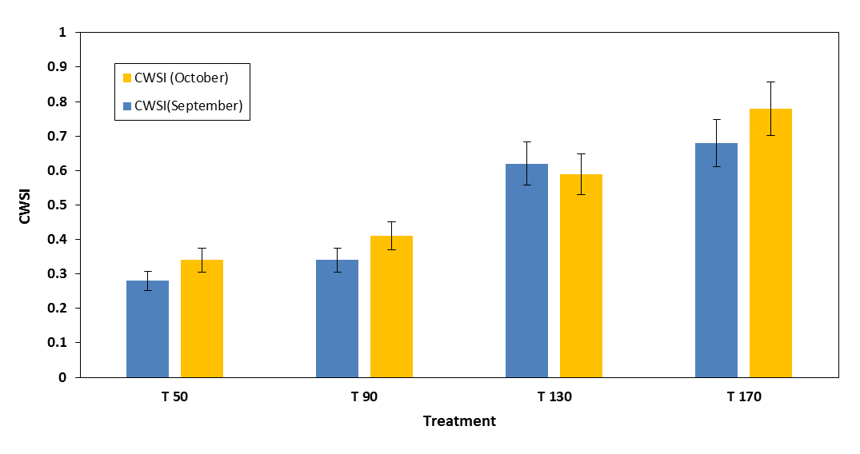
Figure 2. The effect of irrigation treatments on the average crop water stress index (CWSI) in September and October. (T₅₀- irrigation after 50 mm evaporation, T₉₀- irrigation after 90 mm evaporation, T₁₃₀- irrigation after 130 mm evaporation, T₁₇₀- irrigation after 170 mm evaporation).

4. Conclusions
This study was conducted in a sunflower field in northern Khozestan to explore the possibility of minimizing instrumentation requirements in estimating the CWSI using infrared thermometer under different irrigation regimes. The developed non-water-stressed baseline was similar to those developed in south Khozestan for different varieties of sunflower. This likeness suggests that attentively developed baselines can be utilized for morphologically similar varieties of sunflower planted in regions with similar climates. Also the results show that applying a severe deficit irrigation regime resulted in significantly larger CWSI values compared to mild deficit irrigation regime and full irrigation treatments. Overall, experimental results show that the CWSI could be used to measure crop water status and improve irrigation scheduling for sunflower.

Acknowledgements:
Authors are grateful to the Department of Science and Technology, Government of Iran for financial support to carry out this work.

Corresponding Author:
Dr Samira Akhavan
Department of Water Engineering
Faculty of Agriculture, Bu-Ali Sin University
Telephone: +989183134539
E-mail: akhavan_samira@yahoo.com

References
- Alves I, Pereira LS. Non-water-stressed baselines for irrigation scheduling with infrared thermometers: a new approach. Irrigation Science 2000; 19(2): 101-106.
- Englbrecht B MJ, Tyree MT, Kursar, TA. Visual assessment of wilting as a measure of leaf water potential and seedling drought survival. Journal of Tropical Ecology 2007; 23(4): 497-500.‏
- Chen P, Haboudane D, Tremblay N, Wang J, Vigneault P, Li B. New spectral indicator assessing the efficiency of crop nitrogen treatment in corn and wheat. Remote Sensing of Environment 2010; 114(9): 1987-1997.‏
- Cohen Y, Alchanatis V, Meron M, Saranga Y, Tsipris J. Estimation of leaf water potential by thermal imagery and spatial analysis. Journal of experimental botany2005; 56(417): 1843-1852.‏
- Durigon A, & van Lier QDJ. Canopy temperature versus soil water pressure head for the prediction of crop water stress. Agricultural water management 2013; 127: 1-6.‏
- Erdem T, Erdem Y, Orta AH. Use of a crop water stress index for scheduling the irrigation of sunflower (Helianthus annuus L.). Turkish journal of agriculture and forestry 2006; 30(1): 11-20.‏
- Ferrara A, Lovelli S, Tommaso T, Perniola M. Flowering, growth and fruit setting in greenhouse bell pepper under water stress. Journal of Agronomy 2011; 10(1): 12-19.‏
- Gardner BR., Shock CC. Interpreting the crop water stress index. Paper-American Society of Agricultural Engineers (USA) 1988. no. 89-2642.
- Gonzalez-Dugo V, Durand JL, Gastal F. Water deficit and nitrogen nutrition of crops. A review. Agronomy for sustainable development 2010; 30(3): 529-544.‏
- Hsiao TC, Fereres E, Acevedo E, Henderson DW, HSIAO TC. Water stress and dynamics of growth and yield of crop plants. In: Water and plant life. Springer Berlin Heidelberg 1976; 281-305.
- Idso SB. Non-water-stressed baselines: a key to measuring and interpreting plant water stress. Agricultural Meteorology 1982; 27(1-2): 59-70.‏
- Jackson R.D, Idso SB, Reginato RJ, Pinter Jr PJ. Normalizing the stress-degree-day parameter for environmental variability. Agricultural Meteorology 1981; 24: 45-55.‏
- Jackson RD, Kustas WP, Choudhury BJ. A reexamination of the crop water stress index. Irrigation science 1988; 9(4): 309-317.‏
- Jaimez RE, Vielma O, Rada F, Garcia-Nunez C. Effects of water deficit on the dynamics of flowering and fruit production in Capsicum chinense Jacq in a tropical semiarid region of Venezuela. Journal of Agronomy and Crop Science 2000; 185(2): 113-119.‏
- Khan MS, Swati MS, Khalil IH, Iqbal A. Heterotic studies for various characters in sunflower (Helianthus annuus L.). Asian J. Plant Sci 2003; 2(14): 1010-1014.‏
- Kirnak H, Kaya C. Degirmenci V. Growth and Yield Parameters of Bell Peppers With Surface and Subsurface Drip Irrigation Systems Under Different Irrigation Levels/Toprak Üstü ve Toprak Altı Damla Sulama Sistemlerinde Farklı Sulama Düzeylerinin Biber Bitkisinin Gelişim ve Verim Özellikl 2010.‏
- Köksal ES. Hyperspectral reflectance data processing through cluster and principal component analysis for estimating irrigation and yield related indicators. Agricultural water management 2011; 98(8), 1317-1328.‏
- Kovár M, Černý I., Ernst D. Analysis of relations between crop temperature indices and yield of different sunflower hybrids foliar treated by biopreparations. Agriculture 2016; 62(1): 28.‏
- Leinonen I, Jones HG. Combining thermal and visible imagery for estimating canopy temperature and identifying plant stress. Journal of experimental botany 2004; 55(401): 1423-1431.‏
- Maas SJ. Irrigation scheduling by remote sensing technologies. Encyclopedia of Water Science. New York: Marcel Dekker 2003; 523-527.‏
- Mokgolo MJ. Organic manure effects on selected soil properties, water use efficiency and grain yield of sunflower. 2016. PhD Thesis.‏
- Nielsen DC. Non water-stressed baselines for sunflowers. Agric. Water Manage 1994; 26 (4): 265–276.
- Nielsen DC, Anderson RL. Infrared thermometry to measure single leaf temperatures for quantification of water stress in sunflower. Agronomy journal 1989; 81(5): 840-842.‏
- O’Shaughnessy SA, Evett SR, Colaizzi PD, Howell TA. Using radiation thermography and thermometry to evaluate crop water stress in soybean and cotton. Agricultural Water Management 2011; 98(10): 1523-1535.‏
- Orta AH, Erdem T, Erdem Y. Determination of water stress index in sunflower/determination indice the stress. Helia 2002, 25(37), 27-38.‏
- Sarwar MA, Khalil-Ur-Rehman MN, Javeed, HMR, Ahmad W, Shehzad MA., Iqbal S, & Abbas HT. Comparative performance of various sunflower hybrids for yield and its related attributes. Cercetari agronomice in Moldova 2013; 46(4): 57-64.‏
- Sezen SM, Yazar A, Eker S. Effect of drip irrigation regimes on yield and quality of field grown bell pepper. Agric. Water Manage 2006; 81 (1–2): 115–131.
- Taghvaeian S, Chávez J.L, Hansen NC. Infrared thermometry to estimate crop water stress index and water use of irrigated maize in Northeastern Colorado. Remote Sens 2012; 4 (11): 3619–3637.
- Taghvaeian S, Comas L, De Jonge KC, & Trout TJ. Conventional and simplified canopy temperature indices predict water stress in sunflower. Agricultural Water Management 2014; 144: 69-80.‏
- Tuner NC. Plant water relations and irrigation management. Agric. Water Manage 1990; 17: 59–73.
- Wang JH, Geng LH, Zhang CM. Research on the weak signal detecting technique for crop water stress based on wavelet denoising. Advanced Materials Research 2012; 424– 425: 966–970.
- Wanjura DF, Upchurch DR, Mahan JR. Automated irrigation based on threshold canopy temperature. ASAE 1992; 35 (5), 1411–1417.
- Xie J, Cardenas ES, Sammis TW, Wall M.M, Lindsey DL, Murray LW. Effects of irrigation method on chile pepper yield and Phytophthora root rot incidence. Agric. Water Manage 1999; 42: 127–142.

7/9/2017

