The Impact of Gender on the Outcomes of Invasive Versus Conservative Management of Patients with Acute Coronary Syndrome

Saied A. Eldaraky; Tarek H. Abo Elazm; Saeed F. Tawfeek and Mohamed T. M. Elghobary

Cardiology Department, Faculty of Medicine, Benha University, Egypt
mayadamowafy@gmail.com

Abstract: Background: Acute coronary syndrome (ACS) refers to any group of symptoms attributed to obstruction of the coronary arteries. It usually occurs as a result of one of three problems: ST elevation myocardial infarction (30%), non ST elevation myocardial infarction (25%), or unstable angina (38%). These types are named according to the appearance of the electrocardiogram (ECG/EKG) as non-ST segment elevation myocardial infarction (NSTEMI) and ST segment elevation myocardial infarction (STEMI). ACS should be distinguished from stable angina, which develops during exertion and resolves at rest. In contrast with stable angina, unstable angina occurs suddenly, often at rest or with minimal exertion, or at lesser degrees of exertion than the individual's previous angina. ACS represents a life-threatening manifestation of atherosclerosis. The key pathophysiological concepts such as vulnerable plaque, coronary thrombosis, vulnerable patient, endothelial dysfunction, accelerated atherothrombosis, secondary mechanisms of NSTE-ACS, and myocardial injury have to be understood for the correct use of the available therapeutic strategies. The lesions predicting ACS are usually angiographically mild, characterized by a thin-cap fibroatheroma, by a large plaque burden, or by a small luminal area, or some combination of these characteristics. Objectives: In our registry, we aimed at assessment of the impact of gender on clinical outcomes and comparison between results of patients managed by invasive strategy and other patients managed by conservative management in 503 patients presented with acute coronary syndrome to National Heart Institute.. Patients and methods: All patients were subjected to detailed medical history with special emphasis on risk factors, general examination, detailed cardiac examination, full laboratory investigations (including cardiac markers, complete lipid profile, hemoglobin concentration, random blood sugar and serum creaitnine) and electrocardiography. Results: Regarding age distribution, our study showed that the mean age was 57.2 ±10.4 years. Hypertension is the most common risk factor encountered. Regarding treatment, our study showed that In UA/NSTEMI group, 81 males and 15 females had an intervention, while 174 males and 32 females had no intervention. In STEMI group, 107 males and 56 females had an intervention, while 25 males and 14 females had no intervention. Regarding comparison between STEMI group and UA/NSTEMI group as regard complications, our study showed that regarding thirty day complications in UA/NSTEMI group, no complications had occurred, while in STEMI group, only 2 males (0.4%) had re-infarction and 2 males (0.4%) had re-intervention and regarding six-month complications in UA/NSTEMI group, no complications had occurred, while in STEMI group, only one male (0.2%) had re-infarction, one male (0.2%) had re-intervention, 2 males (0.4%) had stroke and 3 males (0.6%) were died. Regarding comparison between male and female as regard complications, our study showed statistically significant difference male and female as regard complications, using chi-square test with p-value <0.05 as no complications occured in 81 male patients (28.9%) vs 252 female patients. Left ventricular dysfunction occurred in 55 male patients (19.6%) vs 22 female patients (22%). Pulmonary edema occurred in 12 male patients (4.3%) vs 3 female patients (1%). Atrial fibrillation occurred in 20 male patients (7.1%) vs 4 female patients, ventricular tachy cardia occurred in 10 male patients (3.6%) and 2 female patients (.7%), ventricular fibrillation occurred in 8 male patients (2.9%) and did not occur in females, while complete heart block occurred in 18 male patients (6.4%) and 2 female patients (.7%). Reinfaction occurred in 3 male patients (1.1%) and 2 female patients (.7%), right ventricular infarction occurred in 9 male patients (3.2%) and 1 female patient (.3%), posterior infarction occurred in 2 male patients (.7%) and 1 female patient (.3%). Overall mortality rate was 0.6%. Mortality was higher in those who have ST elevation as compared to those with other ECG changes. Conclusion: Overall mortality rate was 0.6%. Mortality was higher in those who have ST elevation as compared to those with other ECG changes (0.6 % vs 0%). Mortality was also higher in males compared to females.
[Saied A. Eldaraky; Tarek H. Abo Elazm; Saeed F. Tawfeek and Mohamed T. M. Elghobary. The Impact of Gender on the Outcomes of Invasive Versus Conservative Management of Patients with Acute Coronary Syndrome. Researcher 2017;9(6):73-87]. ISSN 1553-9865 (print); ISSN 2163-8950 (online). http://www.sciencepub.net/researcher. 12. doi:10.7537/marsrsj090617.12.

Key Words: acute coronary syndrome, gender, myocardial infarction

1. Introduction
ACS describes the spectrum of clinical manifestations which follow disruption of a coronary arterial plaque, complicated by thrombosis, embolization and varying degrees of obstruction to myocardial perfusion it is usually one of three diseases involving the coronary arteries: STEMI, NSTEMI and unstable angina ⁽¹⁾.
Jneid et al. ⁽²⁾ have suggested differences in clinical outcomes between men and women following Acute Myocardial Infarction (AMI). Some studies have indicated poorer survival of female AMI patients on admission and short-term follow up, whilst others have shown no difference in outcome.
Poorer outcome was often attributed to less aggressive management or undelrying comorbidities, and women had consistently been shown to be more likely to receive less invasive treatment compared to men. In addition, there were studies suggesting that women who presented with Non-ST-Elevation Myocardial Infarction (NSTEMI) did not benefit form early invsaive strategy. The poor outcome in female patients may be due to higher age at presentation and attendant comorbid conditions ⁽³⁾.
Alfredsson et al. ⁽⁴⁾ assessed gender differences in outcome with an invasive strategy, in a large cohort of unselected patients with NSTE ACS. They documented that women and men had a similar and better outcome associated with an invasive strategy.
The aim of this study is to assess the impact of gender on clinical outcomes in patients presented with ACS and compare between results of patients managed by invasive strategy and patients managed by conservative management.

Subjects And Methods
This study was carried on five hundred patients admitted with acute coronary syndrome at National Heart Institute during the period from November 2013 to August 2014.

Patients:
Patients were classified into 3 groups:
- Acute ST-segment elevation-infarction:
  - Acute chest pain.
  - ST-segment elevation.
  - Elevated biochemical markers of myocardial necrosis ⁽¹⁾.
- Acute non-ST-segment elevation-infarction (≤ 24 hours):
  - Chest pain.
  - Elevated biochemical markers of myocardial necrosis.
  - No ST-elevation ⁽¹⁾.
- Unstable angina pectoris:
Patient can be with any one of the three following features: angina, new-onset angina and recent acceleration of angina ⁽¹⁾.

Inclusion criteria:
Patients presented with ACS with clinical indications for early invasive strategy according to European Society of Cardiology (ESC) including severe ongoing angina, profound or dynamic ECG changes, major arrhythmias, or haemodynamic instability upon admission or thereafter.

Exclusion criteria:
- Patients with multivessel disease who were candidates for coronary artery bypass graft (CABG).
- Patients with previous CABG.
- Patients presented with ACS and with other co-morbidity as cancer, cerebrovascular disease, peripheral vascular disease, chronic lung disease and chronic kidney disease.

Methods:
  - Full history taking.
  - Full general and local examinations.
  - Laboratory tests:
- Cardiac markers (ck-MB-troponins).
- Complete lipid profile (serum cholesterol and HDL remain close to baseline for 24-48 hours and fall thereafter). Samples are taken in the first 2 days after admission.
- Hb%.
- Postprandial blood sugar.
- Serum creatinine.
  - Electrocardiography on admission or with follow up.
  - In-hospital complications:
- Reinfarction.
- Heart failure.
- Cardiogenic shock.
- Rescue intervention.
- Stroke.
- Death.
  - Treatment strategy:
- Reperfusion therapy.
- Fibrinolytic therapy.
- Percutaneous coronary intervention (PCI).

Follow up:
All the patients were contacted for follow up at 30 days and 6 months after the procedure by interviewing with the patients via telephone or the responsible physician to determine the outcomes as regards the major adverse cardiac events (death, myocardial infarction, and need for repeated stroke or recanalization.
Statistical analysis:
Data were analyzed using Statistical Program for Social Science (SPSS) version 18.0. Quantitative data were expressed as mean± standard deviation (SD). Qualitative data were expressed as frequency and percentage.
The following tests were done:
  - Independent-samples t-test of significance was used when comparing between two means.
  - Chi-square (X²) test of significance was used in order to compare proportions between two qualitative parameters.
P-value <0.05 was considered significant. P-value <0.001 was considered as highly significant. P-value >0.05 was considered insignificant.

Results
The present study included 504 patients with acute coronary syndrome; 2 patients (0.4%) were in age less than 20 years, 2 patients (0.4%) were in age ranging from 21 to 25 years old, 5 patients (1%) were in age ranging from 26 to 30 years old, 3 patients (0.6%) were in age ranging from 31 to 35 years old, 8 patients (1.6%) were in age ranging from 36 to 40 years old,, 37 patients (7.3%) were in age ranging from 41 to 45 years old, 44 patients (8.7%) were in age ranging from 46 to 50 years old, 114 patients (22.6%) were I nage ranging from 51 to 55 years old, 135 patients (26.8%) were in age ranging from 56 to 60 years old, 65 patients (12.9%) were in age ranging from 61 to 65 years old, 41 patients (8.1%) were in age ranging from 66 to 70 years old, 32 patients (6.3%) were in age ranging from 71 to 75 years old, 5 patients (1%) were in age ranging from 76 to 80 years old, 10 patients (2%) were in age ranging from 81 to 85 years old and only one patient (0.2%) was in age more than 85 years old (figure 1).
Regarding sex, from the five hundred and four patients, there were 117 (23.2%) females and 387 (76.8%) were males (figure 2).
Out of the five hundred and four patients, 172 patients (34.1%) had unstable angina, 130 patients (25.8%) had NSTEMI and 202 patients (40.1%) had STEMI. Pain duration ranged from 0.5 to 240 hours with mean ± SD of 14 ± 24.41 hours (figure 3).
Regarding ST resolution, 221 patients (43.8%) had ST resolution < 70% and 283 patients (56.2%) had ST resolution > 70% (figure 4).
Regarding vessel lesion, 56 patients (11.1%) had lesions in the left main artery, 310 patients (61.5%) had lesions in the left anterior descending artery, 183 patients (36.3%) had lesions in the left circumflex artery and 261 patients (51.8%) had lesions in the right coronary artery (figure 5).
Regarding complications, 333 patients (56.92%) had no complications. Left ventricular dysfunction was found in 77 patients (13.16%), pulmonary edema was found in 15 patients (2.56%), cardiogenic shock was found in 44 patients (7.52%), cardiac arrest was found in 24 patients (4.1%), left thrombus was found in 3 patients (0.51%), distal embolization was found in 4 patients (0.68%), atrial fibrillation was found in 24 patients (4.1%), VT was found in 12 patients (2.05%), VF was found in 8 patients (1.37%), CHB was found in 20 patients (3.42%), reinfarction was found in 5 patients (0.85%), right ventricular infarction was found in 10 patients (1.71%), posterior infarction was found in 3 patients (0.51%), cerebral hemorrhage was found in only one patient (0.17%) and hematemesis was found in 2 patients (0.34%) (table 1).
Regarding complication distribution, 333 patients (66.3%) had no complications, 112 patients (22%) had single complication and 59 patients (11.7%) had multiple complications (table 2).
In UA/NSTEMI group, 97 patients (76%) were females and 205 patients (53%) were males; whereas in STEMI group, 20 patients (17.1%) were females and 182 patients (47%) were males. The comparative study between the two groups shows highly statistically significant difference between female and male as regard diagnosis (p < 0.001) (table 3).
In UA/NSTEMI group, 81 males and 15 females had an intervention, while 174 males and 32 females had no intervention. In STEMI group, 107 males and 56 females had an intervention, while 25 males and 14 females had no intervention (table 4).
Table (5) shows highly statistically significant difference between females and males as regard smoking, the rest have insignificant, using Chi-square test.
Table (6) shows highly statistically significant difference between female and male as regard smoking, DM and HTN, the rest have insignificant, using Chi-square test.
Table (7) showed statistically significant difference between female and male as regard pain duration (hrs) and blood pressure, using Independent sample t-test (p < 0.05).
In UA/NSTEMI group, in female patients, 41 patients (42.3%) had ST resolution < 70% and 56 patients (57.7%) had > 70%. While in male patients, 92 patients (44.9%) had ST resolution < 70% and 113 patients (55.1%) had ST resolution > 70%. The comparative study showed no statistically significant difference between female and male as regard ST resolution, using Chi-square test (p > 0.05) (table 8).
In STEMI group, in female patients, 12 patients (60%) had ST resolution < 70% and 8 patients (40%) had > 70%. While in male patients, 76 patients (41.8%) had ST resolution < 70% and 106 patients (58.2%) had ST resolution > 70%. The comparative study showed no statistically significant difference between female and male as regard complications, using Chi-square test (p > 0.05) (table 9).
In UA/NSTEMI group, in female patients, 27 patients (27.8%) had time of angiography < 2 days and 70 patients (72.2%) had time of angiography > 2 days. While in male patients, 52 patients (25.4%) had time of angiography ≤ 2 days and 153 patients (74.6%) had time of angiography > 2 days. The comparative study showed no statistically significant difference between female and male as regard angio time (day), using Chi-square test (p > 0.05) (table 10).
In STEMI group, in female patients, 17 patients (85%) had time of angiography< 2 days and 3 patients (15%) had time of angiography > 2 days. While in male patients, 153 patients (84.1%) had time of angiography ≤ 2 days and 29 patients (15.9%) had time of angiography > 2 days. The comparative study showed no statistically significant difference between female and male as regard angio time (day), using Chi-square test (p > 0.05) (table 11).
Table (12) shows statistically significant difference between female and male as regard left circumflex and right coronary artery, while left main artery and left anterior descending artery show non-significant differences.
Table (13) shows no statistically significant difference between female and male as regard vessels lesions, using Chi-square test.
Table (14) shows statistically significant difference male and female as regard complications, using chi-square test with p-value <0.05 S.
Regarding thirty day complications in UA/NSTEMI group, no complications had occurred, while in STEMI group, only 2 males (0.4%) had re-infarction and 2 males (0.4%) had re-intervention (tables 15 and 16).
Regarding six-month complications in UA/NSTEMI group, no complications had occurred, while in STEMI group, only one male (0.2%) had re-infarction, one male (0.2%) had re-intervention, 2 males (0.4%) had stroke and 3 males (0.6%) were died (tables 17 and 18).
Regarding complications in male patients, there was statistically a high significant difference between UA/NSTEMI and STEMI (table 19).
Regarding complications in female patients, there was statistically a high significant difference between UA/NSTEMI and STEMI (table 20).

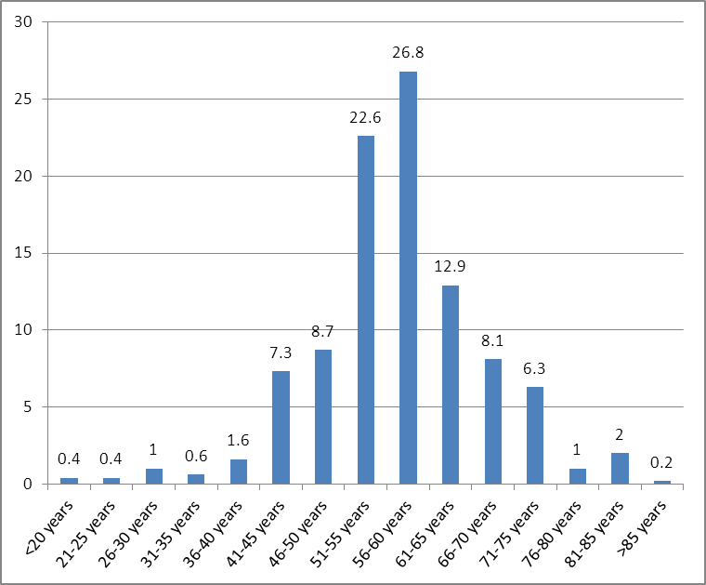

Fig. (1): Age distribution of the patients groups.

Fig. (2): Pie chart showing sex distribution of the patients groups.

Fig. (3): Diagnosis distribution of the patients groups

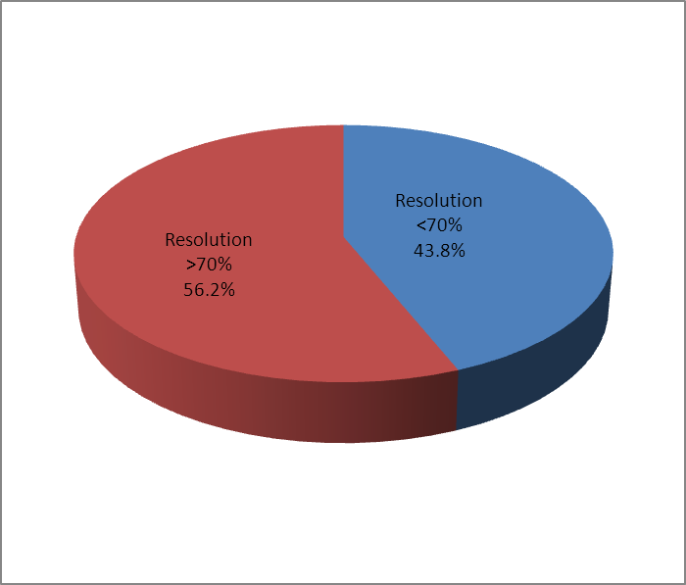

Fig. (4): Pie chart showing ST resolution distribution of the patients groups.

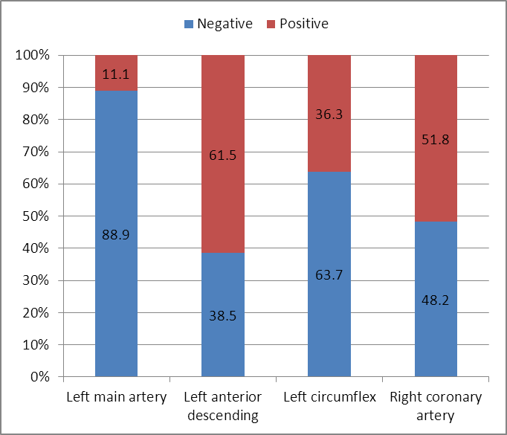

Fig. (5): Bar chart showing vessels lesions distribution of the patients groups.

Table (1): Hospital complications distribution of the study group during hospitalization.
Complications | No. | %
No complications | 333 | 56.92
Complications | 171 | 43.08
LV dysfunction | 77 | 13.16
pulmonary edema | 15 | 2.56
cardiogenic shock | 44 | 7.52
cardiac arrest | 24 | 4.10
LV thrombus | 3 | 0.51
Distal embolization | 4 | 0.68
AF | 24 | 4.10
VT | 12 | 2.05
VF | 8 | 1.37
CHB | 20 | 3.42
Re infarction | 5 | 0.85
RV infarction | 10 | 1.71
Posterior infarction | 3 | 0.51
cerebral hemorrhage | 1 | 0.17
Hematemesis | 2 | 0.34
Total | 504 | 100.00

Table (2): Complications distribution of the patients groups.
Cmplication | No. | %
No complications | 333 | 66.3
Single complication | 112 | 22.0
Multiple complications | 59 | 11.7
Total | 504 | 100.0
Data are expressed as frequency and percentage data.

Table (3): Distribution of ACS type as regard gender
Diagnosis | Female |  | Male |  | Chi-square test
 | No. | % | No. | % | x2 | p-value
UA/NSTEMI | 97 | 82.9 | 205 | 53.0 | 33.53 | <0.001
STEMI | 20 | 17.1 | 182 | 47.0
Total | 117 | 100.0 | 387 | 100.0
Data are expressed as mean±SD for parametric data.

Table (4): Classification of study patients according to admission diagnosis and treatment according to gender.
 | Male |  | Female
 | UA/NSTEMI | STEMI | UA/NSTEMI | STEMI
Intervention | 81 | 107 | 15 | 56
Conservative | 174 | 25 | 32 | 14
Total number | 255 | 132 | 47 | 70

Table (5): Comparison of risk factors through UA/NSTEMI as regard gender
Risk Factors | Female |  | Male |  | Chi-square test
 | No. | % | No. | % | x2 | p-value
Family History
Negative | 67 | 69.1 | 145 | 70.7 | 0.087 | 0.768
Positive | 30 | 30.9 | 60 | 29.3
Smoking
Non smoker | 92 | 94.8 | 77 | 37.6 | 87.673 | <0.001
Smoker | 5 | 5.2 | 128 | 62.4
DM
No | 42 | 43.3 | 110 | 53.7 | 4.719 | 0.194
Oral treatment | 29 | 29.9 | 48 | 23.4
Insulin | 26 | 26.8 | 44 | 21.5
No treatment | 0 | 0.0 | 3 | 1.5
HTN
Not hypertensive | 23 | 23.7 | 57 | 27.8 | 0.567 | 0.452
Hypertensive | 74 | 76.3 | 148 | 72.2
Dyslipidemia
Not dyslipidemic | 78 | 80.4 | 151 | 73.7 | 1.639 | 0.201
Dyslipidemic | 19 | 19.6 | 54 | 26.3
CAD
Negative | 53 | 54.6 | 109 | 53.2 | 0.057 | 0.811
Positive | 44 | 45.4 | 96 | 46.8
CVS
No | 91 | 93.8 | 188 | 91.7 | 3.035 | 0.219
Angina | 5 | 5.2 | 17 | 8.3
PCI | 1 | 1.0 | 0 | 0.0
PVD
No | 97 | 100.0 | 200 | 97.6 | 2.406 | 0.121
Yes | 0 | 0.0 | 5 | 2.4
Data are expressed as frequency and percentage data.

Table (6): Comparison of risk factors through STEMI as regard gender
Risk Factors | Female |  | Male |  | Chi-square test
 | No. | % | No. | % | x2 | p-value
Family History
Negative | 15 | 75.0 | 127 | 69.8 | 0.235 | 0.628
Positive | 5 | 25.0 | 55 | 30.2
Smoking
Non smoker | 19 | 95.0 | 53 | 29.1 | 34.094 | <0.001
Smoker | 1 | 5.0 | 129 | 70.9
DM
No | 7 | 35.0 | 114 | 62.6 | 12.157 | 0.007
Oral treatment | 5 | 25.0 | 37 | 20.3
Insulin | 8 | 40.0 | 23 | 12.6
No treatment | 0 | 0.0 | 8 | 4.4
HTN
Not hypertensive | 7 | 35.0 | 129 | 70.9 | 10.545 | 0.001
Hypertensive | 13 | 65.0 | 53 | 29.1
Dyslipidemia
Not dyslipidemic | 14 | 70.0 | 144 | 79.1 | 0.880 | 0.348
Dyslipidemic | 6 | 30.0 | 38 | 20.9
CAD
Negative | 10 | 50.0 | 85 | 46.7 | 0.079 | 0.779
Positive | 10 | 50.0 | 97 | 53.3
CVS
No | 20 | 100.0 | 177 | 97.3 | 0.563 | 0.453
Angina | 0 | 0.0 | 5 | 2.7
PVD
No | 20 | 100.0 | 179 | 98.4 | 0.335 | 0.563
Yes | 0 | 0.0 | 3 | 1.6
Table (7): Comparison of pain duration (hrs, blood pressure through STEMI as regard gender
 | Female |  | Male |  | t-test
 | Mean | SD | Mean | SD | t | p-value
Pain duration (hrs) | 17.45 | 21.22 | 11.75 | 22.12 | 1.099 | 0.273
SBP (mmHg) | 115.25 | 24.57 | 125.11 | 25.38 | -1.654 | 0.100
DBP (mmHg) | 67.50 | 15.85 | 76.54 | 15.68 | -2.444 | 0.015
Data are expressed as mean±SD for parametric data.

Table (8): Comparison of ST resolution through UA/NSTEMI as regard gender
ST resolution | Female |  | Male |  | Chi-square test
 | No. | % | No. | % | x2 | p-value
<70% | 41 | 42.3 | 92 | 44.9 | 0.182 | 0.670
>70% | 56 | 57.7 | 113 | 55.1
Data are expressed as frequency and percentage data.

Table (9): Comparison of ST resolution through STEMI as regard gender
ST resolution | Female |  | Male |  | Chi-square test
 | No. | % | No. | % | x2 | p-value
<70% | 12 | 60.0 | 76 | 41.8 | 2.439 | 0.118
>70% | 8 | 40.0 | 106 | 58.2
Data are expressed as frequency and percentage data.

Table (10): Comparison of time of angiography (day) through UA/NSTEMI as regard gender
Time of angiography (day) | Female |  | Male |  | Chi-square test
 | No. | % | No. | % | x2 | p-value
<= 2 days | 27 | 27.8 | 52 | 25.4 | 0.208 | 0.648
> 2 days | 70 | 72.2 | 153 | 74.6
Data are expressed as frequency and percentage data.

Table (11): Comparison of time of angiography (day) through STEMI as regard gender
Time of angiography (day) | Female |  | Male |  | Chi-square test
 | No. | % | No. | % | x2 | p-value
<= 2 days | 17 | 85.0 | 153 | 84.1 | 0.012 | 0.914
> 2 days | 3 | 15.0 | 29 | 15.9
Data are expressed as frequency and percentage data.

Table (12): Comparison of vessels lesions through UA/NSTEMI as regard gender
Vessels lesions | Female |  | Male |  | Chi-square test
 | No. | % | No. | % | x2 | p-value
Left main artery
Negative | 89 | 91.8 | 175 | 85.4 | 2.442 | 0.118
Positive | 8 | 8.2 | 30 | 14.6
Left anterior descending
Negative | 43 | 44.3 | 92 | 44.9 | 0.008 | 0.929
Positive | 54 | 55.7 | 113 | 55.1
Left circumflex
Negative | 71 | 73.2 | 116 | 56.6 | 7.705 | 0.006
Positive | 26 | 26.8 | 89 | 43.4
Right coronary artery
Negative | 63 | 64.9 | 103 | 50.2 | 5.752 | 0.016
Positive | 34 | 35.1 | 102 | 49.8
Data are expressed as frequency and percentage data.

Table (13): Comparison of vessels lesions through STEMI as regard gender
Vessels lesions | Female |  | Male |  | Chi-square test
 | No. | % | No. | % | x2 | p-value
Left main artery
Negative | 17 | 85.0 | 167 | 91.8 | 1.014 | 0.314
Positive | 3 | 15.0 | 15 | 8.2
Left anterior descending
Negative | 4 | 20.0 | 55 | 30.2 | 0.910 | 0.340
Positive | 16 | 80.0 | 127 | 69.8
Left circumflex
Negative | 11 | 55.0 | 123 | 67.6 | 1.278 | 0.258
Positive | 9 | 45.0 | 59 | 32.4
Right coronary artery
Negative | 9 | 45.0 | 68 | 37.4 | 0.446 | 0.504
Positive | 11 | 55.0 | 114 | 62.6
Data are expressed as frequency and percentage data.

Table (14): Comparison between male and female as regard complications.
Complications | Male |  | Female
 | No. | % | No. | %
No complications | 81 | 28.9 | 252 | 82.6
LV dysfunction | 55 | 19.6 | 22 | 7.2
Pulmonary edema | 12 | 4.3 | 3 | 1.0
cardiogenic shock | 33 | 11.8 | 11 | 3.6
cardiac arrest | 20 | 7.1 | 4 | 1.3
LV thrombus | 2 | 0.7 | 1 | 0.3
distal embolization | 4 | 1.4 | 0 | 0.0
AF | 20 | 7.1 | 4 | 1.3
VT | 10 | 3.6 | 2 | 0.7
VF | 8 | 2.9 | 0 | 0.0
CHB | 18 | 6.4 | 2 | 0.7
Re infarction | 3 | 1.1 | 2 | 0.7
RV infarction | 9 | 3.2 | 1 | 0.3
Posterior infarction | 2 | 0.7 | 1 | 0.3
cerebral he | 1 | 0.4 | 0 | 0.0
Hematemesis | 2 | 0.7 | 0 | 0.0
Total | 199 | 100.0 | 53 | 100.0
X2 | 6.196
p-value | 0.044 (S)

Table (15): Thirty days complications in UA/NSTEMI
 | Male | Female
Re-Infarction | 0 (0%) | 0 (0%)
Re-intervention | 0 (0%) | 0 (0%)
Stroke | 0 (0%) | 0 (0%)
Death | 0 (0%) | 0 (0%)

Table (16): Thirty days complications in STEMI
 | Male | Female
Re-Infarction | 2 (0.4%) | 0 (0%)
Re-intervention | 2 (0.4%) | 0 (0%)
Stroke | 0 (0%) | 0 (0%)
Death | 0 (0%) | 0 (0%)

Table (17): Six months complications in UA/NSTEMI
 | Male | Female
Re-Infarction | 0 (0%) | 0 (0%)
Re-intervention | 0 (0%) | 0 (0%)
Stroke | 0 (0%) | 0 (0%)
Death | 0 (0%) | 0 (0%)

Table (18): Six months complications in STEMI
 | Male | Female
Re-Infarction | 1 (.2%) | 0 (0%)
Re-intervention | 1 (.2%) | 0 (0%)
Stroke | 2 (.4%) | 0 (0%)
Death | 3 (0.6%) | 0 (0%)
Table (19): Comparison between UA/NSTEMI and STEMI as regard complications in male.
Complications |  | UA/NSTEMI |  | STEMI
 |  | No. | % | No. | %
No complications | 81 | 47 | 58.0 | 34 | 42.0
LV dysfunction | 55 | 18 | 32.7 | 37 | 67.3
Pulmonary edema | 12 | 4 | 33.3 | 8 | 66.7
Cardiogenic shock | 33 | 13 | 39.4 | 20 | 0.6
cardiac arrest | 20 | 7 | 35.0 | 13 | 65.0
LV thrombus | 2 | 0 | 0.0 | 2 | 100.0
distal embolization | 4 | 1 | 25.0 | 3 | 75.0
AF | 20 | 4 | 20.0 | 16 | 80.0
VT | 10 | 2 | 20.0 | 8 | 80.0
VF | 8 | 2 | 25.0 | 6 | 75.0
CHB | 18 | 5 | 27.8 | 13 | 72.2
Re infarction | 3 | 1 | 33.3 | 2 | 66.7
RV infarction | 9 | 3 | 33.3 | 6 | 66.7
Posterior infarction | 2 | 0 | 0.0 | 2 | 100.0
cerebral he | 1 | 0 | 0.0 | 1 | 100.0
Hematemesis | 2 | 0 | 0.0 | 2 | 100.0
Total | 179 | 107 | 38.2 | 139 | 61.8
X2 | 33.191
p-value | <0.001
Table (20): Comparison between UA/NSTEMI and STEMI as regard complications in female.
Complications |  | UA/NSTEMI |  | STEMI
 |  | No. | % | No. | %
No complications | 252 | 154 | 61.1 | 98 | 38.9
LV dysfunction | 22 | 8 | 36.4 | 14 | 63.6
Pulmonary edema | 3 | 1 | 33.3 | 2 | 66.7
cardiogenic shock | 11 | 3 | 27.3 | 8 | 72.7
cardiac arrest | 4 | 1 | 25.0 | 3 | 75.0
LV thrombus | 1 | 0 | 0.0 | 1 | 100.0
distal embolization | 0 | 0 | 0.0 | 0 | 0.0
AF | 4 | 1 | 25.0 | 3 | 75.0
VT | 2 | 0 | 0.0 | 2 | 100.0
VF | 0 | 0 | 0.0 | 0 | 0.0
CHB | 2 | 0 | 0.0 | 2 | 100.0
Re infarction | 2 | 0 | 0.0 | 2 | 100.0
RV infarction | 1 | 0 | 0.0 | 1 | 100.0
Posterior infarction | 1 | 0 | 0.0 | 1 | 100.0
cerebral hge | 0 | 0 | 0.0 | 0 | 0.0
Hematemesis | 0 | 0 | 0.0 | 0 | 0.0
Total | 53 | 168 | 55.1 | 137 | 44.9
X2 | 55.66
p-value | <0.001

Case (1)
A 47 years old female patient admitted to CCU complaining of acute typical ischemic chest pain started half an hour before, giving history of being diabetic, obese and hypertensive non smoker. 18 months before she had angina.
ECG showed regular sinus rhythm rate 75 Bpm, ST segment elevated in leads V1, V2, V3 and V4 and T wave inversion and ST segment depression in leads I, avl, V5 and V6.
Laboratory investigations results were as follow, +ve Ck-MB and +ve Troponin, cholesterol 230, LDL 188, Blood glucose 310.
Echocardiography showed LV wall motion abnormalities in the form of basal & posterior & posterior septal segments hypokinesia.
LV diastolic dysfunction grade I.
Patient was diagnosed as myocardial infarction received streptokinase and admitted on concor, captopril, statin, aspirin, nitrates.

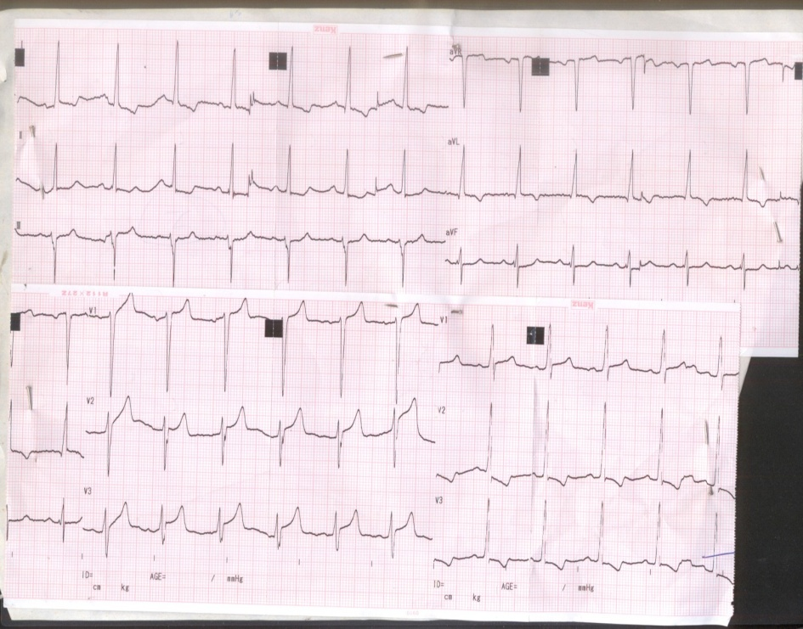

ECG for case 1 (Acute myocardial infarction )

ECHO for case 1 (Acute myocardial infarction )

Case (2)
A 47 years old male patient admitted to CCU with acute typical chest pain, He was heavy smoker, diabetic and hypertensive.
ECG showed regular sinus rhythm, rate 90 bpm, pathological Qs in leads II, III, avf and inverted T wave in lead III, avf.
Laboratory investigations showed +ve CK-MB and Troponin, cholesterol 180, Blood glucose 258.
Echocardiography revealed Normal dimensions with resting LV regional wall motion abnormalities in the form of basal & mid. Inferior, posterior and posterior septal segments hypokinesia.
LV diastolic dysfunction grade I, EF% 60%.
Patient was diagnosed as NSTEMI admitted on concor, nitrates, aspirin, clopidogrel, amilodipine. no complications.

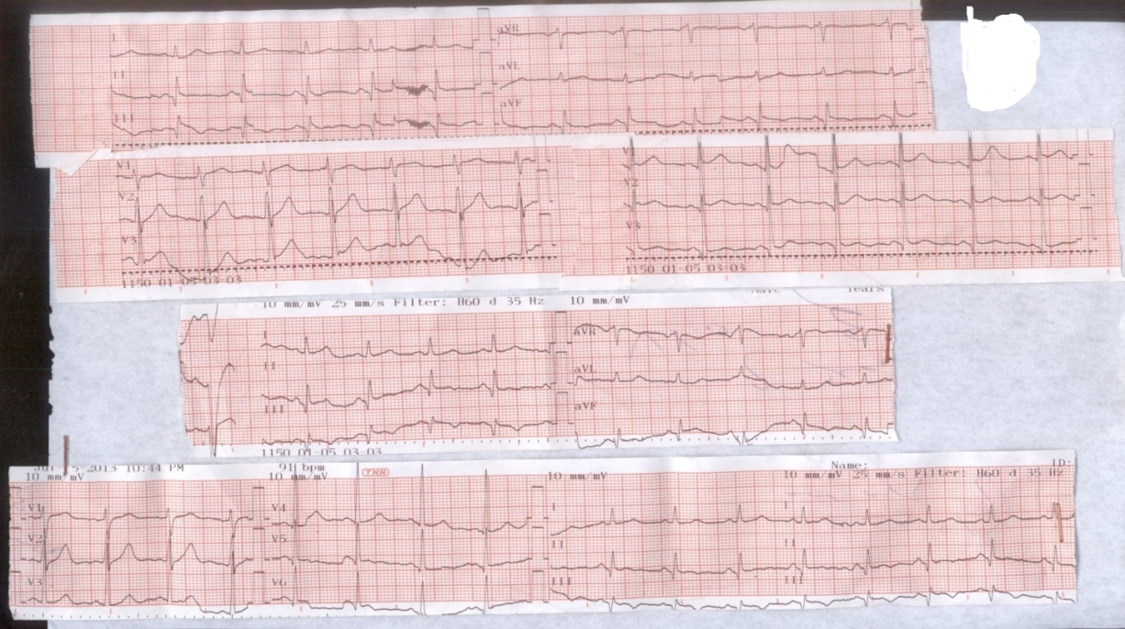

ECG for case (2) NSTEMI

ECHO for case (2) NSTEMI

Case (3)
A 56 years old male patient admitted with acute chest pain repeated for the last few days, he was smoker, hypertensive and had positive family history of ischemic heart disease.
ECG showed regular sinus rhythm 95 bpm T wave inversion in leads II, III, avf and pathological Qs in V1, V2, V3.
Laboratory investigations; -ve Ck-MB and –ve troponin, cholesterol 245, LDL 187, Blood glucose 300.
Echocardiography showed dilated LV internal dimensions with impaired systolic function EF=45 by M-mode, resting wall motion abnormalities in the form of.
- Akinesia of apical, apico & mid septal segments.
- Hypokinesia of all other segments sparing basal posterior & basal lateral segments.
LV diastolic dysfunction grade II.
Patient was diagnosed as unstable angina and admitted on anti-ischemic therapy.

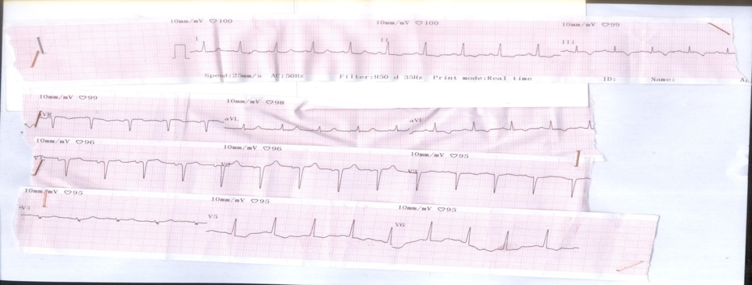

ECG for Case (3) unstable angina

ECHO for Case (3) unstable angina

4. Discussion
Cardiovascular diseases are the leading cause of mortality in economically developed countries. Coronary artery disease (CAD) is the single most frequent cause of death. Over seven million people every year die from CAD, accounting for 12.8% of all deaths. The benefit of an early invasive strategy is particularly evident in patients with ST-changes and/or elevated levels of cardiac biomarkers. However, elderly patients were significantly under-represented in these trials, and a final decision concerning the best strategy to apply in this subset of patients has yet to be made, leaving physicians who deal with this problem on a daily basis with a degree of uncertainty ⁽⁵⁾.
In our study, we aimed at assessment of the impact of gender on clinical outcomes and comparison between results of patients managed by invasive strategy and other patients managed by conservative management in 503 patients presented with acute coronary syndrome to National Heart Institute. All patients were subjected to detailed medical history with special emphasis on risk factors, general examination, detailed cardiac examination, full laboratory investigations (including cardiac markers, complete lipid profile, hemoglobin concentration, random blood sugar and serum creaitnine) and electrocardiography.
Regarding age distribution, our study showed that the mean age was 57.2 ±10.4 years, this was consistent with the results of the Gulf Registry of Acute Coronary Events (Gulf RACE), in which Zubaid M. et al., found that the mean age was 55 years. However, our results were inconsistent with the results of the study conducted by Granger CB. et al. (GRACE registry) which found that the mean age was 66.3 years (elder patients compared to the mean age in our registry). Also Puymirat, E & co-workers found that the mean age in his registry (Euro Heart survey) was 66±13 years, Chin C.T. et al, found the mean age 64 years in the ACTION Registry – Get With The Guidelines (GWTG), and Daida H. et al., found that the mean age was 67 years in the PACIFIC Registry. The age incidence in our registry was lower than the above mentioned international registries. This could be explained by the higher prevalence of risk factors of CAD among Egyptian population especially DM.
Regarding sex distribution, from the five hundred and four patients, there were 117 (23.2%) females and 387 (76.8%) were males. This was concordant with females’ contribution in GULF registry (24% of their enrolled patients) and in the PACIFIC registry (23% of their enrolled patients). However, our result was disconcordant with GRACE, ACTION and EHS registrier in where females represented 33.5 - 35.6 - 31 % of their patients’ populations respectively. We agree with all other registries in having higher incidence of acute coronary syndrome among males than females. This is because women in the age group of 20-50 years are shown to have much less susceptibility to Coronary Heart Disease (CHD) and other atherosclerotic diseases as compared to men. Exact cause of which is not precisely known and estrogen is constantly shown to be associated with this phenomenon.
Regarding risk factors distribution, our study showed that hypertension is the most common risk factor encountered (57.1% of our patients). This results were concordant with Ibrahim, M.M who said that hypertension is common among Egyptian population and that 26.3 % of adult Egyptians had high blood pressure in the years from 1991-1993. He stated that more than 50 % of individuals older than 60 years suffered from hypertension. Our results were also concordant with all other international registries which had hypertension as most prevalent risk factor. However, our result was discocordant with GULF registry which showed less incidence of hypertension (46 %) and PACIFIC, ACTION and EHS registries which showed higher incidence of hypertension (68%, 61% and 72.7% respectively).
Regarding diabetes as a risk factor, our study showed that 45.8 % of our patient were diabetics. Our result was concordant with the study conducted by Shaw JE et al who stated that between 2010 and 2030, there will be a 69% increase in numbers of adults with diabetes in developing countries and a 20% increase in developed countries. However, this result was disconcordant with GRACE, ACTION, EHS and PACIFIC registries which showed lower percentages (23.3 %, 29.5%, 24% and 35%) respectively. This would be explained by the higher prevalence of diabetes in our studied ACS patients compared to the international studies as Egypt will have at least 8.6 million adults with diabetes.
Regarding treatment, our study showed that In UA/NSTEMI group, 81 males and 15 females had an intervention, while 174 males and 32 females had no intervention. In STEMI group, 107 males and 56 females had an intervention, while 25 males and 14 females had no intervention. Our results were disconcordant with GRACE study which showed lower rate of primary PCI, more use of thrombolytic as 40 % of STEMI population underwent PCI of which 18% was primary PCI and 50% received thrombolytics. It is also disconcordant with EHS study in which Puymirat E. et al found that 50% had primary PCI and 21% received thrombolytics and also with GULF registry in which Zubaid, M found that primary PCI was done in 7% while 77% received thrombolytics. On the other side we have less incidence of Primary PCI than the ACTION registry in which Roe M.T. et al. found that 83% underwent primary PCI. This can be explained by the under-usage of an early invasive treatment in the elderly compared with that in younger population which is probably due to the higher rate of comorbid conditions and the greater extent of coronary artery disease in these patients, which carry a high procedural risk when percutaneous or surgical coronary revascularization is planned ⁽⁶⁾.
Regarding comparison between STEMI group and UA/NSTEMI groupas regard complications, our study showed that regarding thirty day complications in UA/NSTEMI group, no complications had occurred, while in STEMI group, only 2 males (0.4%) had re-infarction and 2 males (0.4%) had re-intervention and regarding six-month complications in UA/NSTEMI group, no complications had occurred, while in STEMI group, only one male (0.2%) had re-infarction, one male (0.2%) had re-intervention, 2 males (0.4%) had stroke and 3 males (0.6%) were died. Our results were disconcordant with Bach et al. ⁽⁷⁾ study which showed higher rate of 30-day ischaemic complications, including myocardial infarction (MI) and deathin. This can be explained as UA/NSTEMI patientsare more likely to present with elevated levels of cardiac biomarkers and ST-changes, variables associated with more complications.
Regarding comparison between male and female as regard complications, our study showed statistically significant difference male and female as regard complications, using chi-square test with p-value <0.05 as no complications occurred in 81 male patients (28.9%) vs 252 female patients (82.6%). This result is disconcordant with the study conducted by Alfredsson et al. ⁽⁸⁾ who confirmed that women experience a higher rate of complications and mortality than men. It was also disconcordant with Singh et al. ⁽⁹⁾ study which showed no difference in complications between women and men once baseline risk factors were taken into account.
Our study found that left ventricular dysfunction occurred in 55 male patients (19.6%) vs 22 female patients (22%). Pulmonary edema occurred in 12 male patients (4.3%) vs 3 female patients (1%). This study is disconcordant with the study conducted by Alfredsson et al. ⁽⁸⁾ who showed that the prevalence of pulmonary edema is more in females than males. This may be attributed to that our study has elderly males than females and they had more risk factors.
Our study found that cardiogenic shock occurred in 33 male patients (11.8%) vs 11 female patients (3.6%). This study is disconcordant with the study conducted by Alfredsson et al. ⁽⁸⁾ who showed that the prevalence of cardiogenic shock is more in females than males. This may be attributed to that our study has elderly males than females and they had more risk factors.
Our study found that cardiac arrest occurred in 20 male patients (7.1%) vs 4 female patients (1.3%). This study is disconcordant with the study conducted by Singh et al. ⁽⁹⁾ who showed no difference in complications.
Our study found that atrial fibrillation occurred in 20 male patients (7.1%) vs 4 female patients, ventricular tachy cardia occurred in 10 male patients (3.6%) and 2 female patients (.7%), ventricular fibrillation occurred in 8 male patients (2.9%) and did not occur in females, while complete heart block occurred in 18 male patients (6.4%) and 2 female patients (.7%). This study is inconsistent with the study conducted by Kosuge et al. ⁽¹⁰⁾ which showed that cardiac arrhythmias are more common in females. this can be explained by the higher incidence of risk factors in males and they are elderly than females.
Our study found that re infaction occurred in 3 male patients (1.1%) and 2 female patients (.7%), right ventricular infarction occurred in 9 male patients (3.2%) and 1 female patient (.3%), posterior infarction occurred in 2 male patients (.7%) and 1 female patient (.3%). This study is inconsistent with the study conducted by Heer et al. ⁽¹¹⁾ who showed that early re-infarction is higher in females more than that in males. this can be explained by the higher incidence of risk factors in males and they are elderly than females.
Our study showed that cerebral haemorrhage occurred in 1 male patient (.4%) and did not occur in females, haematemesis occurred in 2 male patients (.7%) and did not occur in females. This study is inconsistent with the study conducted by Mehta et al. ⁽¹²⁾ who showed that the risk of bleeding is much more higher in females than males.
Regarding mortality, our study found that overall mortality rate was 0.6%. Mortality was higher in those who have ST elevation as compared to those with other ECG changes (0.6 % vs 0%). Mortality was also higher in males compared to females (3 males vs no females). This result was disconcordant with Jneid et al. ⁽²⁾ study which have shown no difference in outcome. The poor outcome is often attributed to higher age at presentation, less aggressive management or underlying co-morbidities as DM, hypertension, obesity and dyslipidemia.

Conclusion
Coronary artery disease (CAD) is considered to be the single most frequent cause of death worldwide. Female patients presented with NSTE/ACS tend to be older than male. They had a higher incidence of hypertension, higher score. On the other hand Egyptian male patients smoked much more than female. It was found that LAD affection was more frequent among female. Both genders should be evaluated and treated in the same way.
Regarding mortality, our study found that overall mortality rate was 0.6%. Mortality was higher in those who have ST elevation as compared to those with other ECG changes (0.6 % vs 0%). Mortality was also higher in males compared to females (3 males vs no females).

References
  - Torres M, Moayedi S. Evaluation of the acutely dyspneic elderly patient. Clin. Geriatr. Med.2008.
  - Jneid H, Fonarow GC, Cannon CP. Sex differences in medical care and early death after myocardial infarction. Circulation 2008; 118:2803-10.
  - Milcent C, Dormont B, Durand-Zaleski I, et al. Gender difference sin hospital mortality and use of percutaneous coronary intervention in acute myocardial infarction: Microsimulation analysis of the 1999 nationwide French hospitals database. Circulation 2007; 115: 833-9.
  - Alfredsson J, Lindback J, Wallentin L, et al. Simialr outcome with an invaive strategy in men and women with non-ST-elevation acute coronary syndromes. European Heart Journal 2011; 32: 3128-316.
  - WHO Fact sheet N8310, updated June 2011, http://www.who.int/mediacen/ factsheets/fs310/en/index.html.
  - Liistro F, Angioli P, Falsini G, et al. Early invasive strategy in elderly patients with non ST elevation acute coronary syndrome: comparison with younger patients on 30-day and long-term outcome. Heart. Published online ahead of print March 10, 2005.
  - Bach RG, Cannon CP, Weintraub WS, et al. The effect of routine, early invasive management on outcome for elderly patients with non-ST-segment elevation acute coronary syndromes. Ann Intern Med 2004;141:186–195.
  - Alfredsson J, Stenestrand U, Wallentin L. Gender differences in management and outcome in non-ST-elevation acute coronary syndrome. Heart 2007; 93:1357-62.
  - Singh M, Rihal CS, Gersh BJ. Mortality differences between men and women after percutaneous coronary interventions. A 25-year, single-center experience. J Am Coll Cardiol 2008; 51:2313-20.
  - Kosuge M, Kimura K, et al. sex differences in early mortality in patients under going primary stenting for acute myocardial infarction circ j2006.
  - Heer T, Schiele R, Schneider S, et al. Gender differences in acute myocardial infarction in the era of reperfusion (the MITRA registry). Am J Cardiol. 2002;89(5):511–517.
  - Mehta RH, Stebbins AS, Lopes RD, Califf RM, Pieper KS, Armstrong PW, Van de Werf F, Hochman JS, White HD, Topol EJ, Alexander JH, Granger CB. Comparison of incidence of bleeding and mortality of men versus women with ST-elevation myocardial infarction treated with fibrinolysis. Am J Cardiol 2012;109(3):320-6.

6/13/2017

