Drop in water level of the aquifer of Isfahan plain – Borkhar, making it by artificial recharges

Fariba moradi, heidar zarei, ali mohammad akhunali

Faculty of Water Sciences Engineering, Shahid Chamran University of Ahvaz, Iran.

frb1991@yahoo.com

Abstract: Studies on this research shows that aquifer of Isfahan plain – Borkhar due to excessive harvesting and the indiscriminate use of underground water by reducing the water table or faces piezometric, so any subsequent operation after it has been banned and the need to compensate for this loss replacement by using artificial recharges. Regarding the regional situation and the lack of adequate surface water, the use of recycled sewage is clear and studies have shown that the use of artificial recharge of aquifers can be done after passing through various stages of treatment and passing through the membrane filter in addition to increasing the level of the water table and to remove remained contaminants dramatically effective and useful. And other forms of surface water, during storage treatment process will be provided.
[Fariba moradi, heidar zarei, ali mohammad akhunali. Drop in water level of the aquifer of Isfahan plain – Borkhar, making it by artificial recharges. Researcher 2017;9(4):63-66]. ISSN 1553-9865 (print); ISSN 2163-8950 (online). http://www.sciencepub.net/researcher. 8. doi:10.7537/marsrsj090417.08.

Keywords: Recharging underground water, Sewage, Water level drawdown, Membrane filter.

1. Introduction
Indiscriminate harvesting of underground water in many parts of the world has led to a sharp drop in the level of underground water (Akbari M, 2010). The basic problem in contemporary societies this vital source of contamination caused by human activity, hence it is necessary to control and reduces underground water pollutants and be fully aware of their effects, distribution and dispersion of pollutants in detail. The success of artificial recharge project involves identifying suitable locations for the construction of the recharge project. With the increase in population demand for reliable water sources has increased, they are sources of underground water supply in most parts of the country and the harvest exceeds the amount of recharge they have shown to be in critical condition. (kalantari, et al., 2010)
In a case studying the aquifer of Isfahan plain – Borkhar, checking the water level drawdown in recent years and the creation of a negative balance which resulted in a sharp drop in the mentioned aquifer we consider the feasibility of artificial recharge of underground water by recycling sewage output from existing plants in the area.
In cases where underground water is harvested recharging the sewage reclamation and injected into the ground to be used for drinking source particular care attention on it needs to be taken. The issue in these projects is hesitant of health effects, if inaccuracies that may pathogens and toxins will transfer to the consumer. So should have enough attention to underground water that supposed to be drinking water. In both terms of physical, cognitive the micro-biology, and etc. After taking the organic and inorganic in existing sewage from water, quality needs to be assured before completing the process.
If underground water after artificial recharge consumption consumed it is better to disinfect sewage before the injection and in 80% purified samples of sewage coliform should not more than 1000 per one hundred millilitres. (HOSSEINIAN et al., 1381)
Artificial recharge of aquifers in order to raise the discharge of underground water in 1963 in Los Angeles with an injection of sewage 290,000 cubic meters per day. Also at the point of California, injection 36500 cubic meters of sewage in the ground could stop the advance of seawater into underground water. (HOSSEINIAN et al., 1381).

2. Material and Methods
Fluctuations in the table level of Isfahan plain aquifer – Borkhar-Authorized actions in withdrawals of underground water should be less than the average annual supplement to compensate for the loss of subsidiary (Taheri tiezrou & roushani, 1390).
Borkhar - Isfahan geographical location between the 51 ˚, 05ﹶ, 48 ﹰ to 51˚, 58ﹶ, 13ﹰ eastern length orbits and between 33˚, 33ﹶ, 40ﹰ to 33 ˚, 16ﹶ, 38ﹰ north width orbits exists. Isfahan - Borkhar plain with an area of 3473 square kilometers is located in the center of the Gavkhoni catchment. And placed the center of Isfahan in itself (Figure 1). Increased exploitation of underground water with long periods of drought occurrence in recent years has been a sharp drop in underground water level, this aquifer as in continues, has a negative balance Therefore, as the Ministry of Energy in order to protect and preserve the quantity and quality of aquifers has banned the harvest of some aquifer.
Plain aquifer of Isfahan - Borkhar also subject to this law and the development of its operation is prohibited.

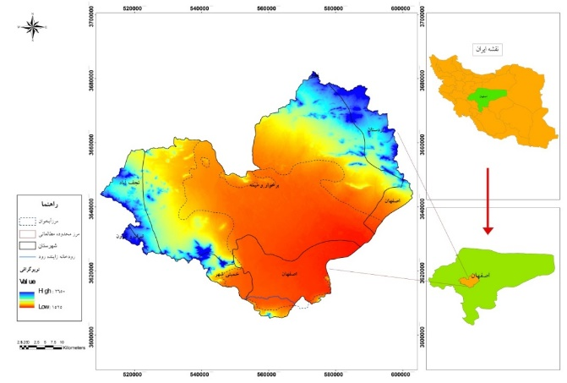
Figure 1: Location of the study area Isfahan – Borkhar.

By monthly statistics of water levels in 35 available wells, in this aquifer we will check the changes of level in underground water table and depth of water level within Isfahan - Borkhar aquifer and the hydrograph unit plain has been prepared in a long-term (Figure 2).

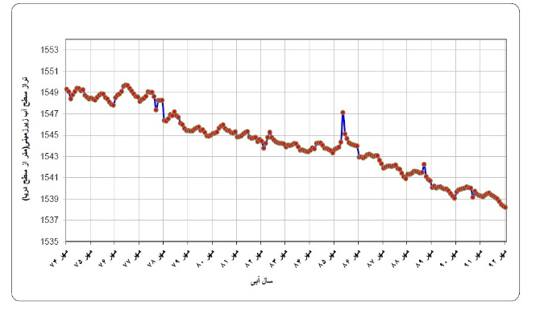
Figure 2: long-term hydrograph unit of the aquifer Isfahan - Borkhar during the years 1374-1392.

Based on hydrograph unit aquifer in a long-term, underground water level of the water year 1375-1374 to 1392-1391 water years can be divided into two different periods as can be seen from 1374 to 1378, the aquifer behavior down to the equivalent but from 1378 to 1392, aquifer deterioration in underground water levels can be seen and the water level dropped as much as 2.9 meters. This shows drop in the need for artificial recharge of aquifers, also due to the lack of sufficient surface water for artificial recharging requires the use of wastewater for it to be clear and enforceable.

3. Results
The necessity of purifying water source
Determine the need and the water refinery source, before an artificial recharge of underground water should be based on the following factors:
- State of underground water quality.
- The physical, chemical and mineral water source.
- Published standards expected for underground water.
- The operation.
Special permitted considerations Purification of water before recharging to reduce the obstruction of recharged areas, improving water quality to recharge for variety uses and etc.
Utilization of purified sewage for artificial recharging
Underground water recharge, practical action with a lot of historical background, knowledge, and experience that has been achieved (Asano, 1985).
However, when the use of recycled sewage or degraded water is used to recharge, needs our particular attention and we should be able to answer questions in this area (Asano, 1992).
Full sampling for the determination of water quality and testing new facility for recharging source, aquifer and recycled water, first of work must be done to determine its suitability for the intended use.
Requirements for sewage purification used in artificial recharge
Urban sewage purification systems usually divided to small system primary, secondary and tertiary. The goal of primary purification is to separate solids from raw sewage. A primary purification system must dissociate almost half of suspended solids in sewage. The output current of the primary purification still has 40 to 50 percent of suspended solids and almost all organic and inorganic matter is the primary solution.
To achieve minimum standards for the EPA should significantly reduce the discharge, organic components, suspended solids, and the solution. Removing this material that is from the secondary purification processes may include physical, chemical or biological. Output current quality secondary purification may not always comply with output current standards In this case; additional treatment for secondary purification system outflow will be required, which is usually called the third treatment and includes the removal of nitrogen and phosphorus compounds, plant growth is nutrients and eutrophication. To remove these additional suspended solids mineral salts and dissolved organic material further treatment may be needed. These all treatment is called the name of restoring water apart from the areas that face water shortages in other cases, due to the considerable cost to rebuild as much good quality drinking water is not justifiable. (Abrahimi and Vaki negad, 1391)
For sewage purification and the necessity of using the membrane filtration process four types of flat membranes under pressure are used in the purification classified according to their pores size they are; (MF), (UF), (NF), (RO).
MF Solutes aerosols and small parts with fluid passing through the membrane, the particles separated by this method are larger than the other three methods. By using this membrane the use of chemicals, especially chlorine used in purification dramatically reduced. (Zazouli and Yosephi, 1388).
UF membranes only prevent the solutes passage of large or macromolecular and a series of micro-organisms including viruses. It is also clear membranes for purification of water with high turbidity and low concentrations of organic material are used. NF membrane able to remove the majority suspended solids and dissolved water. The cysts, bacteria and viruses and NOM of water were removed by the membrane also for softening and desalination of brackish water are used. Reverse osmosis is used to separate ions and micro-molecule of liquid flow. Main working in the refining, desalination and or sea water desalination or oceans and freshen the brackish, Removal of specific contaminants, such as THM and pesticides, deleting NOM, water softening and deleting nutrients and preparing high purity water. (Zazouli and Yosephi, 1388).
BOD & COD parameters are the most practical methods in determining the amount of pollutants in sewage and reduce the amount of dissolved oxygen in the soil due to the presence of aerobic degradation in soil conditions (Jafari, 1392). There is also the maximum amount of BOD and COD removal occurs in soil layers (Essandoh, et al. 2011).
Over time BOD and COD values can increase due to the depletion of dissolved oxygen and create anaerobic conditions in the soil (Essandoh. et al, 2011).

4. Conclusion
Scientific and practical review of the literature suggests that unsaturated layer of soil as a natural filter to reduce the amount of nitrogen, phosphorus, heavy metals and other contaminants (Oron, 2001).
The use of purified sewage as part of a drinking source or for non-drinking issues have recently become more common and require storage for re-use it is necessary for certain time in the unsaturated layer for natural treatment.
Using sewage recycled with high quality it seems necessary and appropriate for artificial recharging process and it requires great care and purification in accordance with existing standards, and the use of membrane filtration helps to purify better water.

Acknowledgements:
Esfahan regional water authority.

Corresponding Author:
Msc. Fariba moradi
Department of Hydrology and Water Resources
Shahid Chamran University-Ahvaz –Iran.
E-mail: Frb1991@yahoo.com

References
- Abrahimi, SA., One race, d. (1391). Environmental Engineering (Volume I). Tabriz Sahand University.
- JA, Q. (1392). The feasibility of using recycled water by sewage purification system (SAT). National Conference on water recycling.
- Housainain, M. (1381). Re-use of Sewage purified used in agriculture, food industry and artificial recharg, underground water. Tehran: Publication of olom rouz.
- (Zazouli and Yosephi, 1388). Principles of membrane processes and their application in water purification and sewage treatment. Tehran: Shahrabi.
- Taheri Tizrou, A., Roushani, A. (1390). Management of underground water resources. Razi University of Kermanshah.
- Akbari M, J. M. (2009). Investigation of dropping (decreasing) of ground water tables using Geographic information system (Case study: Mashhad plain aquifer). Journal of research for water and soil conservation.
- Asano, T. (Editor).(1985). Artificial Recharge of Groundwater, Butterworth publisher, stoneham, mass.
- Asano,T., Leong, L.Y.C., Rigby, M., and Sakaji, R.H. (1992). Evaluation of the California Wastewater reclamation Criteria Using Enteric Virus Monitoring Data, Water Science and Tec., 26:1513-1524.
- Essandoh H.M.K, Tizaoui C., Mohamed M.H.A., Amy G.(2011); Soil aquifer treatment of artificial waste water under saturated conditions; water Research Vol.45; No.11; pp.421 4226.
- Essandoh H.M.K., Tizaoui C., Mohamed M.H.A., Amy G., and Brdjanovic D. (2011). Soil aquifer treatment of artificial wastewater under saturated conditions. Water Research 45 (11): 4211-422 6.
- Kalantari, N., N.J., Pawar., and M.R., Keshavarzi. )2009(. Water Resource Management in the Intermountain Izeh Plain, Southwest of Iran. J. Mt. Sci, 6, 25-41.
- Oron, G. (2001). Management of effluent reclamation via soil-aquifer-treatment procedures. WHO Expert Consultation on Health Risks in Aquifer Recharge by Recycled Water, Budapest.

4/23/2017

Environmental Protection Agency
Microfiltration
Ultrafiltration
Nano filtration
Reverse osmosis
Natural Organic Matter
Trihalomethane
Natural Organic Matter
Biological Oxygen Demand
Chemical Oxygen demand

