Advanced Energy Saving Programs for Commercial Buildings

Alireza Nohesara

MSc in Mechanical Engineering, Field of Energy Conversion, Islamic Azad University of Mashhad, Khorasan Razavi, Iran
alirezanohesara@gmail.com

Abstract: In this paper, advanced energy saving programs for commercial buildings were investigated. Currently in most buildings, the heating, ventilation and air conditioning (HVAC) systems are controlled by the present temperature in the building. Many countries have large energy production but due to the huge increase in domestic consumption and decrease of investment in energy sector become dependent on energy imports. In Future HVAC energy consumption will rise further due to increase in growing population, rapid expansion and call for new residential and commercial buildings, and rising global warming due to climate change. This will provide specific methodologies and information, for energy efficiency improvements for many countries. When the historical data of the building is available, the ANN approach is thought to be the most cost-effective method. Most of previous studies of ANN modelling of building temperature, have either focused on single throughout the building. The proposed modelling methodology can be extended to include other inputs, besides neighboring usage pattern of the building, so that the better intelligent control strategies can be developed for energy saving purposes, based on the more accurate predicted temperatures form the new model.
[Alireza Nohesara. Advanced Energy Saving Programs for Commercial Buildings. Researcher 2017;9(4):50-57]. ISSN 1553-9865 (print); ISSN 2163-8950 (online). http://www.sciencepub.net/researcher. 6. doi:10.7537/marsrsj090417.06.

Keywords: Energy Saving, Commercial Buildings, HVAC

1. Introduction
The argument about energy usage has increased recently in many countries that exposed to repeated electricity failure because of expanding demand, natural gas supply shortages, old infrastructure, and insufficient generation and conduction capability. Commercial buildings consume large amounts of energy. As shown in Fig. 1, commercial and governmental sectors consume about 20% of the total energy consumption. For that, energy saving studies have a great importance nowadays. In fact, it needs nearly 3 kW h of electricity energy to and distribute 1 kW h to the consumers as the electrical energy has approximately 33% efficiency. So saving any little portion of electricity will save a large amount of energy consumed.
Heating, ventilation and air conditioning (HVAC) systems in commercial buildings account for a large proportion of electricity bills for the buildings. An effective way to achieve energy efficiency in HVAC systems is to implement supervisor control systems to optimise the set points and operating modes of local control components [1]. In recent years, supervisory control system design has benefitted greatly from the widespread use of building management systems (BMS). BMS provides operators with a platform to monitor and record the HVAC conditions, as well as to tune the local control parameters with ease. To make the most efficient use of BMS for supervisory control systems design, online predictive models with the ability to track the long-term dynamic behaviours of HVAC systems are needed. The predictive model should cover the entire operating range and be suited to any location in the building, by considering both the HVAC processes and varying ambient environment. This dynamic model can be used for energy-efficiency control, such as in determining the best turn on/off time for the air handling units (AHUs) or chiller and boiler plants.

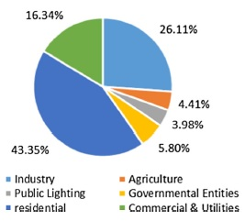
Fig. 1. Average of Energy Saving in the World

In large commercial buildings, the internal space is divided into several adjacent zones, with the temperature and relative humidity of each zone regulated by separate AHUs. Building performance, i.e. temperature modelling is a challenging task. For example, the change of occupant level, weather conditions, the interactions of temperature and relative humidity between individual zones and the operation of HVAC system all affect the temperatures of zones inside a building. Furthermore, HVAC system itself has several coupled control processes that cannot be treated independently. For example, the AHU processes suffer from process-gain and time-delay variation due to the chilled water temperature change and flow-rate fluctuation. Moreover, nonlinear control variables such as temperature, humidity and damper actions make the modelling more difficult.
Traditionally, to overcome the above difficulties, energy and mass balance integral-differential equations are used. The parameters in the equations are with physical significance and can well represent the main characteristics of the systems, but some of them could not be estimated accurately. In addition, the models are computationally demanding and they are not ideal for use with the varying dynamic characteristics of the HVAC system. Recently, intelligent modelling technologies, such as artificial neural network (ANN) models, have been extensively used for HVAC zone temperature prediction. ANN models have proven superior to the linear models and physical models in catching the nonlinearity of HVAC systems.
For example, Ruano et al. built an adaptive radial basis function neural network model to predict the temperature in a school building, with the result revealing better performance than the multi-node physically based model. Using feedforward neural network, Lu and Viljanen [7] constructed a nonlinear autoregressive with external input (NNARX) model to predict both indoor temperature and relative humidity. Based on this study, Mustafaraj et al. developed both a linear ARX model and a neural network-based NNARX model using BMS data to predict the thermal behaviour of an open office.
Besides pure modelling works, the ANN models have also been applied to control application, such as in calculating optimal start and stop time for heating system and designing ANN-based thermal controller in residential buildings.
However, most of the past ANN modelling work had either focused on single-zone examination or assumed that zone temperatures within the building were evenly distributed. In some large commercial or industrial buildings, the thermal space is always divided into separate zones, with each zone controlled by individual AHUs. These zones are inhomogeneous in terms of physical characteristics and dynamic variant. Therefore, it is impossible to predict the future dynamics of these individual zones using a global model. Therefore, dynamic models with the ability to track long-term temperature change for individual zones are needed.
In this paper, a new dynamic neural network model for zone temperature prediction inside a large building using the historical BMS data is proposed and demonstrated. The new model considers the HVAC system characteristics, weather conditions, and thermal interactions between adjacent thermal zones. The ANN model structure is determined under the guidance of a feed-forward input variables selection criterion. Multiple-steps-ahead prediction tests are performed to evaluate the long-term prediction accuracy of the model. The results of using different input combinations are compared to show the effectiveness and importance of the neighbouring zone temperatures when predicting the zone temperature.
System dynamics
It shows the schematic diagram of a chiller plant. The chiller plant provides chilled water for cooling purpose. The chilled water is transmitted from the chiller plants to the cooling coils at individual AHUs by water pumps. The AHU used in this study runs in a constant air volume (CAV) mode. It has fixed-speed fans thus the airflow is regarded as a constant value. Fig. 2 shows the schematic diagram of the CAV air-handling unit. It consists of a cooling coil, a heating coil, water] valves, fans and air dampers. For cooling purpose, the return air is recirculated through the mixed air damper or exhausted through the exhaust damper, depending on the position of these two dampers. The fresh air enters the circuit through the outdoor air damper and then mixed with the return air. The mixed air then passes through the cooling coil and the air temperature decreases after the heat exchange. The chilled water valve is modulated through proportional control to maintain the zone temperature. It can be seen that the most important control variable which influences the supply air temperature is the opening level of cold water valve. Two main types of disturbance which are likely to influence the AHU process include chilled water temperature and chilled water flow rate.

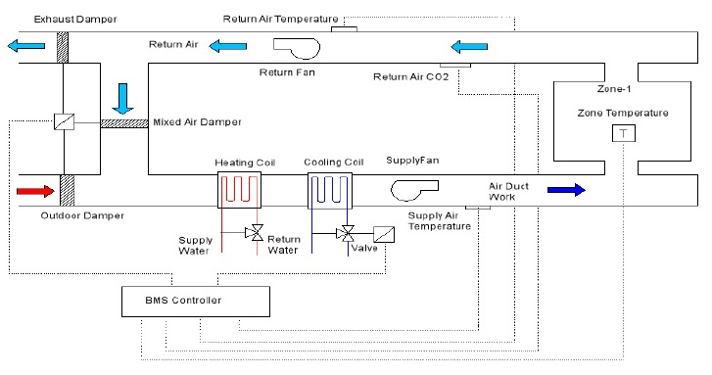
Fig. 2. Schematic of an AHU

It is assumed that there is a big room that is divided into two zones and the temperature in each zone is uniform. It shows the energy (balance) network diagram for the 2-zone case. The temperatures of the zones, i.e. T1 and T2, depend on the surface temperature of the walls, heat transfer coefficient of the walls, outdoor temperature, flow rate of the supply air, supply air temperature, solar gain and neighboring zone temperature etc. The temperature distribution in each zone is assumed to be uniform, the density of the air and air-flow rates are both assumed to be constant. Energy and mass balance governing equation of the zone can be written as:

(1)
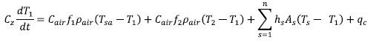
(2)
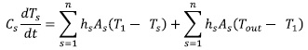

3. ANN modelling
Artificial neural networks (ANN) are black box models which can map nonlinear input-output relationships based on historical data. The most commonly used ANN structure is Multi-layer-perceptons (MLPs). MLPs may consist of 1~n layers and each layer has certain number of neurons. The inputs from the previous layer are multiplied by the weights, summed up and added with a bias. The results pass an activation function at the hidden layer and then go to the next layer.
The MLPs ANN has been proven the most efficient method for the building dynamics modelling. In this work, nonlinear autoregressive with exogenous inputs (NARX) model is used to express the nonlinear neural network structure. A multiple inputs, single output nonlinear system used for one-step-ahead prediction has the following form:
(3)
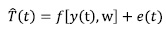
Data gathering
The experimental data used in this study were collected from a commercial HVAC system at through the BMS. To address the problem, thermal zones located in two different areas of the building were selected for experimental purposes. Fig 3 shows the general layout of the selected areas. Zone-1 is located at the outer part, east end of the building. It is adjacent to Zone-2 which is served by another AHU. There is no wall between these two zones. The second test area is an office room, located in the central part of the building. This room is adjacent to a spacious hall but separated by a wall. All the zones are equipped with AHUs and used dry bulb temperature sensors to detect zone temperature. The experiment data were collected on typical summer days in January 2016. The data set were divided into two groups. The data of the first 10 days were used for model training, and the remaining five days data. The data were collected according to the analysis results of the dynamic system from previous section.

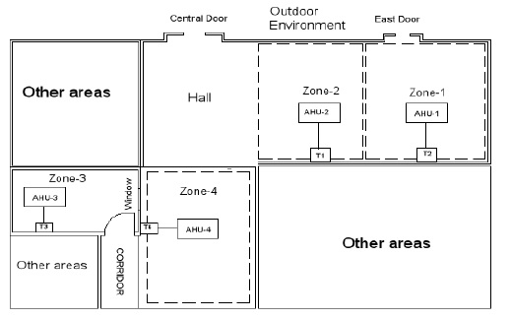
Fig.3. Layout of the experiment area

Table-1 lists a series of variables identified in the previous section for zone temperature prediction. These include controllable variables indicating the operating status of the HVAC system, and uncontrollable variables indicating the thermal conditions of the internal and external environment.

Table 1. input variables definition
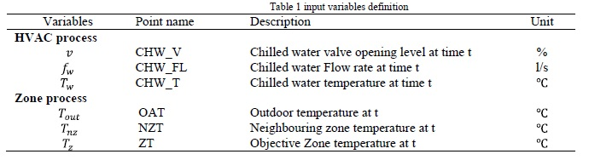

Before modelling work, 2 -1 and Zone-2 to investigate some system dynamics:
Fig 5(a) shows that there was a temperature difference of 2 between zone-1 and zone-2 when AHUs were running. This fact makes the thermal interaction between two adjacent zones a significant factor to consider.
Fig 5(b) illustrates the cold water valve was fully open after AHU started running. This was because Zone-1 temperature was far above the set point temperature during the operating hours.
By analysing both Fig 4(a) and Fig 4(b), it might be concluded that it takes about 4 hours for the Zone-1 temperature to reach the set point temperature after AHU-1 started running on the first day, and it takes about 3 hours for it to reach the set point temperature on the second day. This indicates that under different weather conditions, the response times will be different.
The delay time of cold-water valve opening level on Zone-1 temperature can be estimated by observing the time gap between peak values of input and output data. The delay time for other variables can be estimated using the same strategy.

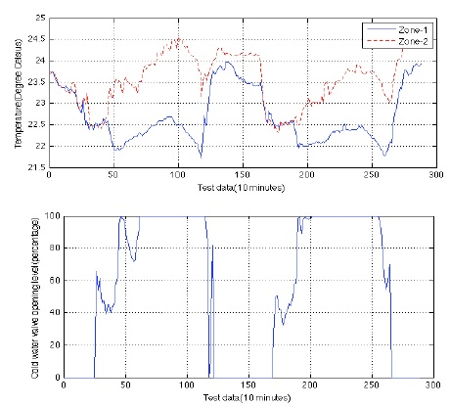
Fig. 4. Data collected from zone-1 between 20th January 2016 to 21th January 2016; (a) zone-1 and zone-2 temperature; (b) cold water valve opening level of AHU-1;

Data preparation
ANN modelling was started by choosing the relevant input candidatures and storing them in a matrix for preparation.
Since some of the candidature variables selected above may be correlated, noisy and have no significant relationships with the outputs, a suitable input variable selection criterion is needed. To address the problem, a simple linear feed-forward selection criterion is used in this study to obtain the best ANN model structure as well as to investigate the relevance of each input variable. Using this method, the initial candidate variables are chosen based on the prior knowledge of the system. The performance of the model is then maximised by changing the orders of input variables and number of hidden layers. The remaining candidature variables are added on top of the previous ones, after the last optimisation process is finished. The candidature variables that fail to improve the performance of the ANN model are abandoned and others will be preserved.
The experiment started by choosing a combination with three inputs: zone temperature (ZT), outdoor temperature (OAT) and chilled water valve opening level value (CV). The delay times of variables were estimated by observing the historical data and were used to re-arrange the input variables. The data preparation method used was employed in this study. After considering the delay, the data matrix can be rewritten as:
Proposed modelling method
The zone process in the case study can be expressed by a multiple-inputs, multiple-outputs (MIMO) ANN model. For instance, a multiple-inputs, double-outputs ANN model with the structure as shown in Fig 4 can be used to express the dynamic behaviour of a double-zone process. U(k-1) is an input vector containing the input variables chosen from Table-1 at the current time stamp; and T(k-1) is the zone temperature at the current time stamp. Eq. (3) shows that the rate change of temperature in one zone is related with the temperature difference between this zone and its adjacent zone. Therefore, the adjacent zone temperature is used as an input for the prediction of the objective zone temperature. Using this method, a MIMO system can be decoupled into two individual multiple-inputs, single-output (MISO) models, as shown in Fig 4 each MISO model stands for the dynamic behaviour of a single-zone process, while maintaining the thermal connection with their adjacent zones. Using the proposed modelling method, dynamic models can be built for the prediction of the zone temperature at any location of a large building. Moreover, the individual zone models can be interconnected to construct a dynamic model for the entire building.
ANN modelling
The neural network with three layers of neurons was employed for training using the prepared data as shown in section. The input data were normalised into [-1,1] to speed up the training process. In this model, the input layer receives information from the data source and transmits it to the hidden layer. The hidden layer uses a logistic sigmoid function as the activation function. The output layer has only one neuron the output of the predictive model. Instead of using the more common Levenberg-Marquardt algorithm for MLP training, Bayesian regulation was employed as the training method, to obtain the optimal regularisation parameters. This algorithm has a slower convergence speed compared with Levenberg-Marquard. However, it can improve the generalisation of ANN models and prevent over fitting.
The ANN was trained in 500 epochs (iterations) and the training process was terminated when the target mean square error (MSE) or the maximum number of epochs was reached. Initially, the number of neurons at the hidden layer was set to be the same as the number of neurons at the input layer. This number was later adjusted between 5 and 12 according to the performance of the model. The weight and bias at the hidden layer were initialised using the Nguyen-Widrow method to keep the resulting model more consistent.
Validation results and discussion
After the training process, the obtained ANN model needs to be validated. To do this, another set of measured data, which are different from the training data, were employed. During the validation, the measured output data were only used at the first prediction. Starting from the second step, the predicted output(s) are used as the input variables for the prediction of the next step. Successive one-step-ahead prediction can then be conducted to realise multiple-steps-ahead prediction. In general, the performance of the predictive model degrades as the step size increases. Therefore, it is important to choose a proper prediction horizon to meet the practical needs with acceptable accuracy. In this study, two-days-ahead prediction (288 steps ahead) was selected because this prediction horizon is long enough for control strategies implementation. The best neural network structure (in terms of input orders, hidden layer nub) was chosen based on three criteria: MSE, mean absolute error (MAE) and maximum error (ME). Table-2 shows the different prediction results obtained using different model structures. Analysis of the results is summarised below:
- They have compared the modelling results when the neighbouring zone temperature was used or not. It was shown that by adding the neighbouring zone temperature as an input, the prediction results for both locations are greatly improved. This indicates that interaction between zones cause by convection is important and the proposed modelling result has revealed the significance.
- It can be observed from Fig 6 and Fig 7 that good prediction results could be obtained when conducting two day ahead prediction. However, this validation results were done based on the assumption that future inputs are known in advance. In order to realise real time prediction, future input data such as weather data with the same sampling interval are also needed.
- According tit, for Zone-1, a good result was obtained when outdoor temperature, cold-water valve opening level and historical data of zone temperature were used as the input variables. On the other hand, shows, for Zone-3, the model performance was not satisfying when these three variables were used. This proves that the thermal zones in the internal part of the building are more related to their less affected by the outdoor weather change.
- According to Table-2, adding chilled water flow rate and chilled water temperature as variables does not bring any significant change on the prediction accuracy, although they are regarded as a source of disturbance in the existing control loop. Neighbouring zone temperature, on the other hand, has more significant impacts on the model performance, especially in the case that the temperature difference is big.
- Overall, the simulation results at two different locations illustrate that the proposed MISO ANN model can provide accurate performance (MSE of 0.129 for Zone-1 and 0.23 for Zone-3) for relative long-term indoor temperature prediction. Moreover, the coupling affects between adjacent zones have also been accommodated by the ANN models. The proposed dynamic model can be further adopted online to implement supervisory control strategy, such as optimum start control of AHUs in large commercial buildings.

Conclusion
In this paper, neural networks have been trained in batch mode to build dynamic models for the prediction of indoor dry bulb temperature. A feed-forward selection criterion is used to determine the optimal structure for the ANN model. Thermal zones located in different areas of a building are selected and compared for experimental purposes. It has been shown that by adding neighbouring zone temperature as an input variable, the performance of the ANN model is improved significantly.
ANN models with this structure have also dealt with the thermal coupling affects between adjacent zones. Two-days-ahead prediction results show that the proposed model can adapt well to the dynamics of the HVAC system across a relatively long period with good accuracy. This result is meaningful in achieving energy savings. For instance, the operating hours and set point temperature for individual AHUs can be re-scheduled based on the prediction result, while taking the constraints such as occupant hours and time-based electricity price into account. Since there are always a large number of AHUs inside large buildings, significant amount of energy saving is possible when the same strategy is applied on each of them. In further studies, the ANN model will be combined with a weather forecast model to realise real time zone temperature prediction. Good prediction result is expected within also be used to calculate the optimal start time and stop time for an AHU to show its effectiveness to achieve energy saving in a large commercial building.

References:
  - American Society of Heating, Refrigerating and Air- Conditioning Engineers, Advanced Energy Design Guide for Small Hospitals and Healthcare Facilities, America Society of Heating, Refrigerating and Air Conditioning Engineers, Inc., 2016, ISBN 978-1-933742-66-3.
  - Electricity Consumption Annual Report, Egyptian Electric Utility and Consumer Protection Regulatory Agency, 2017.
  - Judy A. Roberson, Richard E. Brown, Jonathan G. Koomey, Steve E. Greenberg, Recommended Ventilation Strategies for Energy-efficient Production Homes, University of California: U. S. Department of Energy, 2015.
  - Giacomo Bizzarri, Gian Luca Morini, New technologies for an effective energy retrofit of hospitals, Appl. Therm. Eng. 26 (2006) 161–169, Elsevier Ltd. (2015).
  - Constantinos A. Balaras, Elena. Dascalaki, Athina. Gaglia, HVAC and indoor thermal conditions in hospital operating rooms, Energy Build. 39 (2007) 454–470, Elsevier B.V. (2016).
  - Son H. Ho, Luis Rosario, Muhammad M. Rahman, Threedimensional analysis for hospital operating room thermal comfort and contaminant removal, Appl. Therm. Eng. 29 (2009) 2080–2092, Elsevier Ltd. (2013).
  - M. Fasiuddin, I. Budaiwi, HVAC system strategies for energy conservation in commercial buildings in Saudi Arabia, Energy Build. 43 (2011) 3457–3466, Elsevier B.V. (2016).
  - Rahman Saidur, Md. Hasanuzzaman, H.A. Mohammed, An end-use energy analysis in a Malaysian public hospital, Energy 35 (2016) 4780–4785, Elsevier Ltd..
  - V. Vakiloroaya, S.W. Su, Q.P. Ha, HVAC integrated control for energy saving and comfort enhancement, in: Proceedings of the 28th ISARC, Seoul, Korea, 2015, pp. 245–250.
  - Shady Attia, Arnaud Evrard, Elisabeth Gratia, Development of benchmark models for the Egyptian residential buildings sector, Appl. Energy 94 (2014) 270–284, Elsevier Ltd. (2011).
  - V. Vakiloroaya, Q.P. Ha, B. Samali, Energy-efficient HVAC systems: simulation–empirical modelling and gradient optimization, Automation Constr. 31 (2013) 176–185, Elsevier B.V. (2014).
  - Anil Aswani, Neal Master, Jay Taneja, David Culler, Claire Tomlin, Reducing transient and steady state electricity consumption in HVAC using learning-based model-predictive control, Proceedings of the IEEE, vol. 100, IEEE, 2012, No. 1, January 2015.
  - Fabrizio Ascione, Nicola Bianco, Rosa Francesca De Masib, Giuseppe Peter Vanoli, Rehabilitation of the building envelope of hospitals: achievable energy savings and microclimatic control on varying the HVAC systems in Mediterranean climates, Energy Build. 60 (2013) 125–138, Elsevier B.V. (2015).
  - David S. Dougan, Len Damiano, CO2-based demand control ventilation, ASHRAE J. (2004). American Society of Heating, Refrigerating and Air-Conditioning Engineers, Inc..
  - Konstanti Metelskiy, Demand Controlled Ventilation Systems CO2 Controlled Ventilation Systems, Mikkeli University of Applied Sciences, 2014.
  - ASHRAE Handbook of Fundamental, America Society of Heating, Refrigerating and Air Conditioning Engineers Inc., 2017.
  - H.S. Fink, Promoting behavioral change towards lower energy consumption in the building sector, Eur. J. Soc. Sci. Res. 24 (1– 2) (2014) 7–26.
  - N.A. Aldossary, Y. Rezgui, A. Kwan, Domestic energy consumption patterns in a hot and humid climate: A multiplecase study analysis, Appl. Energ. 114 (2014) 353–365.
  - ASHRAE, Energy Standard for Buildings Except Low-Rise Residential Buildings, ANSI/ ASHRAE/IESNA Standard 90.1- 2004. American Society of Heating, Refrigerating and Air- Conditioning Engineers, Atlanta, GA, 2014a.
  - ASHRAE, Ventilation for Acceptable Indoor Air Quality. ANSI/ASHRAE Standard 62.1-2004, American Society of Heating, Refrigerating and Air-Conditioning Engineers, Atlanta, GA, 2014b.
  - GGHC, Green Guide for Health Care: Best Practices forvCreating High Performance Healing Environments, Versionv2.2, 2017.
  - I. Doebber, E. Bonnema, S. Pless, P. Torcellini, Technical Support Document: Development of the Advanced Energy Design Guide for Small Hospitals and Health Care Facilities –30% Energy Savings, National Renewable Energy Laboratory, Golden, CO, NREL/TP-550-46314, 2013.
  - AIA, AIA Guidelines for Design and Construction of Hospital and Health Care Facilities: 2006 Edition, American Institute of Architects Washington, D.C., 2016.

4/21/2017

