Physico-Chemical And Bactriological Investigation Of Selected Fish Pond In Kuje Area Council, Nigeria.

Ogeneogaga, O, I, And Solomon, R, J.

Department Of Biological Sciences, Faculty Of Science University Of Abuja, Abuja.
johnsol2004@yahoo.com

Abstract: Bacteriological analysis of fish pond water is very important in aquaculture as this gives and insight to the likely hazard that may occurs in fishes, farmers and consumers. Bacteriological studies of selected fish ponds in Kuje area council of Abuja FCT, Nigeria were investigated to evaluate the water quality of the ponds. Some physicochemical properties shows the temperature ranged from 23.00 ± 0.03⁰C to 27.00 ± 0.03⁰C, while pH ranged from 7.00 ± 0.02 to 8.00 ± 0.02, Dissolve oxygen from 5.20 ± 0.22mg/L to 7.10 ± 0.08mg/L, Total hardness ranged from 132.65 ± 0.12mg/L to 185.75 ± 0.14mg/L, COD content also varied from 6.80 ± 0.01mg/L to 7.38 ± 0.06mg/L. the bacterial load ranged from 79.83x10⁵cfu/ml to 154.83x10⁵cfu/ml . Similarly, the coliform count ranged from 110x10⁴cfu/ml in to 201.3x10⁴cfu/ml in. Bacteria of public health importance like E.coli and Samonella spp. were also detected. The frequencies occurrence of isolated bacterial species were as follows: E.coli 25%, Flavobacterium spp. 16.7%, Psuedomonas spp. 8%, Samonella spp. 8%, Bacillus spp. 16.7%, Bacillus cereus 8% and Staphylococcus spp. 16.7%. The presence of this organism show a lack of tentative pond management services which could be harmful to fishes and humans. There is therefore a need to monitor water quality and detect the actual source of contamination and subject the water through a form of treatment to prevent an epidemic outbreak.
[Ogeneogaga, O, I, And Solomon, R, J. Physico-Chemical And Bactriological Investigation Of Selected Fish Pond In Kuje Area Council, Nigeria. Researcher 2017;9(4):31-45]. ISSN 1553-9865 (print); ISSN 2163-8950 (online). http://www.sciencepub.net/researcher. 4. doi:10.7537/marsrsj090417.04.

Key words: Bacteriological analysis, Kuje and physicochemical properties.

Introduction.
Pond water sources are useful for diversified purposes including aquaculture and other related uses at the domestic level. Ponds are naturally formed by a depression in the ground filling and retaining water. Streams or spring water is usually fed into these bodies. A fish pond is an artificial lake (reservoir, pond) intended for fish breeding. Fishes are the most popular animal cultured in the pond. Fishes are among the edible food sources naturally living in water, consumed by man and containing many nutrients such as protein, minerals, fat, oil, etc. Fish ponds are constructed where fishes are fed and their growth are easily observed and monitored. Fishes that are commonly produced in fish ponds are catfish, tilapia and codfish, to mention a few (Bonde, G.J. 1977) In Nigeria, catfish is produced in 98% of our fish ponds. The species of catfish that can be produced include: Clarias anguillaris, Clarias gariepinus, Heterobranchus congifilis, Heterobranchus bidorsalis, etc.
Water is very essential in fish pond, water plays a vital role in the proper functioning of earth ecosystem and also essential for fish and living creatures for metabolism. The temperature of water supplied to a fish pond ranges from 25°C to 35°C as this supports the growth of the microorganisms and fishes found in the pond.There are various sources of water, including well water, borehole water, stream water, river water, etc., that can be supplied to the fish pond. Some bacteria coliform groups like E. coli, in the ponds are transported from these sources of water or the media of transportation into the ponds. There are several microorganisms found in ponds including bacteria, fungi, algae, protozoa, nematodes and viruses. Bacteria has a unique characteristics, they are ubiquitous in every habitation on earth, growing in soil, acidic hot springs, radioactive wastes, water and the live bodies of plants and animals (fredrickson, J.K. et al., 2004). Thus, bacteria are important microorganisms in ponds, whereby, some are beneficial, others are not.
Beneficial ponds bacteria are natural and safe for fish, pets and people. Beneficial bacteria are microorganisms that occur naturally in water gardens, streams, ponds, etc. They are responsible for maintaining crystal clear healthy water, breaking down organic waste, breaking-down ammonia from fish waste, reducing nitrite and nitrate, reducing nutrient load in ponds and balancing the ecosystem. Aquatic bacteria, through the process of decomposition and as sources of food, play an important role in pond ecosystems and also in fish production.
Statement of the Problem .
Fish is the most important single source of protein providing 16% of the animal protein consumed by the world’s population (FAO, 1997). It is estimated that about one billion people world- wide rely on fish as their primary source of animal protein (FAO, 2000). As at 2010, fish provided more than 2.9 billion people with almost 20% of their intake of animal protein, and 4.3 billion people with about 15% of animal protein intake (MSC, 2015). In 2012, Global fisheries an aquaculture production totaled 158million tonnes. This is approximately 10 million tonnes more than 2010 (MSC, 2015) which shows an escalating rising demand. The emergence of diseases associated with beef and poultry such as the Rift Valley Fever, mad cow disease for beef and bird flu for poultry have all contributed to the increase in consumption of fish. There is increased demand for fish in Nigeria which cannot be met by the capture fisheries with stocks stagnating due to over exploitation. The alternative has been the growth in aquaculture with many people turning to farmed fish which is believed to be of better quality whereas it is documented that aquatic environments harbor many bacteria (Novotny, 2004). The use of organic waste for the fertilization of ponds is also a source of pathogenic organisms that may be transmitted to humans via products of aquaculture. There is little information on the quality of fish from Kuje area council as far as the bacterial microorganisms is concerned. There was therefore a need for this study to bridge this gap.
Justification of the study .
A lot of resources and international support are directed to ensure fish safety and quality of fish for export, from the capture fisheries while aquaculture fish has received very little or no attention. In general, a lot of emphasizes has been on the capture fisheries due to the implications on the world trade while the aquaculture fish has received very little if any attention regarding the bacterial flora, water quality and the type of feed used. This is mainly due to the perception that aquaculture fish is assumed to be free of any contamination. Information on the prevalence of bacterial pathogens that may be present in the aquaculture industry in kuje area council and most places in Nigeria are unavailable. Additionally there is no data on the status of sensitivity of these bacteria to anti-microbial agents used in the livestock and horticulture industry in the country.
Against the above background, if fish is going to play a major role in both providing the much needed protein and contributing to the national economy current information on such aspect as fish borne diseases is required. And if aquaculture will reduce the gap between supply and demand for fish and fishery products then there is need to establish the bacterial flora of farmed fish, pond water and of sediment in the ponds and dams. This study was carried out to identify the bacterial flora in the pond water of farmed fish. The findings of this research will be useful in managing aquaculture farms, formulating feeds for aquaculture.
Nutritional and economic value of fish .
Fish is a vital source of food for people. It is man's most important single source of high-quality protein, providing 16 % of the animal protein consumed by the world's population (FAO, 1997). Fish oils are the only concentrated source of eicosapentanoic acid (EPA) and docosahexaenoic acid (DHA). These fatty acids play a major role in the development and maintenance of brain, and prevention of different pathologies mainly the cardiovascular diseases and also psychiatric disorders such as stress, depression and dementia (Bourne, 2005). It is estimated that about one billion people world- wide rely on fish as their primary source of animal protein (FAO, 2000). FAO estimates the value of fish traded internationally to be US$51 billion per annum. Over 36 million people are employed directly through fishing and aquaculture (FAO, 2000) and as many as 200 million people derive direct and indirect income from fish (Garcia and Newton, 1997).
As a maritime nation with a vast population of over 160 million people and a coastline measuring approximately 853 kilometres, fish production as an enterprise possesses the capacity to contribute significantly to the agricultural sector (Osagie, 2012). With an annual fish demand in the country of about 2.66 million tonnes, and a paltry domestic production of about 780,000 tonnes, the demand-supply gap stands at a staggering 1.8 million tonnes. Despite the popularity of farming in Nigeria, the fish farming industry can best be described as being at the infant stage when compared to the large market potential for its production and marketing (Nwiro, 2012). Fish supply is from four major sources viz., artisanal fisheries, industrial trawlers, aquaculture and imported frozen fish (Akinrotimi, et al 2011). The Niger Delta contributes more than 50% of the entire domestic Nigerian fish supply, being blessed with abundance of both fresh, brackish and marine water bodies that are inhabited by a wide array of both fin fish and non-fish fauna that supports artisanal fisheries (Akankali & Jamabo, 2011). The Nigerian fishing industry comprises of three major sub sectors namely the artisanal, industrial and aquaculture of which awareness on the potential of aquaculture to contribute to domestic fish production has continued to increase in the country (Adewuyi, et al 2010). A right step towards arresting the demand-supply deficit for fish is aquaculture, which involves raising fish under controlled environment where their feeding, growth, reproduction and health can be closely monitored (Ejiola & Yinka, 2012). Aquaculture practices as a business venture is capable of bringing significant development in the rural and urban areas by improving family income, providing employment opportunities and reducing problems of food supply and security (Akinrotimi, et al 2009). The vast Nigerian aquatic medium of numerous water bodies like rivers, streams, lakes reservoirs, flood plains, irrigation canals, coastal swamps offer great potentials for aquaculture production and thriving of bacterial flora in Nigeria.
Bacteria associated with farmed fish .
Integrated fish farming combines livestock production with fish farming. In these arrangements, animal manure is shed directly into a fish pond as fertilizer and supports the growth of photosynthetic organisms. Several bacteria are reported to cause infection and mortality in both fish and humans (Novotny, et al 2004) and these represent a particular hazard caused either by handling infected fish on fish farms or in grocery stores or by ingestion of raw or inadequately processed infected fish and or contaminated fish products. Bacterial pathogens are a major cause of infectious diseases and mortality in wild fish stocks and fish reared in confined conditions. Disease problems constitute the largest single cause of economic losses in aquaculture. Concurrent with the rapid growth and intensification of aquaculture, increased use of water bodies, pollution, globalization, and trans-boundary movement of aquatic fauna, the list of new pathogenic bacterial species isolated from fish has been steadily increasing (Ponnerassery et al., 2012).
The level of contamination of aquaculture products by the pathogenic bacteria will depend on the environment and the bacteriological quality of the water in which the fish is cultured. Tilapia, native to Africa and the Middle East is the second most common farm-raised food fish in the world (Fitzsimmons, 1997). Aquatic animals take a large number of bacteria into their gut and gills from water, sediment and food. The intestinal microflora may be significant in fish spoilage (Kaneko, 1971) and may be involved in the spread of feacal contaminants (Geldreich and Clarke, 1966). The microbial populations within the digestive tract of fish are rather dense, the number of micro-organism being much higher than in the surrounding water indicating that the digestive tract provides a favorable ecological niche for these organisms (Horsley, 1977). Some normal bacterial microflora of water, such as Pseudomonas fluorescens, Aeromonas hydrophilla, Edwardsiella tarda, Vibrio species and Myxobacteria (Sugita et al., 1985), These can be found on the body surface or in the intestinal tracts of fish under normal conditions but due to environmental stress may produce epizootics diseases. There are two broad groups of bacteria that will contaminate fish. The first group is the indigeneous microflora which occurs naturally in the environment such as Aeromonas hydrophilla, Vibrio parahaemolyticus, Vibrio cholera, Vibrio vulnificus and Llisteria monocytogenes. The other group is the non- indigenous bacteria that include the members of the family Enterobacteriaceae such as Salmonella species, Shigella species and Escherichia coli. A number of pathogenic microorganisms including Aeromonas, Pseudomonas, Edwardsiella and streptococcus have been implicated in bacterial epidemics in Tilapia (Oreochromis species) cultures (Al – Harbi, 1994; Al – Harbi and Uddin, 2003). The frequency of contamination of fishery products by pathogenic microorganisms has been considered a health hazard to consumers (Ingham and Potter, 1991).
Vibrio paraheamolyticus and other vibrios .
Outbreaks of diarrhea by Vibrio paraheamolyticus have been demonstrated in Japan and Taiwan after ingestion of under cooked fish and raw products, sashimi and sushi (Vuddhakul et al., 2000). Vibrio parahaemolyticus has been isolated from sea and estuary waters on all continents with elevated sea water temperatures. It is isolated from fish throughout the year in tropical climates. It causes acute gastroenteritis that is self-limiting, however, several cases require hospitalization and on rare occasions septicaemia may occur. In the 1970s V. parahaemolyticus was the cause of 14 outbreaks of gastroenteritis in USA (Barker et al., 1974), most of which occurred during the warmer months and were attributed to seafood. Cholera is a highly contagious disease caused by infection of the small intestines with Vibrio cholerae Ol and O139. It is characterized by massive acute diarrhoea, vomiting and dehydration. It is often transmitted by water but fish or fish products that have been in contact with contaminated water or faeces from infected persons also frequently serve as a source of infection (Kam et al., 1995). According to Hay (2012), Vibrio cholera accounted for 75% of Vibrio associated diarrhea in some part of Niger Delta region.
Escherichia coli .
Escherichia coli are enteric bacteria causing gastroenteritis. This bacteria together with other coliforms and bacteria such as Staphylococcus spp. and sometimes Enterococci are commonly used as indices of hazardous conditions during processing of fish. Such organisms should not be present on freshly-caught fish (Chattopadhyay, 2000). An outbreak of diarrhea illnesses caused by ingestion of food contaminated with enterotoxigenic E. coli was described in Japan (Mitsuda et al., 1998) associated with eating Tuna paste. An outbreak caused by salted salmon roe contaminated, probably during the production process, with enterohaemorrhagic E. coli (EHEC) O157 occurred in Japan in 1998 (Asai et al., 1999). The salmon roe was stored frozen for nine months but it appears that Enterohaemorrhagic E. coli (EHEC) could survive freezing and a high concentration of NaCl and retained its pathogenicity for humans. The isolation of E. coli in fishes grown in sewage-fed farms and also in retail market fishes of Kolkata indicated contamination of fishes with faecal matter of animal and human origin (Manna et al., 2008). Food products that show evidence of faecal contamination are generally regarded as a greater risk to human health, as they are likely to contain human-specific enteric pathogens. Some strains of E. coli are capable of causing food-borne disease, ranging from mild enteritis to serious illness and death (FAO/NACA/WHO, 1997).
Salmonella species.
Fish and shellfish are passive carriers of salmonella, which demonstrate no clinical disease and can excrete Salmonella species without apparent trouble. Fish may therefore serve as avector for Salmonella species. In a Canadian outbreak of Salmonella enterica serotype Paratyphi B was linked to aquariums (Gaulin et al., 2002). Another outbreak caused by drug resistance Salmonella enterica subspecies serotype typhimurium DT104 was described in Singapore (Ling et al., 2002). Dried anchovy was found to be the cause of infection. Although most Salmonella outbreaks have been linked to poultry, the Hawaii Department of Health studied 35 cases of Salmonella that arose from October 2007 to February 2008 and found that 86% of these patients had consumed raw fish in the 7 days before they got sick. In most cases, ahi, which is often made from imported frozen tuna, was the reported fish consumed. In April 2008, eight of the nine cases of Salmonella infection reported in the mainland United States also involved consumption of raw tuna.
Staphylococcus aureus .
Enterotoxins produced by Staphylococcus aureus are another serious cause of gastroenteritis after consumption of fish and related products. In southern Brazil, Staphylococcus aureus was isolated from 20% of 175 examined samples of fresh fish and fish fillets. It was also detected during the process of drying and subsequent smoking of eels in Alaska in 1993 (Eklund et al., 2004).
Listeria monocytogenes .
It is widely distributed in the general environment including fresh water, coastal water and in fish from these areas. Contamination and recontamination may also take place during processing (Huss et al., 2000). It is a psychotropic pathogen with the ability to grow at refrigerator temperatures. An outbreak of listeriosis due to vacuum packed gravid and cold smoked fish was described in at least eight human cases for eleven months in Sweden (Tham et al., 2000).
Clostridium botulinum .
The main habitat of C. botulinum is soil but it is also found in sewage, rivers, lakes, sea water, fresh meat and fish (Haagsma, 1991). Clostridium botulinum type F caused deaths after consumption of bought herrings without previous heating. Botulism caused by Clostridium botulinum type B after eating fish salad was described by (Weber et al., 1993). Clostridium botulinum type B which is found in marine and Lake Sediments and in fish intestines does not grow or produce toxins in living fish but is carried passively. The bacterium becomes a hazard when processing practices are insufficient to eliminate botulinal spores from raw fish.
Pseudomomas aeruginosa .
They are widely found in water and are increasingly recognized as an emerging opportunistic pathogen of clinical relevance. They have an ability to metabolize a variety of diverse nutrients and to form biofilms and hence to survive in a variety of unexpected places. Pseudomonas aeruginosa is one of the leading causes of nosocomial infections. The bacteria is intrinsically resistant to many antimicrobial agents, including most β-lactams, the older quinolones, chloramphenicol, tetracycline, macrolides, trimethoprim–sulfamethoxazole and rifampin but a few strains are sensitive to drugs like the ciprofloxacin (Rossolini and Mantengoli, 2005). This state of multi-drug resistance is attributable to a concerted action of multidrug efflux pumps with chromosomally encoded antibiotic resistance genes and the low permeability of the bacterial cellular envelops. Besides intrinsic resistance it easily develops acquired resistance either by mutation in chromosomally encoded genes or by the horizontal gene transfer of antibiotic resistance determinants (Adelaide et al., 2009).
Aeromonas species .
This bacterium can also be found in fresh, salt, marine estuarine, chlorinated water. It can survive in aerobic and anaerobic environments. It is very resistant to chorine, refrigeration or cold temperatures making it hard to kill and posing a danger to fish processing. It occurs in contaminated environments and is also ingested through food products that have been infected with the bacterium (Daskalov, 2006). It causes gastroenteritis which occurs mostly in young children and people who have comprised immune systems or growth problems. About 8.1% of cases of acute enteric diseases in 458 patients in Russia were caused by Aeromonas species (Pogorelova et al., 1995). This could increase the hazard of food contamination, particularly where there is a possibility of cross- contamination with ready-to-eat food products. Some strains are important fish pathogens in aquaculture (Pillay, 1990), while others have been implicated in food borne disease (Morgan and Wood, 1988). Aeromonads can be causative agents not only of human enteritis (Sukroongreung et al., 1983 ), but also of a fatal septicemia as recorded in a 15- year old healthy girl, where the causative agent was found to be Aeromonas sobria (Shiina et al., 2004).
Citrobacter freundii .
Citrobacter species are found in water, soil and decaying matter and can be isolated from the faeces of man and animals. They are small, Gram-negative, non-spore forming rods, and belong to the family Enterobacteriaceae. Citrobacter species grows best at moderate temperatures but can also grow at low temperatures (7 ºC). Citrobacter is one of the major genera of bacteria that are found on fresh meat, minced meat, poultry, plants and plant products (Kleeberger and Busse, 1975; Jay, 2000). Sources of these food contaminants may be the original environment (such as water and soil) of fish, meats and vegetables. Treated wastewater, for example, is reused for irrigation and other purposes in many countries (WHO, 1989). Citrobacteris one of the prevalent species in the influent and effluent of wastewater treatment plants (Abu-Ghazaleh, 2001) therefore; vegetables, fish and other foods in contact with this water may be contaminated. It has strains that have inducible ampC genes encoding resistance to ampicillin. The first generation cephalosporins resistance encountered in this organism could also be as a result of plasmid- encoded resistance genes (Abu-Ghazaleh, 2001).
Edwardsiella tarda .
This is a member of the family Enterobacteriaceae. Edwardsville spp. has been implicated in gastroenteritis in humans and in bacteremic infections that include wound abscesses and meningitis (Sakazaki et.al., 1971). It has been isolated from a diseased pig, an ostrich and was also implicated as the causative agent of a disease in pond-reared eels (Wakabayashi and Egusa, 1973). Incidence of E. tarda in fishes from freshwater aquaculture environment and retail market have been reported (Pankajkumar, 2009), and human liver abscess caused by E. tarda bio group in India (Manchanda et al., 2006) have also been reported.
In a recent study carried out by Njoku et al (2015) in Niger Delta region of Nigeria shows the presence of pathogenic microorganisms especially E. coli, Samonella, Shigella and Vibro which can lead to the transmission of water borne diseases such as, typhoid fever, cholera, food poisoning and gastroenteritis (Piet, 2009) on consumption of improperly cooked fish cultivated in these ponds or through contact with the contaminated fish and water. The diverse group of bacteria isolated from these ponds are in line with the report of okpokwasili and ogbulie (1999) who worked on pond water suggesting that allochthonous bacteria from feeds added to the ponds are the principal sources of bacteria of health importance and dabbor (2008) who reported similar organisms in the microbiological study of El-quanter fish pond.

Materials And Methods.
Study Area.
The study Kuje Area Councils of the Federal Capital Territory. Kuje Area Council lies between latitude 8⁰53’N and longitude 7⁰14’E. It has an area of 1,644 km² and about 40 km SW of Abuja (wikipedia). It is a town undergoing expansion but certain part of it is still rural with much farmlands. The natives of this area speaks two native languages Gbagi and Gwari
Sampling.
Water samples were collected from two farms (two ponds from each farm) using sterile bottles from below water level. The water was transported to the biology laboratory of university of Abuja in an ice-packed container for bacteriological analysis. Other important information about the ponds such as source of water supply, period or length of use was obtained by interview.
Bacteriological Procedure.
This was done by carrying out serial dilution up to 10⁻⁴ and 0.1ml diluent of each dilution was streaked on nutrient agar, Ethylene Methylene Blue (EMB) agar, and Macunke (MAC) agar using the spread plate method. The plates were incubated in an inverted position for 24hrs at 37⁰C. Colony counter (Labtech) and hand-tally were used for the determination of the total bacterial counts in terms of colony forming units per ml (CFU/ml).
Biochemical tests for identification.
Catalase test: Catalase enzyme protects bacteria from hydrogen peroxide (H₂O₂) accumulation, which can occur during aerobic metabolism. If hydrogen peroxide accumulates it becomes toxic to the organism. Catalase breaks down H₂O₂ into water and oxygen (MacFaddin, 1980). In this test small amount of the test organism was smeared from the culture dish or petri plate onto the head of a sterile slide using a sterile wire loop. Then a drop of hydroxide was added to the smear. If bubbles become visible, this concludes that the organism produces catalase. Lack of bubbles indicate negative result.
Oxidase test: Some of the test culture was swabbed into one of the ends of an oxidase dry slide using sterile wire loop. Colour changes to purple or blue after 30s to 1 min is an evidence that the result is positive. The lab test is based on detecting the production of enzyme cytochrome oxidase by Gram-negative bacteria.
Gram Stain: The most common and useful staining procedure is the gram stain which separates bacteria into 2groups according to the composition of their cell walls and was done as described by William et al.,(2001). A film was made on a clean slide by emulsifying part of a colony in loop full of distilled water. The film was then air dried and fixed by slight flaming and stained as follows:
(1) The smear was stained with crystal violet solution for 1-2 mins.
(2) The smear was rinsed rapidly with water and gram’s iodine solution was added and left for 1-2 mins.
(3) The iodine was poured off and the slide was washed with 95% ethanol for 5-15 sec.
(4) The smear was then washed with tap water and stained with safranin solution for 20 sec.
(5) The slide was washed with water and allowed to dry. On microscopic examination the gram positive organisms appeared purple and gram negative organisms appeared pink.

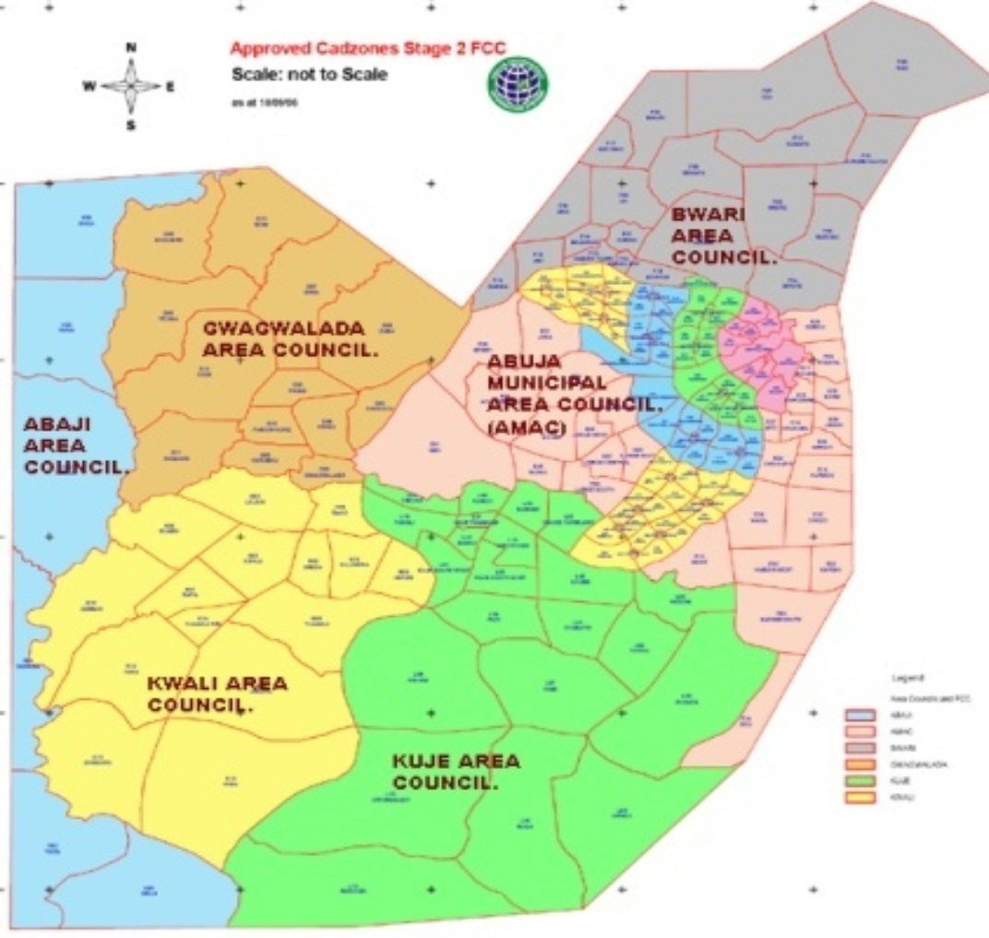
Plate 1: Map of Abuja showing location of Kuje area council (focusonabuja.info)

Physicochemical Analysis of the fish pond water.
The physicochemical parameters of the fish ponds water were analyzed within the holding time of each parameter, following standard methods. Water temperature is measured in-situ using mercury-in-glass bulb thermometer with calibration range (-10 ⁰C – 110 ⁰C) between 10-12 GMT. Samples for the physicochemical parameters were collected in a clean 2 litres plastic bottles (except samples for Dissolved Oxygen (DO) and Chemical Oxygen Demand (COD). Glass reagent bottles were used to collect samples for DO determination. The oxygen content determined by iodiometric titration with N/40 Sodium Thiosulphate solution (Golterman et al., 1978) while dark reagent bottles is used for COD determination and is kept in a dark cupboard for 5 days for subsequent analysis. Sample pH was measured using a pH meter with a glass electrode (Jenway, 3020 model), while electrical conductivity was measured with conductivity meter (Jenway, 4071 model) at 25⁰C. Total water hardness was determined by complexio-metric titration method using Na₂EDTA.

Results.
This study helps to determine the microbiological properties and some ecological parameters of fish pond water sources from the area (Table 1). Pond water samples were collected from different fish ponds in the study area.
Table 1 shows some physicochemical properties including values of temperature which range from 23.00±0.03 (pond 4) to 27.00±0.03 (pond 1), pH ranged from 7.00±0.02 (pond 2) to 8.00±0.02 (pond 4), and dissolve oxygen ranged from 5.20±0.22 (pond 1) to 7.10±0.08 (pond 4). Also, the total hardness of the water samples vary from 132.65±0.12 (pond 4) to 185.75±0.14 (pond 1) and chemical oxygen demand (COD) ranged from 6.80±0.01 (pond 4) to 7.38±0.06 (pond 1). All the parameters were within the range that supports fish production.

Table 1: Physico-Chemical Properties Of Pond Water Samples
Ponds | Temperature (⁰C) | Ph | Do (Mg/L) | Total Hardness (Mg/L) | COD (Mg/L)
Pond One | 27.00±0.03 | 7.20±0.05 | 5.20±0.22 | 185.75±0.14 | 7.38±0.6
Pond Two | 25.00±0.02 | 7.00±0.02 | 6.22±0.04 | 170.20±0.14 | 7.00±0.20
Pond Three | 26.00±0.02 | 8.00±0.02 | 6.28±0.01 | 145.58±0.12 | 6.92±0.01
Pond Four | 23.00±0.03 | 8.00±0.02 | 7.10±0.08 | 132.65±0.12 | 6.80±0.01

Table 2 displays the total bacterial and coliform count of the samples. The bacteria load ranged from as low as 0.79x10⁸cfu/ml in pond 2 to as high as 1.54x10⁸cfu/ml in pond 3. Similarly, the coliform count ranged from 1.10x10⁷cfu/ml in pond 2 to 2.01x10⁷cfu/ml in pond 3. Different bacteria were obtained during the study including Staphylococcus spp., Flavobacterium spp., Escherichia coli, Bacillus spp., Pseudomonas spp., and Salmonella spp.

Table 2: Mean Total Bacteria And Coliform Count Of Pond Water Samples On Solid Media
Ponds | Total Bacteria Count  (x10⁸cfu/ml) | Total Coliform Count  (x10⁷cfu/ml)
Pond 1 | 1.30 | 1.84
Pond 2 | 0.79 | 1.10
Pond 3 | 1.54 | 2.01
Pond 4 | 1.27 | 1.80

Table 3: Percentage occurrence of bacteria in pond water.
Bacteria | Percentage (%)
Escherichia coli | 25%
Flavobacterium spp. | 16.70%
Psuedomonas spp. | 8%
Samonella spp. | 8%
Bacillus spp. | 16.70%
Bacillus cereus | 8%
Staphylococcus spp. | 16.70%

The morphological characteristics and some biochemical characteristics including gram-staining reaction were used to give probable identity of the isolate (Table 4).

Table 4: Culture Characteristics Of Isolated Bacteria
Sample | Media | Catalase | Oxidase | Gram Reaction | Cell Shape | Identification
Pond 1 | NA | + | - | + | Cocci | S. spp.
 | EMB | + | + | - | Short rod | F. spp.
 | MAC | + | - | - | Short rod | Escherichia coli
Pond 2 | NA | + | - | - | short rod | Escherichia coli
 | EMB | + | + | + | Rod | Bacillus spp.
 | MAC | + | - | - | Short rod | Escherichia coli
Pond 3 | NA | + | - | + | Cocci | S. spp.
 | EMB | + | + | - | Rod in Cluster | Pseudomonas spp
 | MAC | + | - | + | Rod in Long Chain | Bacillus spp.
Pond 4 | NA | + | - | + | Long rod in cluster | Bacillus spp.
 | EMB | + | + | - | Rod | F. spp.
 | MAC | + | - | - | Short rod | salmonella spp.
Key.
NA: Nutrient agar
EMB: Ethylene methylene blue
MAC: Macunke agar
F.spp.: Flavobacterium specie
S. spp.: staphylococcus specie
spp.: specie

Discussion.
The water used for the culture of fish will not give maximum production if the physicochemical parameters are not optimal for fish and other aquatic organism. Water temperature, an important parameter in this study, it influences fish growth and biological oxygen demand in ponds. As water temperature increases, it holds less oxygen. As water temperature increases, it holds less oxygen. Also plants and animals use more oxygen due to increased respiration. These factors commonly result in less available oxygen for fish in water. The observed water temperature in ponds in this study is considered normal for aquatic life. It is also within the optimum temperature at which Clarias garienpinus which is the most common species cultured in these areas thrives so well. Adeniji, and Ovie, (1982) and Madu, (1989) both reported that the best temperature range 25-31⁰C. For this study all ponds except pond 4 mean observed temperature fall within this range which also agree to the report by Solomon et al., (2013). The temperature observed in this study also corroborate the report of Boyd, (1979) for good fish production.
Oxygen is needed for the body activities of the fish. It is introduced into the pond mainly through photosynthesis by aquatic green plants and dissolved oxygen from air. The mean dissolve oxygen content for all ponds was in the range of 5.20±0.22mg/L to 7.10±0.08mg/L with temperature range of 23 to 27⁰C. The dissolved oxygen (DO) requirement for fish varies with species. Generally, the water quality for any fish cultured in tropical region must not be less than 3mg/L (Robert, 1979; 2007). This study verified that all the ponds are conducive for aquaculture in terms of dissolve oxygen content. Most of the fish ponds have trees grown around them this could account for the high level of DO level due to their shading effect. Brain, (2006) and Ita, et al., (1995) noted that increased DO level is needed to support increase in metabolic rates and reproduction.
Water pH affects metabolism and physiological processes of fish and also exerts considerable influence on toxicity of ammonia (ICAR, 2006). The ponds observed in this study at Kuje area council agree with the pH starndard for fish pond water by WHO, (2006) and FEPA, (1991). Huet, (1972) also observed that the pH values of 6.5 to 9.0 are good for fish production. Hence the result from this study implies that the pH condition of the ponds is satisfactory. Fish growth is limited in water of <5.0 (Boyd, 1982). Sometimes the pH of the pond water can change quickly as a result of heavy rain which may carry acidic substances, dissolved from the soil into runoff water, into the pond, in this way the pond water gets more acidic thus, leading to decreased pH value. Therefore there is a need for periodic check of water pH in fish ponds. However, when the pH of the water is too high, above recommended standards the water will be too alkaline. At this point more acidic substances should be added to the water to reduce its alkalinity.
Total hardness of water is a measure of the alkaline earth metals such as calcium and magnesium concentration in water samples (Ehiagbonare and Ogundiran, 2010). Calcium and magnesium are essential to fish for metabolic reaction in bone and scale formation. Adequate concentrations of calcium and magnesium are necessary to ensure growth and survival of fish because low levels of calcium reduces disease resistance in fry. The optimal water hardness necessary for fish to thrive is dependent on the species of fish. Most fish grow well over a wide range of hardness values. For this study total hardness measured lowest pond 4 (table 1) and highest in pond 1(table 1). This value is within the WHO, (2006) and FEPA, (1991) standard range of 200mg/L. The study shows that there is a high or increase amount of water soluble salts in the samples. In cases of low presence of soluble salt, it can be increased by addition of lime.
Chemical oxygen demand indicate the pollution level of a given water body (Ehiagbonare and Ogundiran, 2010).
The physicochemical parameters studied showed that the levels obtained are suitable for the cultivation of Clarias gariepinus, and hence for aquaculture.
It has been observed that infectious disease is one of the most important constraints to efficient and sustainable aquaculture production, impacting on food security, socio-economic development, profitability and trade (Walker, 2004). The persistence of pathogens in the water environment also is considered as one of the crucial factors for infection transmission (Mlejnková and Sovová, 2012) in terms of acute outbreaks of disease. In this study, the microbial analyses of the water collected from the fish ponds revealed a high microbial load. The finding is in agreement with the report of Oni et al., (2013) in a study on associated microbial load of artificially cultured C. gariepinus fingerlings, in which high microbial load with low mortality of the fingerlings was recorded. This may be an indication that C. gariepinus is adequately suited to withstand high microbial load. The investigation of bacteria showed a result which ranges from 0.79x10⁵CFU/ml to 1.54x10⁵CFU/ml (table 2). The result of bacteriological characteristic showed that Gram negative bacteria were dominant in the bacteria isolated from the ponds. A total of twelve bacteria were isolated. Seven (7) Gram negative bacteria were encountered and five (5) Gram positive bacteria (table 4). This result is consistent with the study of Njoku et al., (2015) and Adedayo and Anthony, (2014) who isolated 10 bacteria during a pond water bacteriological study at Akungba Akoko, Ondo state Nigeria and found seven to be Gram negative and three Gram positive bacteria.
A total of eight bacteria specie where isolated from the ponds with the following percentage occurrence (table 3) ; E. coli 25%, Flavobacterium spp. 16.7%, Psuedomonas spp. 8%, Samonella spp. 8%, Bacillus spp. 16.7%, Staphylococcus spp. 16.7%, and Bacillus cereus 8%. This result are in agreement with Borah et al., (2010) where they reported that 78% of the ponds they worked with had E.coli contamination and the THBC ranged from 10⁴ to 10⁵ per ml of water sample. From this study the presence of salmonella contamination could lead to infection on ingestion of this microorganism.
E. coli was the most dominant organism occurring in this study. The presence of E.coli in water or food indicates the possible presence of causative agents of gastrointestinal diseases (Ampofo and clerk, 2010) such as typhoid fever, dysentery, cholera and urinary tract infection. Staphylococcus spp. As been noted for food poisoning (Oni et al., 2013). The bacteria species isolated in this course of study were identified using Bergey’s manual of determinative bacteriology.
Coliform counts per unit sample sources show some level of contamination. Though fishes feed on some microorganisms, high level of contamination with the presence of these indicator organisms could cause for alarm and could be linked to neglecting food fish pond management practices. It could also be as a result of increase in the rate of microbial infiltration possibly due to pond fertilization or from other animal and human origin. These condition therefore calls for good water quality for fish pond management practices in order to get improved fish yields, less disease outbreak, decrease mortality rate of fishes and also reduced human infection.

Conclusion.
The study has provided information about the water quality status of Kuje area council of Abuja FCT and its suitability for aquaculture uses. The water quality varies considerably between sources at different locations. The field observations on the water quality revealed that the study area have high potential for aquaculture development based on the values obtained which were in conformity with recommended values for fresh water fish farming.

Recommendation.
Sanitary conditions under which fish are reared in ponds should be improved, by following standard or good practices; such as use of good quality water, use of feeds with high microbial quality, regular draining of pond water after specific period of time, closure of ponds to the public among other things.
Continuous monitoring of these physicochemical parameters would give farmers firsthand information on strategies to employ in preventing and reducing fish mortality. This will also help farmers maintain good water quality with view producing larger and healthier fish for human consumption.

Reference
- Adedayo Olajide Ajayi and Anthony Ifeanyin Okoh, (2014). Bacteriological study of pond water for aquaculture purposes Journal of Food, Agriculture & Environment Vol.12 (2): 1 2 6 0 - 1 2 6 5.
- Adeniji H. A, and Ovie S. I., (1982). Study and appraisal for the Water quality of the Asaoli and Niger Rivers. NIFFR Annual Report pp. 15-20.
- Akinrotimi, O.A., Abu, O.M.G. Ibemere, I.F. & Opara C.A., (2009). Economic viability and marketing strategies of periwinkle Tympanotonus fuscatus in Rivers State, Nigeria. International Journal of Tropical Agriculture & Food systems, 3(3): 238 – 244.
- Akinrotimi, O.A., Abu, O.M.G. & Aranyo, A.A., (2011). Environmental Friendly Aquaculture Key to Sustainable Fish Farming Development in Nigeria. Continental Journal Fisheries & Aquatic Science, 5 (2): 17 – 31.
- Akankali, J.A. & Jamabo, N.A., (2011). A Review of Some Factors Militating Against Sustainable Artisanal Fisheries Development in Niger Delta, Nigeria. Asian Journal of Agricultural Sciences, 3(5): 369-377.
- Adewuyi, S. A., Phillip, B. B., Ayinde, I. A. & Akerele, D., (2010) Analysis of Profitability of Fish Farming in Ogun State, Nigeria. Journal of Human Ecology, 31(3): 179 -184.
- Abualdahal M, Kamal and Gorani M, Abdalgader, (1983). Bacteria, Eltamareen Almalyia Alasaseeya (in arabic), pp. 86-87
- Al-Harbi, A. H., (1994). First isolation of Streptococcus spp. From hybrid tilapia (Oreochromisniloticus and O. aureus) in Saudi Arabia. Aquaculture, 128: 195-201.
- Al-Harbi, A. H. and Uddin, N., (2003). Quantitative and qualitative studies on bacterial flora of hybrid tilapia (Oreochromis niloticus and O. aureus) cultured in earthen ponds in Saudi Arabia. Aquaculture Research, 34: 43 - 48.
- Ampofo J.A. and Clerk G., (2010). Diversity of bacteria contaminants in tissues of fish cultured in organic waste fertilized ponds; Health implications. The Open Fish Science Journal
- Asai, Y., Murase, T., Osawa, R., Okitsu, T., Suzuki, R., Sata, S., Yamai, S., Terejima, J., Izumaiya, H., Tamura, K. and Wanatabe H., (1999). Isolation of Shiga toxin-producing Escherichia coli 0157:H7 from processed salmon roe associated with outbreaks in Japan, 1998 and molecular typing of the isolates by pulsed-field gel electrophoresis. The Journal of the Japanese for Infectious Disease, 73 (1):20-24.
- Adelaide, A., Ângela, C., Newton, C. M., Gomes, Eliana, A., Liliana C., and Maria,A. F., (2009). Phage Therapy and Photodynamic Therapy: Low Environmental Impact Approaches to Inactivate Microorganisms in Fish Farming Plants. Journal of Marine Drugs, 7(3):268-313.
- Abu-Ghazaleh, (2001). Fecal coliforms of wastewater treatment plants: Antibiotic resistance,survival on surfaces and hellip. Microbiological, 24:379-387.
- Barker, W. H., Mackowiak, P.A., Fish, M., Morris, O. K., D’ Alfonso, J. A., Hauser, G. H. and Felsenfeld, O., (1974). Vibrio Paraheamolyticus gastroenteritis outbreak in Covinton Louisiana, in August 1972. American Journal of Epidemiology, 100 (4): 316-323.2
- Borah, K. (2006). Nutrient load and pollution study of some selected station along Ogunpa River in Ibadan, Nigeria. M.sc Dissertation. University of Ibadan, Nigeria.
- Bonde, G. J., 1977. Bacterial indication of water pollution. In Droop, M.R. and Jannasch, H. W. (eds). Advances in Aquatic Microbiology. Vol.1. Academic Press, London, pp. 273-364.
- Boyd C. E., (1979). Water quality in warm water fish pond Auburn University of Agric Experimental Station. Craftmaster Printers, Inc. Opelika, Alabama. pp.359.
- Bourre, J. M., (2005). Where to find omega-3 fatty acids. Journal of Nutrition Health Aging, 9 (1):31-38.
- Brian, O., (2006). Dissolved Oxygen Environmental quality. 84: 18766.
- Chattopadhyay, P., (2000). Fish- Catching and handling. (In Robinson R. K. edition). Encyclopedia of Food Microbiology, (2): London: Academic Press. Covinton Lousiana, in August 1972. American Journal of Epidemiology, 100(4): 316-323.
- Ejiola, M. T, and Yinka, O. F., (2012). Comparative Cost Structure and Yield Performance Analysis of Upland and Mangrove Fish Farms in Southwest, Nigeria. International Journal of Agricultural Management & Development, 2(3): 187-198.
- Daskalov, H., (2006). The importance of Aeromonas hydrophila in food safety. Food Control, 17(6):474-483.
- Ehiagbonare J. E, Ogunrinde Y. O., (2010). Physico-chemical analysis of fish pond water in Okada and its environs, Nigeria. Africa Journal of Biotechnology. 9 (36): 5922-5928.
- Eklund, M. W., Peterson, M. E., Poysky, F. T., Paranjpye, R. N. and Pelroy, G. A., (2004).Control of bacterial pathogens during processing of cold-smoked and dried salmon strips. Journal of Food Protection, 67 (2):374-381
- Fredrickson, J. K., Zachara, J. M., Balkwill, D. L., Kennedy, D., Li, S. W., Kostandarithes, H. M., Daly, M. J., Romine, M. F. and Brockman, F. J., (2004). Geomicrobiology of high level nuclear waste contaminated vadose sediments at the Hanford Site, Washington State. Applied Environmental Microbiology. 70:4230-4241.
- Foster, R. and Smith, M. 2013. Fish Anatomy and Physiology. LiveAquaria.com. Veterinary and Aquatic Services Department, pp. 1-2. http://www.peteducation.com/article.cfm?c=16+2160&aid=583. Accessed on 8th March, 2013.
- Focusonabuja.info accessed on 12 of September 2015.
- Food and Agriculture Organization, (2000). The State of World Fisheries and Aquaculture.
- Food and Agriculture Organization, National Agency for the Control of Aids and World Health Organization, (1997). Report of a Joint Study Group. Food Safety issues Associated with Products from Aquaculture. WHO Technical Report 883.WHO, Geneva,
- Federal Environmental Protection Agency (FEPA), (1991). Guideline and standard for environmental pollution control in Nigeria.
- Fitzsimmons, K., (1997). Introduction to Tilapia Nutrition. Northeast Regional Agricultural Engineering Service Publication, 106: 808.
- Gaulin, C., Vincent, C., Alain, L. and Ismail, J., (2002). Outbreak of Salmonella paratyphi B Linked to aquariums in the province of Quebe, 2000. Canada Communicable Diseases Report, 28 (11):89-93, 96.
- Garcia, S. and Newton, C., (1997). Current situation, trends and prospects in world capture fisheries. American Fisheries Society Monograph Series, 352.
- Geldreich, E. E., and Clarke, N. A., (1966). Bacterial pollution indicators in the intestinal tract of freshwater fish. Applied Microbiology, 14: 429-437.
- Golterman R.L., Clymo R.S., Ohnstand, M. A. M., (1978). Methods for physical and chemical analysis of freshwater, IBP Handbook No. 8 Blackwell Scientific Publication Oxford 214pp
- Huet, M., (1972). Textbook of fish culture: Breeding and cultivation of fish. Fishing News Books Ltd., Farnham, Surrey, England. pp. 436.
- Horsley, R.W., (1997). A review of the bacterial flora of teleosts and elasmobranchs, including methods for its analysis. Journal of Fish Biology, 10: 529-553.
- Huss, H. H., Jorgensen, L. V. and Vogel, B. F. (2000). Control options for Listeria monocytogenes in seafoods. International. Journal of Food Microbiology, 62 (3): 267-274.
- Haagsma, J., (1991). Pathogenic anaerobic bacteria and the environment. Review Science Technology, 10 (3):749-746.
- ICAR, (2006). Indian Council of Agricultural Research. Handbook of Fisheries and Aquaculture. Directorate of Information and Public of Agriculture, New Delhi 110 012.pp.755.
- Ingham, S. C., and Potter, N. N., (1991). Survival and growth of Aeromonas hydrophila, Vibrioparahaemolyticus, and Staphylococcus aureus on cooked mince and surimis made from Atlantic Pollock. Journal of Food Protection, 51: 634 – 638.
- Ikiara, M. M., (1999). Sustainability, livelihood, production and effort supply in a declining
- Ita, E. O, Balogun J. K, Adimula A. B., (1995). A preliminary report of preimpoundment of fishes Survey of Goronyo Reservoir Sokoto. NIFFR Annual Report. Pp. 35-38.
- Jun, X., Xiuzheng, F. and Tongbing, Y., (2000). Physico-chemical factorsand bacteria in fish ponds. Naga, the ICLARM Quarterly 23(4):16-20.
- Jay, J. M., (2000). Modern Food Microbiology. (6th edition). Chapman and Hall, New York USA.
- Kaneko, S., (1971). Microbiological study of fresh fish. New Food Industry, 13:76–80.
- Kam, K. M., Leung, T. H., Ho, Y. Y., Ho, N. K. and Saw, T. A., (1995). Outbreak of Vibrio cholerae Ol in Hong Kong related to contaminated fish tank water. Public Health, 109 (5):389-395.
- Kleeberger, A., Busse, M., (1975). Total count and bacterial flora of minced meat with special reference to enterobacteria and pseudomonads. Z lebensm Unters Forsch, 158 (6):321-33.
- Ling, M. L., Goh, K. T., Wang, G. C., Neo, K. S. and Chua, T., (2002). An outbreak of multidrug – resistance Salmonella enterica subsp.enterica serotype Typhimurium, DT104 Llinked to dried anchovy in Singapore. Journal of Epidemiology Infections, 128 (1):1-5.
- Marine Stewardship Council, (2015): fish as food. https://www.msc.org/healthy-oceans/the-oceans-today/fish-as-food. Accessed on 16th August, 2015.
- Manna, S. K., Das, R. and Manna, C., (2008). Microbiological quality of fish and shellfish from Kolkata, India with special reference to E. coli O157. Journal of Food Science, 73 (6):283-286.
- Mitsuda, T., Muto, T., Yamada, M., Kobayashi, N., Toba, M., Aihara, Y., Ito, A. and Yokota, S., (1998). Epidemiological study of food- borne outbreak of enterotoxigenic Escherichia Coli, Journal of Clinical Microbiology, 36 (3): 652-656.
- Mlejnkova H, Sovova K., (2012). Impact of fish pond manuring onmicrobial water quality. Acta Universitatis Agriculturae et silviculture mendelianae brunensis, 60 (3): 117-124.
- Morgan, D. R. and Wood, L.V., (1988). Is Aeromonas sp. a foodborne pathogen? Review of clinical data. Journal of Food Safety, (9): 59 – 72.
- Manchanda, V., Singh, N. P., Eideh, H. K., Shamweel, A. and Thukral, S. S., (2006.) Liver abscess caused by Edwardsiella tarda biogroup1 and identification of its epidemiological triad by ribotyping. Indian Journal of Medical Microbiology, 24(2): 135-137.
- Mei, Z. P., Shi, Z. F. and Zhu, X. B., (1995). The studies on the nutritional content and the release of the fish pond mud. In Zhu, X. B. and Shi, Z. F. (eds). The Studies of the Ecosystem in the Chinese Fish Pond. Science and Technology Press, Shanghai, pp. 29-36.
- Novotny, L., Dvorska, L., Lorencova, A., Beran, V. and Pavlik, I. (2004). Fish: a potential source of bacterial pathogens for human beings. Veterinary Research Institute, 9:343-358.
- Njoku, O. E., Agwa, O. K. and Ibiene, A. A., (2015). An investigation of the microbiological and physicochemical profile of some fish pond water witin the Niger Delta region of Nigeria. African journal of food Science vol. 9(3) pp. 155-162
- Nwiro, E., (2012) Fish Farming a Lucrative Business. Accessed online 20th October 2012 from http://www.thisdaylive.com/articles/fish-farming-a-lucrative-business/119253/
- Oni T.A, Olaleye V. E, Omafuvbe B.O., (2013). Preliminary studies on associated bacterial and fungal load of artificially cultured Clarias gariepinus Burchell 1822 fingerlings. Ife Journal of Science. 15 (1): 9-16.
- Osagie, C., (2012). Aquaculture as Path to Thriving Agriculture. Acessed online 5th October 2012 from http://www.thisdaylive.com/articles/aquaculture-as-path-to-thriving-agriculture/124614/.
- Ponnerassery, S., Sudheesh., Aliya, A., Nashwa, A., and Saoud, A., (2012). Comparative problem for human and animal health and for the environment. Environmental microbiology, 8 (7):1137-1144.
- Pogorelova, N. P., Zhuravleva, L. A., Ibragimov, F. K. H., Iushchenko, G. V., (1995). Bacteria of the genus Aeromonas as the causative agents of saprophytic infection (in Russian). Epidemiology Immunobiology, (4): 9–12.
- Pillay, T. V. R., (1990). Aquaculture: Principle and Practices. Fishing Book News, London, 575.
- Pankajkumar, (2009). Prevalence of Edwardsiella tarda in commercially important fishes and its sensitivity to antibiotics and sanitizers. MFSc Thesis, West Bengal University of Animal and Fishery Sciences, Kolkata. Pathogenomics of Bacteria Causing Infectious Diseases in Fish. International.
- Robert C. S., (2007). Water quality consideration for Aquaculture. Journal of Animal Ecology, 2: 1 – 15.
- Robert K., (1979). The Range of Choice in Water Management. A Study of Dissolved Oxygen in Potomac Estuary. John Hopkins England. Pp. 48-56
- Rossolini, G. M. and Mantengoli, E., (2005). Treatment and control of severe infections caused by multi-resistant Pseudomonas aeruginosa. Clinical Microbiology and Infection, 11 (4):17-32.
- Solomon Wisdom G.O, Olatunde A. A and Matur, B.M., (2013). Some Physicochemical Parameters of Selected Fish Ponds in Gwagwalada and Kuje Area Councils, Federal Capital Territory, Nigeria. Global Advanced Research Journal of Agricultural Science Vol. 2(1) pp. 017-022
- Sugita, H., Fushino, T., Oshima, K. and Deguchi, Y., (1985). Microflora in the water and sediment of freshwater culture ponds. Bulletin of the Japan Society of Scientific Fisheries, 51: 91-97.
- Sukroongreung, S., Nilakul, C. and Tantimavanich, S., (1983). Distribution of IMVC biogroups of Aeromonas sobria isolated from human, fish and water. Southeast Asian Journal of Tropical Medicine Public Health. 14(3): 330-5.
- Sakazaki, R., Ewing, W. H., and McWhorter, A. C., (1971). Provisional antigenic schema for Edwardsiella tarda. Journal of Tropical Medicine 2: 186-189.
- Tham, W., Ericsson, H., Loncarevic, S., Unnerstad, H. and Danielsson-Tham, M. L., (2000). Lessons from an outbreak of listeriosis related to vacuum - packed gravad and cold smoked fish. International Journal of Food Microbiology, 62 (3):173-175.
- Walker P. J., (2004). Disease Emergence and Food Security: Global Impact of Pathogens on Sustainable Aquaculture Production In A.G. Brown edition: Fish, Aquaculture and Food security, Sustaining Fish as a Food Supply pp. 45-51.
- Wakabayashi, H., and Egusa, S., (1973). Edwardsiella tarda (Paracolobactrum anguillmortiferum) associated with pond-cultured eel disease. Bulletin Japan.
- William A. Strohl, Harriet Rouse and Bruce D. Fisher, (2001). Lipincott’s illustrated Reviews, microbiology. Pp. 22-23,102-103.
- Weber, J. T., Hibbs, R. GJr., Darwish, A., Mishu, B., Corwin, A. L., Rakha, M., Hatheway, C. L., el Sharkawy, S., el- Rahim, S.A., al- Hamd, M. F., (1993). A massive outbreak of type E botulism associated with traditional salted fish in Cairo. Journal of Infectious Diseases, 162 (2): 451 – 454.
- World health organization, (1989). Safe use of wastewater and excreta in agriculture and aquaculture. Geneva: WHO, Library.World health organization (WHO), (2006). Guidelines for dringing water quality. Recommendation WHO, Geneva (1-3): 569-571
- Zhang, Z. Y. and Tang, Y. J., (1989). Pond Fish Culture in China. Science Publishing House, China, pp. 45-47.

Appendix.

Table 5: Shows the comprehensive mean total bacteria and coliform count .
Sample | Media | Bacteria Count | Coliform Count | Total Bactria Count  (x10⁵ cfu/ml) | Total Coliform Count  (x10⁴ cfu/ml)
Pond 1 | NA | 191.00 | 263.00
 | EMB | 138.00 | 213.50 | 129.30 | 184.50
 | MAC | 59.00 | 77.00
Poond 2 | NA | 108.5 | 162.00
 | EMB | 49.00 | 73.50 | 79.83 | 110.00
 | MAC | 82.00 | 94.50
Pond 3 | NA | 178.50 | 220.50
 | EMB | 92.00 | 121.50 | 154.83 | 201.30
 | MAC | 194.00 | 262.50
Pond 4 | NA | 159.00 | 195.50
 | EMB | 146.50 | 198.50 | 127.83 | 180.00
 | MAC | 78.00 | 146.50
Note: All Value Used Are Mean Of Duplicate Results.
KEY.
NA: Nutrient agar
EMB: Ethylene methylene blue
MAC: Macunke agar

Figure 1: The Concentration of pH, Temperature and Dissolve oxygen (DO).

Figure 2: Graph showing the Concentration of total hardness and chemical oxygen demand (COD)

Figure 3: Graph showing the relationship of bacteria occurrence in pond water.

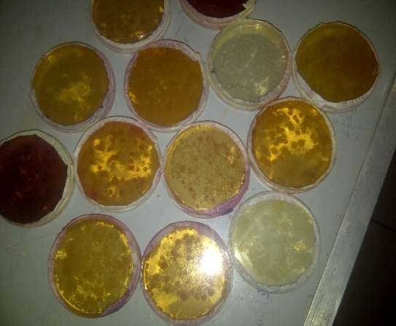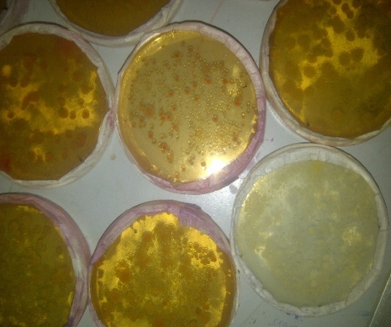

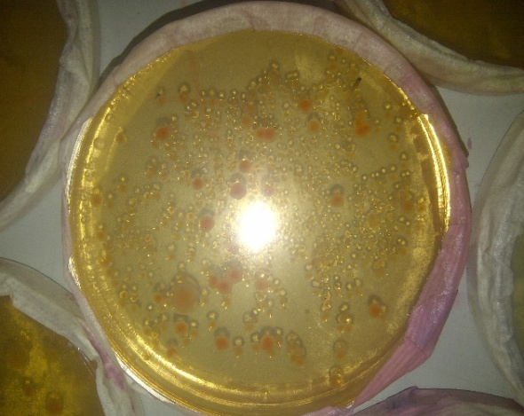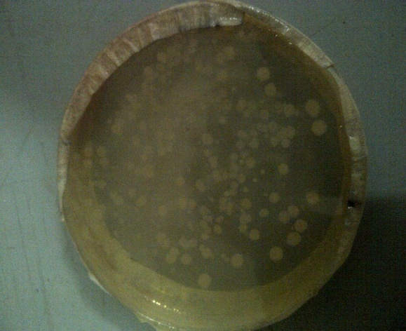

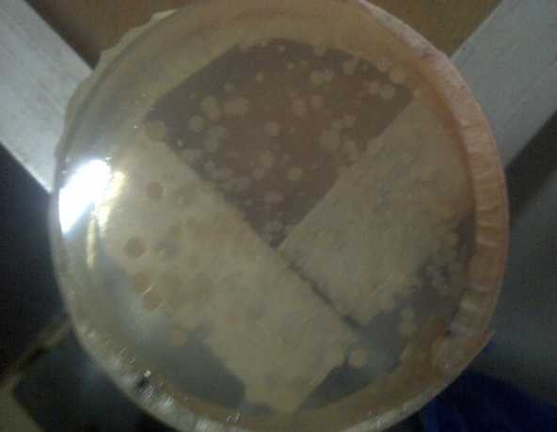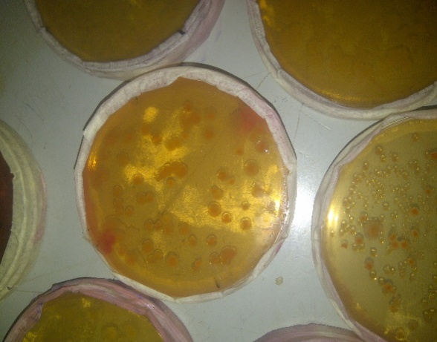
Media plates showing the growth of microorganism.

4/17/2017

