Potential impact of cropping system for Carbon dioxide capturing, case study of Vision Agribusiness Farm in Rwanda

SIBOSIKO Consolée¹ and G.N. Pandey²

University of Rwanda, College of Science and Technology, Department of Chemistry, Rwanda,
Email: consolata@weclearn.net, consibo@gmail.com
Department of Engineering and Technology, Arunachal University of Studies
Email: pandey63@gmail.com

Abstract: The carbon sequestration plays a major role in balancing climate change for environmental protection and the cropping system is one of different alternatives that were utilized in this study. With the Vision Agribusiness Farm novel methodology to cultivate beans in Rwanda, there is conservation of forest, more aeration, more productivity and this implies more carbon captured. During our analysis by using oxidation and back titration methods, we obtained significant quantities of Carbon tone per hectare per year (CTha⁻¹ yr⁻¹) and carbon dioxide tone per hectare per year (CO₂T ha⁻¹ yr⁻¹) in different parts of bean. For C T ha⁻¹ yr⁻¹ was ranging between 0.12 ± 0.005 in roots, 0.89 ± 0.2 in stems, and 1.13 ± 0.5 in seeds. On the other hand, for the captured CO₂ T ha⁻¹yr⁻¹, the results ranged between 0.44 ± 0.1 in roots, 3.28 ± 0.8 in stems, and 4.14 ±1.8 in seeds respectively. In the same line of idea, the quantity of CO₂ emitted in the air was reduced and hence mitigating the environmental pollution problem while returning back the biomass residues to the soil and in turn maintaining the soil health.
[SIBOSIKO Consolée and G.N. Pandey. Potential impact of cropping system for Carbon dioxide capturing, case study of Vision Agribusiness Farm in Rwanda. Researcher 2017;9(4):20-30]. ISSN 1553-9865 (print); ISSN 2163-8950 (online). http://www.sciencepub.net/researcher. 3. doi:10.7537/marsrsj090417.03.

Keywords: Cropping system, Beans, Carbon dioxide, Sequestration, Biomass oxidation, back titration, Mitigation.

Introduction
The terrestrial vegetation responds to climate change due to the process of uptake and translocation of CO₂, water and other nutrients (Alain et al., 2003). It was previously shown that the potential impact of CO₂ on the soil with beans plants results in reduction of production, the inhibition of the growth of roots, stems and leaves as long as Carbon captured by soil is in excess (Manal et al., 2012). Also, the cropping system and the soil management can affect the carbon sequestration in the soil organic matter.
The potentiality of carbon sequestration throughout cropping system of bean in India showed a higher sustainable production and profitability (Dibakar et al., 2015). The modern agriculture deteriorates the environment; it is in this way that the anthropogenic activities are among the causes of pollution. Depending on the use of fertilizers, the carbon sequestration is significant or not due to the biomass production (Prinz, 1986). The current terrestrial estimation of C stored in plant and soil is higher to about 25 % (DOE., 1999) and it increases continuously if there is no decision taken. Through agriculture, the removal of CO₂ from atmosphere and its storage into plant is a positive phenomenon because CO₂ under photosynthesis process. It helps in the crop growth as confirmed by several researchers (Paustian et al., 2000; Schaffer, 1997; Pan et al., 1998; Centritto et al., 2001). On the other hand, the non-captured CO₂ has negative impact to global warming and climate change and not only affect the living being but also the whole ecosystem (Government of Nepal., 2009). The growth of the plant depends on nature as well as rainfall sunlight and temperature. The main solution is the removal of CO₂ from atmosphere and its storage in the terrestrial biosphere. As such, agriculture and reforestation play a big role in absorbing enormous quantity of CO₂ (Alain et al., 2003; Six et al., 2000; Pires et al., 2011). This CO₂ absorption occurs as biomass in all part of the plant, stems, leaves, seeds and roots.
Therefore, this research work was conducted in order to investigate the advantages and role of staking beans for environmental protection. Data were collected from a farm of four hectares producing 4.5 tons from 60 kg per hectare cultivated by the Vision Agribusiness Farm (VAF) in Rwanda for the period 2015-2016.
The aim of this paper is to analyze and see how much quantity of carbon and carbon dioxide shall be up taken by beans during an agriculture semester. Based on the work done by (Pramol et al., 2014), (Richter et al., 1973) and (Schlesinger, 1977), on the Kyoto protocol in order to determine total organic carbon (TOC) in the soil and plants. The oxidation and back titration methodology was used to analyze organic carbon matter captured through different parts of beans crop such as roots, stems and seeds. For soil health (Lopez et al., 2012), (Saha et al., 2008), the soil organic carbon (SOC) as well as the organic manure are paramount to produce big quantity of cash crop and for environmental benefits (Nair 2012a). Therefore, an appropriate sequestration technique should protect all plants or replace some with the one capturing a big quantity of CO₂. With the Vision Agribusiness Farm methodology, the novel component resides in using strings steel as beans stakes for the first time in Rwanda. This methodology protects plants, forests and captures a considerable quantity of CO₂ as detailed in our results discussion.
The common bean (Phaseolus vulgalis) is a major source of proteins for about 70 million people in the world. The eastern and southern Africa produced 16% of world production in 2013 (Umubyeyi et al., 2015) and Rwanda was rank 10th (Catherine and Jeffrey, 2014), per capita consumption of common bean, Rwanda is the highest in the world (FAO Statistical yearbook, 2013), confirming that the crop is food security. Beans are an important staple crop, and food security as a major source of protein (20-30%) in the world (Umubyeyi et al., 2015). As the concern of climate change has been emphasized in the field of economics to the challenge of adapting to global warming, most of time depending on greenhouse gas (Krishna, 2009), the global warming and climate change are great concern of today since they affect life being, ecosystem and economy in the world, many people are now aware that high amount of CO₂ pose threat to the environment and the one way to reduce CO₂ is available of trees and spaces of herbaceous (Shanka et al., 2009; Lal, 2003). The atmospheric CO₂ is photosynthesized and stored as plant biomass and some of the biomass carbon is humus and stored in soil as organic carbon through biodegradation process and the strategy is to return biomass in the soil with the excess of mineralization. To study how much carbon shall be sequestrated into beans which in turn the waste become biomass and rich soil organic carbon and the carbon cycle (Davidson et al, 1993). This part has aim to protect environment especially tree and produce much beans which shall sequestrate pas mal of carbon. Yet, the trees can sequestrate 3.4-5.9 kg C tree⁻¹ year⁻¹ (Zirkle et al., 2011; Woodbury et al., 2007), our study on beans staked by fibers, we used few trees and facilitate photosynthesis due to more aeration and much carbon mitigation.
Among climate change scenarios, SOC stock changes ranged from 0.15- 0.32Tg C year⁻¹(Smith et al., 200.8). Agricultural soils play a major role by increasing or decreasing the stocks of SOC stored within the soil profile which is the result of the balance between carbon grains mainly from crop residues and carbon losses from the decomposition of biomass by micro-organism (Robertson et al., 2000).

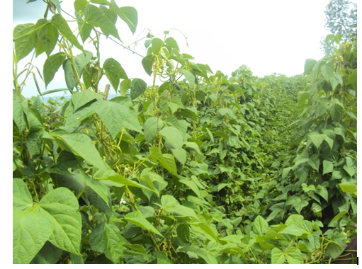
Figure 1: Crop system of beans staked by fiber and string steel at Vision Agribusiness Farm Ltd (VAF)

  - Carbon dioxide and climate change
The rising of temperature is speeding up comparing today with the before industrialization period. The CO₂ emission per annum equals to the billion tons (Alain et al., 2003) and the largest origin coming from burning fossil fuels. The concern of climate change has been emphasized in the field of economics too owing to the challenge of adapting to global warming for sustainable development and growth. Many people are now aware that high amounts of carbon dioxide CO₂ pose a threat to the environment. In fact, studies have shown that climate warming is very likely due to the increase of CO₂ emissions which is among the major issues challenging the world Klaus et al., 2015). Meanwhile, it is very important to reduce the amount of CO₂ emissions by agroforestry system which is a great way of helping to mitigate climate change (Klaus et al., 2015). The temperature increases globally in average of 0.76 ⁰C and the carbon dioxide emission per day is about the billions tones (IPCC, 2012). The world impact will be worse not only on the environment, also the economic and life being. In the urban cities, the increasing of population and vehicle contribute to the challenge with the increase of air pollution. The direct impact of carbon dioxide is not harmful to the human health, but this exhaustive gas become harmful to the global warming by trapping on the earth (US-EPA, 1994).
  - Volatile organic compound
Vegetation naturally release organic compound to the atmosphere excluding CO and CO₂. This implies the natural emission of volatile organic compound VOC) from the trees and other vegetation could make a significant effect on chemistry of the earth’s atmosphere. Some of those vapour of volatile organic compound depend on different factors, like isoprene emission produce by photosynthesis or photorespiration under lightness for the other VOCs chemically process continue even during the night (Robertson et al., 2000). Among the volatile organic compounds which could be emitted by vegetation, we can say isoprene, camphene, 2-carene, pinene etc. Also, the carbon assimilation through photosynthesis process under sunlight transforms carbon dioxide into carbohydrate as shown in this equation.
nCO₂ +2n H₂O (CHO)_{n} + nO₂ + nH₂O.
  - Climate change with temperature variation
The greenhouse gas (GHGs) in particular CO₂ conduces to climate change and warming the earth’s atmosphere. The emission of CO₂ contributes to the rising of temperature, the atmospheric concentration of CO₂ before industrialization revolution period was 280 ppm and the concentration of CO₂ has been increased to 396.45 ppm in 2012, 398.35 ppm in 2013, 401.29 ppm in 2014, 403.26 ppm in 2015 (Ralph, 2015).

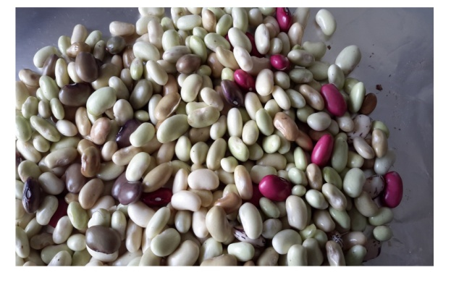

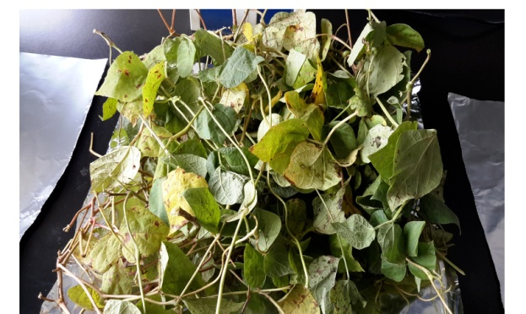
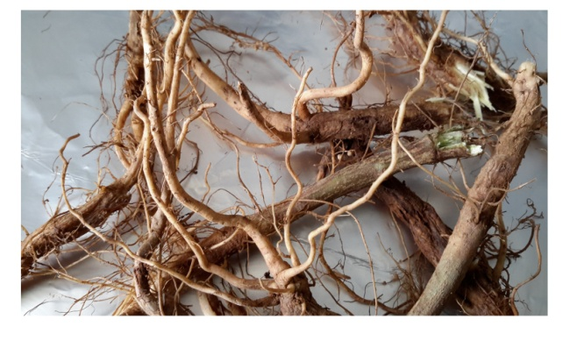
Figure 2: The beans plant separated from its root, stem and leaves. Left (sample of seed bean), right (samples of bean root), middle (stem and leaves as of bean)

- Methodology
  - Raw materials
Bean plant was obtained from a local Gicumbi District at Vision Agribusiness Farm. The bean plant was separated from the roots and leaves and later were washed with tap water, and then weighed with an electric balance in order to get the estimated quantity needed. The plant were then dried in an oven at 70 ^{O}C, for root and leaves 24 hours while seeds took 48 hours until complete dry plant were obtained for completed dryness. The bean plants were later crushed using a crusher and sieved to obtained fine uniform particle size products. Crushed plant were placed in an opaque glass bottles and stored in ambient temperature until used.

  - Determination of Carbon Organic Matter
All reagent and solvent used were purchased from sigma Aldrich suppliers, Kenya and Uganda. The following list of chemicals have been used; H₂SO₄, 98%, H₃PO₄, 85 %, NaF, solid, standard 0.167 M K₂Cr₂O₇, 0.5 M Fe(NH₄)₂(SO₄).6H₂O, ferroin indicator as a mixture of o-phenanthroline and FeSO₄.7H₂O in water.
The method of oxidation of the organic matter or C elemental by dichromate is usually useful and it has been used according (Ball et al., 1964) and then the excess of dichromate is titrated using ferrous ammonium sulfates. The addition of phosphoric acid is required to complex Fe³⁺ during the titration as it was suggested by (Tinsley, 1950; Shaw, 1959).
Reaction of Cr₂O₇²⁻ with organic matter
a. Cr₂O₇²⁻ reacts with carbon as follows:

2 Cr₂O₇²⁻ + 3 C⁰ + 16 H⁺ 4 Cr³⁺ + 3 CO₂ + 8 H₂O

b. Similarly, Cr₂O₇²⁻ reacts with organic hydrogen as follows:

Cr₂O₇²⁻ + 6 H⁰ + 8 H⁺ 2 Cr³⁺ + 7 H₂O

The excess of Cr₂O₇²⁻ is then back titrated by Fe²⁺ to determine the dichromate oxidized C⁰ to C⁴⁺ as has been shown in below reaction
Ferrous iron reacts with Cr₂O₇²⁻ as follows:

6Fe²⁺ + Cr₂O₇²⁻ + 14 H⁺ 2 Cr³⁺ + 6 Fe³⁺ + 7 H₂O

The yellow-orange turning to dark green color is due to the unreached Cr₂O₇²⁻ which during titration with Fe²⁺ pass through gray before the endpoint and then to wine red at the end point.

- Results and discussion
During the analysis by measuring carbon in beans crop cultivated at Vision Agribusiness Farm in Rwanda, owing results obtained were obtained as shown in (Table 1), which shows a good correlation good idea for environmental protection. The carbon and carbon dioxide captured is in significant quantity.

Table 1: Various parts of the Bean plant; root, stem and leaves, based on the fresh and dry weight samples, humidity, percentage of carbon, total amount of carbon and CO₂ respectively in different sections of biomass (g) in beans by using H₂PO₄ semester one.
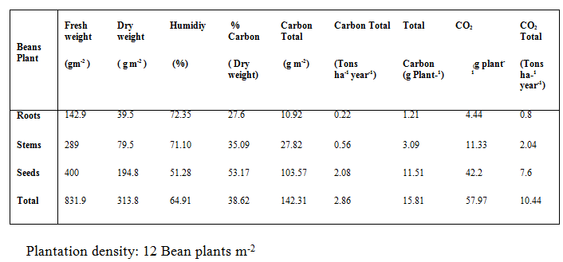

This agriculture of the bean plant, semester 1 took place during the period of September to December 2015.
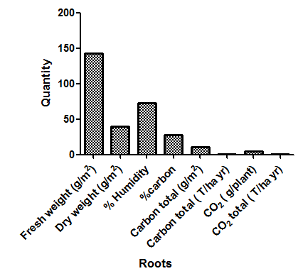
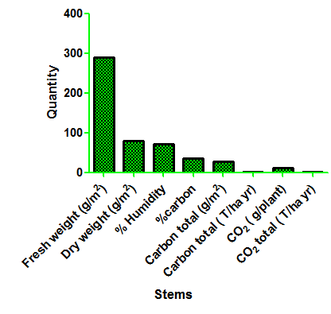

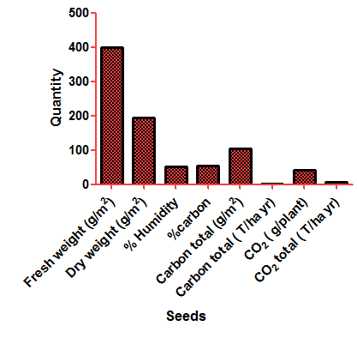
Figure 3: The beans plant quantities from its root, stem and leaves. Left (sample of seed bean), right (samples of bean root), middle (stem and leaves as of bean) during agriculture semester one.

The data collection shows fresh beans weight which it was high in seeds at 400 g m⁻², 289 g m⁻² in then stems and 142.9 g m⁻² in roots respectively. The dry weight shows a big loss of water in roots and stems, the humidity percentage were 72.35 %, 71.10 % and 51.28 % in roots, stems and seeds respectively. The carbon percentage was captured increasing in order at 27.6 %, 35.09 %, and 53.17 % in roots, stems and seeds respectively. A lot of seeds have been produced on few stems and therefore, more carbon captured in seeds compare to the other parts of the plant. The condition of soil, the seasonal factors or environment can affect the growth of the plant, comparing the agriculture semesters and the first was better than the second.
Table 2 and Table 3 show the results obtained during the second agriculture semester of beans crop production. Analysis of the results was carried out without phosphoric acid in one duplicate and another duplicate we have titrated with phosphoric acid. Here, stems and leaves (696.6 g) were high weight than seeds (258.9 g) whereas in first agriculture semester seeds were high in weight (400 g) than in stems and leaves (286 g).

Table 2: Various parts of the Bean plant; root, stem and leaves, based on the fresh and dry weight samples, humidity, percentage of carbon, total amount of carbon and CO₂ respectively in different sections of biomass (g) in beans without using H₂PO₄ semester two.
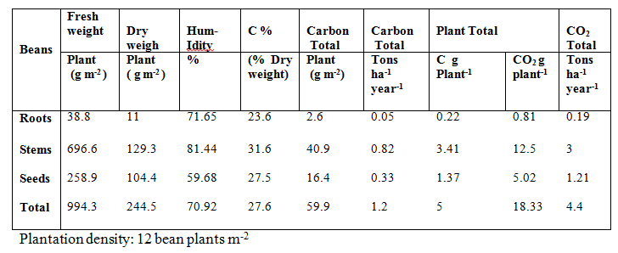

In these experiments the fresh weight of different parts in beans were observed as 38.8 g m⁻² in roots, 696.6g m⁻² in stems and leaves and 258.9 g m⁻² in seeds respectively.
The highest weight was observed in stems and leaves and lowest weight was in root. During the dry process, stems and leaves loss high weight compare to the roots and seeds. Therefore, the humidity was higher in the stems and leaves while in roots and seeds moisture were less. The humidity variations were 81.44 %, 71.65 % and 59.68 % respectively in stems and leaves, roots and seed, therefore, the total humidity was 70.92 %. The total CO₂ captured in different parts of beans were expressed in tons per hectare per year were found to be 3, 1.21 and 0.19 in stems and leaves, seeds and roots.
We found the importance of phosphoric acid being used during the manipulation; it helps the dichromate to be oxidized completely to Cr³⁺ and release more carbon free (C⁰) as we can observe in result. With the same fresh beans quantity taken in Table 2 and Table 3, the carbon released were so high, we obtain 50.7 %, 47.1 % and 41.7 % in stems, seeds and roots respectively. Moreover, the CO₂ captured were in the variations from higher to smallest in Tons per hectare in that considered agriculture semester two as follow: 4.8 in stems and leaves, 3.61 in seeds and 0.33 in roots.

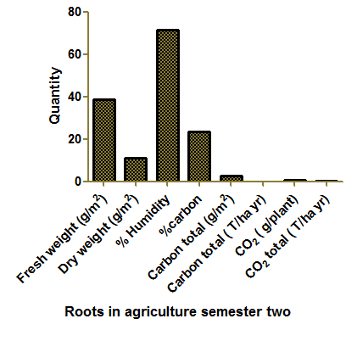

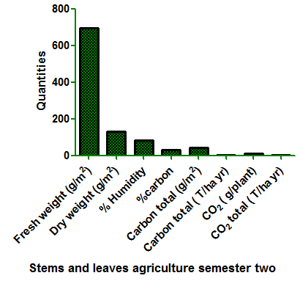

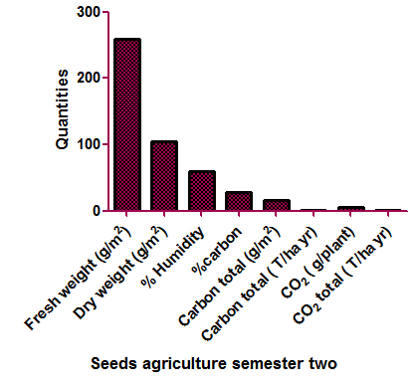
Figure 4: The beans plant quantities from its roots, stem and leaves and seeds. Left (sample of seed bean), right (samples of bean root), middle (stem and leaves as of bean) during agriculture semester two.

By applying the new system of agriculture using strings steel, the production has been investigated and confirms to be five times more sufficient than the tradition agriculture method used. The great potential of carbon sequestration in cropland has provided a promising approach to reduce the atmospheric concentration of CO₂ for mitigating climate change. However, this approach depends on cropping systems and rainy reason which may be defined as an operating system for growers to follow in their practices for crop production by using sisal ropes and string steel to aerate the cropping area for increasing photosynthesis rate. This type of cropping system of beans allow photosynthesis to take place well because between one tree and another which supporting string steel, there is five meters and this facilitate the aeration and allow the light to pass through. In addition, this system allows the conservation of forestry. However, after collection of seeds, the all residue must be decompose to be reused and then maintain the carbon in soil which usually washed by rainfall. The human activities are among the majors for CO₂ emission and the global warming occurs, the carbon capture and stored is potential contributor to reduce the one emitted by the industries or by burnt of fuels. The bean plant has been used in this process of carbon capture and storage (CCS) to investigate the yield production with respective of the CCS in the soil, the quantity of the CCS affect in term of reducing production at some extent of excess of CCS. While our results show the positive potential impact to capture carbon and reduce the CO₂ emitted in atmosphere. The total CO₂ equal to 7.86 ±1.79 T ha⁻¹ year⁻¹ has been obtained with the good yield of bean.
Table 4 shows the average results of total carbon and total carbon dioxide captured during the agriculture semesters at Vision Agribusiness Farm in the whole year 2015-2016. The total carbon in bean plant gram per meter square was 6.04; 44.76; 56.38 in roots, stems and seeds respectively. We obtained significant quantities of carbon total Tone per hectare per year of 2.14 ± 0.49 (CTha⁻¹yr⁻¹) and that of carbon dioxide total Tone per hectare per year of 7.86 ±1.79 (CO₂ T ha⁻¹yr⁻¹).
These results confirm that the method utilized by the Vision Agribusiness Farm reduces a big quantity of CO₂ from the earth atmosphere and hence a potential impact in environmental protection and global warming issue mitigation.

Table 3: Values of carbon and carbon dioxide in different sections of biomass (g) in beans by using H₃PO₄ in semester two.
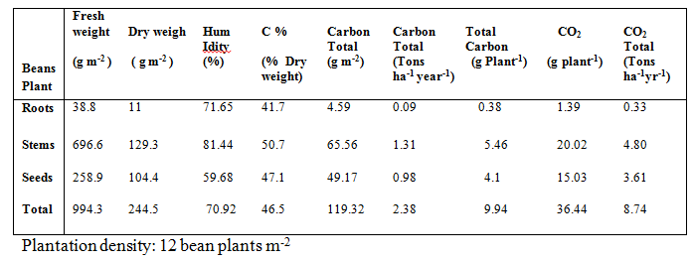

Table 4: Results of carbon and carbon dioxide in crop system (beans)
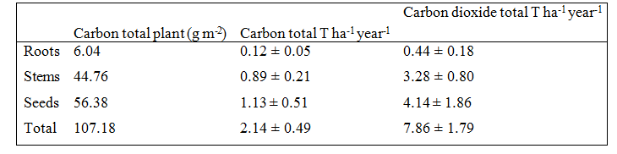

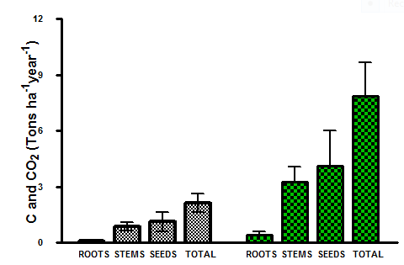
Figure 5: Values of Carbon and carbon dioxide in different parts of beans

This paper shows a big contribution to demonstrate the environmental protection by bean cropland system, the carbon dioxide captured is significant quantity, and the standard deviation between different agriculture semesters is ranging in 0.05 to 0.5 for carbon while for CO₂, was ranged in 0.18 to 1.86. The carbon assimilation through photosynthesis process under sunlight transforms carbon dioxide into carbohydrate which is health to human. We found more carbon dioxide into seeds followed by stems and then roots.
We discuss the greenhouse gas and accuse carbon dioxide to be the principal to the global warming. The data collection in 40 years from 1971 to 2011, the industrialization evolution, the annual temperature in Rwanda has been increasing and the below figures give us an image of today’s climate change in Rwanda. These annual temperature are for Kigali city to Kanombe airport. It was observed the slight change in annual temperature variation.
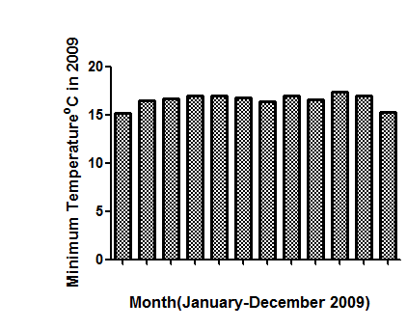

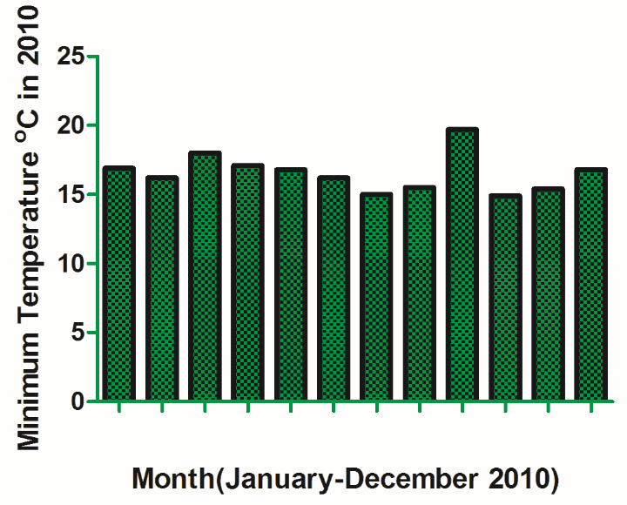

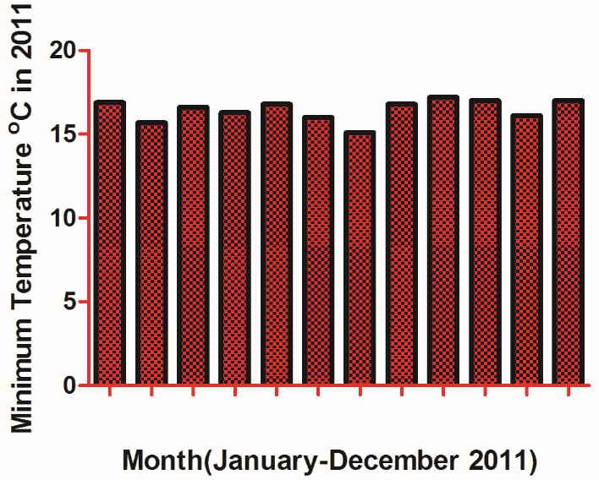
Figure 6: The annual minimum temperature in Kigali-Rwanda. Left (year 2011), right (year 2009), middle (year 2010)

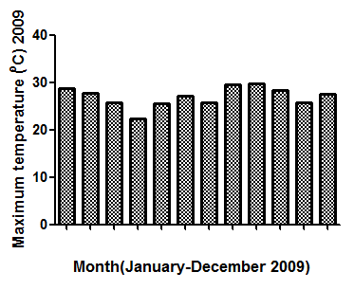

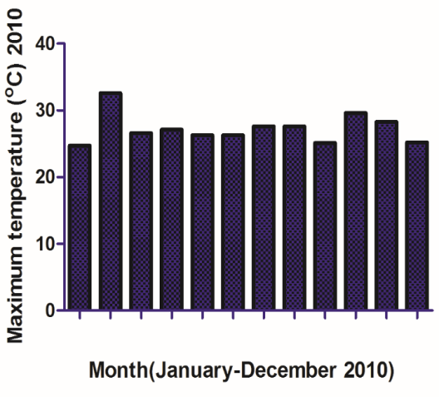

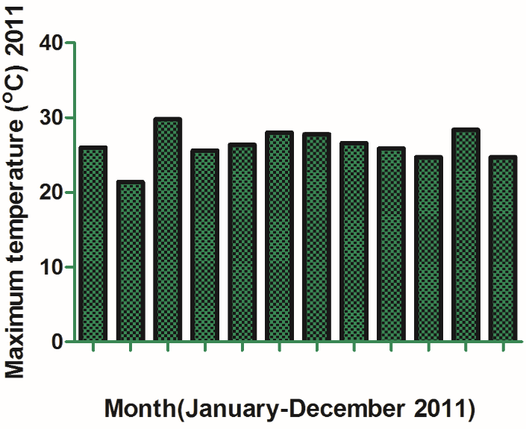
Figure 7: The annual maximum temperature in Kigali-Rwanda. Left (year 2011), right (year 2009), middle (year 2010).

We investigated that the minimum temperature was in January, July and sometimes in December, like in 2009, then it averaged to 15.2 ⁰ C in January, 16.4 º C in July and 15.3 º C in December. The following year in 2010 and 2011, the minimum temperature were found to be 16.2 and 15.7 º C in February, during July we got an average of 15 and 15.1 º C. In September 2010, the minimum temperature was very high compare to the other time, this was due to the dry season which took place and the rainfall season was too short. Whereas the results on average maximum temperature during the years 2009 to 2011 were 28.8; 32.6 and 29.8 º C respectively in January 2009, February 2010 and March 2011. The dry and rain season can affect the increasing or decreasing temperature in Rwanda because during the rainy season the smog are so less and then resulting CO₂ trapping on the earth and the warming occur， which was 21.6 ± 0.41 º C, the other higher annual temperatures were in 2002, 2005 and 2009. The graphic indicated the increasing of annual temperature against time in year per year and the origin is the CO₂, CH₄, NOx and particulate matter which are major to greenhouse gases.

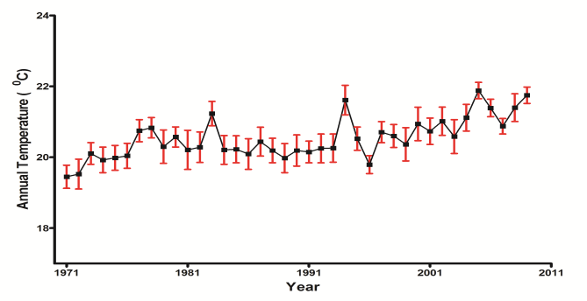
Figure 8: Annual temperature variation in Kigali- Rwanda from 1971 to 2011

The annual variation temperature in Rwanda shows increasing every year. Always the maximum temperatures were ranged between 19.5 to 32.6 ⁰C and the minimum were ranged above 15 to 20 ⁰C. This indicator is to be taken as serious issue on climate change and the degradation of trees has to avoid. We found that the cropland plays the food security and in the same time the environmental management. Cropping system can decrease CO₂ from atmosphere.

- Concluding remarks
The rising of temperature is speeding up nowadays compared with the before industrialization period (IPCC, 2012). The CO₂ emission per annum equals to the billion tons (Alain, 2015) and the largest origin comes from burning fossil fuels.
In this study, a new cropping system methodology in Rwanda of strings steel as beans stakes has been investigated to assess its contribution in capturing the CO₂. We have realized that this cropping system enormously contributed in reducing the CO₂ emitted in atmosphere. The total CO₂ and carbon captured were respectively 7.86 ±1.79 of CO₂ T ha⁻¹ yr⁻¹ and 2.14 ± 0.49 of C Tha⁻¹ yr⁻¹ of carbon. With these results, it can be confirmed that carbon sequestration in cropland is a promising approach to reduce the CO₂ concentration in the atmosphere and hence potential in mitigating climate change issues. In fact, literature says that climate warming is very likely due to the increase of CO₂ emissions which is among the major challenges of the world (Klaus et al., 2015).
Therefore, this study proved that the Vision Agribusiness Farm novel cropping system methodology is a key contributor in attenuating the global warming. In the same sense, further researches should be made to assess the biomass residues contribution to the soil sustainability as health benefit as well as soil productivity which was beyond the scope of this study.

- Conflict of Interest
The authors declare that there is no conflict of interest regarding the publication of this paper.

- Acknowledgement
I would like to thank the University of Rwanda and the Worldwide E-Learning Campus for the support and the encouragement.

Reference
- Alain Albrecht, Serigne, T., Kandji 2003. Carbon sequestration in tropical agroforestry systems. Agriculture. Ecosystems and Environment. 99, 15-27.
- Ball, D.F. 1964. Loss-on-ignition as an estimate of organic matter and organic carbon in non-calcareous soils. J. Soil Sci. 15:84-92.
- Catherine, L. and Jeffrey, D. 2014. Impact of improved beans varieties on food security in Rwanda. Paper presented at agricultural and applied economics association, 2014 annual meeting, Minneapolis, Jully 27-29,2014.
- Centritto. M., Magnani. F., Lee. H. S. J., Jarvis. P. G., 1999b. Interactive effects of elevated CO₂ and drought on cherry ( Prunus avium) seedlings. II. Photosynthetic capacity and water relations. New phytol. 141,141-153.
- Dibakar Mahanta, R. Bhattacharyya, D. C. Sahoo, M. D. Tuti, K. A. Gopinath, R. Arunkumar, B. L. Mina, B. M. Pandey, J. K. Bisht, A. K. Srivastva & J. C. Bhatt. 2015. Optimization of Farmyard Manure to Substitute Mineral Fertilizer for Sustainable Productivity and Higher Carbon Sequestration Potential and Profitability under Gardenpea-French Bean Cropping System in the Indian Himalayas Journal of plant nutrition 38: 11, 1709-1733.
- DOE, 1999. Carbon sequestration: State of the science. U.S. Department of energy (DE). Washington. DC.
- Davidson EA, Ackerman IL. 1993. Changes in soil carbon inventories following cultivation of previously untied soils. Biogeochemistry 20: 161-193.
- FAO Statistical yearbook, 2013. World food and agriculture. Food and agriculture organization of United Nations, Rome.
- Government of Nepal 2009. Ministry of Agriculture and cooperative Klaus Lorenz. Rattan Lal 2015. Soil organic carbon sequestration in agroforestry systems. A review. Hal id: hal 01234833.
- IPCC Intergovernmental Panel on Climate Change. 2012. Air pollution and reduction control in South Asia.
- J. C. M. Pires, F. G. Martins, M. C. M. Alvim- Ferraz, M. Simões 2011. Recent developments on carbon capture and storage: An overview. Chemical engineering research and design 89, 1444-1460.
- John H. Seinfeld, Spyros N. Pandis, 2006. Atmospheric Chemistry and Physics. From air pollution to climate change 2nd ed, pp 43-45.
- Klaus Lozenz, Rattan Lal, 2015. Soil organic carbon sequestration in agroforestry systems.
- Krishna Prasad Pant, 2009. Effects of agriculture on climate change: a cross country study of factors affecting carbon emissions The Journal of Agriculture and Environment Vol: 10.
- Lal, R. 2003. Offsetting global CO₂ emissions by restoration of degraded soils and intensification of world agriculture and forestry. Land Degrad. Dev. 14, 309–322.
- Lopez, M.V., N. Blanco-Moure, M. A. Limon and Gracia. 2012. No tillage in rain fed Aragon (NE Spain): Effect on organic carbon in the soil surface horizon. Soil & Tillage Research 118: 61-65.
- Manal Al-Traboulsia, Sofie Siogersten, Jeremy Colls, Michael Steven, Jim Craigon, Colin Black, 2012. Potential impact of CO₂ leakage from carbon capture and storage (CCS) system on growth and yield in spring field bean. Environmental and experimental Botany 80: 43-53.
- Nair P K R 2012a. Carbon sequestration studies in agroforestry systems: A reality check. Agroforsyst 86, 243-253.
- Pan, Q., Wang, Z., Quebedeaux, B., 1998. Responses of the apple plant to CO₂ enrichment: Changes in photosynthesis, sorbital. 25, 293-297.
- Paustian, K., Six, J., Elliott, E. T., Hunt, H. W., 2000. Management options for reducing CO₂ emission from agricultural soil. Biogeochemistry 48, 147-163.
- Pramol JHA, A. K. Biswas, Brijlal Lakaria, R. Sah, Muneshwar Singh, and A. Subba Rao. 2014. Predicting total organic carbon content of soil from Walkley and Black analysis. Institute of soil Science, Bhopal, India. Communication in soil Science and Plant Analysis 45: 713-725 ( ISSN: 0010-3624).
- Prinz, D., 1986. Increasing the productivity of smallholder framing systems by introduction of planted fallows. Plant Res. Dev. 24, 31-56.
- Ralph Keeling, Son of Charles David Keeling, 2015, The Script of Oceanography. Atmospheric CO₂ for April 2015.
- Rao, M. R., Nair, P. K., Ong, C. K., 1998. Biophysical interactions in tropical agro forestry systems. Agrofor. Syst. 38, 3-50.
- Richter, M., G. Massen, and I. Mizuno. (1973). Total organic carbon and oxidizable organic carbon by Walkley- Black procedure in some soil of argentni pampa. Agrochimica (17) 462-472.
- Robertson G. P., Paul E. A., Harwood R. R. 2000. Greenhouse gases in intensive agriculture: Contribution of individual gases to the radioactive forcing of the atmosphere. Science 289: 1922-1925.
- Saha,, S., B. L. Mina, K. A. Gopinath, S. Kundu, and H. S. Gupta. 2008. Relative changes in phosphatase activities as influenced by source and application rate of organic composts in field crops. Bioresource. Technology 99: 1750–1757.
- Schaffer, B., Whilev. A. W., Searle, C., Nissen, R. J., 1997. Leaf gas exchange, dry matter partitioning and mineral element concentrations in mango as influenced by elevated atmospheric carbon dioxide and root restriction. J. Am. Soc. Hort. Sci 122, 849-855.
- Schlesinger, W. H. 1977. Carbon balance in terrestrial detritus. Annual review of Ecology and systematic. (8) 51-81.
- Shanka Prasad Acharya, Guna Raj Bhatta, 2009. Impact on Climate change on agricultural growth in Napal.
- Shaw, K. 1959. Determination of organic carbon in soil and plant material. J. Sci. 10, 316-326.
- Six, J., E. T. Elliott and K. Paustian 2000. Soil macroaggregate turnover and microaggregate formation: A mechanism for C sequestration under no-tillage agriculture. Soil Biol. Biochem. 32(14): 2099-2103.
- Smith P., Fang C., Dawson JJC, Moncrieff J B. 2008. Impact of global warming on soil organic carbon. Adv Agron 97: 1-43.
- Tinsley, J. 1950. The determination of organic carbon in soils by dichromate mixtures.
- Umubyeyi S. and Rukazambuga N. D. T. M. 2015: Farmers knowledge on grain losses from bean bruchid, pesticides use by small scale farmers and implication on food security and safety in Huye District- Rwanda.
- US-EPA. 1994. Automobile Emissions: An overview. U.S. Environmental Protection Agency.
- Woodbury P. B. Smith J. E., Health L. S. 2007. Carbon sequestration in the US forest sector from 1990 to 2010. Ecole Manage 241: 14-27.
- Zirkle G. N., Lal R., Augustin B. 2011. Modeling carbon sequestration in home laws. Hort Science 46 (5): 808-81.

4/7/2017

