Surgical Management and Facial Reanimation after Facial Nerve Injury

Ahmed Hamed Abd El Maksod, Hussein Gamal Elgohary, Ehab Mahroos Oraby and Mahmoud Mohamed Ahmed Hasab-Allah

General Surgery Department, Faculty of Medicine, Benha University, Benha, Egypt
Hasaballa21.mh@gmail.com

Abstract: There are many options of treatment, which are available for the patient with facial nerve paralysis. The treatment goals are directed to the functional and cosmetic deficits that are present and are individualized to suit the patient's needs. Even after surgery, medical line of treatment is important which includes steroids, antibiotics and physiotherapy under supervision. The outcome of the surgery depends on the processor regeneration. The timing of surgery should be such that maximum ability of nerve regeneration is achieved before degenerative changes occur. There are various factors which influence regeneration like age, nutrition, type and duration of injury, infection, hematoma formation, fibrosis of cut ends of the nerve and hormonal. Improved facial tone and symmetry preceded initial facial movements. In all patients, facial movements appeared at 4-18 months and were usually first observed in the mid-face. We observed that the longer the duration before the operation, the poorer the result. When the duration of paralysis exceeded 2 years, recovery of the muscles of facial expression was poor. Synkinesis was observed in most patients, but no mass movements or gross hypertonia was present. Initial anesthesia due to ablation of the greater auricular nerve appeared insignificant to all patients. Problems with speech, mastication or swallowing were not seen. In a small percentage of patients, slight asymmetry due to reduction in the size of the homolateral tongue was observed. Another small percentage of patients showed no improvement at all.
[Ahmed Hamed Abd ElMaksod, Hussein Gamal Elgohary, Ehab Mahroos Oraby and Mahmoud Mohamed AhmedHasab-Allah. Surgical Management and Facial Reanimation after Facial Nerve Injury. Researcher 2017;9(4):10-19]. ISSN 1553-9865 (print); ISSN 2163-8950 (online). http://www.sciencepub.net/researcher. 2. doi:10.7537/marsrsj090417.02.

Keywords: Surgical Management, Facial Nerve Injury

1. Introduction
Facial palsy is a common condition with an estimated incidence of 20-25 cases per 100000 population, which may arise due to various reasons as idiopathic (Bell’s palsy), trauma, inflammation tumors, and others. The facial nerve palsy following trauma, is an uncommon condition which occurs in 1.5% patients of skull base fractures, majority of them due to road traffic accidents and missile injuries causing temporal bone fractures. ⁽¹⁾
Facial animation is an essential part of human communication and one of the main means of expressing emotions, indexing our physiologic state and providing non-verbal cues. The loss of this important human quality due to facial paralysis can be devastating and is often associated with depression, social isolation and poor quality of life. Facial paralysis significantly impairs eyelid closure, nasal breathing, lip competence and speech. ⁽²⁾
The goals in the treatment of facial paralysis are to achieve normal appearance at rest, Symmetry with voluntary motion as well as with involuntary emotional control of the ocular, oral and nasal sphincters, and No significant functional deficit secondary to the reconstructive surgery. ⁽³⁾
Functional recovery takes priority in the reconstruction. It is of utmost importance, in view of the possibility of corneal ulceration and blindness, to prevent eye complications in the patient with facialparalysis. The treatment of facial paralysis requires the skill of many specialists like neurosurgeon, neurologist, ophthalmologist, otolaryngologist and plastic surgeon. A multiple or combined surgical approach depending on the cause, time interval and wound characteristics often gives best results.⁽⁴⁾
Course of Facial Nerve
The facial nerve is the nerve of the second branchial arch. It is a mixed nerve. The facial nerve consists of a motor root, carrying fibers to the muscles of the second pharyngeal arch (muscles of facial expression, scalp, auricle, stylohyoid, stapedieus and the posterior belly of the digastric). While the sensory root consists of Special visceral afferent (SVA) which Carries sensation Taste from anterior 2/3rd of the tongue via the chorda tympani, General visceral efferent (GVE) which Supplies Salivary glands via the petrosal nerves and the Special visceral efferent (SVE) To the facial muscles. ⁽⁵⁾
The first part of facial nerve course is Supranuclear pathway which the facial nucleus is represented in the precentralgyrus of the cerebral cortex. The facial nerve fibers run downwards from the precentralgyrus through the genu of the internal capsule and then through the pons, where majority of the fibers cross over to reach the opposite facial nerve nucleus. Some fibers continue on the same side to terminate in the ipsilateral nucleus They emerge from the lower border of the pons between the olive and the restiform body as a motor root and a sensory root (nerve of Wrisberg) and it is from here that the infranuclear pathway starts. ⁽⁷⁾ Intracranial-intramedullary course of facial nerve fibers⁽⁶⁾

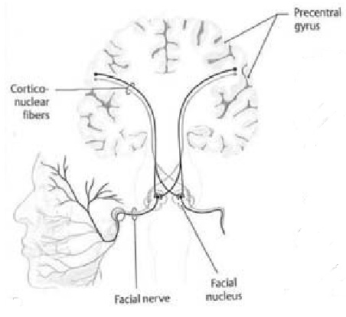

While the second part of facial nerve course is called Infranuclear pathway which the facial nerve after leaving its nucleus travels along with the eighth cranial nerve in the cerebellopontine angle to enter the internal auditory canal (IAC). Upon entering the pons (IAC), the seventh cranial nerve and the nervusintermedius join to form a common trunk, which lies slightly above and anterior to the eighth cranial nerve. After leaving the internal auditory canal, the facial nerve enters a separate bony canal, the fallopian canal in the temporal bone. The facial nerve has a unique course through the long, narrow and tortuous bony fallopian canal in its intratemporal segment.⁽⁸⁾
The Extratemporal Facial Nerve course start after it emerges from the stylomastoid foramen, the nerve turns anteriorly in the substance of the parotid gland and divides at the posterior border of the ramus of the mandible into two main primary branches, the Superior (temporofacial) branch which is larger and horizontally directed. And the Inferior (cervicofacial) branch which is smaller and longer and vertically directed. From this, a plexiform arrangement of nerves arises called the parotid plexus or the Pes Anserinus (as it resembles goose feet). These nerves are distributed over the head, face and upper part of the neck. In the parotid gland, the facial nerve presents a curvilinear course and then as it emerges from the parotid, it rapidly becomes superficial and is related to the external wall of the parotid space; which is a thin glandular bed. ⁽⁹⁾
The extra temporal branches of the facial nerve innervate the facial mimetic muscles that consist of the orbicularisoris and 23 other paired muscles. The mimetic muscles can be further divided into four layers, based on depth, as demonstrated in cadaveric dissections. The most superficial three muscle layers are innervated on their deep surfaces, and the muscles of the deepest layer, consisting of the mentalis, buccinator, and levatorangulioris, are innervated on their lateral or superficial surfaces.⁽¹⁰⁾
Terminal Branches of the Facial Nerve and Parotid Gland⁽¹¹⁾

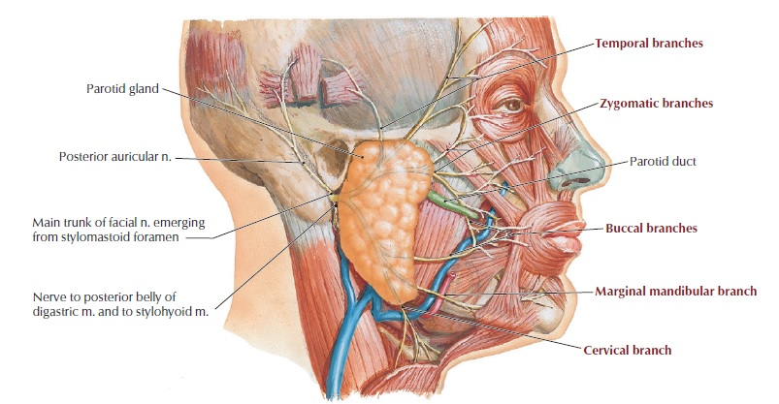

The vascular supply of the facial nerve is complex. The posterior vertebrobasilar circulation supplies the proximal and middle portions of the nerve via the anterior inferior cerebellar artery and the internal auditory artery, respectively. Further supply of the middle portion of the nerve comes from the petrosal artery via the middle meningeal artery of the external carotid. Distal segments receive blood from the stylomastoid artery, which is also a branch of the external carotid. The considerable overlap of the arterial supply especially in the middle Portions through the facial canal make it unlikely that occlusion of any single artery will compromise facial nerve function.⁽¹²⁾
Each nerve fiber is surrounded by connective tissue, the endoneurium. The endoneurium is closely adherent to the Schwann cells. Highlighting the structural relevance to normal physiological function, Schwann cells serve as a conduit for regenerating nerve fibers following injury. The perineurium is a sheath of concentric layers of polygonal cells surrounding groups of endoneurium-covered neurons. The perineurium provides tensile strength and intrafunicular pressure. At the outermost layer, the epineurium, loose areolar tissue, holds and separates nerve fasicles. The epineurium contains the vasa nervorum and lymphatic vessels, which provide nutrition to the nerve fibers.⁽¹³⁾
At 1943 Seddon was describe three types of nerve injuries. Firest type is Neurapraxia which caused by pressure on a peripheral nerve can block the transmission of the impulses without death and degeneration of the axon beyond the site of pressure and may be associated with the loss of myelin at the site of pressure. Release of pressure results in rapid and complete recovery of function, without residual deficit. This is a reversible conduction block.⁽¹⁴⁾
Axonotmesis is the second type of nerve injury which sectioning of an axon or sufficient pressure to block off axoplasm in the distal segment completely results in the death of the distal segment not at once but after several days. And the Neurotmesisis Sectioning or disruption of the entire nerve trunk and known as third typ. ⁽¹⁵⁾
At 1978 showed anew classification was described by Sunderland based on histological finding as five degrees of nerve injury, as the first degree indicates compression of the nerve that is reversible and the recovery is complete. This is similar to neuropraxic damage to the nerve. And the second degree there is interruption of the axoplasm and the myelin. This occurs when the compression persists. It results in loss of axons but the endoneurium remains intact. Recovery may take more than 1-2 months but is usually complete. This correlates well with the axonotmesis type of nerve injury.⁽¹⁶⁾
The third degree of nerve injury is loss of myelin tubes due to an increased intraneural pressure. In this case recovery may take as long as 2-4 months, there may not be a complete recovery or the recovery though complete may be accompanied by complications of faulty regeneration. The third degree nerve injury correlates with the neurotmesis type of damage.⁽¹⁴⁾
While the fourth and fifth degrees are differentiated as the Fourth degree of nerve injury implies a partial transection of the nerve and recovery is poor, and in the fifth degree of nerve damage, there is a complete transection of the nerve and there is absolutely no recovery. ⁽¹⁶⁾
Facial Nerve Grading System for Recovery
At 1984 The American Academy of Otolaryngology was approve the House and Brackmann's Grading System for Recovery of Facial Nerve Function. Which is based on six grades. The grade 1 showing normal nerve function, the Grade 2 showing mild dysfunction, grossly there is a slight weakness noticeable on close inspection, at rest there is normal symmetry and tone. Motion as observed in the forehead, is moderate to good. Eye closure is complete with slight asymmetry of the mouth.⁽¹⁷⁾

House-Brackmann facial nerve system
Grade description | Characteristics
I Normal | Facial function in all areas
II Mild dysfunction | Slight weakness noticeable on close inspection; may have very slight synkinesis. At rest: normal symmetry and tone.
III Moderate dysfunction | Gross: obvious but not disfiguring difference between two sides: noticeable but not severe synkinesis, contracture, and/or hemifacial spasm. At rest: normal
IV Moderately severe dysfunction | Gross: obvious weakness and/or Disfiguring asymmetry and tone.
V Severe dysfunction | Gross: only barely perceptible motion. At rest: asymmetry
VI Total paralysis | No movement
House-Brackmann facial nerve system⁽¹⁸⁾

The Grade 3is moderate dysfunction and grossly there is obvious but no disfiguring difference between two sides and at rest there is normal symmetry and tone. Motion as seen in the forehead is slight to moderate, there is weakness of the angle of the mouth on maximal effort and eye closure is complete with effort. While the moderately severe dysfunction is regarding as Grade 4 and grossly, there is obvious asymmetry or disfigurement or both. At rest, there may be normal symmetry and tone. There is no motion in the forehead, the eye closure is incomplete even with maximal effort and there is mouth movement with asymmetry on maximal effort.⁽¹⁹⁾
When the Severe dysfunction is Grade 5 and grossly there is only barely perceptible motion at rest. Forehead motion is none and eye closure is incomplete with maximal effort and there is very slight mouth movement. While grade 6 is showing Total paralysis, i.e. no movement.⁽¹⁷⁾
Electrophysiological testing of the facial nerve in clinical practice is measured by assessing the muscle response. Muscle response can be elicited with voluntary contraction or it can be evoked with electrical signal. Electrophysiological testing provides both quantitative and qualitative measures of physiological degeneration and recovery following facial nerve injury. These tests can be used to predict the degree of injury, the likelihood of recovery, and assist the surgeon in clinical decision making. ⁽¹³⁾
The most common kind of testes are the Prognostic Tests. As The electromyography (EMG) which measures voluntary muscle response. The motor unit response morphology provides further information. In addition to the amplitude and latency of the muscle responses, denervation patterns such as positive sharp waves or fibrillation can be recorded. Reinnervation can be documented with polyphasic potentials. Approximate correlations of degree of injury, using the Sunderland classification, to evoked electromyographic response as a percentage of normal have been described the First degree has 100% response on evoked electromyography, the second degree has 25% response on evoked electromyography and the third degree: zero to 10% response on evoked electromyography. ⁽¹⁵⁾
The imaging modalityfor evaluation of the brainstem, cisternal segment and the intracanalicular segment and information regarding parotid tumors, its relationship to facial nerve and its aggressiveness. It can do by Computed tomography (CT) or Magnetic Resonance Imaging. (MRI).⁽²⁰⁾
Surgical Treatment of Bell’s Palsy
House and Crabtree in 1965 and Pulec in 1966 described total facial nerve decompression using the middle fossa transmastoid approach. The middle cranial fossa (MCF) approach provides access to the facial nerve from the brain stem to the tympanic segment of the facial nerve. The MCF approach allows for auditory and vestibular function preservation. Prior to 1961, full access to the nerve required a translabyrinthine approach, sacrificing hearing and balance function, neither of which is acceptable for a patient with a 50% chance of good functional recovery. ⁽²¹⁾
The fallopian canal should be opened as far as the cochleariform process. A very thin layer of bone should be left over the course of the nerve until the entire nerve is exposed. This bony layer is then removed with small right angle hooks. After the bone has been removed from the nerve, the dura of the IAC should be opened away from the facial nerve and out to the distal IAC using a microscalpel. The tight arachnoid band at the meatal foramen must then be incised. The epineurium/ periosteum of the labyrinthine segment should be opened to the geniculate ganglion. The epineurium from the cochleariform process back to the geniculate ganglion should also be opened. Following the exposure of the nerve, a free muscle graft from the under surface of the temporalis muscle is harvested. This muscle is used to plug the dural defect. The previously harvested fascia graft is then brought to cover the IAC and epitympanic defects.⁽²²⁾
The most likely serious complications involve injury to the basal turn of the cochlea or injury to the facial nerve. Bleeding from the anterior inferior cerebellar artery, which frequently loops into the proximal anterior inferior cerebellar artery, can be catastrophic. The MCF approach does not provide adequate access for exposure and control of the artery and its accompanying veins. Control can be accomplished with a retrosigmoid or suboccipital craniotomy. Injury to this vessel results in infarction of the brainstem, cerebellum, and inner ear.⁽²³⁾
Other complications are those associated with the MCF approach. Temporary aphasia from temporal lobe retraction of the dominant language center is more common in older patients with left-sided surgery. Other risks include meningitis, cerebrospinal fluid leak (2-6%). seizure, stroke, or hematoma (epidural /subarachnoid /parenchymal). Due to exposure of the epitympanum, there is the possibility of temporal lobe encephalocele. Manipulation of the ossicles may result in conductive hearing loss; accidental drilling of the ossicles may result in a vibratory injury to the inner ear.⁽²³⁾
Facial Nerve Repair
The timing for the surgery is important. In cases with the immediate and complete paralysis the nerveshould be explored as soon as possible. However, for the cases with unfavorable improvement or delayedparalysis, it may be possible to explore later within6 to 12 months.⁽²⁴⁾
It is necessary to repair the nerve when there appears a defect on the nerve. The purpose should be uniting the nerve endings. The technique should be adopted due to the amount of tissue loss on the nerve. If the nerve damage comprises less than 30% of the nerve section, it is possible to preserve the nerve. However, the lesions more than 30% require total lysectioning the nerve and anastomosing either end-to end or by inserting a nerve graft between the ends. ⁽²⁵⁾
Primary Nerve Repair
Recovery of function is usually better through primary repair than through grafts. Intratemporal repair can be performed with facial nerve rerouting, facilitated by concomitant canal wall-down mastoidectomy surgery, so suturing can take place in the distal vertical segment. The horizontal segment is not amenable to suture repair, and if this region is involved, the nerve ends should simply be approximated and held in place with fibrin glue. It is important to reapproximate the nerve ends without tension to minimize fibrosis. In cases involving the loss of 17 mm orless of the facial nerve, primary neurorrhaphy can be obtained by re-routing the facial nerve within the temporal bone to gain further length and thus permit tensionless coaptation. Timing is important, and all repairs, no matter their location, should be performed within the first 72 hours after injury, during which time the distal nerve segment retains electrical stimulability.⁽²⁶⁾
Nerve Grafting
The ideal time of nerve grafting is within 30 days of onset of palsy but it can be done as a re-innervation procedure up to 18 months following injury. Using an autograftsegment of donor sensory nerve, is interposed between the proximal and distal facial nerve endings. The great auricular nerve is ideal for repairs that require grafts of< 6 cm. The resulting anesthesia to the ipsilateral auricle is well tolerated. And the nerve is of adequate diameter and caliber to provide a suitable graft a contraindication to using it is the presence of a nearby neurotrophic malignancy, in which case the sural or medial antebrachial nerves are preferred.⁽²⁶⁾

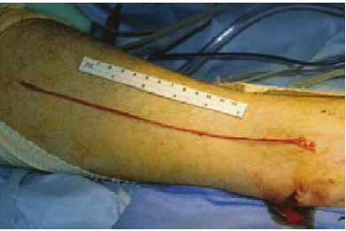
Sural nerve graft ⁽²⁷⁾

The sural nerve is removed from the leg via an incision adjacent to the lateral malleolus. Harvest of the sural nerve usually produces low morbidity, but the patient should expect decreased sensation over the dorsolateral foot. And 20-30% of patients may experience a mild level of "neuromatous pain" even years following harvest' the sural nerve can provide up to 30 cm of healthy nerve graft. For total facial nerve reconstruction from the main trunk to peripheral branches, the medial antebrachial cutaneous nerve is most appropriate. There are at least four reliable branches, and it has adequate length to perform grafting of the entire facial nerve, even when the distal stumps lie at the anterior border of the parotid gland.⁽²⁶⁾
The principles of primary nerve repair and nerve grafting are similar. Repairs should be performed within the first 72 hours after injury or sacrifice, irrespective of the need for subsequentradiation therapy. In most cases, the return of movement appears within 6 to 12 months. Improvement may generally be expected over the course of 1 to 3 years.⁽²⁶⁾
Hypoglossal Facial Transfer
Nerve crossovers are used when directanastomoses or grafting is not feasible when facial paralysis is resulting from intracranial lesions or disorders of the temporal bone. Commonly used nerves are glossopharyngeal, accessory, phrenic and hypoglossal nerves. The hypoglossal-facial nerve crossover is the most popular crossover operation in use today. These techniques are advantageous because they are simple, require only a single suture line and serve as a powerful source of innervations. The main disadvantage is that they result in associated, uncoordinated movements, loss of emotion on face and in loss of function of the donor nerve.⁽⁴⁾

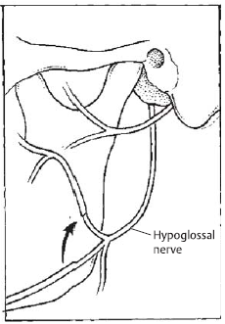
Diagrammatic Hypoglossal facial nerve transfer.⁽²⁶⁾

The surgical technique of XII-VII procedure is performed via a modified Blair parotidectomy incision. The main trunk of the facialnerve and the pesanserinus are identified using standard facial nerve landmarks, such as the tragal pointerand the tympanomastoid suture line. The hypoglossal nerve is then located in its ascending portion, deep to the posterior belly of the digastric muscle, along the medial surface of the internal jugular vein. The nerve is followed anteriorly, to just beyond the takeoff point of the descendenshypoglossi. The hypoglossal nerve is sharply transected and reflected superiorly to meet the facial nerve. The facial nerve is transected at the stylomastoid foramen, and the distal trunk reflected inferiorly and secured to the hypoglossal nerve with five to seven 10-0 nylon epineurialmicrosutures.⁽²⁶⁾
The two major disadvantage of the procedure are the mass facial movement experienced by many patients and the variable tongue dysfunction, which has been categorized as "severe" in up to 25% of patients. Articulation and mastication difficulties are commonly cited. The modifications mentioned are aimed at one or the other of these two problems. In addition, botulinum toxin administration in the region of the eye and physical therapy have proven useful adjuncts for patients with clinically significant mass movement.⁽²⁸⁾
The procedure is contraindicated in patients who are likely to develop other cranial neuropathies (i.e., neurofibromatosis type 2) or who have ipsilateral tenth nerve deficits, as the combined X-XII deficit can lead to profound swallowing dysfunction.⁽²⁶⁾
Facio-facial Cross-Face Nerve Grafting

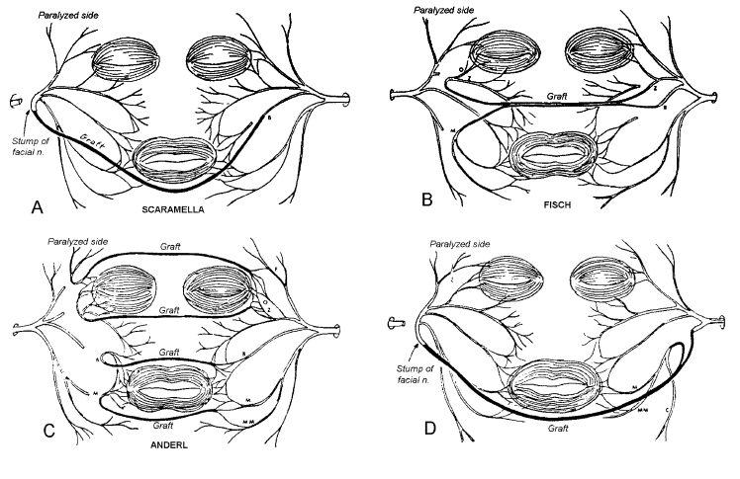
Techniques of cross-face nerve grafting.⁽²¹⁾

The procedure is based on cross-innervations from the non-paralyzed side by means of sural nerve grafts that connect the reservoir of peripheral healthy facial nerve fascicles to the corresponding branches of specific muscle groups on the paralyzed side. ⁽²⁹⁾
Fascicular repair is used and the length of the grafts varies from 6-8 cm. Most authors prefer a two stage procedure, allowing the nerve axons to grow to the opposite side and then resecting the neuroma to demonstrate the success of the axon regrowth before suturing the graft to the paralyzed side. This procedure has limited applications (except when combined with micro-neuromuscular muscletransfers) and the overall results were disappointing when compared to those obtained with classic procedures.⁽⁴⁾
The major difficulty with cross-facial nerve grafting is that results are inconsistent some authors report excellent recovery, while many others find it entirely unsatisfactory. It appears that it is most useful in association with other reanimation modalities, to address a single territory within the face, rather than to reinnervate the entire contralateral facial nerve. Recent studies employing the cross facial graft for isolated marginal mandibular paralysis demonstrate its utility.⁽²⁶⁾
In general, the distinct disadvantages are, there are two suture lines for each nerve graft, increasing the probability of a greater loss of sprouting axons, and a longer time is required for reinnervation from these long grafts, during which there may be further muscle atrophy. Where the greatest disadvantage is the reduced axonal input to accomplish powerful reinnervation if one is not to sacrifice too much function on the normal side, with technical difficulty in identifying distal branches of the facial nerve. And postoperatively mass movements are seen.⁽⁴⁾
Dynamic Reanimation
Themuscle transfers is first type of dynamic reconstruction which transfer of muscle to the paralyzed face is usually done under many circumstances as, After long-standing muscle atrophy, an adjunct to the mimetic muscles to provide new muscle and myoneurotization and in combination with a nerve graft or crossover nerve implanted in the transposed muscle. Masseter and temporalis muscle transposition aremost commonly used.⁽⁴⁾
Masseter muscle transposition is ideally suited to give motion to the lower half of the face. Commonly, three muscle slips are sutured to the dermis of the lower lip, oral commissure and upper lip. Over-correction must be accomplished. The patient maintains voluntary control over the muscle and can activate it by clenching the teeth.⁽²⁰⁾

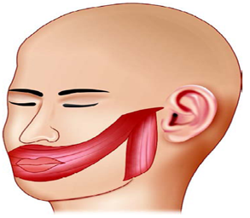
Masseter muscle transposition⁽⁴⁾

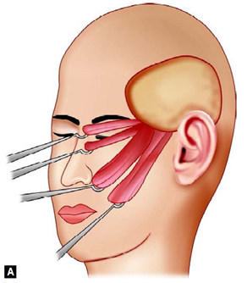
(A) Temporalis muscle transposition. Four or five muscle slips are transposed to the upper and lower eyelids, upper lip and nasolabial fold, lower lip and commissure. Over correction is essential;

Temporalis muscle transpositionfor facial rehabilitation, the temporalis muscle has enjoyed more popularity than the masseter because of its position, its facility for greater excursion of movement and its adaptability to the orbit. The technique that is now most widely employed involves two temporal musculofascial strips, which are woven around the zygoma. These musculofascial strips are used to reconstruct upper lip, lower lip and both eyelids. Additional fascial strips can also be anchored to ala of the nose. The technique has several advantages, one of which is that the muscle provides good muscle bulk to compensate lack of fullness on the paralyzed side, in the severely atrophic face. Furthermore, there is direct muscular insertion on the structures to be moved giving greater range of mobilization and direct muscular insertion enhances chances of myoneurotization.⁽³⁰⁾
The most recent contribution to reanimation of the paralyzed face is the micro-neurovascular muscle transfer, combined with cross face nerve graft, ipsilateral nerve graft or split hypoglossal anastomosis. This technique provides new, vascularized muscle to the face that can produce pull in various directions and accomplish more normal facial animation. The advantage over the muscle transfer technique is that the transferred muscle can be reinnervated by a cross face nerve graft, thereby enhancing control of voluntary facial movement. ⁽⁴⁾

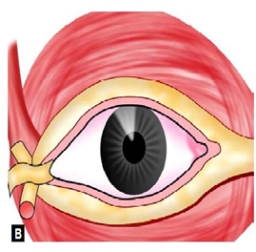
(B) Technique of transplantation of temporalis: muscle and facia to upper and lower eyelids. ⁽⁴⁾

Static Reanimation
The static methods of reconstruction of the paralyzedface are the well-known techniques of suspension with fascia lata, tendon or alloplastic materials. Materialsvarying from wire, silk, stainless steel and tantalum are also used. Static slings are used to achievesymmetry at rest without providing animation. Face lifting and stabilization with dermal flaps have also been used. Static techniques can, however, be complementary to dynamic reconstruction.⁽³¹⁾
Fascia lata or various tendons are harvested and are placed between the orbicularis oris muscle and the temporal fascia, suspending the commissure at a desired position. This is done in conjunction with facelift.⁽³²⁾
Various mechanical devices like gold weights, springs and magnets are used for eyelid closure.⁽⁴⁾
Selective neurectomy which selective sectioning of the intactfacial nerve in order to accomplish a more balancedace. And various techniques for selectivemyectomy of the facial muscles are accomplishing better balance in repose and during facial expression.⁽²⁾
The new era use of clostridium botulinum toxin (Botox) injection is a neurotoxin that temporarily interferes withacetylcholine release from motor nerve endplates, causing skeletal muscle paralysis. The effect lasts for4-6 months. Botulinum toxin has been useful in the treatment of facial paralysis by weakening the contralateralside to allow centering of the mouth, moresymmetry on smiling and treatment of hypertrophiedplatysmal bands.⁽²⁾

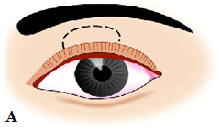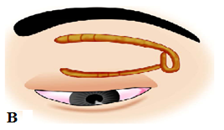Figure 25 A& B: (A) Weights to aid lid closure. Weight inserted superficial to tarsal plate and deep to orbicularis oculi. (B) Spring to help eyelid closure. Upper limb sutured toperiosteum of supraorbital rim. Lower limb sutured to tarsal plateat eyelid margain. ⁽⁴⁾

Facial-Hypoglossal Nerve Jump Anastomosis
The new technique wherein the hypoglossal nerve and the facial nerve are anastomosed with the interposition of a free nerve graft, end-to-end to the distal facial nerve stump and end-to-side to the hypoglossal nerve. The latter is cut in transverse direction for approximately 50% of its diameter. The procedure is indicated in patients with an intact homolateral hypoglossal nerve, an inaccessible central facial nerve stump and a preserved distal facial nerve stump. The activity of the muscles of facial expression should have the potency to be reversible. With this technique, has good facial reanimation and rarely atrophy or impaired movement of the homolateral side of the tongue.⁽³³⁾
The major disadvantage of donor nerve techniques is that a functional nerve has to be sacrificed, leaving the patient with functional loss. Results of facial nerve reinnervating surgery are related to the duration of the paralysis, i.e. the functional state of the muscles of facial expression. The functional recovery of denervated muscles is time dependent. ⁽³⁴⁾

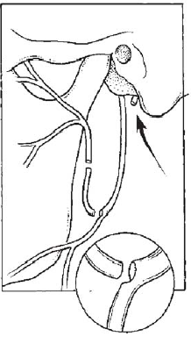
Diagrammatic of Jump graft modification.⁽²⁶⁾

Threadlift Facelift
Initially the thread were called contour threads, the threadlift facelift procedure is a minimally invasive procedure that utilizes sutures to mechanically lift the skin. The thread lift facelift sutures have cogs or knots and cones on one side of the suture. The cogs or cones are able to engage the soft tissue and create a lifting effect to the face and neck.⁽³⁵⁾
The first type of thread lift is bidirectional thread lift without incision which called “Aptos thread lift”. The Aptos threadlift facelift procedure involved insertion of a polypropylene suture with bidirectional barbs. The Aptos Thread lift suture was inserted using a needle and was not secured to deeper tissue. ⁽³⁶⁾
Later, a needleless thread was created; it had converging prominences and could be introduced subcutaneously through a conducting needle; it also needed a more simplified manipulation, without needing a significant incision. Accordingly, the optimal skin marking was developed for each area of the face, with full consideration for different anatomical, functional and pathological features of the different areas and pathologies. This technique of thread lifting became popular very soon and came to be called the Aptos thread.⁽³⁵⁾
The other type of threadlift is unidirectional threadlift requiring incision, the new facelift thread is called a “Silhouette Suture”. Silhouette sutures do not have sharp barbs, which can weaken the suture. A barbed suture is created when cuts are made in the shaft of conventional sutures, which then weakens the inherent strength of the thread itself. Silhouette sutures are made from 3-0 polypropylene substrate, which allows for smaller knot tying in the temporal area and also utilizes clear, flexible, absorbable cones. Over time the cones are completely absorbed and tissue grows around and through the small knots to allow for long-lasting tissue suspension.⁽³⁷⁾

References
  - Popovic D., Milan S., Zorica P. and Dusan M. (2003): Traumatic facial palsy. Facta Universitatis Series, Medicine & Biology 2003; 10:145-7.
  - Boahene K. (2013): Reanimating the paralyzed face, F1000 Prime Reports 1-10 DOI: 10.12703/P5-49.
  - Grabb and Smith (1997): Reconstruction of the paralyzed face. Plastic Surgery Lippincott - Raven. 545-57.
  - Pandya N. and Shah A. (2012): Plastic-Surgical Repair of the Paralyzed Face, Atlas of Surgery of the Facial Nerve. 2nd edition: 161-170.
  - Grewal D. (2012): Anatomy of the Facial Nerve, Atlas of Surgery of the Facial Nerve. 2nd edition; 1:17.
  - Schuenke M., Schulte E. and Schumacher U. (2016): Classification of the Neurovascular Structures, Head, Neck, and Neuroanatomy, THIEME Atlas of Anatomy. Second Edition Vol: 3 (4): 88-135.
  - Portelinha J., Passarinho M. and Costa J. (2015): Neuro-ophthalmological approach to facial nerve palsy, Neuro-ophthalmology Update, Saudi Journal of Ophthalmology 29: 39-47.
  - Tuccar E., Tekdemir I., Aslan A., Elhan A. and Deda H. (2000): Radiological Anatomy of the Intratemporal Course of Facial Nerve. Clinical Anatomy 13:83–87.
  - Gupta S., Mends F., Hagiwara M., Fatterpekar G. and Roehm B. (2013): Imaging the Facial Nerve, A Contemporary Review, Radiology Research and Practice, Volume 2013, DOI: org/10.1155/2013/248039.
  - Myckatyn T., and Mackinnon S. (2004): A Review of Facial Nerve Anatomy, Seminars in Plastic Surgery, V18, N1.
  - Netter F., Machado C., andJohn T. (2010): Head and neck, Netter’s Clinical Anatomy, chapter 8: 373.
  - Hasan G., Hasan A., Kaur K., Ahmad M. and Shafi M. (2005): The Facial Nerve, The Anatomical and Surgical important, JK-Practitioner 12(1):53-57.
  - Santos F. and Slattery W. (2014): Physiology of the facial nerve, The Facial nerve, 1st edition: 12-17.
  - Lee S. and Wolfe S. (2000): Peripheral Nerve Injury and Repair. Journal of the American Academy of Orthopedic Surgery Vol 8, No.4 243-252.
  - Campbell W. (2008): Evaluation and management of peripheral nerve injury. Uniformed Services University of the Health Sciences. Paper 3. International Federation of Clinical Neurophysiology. 119: 1951-1965 DIO:10.1016/j.clinph.2008.03.018.
  - Goubier J. and Teboul F. (2015): Grading of nerve injuries, Injuries of the prepheral nerves, Nerves and nerve injuries Vol 2 Part 4, chapter 38: 603-610.
  - Malhotra V., Dayashankara J., Arya V. Sharma S. Kataria Y. and Luthra P. (2015): Assessment of facial nerve injury with “House and Brackmann facial nerve grading system” in patients of temporomandibular joint ankylosis operated using deep subfascial approach, National Journal of Maxillofacial Surgery: Vol 6 (2): 194-199. DOI:10.4103/0975-5950.183876.
  - Manni J. (2012): Facial-Hypoglossal Nerve Jump Anastomosis for Reanimation of the Paralyzed Face, Atlas of Surgery of the Facial Nerve. 2nd edition: 177-183.
  - House J. and Lorenz M. (2014): Measurement of Facial Nerve Function, The Facial nerve, 1st edition: 41-47.
  - Volk G., Pantel M. and Guntinas-Lichius O. (2010): Modern concepts in facial nerve reconstruction, Head and Face Medicine: 6-25.
  - Anderson R. (2006): Facial nerve disorders and surgery, Selected readings in plastic surgery, Vol 10, (14): 1-41.
  - Yanagihara N., Hato N., Murakami S., and Honda N. (2001): Transmastoid decompression as a treatment of Bell palsy. Otolaryngology Head Neck Surgery 124(3): 282-286.
  - Bodenez C., Bernat I., Willer J., Barre P., Lamas G. and Tankere F. (2010): Facial nerve decompression for idiopathic Bell's palsy: report of 13 cases and literature review. Journal of Laryngol Otol; 124(3): 272-278.
  - Özgirgin N. (2012): Traumatic Facial Nerve Paralysis. Atlas of Surgery of the Facial Nerve. 2nd edition: 94-107.
  - Humphrey C. and Kriet J. (2008): Nerve repair and cable grafting for facial paralysis. Facial Plastic Surgery;24:170-6.
  - Henstrom D. and Hadlock T. (2014): Facial Nerve Repair. The Facial Nerve.179:191.
  - Lippincott W. and Wilkins (2010): Facial reanimation. In: Urken ML. ed. Multidisciplinary Head and Neck Reconstruction: A Defect-Oriented Approach. Philadelphia, 435-454.
  - Husseini S., Kumar D., Donato G., Almutair T. and Sanna M. (2012): Facial Reanimation After Facial Nerve Injury Using Hypoglossal to Facial Nerve Anastomosis, The Gruppo Otologico Experience, Indian Journal of Otolaryngol Head and Neck Surgery, 65(4):305-308; DOI:10.1007/s12070-011-0468-3.
  - Lee E., Hurvitz K., Evans G. and Wirth G. (2008): Cross-facial nerve graft: past and present Journal of Plastic Reconstructive Aesthetic Surgery; 61(3):250-256.
  - Gordin E., Lee T., Ducic Y. and Arnaoutakis D. (2015): Facial Nerve Trauma, Evaluation and Considerations in Management, Craniomaxillofac Trauma Reconstruction, Vol8:1-13.
  - White H. and Eben R. (2013): Static and Dynamic Repairs of Facial Nerve Injuries, Repairs of Facial Nerve Injuries, Oral Maxillofacial Surgery Clinic 303-312.
  - Gur E., Stahl S., Barnea Y., Leshem D., Zaretski A., Amir A., Meilik B., Miller E. et al., (2010): Comprehensive Approach in Surgical Reconstruction of Facial Nerve Paralysis: A 10-year Perspective, Jornal of Reconstructive Microsurgery, Vol 26(3):171–180.
  - Coulson S., O'dwyer N., Adams R. and Croxson G. (2004): Expression of emotion and quality of life after facial nerve paralysis. Otology and Neurology; 25(6):1 014--1 019.
  - Hadlock T., Greenfield L., Wemick-Robinson M. and Cheney M. (2006): Multimodality approach to management of the paralyzed face. Laryngoscope 2006; 116(8):1385-1389.
  - Jagade M. and Ganeshan (2012): Threadlift Facelift in Paralyzed Face, Atlas of Surgery of the Facial Nerve. 2nd edition; 170:176.
  - Adamyan A., Skuba N., Sulamandize M., and Khusnutdinova Z. (2002): Morphological foundations of facelift using APTOS filaments. Annals of plastic reconstructive and aesthetic surgery. 3:19-27.
  - Paul M. (2008): Barbed sutures for aesthetic facial plastic surgery: indications and techniques. Clinical Plastic Surgery 35(3):451-61.

3/25/2017

