The Role of Superstition in Kilims and Gabbehs of Iran

Nazanin Pooladi

MA in visual communication (Graphics), Islamic Azad University Central Tehran Branch, Tehran, Iran

Abstract: The aim of this study is to identify motifs of Iranian kilims and gabbehs, which have long been studied so far. Gabbeh and rug are concrete manifestation of Iranian art which are worthy of an extended amount of importance and value. Such motifs and designs tend to determine the creative mind, unworldly wisdom, never-resting muscles, ultimate power and the ideas of the weavers. These motifs and designs feature certain secrets and roots in a way that getting to know them provides insight on life philosophy, myths and structure of customs of native tribes. Beliefs and customs of every nation or race could be examined through stories, myths, historic sites and ancient remains from the old times. Encryption-intended designs and motifs in addition to simplify the designs along with vivid and dynamic coloring do require wide range of attention and analysis. Of the major strengths of the rugs are the originality, nativity and finally being wholly Iranian.
[Nazanin Pooladi. The Role of Superstition in Kilims and Gabbehs of Iran. Researcher 2017;9(3):29-38]. ISSN 1553-9865 (print); ISSN 2163-8950 (online). http://www.sciencepub.net/researcher. 6. doi:10.7537/marsrsj090317.06.

Keywords: Kilim – Gabbeh – Beliefs and superstition – Motifs

1. Introduction
Rugs are objective manifestations of Iranian art products and under various aspects, are considering worthy of the utmost importance and value. Plans and designs and simplicity of the motifs with vivid coloring are necessary to be analyzed. Rug motifs and designs are the roots and mystery of the rugs that can be created under different conditions. The mysteries have remained over the centuries and own a certain language. Over the years, the weavers patch together graphs to create plans more complex and more elaborately. Beliefs and customs of a nation can be found through stories, myths, monuments, archaeological traces of the remains of past civilizations and lastly the crafts which people of that land had made.
All these are relics of primitive man's beliefs, cultural background or religious beliefs. The religious beliefs of the primitive began at myths, then they became religion-based, and then they appeared as holding ceremonies, rituals, building temples and citadels, and creating iconic objects and crafts. Regarding the evidence which refer to some-thousand-year history of weaving in Iran, such works and their motifs have gone down from a generation to another and a chest to another for years in an intended route.
What today the tribes have brought to this land, is nothing but a relic of the authenticity of our ancestors. In fact, products of every nation with their design and motif done in a sustainable and genuine way of thinking represent the beliefs of that land. Unfortunately, today, many of these designs are not available to us, but the beauty and originality has eluded them form any eye.
Rug and Gabbeh have an ancient history. The motifs are historically genuine. With the emergence of Islam although the visuals got more limited since the weavers had to avoid imaging the living things, but the icons and symbols moved on from the past generations to the new. Mentality in the design and color of Qashqai products act in a very wide way. The composition of the simplest geometric designs to intricate and mysterious motifs each open up a door to another world for the researchers. The main strengths of products are being original, indigenous and Iranian in nature (Tanavoli, Parviz, 2004).
In terms of originality and history it can be concluded that Fars Province is one of the 1st leaders of carpet, rug and gabbeh weaving. Gabbeh weaving in Fars province dates back to more than a hundred and fifty years ago. Fars Province is home to three groups of nomads:
- Qashqai
- Khamse
- Mamasani
Gabbeh definition:
The word Gabbeh is now known everywhere in the world and has been globalized, which until recently was unknown word and had not made its way through carpet literature.
In the late sixties the term first found its way into contemporary carpet literature (Reinhard G, Londan.1791 (.
In 1974 it was mentioned in the Catalogue of the Persian Milky Rugs. Nine years later (1983 in two papers at the same time) Gabbeh was written about in a journal called Holly (D. Martin, 1983(.
Dehkhoda described Gabbeh carpet with long weft (Ali Akbar Dehkhoda, p. 141, Tehran 1959) - some lexicographers have considered Gabbeh like a thick carpet and have equated it with the badger (Moein, Mohammad, Tehran, 1985 (.
Kilim (Rug) Definition:
The word Kilim is Persian and has been around since the first decades of the fourth century in Persian language.
At first it was called as a big furry clothe, but now the term is used for a carpet which is a woven fabric made of wool, cotton or jute yarn and lint that will be woven via the composition of the materials. Star is the most used of the paintings and can be seen in various forms in all kinds of kilims motifs especially in the form of eight-pointed stars (Hull, Alastair and Jose Logic Vyveska, 1998).
Illustrations:
Such historic trend gradually changed the base of weaving industry and crafts and made it different and diverse.
The oldest of Qashqayi motifs in the world are not more than 300 years old and most of the remained models are fragile and valuable works exhibited in world's renowned museums and due to their being invaluable and their fragility they could not represent the original and usual brand of styles existed in the previous centuries (Motifs of Gabbeh in Bakhtiari nomad, Goljam, Journal of Scientific Society of Iranian Carpet, number two, p60-59, spring 2006).
Colors:
Color has a lot of appeal and in terms of its nature, attracts more than anything to look at.
A variety of colors and their combinations are of the most important elements in the beauty and quality of kilims, adding to the charm of the designs. The most appealing colors are derived from natural elements. You never know what you will achieve by trying to make colors out of nature since mixing of the colors is based upon personal taste and is influenced by unstable elements such as type of soil; climate, color release materials and compositors. When weaving a carpet, harmonious use of color is important and nomadic and rural weavers have an extraordinary talent in combining them.
Nomadic weavers, due to lack of contact with the outside of their native environment are inspired by the brilliance of nature around them. Western scholars describe the red/blue colors as Animism colors, which are believed to reincarnate the spirit of all nature components and accept them separately.
Probably because the carpet is some sort of insulation, warm colors such as red, orange, yellow and brown are worked on it (L, Alastair and Jose Logic Vyveska, 1998).
Beliefs and Superstitions:
From the eighth century AD, in the lands of rug weavers, a view of the artistic and technical creativity emerged. before that Shamanism, Animism, Judaism, Christianity, Buddhism, etc. were common. Thus, new beliefs included religious beliefs and perhaps corrected some of the past beliefs, so they created a new identity in the minds of people.
Now Islam, Christianity and Buddhism are major religions of weavers' countries. Symbols concerning those religions have penetrated deeply into the creative idea-making mind of the weavers.
The first juxtaposition of positive and negative forms, are visibly illustrated in symbolic images of Tattoo artist "Yin-Yang".
Later Sufi philosophy expanded belief of balance in everything.
Chalipa (cross) can be cross-linked to Christian sects.
Due to ease of drawing the cross gets regularly used but often the meaning of this symbol is misunderstood.(Pic1)

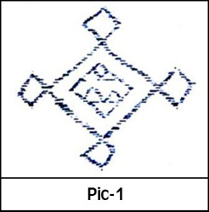

Islam limitations banned representation of the face and body, instead repeated interest in various forms of curves and angles and numbers, including the number five: five bodies and five fingers were observed. Images lose their meanings over time, but the culture and traditions of the tribe, they maintain their special status.
Superstition, visual icons and beliefs of various paintings transforms chest to chest, over successive generations and gets more complex and become similar to other tribal customs, legends and folk culture. With the original meanings gone, images related to the new name are purely symbolic images.
And the images boast three types of functions:
- family and tribal beliefs.
- Spells to ward off the evil eye and fortune-solving.
- Weaver's aesthetic knowledge.
One of the most common ways to ward off the evil eye is the red central medallion tissue that is found on woven cloak or Abaa as well, with lines painted dark blue, (Pic2) which shows the concentration of forces in the spell. At all stages of weaving, spinning to final payments, awareness of the world of spirits dominates and symbols are carved on most tools such as combs and spindles to rule out the demons.

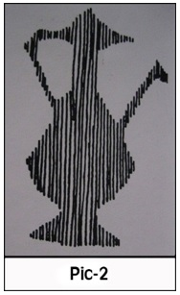

John Thompson, a carpet expert suggests that:
"The risk is that communicating mind get manipulated to something that is intended for it, and no evidence is available to prove reality."
According to James Opie, westerners interpret simple graphs and personal inspiration in the indigenous culture way too seriously and give them huge credit. The animals' heads are of the most important motifs of rug designs and the history and meaning of rug motifs is evaluated based on images and symbols and for example Lorestan bronze animal heads since two and three millenniums ago.
The relationship between bronze and hand-woven designs comes to mind first through the Qashqai, Lori and Bakhtiari siliques medallion design in the shape of animals' head with long horns.
Then similarities between these forms of decorative images and objects in the ancient tombs such as two-headed animals, harness and blinders of horses catch the eyes.
Mythological animals boast deep roots in the culture of these areas and still portrayal of animals is part of their daily lives.
Bakhtiari and Qashqai women drown in their isolation and without any external influences have continued to weave these ancient motifs. Since goats and sheep are closer to the nomads than other animals, which had not only in life been considered private property of people, but their bones, skull and horns can be found in the tombs. Portrayals of these animals were used in textiles and objects being worshiped so as the heads of the oldest animals could be seen in the oldest rug by the name of Pazirik.
Other designs include S-shaped bronze works in Lorestan logs with ends of it, both in bronze and of the tissue, decorated with animals' heads.
Also in the mythological bronze works in Lorestan, female figures appear on sacramental and spiritual rituals. These forms also have been found in Jajim saddlebags and bronze idols of Lorestan belonging to the first millennium. Miniature bronze animal heads seen in textiles around a medallion is reproduction of an image which span around a Toranj symbol that appears in form of a chain or a column among the hand-woven craft.
According to James Opie, this image roots in an ancestral origin and does not take origin in the Zagros Mountains, but certainly for two millennia or more they had been preserved in this area, then the easier forms were used in medallion and borders of Anatolian kilims, in Central Asia and Shahsavan of Iran.
In more simple types, long graphs are contracted, or are separated in many united forms. Thus, woven eyes and horns in original hand-woven crafts of the Qashqai and Bakhtiari have faded away, which reflects the inevitability of changes and simplifications.
The graphs could be developed in a way that the reversed space within or the space between two adjacent designs could own the same importance of the graph and actually become part of it.
Reason of their deserved importance is left within the lives of weavers. For example, the shape, size and star type; that have rays of hook-like heads are so subdivided and varied that can be transformed into a shape of a spider or a crab. Since the eight-pointed stars is inevitably made of triangular and diamond-shaped motifs (stepped or angled) (Figure 3 and 4), we can suspect that the evolution of this motif is based on restrictions of slotted tissue (Pic3-4).

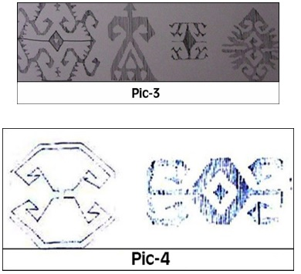

Dragon image is based on the S shape, and has evolved into complicated and repeating motifs within centuries. The S shape is widely used specially by the Turks, they are observed among all handcrafts of Turkish speakers and the Balooch.
The constant imagination in the motifs:
Of the major features of the Fars hand-woven crafts is generally the use of imagination in motifs and its reflection.
Persian motifs, handed down generation to generation, constantly and with blessing of ancient traditions have been a never-ending treasure. Most of the motifs ascending from past generations never changed a big deal and some changed in terms of form, looks and to some extent concept and perception but all succeed to maintain the basic elements up until now. So it could be concluded that Farsi weavers largely and over the centuries, have applied similar or even same graphs.
Most of motifs related to the Fars weaving depend heavily on its ancient cultural heritage. Among these, paintings imply on images of original mythological beliefs and symbolic miniatures dating back to very long time ago. Some of these motifs visibly refer to examples of very historic times which their influence is sensed on clay creations of 4.000 to 3.000 BC.
Persian rug motifs sustained for thousands of years, and their impact on other arts such as pottery to painting and textile has been unparalleled.
Passing of the time and imitation without thinking, incorrect drawing, misunderstanding motifs, hyper stylization, transferring of the motifs, mandatory single-place-habitation and violent migration and so on have caused the ancient markings altered. Like the words that give life to languages, motifs are like words which either resist getting changed over the years or their penetrability is not significant, it means that some motifs remain the same with time gone by but some even lose their initial meanings forever. Weaver discretion and authority as an artist is by no means fewer or more than a poet's. The innovation of the tasteful artist shows itself not by creating motifs and designs but in the way she arranges the ever-repeating graphs and also the symbolism and brand new compositions and painting method and colors synergy. Repeating motifs is a process in creative and energetic way which absorbs cultural heritage. This creativity is so deeply rooted that even if tribal weaver works in a workshop or wishes to weave a rug for the market, is rarely able to change or develop traditional motifs.
Native Culture and Traditions:
Over the centuries, the lifestyle of weavers from nomads and villages has made little change although the urban centers have grown in terms of art and culture, but the lives of villagers and nomads have remained in close contact with nature. Life for this group is very simple and their history had been told from generation to generation and chest to chest by songs of the elderly and shamans, which rituals sometimes take some nights in a row.
One of the shamans of Kyrgyzstan is famed for rewriting three hundred thousand verses from "Mana" of Kyrgyz originated folks.
Since they knew no way to illustrate their historical picture, history of these people lies within their kilims' secret sigils. Property of nomads are little, and their lone heritage can be summarized in tents, animals, cooking utensils, a few clothes, hand-woven objects, customs, their beliefs and superstitions, which until recently was unchanged for centuries. Considering permanent residence of these people in the villages and lifestyle changes, of seasonal migrations to an existing single-place habitation and agriculture, it is inevitable that tribal traditions which had been closely linked to migration, have changed to constant native rural culture. (Pic 5)

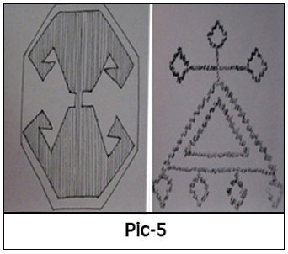

These developments boasts a highly internal process and the impact derived from thinking of women as weavers, had reflected deeply on the traditions. This has reached from mother to daughter and new stories and superstitions have been added on the existing traditions of ancestors. Wishes and aspirations of rural dwellers gradually changed, capital accumulation through land ownership and goods added to the need for happiness and prosperity, and rug due to its capacity of holding spellbound images and symbols became an ultimate object to express wishes and desires of weavers. These symbolic forms could either exist in an irregular way scattered across the field of the rug, or in the frequent graphs existing in hidden part of the background and border. These forms can be found in Qashqai rugs and the interlocking and repeated motifs can be seen in the Baloch and Shahsavan hand-woven rugs.
Goddess Mother:
Somatic of humanoid Goddess can be seen sometimes with the baby in the abdomen that symbolizes life / birth and a desire to give birth to a child. This image appears as a single image and mirror image into the field and borders. There is another idea based on Goddess Mother Theory derived from the surviving pictures and documents of Catal Huyuk excavations, which is located in Turkey today. (Pic 6)

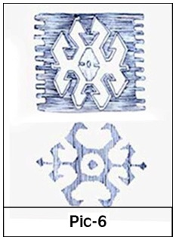

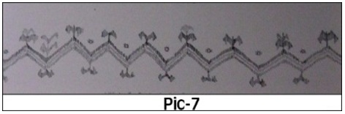

Ram's horn:
Eternal power of the ram's horns symbolizes masculinity, male fertility, strength and courage. When weaving this image, the female weaver hopes that his husband won't lack in power and that his power surpasses that of the time's. This image is originated from the spiral form which is sign of immortality (Pic7).
Blessing:
The image above comes with the merging of the two images and is a symbol of fertility. Multi-grain products and fruits also mean fertility.
Human:
The human body means waiting for the baby and to celebrate concept of respecting the dead.
Brush, flower in hair or earrings:
This image shows the weaver's willingness to marry.
Brush or flower in hair, are the ornaments of the bride and earrings are of the gifts she receives. (Pic8)

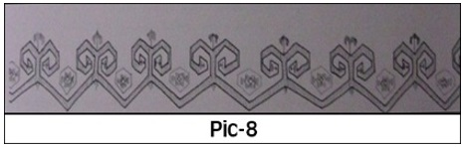

Animal Shackle:
Sign of family ties as a result of such dependency.
Chest:
The bride's personal belongings are placed in it. Girls from childhood weaving all types of rugs, saddlebags, and so on to hold their personal belongings and with embroidery on dresses, scarfs and waist, they get ready for marriage.
Various instruments of the girl, which are never used before marriage, are kept in the chests that are preserved in very beautiful covers.
Yin-Yang:
It displays the desire for harmony in the relationship between men and women.
Star:
In general, it is a sign of happiness.
In the products, due to the limitations and technical principles eight-pointed stars are often used. (Pic9)

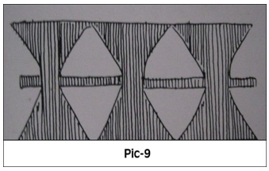

Pouring water:
Since there is no life without water, this very important image refers to life manifestation. (Pic10-11).

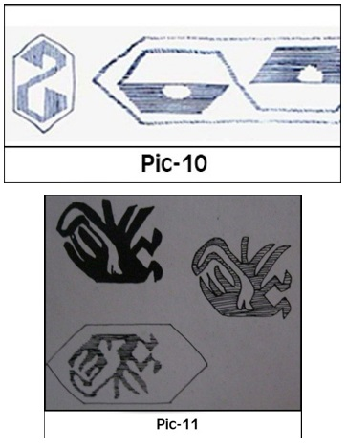

Burdock plant:
Plant produces scales that stick to everything; these scales (poolak) are seen in the roots of the rugs which their field has faded by light.
Hands, fingers and shoulders:
They are representatives of Hazrat Fatima. Shoulder marks desire to marry and have a family and children safe from evil eye.
"Talisman" and the evil eye:
According to Anatolian beliefs, people's eyes can kill, injure or create misery with looking. Since the human eye is the source of bad omen, so the best prevention is also drawing the eyes.
Motifs drawn from the eye can help neutralize the effects of the evil eye and keep people in danger, safe. To do this, Khoramhare, the mascot of the victim, is the most common spell. But other things, like silver, gold and other metals, as well as wild mustard, garlic, turtles and a variety of shellfish have been found effective.
Since there is still fear of the evil eye, many of the paintings of kilims, keep people in danger, safe.
Juju (mascot):
They are usually in form of cloth and covered with fabrics and ornamented by the likes of shells, buttons, coins, medals, old pieces of furniture, mirrors, torn kilims and decorated carpets, they are also made in various forms of round, oval or pear-shaped hangings.
At the bottom of some of these wall amulets, certain strips are woven and wool tassels are hanging from their main body.
Sometimes they are made with pieces of colored glass or ceramics, or the beans are chained in shape of a triangle and they are hanged from a thin thread and strips of colored cloth and wool are added to them.
Evil eye graphs:
They are usually in diamond-shaped figures, but they're sometimes seen as square or triangular. (Pic12)
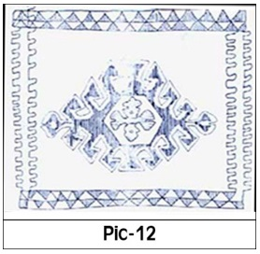

Cross:
Primordial logs dating back to pre-Christian and is used to secure from the evil eye.
Clasp:
Another image used against the evil eye. (Pic13)

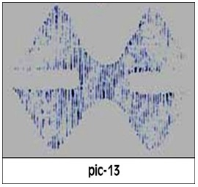
Snake:
It's a symbol of fertility and happiness and mobility.
The weather Goddess:
The weather Goddess is the Tree of Life handler and guardian of the secrets of the galaxy.

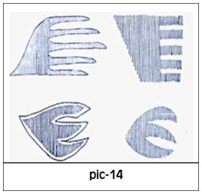

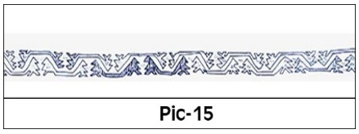

Dragon:
As a symbol of fertility in the Qashqai kilims, especially Vish Pagorg carpets have been very popular.
This motif by the name "Needle Dragon" or Zili can be seen in bolt-woven kilims, the images of the smaller dragons are used in the borders as additional decorations. (Pic14)
Scorpion:
The weaver protects herself with this image against this poisonous creature. (Pic15)
Wolf mouth or footprint:
Since the nomads were pastoral, wild animals had been always considered a fatal risk for them. (Pic16)
This image was sketched for protection against wild animals.

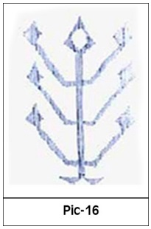

Birds:
Swarm flight marks the entry of spirit to heaven. Corks are symbols of death and sign of souls of the dead.
The Tree of Life:
Man won't get hold of mythical fruit of the eternal tree of life.
However, by illustrating it, the hope of life after death lives on.
Religions which believe in One God, use this symbol.
Interestingly in rural households, kilims with these motifs are hung from the bottom to the top. This represents the belief that roots of the tree are there in the heaven, the source of all powers, these powers are transmitted by its branches to the ground.

Conclusion:
The word Kilim is Persian. Nomadic women and girls are tasked with carpet production. At first large furry garment were known as Kilim. Gabbeh and kilim motifs are mental forms and those designs are used that had been transferred from generations past. Carpet motif is a reflection of nature. The innovation of the tasteful artist shows itself not by creating motifs and designs but in the way she arranges the ever-repeating graphs and also the symbolism and brand new compositions and painting method and colors synergy which echo their very existence. Symbols such as milk, cypress, sun and graphs that are sourced of superstition are very important to Gabbeh and kilim. The sun is an Aryan symbol, which is the oldest of the ancient motifs and its effect in courses of several thousand years had remained in ancient civilizations. This mysterious sign have been a wonder of human civilization and its motif in bergamots could refer to the centerism of the sun in ancient civilization of Iran, which then boasts an ancient importance. Many of complicated forms and common ones in modern design of Iran, is a composition of graphs which are woven by angled and broken lines in villages and some small cities. One of the most important issues in Gabbeh and kilim is the combinations of colors and motifs and this element is very effective in understanding Gabbeh as a valuable work of art.
Weaving women use a plan to weave which is inspired by their very existence and they do their job, combining colors and designs in a way that you would think of her as an academically able professor of aesthetical art.
These motifs which are derived from the very soul of famine feelings are invaluable and indicate the improvement of aesthetic sense among them, and their constant touch with the nature and its beauties cause this and those women could be recognize as great masters of art. Beauty is one of spiritual feelings that develop feelings of a human, and everything that feels beautiful raises the feeling's level. Of golden shapes, golden rectangle and distinguished square can be pointed out.
Distinguished square, is a square from which most forms and scopes are created and evolved from and by dismantling some Gabbehs, distinguished square can be realized.
Equilibrium is an element to influence the combination of graphs, which instantiates from nature and natural structures of human has led to the creation of mirror compositions in works by women weavers which are used covering the entire surface of the Gabbeh or in partial designs.
The weaver using one or two colors has got to a strange form, simple and elegant. Qashghayi weavers had with themselves tons of invaluable weaving traditions and a world full of designs and images.
Of the basic and essential attributes of Persian hand woven crafts are generally imagination concerning the motifs and their reflections, most of the motifs and designs in Persian hand-woven craft depends heavily on ancient cultural heritage. Among the paintings, there are images having bonds with original mythological beliefs and symbolic miniatures belonging to a very long time ago.
Production process and nomadic craft as a part of national handcrafts, explain culture and identity of Iranians and since nomadic culture is a rich one with valuable concepts (inspired by their special structure) they can illustrate the culture and civilization integrity of ancient Iran (IranZamin). These bonds and cultural integrity, crossing the borders, introduce various people of different nations and ethnics with the culture, civilization of the past history of Iran and with it, views, emotions, feelings and beliefs of them are transformed to each other. Therefore, traditional arts in nomads and especially kilims and Gabbehs can play highly valuable roles in cultural development and in relationship with the other nations.

References:
  - Esmaeilpour, A., The Myth of symbolic expression, Tehran, Soroush Publications, 1998.
  - Parham, Cyrus, the Persian Dstbafthay rural and nomadic, Volume II, Tehran, Amir Kabir Publications, 1992.
  - Parham, Cirrus, masterpieces of carpet weaving in Fars, Tehran, Soroush Publications, 1996.
  - Tanavoli, Parviz. Gabbeh Art underfoot, publications usher, Volume I, 2009.
  - Dygar, Jean-Pierre, techniques Bakhtiari nomads, translation, Karimi, A., Astan Razavi 1990-1991.
  - Precious, rare, mint translations Saeedi, Negin Pars (Persepolis), Tehran, art house Goya, 2003.
  - Hull, Alastair Vkhvz·h logic is loosely Vyvvska, products (History, patterns, textures and identification), Shirin Homayoonfar and affection lotus worth, Tehran, First Edition, 1998.
  - Informatics center and south of Development Studies, Office of Planning, Economic and social situation in the province, nomadic communities, First Edition Shmarh2-70, Shiraz, summer 1991.
  - Ali Akbar Dehkhoda, dictionaries, Volume I, Tehran 11959 Mohammad Moein, Persian Culture, Volume 3, Tehran 1985.
  - Estakhri, masalek and countries, the efforts of Iraj Afshar, Tehran 1995.
  - Sirus Parham, the height and character Gabbeh, new knowledge, Issue 6, Tehran 1991.
  - Mohammad Moin: Proceedings, Volume one, number seven, seven military body, Tehran 1985.
  - Center for Anthropology, Ethnology Proceedings 3, First Edition, Tehran, Cultural Heritage, Spring 1987.
  - Ahmad Matin friend, Aryan beliefs, Isfahan, Chahar Bagh Press, 2005.
  - A., Dadvar, Introduction to Iranian myths and symbols. India in ancient times, Tehran, Kalhor, 2006.
  - Tanavoli, Parviz. Iran rug image. Tehran, Soroush Publications, 1989.
  - Reinhard G. Hubel. The Book of Carpet (londan.1971) p.224.
  - Parviz Tanavoli. Lion Rugs from fars (Washing. D. C.1974). p. 11.
  - D.W.Martin.’ The Gabbehs of Fars: An Abstract Tribal Art. Hali 5. no.4 (1983): pp.462-473.
  - Thampson; john; Carpet from the tents; Laurence king 1393.
  - Siawosch Azadi. Mystik der Gabbeh (Hamburg.1987) pp.12-1.
  - A light, especially a Bakhtiari, Iran's Culture and Arts Foundation, eighth and ninth numbers, Persian date Khordad 1980.
  - Glam, Quarterly, Journal of Association of Iranian carpets, number two, Spring 2006.
  - Journal of the fifth edition of Visual Arts motifs second year, spring and summer 2010.

3/10/2017

"Shamanism" follows the ideas of the priests and wizards that only by adhering to magic, the priest or the wizard can earn his/her wishes.
Animism believes that a united spirit is reincarnated through all components and accepts separate and abstract spirits.
Mainly placed in the borders of the rug.
Symbolize fertility
"Talisman" is a written spell that is kept in the triangular cover and it boast a religious power of magic against the evil eye.
Mascots are made in form of wall hangings. .
The cross due to its religious power contracts the force of evil eye.
Birds symbolize of love, goodness, happiness, joy and also they represent power and force.
It is a symbol for eternity.

