A Conductivity Study of Salt and Temperature Effect on Critical Micelle Concentration of Alkyl Benzene Sulphonic Acid

Mohammad Ali Ahmadi^{1*}, Seyed Reza Shadizadeh²

¹⁾ Department of Petroleum Engineering, Ahwaz Faculty of Petroleum Engineering, Petroleum University of Technology, Ahwaz, Iran
²⁾ Department of Petroleum Engineering, Abadan Faculty of Petroleum Engineering, Petroleum University of Technology, Abadan, Iran
ahmadi6776@yahoo.com

Abstract: After primary and secondary oil recovery methods, reservoir is faced to residual oil condition. Surfactants can reduce interfacial tension between rock surface and residual oil. Temperature and salt are two affective parameters that affect surfactants behavior in the reservoir in addition to critical micelle concentration (CMC) of them. The purpose of this experiment is measuring the (CMC) of two surfactants; this was to be done by conductivity method. Conductometry is a very promising technique, the CMC value of Alkyl Benzene Sulphonic Acid (ABSA) as an anionic surfactant was determined by electrical conductivity measurements. The influences of salt and temperature conditions on CMC variation of selected surfactant are considered. It was found the addition of NaCl reduces the CMC of surfactants. The variation of CMC was investigated under different temperatures from 25°C to 70°C with increments of 5°C. Results were shown when temperature rises, the CMC of surfactant reduces.
[Mohammad Ali Ahmadi, Seyed Reza Shadizadeh. A Conductivity Study of Salt and Temperature Effect on Critical Micelle Concentration of Alkyl Benzene Sulphonic Acid. Researcher 2017;9(2):82-87]. ISSN 1553-9865 (print); ISSN 2163-8950 (online). http://www.sciencepub.net/researcher. 9. doi:10.7537/marsrsj090217.09.

Keywords: Temperature, Salt, CMC, Alkyl Benzene Sulphonic Acid, Anionic Surfactant

1. Introduction
Surfactant mixtures have a relevant role in a variety of technical applications in our day-to-day life and in industry, like those related with enhanced interfacial performance or control of the rheological properties of materials (Holland and Rubing, 1991; Ogino, 1993). Surfactants are amphipathic, they contain a polar group at one end and long hydrophobic carbon chain at the other end. The polar group forms hydrogen bonds with water molecules and the hydrocarbon chains interact by hydrophobic reactions and aggregate. Surfactants molecules exist as monomers at low concentrations, but when the detergent concentration increases above a critical concentration, the detergent molecules self-associate and form micelles. This critical micelle concentration (CMC) is important for selecting an appropriate detergent. At the CMC, detergents begin to accumulate in the membrane (interface between two connected phases). Other components such as lipids, pH, ionic strength, and temperature of the medium can effect on the CMC. The addition of salts to ionic detergents may reduce the CMC because increased ionic strength tends to reduce the repulsion between charged head groups, allowing micelles to form at a lower concentration. At higher concentrations than CMC, monomers and micelles coexist in equilibrium (Kowalska et al., 2003). Foaming agents, emulsifiers, and dispersants are also surfactants, which suspend gases, immiscible liquids, or solid particles in water or in some other liquid, respectively. Although there is a similarity in these systems, in real practice surfactants required to perform the functions of these systems differ widely. An emulsion can be either oil droplets suspended in water, an oil-in-water (o/w) emulsion, water suspended in a continuous oil phase, a water-in-oil (w/o) emulsion, or a mixed emulsion. Each of these three functions is related to the adsorption of surfactant at a surface with hydrophilic ends of the molecules oriented to the water phase. The surfactants form a protective coating around the suspended material, and these hydrophilic ends associate with the neighboring water (Halder, 2007). In some applications, the choice of surfactant for a given active component can be critical. Since many pest control chemicals carry electrical charges, it is vital to use a surfactant that is electrically compatible with that ingredient. If the active material is positively charged, the addition of an anionic surfactant can, and probably will, result in the formation of a poorly soluble salt that will precipitate out directly before being applied, or the salt will be significantly less active, resulting in an unacceptable loss of cost-effectiveness (Myers, 2006). The addition of salts is known to modify significantly the properties of aqueous solutions, such as solubility, dissociation equilibrium, aggregation numbers, hydration, and solute–solute and solute–solvent interaction parameters (Miyagishi et al., 2001; Abezgauz et al., 2010). The aim of this research is to evaluate the influence of temperature and salt on active agent concentration.

2. Materials and procedure
Alkyl Benzene Sulphonic Acid (ABSA) from Mojjalali group (IRAN) was 99% pure. Conductivity detector which was applied for experiments is from Crison company and oven for temperature rising. The different solution of these surfactants was prepared. Since most properties of physical chemistry would make a sudden change along with the formation of micelle, measuring of CMC is vital for doing further researches such as applying in enhanced oil recovery. There are many ways to determine the CMC by which make physical chemistry properties of the solution have a sudden change along with the concentration changing of surfactant. Generally, there are several methods to measure CMC; in this work conductivity method was selected. Concentration of ABSA was varied from 100 PPM to 60000 PPM. Conductivity of solutions was determined from high concentration to low one. At first Conductivity detector should calibrated with standard solution. In all of experiments electrode was washed up with distilled water and after that with peculiar solution. This is so necessary for accuracy of solutions conductance and immersing the probe of conductometer in solution. In the next step, conductivity of terms of ABSA solutions was measured. For getting the CMC, data should be drawn a graph of conductivity versus concentration and figure out the value of CMC from the turning point in the curve. When concentration of surfactant solution increases to a certain value, its ions or molecules will come to association reaction, and start to be micelles, hence a sharp change in trend of curve. Careful experimental measurements using highly purified systems revealed that somewhat gradual and continuous changes in physicochemical properties occurred near the CMC. The micelles appeared to be polydisperse and that monomer activities changed above the CMC.
2.1. Anionic surfactant
The largest class of surface-active materials in general use today fall in the anionic classification, constituting 70–75% of total worldwide surfactant consumption. Surfactants that carry a negative charge on the surface-active portion of the molecule are anionic. The hydrophile is a negatively charged group such as carboxyl (RCOO⁻M), sulfonate (RSO3⁻M), sulfate (ROSO3⁻M), or phosphate (ROPO3⁻M). ABSA is dissociated into the surface active CH₃(CH₂)₁₁OSO₃⁻ anion and the sodium cation Na⁺ (counter ion) in the aqueous solution. Alkyl benzene sulphonic acid is the largest-volume synthetic surfactant because of its relatively low cost, good performance, the fact that it can be dried to a stable powder and the biodegradable environmental friendliness as it has straight chain. The surface active amphiphilic anions are adsorbed on the water surface where they create a characteristic monolayer. The lipophilic dodecyl alkyls -CH₃(CH₂)₁₁ are oriented outside from the water surface, while the hydrophilic -OSO₃₋ head groups are directed into the aqueous environment. When the concentration of Alkyl Benzene Sulphonic Acid reaches to corresponding CMC value, the sulfate anions start to aggregate into the negatively charged globular micelles. The lipophilic core of the micelles is built up from the non-polar hydrocarbon alkyl chains while anionic groups are localized on the micelle surface with orientation to the polar aqueous environment. Negatively charged micelles bind by electrostatic forces certain fraction of the Na+ counter ions or other cations which may be present in the solution (Myers, 2006).

3. Results and discussion
The CMC value was determined by measuring the solution conductivity at temperature of 25, 30, 35, 40, 45, 50, 55, 60, 65 and 70°C. The ABSA concentration in solutions was varied from 100 PPM to 60000 PPM. The CMC values were calculated as the intersection of linear parts in the dependence of conductivity versus surfactant concentration.
3.1. Influence of temperature on CMC
An increase in temperature can have varying effect on the CMC of different surfactants (Volpe and Silva Filho, 1995). Figure 1(a to j) shows surfactant concentration at different temperatures. Intersection of two straight lines at a concentration that correspond to the CMC. In the case of anionic surfactants (ABSA), although the CMC of ABSA has increased but it is influenced little by temperature. The value of ABSA CMC has increased by rising temperature. At temperature of 25°C, the CMC of ABSA was found to be 6934 PPM then with the increments of 5°C till 70°C.
Figure 2 shows the dependence of conductivity versus ABSA concentration under temperature rising. Taking into account the results, the CMC values varied from 6934, 6967.3, 6972.51, 6979.44, 6982.32, 6988.84, 6993.51, 6997.43, 7009 and 7013.55 PPM, respectively. The minimum value 6934 PPM was obtained at 25°C. With an increase in the solution temperature, the CMC value increased sharply. It is predicted that a minimum temperature below or around the room temperature. The effect of temperature on the CMC of surfactants in aqueous solution is usually analyzed in terms of two opposing factors. First, as the temperature increases the degree of hydration of the hydrophilic group decreases, which favors micellization; however, an increase in temperature also causes the disruption of the water structure surrounding the hydrophobic group and this is unfavorable to micellization (Varade et al., 2005).
3.2. Influence of salt on CMC
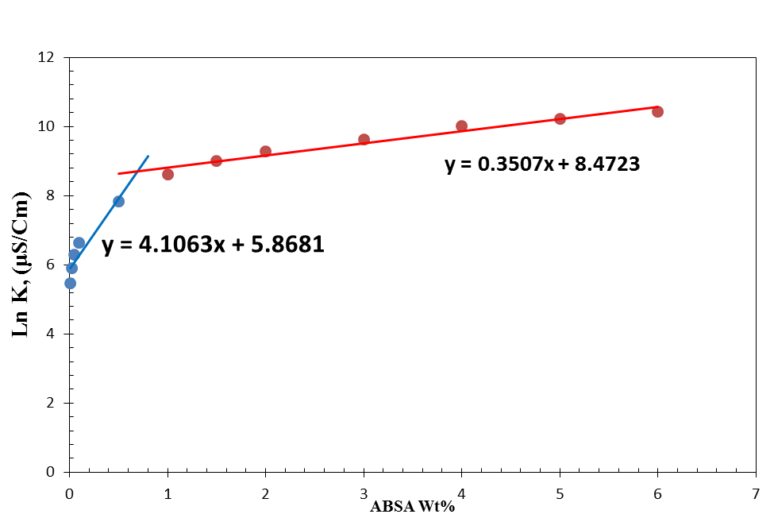
(a)

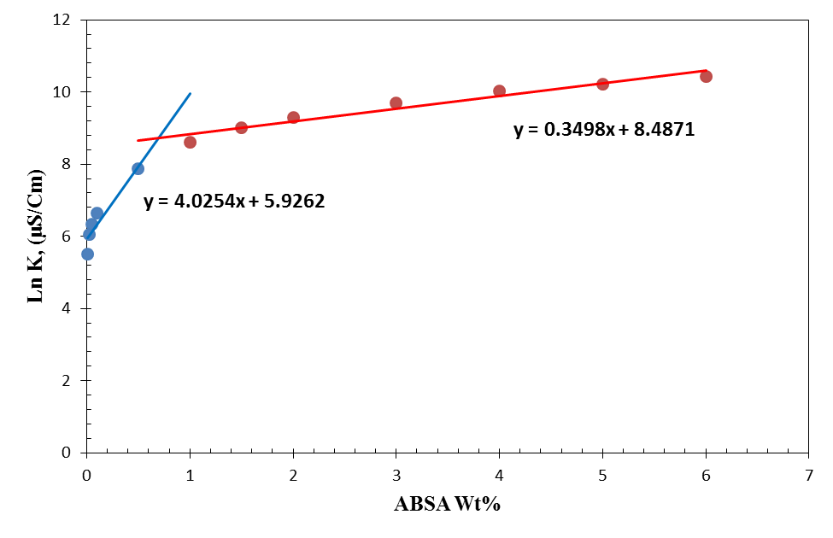
(b)

In the next step effect of Chloride sodium salt (NaCl) on CMC was considered. For considering the effect of NaCl three concentrations was tested. The presence of salt influences the interactions between the surfactants in the monolayer as well as in the micelle. Addition of a cationic electrolyte such as NaCl to the ionic micelles (ABSA) results in a decrease in the CMC value and an increase in the aggregation number (Turro and Kuo, 1986). The decreasing in the CMC value is mainly due to the decrease in the thickness of the ionic atmosphere surrounding the ionic head groups in the presence of the additional electrolyte and the consequent decreased electrical repulsion between them in the micelles (Rosen, 1978).
Figure 3 show the CMC of ABSA as a function of NaCl concentration. Three concentration of NaCl was considered. At 2000 PPM, 5000PPM and 10000 PPM of NaCl, CMCs of ABSA solutions were obtained 4938.81 ppm, 3774.55ppm and 3426.15 ppm.
The trend in Figure 4 is as follows the CMC decreases with increasing NaCl concentration. Critical micelle concentration is the concentration of surfactant where suddenly micelles appear in equilibrium with free molecules and surface films, the head groups in a micelle in contact with water in an ionic surfactant are charged. So adding the NaCl as a salt in solution causes the added ions that are oppositely charged to that head group will be attracted to the head group. This changes the packing density of the head groups and leads to the formation of larger micelles and it should increase entropy of micelles formation (Maiti et al., 2009). As increasing sodium concentration levels, the adsorption of ABSA on carbon surfaces increases. Increasing in ionic salt leads to a decrease in the repulsive forces between the head groups of surfactants. Moreover, decreasing the electrical repulsion between the similarly charged adsorbed ions permits closer packing, finally CMC decreases sharply.

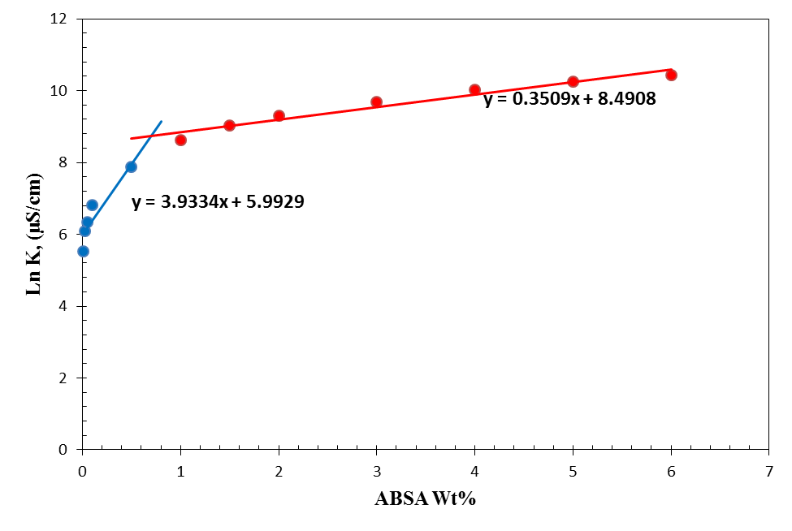
(c)

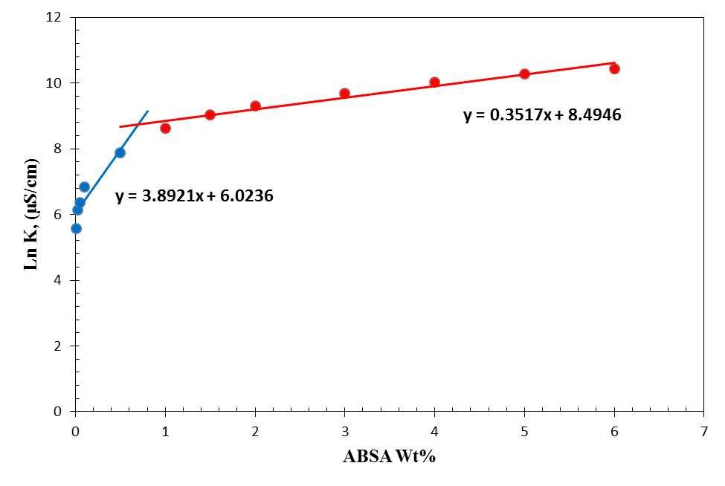
(d)
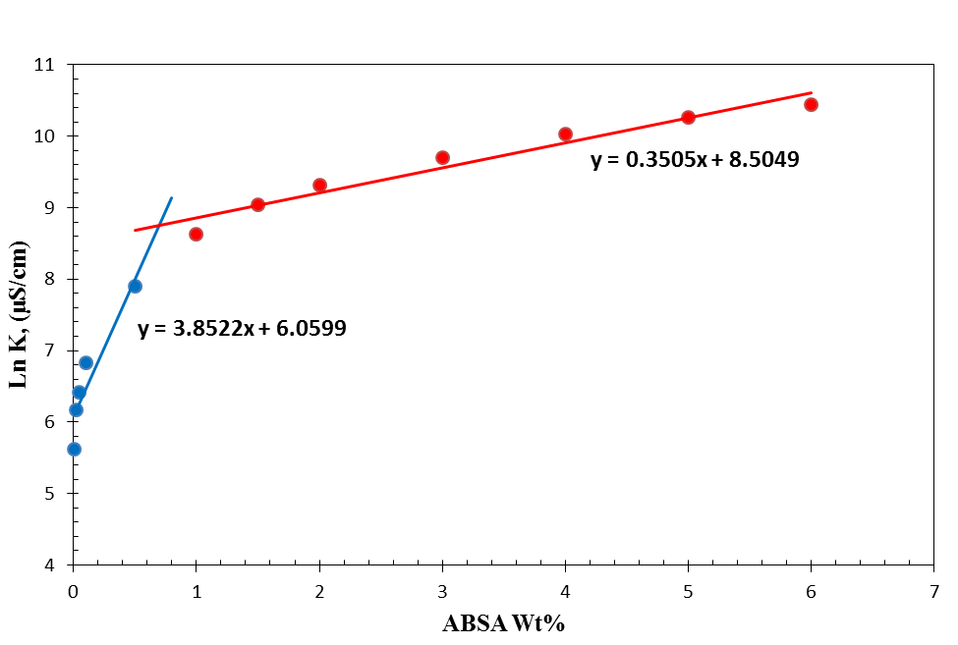
(e)

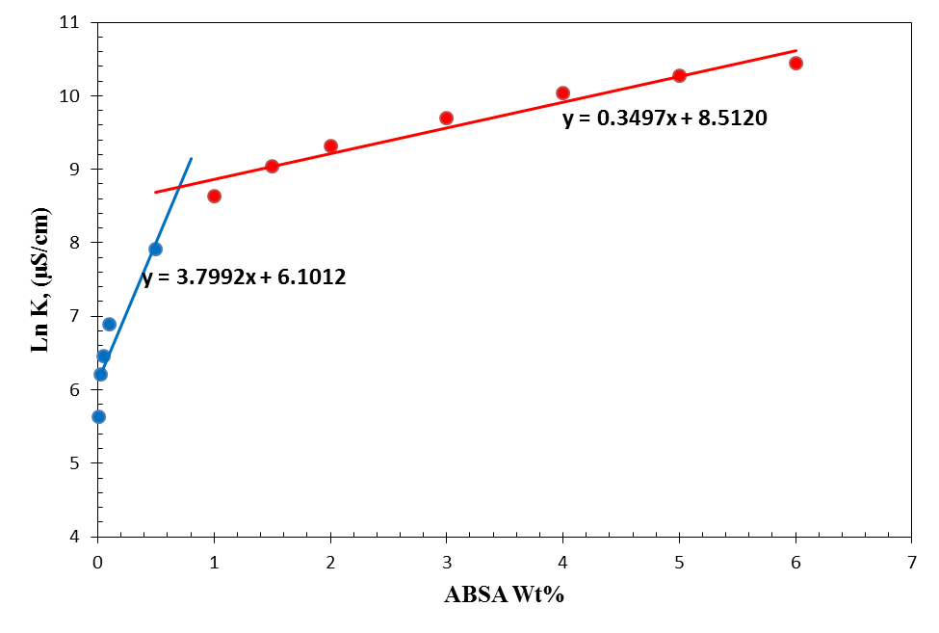
(f)

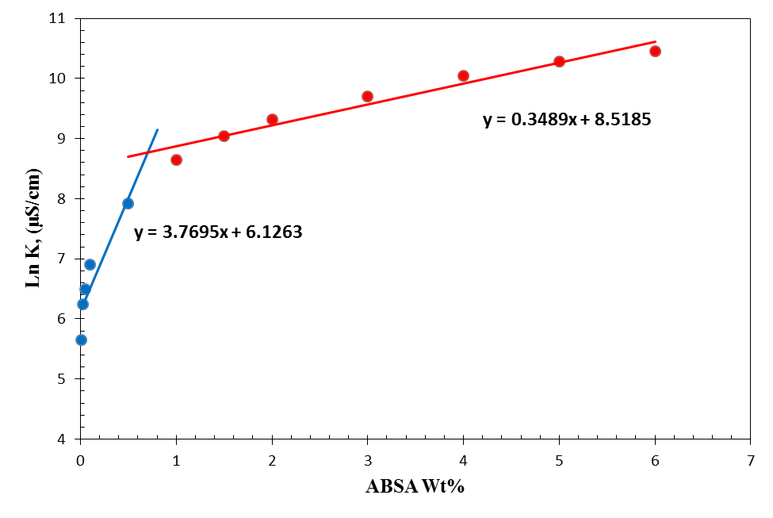
(g)
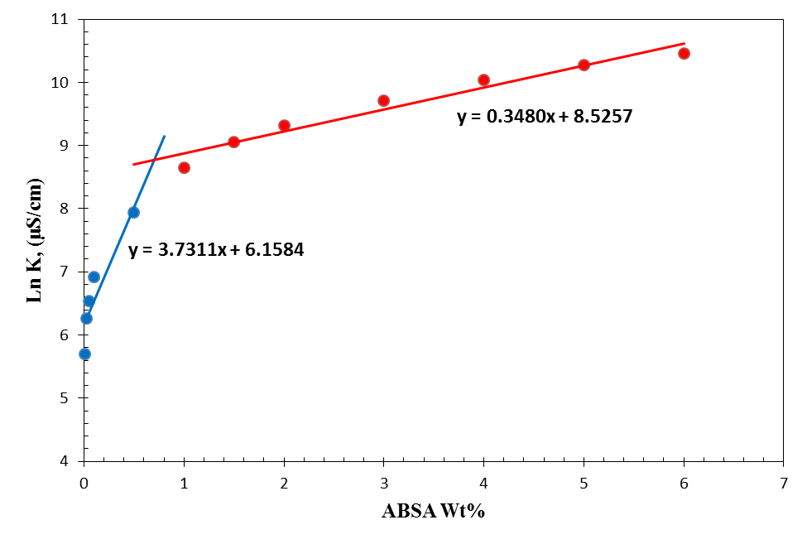
(h)

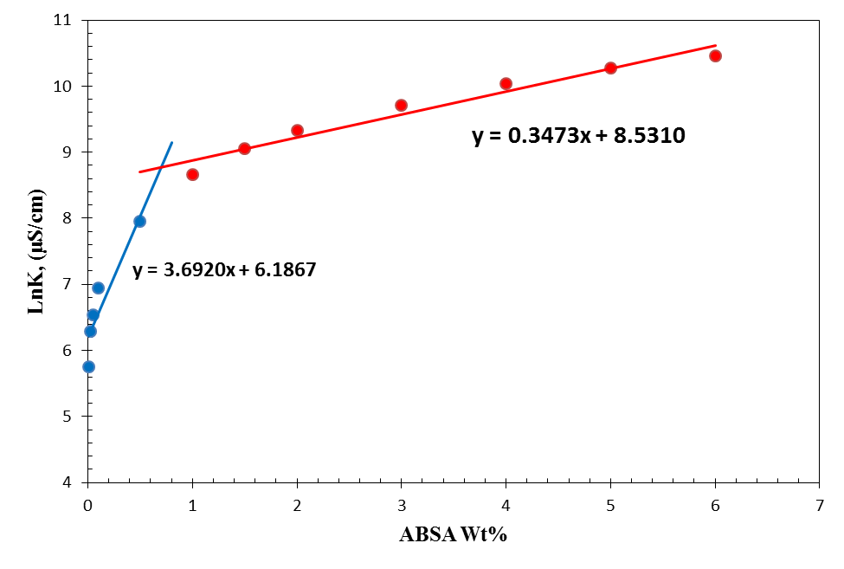
(i)

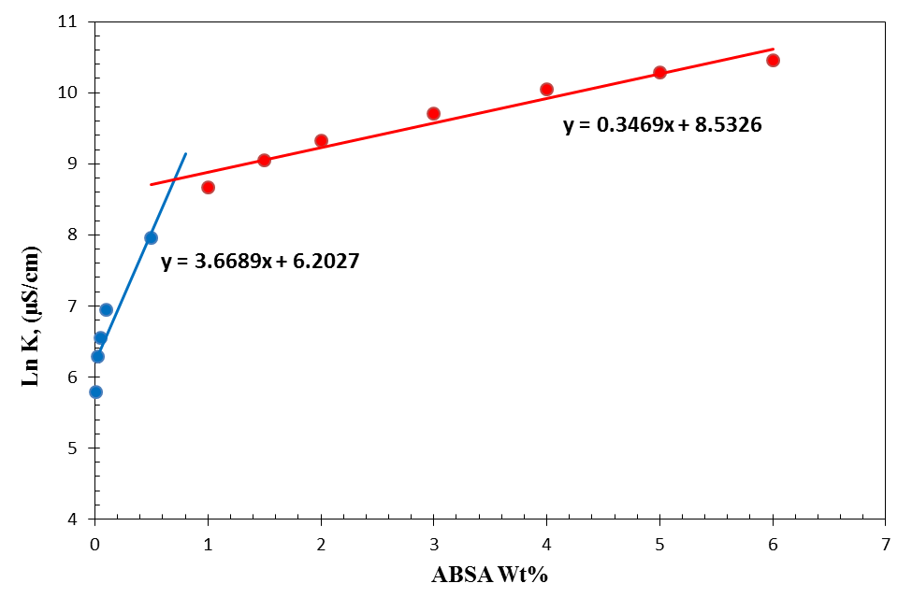
(j)
Figure 1: Solution conductivity vs. ABSA concentration at tene temperatures: (a) at 25°C, (b) at 30°C, (c) at 35°C, (d) at 40°C, (e) at 45°C, (f) at 50°C, (g) at 55°C, (h) at 60°C, (i) at 65°C, (j) at 70°C

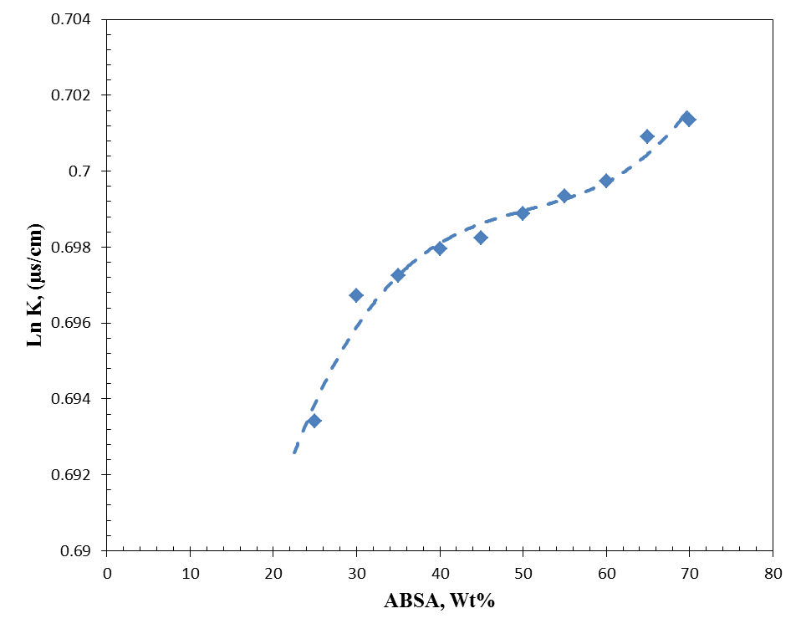
Figure 2: Temperature dependence of the CMC of ABSA

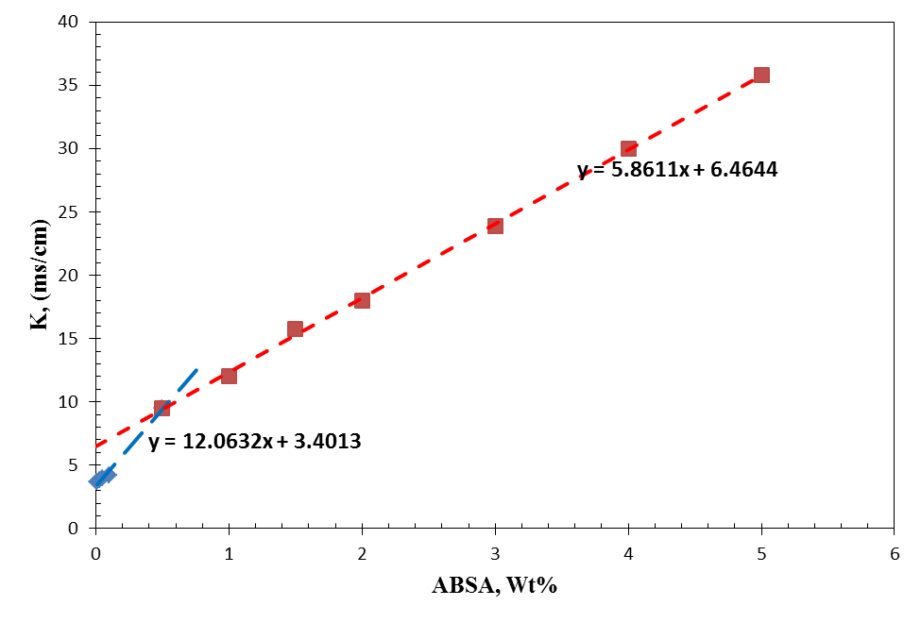
(a)

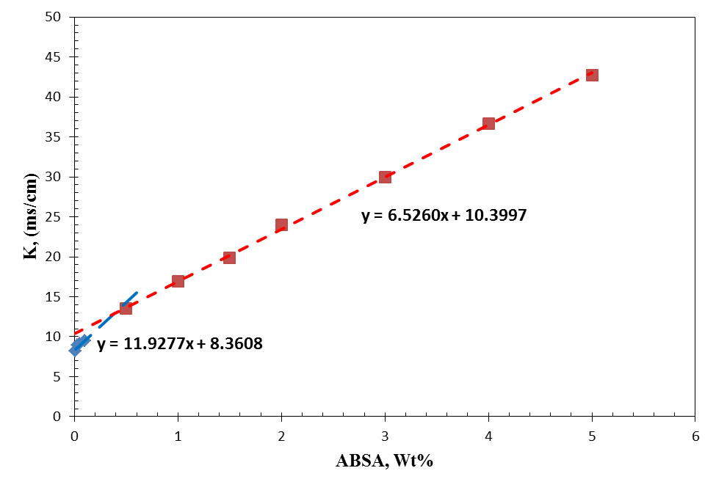
(b)
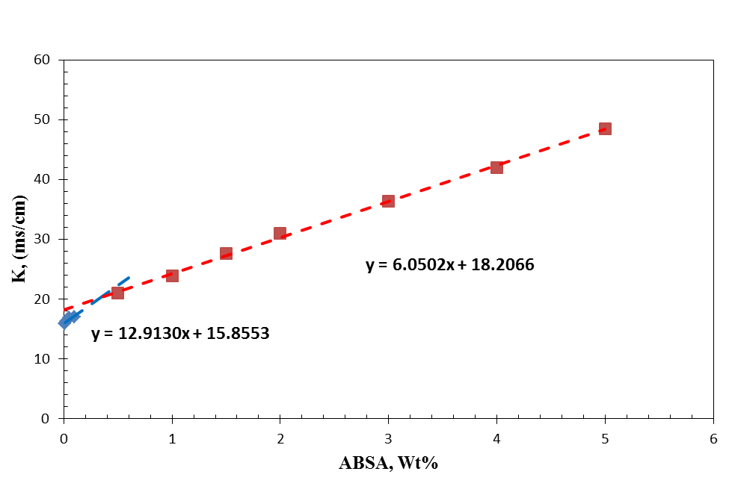
(c)
Figure 3: Effect of NaCl on CMC of ABSA: (a) at 2000 PPM NaCl, (b) at 5000 PPM NaCl, (c) at 10000 PPM NaCl
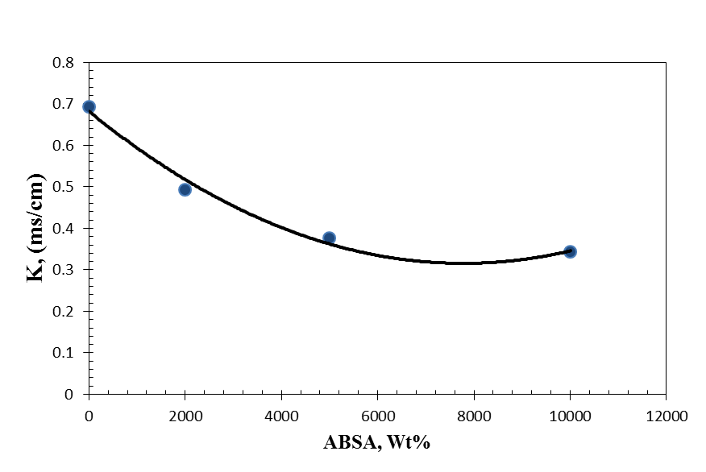
Figure 4: Effect of NaCl on CMC variation of ABSA

Conclusions
ABSA is very sensitive to the polarity of the medium. The increase in the CMC value of ABSA with a rise in temperature is an indication of the demicellization process caused by palisade layer disruption of the micelle. Addition of counter ions such as Na⁺ to negatively charged micelles such as ABSA results in surface charge screening concomitantly, the micelle size increases as the CMC decreases finally causes decreasing in CMC.

Acknowledgements:
Authors are grateful to the Petroleum University of Technology for providing laboratory facilities to carry out this work.

Corresponding Author:
Mohammad Ali Ahmadi
Department of Petroleum Engineering, Ahwaz Faculty of Petroleum Engineering, Petroleum University of Technology, Ahwaz, Iran
P.O.BOX: 63431
E-mail: ahmadi6776@yahoo.com

References
- P. Holland, D. Rubing, in: D. Rubing, P. Holland (Eds.), "Cationic Surfactants, Marcel Dekker", New York, 1991, p. 141.
- K. Ogino, A. Masahiko (Eds.), "Mixed Surfactant Systems", Marcell Dekker, New York, 1993.
- I. Kowalska, K. Majewska-Nowak, M. Kabsch-Korbutowicz "Influence of temperature on anionic surface active agent removal from a water solution by ultrafiltration", Journal of Desalination 198 (2006) 132–139.
- M. Halder, "Determination of the Critical Micellar Concentration (CMC) of a Cationic Micelle from Stokes Shift Data", The Chemical Educator, Vol. 12, No. 1, 2007.
- D. Myers, "Surfactant science and technology", Wiley-Interscience, New York, 2006.
- S. Miyagishi, K. Okada, and T. Asakawa "Salt Effect on Critical Micelle Concentrations of Nonionic Surfactants, N-Acyl-N-methylglucamides (MEGA-n)", Journal of Colloid and Interface Science 238, 91–95 (2001).
- L. Abezgauz, K. Kuperkar, P.A. Hassan, O. Ramon, P. Bahadur, D. Danino, "Effect of Hofmeister anions on micellization and micellar growth of the surfactant cetylpyridinium chloride", Journal of Colloid and Interface Science 342 (2010) 83–92.
- P.L.O. Volpe and E.A. Silva Filho, "Calorimetric study of SDS micelle formation in water and in NaCl solution at 298 K", Thermochimica Acta, 257 (1995) 59–66.
- D. Varade, T. Joshi, V.K. Aswal, P.S. Goyal, P.A. Hassan d, P. Bahadur, "Effect of salt on the micelles of cetyl pyridinium chloride", Journal of Colloids and Surfaces A: Physicochem. Eng. Aspects 259 (2005) 95–101.
- N.J. Turro, P.L. Kuo," Surface and Bulk Interactions of Ionic and Nonionic Surfactants" J. Phys. Chem. 90 (1986) 837.
- M.J. Rosen, Surfactants and Interfacial Phenomena, Wiley-Interscience, New York, 1978.
- K. Maiti, D. Mitra, S. Guha, Satya P. Moulik "Salt effect on self-aggregation of sodium dodecylsulfate (SDS) and tetradecyltrimethylammonium bromide (TTAB): Physicochemical correlation and assessment in the light of Hofmeister (lyotropic) effect", Journal of Molecular Liquids, 146 (2009) 44–51.

2/25/2017

