**A New Solution to Account Pseudo-skin Due to Partial Completion of Wells**

Vahid Farokhi1, Shahab Gerami2

**1.** Department of Petroleum Engineering, University of Technology (Tehran Polytechnic), Tehran, Iran

2. National Iranian Oil Co. (IOR Research Institute), Tehran, Iran

[vahid.farokhi@aut.ac.ir](mailto:vahid.farokhi@aut.ac.ir), [vahid.farokhi@yahoo.com](mailto:vahid.farokhi@yahoo.com), [gerami@nioc.rtd.ir](mailto:gerami@nioc.rtd.ir)

**Abstract**: To prohibit gas and/or water coning, it has been very common for wells to be completed over only a portion of their productive zone. Such procedure causes an additional pressure drop termed as pseudo-skin that reduces the well productivity. In order to figure out whether a partially-penetrated well required to be stimulated or not, it’s crucial to both qualitatively and quantitatively determine different components of the total skin. Hence, in a partially-penetrated well, accurate evaluation of pseudo-skin as one of the main components of total skin is extremely essential. Many authors have proposed mathematical methods that can be used to estimate the pseudo-skin factor due to partial completion. This paper aims to present a simple analytical model that can be used to accurately predict the pressure behavior as well as the pseudo-skin factor in a partially-penetrated well. In this model, the impacts of anisotropy and arbitrariness of the open interval location are taken into account. To better illustrate the validity and reliability of the model for estimating the pseudo-skin factor, a comparison of the values obtained by the presented model and those estimated by other available models with a numerical simulator as the comparison base has been made. The results have shown that the assumptions on the basis of which the model is developed are valid and furthermore, compared to other methods the analytical model has estimated the pseudo-skin factor favorably so close to that obtained by the simulator.

[Vahid Farokhi, Shahab Gerami. **A New Solution to Account Pseudo-skin Due to Partial Completion of Wells.** *Researcher* 2017;9(2):71-81]. ISSN 1553-9865 (print); ISSN 2163-8950 (online). <http://www.sciencepub.net/researcher>. 8. doi:[10.7537/marsrsj090217.08](http://www.dx.doi.org/10.7537/marsrsj090217.08).

**Keywords:** pseudo-skin factor, analytical model, partial completion, anisotropy, numerical simulator

**Introduction**

For many years, it has been very usual for wells to be completed over only a portion of their productive zone in order to delay water and/or gas coning. In such situations the well is referred to as a restricted entry or partially-penetrated well. In comparison to fully penetrated wells, flow lines in a partially penetrating well are converged vertically toward the well. This distortion of flow pattern, results in an additional pressure loss known as pseudo-skin effect due to partial completion. In order to figure out whether a partially-penetrated well should undergo stimulation or not, it’s crucial to both qualitatively and quantitatively determine different components that form the total skin. Hence, in a partially-penetrated well, accurate evaluation of pseudo-skin as one of the main components of total skin is extremely essential.

Numerous authors have studied the effect of partial penetration on pressure behavior and well productivity losses. Using method of images, Muskat (1949, 1982) investigated the partial penetration effect on a single-layered homogeneous reservoir for incompressible fluid and estimated productivity loss duo to partial completion. Nisle (1958) considered a partially-penetrating well in an infinite slab and based on point source solution technique, he used method of images and constructed synthetic buildup pressure transient responses in a single-layered homogeneous reservoir. His work was then extended by Brons and Marting (1961) to suggest an empirical correlation for the pseudo-skin factor due to partial completion. Their results compared closely with the steady state solutions of Muskat. Odeh (1968) used a finite cosine transform to arrive at a solution for steady state flow of a slightly compressible fluid where the open interval was arbitrary within the producing formation. Streltsova-Adams (1979) employed Laplace and Hankel transformations to solve partial completion problem in a single-layered reservoir and derived an expression for pseudo-skin factor in terms of infinite sine and cosine series for an arbitrary position of perforations. She also investigated the effect of arbitrariness of perforation location on pseudo-skin factor and observed that the minimum value is for centrally-located open intervals. Kuchuk and Kirwan (1987) derived an analytical solution for the transient pressure behavior of a partially penetrated well when wellbore storage and skin effects were significant. They also presented a formula for pseudo-skin factor assuming a uniform flux model that is only applicable for perforations at the base or top of the producing formation. Vrbik (1986) used separation of variable technique to find a simple formula for the pseudo-skin factor using equations for steady state flow of incompressible fluid and the assumption of uniform flow across the perforated length. Papatzacos (1987) solved partial penetration problem by the use of method of images for a single-layered, homogeneous reservoir and taking infinite conductivity into account analytically derived an expression for pseudo-skin factor in terms of dimensionless wellbore radius, dimensionless open interval and its location within productive zone.

In the following first we describe a physical model including a partially-penetrated well with arbitrary location of open interval. Then considering some simplifying assumptions an analytical model is developed for the physical model. Next the Laplace and finite Fourier cosine transforms are applied successively to arrive at a solution for dimensionless pressure in the Laplace domain for both transient and boundary-dominated flow. By the aid of a numerical Laplace transform inverter, we return the solution back to the time domain and then check the validity of the assumptions of the model against a numerical reservoir simulator.

The Laplace domain solution consists of a term that accounts for apparent skin due to partial completion of the well. To investigate the validity of the predicted apparent skin, some base cases are considered and the results obtained by the analytical model and other available models found in the literature are all compared with that of the numerical simulator as the comparison base.

**1. Model Development**

**1.1 Physical Model**

Referring to figure1, we consider a vertical single-layered porous cylinder with drainage radius ofand uniform thickness of  which is initially at a uniform pressure of (i.e., neglecting hydrostatic pressure gradient). It is assumed that a centrally-located well of radius is drilled through the formation and is partially completed.  and  are respectively the distance from the top and bottom of the open interval with length of  to the top of the formation. the top and bottom boundaries of the formation are impermeable to flow. At time, oil is produced from the reservoir at a constant rate, , causing the pressure in the reservoir to be reduced gradually tobelow the equilibrium pressure.

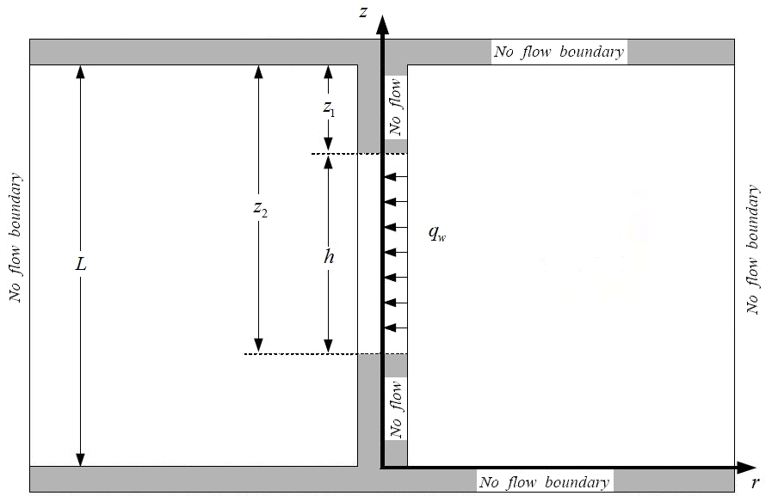

Figure 1. Physical model

**1.2 Mathematical Model**

The important physical processes taking place in the above-described reservoir system can be incorporated in a set of partial differential equations with appropriate initial and boundary conditions. The following assumptions and conditions are taken into account in order to allow a model development:

1. A homogeneous and anisotropic porous medium of uniform thickness with constant permeability (non-zero vertical permeability).
2. The flow is considered as two dimensional, radial-vertical Darcy’s flow of single-phase oil through the reservoir.
3. The change in pore volume is negligible.
4. The fluid is slightly compressible with constant viscosity.
5. The gravity effects and wellbore storage are ignored.
6. The flux into the well is uniformly distributed over the perforated interval.
7. The geothermal gradient is ignored.
8. No skin effect from damage or stimulation is considered.

Mathematically the problem could be stated as that of finding a solution to the dimensionless form of diffusivity equation:

 (1)

The dimensionless variables are defined by:

 (2)

 (3)

 (4)

 (5)

 (6)

 (7)

Initial and boundary conditions are given by:

1. Initial condition

 (8)

1. Inner boundary conditions(constant rate)

 (9)

1. Outer boundary condition

 (10a)

Or

 (10b)

1. Top and bottom boundary conditions

 (11)

Note that equations (10a) and (10b) are outer boundary conditions for finite acting and infinite acting reservoirs, respectively.

**1.3 Solution**

The Laplace-domain solution for dimensionless pressure,, can be obtained by taking Laplace transforms with respect to dimensionless time and finite Fourier cosine transforms with respect tocoordinate from equations (2) to (9). The details are given in the appendix. The solution for a finite and an infinite reservoir are obtained as follows:

 (12)

Whereis the Laplace transform of. The parametersandfor a finite reservoir are:

 (13)

 (14)

As indicated in the appendix, for an infinite reservoir these parameters are obtained as:

 (15)

 (16)

Equation (12) consists of two terms in Laplace domain; the first term,, accounts for the behavior of a fully penetrating well (equation(13) and (15)) and the second term,, that accounts for apparent skin due to partial penetration of the well,. This series term acts as a modifier to pressure drop, taking into account the effect of limited flow entry.

Equations (14) and (16) are functions of. Hence, in order to obtain a uniform pressure distribution along a perforated portion of the well; these equations may be integrated with respect toover the limits of the open interval. The results are equations (17) and (18) describing the average pseudo-skin at the wellbore (), for the finite and infinite reservoir, respectively.

 (17)

 (18)

Now with the aid of a numerical Laplace inverter, one may obtain the average pseudo-skin and consequently the solution for dimensionless wellbore pressure (the inversion of) in the dimensionless time domain.

**2. Model Validation**

By the employment of the Stehfest algorithm (1970) as a Laplace inverter, equation (12) was programmed to obtain numerical answers. Referring to table 1, 8 different cases were considered to examine the validity of the model’s assumptions against a numerical simulator (ECLIPSE). Note that the other required data for these cases are common with the base case described in table 3. As shown in figure 2 to figure 9, the analytical model for all 8 cases is in good agreement with the results obtained by the simulation.

Table 1. List of cases studied to investigate the model validity (* refers to the base case)

|  |  |  |
| --- | --- | --- |
| **Case ID** | **Parameter studied** | **value** |
| 1 | Base case | * |
| 2 |  | 0.15 |
| 3 | () | 800 |
| 4 | () | 150 |
| 5 |  | 0.3 |
| 6 | Open interval location | Centre |
| 7 | () | 200 |
| 8 | () | 2 |

Table 2. List of cases studied for estimative of pseudo-skin(Note that for each case 5 completion fractions are considered and * refers to the base case)

|  |  |  |
| --- | --- | --- |
| **Case ID** | **()** | **Open interval location** |
| 9 | * | * |
| 10 | 20 | Centre |
| 11 | 2 | Top |
| 12 | 2 | Centre |

Table 3. The base case

|  |  |
| --- | --- |
| **parameters** | **Value** |
|  | 0.2 |
| () | 1.05 |
| () | 2 |
| () | 6.66*e-6 |
| () | 20 |
| () | 20 |
|  | 0.1 |
| Open interval location | top |
| () | 0.35 |
| () | 1000 |
| () | 75 |
| () | 100 |
| () | 5000 |

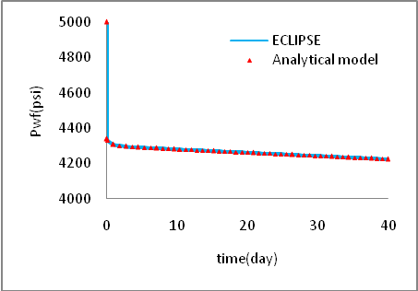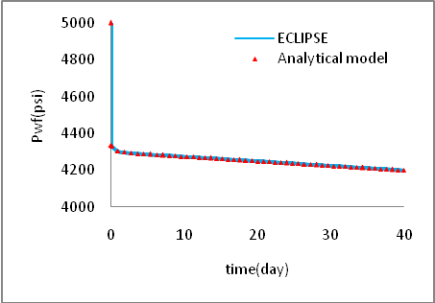

Figure 2. Verification-base case Figure 3. Verification-case2 ()

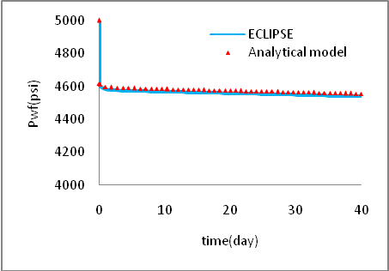

Figure 4. Verification- case3 () Figure 5. Verification-case4 ()

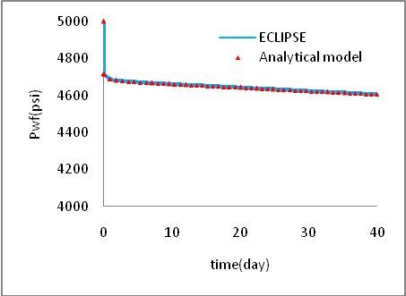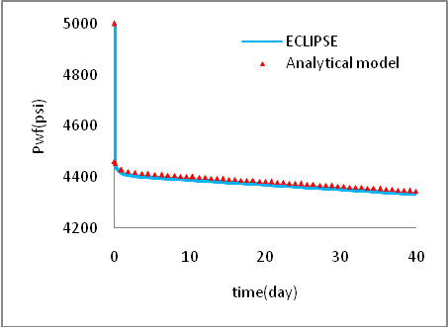

Figure 6. Verification- case5 () Figure 7. Verification-case6 (perforation location)

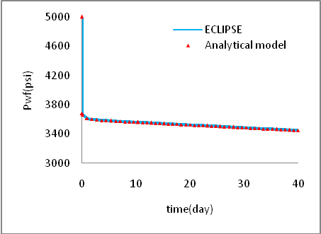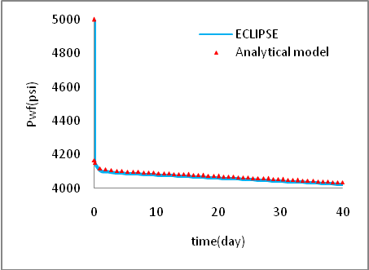

Figure 8. Verification- case7 () Figure 9. Verification-case8 ()

**3. Model Comparison**

Same as the analytical model, some available models in the literature were programmed to be compared against the numerical simulator for the estimative of pseudo-skin factor due to partial completion. For this purpose and also to better illustrate the impacts of anisotropy and open interval location on pseudo-skin factor, referred to table 2, four different cases with certain completion percentages were considered. Note that the other required data for these cases are similar to the base case. Table 4 show the values for the pseudo-skin obtained by different techniques and the simulator. Taking the results of the numerical simulator (ECLIPSE) as the comparison base, the analytical model and Streltsova-Adams (1979) technique have had the best agreements. Papatzacos’s (1987) has also predicted the pseudo-skin factor relatively close to that of the simulator while almost other techniques have either underestimated or overestimated the pseudo-skin. These differences are partly known as the result of not taking the anisotropy and/or arbitrariness of the open interval location into consideration. Furthermore, one may propose that different mathematical solutions to partial completion problem and simplifying assumptions are the other reasons for deviations of the models from that of the simulator.

Table 4. the pseudo-skin values obtained by different methods and the simulator for all four conditions listed in table 2 (O, B, M, S, P, V, K respectively stands for Odeh (1968), Brons&Marting (1961), McKinley (1984), Streltsova (1979), Papatzacos (1987), Vrbik (1986), Kuchuk&Kirwan (1987))

|  |  |  |  |  |  |  |  |  |  |  |  |
| --- | --- | --- | --- | --- | --- | --- | --- | --- | --- | --- | --- |
| **Case 9** | b | **O** | **B** | **M** | **S** | **P** | **V** | **K** | **Analytical model**  **(finite reservoir)** | **Analytical model**  **(infinite acting)** | **ECLIPSE** |
| 0.1 | 23.78 | 27.27 | 30.3 | 28.56 | 25.66 | 23.31 | 26.8 | 28.23 | 28.23 | 28.38 |
| 0.2 | 12.14 | 14.02 | 13.46 | 14.6 | 13.31 | 12.37 | 14.02 | 14.5 | 14.5 | 14.52 |
| 0.3 | 7.75 | 8.52 | 7.85 | 9.03 | 8.28 | 7.89 | 8.69 | 8.99 | 8.99 | 9.01 |
| 0.4 | 5.36 | 5.69 | 5.05 | 5.96 | 5.47 | 5.43 | 5.75 | 5.94 | 5.94 | 5.97 |
| 0.5 | 3.82 | 3.77 | 3.36 | 4 | 3.69 | 4.01 | 3.86 | 3.99 | 3.99 | 4.03 |
| **Case 10** | b | **O** | **B** | **M** | **S** | **P** | **V** | **K** | **Analytical model**  **(finite reservoir)** | **Analytical model**  **(infinite acting)** | **ECLIPSE** |
| 0.1 | 23.05 | 21.03 | 30.3 | 22.54 | 23.57 | 23.31 | 26.8 | 22.11 | 22.11 | 22.9 |
| 0.2 | 11.8 | 11.24 | 13.46 | 11.89 | 12.63 | 12.37 | 14.02 | 11.75 | 11.75 | 11.92 |
| 0.3 | 7.56 | 6.9 | 7.85 | 7.44 | 7.96 | 7.89 | 8.69 | 7.36 | 7.36 | 7.47 |
| 0.4 | 5.25 | 4.65 | 5.05 | 4.94 | 5.33 | 5.43 | 5.75 | 4.89 | 4.89 | 4.98 |
| 0.5 | 3.76 | 3.07 | 3.36 | 3.32 | 3.64 | 4.01 | 3.86 | 3.29 | 3.29 | 3.39 |
| **Case 11** | b | **O** | **B** | **M** | **S** | **P** | **V** | **K** | **Analytical model**  **(finite reservoir)** | **Analytical model**  **(infinite acting)** | **ECLIPSE** |
| 0.1 | 33.23 | 27.27 | 40.66 | 38.72 | 38.04 | 32.98 | 37.81 | 38.63 | 38.63 | 38.67 |
| 0.2 | 16.97 | 14.02 | 18.07 | 19.16 | 18.91 | 16.79 | 18.83 | 19.14 | 19.14 | 19.12 |
| 0.3 | 10.85 | 8.52 | 10.54 | 11.69 | 11.6 | 10.5 | 11.48 | 11.68 | 11.68 | 11.73 |
| 0.4 | 7.51 | 5.69 | 6.77 | 7.67 | 7.66 | 7.12 | 7.56 | 7.67 | 7.67 | 7.75 |
| 0.5 | 5.36 | 3.77 | 4.51 | 5.15 | 5.18 | 5.15 | 5.05 | 5.14 | 5.14 | 5.24 |
| **Case 12** | b | **O** | **B** | **M** | **S** | **P** | **V** | **K** | **Analytical model**  **(finite reservoir)** | **Analytical model**  **(infinite acting)** | **ECLIPSE** |
| 0.1 | 32.41 | 21.03 | 40.66 | 32.51 | 33.93 | 32.98 | 37.81 | 32.35 | 32.35 | 32.81 |
| 0.2 | 16.6 | 11.24 | 18.07 | 16.39 | 17.23 | 16.79 | 18.83 | 16.35 | 16.35 | 16.46 |
| 0.3 | 10.64 | 6.9 | 10.54 | 10.08 | 10.65 | 10.5 | 11.48 | 10.06 | 10.06 | 10.13 |
| 0.4 | 7.39 | 4.65 | 6.77 | 6.64 | 7.06 | 7.12 | 7.56 | 6.63 | 6.63 | 6.72 |
| 0.5 | 5.29 | 3.07 | 4.51 | 4.45 | 4.79 | 5.15 | 5.05 | 4.45 | 4.45 | 4.55 |

**Conclusion**

In this work:

* A simple analytical model was developed and programmed to accurately predict the pressure behavior and estimate the pseudo-skin factor due to partial completion.
* A numerical simulator (ECLIPSE) was employed to examine the validity of the model for a particular base case.
* Same as the presented model, some analytical and numerical methodologies found in the literature were programmed and a comprehensive comparison of them all was made against the numerical simulator to find the most accurate ones for the estimative of pseudo-skin factor due to partial completion. Therefore the analytical model and Streltsova’s (1979) both were observed to predict the closest values for the pseudo-skin factor to that of the numerical simulator.

**Nomenclature**

=penetration ratio, dimensionless

, , , = constants in Eq.(A-8) and Eq.(A-21)

= total reservoir compressibility, 

= formation thickness, 

= length of the open interval, 

 = distance between the top of the open interval and the top of the reservoir, 

= distance between the bottom of the open interval and the top of the reservoir, 

= reservoir permeability in radial direction, 

= reservoir permeability in vertical direction, 

 = pressure, 

= initial equilibrium pressure, 

= bottom hole pressure, 

= well production rate, 

= reservoir drainage radius, 

= wellbore radius, 

 = pseudo-skin factor due to partial penetration, dimensionless

= time, 

= vertical coordinate, vertical depth measured from the formation top, 

= radial coordinate, radius, 

= dimensionless radius defined by Eq. (2)

= dimensionless vertical depth defined by Eq. (3)

= dimensionless time defined by Eq. (6)

= dimensionless pressure defined by Eq. (7)

= the Laplace transform of dimensionless pressure

= dimensionless variable defined by Eq. (4)

= dimensionless variable defined by Eq. (5)

= oil formation volume factor, 

= the Laplace-domain variable

= dimensionless drainage radius

= the modified Bessel functions of first kind of order zero

= the modified Bessel function of second kind of order zero

 = the first order modified Bessel function of first kind

= the first order modified Bessel function of second kind





= finite Fourier transform of 

**Greek symbols**

= reservoir porosity, fraction

= oil viscosity, 

**Superscripts**

= partial penetration

= complete penetration

**Corresponding Author:**

Vahid Farokhi

Department of Petroleum Engineering

Amirkabir University of Tehran (Tehran Polytechnic)

Tehran, Iran

E-mail: [vahid.farokhi@yahoo.com](mailto:vahid.farokhi@yahoo.com),

[vahid.farokhi@aut.ac.ir](mailto:vahid.farokhi@aut.ac.ir)

**References**

1. Muskat, M. (1949), Physical Principles of Oil Production, McGraw Hill Book Co., Inc., N.Y. 211.
2. Muskat, M. (1982), The Flow of Homogeneous Fluids through Porous Media; International Human Resource Development Corporation, Boston, MA.
3. Nisle, R.G. (1958), the Effect of Partial Penetration on Pressure Build-Up in Oil Wells, Trans., AIME Vol. 213, 85-90.
4. Brons, F. and Marting, V. E. (Feb. 1961), the Effect of Restricted Flow Entry on Well Productivity, J. Pet. Tech 172-174; Trans., AIME, 222.
5. Odeh, A. S. (March 1968), Steady-State Flow Capacity of Wells with Limited Entry to Flow, SPEJ 43-51; Trans, AIME, vol. 243.
6. Streltsova-Adams T.D. (1979), Pressure Drawdown in a Well with Limited Flow Entry, paper SPE 7486.
7. Kuchuk, F. and Kirwan, P.A. (Dec. 1987), New Skin and Wellbore Storage Type-curves for Partially Penetrated Wells, paper SPE 11676.
8. Vrbik, J. (1986), Calculating the Pseudo-skin Factor due to Partial Well Completion, JCPT 57-61.
9. Papatzacos, P. (May 1987), Approximate Partial Penetration Pseudo-skin for Infinite Conductivity Wells, SPERE 227-234.
10. Stehfest, H. (January 1970), Numerical Inversion of Laplace Transforms (Algorithm 368 with correction), Communications of the ACM, 13, No.1, 47-49.
11. McKinley, R.M. et al. (Feb. 1984), Early-Time Pressure Buildup Analysis for Prudhoe Bay Wells, J. Pet. Tech, 311-319; Trans., AIME, 277.

**Appendix**

Taking the Laplace transform from equation (1) and equation (8) to (11) yields:

 (A-1)

 (A-2)

 (A-3)

 (A-4)

 (A-5)

 (A-6)

Applying finite Fourier cosine transform with respect tocoordinate for equations (A-1) to (A-6) results:

 (A-7)

Equation (A-7) is Bessel modified differential equation which has the general solution as:

 (A-8)

 and  are, respectively, the modified Bessel’s functions of the first and second kind of order zero. For the sake of simplicity in derivations, the parameter in equation (A-8) is expressed by equation:

 (A-9)

The transformed boundary conditions are:

 (A-10)

 (A-11)

Using properties of Bessel function and applying boundary conditions to equation (A-8), one may obtain:

 (A-12)

 (A-13)

 and  are first order modified Bessel’s functions of the first and second kind, respectively.

Therefore the solution of dimensionless pressure in Fourier-domain becomes:

 (A-14)

Applying the inverse finite Fourier cosine transform with respect to thecoordinate for equation (A-14), the solution for dimensionless pressure in Laplace-domain becomes:

 (A-15)

In equation (A-15) one needs to evaluate two terms including and . The values ofand can be obtained from equation (A-14). To evaluate, one needs to take the limit ofwhen n approaches to zero. Using L’ Hospital’s rule, one may obtain:

 (A-16)

Therefore the dimensionless wellbore pressure can be obtained as:

 (A-17)

Where

 (A-18)

 (A-19)

In the case of infinite acting reservoir the outer boundary condition becomes as:

 (A-20)

The general solution is the same as the bounded reservoir case, equation (A-8).

 (A-21)

Considering properties of Bessel function and applying boundary conditions to equation (A-21), one may obtain:

 (A-22)

 (A-23)

Following the same procedure as that for finite reservoir, the dimensionless wellbore pressure can be obtained as:

 (A-24)

Where

 (A-25)

 (A-26)

2/25/2017