**Limitations of Conventional Decomposition Method in Comparison with Modified Decomposition for Simulating the Instability of Nano-Switches**

Ali koochi1, Asiehsadat Kazemi2, Mohamadreza Abadyan3

1. Mechanical Engineering Group, Naein Branch, Islamic Azad University, Naein, Iran

2. Engineering Department, Bojnourd Branch, Islamic Azad University, Bojnourd, Iran

3. Engineering Group, Naein Branch, Islamic Azad University, Naein, Iran

[Abadyan@yahoo.com](mailto:Abadyan@yahoo.com)

**Abstract:** Herein, the conventional Adomian decomposition (CAD) and modified Adomian decomposition (MAD) methods are applied to solve the forth-order nonlinear deferential equation of nano electromechanical switches (NEMS). The pull-in instability parameters of the switch have been determined and compared with those of numerical solution. It is found that using conventional decomposition method in solving NEMS problems can lead to physically incorrect results. The values of instability parameters computed by CAD series might converge to the values which differ from that obtained by numerical methods. The inaccuracy becomes more highlighted in the case of doubly-supported NEMS compared to cantilever one. This shortcoming is not observed for MAD and therefore, modified decomposition method could easily utilize to simulate the pull-in performance of the beam-type NEMS.

[Ali koochi, Asiehsadat Kazemi, Mohamadreza Abadyan. **Limitations of Conventional Decomposition Method in Comparison with Modified Decomposition for Simulating the Instability of Nano-Switches.** *Researcher* 2017;9(2):57-63]. ISSN 1553-9865 (print); ISSN 2163-8950 (online). <http://www.sciencepub.net/researcher>. 6. doi:[10.7537/marsrsj090217.06](http://www.dx.doi.org/10.7537/marsrsj090217.06).

**Keywords:** Nonlinear differential equation, Conventional Adomian decomposition, Modified Adomian decomposition, Nano electromechanical switch (NEMS), Instability

**1. Introduction**

It is well-established that the governing equation of most engineering and physical systems is nonlinear in its nature and hence, many efforts have been conducted by scientists to solve the mathematical nonlinear equations of the systems. Recently, various mathematical methods, such as Adomian decomposition [1,2], variational iteration [3,4], homotopy perturbation [5,6], exp function [7,8] and others [9,10] have been proposed for obtaining analytical approximation solutions of nonlinear problems. Among these methods, the decomposition method proposed by Adomian has been widely used to solve stochastic systems [11-13] and engineering problems such as oscillation [14-16], heat transfer [17,21], etc. due to the convenience of the computations.

After introducing the conventional Adomian method, several investigators made attempt to improve the abilities and convergence speed of the decomposition method. Rach proposed a systematic formula for computing the Adomian's polynomials [22]. Further modification of the polynomials was also provided by Gabet [23]. The convergence and the generalization of Adomian series were addressed in other references [24,25]. Furthermore, comparison between the decomposition method and the Taylor series approximation shows that the decomposition method is much more efficient than the Taylor series method [26]. A modified Adomian decomposition method has been applied to simulate the static deflection of electrostatic micro-actuators [27]. Wazwaz proposed a powerful modification of the Adomian decomposition method [18]. This modification highly accelerates the convergence of the decomposition polynomials and has been applied for solving higher order boundary value problems [19,20].

With increasing growth of nanotechnology, nano electromechanical switches (NEMS) have become the center of interest for researchers. Many investigations have been focused on solving the nonlinear governing equation and modeling the instability of electromechanical switches. In this paper, the limitations/abilities of conventional and modified Adomian decomposition methods in solving constitutive equation of NEMS are investigated. In addition, numerical solution is obtained using MAPLE commercial software and Adomian solutions are compared with the numerical results. The precision and convergence speed of both methods are compared.

**2. Governing Equation of NEMS**

Figure (1) shows the typical cantilever and doubly-supported beam-type NEMS constructed from a conductive electrode suspended over a conductive substrate. Applying voltage difference between the electrode and ground causes the electrode to deflect towards the ground. At a critical voltage/deflection, which is known as pull-in instability voltage/deflection, the electrode becomes unstable and pulls-in onto the substrate. The pull-in voltage and pull-in deflection of a NEMS are named as the pull-in parameters of the switches. Determining the electrode deflection and pull-in parameters of NEMS are crucial issues for engineers. Considering the van der Waals force, the governing equation of beam-type NEMS can be derived into [28]:

 (1-a)

 (B.C for Cantilever and doubly-supported) (1-b)

 (B.C for cantilever), (1-c)

 (B.C for doubly-supported). (1-d)

where *W* is the deflection of the electrode, *Z* is the distance from the clamped end and *I* is the moment of inertia of the electrode cross section, *Eeff* is the effective electrode material modulus,* 0* is the permittivity of vacuum, *V* is the applied voltage, *g* is the initial gap between the electrode and the substrate, *d* is the width of cross section and *A* is the Hamaker constant. Using the substitutions *w*=*W*/*g* and *z*=*Z*/*L*, equation (1) becomes:



(2-a)

*w*(0) = 0, *w′*(0) = 0

(B.C for cantilever and doubly-supported) (2-b)

*w′′*(1) = 0, *w′′′* (1) = 0

(B.C for cantilever) (2-c)

*w*(1) = 0, *w′*(1) = 0

(B.C for doubly-supported) (2-d)

In above equations, the dimensionless parameters, **, ** and ** are defined according to

 (3-a)

 (3-b)

 (3-c)

Using numerical computations, the variation range of above parameters which satisfies physical considerations [28] approximately could be defined as:



For cantilever NEMS



For doubly-supported NEMS

Note that at the onset of the instability, the maximum deflection of the electrode increases without requiring any further increase in voltage. In mathematical view, the slope of *w*-** curve reaches infinity when instability occurs, i.e. *dw/d*(*z*=1)*→∞* and *dw/d*(*z*=0.5)*→∞* for cantilever and doubly-supported NEMS, respectively. As a convenient approach, the pull-in instability voltage, *PI*, and pull-in deflection, *uPI*, of NEMS can be determined via plotting *w*(*z=*1) vs. ** for cantilever and *w*(*z=*0.5) vs. ** for doubly-supported NEMS.

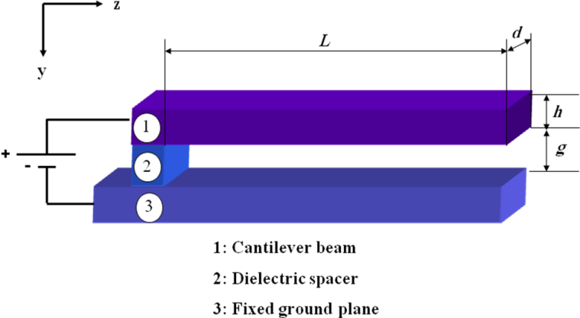

(a)

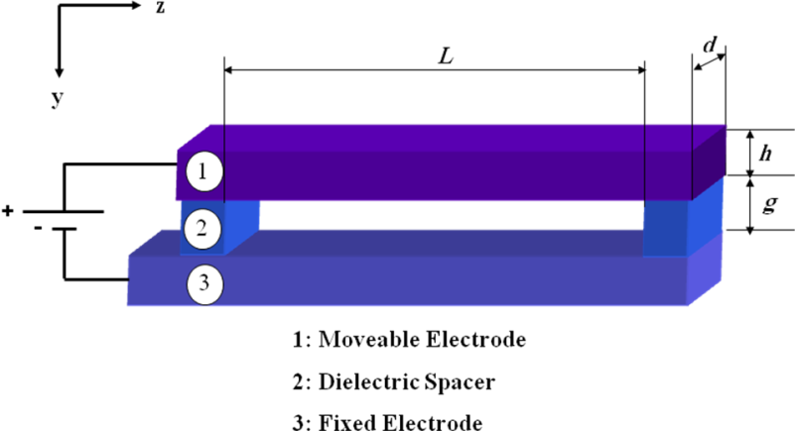

(b)

Figure 1. Schematic representation of (a) a cantilever NEMS and (b) doubly-supported NEMS

**3. Fundamentals of Decomposition Methods**

In order to explain the fundamental of Adomian decomposition methods, consider a differential equation of a fourth-order boundary-value problem [20],

 (4)

With boundary conditions

 (5)

Equation (4) can be represented as

 (6)

Where *L*(4) is a differential operator, which is defined as:

 (7)

The corresponding inverse operator *L*-(4) is defined as a 4-fold integral operator, that is

 (8)

Employing the decomposition method [20], the dependent variable in equation (4) can be written as:

 (9)

where constants *C1* and *C2* can be determined from the boundary condition at another boundary point. In above relations, function *An* approximates nonlinear function *f*(*x*,*y*) and is determined as a polynomial series [12]:

 (10)

According to conventional Adomian decomposition (CAD), series *An*is obtained using the following formula [1]

 (11)

On the other hands, according to modified Adomian decomposition (MAD), the following convenient equations can be utilized to obtain an appropriate solution for *An* [13, 22]:

 (12)

where , , n>0, ,  and *ki* is the number of repetition of the *pi*, the values of *pi* are selected from the above range by combination without repetition.

Now, according to decomposition methods, the recursive relations of equation (9) can be provided as follows:

 (13)

In this study we compare the ability and limitations of both conventional and modified Adomian methods in solving the governing equation of NEMS. In order to apply decomposition methods for simulating deflection and pull-in behavior of NEMS, the substitution *y*=1-*w* is used to rewrite equation (2) into the following simpler form:

 (14-a)

*y*(0) = 1, *y′*(0) = 0

(B.C for cantilever and doubly-supported) (14-b)

*y”*(1) = 1, *y′”*(1) = 0

(B.C for Cantilever NEMS) (14-c)

*y*(1) = 0, *y′*(1) = 0

(B.C for doubly-supported NEMS) (14-d)

According to what mentioned above and considering equation (9), he solution of equation (2) can be represented as:



(15)

where the constants *C1* and *C*2 can be determined by solving the resulted simple algebraic equations from boundary conditions at *z*=1*,* *i.e.* using equation (14-c) and (14-d) for cantilever and doubly-supported NEMS, respectively.

*3.1 Conventional Adomian method (CAD)*

In order to solve equation (15) using CAD, formula (11) is expanded to obtain

,

,

,

, (16)

Substituting relation (16) in recursive equation (13), we obtain:





…. (17)

Therefore the solution of equation (2) is obtained as:

 (18)

*3.2 Modified Adomian method (MAD)*

In the case of modified domain methods (equation (12)), it is obtained:

 (19)

Substituting relation (19) in equation (13), we obtain:

 (20)

Therefore, the solution of equation (2) can be summarized to:

 (21)

*3.3. Case studies and comparing of the methods*

In order to compare decomposition methods, typical cantilever and a doubly-supported NEMS are simulated and the results are compared with numerical data.



(a)



(b)



(c)



(d)



(e)



(f)

Figure 2. Convergence check for the NEMS tip deflection (*β*=*γ*=0.5) vs. number of series terms for three typical cantilever cases: (a) and (b) *α*=0, (c) and (d) *α*=0.25 (e) and (f) *α*=0.5



Figure 3. Variation of *PI* for typical cantilever NEMS (*α=*0.5 and *=*0.65)

Figures (2a-2c) shows the variation of tip deflection as a function of series terms for three typical cantilever NEMS (*β*=*γ*=0.5) with different van der Waals coefficients (*α*=0, 0.25 and 0.5). This figure reveals that the value of ** coefficient has a great influence on the convergence of the conventional series. As seen, the CAD series might not converge for large * *values. However, this shortcoming is not observed in the case of the MAD series (Figures (2d-2f)) where the series solution rapidly converges to the numerical solution. Figure (3) shows the convergence of pull-in value for typical cantilever NEMS obtained by various series terms. This figure reveals that CAD converges to a pull-in value which is different from numerical values. However the pull-in value obtained by modified method converges to that of the numerical value. Figure (4) shows the variations of pull-in voltage for cantilever NEMS as a function of van der Waals force parameter (*α*). This figure shows that the difference between Adomian and numerical solutions increases by increasing the *α* value. As seen, no solution exist, when *α* exceeds its critical value.



Figure 4. Variation of pull-in voltage (*PI*) of cantilever NEMS as a function of van der Waals force (α) (*γ*=0.65)

Figure (5) shows the variation of tip deflection for typical doubly-supported NEMS (*α*=*β*=5, *γ*=0.5) as a function of series terms. This figure reveals that conventional decomposition cannot be applied for modeling pull-in performance of doubly-supported NEMS. As seen, while the MAD method rapidly converges to the numerical solution, CAD series converges to an unacceptable value. Furthermore, Table 1 shows the convergence of pull-in voltage of typical doubly-supported NEMS obtained by Adomian method using various series terms. As seen *PI* values obtained by MAD series converge to that of numerical value, i.e. *PI*=43.575. In Table 1, only the *PI* values obtained by MAD have been presented since the CAD method is not reliable for simulating double-supported NEMS. Note that the MAD series which are not able to capture the instability of the switch are physically meaningless and cannot be used for investigating the pull-in performance of the NEMS.



Figure 5. Convergence check for the tip deflection of a typical doubly-supported NEMS (*α*=*β*=5, *γ*=0.5) vs. number of series terms

Table 1. Convergence check of pull-in voltage for typical NEMS (*=*5 and *=*0.65). As seen, *PI* values obtained by Adomian series converge to that of numerical value (i.e. *PI*=43.575)

|  |  |  |  |  |  |
| --- | --- | --- | --- | --- | --- |
|  | 2 Terms | 3 Terms | 4 Terms | 5 Terms | 6 Terms |
| Value of *PI* obtained by Modified Adomian | Can’t determine pull-in | 61.701 | Can’t determine pull-in | 45.298 | Can’t determine pull-in |
| Difference with Numerical (%) | Can’t determine pull-in | 41.6 | Can’t determine pull-in | 3.95 | Can’t determine pull-in |

**4. Conclusions**

Modified and conventional Adomian decomposition methods were applied to solve nonlinear governing equation of beam-type NEMS. The deflection and pull-in parameters of cantilever and doubly-supported NEMS were computed and the result was compared with the numerical solution.

It was observed that conventional Adomian method provides computational errors in modeling deflection and pull-in instability of NEMS. It is found that the convergence of the conventional series highly depends on the values of constant coefficients in the NEMS governing equation. Specially, for doubly-supported NEMS, the deflection value computed by conventional decomposition series is very different from that of numerical method.

Interestingly, none of the mentioned shortcomings was observed for modified Adomian decomposition series. Compared to conventional decomposition method, the modified Adomian method provides acceptable results and converges rapidly to numerical solution.

**Corresponding Author:**

Dr. Mohamadreza Abadyan

Engineering Group

Naein Branch, Islamic Azad University

Naein, Iran

Telefax: +982166886425

E-mail address: [Abadyan@yahoo.com](mailto:Abadyan@yahoo.com).

**References**

1. G. Adomian, A review of the decomposition method in applied mathematics, J. Math. Anal. Appl. 1988; 135: 501-544.
2. G. Adomian, Solving Frontier Problems of Physics: The Decomposition Method, Kluwer Academic Publishers, Boston, 1994.
3. J.H. He, A new approach to nonlinear partial differential equations, Commun. Nonlinear Sci. Numer. Simul. 1997; 2 (4): 203-205.
4. J.H. He, Variational iteration method_A kind of nonlinear analytical technique: Some examples, Internat. J. Non-Linear Mech. 1999; 34:708-799.
5. J.H. He, A coupling method of a homotopy technique and a perturbation technique for non-linear problems, Internat. J. Non-Linear Mech. 2000; 35 (1): 37-43.
6. J.H. He, New interpretation of homotopy-perturbation method, Internat. J. Modern Phys. B 2006; 20 (18):2561-2568.
7. J.H. He, Xu-Hong Wu, Exp-function method for nonlinear wave equations, Chaos Solitons Fractals 2006; 30 (3): 700-708.
8. J.H. He, M.A. Abdou, New periodic solutions for nonlinear evolution equations using Exp-function method, Chaos Solitons Fractals 2007; 34: 1421-1429.
9. J.H. He, Some asymptotic methods for strongly nonlinear equations, Internat. J. Modern Phys. B 2006;20 (10):1141-1199.
10. J.H. He, Non-perturbative methods for strongly nonlinear problems. Berlin: Dissertation. de-Verlag in Internet GmbH., 2006.
11. G. Adomian, Inversion of nonlinear stochastic operators, J. Math. Anal. Appl. 1983;91: 39-46.
12. G. Adomian, Stochastic Systems, Academic Press, London, 1983.
13. G. Adomian, Nonlinear Stochastic Operator Equations, Academic Press, London, 1986.
14. S.N. Venkatarangn and K. Rajalakshmi, A modification of Adomian's solution for nonlinear oscillatory systems, Computers Math. Applic. 1995; 29 (6):67-73.
15. N.T. Shawagfeh, Analytic approximate solution for a nonlinear oscillator equation, Computers Math. Applic. 1996;31 (6):135-141.
16. G. Adomian, Solution of coupled nonlinear partial differential equations by decomposition, Computers Math. Applic. 1996;31 (6):117-120.
17. D. Lesnic and L. Elliott, The decomposition approach to inverse heat conduction, Math. Anal. Appl. 1999;232:82-98.
18. A.M. Wazwaz, A reliable modification of Adomian decomposition method, Appl. Math. and Comput. 1999;102:77-86.
19. A.M. Wazwaz, Approximate solutions to boundary value problems of higher order by the modified decomposition method, Computers Math. Applic. 2000;40 (6/7): 679-691.
20. A.M. Wazwaz, The numerical solution of sixth-order boundary value problems by the modified decomposition method, Appl. Math. and Comput. 2001;118:311-325,.
21. C.H. Chiu and C.K. Chen, A decomposition method for solving the convective longitudinal fins with variable thermal conductivity, Int. J. Heat Mass Transfer 2002;45:2067-2075.
22. H. Rach, A convenient computational form for the Adomian polynomials, J. Math. Anal. Appl. 1984;102:415-419.
23. L. Gabet, The theoretical foundation of the Adomian method, Computers. Math. Appl. 1994;27 (12):41-52.
24. K. Abbaoui, Y. Cherruault and V. Seng, Practical formulae for the calculus of multivariable Adomian polynomials, Math. Comput. Modelling 1995;22 (1):89-93.
25. G. Adomian and R. Ruch, Modified Adomian polynomials, Mathl. Comput. Modelling 1996;24 (11): 39-46.
26. A.M. Wazwaz, A comparison between Adomian decomposition method and Taylor series method in the series solution, Appl. Math. and Comput. 1998;97:37-44.
27. J. H. Kuang and C. J. Chen, Adomian Decomposition Method Used for Solving Nonlinear Pull-In Behavior in Electrostatic Micro-Actuators, Math. Comp. Model. 2005;41:1479-1491.
28. A. Ramezani, A. Alasty and J. Akbari, Closed-form approximation and numerical validation of the influence of van der Waals force on electrostatic cantilevers at nano-scale separations. Nanotechnology 2008;19:015501 (10pp).

2/25/2017