Assessment of Soil pH of Selected Land Use in Kabba, Southern Guinea Savanna Zone, Nigeria

Babalola, T.S. and Kadiri, W.O.J.

Kabba College of Agriculture, Division of Agricultural Colleges, Ahmadu Bello University. PMB 205, Kabba
Corresponding Author: Pauloxti@yahoo.com, +2347030547750

Abstract: This study was conducted to assess the pH levels of soils of major land use types in Kabba College of Agriculture. An area that is representative of each land use was selected and soil samples were collected following standard procedures for laboratory analysis for pH in CaCl₃. Laboratory results were analyzed using graph to show pH distribution across field, pH scale was used to determine the level of acidity or alkalinity of the soil; Standard nutrient availability chart was used to determine nutrient availability for the area while the lime requirement was calculated from the pH values. Results obtained shows that Forest land is having the highest pH value (5.3) followed by Oil palm plantation (5.2), citrus orchard (5.0) and Nursery site (4.9). The lowest pH value was recorded at the Arable land site (4.0). Also the soils of the study site are classified to be slightly acidic this may hamper nutrient availability to plants. Lime application is recommended for the area at Forest Land: 10t/ha, Nursery Site: 13t/ha, Oil Palm: 10t/ha, Arable: 13t/ha, Citrus Orchard: 12t/ha.
[Babalola, T.S, and Kadiri, W.O.J. Assessment of Soil pH of Selected Land Use in Kabba, Southern Guinea Savanna Zone, Nigeria. Researcher 2017;9(2):5-8]. ISSN 1553-9865 (print); ISSN 2163-8950 (online). http://www.sciencepub.net/researcher. 2. doi:10.7537/marsrsj090217.02.

Keywords: pH value, Nutrient Availability, Lime requirement

Introduction
Soil pH is a measure of the acidity or basicity in soils. pH is defined as the negative logarithm of the hydrogen ion concentration. [H⁺]; that is pH = -log [H⁺] (Wikipedia, 2017). Soils are referred to as being acidic, neutral, or alkaline (or basic), depending on their pH values on a scale which ranges from 0 to 14. A pH of 7 is neutral (pure water). Less than 7 is acidic, and greater than 7 is alkaline, because pH is a logarithmic function, ach unit on the pH scale ten times less acidic (more alkaline) than the unit below it. For the example, a solution with a pH of 6 has a 10 times greater concentration of H⁺ ions than a solution with a pH of 7, and a 100 times higher concentration than a pH 8 solution (McCauley et al., 2009).
The soil pH is important because the level of acidity in the soil has a major impact on nutrients availability, and as a consequence, the growth of the plants living in that soil. For Agricultural soils a good “rule of thumb” is to aim for soil pH of 5.8 – 6.2 (Dave, 2013). Within this range most of the nutrients required by the plants will be available and thus, all things being equal, optimum growth can be expected. Different nutrient are available at a different pH level i.e some are more available at a higher pH (calcium, magnesium) others at lower pH levels (manganese, iron, copper, zinc) while some are most available at a slightly acidic/neutral pH (Phosphorus, potassium, sodium, boron, selenium, molybdenum). The availability of some nutrients (Nitrogen, Sulfur) is not greatly impacted by soil pH. However, between pH 5-8-6-2 all the plant essential nutrients will be available (Dave, 2013).
Cation and Anion exchange capacities are directly affected by soil pH (MacCauley et al., 2009). Exchange capacity is the soil ability to retain and supply nutrient to a crop. The soils cation exchange capacity (CEC) is higher than the anion exchange capacity (AEC). Soils with high CECs are able to bind more cations such as Ca^{2t} or k^{t} to the exchange sites (location at which ions bind) of clay and organic matter particle surfaces. A high CEC soil will also have a greater buffering capacity increasing the soils ability to resist change in pH (McCauley et al., 2009) Soil microorganism activity is also greatest near neutral conditions, but pH ranges very for each types of microorganism.
The assessment of soil pH is essential for nutrient management of soil conditions for optimum soil productivity hence the need for this study becomes imperative. The objectives of the study are:
- To determine pH distribution across land use types in the study area.
- To predict nutrient availability in the land use studied using pH status.
- To determine lime requirement for the land use types.

Materials and Methods
Description of the Study Area: The study area is located in Kabba, southern guinea savanna ecological zone of Nigeria (latitude 7° 52'N and 7° 34'N and longitude 6° 02'E and 7° 42'E). The rainfall spans from April to November with the peak in June to September. The dry season extend from December to March. The mean annual rainfall is 1,200mm per annum with an annual temperature range of 28⁰C – 32⁰C. The mean relative humidity is 67% (KCA Meteorological Data, 2016).
The main vegetation of the area are; tall grasses, Shrubs, some trees plantains, oil palm, etc. some parts of the area however, had been put to cultivation of arable like maize and tuber such as yam and cassava while a part of the site is used for field experiment with experimental crops such cowpea, Cassava, maize, tomato being planted. The major soil order within the experimental site is Gleysol (Higgin, 1957; Babalola et al., 2011).
Agricultural land use: the land uses under consideration includes:-
- Oil palm plantation
- Nursery site
- Arable crops land
- Citrus orchard
- Forest land
Soil sampling: An area of 100mx100m that is representative of each of the land use was selected for soil sampling. The area selected was demarcated to eight and composite soil sample was collected at each of the demarcated area at soil depth 0-50cm.
Laboratory analysis: The soil sample collected was analyzed for soil pH (CaCl₃) following standard procedure suggested by (IITA, 1979).
Data analysis: Data collected was compared with a standard pH scale to determine the level of acidity and alkalinity. Graph was used to show soil pH distribution across agricultural fields in the study area. Lime requirement was calculated according to the methods of Ristow et al. (2010).

Results and Discussion
Soil pH distribution in the study area: Results on pH distribution across land use in the study area presented in figure 1 shows that Forest land is having the highest pH value (5.3) followed by Oil palm (5.2), Citrus (5.0) and Nursery site (4.9). The lowest pH value was recorded at the Arable land site (4.0).
Comparing the results of all the land use with standard pH scale (Figure 2) the soil of the study site are slightly acidic, this has been attributed to inherent factors which are ephemeral (Babalola, 2011; 2012; 2013) such as climate, mineral content and texture. The texture of the study area as reported by Babalola (2012) range from sandy to sandy loam soil with medium to low buffering capacity. Soils with high clay and organic matter content are more able to resist a drop or rise in pH (have a greater buffering capacity) than sandy soils. Although clay content cannot be modified, organic matter content can be changed by management. Sandy soils commonly have low organic matter content, resulting in a low buffering capacity, high rates of water percolation and infiltration making them more vulnerable to acidification (Ayodele, O.J 2010-personal communication). Soil pH is affected by land use and management (Tang et al., 1999). Considering the highest and lowest pH value recorded at Forest and Arable land respectively; Vegetation type impacts soil pH. Areas of forestland tend to be more acidic than areas of grassland. Conversion of land from forestland or grassland to cropland can result in drastic pH changes after a few years (USDA, 2009) These changes are caused by a loss of organic matter, removal of soil minerals when crops are harvested, erosion of the surface layer, and effects of nitrogen and sulfur fertilizers.
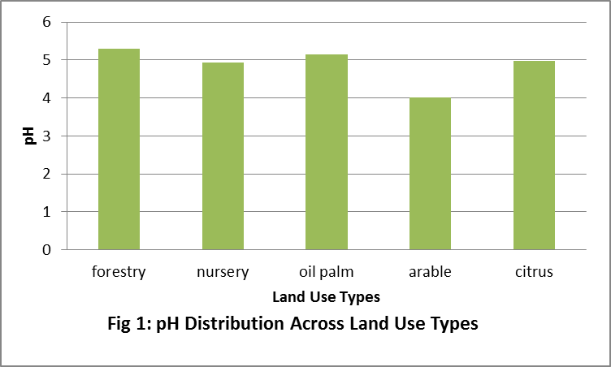
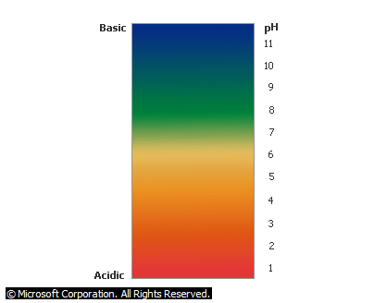
Fig 2: Soil pH Scale

Soil pH and Nutrient Availability: Considering the pH values recorded in this study (Forest land: 5.3, Oil palm: 5.2, Citrus: 5.0, Nursery site: 4.9 and Arable land site: 4.0) and recommended range of nutrient availability in relation to pH (figure 3); nutrient will be less available to plant. According to Belinda (2000) With the exception of P, which is most available within a pH range of 6 to 7, macronutrients (N, K, Ca, Mg, and S) are more available within a pH range of 6.5 to 8, while the majority of micronutrients (B, Cu, Fe, Mn, Ni, and Zn) are more available within a pH range of 5 to 7. Outside of these optimal ranges, nutrients are available to plants at lesser amounts.

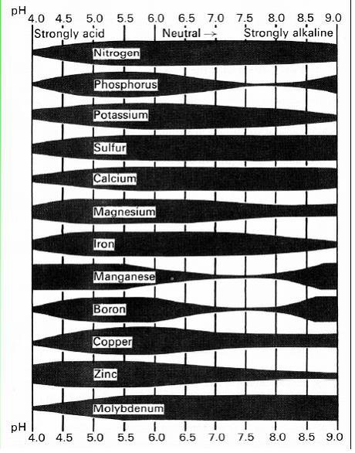
Fig 3: Relationship between plant nutrient availability and soil reaction (National Soil Survey Manual, NRCS)

Lime Requirement for the study area: One of the main goals of soil testing is to measure the soil pH. Knowing the pH is necessary to determine whether soil amendments are necessary in a soil planting area. Results obtained from this study revealed that the soil pH is not in the optimum range recommended especially for arable crop production hence there is need for amendments to improve the soil condition.
Results of computation made (Table 1) revealed that Forest Land and Oil Palm requires 10t/ha of grounded lime, Citrus orchard requires 12t/ha of grounded lime while Nursery and Arable sites requires 13t/ha of lime to make them to be productive.

Table 1: Lime Requirement of Land Use Types
Land Use Types | Measured pH | Soil Type (Babalola et.al, 2012) | Lime Application Requirement (Ground Limestone t/ha)
Forest Land | 5.3 | Sandy Loam | 10
Nursery | 4.9 | Sandy Loam | 13
Oil Palm | 5.2 | Sandy Loam | 10
Arable | 4.0 | Sandy Loam | 13
Citrus Orchard | 5.0 | Sandy Loam | 12

Conclusion and Recommendation
From the result obtained in the study, it is can be concluded that the soils of the study area is acidic and cannot sustain optimum arable crop production.
Lime application is recommended for the area at the following rates:

- Forest Land 10t/ha
- Nursery Site 13t/ha
- Oil Palm 10t/ha
- Arable 13t/ha
- Citrus Orchard 12t/ha

Corresponding Author:
Babalola Temitope Seun
Department of Crop Production Technology
Kabba College of Agriculture
Division of Agricultural Colleges
Ahmadu Bello University
Telephone: +2347030547750
E-mail: pauloxti@yahoo.com

References
- Wikipedia. Soil pH. https://en.wikipedia.org/wiki/Soil_pH. 2017. Retrieved 20th February, 2017.
- McCauley A, Jones C, Jacobsen A. Soil pH and Organic Matter. Montana State University, Nutrient Management 2009. Module 8.
- Dave M. Plant and Nutrient Availability. Soil Tech, Soil Testing Specialist. 2013.
- Higgins GM. Preliminary report on the detailed land, soil and contours survey of river line Area of School of Agric Kabba, Soil Survey Bulletin 1957. No 31. 28pp.
- Babalola TS, Oso T, Fasina AS, Godonu K. Land Evaluation Studies of Two Wetland Soils in Nigeria. International Research Journal of Agricultural Science and Soil Science. 2011. 1(6), 193-204.
- International Institute of Tropical Agricultural. (IITA) Selected methods for soil and plant analysis manual series No 1. Third Edition IITA, Ibadan, Nigeria. 1979. 34pp.
- Ristow PL, Foster J, Ketterings QM. Lime Guidelines for Field Crops; Tutorial Workbook. Department of Animal Science. Cornell University, Ithaca NY. 2010. 47pp.
- Babalola TS, Oloniruha JA, Ayodele FG, Kadiri WOJ, Ogundare SK. Assessing soil quality of three land use types in Otite, Southern Guinea Savannah, Nigeria. Biological and Environmental Sciences Journal for the Tropics 2012. 9(3):99-102.
- Babalola TS, Ogundare SK, Attah ES. Variability Studies of Soil Properties and Maize Yield in a Guinea Savannah Environment of Nigeria” International Journal of Applied Research and Technology 2013. 2(1):91 – 95.
- Tang C, Unkovich MJ, Bowden JW. Factors affecting soil acidification under legumes. III. Acid production by N2-fixing legumes as influenced by nitrate supply New Phytol. 1999. 143:513-521.
- United State Department for Agriculture (USDA) Soil pH. Soil Quality Kit, Guide for Educators. 2009. 6pp.
- Belinda L. Understanding Soil pH. New South Wales Acid Soil Action Program. 2000. Leaflet number 2.

2/19/2017

