Immediate and short-term effect of balloonmitral valvuloplasty on circumferential strain, global and regional biventricular systolic function: a two-dimensionalstrain echocardiographic study

Mohey Alabaady, Abdelrhman Ali, Mostafa Alsawasany, Mohammed Al-Deftar and Ahmed Saeed Swailum

Cardiology Department, Faculty of Medicine, Al-Azhar University, Egypt.
Ahmed_swelem38@yahoo.com

Abstract: Background: Two-dimensional strain has been developed for the quantitative assessment of global and regional myocardial function. Two-dimensional strain represents a novel technique to predict subclinical ventricular dysfunction in many diseases as ischemic heart disease with preserved ventricular function and hypertrophic cardiomyopathy. We use this technique in assessing regional, global longitudinal strain of both LV and RV and circumferential strain of LV before and after BMV done for patients with Rheumatic MS. Introduction: Mitral stenosis (MS) is the most common valve lesion in chronic RHD. Several mechanisms have been postulated to explain left ventricle (LV) systolic dysfunction in patients with MS, including chronically reduced preload, resulting in adverse LV remodeling, and the extension of inﬂammatory process from the mitral valve apparatus into the adjacent myocardium. Systolic dysfunction of the right ventricle (RV) is well documented in patients with rheumatic MS; RV dysfunction is usually overlooked before the emergence of clinical signs of systemic venous congestion because of difﬁculties in the quantitative of RV function. Aim of the study: Assessment of the immediate and short term effect of balloon mitral valvuloplasty (BMV) on circumferential strain, global and regional biventricular systolic function using 2D TTE strain. Methods and results: Twenty patients with mitral stenosis (MS) and 20 healthy subjects underwent full echocardiographic examinations, including left ventricle (LV) and right ventricle (RV) regional and global longitudinal strain (GLS) measurements. In MS patients, measurements were repeated within 24 h and 1 month after BMV. Patients with MS had lower LV and RV GLS compared with control (15.15±1.76 vs 20.95±1.43, P<0.001) and (17.55±2.45 vs -19.35±2.54 VS, P=0.031), respectively, at baseline before BMV. Signiﬁcant decrease was noted in the basal and septal segments compared with the apical LV segments and basal RV free wall. BMV resulted in signiﬁcant improvement in LV and RV GLS within 24 h post-BMV compared with baseline values (P < 0. 001 and <0.001, respectively), an improvement which was maintained after month. There was signiﬁcant positive correlation between both LV and RV GLS at baseline and mitral valve mean pressure gradient and RV systolic pressure and signiﬁcant inverse correlation between LV GLS and MVA. Conclusion: MS patients have subclinical LV and RV systolic dysfunction by GLS despite normal ejection fraction and fractional area change. BMV results in marked improvement in LV and RV GLS as well as CS immediately post-BMV with trend towards normalization at follow-up after 1 month. A mixed etiology theory involving a myocardial as well as a hemodynamic factor is believed to be the cause for this subclinical biventricular dysfunction and its improvement at short-term follow-up post-BMV. Recommendations: The presence of subclinical affection of LV function in patients with MS and the signiﬁcant sustained improvement in GLS of LV & RV also CS during short-term follow-up post-BMV proved in this study should have their impact on the current guidelines for BMV, so that we may consider in the future BMV for patients with impaired LV GLS in order to protect these patients from developing progressive LV systolic dysfunction. In addition, we recommend further study of the CS of LV in order to detect subclinical affection in patients with MS.
[Mohey Alabaady, Abdelrhman Ali, Mostafa Alsawasany, Mohammed Al-Deftar and Ahmed Saeed Swailum. Immediate and short-term effect of balloonmitral valvuloplasty oncircumferential strain, global and regionalbiventricular systolic function: a two-dimensionalstrain echocardiographic study. Researcher 2017;9(1):10-20]. ISSN 1553-9865 (print); ISSN 2163-8950 (online). http://www.sciencepub.net/researcher. 2. doi:10.7537/marsrsj090117.02.

Keywords: Two-dimensional strain - Global longitudinal strain – Circumferential strain –balloon mitral valvuloplasty - mitral valve area – Rheumatic heart disease - mitral stenosis.

1. Introduction
Rheumatic heart disease (RHD) is one of the most common forms of cardiac diseases, particularly in developing countries, where it remains the second most common cause of cardiovascular morbidity and mortality after atherosclerotic vascular disease^{1 – 3}. Mitral stenosis (MS) is the most common valve lesion in chronic RHD. Several mechanisms have been postulated to explain left ventricle (LV) systolic dysfunction in patients with MS, including chronically reduced preload, resulting in adverse LV remodeling, and the extension of inﬂammatory process from the mitral valve apparatus into the adjacent myocardium⁴. Systolic dysfunction of the right ventricle (RV) is well documented in patients with rheumatic MS; RV dysfunction is usually overlooked before the emergence of clinical signs of systemic venous congestion because of difﬁculties in the quantitative of RV function^{5 – 7}. Nowadays, a novel method, 2D strain, has been developed for the quantitative assessment of global and regional myocardial function^{8,9}. Two-dimensional strain represents a novel technique to predict subclinical ventricular dysfunction in many diseases as ischemic heart disease with preserved ventricular function¹⁰ and hypertrophic cardiomyopathy¹¹. The use of such technique to predict subclinical affection of biventricular function in MS patients and effect of BMV on this affection is lacking. The objective of this study was to assess global and regional LV and RV functions and CS using 2D strain in patients with MS before and after BMV. We postulate that the subtle changes in RV and LV functions in these patients will be evident using global longitudinal strain (GLS) despite presence of normal ventricular functions and that BMV will have its positive effect on these subtle changes.

2. Patients and methods
Patient population
This was a prospective observational study which included patients underwent elective BMV in the Cardiology Department of Bab El She’ryia University Hospital in the period from October 2015 to September 2016. The study included 20 patients and 20 healthy age- and sex-matched controls. The inclusion criteria for the study group were as follows: (i) patients’ age from 21 to 45 years. (ii) Symptomatic moderate-to-severe MS. (iii) Asymptomatic moderate-to-severe MS with significant pulmonary hypertension (ESPAP more than 50 mmHg at rest). The exclusion criteria were as follows: (i) patients with mild MS (MVA more than 1.5 cm). (ii) Patients who are not candidates for BMV (due to either Wilkins score ≥10, commissural calciﬁcation or left atrial thrombus). (iii)Moderate-to-severe valvular disease other than MS. (iv) Congenital MS. (v) Patients with organic tricuspid valve disease. (vi) Evidence of rheumatic activity during the preceding 6 months.(vii) Patients with impaired LV systolic function (deﬁned as EF, 54% using modiﬁed Simpson’s rule)¹². (viii) Patients with clinical evidence of right-sided heart failure. (ix) Patients with atrial ﬁbrillation or other atrial arrhythmias. (x) Patients with atrioventricular conduction abnormalities. (xi) Patients with hypertension, diabetes, or ischemic heart disease. (xii) Patients with chronic obstructive pulmonary disease. (xiii) Patients with pulmonary thromboembolic disease.
Echocardiographic and clinical data collection
All patients were subjected to the following: Informed verbal consent, full history taking. All patients were assessed clinically with full cardiological examination & resting 12 leads ECG was done to all. All patients (including control group) were studied in the left lateral decubitus position using an ultrasound system (Model Philips IE 33, Philips Medical Systems, USA)) using X5 & S5 transducers 3.5 MHZ. Standard 2D and M-mode echocardiograms were obtained. Basic measurements included LV wall thickness, LV internal dimensions, LV end-diastolic, and end-systolic volumes, LV EF by M mode and modiﬁed Simpson’s rule, left atrial (LA) anterior – posterior dimensions, left atrial end-diastolic volume, RV end-diastolic(RVEDA) and end-systolic areas(RVESA), RV fractional area change (RVFAC) which is calculated as(RVEDA - RVESA)/RVEDA X 100 and tricuspid annular plane systolic excursion13The conventional indices for assessment of the severity of MS; MVA by planimetry and pressure half-time and the mean mitral valve pressure gradients and PASP were measured as recommened¹⁴.
2D strain imaging
2D echocardiography images were obtained from para sternal short axis at the level of MV to get circumferential strain (global & segmental) LV apical long axis apical three chamber, apical four- and two-chamber views and modiﬁed apical view for RV. All images were obtained during breath hold, and stored in cine-loop format from three ormore consecutive beats. The frame rate for images was between 50 and 90 frames/s. All data were saved for further ofﬂine analysis. After deﬁning the endocardial border manually and adjusting the ROI width, an epicardial tracing was automatically developed by the software system in the following sequence: para sternal short axis (MV level) for a circumferential strain (global & segmental) apical long axis, apical four-chamber, and apical two-chamber for LV and modiﬁed apical view for RV. For each view, the endocardial border was manually traced in the end-systolic frame. The software then automatically generated myocardial strain curves by frame-by-frame tracking of the natural acoustic markers throughout the cardiac cycle. If the automatically obtained tracking segments were adequate for analysis, the software system was allowed to read the data, whereas analytically inadequate tracking segments were either corrected manually or excluded from the analysis. The myocardium of the LV in apical views was automatically divided into six walls (anterior septum, inferolateral, anterior, inferior, inferior septum & lateral,)and the myocardium of RV was divided into two walls (septum and RV free wall), all walls were then subdivided into three segments (apical, mid, and basal)while the myocardium of the LV in para sternal view short axis MV level was devided into sex segments (anterior, anteroseptum, anterolateral, inferior, inferolateral & inferoseptum). In blinded post-processing, longitudinal and circumferential deformation had been assessed by speckle tracking, being measured the peak systolic longitudinal strain (SPLS) for the 17 segment LV model from the apical 4-chambers, 2-chambers and long axis views, with high frame rates (> 60 frames/s) using Q LAB. End-systole was defined as aortic valve closure in the apical long-axis view by continuous Doppler wave recording. Automated delineation of endocardial borders was obtained through marking the mitral annulus level and at the apex on each digital loop. The area of interest was manually adjusted if automated delineation was not optimal. Segments with poor image acquisition or artifacts were excluded due to inability to measure LS. Segmental LS was calculated as the percentage of lengthening or shortening and the results for each plane were displayed. The peak systolic circumferential strain (SPCS) for 6 segments protocol were calculated from the short axis views at the level of mitral valve with high frame rates (> 60 frames/s).
Follow-up echocardiogram
All patients in the study group underwent full echocardiographic study including 2D strain of both RV and LV and CS within24 h and after 1 month post-BMV using the same machine for transthoracic echocardiogram (Follow-up study).
Statistical analysis
The collected data were revised, organized, tabulated and statistically analyzed using statistical package for social sciences (SPSS) version 23.0 for windows. Data are presented as the Mean ± standard deviation (SD), frequency, and percentage. Categorical variables were compared using the chi-square (χ2) and Fisher's exact tests (if required). Continuous variables were compared by the Student t test (two-tailed) for parametric data. Mann-Whitney U test was used to compare continuous nonparametric data. Paired sample T test was used to compare two 2 related samples for normally distributed data and Wilcoxon signed – rank and Friedman's ANOVA tests were used to compare related samples of data which were abnormally distributed. The level of significance was accepted if the P value < 0.05.

3. Results
Out of 50 patients referred to our hospital in the speciﬁed period of time for elective BMV, 20 patients were enrolled in this study. Ten patients were not ﬁt for BMV due to presence of LA thrombus by trans- esophageal echocardiographic study. The remaining 20 patients underwent BMV but were excluded from the study due to presence of comorbidities that might affect the LV-GLS values e.g. diabetes, hypertension and atrial ﬁbrillation. Of the excluded patients 3 had concomitant LV dysfunction deﬁned as EF≤54%.

Table (1): Demographic data of the studied sample.
Variables | No. (N= 40) | %
Group  Patient | 20 | 50.0
Control | 20 | 50.0
Gender  Male | 13 | 32.5
Female | 27 | 67.5
Age (M ± SD) | 28.93 ± 6.07

Table (2): Comparison baseline echocardiographic parameters between patients pre BMV and control groups.
Parameters |  | M ± SD |  |  | P
LAD | Patient | 5.09 | ± | 0.74 | < 0.001
 | Control | 35.46 | ± | 2.30
LVEDD | Patient | 47.3 | ± | 0.61 | 0.23
 | Control | 47.01 | ± | 0.99
LVESD | Patient | 31.3 | ± | 0.55 | 0.75
 | Control | 30.24 | ± | 2.89
EF SIM | Patient | 57.70 | ± | 2.39 | 0.931
 | Control | 57.59 | ± | 5.38
LVEDV | Patient | 85.80 | ± | 16.65 | < 0.001
 | Control | 108.95 | ± | 17.85
LVESV | Patient | 36.95 | ± | 7.39 | 0.001
 | Control | 46.90 | ± | 10.03
LAV | Patient | 104.15 | ± | 29.06 | < 0.001
 | Control | 37.35 | ± | 8.38
RVESV | Patient | 18.35 | ± | 2.92 | 0.054
 | Control | 20.45 | ± | 3.72
RVEDV | Patient | 34.40 | ± | 4.17 | 0.021
 | Control | 37.20 | ± | 3.11
FAC | Patient | 44.16 | ± | 3.32 | 0.41
 | Control | 45.03 | ± | 6.90

Table (3): Comparison of speckle tracking echocardiographic, global longitudinal strain, between patients and control groups.
Parameters |  | M | ± | SD | P
AP2 | Patients | -13.75 | ± | 1.65 | < 0.001
 | Control | -20.55 | ± | 1.76
AP4C | Patients | -15.05 | ± | 2.19 | < 0.001
 | Control | -21.35 | ± | 1.93
LAX(3C) | Patients | -14.70 | ± | 2.77 | < 0.001
 | Control | -20.50 | ± | 1.73
GLS LV | Patients | -15.15 | ± | 1.76 | < 0.001
 | Control | -20.95 | ± | 1.43

Table (4): Comparison of LV segmental speckle tracking echocardiographic parameters between patients pre BMV and control groups.
Parameters |  | M | ± | SD | P
A ANT | Patients | -9.35 | ± | 1.84 | < 0.001
 | Control | -19.45 | ± | 2.39
AP INF | Patients | -20.30 | ± | 4.26 | 0.263
 | Control | -21.60 | ± | 2.84
AP IL | Patients | -14.50 | ± | 3.33 | < 0.001
 | Control | -21.30 | ± | 3.28
AP LAT | Patients | -13.10 | ± | 2.10 | < 0.001
 | Control | -18.80 | ± | 5.97
AP AS | Patients | -16.25 | ± | 9.26 | 0.051
 | Control | -20.60 | ± | 2.72
AP IS | Patients | -21.05 | ± | 3.10 | 0.747
 | Control | -21.35 | ± | 2.72
B ANT | Patients | -14.37 | ± | 3.04 | < 0.001
 | Control | -21.30 | ± | 3.13
B AS | Patients | -10.85 | ± | 1.31 | < 0.001
 | Control | -21.35 | ± | 2.78
B IS | Patients | -9.80 | ± | 8.53 | < 0.001
 | Control | -20.55 | ± | 3.30
B INF | Patients | -19.55 | ± | 2.96 | < 0.001
 | Control | -22.95 | ± | 2.35
B LAT | Patients | -20.45 | ± | 2.42 | 0.006
 | Control | -22.90 | ± | 2.90
B IL | Patients | -15.95 | ± | 2.54 | < 0.001
 | Control | -21.35 | ± | 2.89
M ANT | Patients | -16.35 | ± | 3.83 | < 0.001
 | Control | -21.10 | ± | 2.69
M AS | Patients | -18.90 | ± | 1.33 | 0.027
 | Control | -20.45 | ± | 2.70
M IS | Patients | -14.95 | ± | 1.19 | < 0.001
 | Control | -22.40 | ± | 2.52
M INF | Patients | -19.40 | ± | 1.14 | 0.001
 | Control | -22.30 | ± | 3.29
M IL | Patients | -16.55 | ± | 3.19 | < 0.001
 | Control | -21.20 | ± | 2.89
M LAT | Patients | -17.40 | ± | 1.19 | < 0.001
 | Control | -21.25 | ± | 2.88

Table (5): Comparison of speckle tracking echocardiographic, circumferential strain, between patients pre BMV and control groups.
Parameters |  | M | ± | SD | P
CS | Patients | -17.05 | ± | 2.70 | < 0.001
 | Control | -27.65 | ± | 5.67

Table (6): Comparison of speckle tracking echocardiographic, right ventricular strain, between patients and control groups.
Parameters |  | M | ± | SD | P
B RV S | Patients | -10.05 | ± | 1.32 | < 0.001
 | Control | -18.00 | ± | 1.26
M RV S | Patients | -11.75 | ± | 2.22 | < 0.001
 | Control | -18.20 | ± | 1.15
AP RV S | Patients | -20.70 | ± | 2.77 | < 0.001
 | Control | -17.75 | ± | 1.48
B RV FW | Patients | -16.40 | ± | 3.53 | < 0.001
 | Control | -22.25 | ± | 2.10
M RVF W | Patients | -24.35 | ± | 3.59 | 0.003
 | Control | -21.50 | ± | 1.85
AP FW | Patients | -23.60 | ± | 3.23 | 0.001
 | Control | -20.50 | ± | 2.21
G RV | Patients | -17.55 | ± | 2.54 | 0.031
 | Control | -19.35 | ± | 2.54

Table (7) and figure (1): Comparison of MVA and MPG pre-& post BMV.
Parameters |  | M | ± | SD | P
MAV (2D) | Pre | 1.0 | ± | 0.15 | < 0.001
 | Post | 1.91 | ± | 0.22
M PG | Pre | 17.45 | ± | 6.68 | < 0.001
 | Post | 6.10 | ± | 2.25

Table (8): Comparison between baseline echocardiographic parameters measured in the study group before BMV and 24 hours post.
Parameters |  | M ± SD |  |  | P
LAD | Pre | 5.09 | ± | 0.74 | < 0.001
 | Post | 4.52 | ± | 0.45
LVEDD | Pre | 4.73 | ± | 0.61 | < 0.001
 | Post | 5.03 | ± | 0.54
LVESD | Pre | 3.13 | ± | 0.55 | 0.033
 | Post | 3.29 | ± | 0.52
EF SIM | Pre | 57.70 | ± | 2.39 | < 0.001
 | Post | 60.50 | ± | 2.69
LVEDV | Pre | 85.80 | ± | 16.65 | < 0.001
 | Post | 99.10 | ± | 21.82
LVESV | Pre | 36.95 | ± | 7.39 | < 0.001
 | Post | 42.65 | ± | 7.92
LAV D | Pre | 104.15 | ± | 29.06 | < 0.001
 | Post | 80.50 | ± | 25.71
RVESV | Pre | 18.35 | ± | 2.92 | < 0.001
 | Post | 11.70 | ± | 2.03
RVEDV | Pre | 34.40 | ± | 4.17 | < 0.001
 | Post | 24.60 | ± | 4.01
FAC | Pre | 46.16 | ± | 3.32 | < 0.001
 | Post | 50.77 | ± | 4.41

Table (9) and figure (2): Comparison between RV systolic pressure measured in the study group before and immediately & 1 month after BMV.
Parameters |  | M | ± | SD | P
RVSP | Pre | 54.20 | ± | 14.55 | < 0.001
 | 24 hrs. post. | 39.25 | ± | 9.30
 | 1 mon. post. | 35.40 | ± | 8.61

Table (10) and figure (3): Comparison between LV global strain (longitudinal & circumferential) and RV global strain measured in the study group before BMV, 24 HS post& 1 month after BMV.
Parameters |  | M | ± | SD | p
AP2 | Pre | -13.75 | ± | 1.65 | < 0.001
 | 24 hrs. post. | -18.25 | ± | 2.02
 | 1 mon. post. | -21.65 | ± | 2.39
AP4C | Pre | -15.05 | ± | 2.19 | < 0.001
 | 24 hrs. post. | -19.60 | ± | 1.96
 | 1 mon. post. | -21.75 | ± | 2.07
LAX (3C) | Pre | -14.70 | ± | 2.77 | < 0.001
 | 24 hrs. post. | -18.50 | ± | 2.46
 | 1 mon. post. | -20.55 | ± | 2.44
GLS LV | Pre | -15.15 | ± | 1.76 | < 0.001
 | 24 hrs. post. | -18.70 | ± | 1.72
 | 1 mon. post. | -20.75 | ± | 1.92
CS | Pre | -17.05 | ± | 2.70 | < 0.001
 | 24 hrs. post. | -21.90 | ± | 2.83
 | 1 mon. post. | -23.75 | ± | 2.20
G RV | Pre | -17.55 | ± | 2.54 | < 0.001
 | 24 hrs. post. | -23.40 | ± | 2.62
 | 1 mon. post. | -26.65 | ± | 2.92

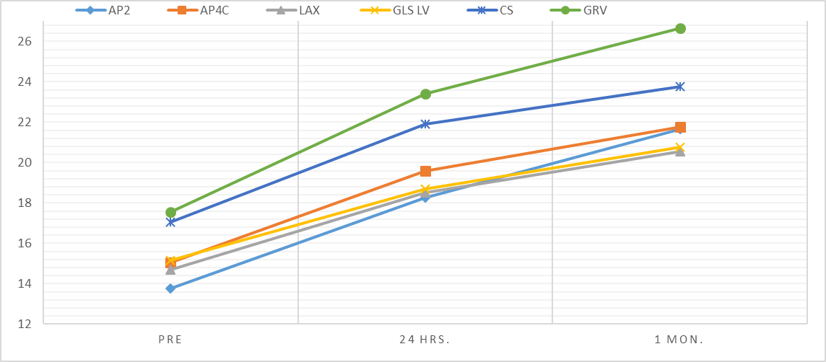
Figure (3): Comparison between LV global strain (longitudinal & circumferential) and RV global strain measured in the study group before immediately & 1 month after BMV

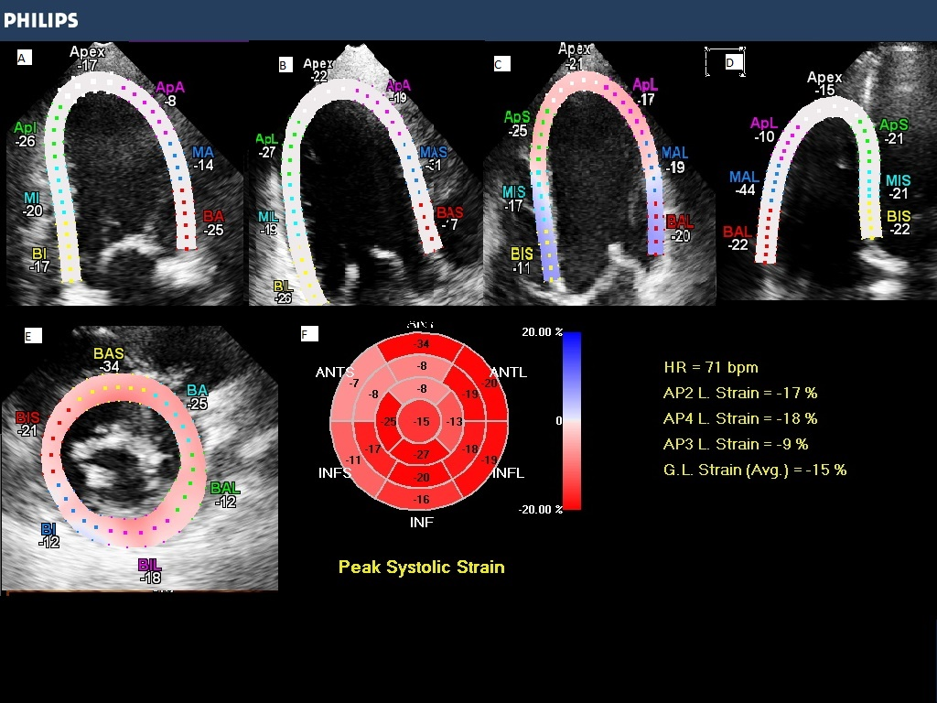

Figure (4): 2D strain analysis of the LV as traced in the apical four-chamber pre (left side) and post BMV (right side).

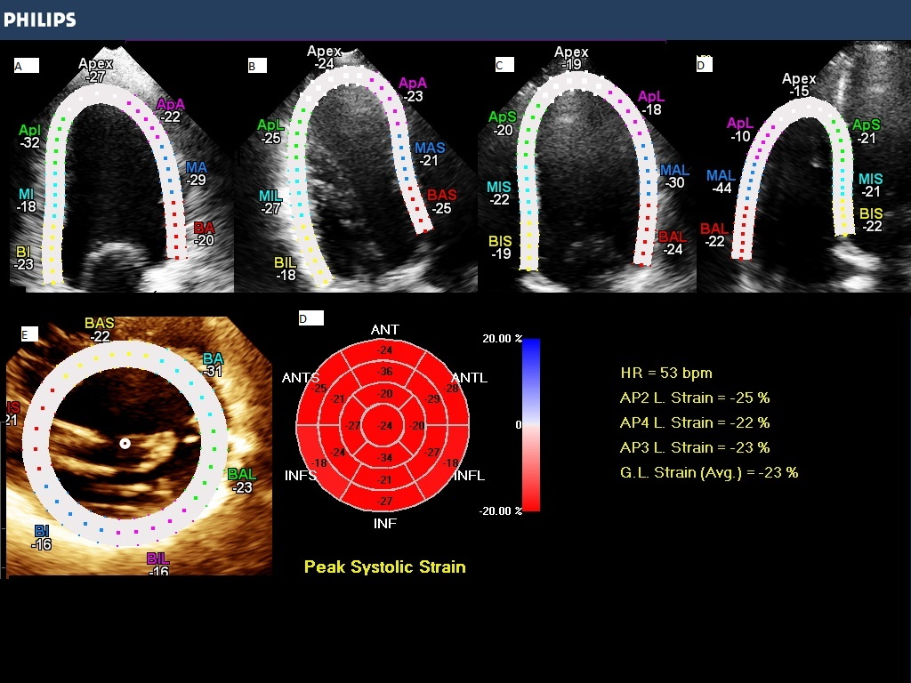
Figure (5): 2D Longitudinal strain of the RV pre (left side) and post BMV ( right side)in the same patient.

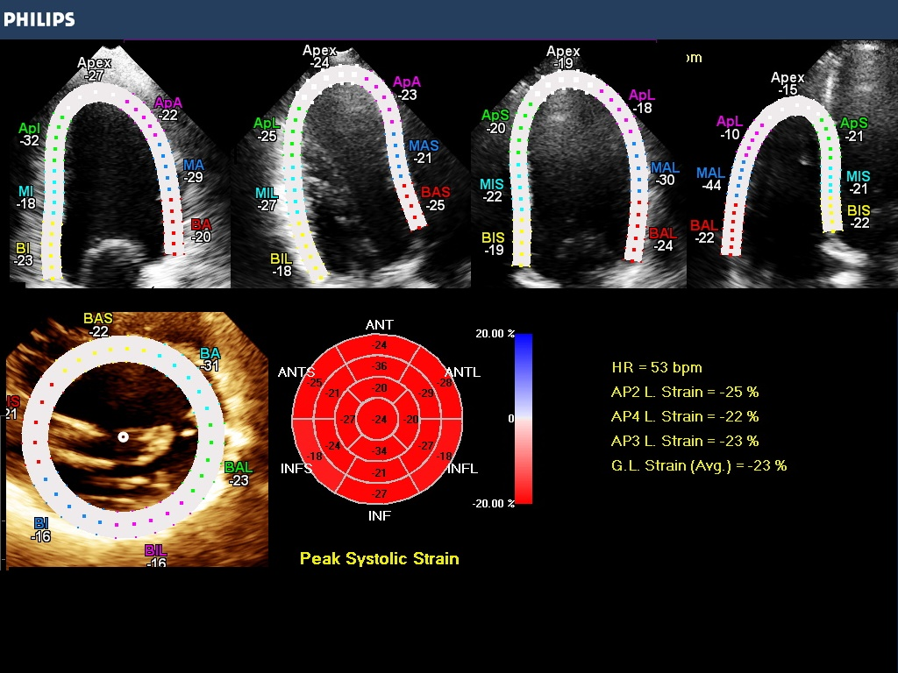
Figure (6): Comparison between LV global strain (longitudinal & circumferential) and RV global strain measured in the study group before immediately & 1 month after BMV.

4. Discussion
Although there is a downwards trend in the prevalence of MS in developed countries, it stands out as a huge public health problem in developing countries. Few studies have reported that LV systolic dysfunction may not be uncommon and may indeed contribute to the development of symptoms in patients with MS¹⁵. The researches for the most appropriate method to measure contractile characteristics of myocardium are still carrying on²². Nowadays, a novel method, 2D strain, has been developed for the quantitative assessment of global and regional myocardial function²³. This study did not study the effect of MS on global and regional subclinical biventricular function only, but also systematically evaluated the effect of BMV on these functions using GLS & CS immediately and after 1month post-BMV. As regard the study, the mean age of patients with MS was (28.93 ± 6.07). The mean duration of symptoms was 3.1± 4.2 years; all patients were in NYHA class II – III. Baseline echocardiographic parameters are shown in table (2). There was no signiﬁcant difference between the study group and the control group as regard LV dimensions, LV function by modified Simpsons’ method, and RV function by FAC. There was signiﬁcant difference between the study group and the control group as regard LA antero-posterior diameter (5.09±0.74 vs 35.46±2.30, p<0.001) & LA volume (104.15±29.06 vs37.35±8.3, p<0.001), which is be due to increase LA pressure due to valve stenosis & LV volumes (LVEDV & LVESV), 85.8± 16.65 vs 108.95±17.85, p<.001 and 36.95±7.39 vs 46.9±10.03, P<.001 respectively). that is may be due to decrease flow across the mitral valve and decrease LV filling. Most of the patients in the study group underwent successful BMV with signiﬁcant increase in planimetry measured MVA (1.0±0.15 vs 1.91±0.22, p<0.001) as well as signiﬁcant drop in mean PG across the mitral valve (17.45±6.68 vs 6.1±2.25, p<0.001) and pulmonary artery systolic pressure (54.2±14.55 VS 39.35±9.3, p<0.001) (Table 7). There was signiﬁcant decrease in LA diastolic dimension with base line measurements before BMV (5.09±0.74 VS 4.52±0.45, P<0.001 and diastolic volume (104.15±29.06 vs 80.5±25.71, p<0.001). There was also signiﬁcant increase in LV end -diastolic and systolic volumes (85.8±16.65 VS 99.1±21.82, P<0.001 and 36.95±7.39 VS 42.65±7.92, P<0.001) respectively. There is also significant increase in EF (57.7±2.93 VS 60.50±2.69, P<0.001). There was signiﬁcant decrease in RV volumes (RVESV &RVEDV) (18.35±2.92 vs 11.7±2.03, p<0.001 and 34.4±4.17 vs 24.6±4.01, p<0.001) respectively immediately after BMV. There was signiﬁcant increase in RV FAC (46.16±3.32 VS 50.77±4.41, P<0.001). The decrease in LA dimension and volume may be due to decrease pressure across the mitral valve after balloon dilatation of the MS. While the increase in LV dimension systolic & diastolic and accordingly EF is due to increase flow through the MV after dilatation (increase LV filling) (hemodynamic effect). As regard RV volumes & FAC; the decrease in volumes may be due to decrease LA pressure and accordingly decrease PVR &also may be due to decrease RVSP. Compared with the control group, patients had signiﬁcantly lower LV and RV GLS (-15.15±1.76 vs 20.95±1.43, P<0.001) and (-17.55±2.45 vs -19.35±2.54 VS, P=0.031), respectively, at baseline before BMV (Table 3). Although, compared with the control group, patients had signiﬁcantly lower circumferential strain (CS) (MV level) (-17.05±1.43 vs -27.65±5.67, P=0.001) (table 5). The signiﬁcant decrease in the LV GLS values compared with control group was signiﬁcant throughout the whole segments with the exception of the apical inferior, apical antero-septum and apical inferior septum (Tables (4). On the other hand, the decrease in RV GLS vs. control group was only signiﬁcant in the septalsegments (mid& basal) only and basal RV free wall (Table 6). While there is increase in segmental LS of the RV vs control group was noticed in other segments (apical RV septum, mid RV free wall and apical RV free wall), but the net of the total segments was decrease in RV GLS in the study group compared to control group (Table 6). Immediately after BMV, there was signiﬁcant improvement in LV GLS in all views as well as the average GLS compared with baseline measurements (-18.7±1.72 vs -15.15±1.76, p<0.001). This improvement was sustained at follow-up after 1 months with signiﬁcant improvement compared with both the pre-BMV values (-20.75±1.92 vs -15.15±1.76, p<0.001) and the immediate post-BMV values(-20.75±1.92 vs -18.7±1.72, p<0.001) (Table 10). There was progressive trend towards normalization of the LV GLS values compared with the control group measurements during follow-up. There was also signiﬁcant improvement in RV GLS compared with baseline measurements (-23.4±2.62 vs -17.55±2.54, p<0.001). This improvement was sustained at follow-up after 1month with signiﬁcant improvement compared with both the pre-BMV values (-26.65±2.92 vs -17.55±2.54, p<0.001) and the immediate post-BMV values (-26.65±2.92 vs -23.4±2.62, p<0.001), table (10). There was also progressive trend towards normalization of the RV GLS values compared with the control group measurements during follow-up (Figure 5). The LV average GLS showed modest but signiﬁcant positive correlation with mean pressure gradient across mitral valve (MPG; r= 0.5, P = 0.006) and right ventricular systolic pressure (RVSP; r =0.6, P ¼ 0.005), and modest but signiﬁcant inverse correlation with MVA by planimetry (r =20.4, P = 0.04. The RV GLS showed strong highly signiﬁcant correlation with RVSP (r = 0.7, P 0.001) and modest but signiﬁcant correlation with the MPG across the mitral valve (r = 0.6, P= 0.001). This study is the first study to evaluate the CS in patients with MS and the effect of BMV on it. We choose LV-CS on the MV level as it may be the most affected one (nearest segments to the MV leaflets). There was significant decrease of CS in patients with MS compared with control group(-17.05±2.7 vs -27.65±5.67, P<0.001) (table 5). Immediately after BMV, there was signiﬁcant improvement in LV CS global and segmental compared with baseline measurements (-17.05±2.7 vs -21.9±2.83, p<0.001). This improvement was sustained at follow-up after 1 month with signiﬁcant improvement compared with both the pre-BMV values (-23.75±2.2 vs -17.05±2.7, p<0.001) and the immediate post-BMV values (-23.75±2.2 vs -21.9±2.83, p<0.001)(table10). Further assessment of this function is of importance in order to assess the CS in patients with MS in the 3 levels of the short axis (MV level, papillary muscle level & apical level). We were expecting that CS of the LV which is a part of the LV function will try to compensate the decrease in LV LS, but this does not occur. In order to test an underlying myocardial factor for this decrease, this study compared regional LV longitudinal strain in the study group vs. control group. The presence of signiﬁcant decrease in LV basal and mid-segmental strain values compared with control group and less or non-signiﬁcant decrease in some apical segments (apical inferior, apical anterior septum & apical infero-septum) point out to possible underlying myocardial factor where rheumatic endocarditis and scarring extend from the mitral annulus to the surrounding LV segments; an effect that fades away as we go towards the apical segments. As our study found that the rest of other apical segments is affected and have lower segmental LS for example for apical anterior in study group compared to control group (-9.35±2.7 vs -19.45±2.39, p<.001), this may decline the thinking of rheumatic endocarditis and scarring may be the cause of subclinical affection. This myocardial factor could be the cause of incomplete improvement of the GLS after BMV and act as a contributing factor to the main effect of preload reduction in patients with MS on GLS. Immediately after BMV, there was signiﬁcant improvement of LV GLS compared with the same measurements before BMV (-15.15±1.76 vs 20.95±1.43, P<0.001). We demonstrated the presence of modest but signiﬁcant correlation between LV GLS and indicators of success post-BMV, namely MPG (r = 0.5, P= 0.006) and RVSP (r=0.6, P= 0.005), and modest but signiﬁcant inverse correlation with MVA by planimetry (r=20.4, P=0.04 and r=20.5, P= 0.005). In addition, this study showed a trend towards normalization of LV GLS compared with the control group after follow-up period of 1 months (-20.75±1.43 vs. -20.95±1.92). Whether this trend will continue on long-term follow-up till the complete normalization of these measurements or the suspected underlying myocardial factor will prevent these variables from complete normalization will need longer term follow-up. This study also found reduced RV GLS in patients with MS compared with controls (-23.4±2.62 vs -17.55±2.54, p<0.001). This study also demonstrated difference in regional RV longitudinal strain, there was signiﬁcant decrease in the RV strain values of the septal segments, and basal RV free wall but there was no signiﬁcant difference between the mid and apical RV free wall segments and those of the control group. This difference in the septal segments may point out to possible underlying myocardial factor where the rheumatic endocarditis and scarring extend from the mitral annulus to the surrounding LV segments and thus reﬂecting changes actually also occurring in the LV septum and affecting the mid & basal segments of the RV side. Our study found that segmental LS of the basal RV free wall is decreased compared to control group) -16.4±3.53 vs -22.25±2.1, p<0.001)this may be due to that the selected patients might have mild rheumatic TV affection undetected which affect basal RV free wall and affect also the basal septum of the RV. Most of the patients in our study have TR of varying degrees which is common than TS in rheumatic TV affection. Our study also found that apical segments (septal & RV free wall) have normal segmental LS in the patients group and even have higher LS compared to control group. This may be due to compensatory increase in their LS, may be due to increase in RVSP. Immediately after BMV, there was signiﬁcant improvement of the RV GLS compared with the RV GLS before BMV (-19.35±2.54 VS 17.55±2.54, p<0.001). All septal segments and basal RV free wall have shown improvements immediately and after 1month. This improvement could be due to the improvement in the RV afterload as a result of the relief of the LV inﬂow obstruction. There was signiﬁcant correlation between the RV-GLS and both MPG (r = 0.6, P= 0.001) and RVSP (r = 0.7, P = 0.0001) which again points out to the role of BMV in the relieve of the LV inﬂow obstruction and consequently the decrease in the RV afterload which represent a major contributing factor in the improvement of the RV GLS. This study showed signiﬁcant improvement of RV GLS compared with the control group immediately after BMV (-23.40± 2.62% vs. - 19.35± 2.54) which continued at follow-up after 1 month (-26.65+ 2.92% vs. -19.35± 1.3). We believe that this improvement is directly related to the signiﬁcant reduction in both RV volumes as well as RV systolic pressure post-BMV.
Study limitations and recommendations
The extensive exclusion criteria applied to the patients before enrolment in the study may suggest that the population is not a real-world population. The main objective of this extensive exclusion criteria was to try to document the presence of subtle changes in LV and RV systolic functions related to MS and not to any other disease process and to test the effect of BMV on these changes. Correlation of decreased LV GLS in MS patients and future development of LV systolic dysfunction deﬁned as EF ≤54%. Using longer-term studies should be considered. Such a correlation if proved together with the presence of subclinical affection of LV function in patients with MS and the signiﬁcant sustained improvement in GLS of LV & RV also CS during short-term follow-up post-BMV proved in this study should have their impact on the current guidelines for BMV, so that we may consider in the future BMV for patients with impaired LV GLS in order to protect these patients from developing progressive LV systolic dysfunction. Also we recommend further study of the CS of LV in order to detect subclinical affection in patients with MS.

Conclusions
2D strain represents an evolving technique to identify subclinical LV and RV systolic dysfunction. This study represents the ﬁrst attempt to study both LV and RV 2D strain and CS in the same group of patients with MS and to follow-up these patients after successful BMV. There was a signiﬁcant decrease in both LV and RV GLS as well as CS compared with control group, a decrease which showed signiﬁcant improvement in the immediate and short-term follow-up after BMV. We strongly support a mixed etiology theory involving both an. underlying myocardial as well as hemodynamic factor for subclinical affection of both RV and LV functions in patients with MS. The presence of signiﬁcant difference in the regional strain values of both LV and RV segments and CS compared with control group points out to a myocardial factor, whereas the signiﬁcant improvement in the RV and LV GLS and CS post-BMV underlines the important role of a hemodynamic factor in this improvement.

Reference
- Pastore S, De Cunto A, Benettoni A et al. The resurgence of rheumatic fever in a developed country area: the role of echocardiography. Rheumatology (Oxf) 2011;50:396 – 400.
- Chandrashekhar Y, Westaby S, Narula J. Mitral stenosis. Lancet 2009;374:1271 – 83.
- Wang CR, Liu CC, Li YH et al. Adult-onset acute rheumatic fever: possible resurgence in southern Taiwan. J Clin Rheumatol 2005;11:146 – 9.
- Mohan JC, Khalilullah M, Arora R. Left ventricular intrinsic contractility in pure rheumatic mitral stenosis. Am J Cardiol 1989;64:240 – 2.
- Sagie A, Freitas N, Padial LR et al. Doppler echocardiographic assessment of long-term progression of mitral stenosis in 103 patients: valve area and right heart disease. J Am Coll Cardiol 1996;28:472 – 9.
- Sadeghpour A, Harati H, Kiavar Met al. Correlation of right ventricular dP/dt with functional capacity and RV function in patients with mitral stenosis. Int Cardivasc Res J 2008;1:208 – 15.
- Haddad F, Doyle R, Murphy DJ et al. Right ventricular function in cardiovascular disease, Part II pathophysiology, clinical importance, and management of right ventricular failure. Circulation 2008;117:1717 – 31.
- Leitman M, Lysyansky P, Sidenko S et al. 2D Strain novel software for real-time quantitative echocardiographic assessment of myocardial function. J Am Soc Echocardiogr 2004;17:1021 – 9.
- Teske AJ, De Boeck BWL, Melman PG et al. Echocardiographic quantiﬁcation of myocardial function using tissue deformation imaging, a guide to image acquisition and analysis using tissue Doppler and speckle tracking. Cardiovasc Ultrasound 2007;5:27.
- Cimino S, Canali E, Petronilli V et al. Global and regional longitudinal strain assessed by two-dimensional speckle tracking echocardiography identiﬁes early myocardial dysfunction and transmural extent of myocardial scar in patients with acute ST elevation myocardial infarction and relativelypreserved LV function. EHJ-CI 2013;14:805 – 11.
- Saito M, Okayama H, Yoshii Tet al. Clinical signiﬁcance of global two-dimensional strain as a surrogate parameter of myocardial ﬁbrosis and cardiac events in patients with hypertrophic cardiomyopathy. EHJ-CI 2012;13:617 – 23.
- Devereux RB, Roman MJ, Liu JE et al. Congestive heart failure despite normal left ventricular systolic function in a population-based sample: the strong heart study. Am J Cardiol 2000;86:1090 – 6.
- Lang RM, Bierig M, Devereux R et al. Recommendations for Chamber quantiﬁcation: a report from the American Society of Echocardiography’s Guidelines and Standards Committee and the Chamber Quantiﬁcation Writing Group, Developed in Conjunction with the European Association of Echocardiography, a Branch of the European Society of Cardiology. Eur J Echocardiogr 2005;12:79 – 108.
- Baumgartner H, Hung J, Bermejo J et al. Echocardiographic assessment of valve stenosis. EAE/ASE recommendations for clinical practice. Eur J Echocardiogr 2009;10:1 – 25.
- Klein A, Carroll JD. Left ventricular dysfunction and mitral stenosis. Heart Failure Clin 2006;2:443 – 52.
- Gaasch WH, Folland ED. Left ventricular function in rheumatic mitral stenosis. Eur Heart J 1991;12(Suppl. B):66.
- Sagie A, Freitas N, Padial LR et al. Doppler echocardiographic assessment of long-term progression of mitral stenosis in 103 patients: Valve area and right heart disease. J Am Coll Cardiol 1996; 28:472.
- Meris A, Faletra F, Conca C et al. Timing and magnitude of regional right ventricular function; a speckle tracking-derived strain study of normal subjects and patients with right ventricular dysfunction. J Am Soc Echocardiography 2010;23:823–31.
- Pedrinelli R1, Canale ML, Giannini C, et al. Abnormal right ventricular mechanics in early systemic hypertension: a two-dimensional strain imaging study. Eur J Echocardiogram 2010;11:738–42.
- Tulevski II, Romkes H, Dodge-Khatami A, et al. Quantitative assessment of the pressure and volume overloaded right ventricle: imaging is a real challenge. Int J Cardiovasc Imaging 2002;18: 41 – 51.
- Wang A, Ryan T, Kisslo KB, et al. Assessing the severity of mitral stenosis: variability between noninvasive and invasive measurements in patients with symptomatic mitral valve stenosis. Am Heart J 1999;138:777 – 84.
- Mor-Avi V, Lang R, Badano L, et al. Current and evolving echocardiographic techniques for the quantitative evaluation of cardiac mechanics: ASE/EAE consensus statement on methodology and indications. Eur J Echocardiogr 2011;12:167 – 205.
- Guven S, Sen T, Tufekcioglu O, et al. Evaluation of left ventricular systolic function with pulsed wave tissue Doppler in rheumatic mitral stenosis. Cardiol J 2014;21:33 – 8.
- Delgado V, Tops LF, van Bommel RJ, et al. Strain analysis in patients with severe aortic stenosis and preserved left ventricular ejection fraction undergoing surgical valve replacement. Eur Heart J 2009;30: 3037–47.
- De Isla LP, de Agustin A, Rodrigo JL, et al. Chronic mitral regurgitation: a pilot study to assess preoperative left ventricular contractile function using speckle-tracking echocardiography. J Am Soc Echocardiogr 2009;22:831–8.
- Tayyareci Y, Yildirimturk O, Aytekin V, et al. Subclinical left ventricular dysfunction in asymptomatic severe aortic regurgitation patients with normal ejection fraction: a combined tissue Doppler and velocity vector imaging study. Echocardiography 2009; 27:260–8.
- Ozdemir AO, Kaya CT, Ozdol C, et al. Two-dimensional longitudinal strain and strain rate imaging for assessing the right ventricular function in patients with mitral stenosis. Echocardiography 2010;27:525 – 33.
- Kumar V, Jose VJ, Pati PK, et al. Assessment of right ventricular strain and strain rate in patients with severe mitral stenosis before and after balloon mitral valvuloplasty. Indian Heart J 2014;66:176 – 82.
- Sengupta SP, Amaki M, Bansal M, et al. Effects of percutaneous balloon mitral valvuloplasty on left ventricular deformation in patients with isolated severe mitral stenosis: a speckle-tracking strain echocardiographic study. J Am Soc Echocardiogr 2014;27:639 – 47.
- Bilen E, Kurt M, Tanboga IH, et al. Severity of mitral stenosis and left ventricular mechanics: a speckle tracking study. Cardiology 2011;119:108 – 15.
- Alaa M. Roushdy, Sameh S. Raafat, Khaled A, et al. Immediate and short-term effect of balloon mitral valvuloplasty on global and regional biventricular function: a two-dimensional strain echocardiographic study: European Heart Journal - Cardiovascular Imaging Advance Access, 2015.

1/3/2017

