Evaluation of Habitats of Mosquitoes (Culicidae) Larvae in the Gwagwalada Area Council, Federal Capital Territory Abuja

Ebuzoeme, Vincent

Department of Biological Science, University of Abuja, Nigeria.
ebuzoemev@gmail.com

Abstract: Studies on the evaluation of larval habitats of mosquitoes (culicidae) in selected Communities of Gwagwalada Area Council of Federal Capital Territory, Abuja were carried out from January 2015 to December 2015 using standard entomological procedures at various communities of Dobi, Kutunku, Paiko Kore and Tungamaje. Of the 391 selected potential larval habitats/sites examined 272 breeding were found to contain larvae. The abundance of mosquito larvae in the various breeding habitats were as follows; Gutters (BH1) 528 (30.72%), Ditches/ponds (BH2) 289 (16.81%), Road side pot holes (BH3) 163 (9.48%), Clay pots (BH4) 283 (16.46%), peri-domestic run-off water (BH5) 115 (6.69%), Plastic Containers (BH6) 77 (4.48%), Abandoned tyres (BH7) 207 (12.04%), Metals containers (BH8) 49 (2.85%), Tree holes/leaf axils (BH9) 8 (0.47%) respectively. A total of one thousand seven hundred and nineteen (1719) mosquito larvae were collected and classified into three genera Aedes 601 (34.96%), Anopheles 309 (17.98%) and Culex 809 (47.06%) respectively. The mosquito larval abundance in these study areas were significantly (P<0.05) different. The continued presence of Anopheles and Culex would ensure endemicity of malaria and filariasis in Gwagwalada, while the presence of Aedes points towards the potential risks of yellow fever and arbo-virus diseases in the area. The results are discussed and the need for concerted efforts in mosquito control in Gwagwalada is hereby suggested.
[Ebuzoeme, Vincent. Evaluation of Habitats of Mosquitoes (Culicidae) Larvae in the Gwagwalada Area Council, Federal Capital Territory Abuja. Researcher 2016;8(12):1-5]. ISSN 1553-9865 (print); ISSN 2163-8950 (online). http://www.sciencepub.net/researcher. 1. doi:10.7537/marsrsj081216.01.

Keywords: Larvae, Mosquitoes, Breeding habitats, Abundance, Gwagwalada.

1. Introduction
Mosquito-borne diseases constitute one of the major health problems in Nigeria. Mosquitoes are of great and remarkable importance to the health and economic development of man. They transmit and disseminate both human and animal diseases. Among the public health and veterinary important arthropods, mosquitoes rank first in the spread of such diseases as malaria, yellow fever, filariasis, dengue fever, encephalitis as well as other viral and bacterial diseases (Gillet, 1972; Service, 1980). Apart from disease transmission, mosquitoes are regarded as public enemies because of their biting annoyance, noise nuisance, sleeplessness and allergic reactions due to their bites (Onyido et al., 2009).
Mosquito aquatic habitats are often created by human or animal activities where in larvae are found in small depressions including foot or hoof prints, edges of boreholes, burrow pits, road side puddles formed by tyre tracks, irrigation ditches and other artificial bodies of water (Gimnig et al., 2001). Vector control is one of the major elements of the world health Organization (WHO) global mosquito-borne diseases control strategy, that is primarily focused on indoor residual spraying and the use of Insecticide Treated Nets (ITNs), however these control measures have drawbacks including insecticide resistance and difficulties in achieving high coverage (Killeen et al., 2002). Before World War II, source reduction and other anti-larval measures were the main pillars of mosquito borne disease control (Kitron and Spielman, 1989). This control approach has been largely neglected in past decades in Sub-Saharan Africa, partly because of the perceived difficulties in identifying larval habitats especially in rural and difficult to reach areas (Sogoba et al., 2007).
Interest in environmental management of mosquito larval habitats has been rekindled due to the debilitating effects of malaria in tropical Africa (Fillinger et al., 2004). Appropriate management of larval habitats in Sub-Saharan countries, particularly during the dry season may help suppress vector densities and mosquito-borne diseases transmission. Permanent breeding sites during the dry season may serve to seed the additional habitats formed during the rainy season (Lindsay et al., 1991; Killeen et al., 2006). Therefore, dry season larval control might prevent this sharp increase that is in the absence of adult mosquitoes which normally survive the dry season by aestivating and thus play a crucial role in integrated vector control strategy (Fillinger et al., 2004). For instance, source reduction through management of larval habitats had been the key factor in malaria eradication efforts in the United States, Italy and Israel (Kitron and Spielman, 1989).
Suppression and even eradication of malaria in these regions were attributed to effective large scale programmes that targeted the immature vector mosquitoes or reducing the extent of suitable habitats in proximity to vulnerable human populations (Killeen et al., 2002). Therefore, application of larval control approach is considered an effective method of mosquito control and for the campaign to be successful, the types of habitats must be considered. Subsequently the most productive habitat should be given a priority attention.

2. Materials and Methods

The study was carried out in some selected areas of Gwagwalada Area Council, Federal Capital Territory (Abuja) Nigeria. The area is located between latitude 8⁰55’52’’N, 9⁰14’34’’N and longitude 6⁰51’36’’E, 7⁰11’35’’E (Balogun, 2001). The whole study area is located within the northern boundary of the Guinea Savannah, the total annual rainfall of approximately 1,650mm per annum. Four settlement areas were randomly selected out of Gwagwalada, these are: Tunganmaje, Poiko Kore, Kutunku and Dobi. Recently, Gwagwalada has witness an influx of people from different parts of Nigeria and beyond due to its proximity to the Abuja the Federal Capital city and the University of Abuja. The influx of people necessitated huge construction activities opening up areas which were hitherto unoccupied. The data were analyzed using the Chi-Square at probability of 0.05. The relative abundance and distribution of the mosquito larvae and species were determined and expressed as percentages of the total. Charts were also used to express some of the observations.

3. Results

The mosquito breeding habitats and abundance in selected areas of Gwagwalada, FCT are presented in figure 1. The number of selected potential larva breeding habitats/sites examined was 391 of which 272 breeding habitats site were found to contain one or more larvae. Within the study areas of Dobi, Kutunku, Poiko Kore and Tunganmaje different types of habitats were identified, the included; Concrete Gutters (BH1) 528 (30.72%), Ditches/ponds (BH2) 289 (16.81%), Road side pot holes (BH3) 163 (9.48%), Clay pots (BH4) 283 (16.46%), Peri-domestic run-off water (BH5) 115 (6.69%), Plastic Containers (BH6) 77 (4.48%), Abandoned types (BH7) 207 (12.04%), Metals containers (BH8) 49 (2.85%), Tree holes/leaf axils (BH9) 8 (0.47%). The result showed that BH1 seems to potentially breed highest proportion of larva among other breeding sites while BH9 had the least numbers of mosquito larvae. There was a significant difference in the diversity of larval habitats of mosquitoes in selected areas P-Value 0.000< 0.05.
The results shown in figure 2 revealed that Culex had the highest percentage of occurrence at Dobi 271 (44.21%), Kuntuku 298 (58.32%), Tunganmaje 137 (44.63%) while Aedes had the highest percentage of occurrence in Poiko Kore 107 (37.15%). Culex was found to be the most abundant species within the four sample locations 809 (47.06%) while Anopheles was the least in occurrence 309 (17.98%) there was a significant difference (P-Value 0.000 < 0.05) in the relative abundance and distribution of mosquito larvae within their breading habitats.
The distribution of mosquito species in different breeding habitats Figure 3 shown that Anopheles breeds highest numbers of larvae in BH2 (170), Aedes had it highest breeding in BH4 (194) and Culex in BH1 (410). Aedes and Culex had their least occurrence in BH9 (0). There was a significant difference (P<0.05) in mosquito breeding and preferred larval habitats in selected areas of Gwagwalada FCT.
The monthly distribution and abundance of mosquito larvae at various study areas is shown in figure 4. The month of July had the highest recorded abundance for the three species of mosquito, Anopheles 50 (2.91%), Culex 196 (11.60%) and Aedes (6.23%) respectively while the least recorded species abundance was noted in the month of January, Anopheles 8 (0.47%), Culex 20 (1.16%) and Aedes 16 (0.93%).

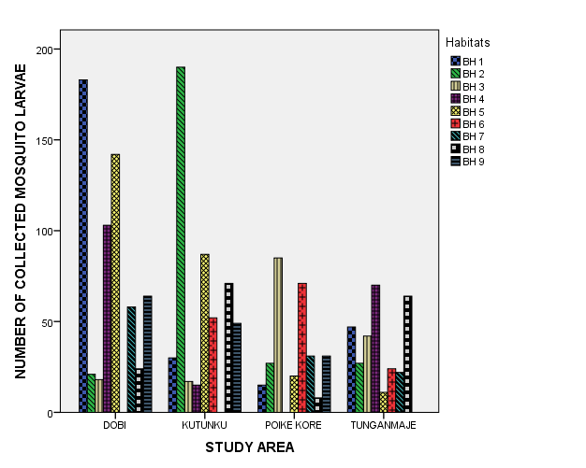
Figure 1: Mosquito breeding habitats and the relative abundance of mosquito larvae in study areas.

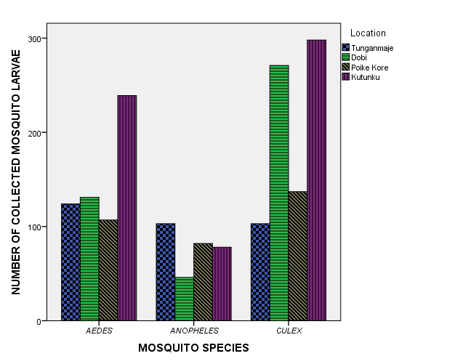
Figure 2: Distribution of mosquito larvae species in selected study areas of Gwagwalada Area Council of FCT.

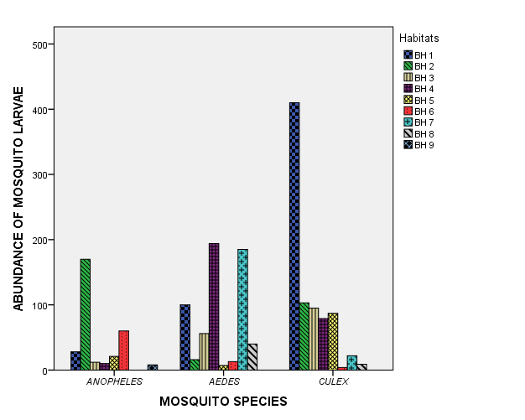
Figure 3: Distribution of mosquito species in different breeding habitats.

Figure 4: Monthly distribution and abundance of mosquito at various study areas

4.0 Discussion
Mosquitoes use different natural and artificial habitats as sources of water for oviposition and breeding. These breeding sites were numerous in Gwagwalada. This was due to varied human activities, poor economic conditions, abundant numbers of construction sites, poor sanitation level and indiscriminate disposal of discarded household materials. The resultant effect is abundance of ditches/ponds, road side pot holes, clay pots, peri-domestic runoff water, abandoned tyres, water collections in tins, bowls, drums and containers of varying sizes. This observation is in line with the acertions of Mafiana et al. (1998). Gwagwalada also lies in the Guinea savanna area of Nigeria, an area that had been described to be conducive for the breeding and survival of mosquitoes of different species (WHO, 1989).
Dobi community had the highest breeding sites with the highest number of larvae collected. This may be as a result of differences in the microhabitat conditions of these study areas. For instance, during the study it was observed that the study areas were low lying, prone to flood waters and had swampy terrain. Dobi and Kutunku study areas also are more of rural settings with inhabitants often keeping water holding vessel around their homes. Due to the swampy terrain of the communities, the grounds were able to retain water for a longer period of time thus serving as breeding sites for mosquitoes. These explain why there were higher numbers of breeding sites recorded in Kutunku. The collection of one thousand seven hundred and nineteen mosquito larvae from different breeding sites in Gwagwalada is an indication of intensive breeding of mosquito in the area as well as preponderance of their breeding sites.
Breeding Habitat type 1 also had the highest larval mean density thereby making it the most preferred breeding habitat in the study areas with about thirty percent of all larvae collected from them, while Breeding Habitat type 9 (tree holes/leaf axils) where least preferred. The breeding habitat choice of mosquitoes was in line with that recorded by Okogun et al. (2005), Awolola et al. (2005), Oyewole et al. (2007), Anosike et al. (2007) and Adeleke et al. (2008), who observed that domestic containers, gutters and cans were the breeding site of choice by mosquitoes. Mwangangi et al. (2007) and Okogun et al. (2005) opined that the greater larval density observed in gutters, cans, containers and tyres was due to the absence of or reduced larval predation by mosquito natural enemies in such habitats the result of the present study showed a similar trend.
During the study, three genera of mosquitoes were collected; Anopheles, Aedes and Culex found to breed in a wide variety of habitats. All species of mosquitoes reported in this study had also been reported by different researchers elsewhere in Nigeria (Okorie, 1978; Ezike et al., 2001; Aigbodion and Odiachi, 2003; Mbanugo and Okpalaononuju, 2003; Onyido et al., 2003, 2009; Ozumba and Nwosu, 2003; Okogun et al., 2005; Anosike et al., 2007; Adeleke et al., 2008; Adebote et al., 2008; Awolola et al., 2005; Oyewole et al., 2007; Abdullahi et al., 2010; Umaru et al., 2006 and Oguoma and Ikpeze, 2008).
In conclusion, Increased human development efforts, indiscriminate disposal of tins and cans used for food and procuring cooking ingredients by inhabitants of the town, and a breakdown of public pipe borne water system had caused people to store up water in containers possible responsible accountable for increase in the number of potential breeding sites in the study area. A combination of factors such as abundant rainfall, tropical temperatures and a high relative humidity account for mosquito breeding in both dry and wet periods in the study area. The availability of Aedes, Culex and Anopheles, which are known vectors of urban yellow fever, lymphatic filariasis and malaria respectively suggest that the residents of Gwagwalada are at risk of mosquito-borne diseases.

Corresponding Author:
Dr. Y.D. Malann
Biological Science Department,
University of Abuja- Nigeria
Telephone: 09077523005/09052028492
Email: malannyd@gmail.com

References
- Abdullahi, K., Abubakar, U., Daneji, A.I., Adamu, T., Abdullahi, Y.M., Bandiya, H.M. and Hassan, S.W. (2010). Anopheles gambiae in Sokoto North western Nigeria. Nigerian Journal of Parasitology, 31(2): 118-122.
- Adebote, D.A., Oniye, S.J. and Mohammed, Y.A. (2008). Studies on Mosquitoes Breeding in Rock Pools in Inselbergs around Zaria, Northern Nigeria Journal of Vector Borne Disease, 45: 21-28.
- Adeleke, M.A., Mafiana, C. F., Idowu, A.B., Adekunle, M.F. and Sam-Wobo, S.O. (2008). Mosquito Larval Habitats and Public health Implication in Abeokuta, Ogun State, Nigeria. Tanzanian Journal of Health Research, 10(2): 103-107.
- Aigbodion, F.I. and Odiachi, F.C. (2003). Breeding Sites Preferences of Anopheline Mosquitoes in Benin City, Nigeria. Nigerian Journal of Entomology, 20: 1-7.
- Anosike, J.C., Nwoke, B.E.B., Okere, A.N., Oku, E.E., Asor, J.E., Emmy-Egbe, I.O. and Adimike, D.A. (2007). Epidemiology of Tree-hole Breeding Mosquitoes in The Tropical Rainforest of Imo State, Southeast Nigeria. Annals of Agric and Environ. Medicine, 14: 31-38.
- Awolola, T.S., Oyewole, I.O., Koekemoer, L.L. and Coetzee, M. (2005). Identification of Three Members of Anopheles funestus (Diptera: Culicidae) group and Their Role in Malaria Transmission in two Ecological Zones in Nigeria. Transactions of the Royal Society of Tropical Medicine and Hygiene, 99: 525-531.
- Balogun, O. (2001). The Federal Capital Territory of Nigeria: Geography of its Development. University Press, Ibadan.
- Ezike, V.I., Ozumba, N.A., Nwankwo, C.A.N., Nasiddi, A., Onyido, A.E. and Nwankwo, E.A. (2001). Ecology, Distribution and Epidemiological Impact of Aedes albopictus in Nigeria. Nigerian Journal of Parasitology, 25:55-60.
- Fillinger, U., Songe, G., Killen, G.F., Knols, B.G. and Becker, N. (2004). The Practical Importance of Permanent and Semi-permanent Habitat for Controlling Aquatic Stages of Anopheles gambiae sensu lacto Mosquitoes: Operational Observation from a Rural Town of Western Kenya. Tropical Medicine International Health, 9: 1274-1289.
- Gillies, M.T. and Coetzee, B.A. (1987). Supplementary to Anophelinae of Africa, South of Sahara (Afro-Tropical Region). Publication of the South African Institute of Medical Research, 55:1-143.
- Gillet, J.D. (1972). Common African Mosquitoes and their Medical Importance. William Heinemann Medical Books LTD, UK. 236pp.
- Gimnig, J.E., Ombok, M., Kaman, L. and Hawley, W.A. (2001). Characteristics of Larval Anopheline (Diptera: Culicidae) Habitats in Western Kenya. Journal of Medical Entomology, 38:282-288.
- Hopkin, G.H.E. (1952). Mosquitoes of the Ethiopian Region. Larval Bionomics of Mosquitoes and Taxonomy of Culicine larvae. British Museum (Nat. History) 8:1-14.
- Killeen, G.F., Fillinger, U., Kiche, I., Gouagna, L.C. and Knols B.G. (2002). Eradication of Anopheles gambiae from Brazil: Lessons for Malaria Control in Africa. Lancet Infect. Dis., 2:618-627.
- Killeen, G.F., Tanner, M., Mukabana, W.R., Kalongolela, M.S., Kanady, K., Lindsay, S.W., Fillinger, U. and de Castro, M.C. (2006). Habitat Targeting in Controlling Aquatic Stages of Malaria Vectors in Africa. American Journal of Tropical Medicine and Hygiene, 74: 517-518.
- Kitron, U. and Spielman, A. (1989). Suppression of Transmission of Malaria Through Source Reduction: Anti Anopheline Measures Applied in Israel, The United States and Italy. Rev. Infect Dis., 11: 391-406.
- Lindsay, S. W., Wilkins, H.A., Zieler, H.A., Daly, R.J., Petrarca, V. and Byass, P. (1991). Ability of Anopheles gambiae to transmit malaria during the dry and wet seasons in an area of irrigated rice cultivation in The Gambia. Journal of Tropical Medicine and Hygiene, 94:313-324.
- Mafiana, C.F., Anaeme, L. and Olatunde, G.O. (1998). Breeding sites of larval Mosquitoes in Abeokuta Nigeria. Nigerian Journal of Entomology, 15:136-143.
- Mbanugo, J.I. and Okpalaononuju, C.N. (2003). Surveillance of Mosquito Vectors in some Habitats of Awka Metropolis, Anambra, Nigeria. Nigerian Journal of Parasitology, 24:184-190.
- Mwangangi, J.M., Mbogo, C.M., Muturi, E.J., Nzovu, J.G., Githure, J.I., Yan G., Minakawa, N., Nonak, R. and Beier, J.C. (2007). Spatial Distribution and Habitat Characterization of Anopheles larvae along the Kenyan Coast. Journal of Vector Borne Diseases, 44: 44-51.
- Oguoma, V.M. and Ikpeze, O.O. (2008). Species composition and abundance of mosquitoes of a tropical irrigation ecosystem. Animal Research International, 5(2): 866-871.
- Okogun, G.R.A., Nwoke, B.E.B., Okere, J.C. and Anegbe, C. (2003). Epidemiological Implications of Preferences of Breeding Sites of Mosquito Species in Midwestern Nigeria. Ann. of Agric. Environ. Med., 10: 217-222.
- Okorie, T.G. (1978). The Breeding Site Preference of Mosquitoes in Ibadan, Nigeria. Nigerian Journal of Entomology 1: 71-80.
- Onyido, A.E., Ezike, V.I., Ozumba, N.A., Nwankwo, A.C.N., Nwankwo, E.A. and Nwosu, E.O. (2003). Surveillance of yellow fever vectors in the Government Reservation Area (GRA) of Enugu metropolis. 27th Annual Conference of the Nigerian Society for Parasitology, 19: 22.
- Onyido, A.E., Ezike, V.I., Ozumba, N.A., Nwankwo, A.C.N., Nwankwo, E.A. (2009). Yellow fever vectors’ surveillance in three satellite communities of Enugu Municipality. The Nigerian Journal of Parasitology, 30(1): 13 17.
- Oyewole, I.O., Awolola, T.S., Ibidapo, C.A., Oduola, A.O., Okwa, O.O. and Obansa J.A. (2007). Behavior and Population Dynamics of the Major Anopheline Vectors in a Malaria Endemic Area in Southern Nigeria. Journal of Vector Borne Diseases, 44: 56-64.
- Ozumba, N.A. and Nwosu, E.O. (2003). Some implications of undisposed solid wastes in Enugu urban, Southeastern Nigeria: A preliminary epidemiological perspective study. 27th Annual Conference of the Nigerian Society for Parasitology, 43: 48.
- Service, M.W (1976): Mosquito Ecology: Field Sampling Methods. Applied Science Publishers Ltd. London pp 583.
- Service, M.W (1980) A guide to Medical Entomology Macmillan Tropical and sub- Tropical Medical Text. Macmillan press Ltd 266 pp.
- Sogoba, N., Doumbia, S., Vounatsou, P., Baber I., Keita, M., Maiga, M., Traore, S.F., Toure, A., Dolo, G., Smith, T and Ribeiro, J.M.C. (2007). Monitoring of Larval Habitats and Mosquito Densities in the Sudan Savannah of Mali: Implication for Malaria Vector Control. American Journal of Tropical Med. And Hygiene, 77(1): 82-88.
- Umaru, N.F., Akogun, O.B. and Owuama C.I. (2006). Species identification of Anopheles and Culex mosquitoes and its epidemiological implications in Yola, Nigeria. Nigerian Journal of Parasitology, 27(1): 22-31.
- W.H.O. (1989). World Health Organization. Geographical distribution of arthropod borne diseases and their principal vectors. W.H.O./VBC/89.96. Geneva, 426pp.

11/25/2016

