Chemical water quality monitoring in terms of agriculture and drinking in the city of Fasa

Marjan TalebInia¹, Khadijeh Rahimi Balkanlou², Saeed Shojaei^{3*}

¹M.S. student of Combating Desertification, Faculty of Natural Resources, University of Tehran
²Ph.D. Student of Desertification at University of Kashan, Department of Desert Engineering, Faculty of Natural
Resources and Geo Sciences, University of Kashan, Kashan, Iran
³Ph.D. Student of Desertification, Department of Management the Arid and Desert Regions, College of Natural Resources and Desert Yazd University, Yazd, Iran
s_shojaei@ut.ac.ir

Abstract: In past years, Water resource limitation is one of most important challenges of human life. Poor management of this resource, growing competition in fresh water consumption and quality degradation; only exacerbate the problem of water scarcity (dairy et al). Increasing concentration of population is the one of important factors that affect quality of water resources. This is common factor of excessive stress on arid regions water resources.
[TalebInia M, Rahimi Balkanlou K, Shojaei S. Chemical water quality monitoring in terms of agriculture and drinking in the city of Fasa. Researcher 2016;8(11):81-84]. ISSN 1553-9865 (print); ISSN 2163-8950 (online). http://www.sciencepub.net/researcher. 7. doi:10.7537/marsrsj081116.07.

Keywords: Chemical; water; quality; monitoring; agriculture; drinking; city; Fasa

1. Introduction
Reduction quality of agricultural products and a considerable decrease of water resources in the quality and quantity is the consequence of increasing concentration of population and mismanagement of resources) Giridhari, 2004(. The majority of water resources in the world are ground waters. From the old year’s groundwater as main water resources is needed in many countries, such as Iran.
In this research, quality of wells groundwater at national park of Fasa, Kooshk Ghazi, Gale Raesi and Akbar Abad Sardasht are investigated according to qualitative standards; in 1394 statically year.
Abbasi Jandani et al (2012) in a research based on effect of water transportation on quality of groundwater resources in Segzi plain- Isfahan, understood that water quality for agriculture in each period was inappropriate, according to Wilcox classification. However, after water transport; Factors such as rainfall reduction and changes in land use, reduced water quality.
Foroughifar et al (2012) in their research reported that groundwater quality in different parts of aquifer, is not suitable for drinking.
Parvanekhah Tehran (2012) compare groundwater salinity for different uses in west and east parts of Talar-Babol-Haraz coastal aquifer. Quality in this area was inappropriate for various uses. Also in this research practical solutions were proposed to control the interaction of fresh and salt water.
Ghare mohammadlou (2004) along with the introduction of radial parameters and distribution of EC, Cl, No3 and So4 in protection zones, determined health range of drinking water wells.
Mohammadi et al (2004) through hydrological and hydro chemical field studies in Ramsar region and analyses of ions in water samples such as Na, Ca, K, SO4, Cl, HCO3, NO3, NO2 and PO4; classified water samples by using Schuler, Piper and Wilcox Diagrams, although in this research ion curve of groundwater were drawn and contaminated sites were identified.
In this research, according to standards of the Schuler and Wilcox classification quality of ground water resources of Fasa city were studied. Also water quality trend between selected wells measured.
There are various methods for quality of agricultural water assessment that most of them based on the total dissolved solid and ionic compounds. Wilcox method is one of the best known methods in this field.

2. Material and Methods
Fasa city is located in the central part of Fars province (28˚ 31′-29˚ 24′ N, 53˚ 19′- 54˚ 15′ E). the city of fasa is 140 km away from Shiraz. This county neighbors Estahban from North, Darab and Zarindasht from East, Jahrom from south, Sarvestan from west and Kharameh from Northwest. It has 4200 km2 area with 1450 m height above sea level and the average annual temperature and precipitation are 18.50˚C and 300 mm.
From agricultural perspective, Fasa is prosper and has one number in Wheat production in the country. In the city, there are Palm trees, Walnut and other tree species and cotton cultivation has boomed. Figure 1 shows the location of study area.

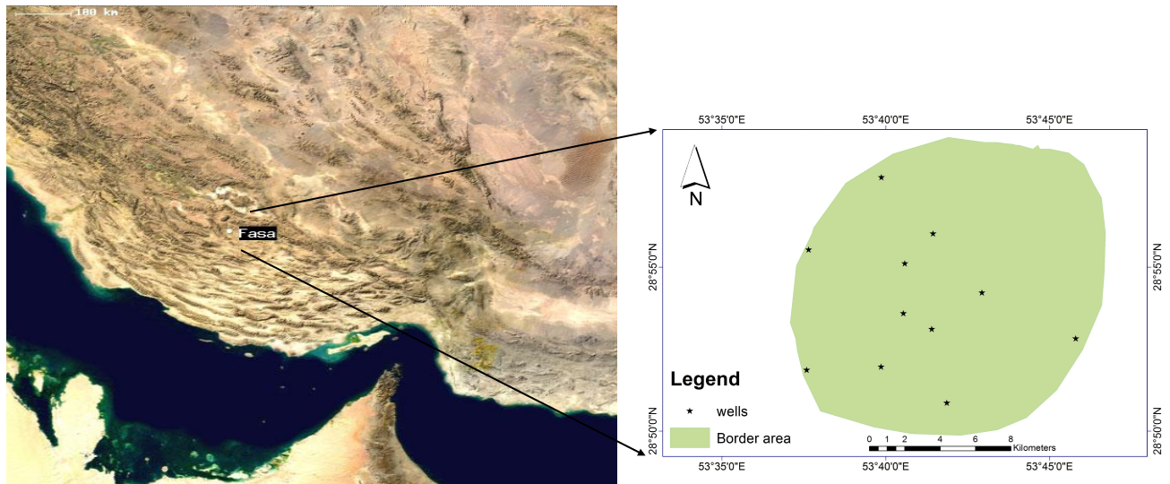
Figure 1. Geological location of Iran, Fars province, Fasa city and sampling wells

In order to investigate the chemical quality of water resources we use datas that has been catched from Tamab organization. Due to large numbers of wells in this area, the wells were used in 4 basins consist of Fasa northern wells, KooshkGazi and harem. Evaluation of chemical quality of water for agriculture were done based on Wilcox and schuler classification methods. To study quality of industrial use, water Hardness and pH are noticeable.

3. Results
3.1 Water quality for agriculture uses
In addition to the water quantity, water quality is important for agricultural operation. In this field poor quality can be a limiting factor and also causes problems in soil (Mahdavi, 2012).
For measuring water quality in agriculture, parameters such as EC, Na+ were assessed. This parameter affects plant growth, soil permeability and water grading in terms of suitability for irrigation.
In this classification horizontal graph show the EC and it representative is C, Vertical graph represent the Sodium absorption ratio (SAR) and it representative is S. each graph is divided into four parts and totally contain 16 group of water quality. 1, 2, 3 and 4 values respectively are indicant of very good, good, medium and poor water in terms of quality.

Table1. Water quality for agriculture in study basin
Water quality for agriculture | Water class | EC | SAR | Sampling site
Inappropriate waters | C4S1 | 4879 | 0.627 | Nothern of Fasa
Inappropriate waters | C4S1 | 3150 | 0.568 | Sahraroud
Average water quality | C3S1 | 1288 | 0.761 | Kooshkghazi
Average water quality | C3S1 | 1850 | 1.667 | Harem
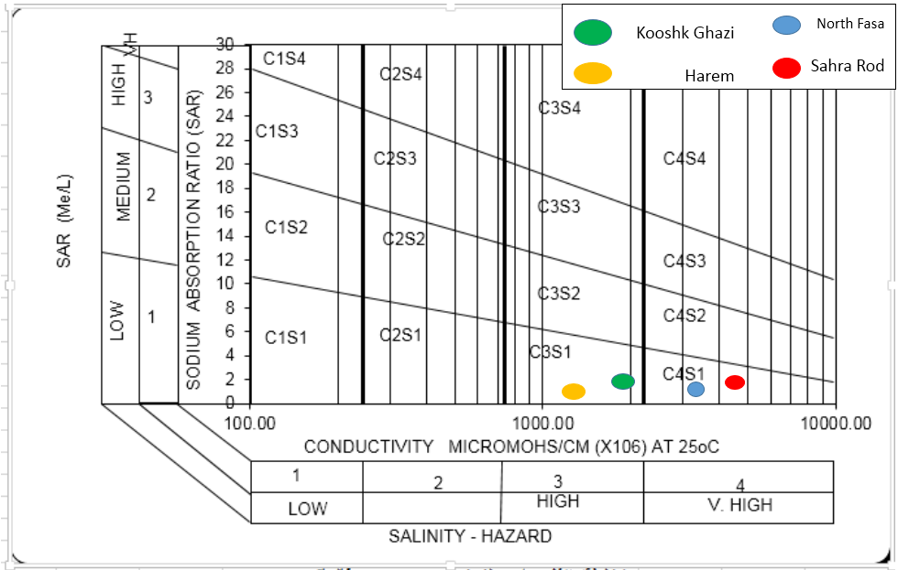
Figure 3. Wilcox diagram of water samples taken from the study field

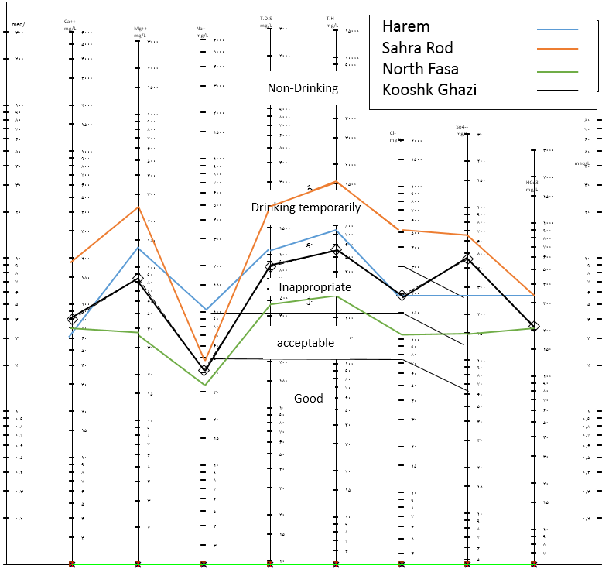
Figure 4. Schuler diagram of water samples taken from the study field

4. Discussion and Conclusion
Salinity and sodium are the most important water classification factors of agriculture water. These factors are effective not only in plant growth but also in soil permeability.
Various water types can be classified for human consumption according to Schuler diagram based on values of cation and anion concentration.
Based on Wilcox diagram, the class of studied sample wells at north of Fasa is C4S1, class of Sahra roud samples is C4S1, Kooshk ghazi is C3S1 and Harem samples is C3S1 that has limitation for agricultural uses.

References
- Parvanehkhah Tehran, R., 2012. Qualitative comparison of the salinity of groundwater resources for various uses in the East and West Coastal Aquifer Basin rivers of Talar-Babol-Haraz, 4th Iran Water Resources Management, Amirkabir University of Technology, Tehran, Iran.
- Ghare Mohammadlou, M., Naseri, H.R. and Radin, A, 2004. Determining the health privacy of Drinking Water wells in sari city, MSc thesis, Department of Earth Sciences, Shahid Beheshti University.
- Abbasi Jandani, S., Fattahi, S., 2013. Evaluating the trend of climatic parameters and changes of them during the period (case study: Plain Pediment- Segzi, Isfahan), Second National Conference on desert Management.
- Foroughifar, R., Espahbod, M., 2012. Rāmhormoz plain drinking water quality classification for different uses, agriculture and industry (based on chemical analysis). Thirtieth Conference on Earth Science.
- Iran Water Resources Management Co. www.wrm.or.ir
- Mohammadi, Y., Haghighat, R., Naseri, H.R. and Mashkoori Najafi, N. 2005. Hydrogeological, geochemical and groundwater pollution Ramsar region, MSc Thesis, Department of Earth Sciences, Shahid Beheshti University.
- Deiry, M., Vali Mogaddam, S., 2008. International challenges in urban water management and governance impact on Integrated Management of Tehran, 2nd conference of Environmental Engineering, University of Tehran.
- Mahdavi, M., 2013. Applied Hydrology (Second Vol), Tehran University Press.
- FAO. (2004). Carbon sequestration in dryland soils word soils resources report 102, NRCS, Rome.
- Giridhari, S. P., and Thapa, G. B. (2004). “Impact of social, institutional and ecological factors on land management practices in mountain watersheds of Nepal.” Applied Geography, 24, 35-55.

11/25/2016

