Ecological Factors Determining the Distribution and Abundance of Vectors of Human Mosquito Borne-Infections in Gwagwalada Area Council of Federal Capital Territory, Abuja.

Ebuzoeme, Vincent

Department of Biological Science, University of Abuja, Nigeria.
ebuzoemev@gmail.com

Abstract: The study of ecological factors determining the distribution and species abundance of vectors of human mosquito borne-infections was undertaken in four selected communities in some parts of Gwagwalada, an Area Council in Abuja, Nigeria. These sites are Tunganmaje, Paiko Kore, Kutunku and Dobi. Approximately sixty three percent (63%) of the mosquitoes bred in clear water while 18.50% mostly Culex was found to breed in water containing turbid matter. All mosquito genera encountered were collected from shallow water and none were found in deep water habitats. All genera of mosquito breed in shaded and sun-lit habitats. Culex mosquitoes breed in all types of habitat both with and without vegetation cover, while none were found in floating plants. Culex was only collected in habitats with vegetative cover except the presence of algae while Anopheles preferred both habitats with or without vegetation cover except those with floating plants. The Simpson’s indices of diversity for the types of breeding sites, species of mosquito and their seasonal distribution varied significantly (P<0.01) in this study. Most identified habitats were largely associated with human activities. When seeking novel avenues for ecological control of mosquitoes and mosquito borne diseases, mosquito breeding behavior should receive more attention.
[Ebuzoeme, Vincent. Ecological Factors Determining the Distribution and Abundance of Vectors of Human Mosquito Borne-Infections in Gwagwalada Area Council of Federal Capital Territory, Abuja. Researcher 2016;8(11):6-10]. ISSN 1553-9865 (print); ISSN 2163-8950 (online). http://www.sciencepub.net/researcher. 2. doi:10.7537/marsrsj081116.02.

Keywords: Distribution, larvae, habitats, ecological factors

1. Introduction
The adaptability to environmental changes leading to marked contrasts in vector bionomics has led to the development of various levels of vectoral efficiency for populations of mosquito species in heterogeneous environments within the same locality and has thus become an important factor in determination of epidemiology of mosquito borne diseases (Toure et al., 1994). Environmental heterogeneities have arisen as a result of human activities which act as a means of constant evolutionary challenge as they provide a source of environmental change to which anthropophilic mosquitoes have to respond by developing a highly dynamic vector host relationship (Mwangangi et al., 2007). As heterogeneous environments, aquatic habitats differ in their capacity for mosquito production (Fillinger et al., 2004).
Control directed on the mosquito vector also has numerous similar problems of resistance to insecticide used on the larvae mosquitoes, environment pollution due to the persistence of some of the insecticide similarly directed on the larvae mosquitoes have problem of emergence of resistance strain. A successful implementation of this strategy requires that several critical issues must be addressed. To begin with, breeding habitats should be evaluated on the basis of quantitative measures of mosquito productivity. “Productivity” is the rate of adults emerging from individual habitats.
The indices of the productivity currently use include presence/absence or density/abundance of larvae/pupae. Understanding of variability in mosquito productivity requires spatial accounts of oviposition processes (Gu et al., 2008). Environmental management of larval habitats can profoundly impact on mosquito-borne disease transmission, particularly when used in combination with other proven vector control measures such as indoor residual spraying and insecticide-treated nets (Keiser et al., 2005).
A preliminary requirement for management is to identify the habitats of the immature stages, since control is most efficiently carried out at the larval stage when the spatial distribution is limited to water bodies ( Dale et al., 2003) and targeted environmental management is based on a sound understanding of the heterogeneity in mosquito breeding habitat productivity (Gu et al., 2008).
Several environmental characteristics affect larval density which may influence the development and survival rate of the mosquito larvae. These characteristics include climate, physical and chemical conditions of the aquatic habitats, vegetation type and biological characteristics (Fillinger et al., 2004). Knowledge of larval vector ecology is a key factor in risk assessment and establishment of effective control measures, because the most effective method for controlling vector populations is to control the larvae in their aquatic habitats before they emerge as adults.

2. Materials and Methods
The study was undertaken in four selected sites in some parts of Gwagwalada, an Area Council in Abuja, Nigeria. These sites are Tunganmaje, Paiko Kore, Kutunku and Dobi. Gwagwalada Area Council is located about 55km away from Federal Capital City. It lies on latitude 8° 55', North and 9° 00' North and longitude east and 7°.05' east (Ishaya, 2013). The area covers a total of 65sq kilometer located at center of very fertile area with abundance of grasses (Ishaya, 2013). The study area falls in to the guinea savanna vegetation zone of the country which is the broadest of all the vegetation types, constituting about 50% of the land area of Nigeria.
There are two seasons within this vegetational zone, dry season that lasts between four to seven months and a rainy season that lasts between four to five months. The rainfall ranges between 1016mm and 1524mm with relative humidity of between 60% and 80%. The guinea savanna is divided into two vegetation zones: - the northern and the southern guinea savanna (Ishaya, 2013).
Data were analyzed using the Chi-Square. Shannon-Weiner Index was used to analyze the species diversity in the study area. It is expressed as H = (N log N - Σni logni)/N, where ni is the abundance and N the total number of individuals in the species (Ogbeibu, 2005).

3. Results
The ecological factors determining the distribution and species abundance of vectors of human mosquito borne-infections was undertaken in four selected communities in some parts of Gwagwalada, an Area Council in Abuja, Nigeria. These sites are Tunganmaje, Paiko Kore, Kutunku and Dobi.
The distribution of mosquito genera found in different habitats of environmental influence were shown in Figure 1, 2 and 3; approximately sixty three percent (63%) of the mosquitoes bred in clear water, 18.5% bread in organic water while 18.50% were found to breed in water containing turbid matter. All mosquito genera (100%) were collected from shallow water and none were found in deep water habitats.
All genera of mosquito breed in shaded and sun-lit habitats. Culex mosquitoes breed in all types of habitat with and without vegetation cover, Aedes larval preferred water quality with organic content, Culex larval preferred turbid water with little or no algae growth while Anopheles species shows preference for clear and organic water. There was a strong association between mosquito genera and water clarity, light intensity and vegetation cover (P<0.05).
Diversity and abundance of mosquito species in the different months of the study are presented in figure 4. The analysis of these data indicates that the largest numbers of mosquito species diversity was in the month of December (0.475) followed by November (0.472). The quantitative composition of the monthly species diversity in the selected communities is summarized for mosquito species in the twelve months of this study (figure 4).

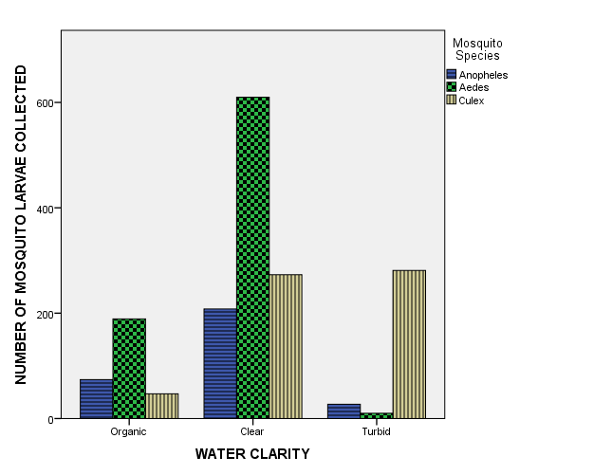
Figure 1: Influence of water clarity on mosquito larvae abundance in the study areas.

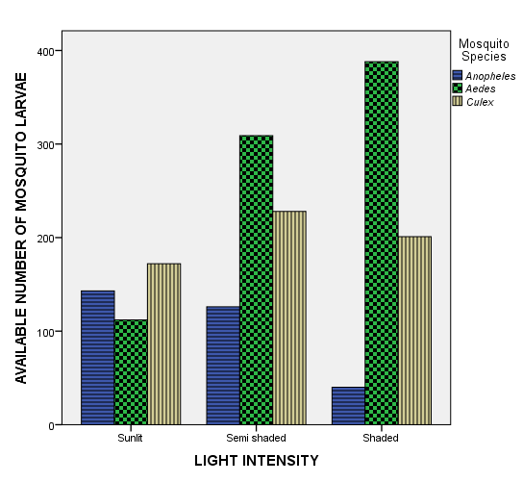
Figure 2: Influence of light intensity on mosquito larvae abundance in the study areas.

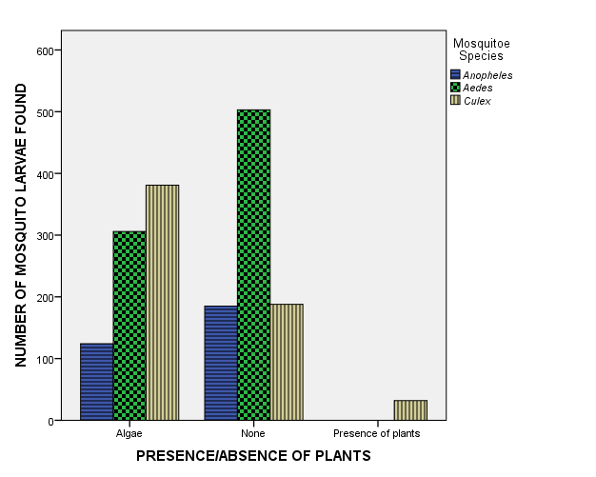
Figure 3: Influence of presence/absence of plants on mosquito larvae abundance in the study areas.

Figure 4: Index of diversity of mosquito species in the twelve months of study

4. Discussion
Different mosquito species make use of different type of water quality and habitats for breeding (Onyido et al., 2009). The high number of gutters, clay pots, ditches, cans, containers, tyres in the study area is due to unavailability of good roads, poor drainage systems, lack of portable water supply had led inhabitants of the communities to resort to storing water and also the general poor waste disposal culture in Nigeria (Mbanugo and Okpalaononuju, 2003; Okogun et al., 2003). Anopheles utilized all nine habitat types in this study, Culex and Aedes breeds not in tree holes/leaf axils in this study, tree holes and leaf axils can only retain water for short period of time and dry out at the absence of rain. This may be the reason for the low species distribution in tree holes and leaf axils in these study areas. Although these mosquitoes breed in water, they differ in their micro habitat requirements for their breeding. Some species are restricted to a single type of breeding habitat while others possess a larger adaptability, but their presence in a given type of breeding place is due to the oviposition habits of the female mosquito, which is the main determining factor of the presence of larvae in different types of larval habitats (Huang et al., 2005; Chen et al., 2007).
Open, clear and sunlit pools appeared to favour the breeding of Anopheles. The preponderance of Anopheles in such small, open, temporal pools can be explained by the fact that the female species of Anopheles preferentially select them for oviposition as evidently demonstrated by the works of Bentley and Day (1989). Their ability to survive in these small pools compared to permanent large pools could also be that larval predation is less prevalent or non-existent in these temporal pools as opposed to large permanent habitats. This view is shared by Washburn (1995) and Sunahara et al. (2002).
The occurrence of the Anopheles species in all the nine habitat type shows that they are very versatile and highly adapted to all the different types of environments found in the selected communities of Gwagwalada. The species preference of breeding site was not only for the vessel/site in question but also for the water quality, depth, light and vegetation which serves as sources of food and shelter appropriate for their survival and development (Sattler et al., 2005; Chen et al., 2009).
Findings from this study shown that mosquitoes prefer shallow water bodies. Their specific requirements for water quality, shade and vegetation differs. Example Aedes larval preferred water quality with organic content, Culex larval preferred turbid water with little or no algae growth while Anopheles species shows preference for clear and organic water. This concurred with the findings by Bunza et al. (2010. In the Shannon- Weiner index of diversity, December had most diversity index followed by November in this study. Therefore this study is of epidemiological importance. These are proven and established vectors of malaria and lymphatic filariasis in Nigeria (Ukpai and Ajoku, 2001; Matur et al., 2001; Ogbeibu, 2005).
In conclusion, it is important that residents of the City are enlighten on the environmental factors that contribute to mosquito breeding and for the Government to institute proper sanitation measures to reduce mosquito breeding site, to achieve this, a detailed ecological knowledge of these mosquito breeding habitats will be of great assistance especially at the community levels for total eradication.

Corresponding Author:
Dr. Y.D. Malann
Biological Science Department,
University of Abuja- Nigeria
Telephone: 09077523005/09052028492
Email: malannyd@gmail.com

References
- Bentley, M.D. and Day, J.F. (1989). Chemical Ecology and Behavioral Aspects of Mosquito Oviposition. Annual Review of Entomology, 34: 401-421.
- Bunza, M.D.A., Suleiman, A.A., Yusuf, A.M. and Bala, A.Y. (2010). Relative abundance of mosquito species in Katsina metropolis, Katsina state, Nigeria. Nigerian Journal of Parasitology, 31(2): 73-78.
- Chen, C.D., Nazni, W.A., Seleena, B., Moo, J.Y., Azizah, M. and Lee H.L. (2007). Comparative oviposition preferences of Aedes (Stegomyia) aegypti (L) to water from storm water drains and seasoned tap water. Dengue Bulletin, 31: 124-130.
- Chen, H., Fillinger, U. and Yan, G. (2009). Oviposition Behavior of Female Anopheles in Western Kenya. Inferred from microsatellite markers. American Journal of Tropical Medicine and Hygiene, 75(2): 246-250.
- Dale, P.E.R., Knight, J., Kay, B.H., Chapman, H., Ritchie, S.A. and Brown, M.D. (2003). Habitat characteristics and eggshell distribution of the salt mash mosquito, Aedes vigilax, in marshes in subtropical eastern Australia. Journal of Insect Science, 8: 25-31.
- Fillinger, U., Songe, G., Killen, G.F., Knols, B.G. and Becker, N. (2004). The Practical Importance of Permanent and Semi-permanent Habitat for Controlling Aquatic Stages of Anopheles gambiae sensu lacto Mosquitoes: Operational Observation from a Rural Town of Western Kenya. Tropical Medicine International Health, 9: 1274-1289.
- Gu, W., Utzinger, J. and Novak, R.J. (2008). Habitat Based Larval Interventions: A New Perspective for Malaria Control. American Journal of Tropical Med. and Hygiene, 79(1): 2-6.
- Huang, J., Walter, E.D., Groux, P.Y., Vulule, J. and Miller, J.R. (2005).Ovipositional site selection by Anopheles gambiae: Influence of Substrate Moisture and Texture. Medical and Veterinary Entomology, 19: 442-450.
- Ishaya S (2013) Analysis of Growing Season Rainfall and Temperature Variability in the Federal Capital Territory of Nigeria. Nigeria Journal of Tropical Geography. Vol. 4(2) pp 471-490. Nasarawa State University.
- Keiser, J., Singer, B.H. and Utzinger, J. (2005). Reducing the Burden of Malaria in Different Eco-Epidemiological Settings with Environmental Management: A Systematic Review. Lancet Infectious Diseases, 5: 697-708.
- Matur, B.M., Azare, B.A. and Ugbong, L. (2001). Prevalence of malaria parasites amongst undergraduate students of University of Abuja. Nigerian Journal of Parasitology, 22(1&2):49-52.
- Mbanugo, J.I. and Okpalaononuju, C.N. (2003). Surveillance of Mosquito Vectors in some Habitats of Awka Metropolis, Anambra, Nigeria. Nigerian Journal of Parasitology, 24:184-190.
- Mwangangi, J.M., Mbogo, C.M., Muturi, E.J., Nzovu, J.G., Githure, J.I., yan G., Minakawa, N., Nonak, R. and Beier, J.C. (2007). Spatial Distribution and Habitat Characterization of Anopheles larvae along the Kenyan Coast. Journal of Vector Borne Diseases, 44: 44-51.
- Ogbeibu, A.E. (2005). Biostatistics: A practical approach to research and data handling. Mindex Publishing Company Limited, Benin City, Nigeria, 7: 23-26.
- Okogun, G.R.A., Nwoke, B.E.B., Okere, J.C. and Anegbe, C. (2003). Epidemiological Implications of Preferences of Breeding Sites of Mosquito Species in Midwestern Nigeria. Ann. of Agric. Environ. Med. 10: 217-222.
- Onyido, A.E., Ezike, V.I., Ozumba, N.A., Nwankwo, A.C.N., Nwankwo, E.A. (2009). Yellow fever vectors’ surveillance in three satellite communities of Enugu Municipality. The Nigerian Journal of Parasitology, 30(1): 13 17.
- Sattler, M.A., Mtasiwa, D., Kiama, M., Premji, Z., Tanner, M., Killeen, G.F. and Lengeler, C. (2005). Habitat Characterization and Spatial Distribution of Anopheles species Mosquito Larvae in Dar es Salaam (Tanzania). During an Extended Dry Period. Malaria Journal, 4: article 4.
- Sunahara, T., Ishizaka, K. and Mogi, M. (2002). Habitat Size: A Factor Determining the Opportunity for Encounter between Mosquito Larvae and Aquatic predators. Journal of Vector Ecology, 27:8-20.
- Toure, Y., Petrarca, V., Traore, S.F., Coulibaly, A., Maiya, H.M., Sonkare, O., Sow, M., Di Deco, M.A. and Coluzzi, M. (1994). Ecological Genetic Studies in the Chromosomal form of Anopheles Gambia s.s. in Mali, West Africa. Genetica, 94(2-3): 213-223.
- Ukpai, O.M. and Ajoku, E.I. (2001). The prevalence of malaria in Okigwe and Owerri Areas of Imo state Nigeria. Nigerian Journal of Parasitology, 22(1&2): 43-48.
- Washburn, J.Q. (1995). Regulation of Factors Affecting Larval Mosquito Population in Container and Pool Habitats. Implication for Biological Control. Journal of the American Mosquito Control Association, 11: 279-283.

11/25/2016

