The Determinants of Agricultural Production in Musanze District, Rwanda

Aristide Maniriho¹, Alfred R. Bizoza²

- School of Economics, University of Rwanda, P. O. Box 1514 Kigali, Rwanda.
Email: manirihoaristide1@gmail.com (Corresponding author)
- Directorate of Research, Institute of Policy Analysis and Research, P. O. Box 6005, Kigali, Rwanda. Email: alfredbiz23@gmail.com; a.bizoza@ipar-rwanda.org

Abstract: This paper estimated the Cobb-Douglas production function in reference to the agricultural production function in Musanze District, Northern Rwanda. Data were collected through a survey of 107 farmers, selected purposively from the study area. Both descriptive and econometric approaches were used for the data analysis. Results from the analysis substantiate that the overall agricultural production was positively correlated to the inputs used, namely labour, fertilizers, seeds and pesticides. Labour, fertilizers and seeds were highly significant (p<0.05) factors contributing to production as they explained 66% of the variation in agricultural production. Overall significance and the normality test of residuals showed that results from the estimated model were reliable for the prediction and policy formulation. The sum of input coefficients (0.99) indicated that agriculture was recording decreasing returns to scale. Based on results of this study, we recommend that farmers could achieve the least production cost through a more rational use of available inputs. The government and other agricultural development agencies should promote actions that guarantee markets to farmers and facilitate access to proximity extension services.
[Aristide Maniriho, Alfred R. Bizoza. The Determinants of Agricultural Production in Musanze District, Rwanda. Researcher 2016;8(10):39-46]. ISSN 1553-9865 (print); ISSN 2163-8950 (online). http://www.sciencepub.net/researcher. 7. doi:10.7537/marsrsj081016.07.

Key words: Agricultural production, Cobb-Douglas production function, Musanze District, Rwanda

- Introduction
Background
Economic theory tells us that a production function describes the technical relationship that transforms inputs (resources) into outputs (commodities) (Debertin, 2012). Poudel et al. (2010) used a Cobb-Douglas production function to estimate the production function and resource use condition of organic cultivation in different farm size and altitude categories in the Hill Region of Nepal. By using the OLS method and cross section data collected in 2010 on 280 coffee farming households selected randomly from 400 households in 12 Village Development Committee (VDC) in the Gulmi District. The data were for the 2009 normal coffee growing year and organic farms were classified according to farm size and farm altitudes. The variables included in the model are the coffee output, farm size, labour used, fertilizer, inter/shade crops, the number of coffee trees, the sex of the coffee farm manager, household size, the extension training of the coffee farm manager, the age of the coffee farm manager, the farm experience, and the labour cost. The results showed the greater significance of labour employed and organic fertilizer application. Increasing returns to scale was observed in all categories while summing of elasticities. Labour was found overutilized while remaining factors were underutilized. Therefore, available inputs should be rearranged effectively to enhance the technical efficiency.
While conducting a research on production function of rice in Morang district in Nepal, Bhujel and Ghimire (2006) have used a semi-structured questionnaire through face-to-face interview to collect information necessary to estimate this function. Considering the results of this study, human labour and bullock labour have not any significant effect in production. The nitrogen effect on production is significant at 1% level and has negative value which indicates the excess application and the variety which is not much responsive to higher dose of nitrogen, however the dose of phosphorous and potash can be increased.
Hussain and Saed (2001) aimed at assessing and evaluating the crop production function parameters in Jordanian’s agricultural sector during the period 1981-1996. The main objectives of this research are to estimate the relationship between the output per tones and the level of inputs (area, labour, and capital), and to test the hypothesis that reallocation of resources with farm capital intensity bias will promote growth, employment potential growth and agricultural productivity in Jordan. To estimate this production function, the author has used the usual Cobb-Douglas production function. The estimated production function show the increasing returns to scale. The analysis indicates that agriculture is characterized by the intensive labour method since the elasticity of labour was greater than that of capital, respectively of 0.455 and 0.130.
In Canada, a study was conducted by Echevarria (1998) with the aim of the estimation of value added in agriculture as a constant returns to scale function of the three factors of production (land, labour and capital) using Canadian data on the period 1971-1991. After a constant returns to scale production function is estimated, the author has calculated the average of the factor of change of the Solow residuals using a Cobb-Douglas function. The results show that agricultural production functions in Canada, both at provincial and national levels register constant returns to scale, because the sum of partial elasticities is unity.
Besides the above authors, there are also a number of scholars who have empirically worked on the estimation of agricultural production function all around the world. These include for instance Hoch (1962), Ike (1977), Ecchevaria (1998), Hussain and Saed (2001), Hu and McAleer (2005), Olubanjo and Oyebano (2005), Armagan and Ozden (2007), Arene and Mbata (2008), Mussavi-Haghighi et al. (2008), Olujenyo (2008), Alao and Kuje (2010), Poudel et al. (2010), and Onoja and Herbert (2012).
In Rwanda, similar research has been conducted with the aim of defining the determinants of the banana production function (Mpawenimana, 2005) and to analyse the profitability of agricultural projects (Maniriho and Bizoza, 2013).
As one of the development priorities of Rwanda, agriculture was recognised as the engine of the primary growth (Republic of Rwanda, 2004; IMF, 2008). It has been chosen as the first and strongest leverage to put the country on a sustainable development process and to fight against poverty and the investment policy in agricultural sector will contribute to change in the structures, methods, marketing and efficiency of agricultural activities with a very high impact on the revenue of the majority of the population and most of the poor, on exports and on the GDP. The major agricultural policies adopted by the Government of Rwanda to transform and mechanize the agriculture through the development of modern agriculture include the promotion of more intensive agricultural practices through the increased use of agricultural inputs, agricultural professionalization that promotes high enterprise profitability, the promotion of soil fertility and protection, improved marketing initiatives, and the reinforcement of agricultural research and advisory including a greater role for farmer cooperatives and associations (Bingen and Munyankusi, 2002). Another government policy known as Economic Development and Poverty Reduction Strategy, EDPRS (Government of Rwanda, 2007) identifies the agricultural sector as a crucial area for a growth and calls for energetic public action in collaboration with private and nongovernmental development partners to encourage greater input use and to assist in the provision of services and their monitoring.
All these efforts have improved the Rwandan economy in general and the agricultural status in particular. All undertaken strategies by the Government of Rwanda have improved the situation of Rwandan agriculture, but making appropriate economic policies is still of current interest. The question is to know to what extent this improvement has contributed to the development of agricultural sector. Besides, in the agriculture sector, farmers do not know how to measure the relationship between inputs and output. Yet the suitability of crops planned for each region in the context of crop intensification with focus to land use consolidation still requires more explanations. In part of response to these questions, the study aims at analysis the agricultural production function in a sample District. Results will inform the policy where further efforts are needed to sustain the on-going agricultural development process in Rwanda.
Agricultural production function: conceptual framework

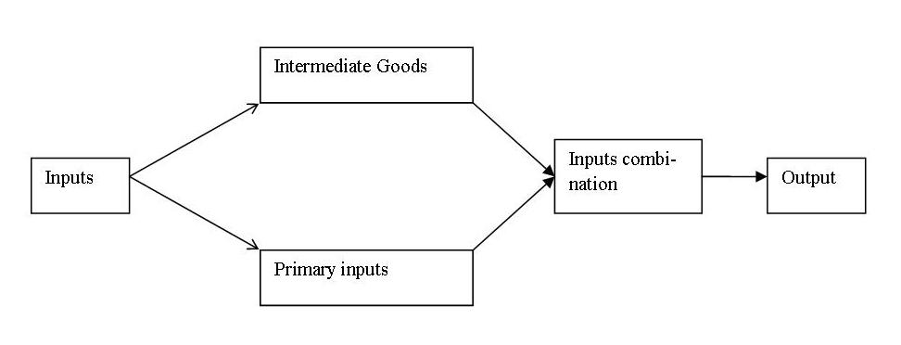

Figure 1: Production process

Conceptually, Picard (2002) and Descamps (2005) described the production function as the relationship between amounts used of various inputs and the maximum level of output to be produced. The production function represents the set of technical constraints that a firm is facing. They stated that the output is achieved by combining certain amounts of different inputs. This hypothesis is depicted in Figure 1.
Mudida (2003) stated that a simple agricultural production function is obtained by using labour and land as inputs and by recording alternative outputs per unit of time. Ahuja (2006a, 2006b) precised that a production function, especially agricultural production, can be extended to include more than two factors like land, irrigation, and fertilizers.

- Materials and methods
Presentation of the study area
Musanze District is one of the five Districts of the Northern Province. It has a surface of 530.4 km² of which 60 km² for the Volcano National Park and 28 km² of the Ruhondo Lake. The average altitude is of 2,000 m including the chain of the volcanoes Kalisimbi (4,507 km), Muhabura (4,127 km), Bisoke (3,711 km), Sabyinyo (3,574 km), Gahinga (3,474 km) which offers beautiful and attractive touristic site. Musanze District faces tropical climate of highlands with has mean temperature of 20ºC. Generally with enough rain the whole year, the precipitations vary between 1,400 mm and 1,800 mm.
Two main and two small seasons characterize the study area namely the rainy and the dry seasons: from June to mid-September, we have the great dry season; from January to mid-March, the small dry season; from mid-March to the end of May, the great rainy season; and from mid-September to the end of December, the small rainy season. In terms of physical characteristics of the study area, the soil of Musanze District is dominated by volcanic soil which is essentially fertile. The main crops of Musanze District are Irish potato, bean, corn and wheat (District de Musanze, 2007). According to current statistics, the population of Musanze District rises to an average density of 695 inhabitants per km² (NISR, 2012).

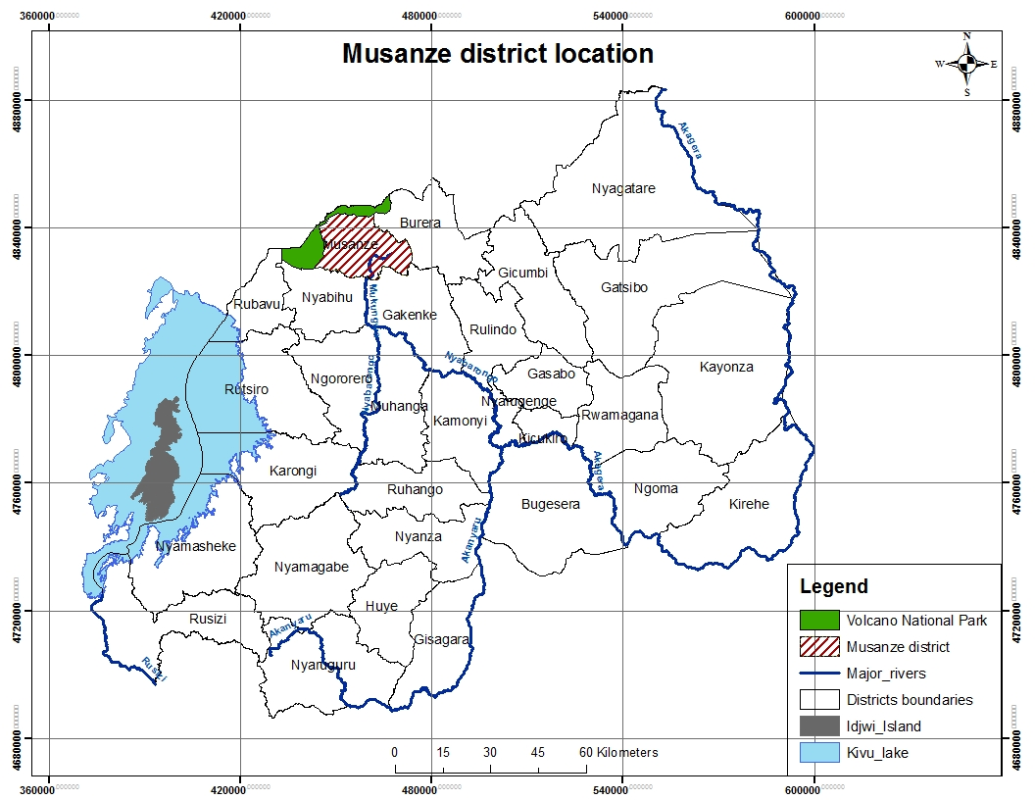

Figure 2: Location of Musanze District on the map of Rwanda

Data Collection Methods
For the purpose of data collection, a field survey was conducted in Musanze District during August and September 2012 from a purpose sample of 107 farmers’ organizations assisted by the Programme DERN in Musanze District through the self-administered questionnaire. Besides the field survey, the documentary method was used in collecting data.
Descriptive statistics
The data collected for the purpose of this research have been summarized in tables both in real terms and in money value. Data are comprised in a table and include the mean, the median, the maximum, the minimum, the standard deviation, the skewness, the kurtosis, the Jarque Bera and its probability as well as the number of observations for each variable. The table 1 describes the agricultural production in Musanze District. It presents the socioeconomic characteristics of main crops produced in the study area. This table shows that the production (Y) is RwF 185,905 worth, and it costs RwF 39,140 for labour (L), RwF 28,464 for fertilizers (F), RwF 48,408 for seeds (S), and RwF 10,626 for pesticides (P). This comes to the production of RwF 10,317, and the costs of RwF 2,172 for labour, RwF 1,580 for fertilizers, RwF 2,686 for seeds, and RwF 590 for pesticides per are.

Table 1: Description of crop production in RwF in Musanze District
 | Y | L | F | S | P
Mean | 185,905.3 | 39,139.72 | 28,463.87 | 48,407.99 | 10,626.24
Median | 116,400.0 | 25,500.00 | 19,720.00 | 24,500.00 | 4,000.000
Maximum | 1,200,000. | 170,000.0 | 233,950.0 | 450,000.0 | 184,000.0
Minimum | 7,500.000 | 4,250.000 | 1,000.000 | 100.0000 | 0.000000
Std. Dev. | 235,228.4 | 38,283.55 | 35,018.29 | 71,806.90 | 22,360.21
Skewness | 2.947173 | 2.010700 | 3.737338 | 3.054826 | 4.953687
Kurtosis | 12.34640 | 6.416958 | 19.34468 | 14.53104 | 35.64035
Jarque-Bera | 544.3558 | 124.1523 | 1440.128 | 759.2220 | 5187.487
Probability | 0.000000 | 0.000000 | 0.000000 | 0.000000 | 0.000000
Observations | 107 | 107 | 107 | 107 | 107
Source: Field survey, August and September 2012 (Summarized by using EViews)

In the above paragraphs, the socioeconomic characteristics of the crops grown in Musanze District have been presented. In the following paragraphs, the same characteristics are presented but for individual crops.
The socioeconomic characteristics of potato production in Musanze District show that the production of potato on average is RwF 251,739, and its cost is RwF 30,078 for labour, RwF 39,178 for fertilizers, RwF 83,226 for seeds, and RwF 16,872 for pesticides. As for the bean, the socioeconomic characteristics show that the production of bean on average is RwF 75,853, and its cost is RwF 46,838 for labour, RwF 14,572 for fertilizers, RwF 7,054 for seeds, and RwF 10102 for pesticides. Yet for the corn, the results show that the production of corn on average is RwF 190,417, and its cost is RwF 76,075 for labour, RwF 22,548 for fertilizers, RwF 12,821 for seeds, and RwF 6,795 for pesticides. And for the wheat, the results show that the production on average is RwF 97,500, and its cost is RwF RwF 24,083 for labour, RwF 12,861 for fertilizers, RwF 7,408 for seeds, and RwF 13,757 for pesticides.
Definition of variables and Specification of the Model
The table 2 below summarizes the definition, the symbol and the measurement of both dependent and independent variables. The dependent variable is the agricultural output, and the independent variables include the labour used, the fertilizers, the pesticides, and the seeds. Each independent variable is positively related to the dependent variable. This means that the signs of the coefficients are expected to be positive.

Table 2: Definition and measurement of variables
Variables | Symbol | Measurement | Definitions
Agricultural output  Labour  Fertilizers used  Pesticides used  Seeds | Y  L  F  P  S | Kilograms  Man days  Kilograms  Litres  Kilograms | Agricultural produce for one crop  Number of workers used  Minerals and organic manure used  Value of pesticides used in RwF  Seeds used in RwF

In the intent of the model specification, Gujarati (1995) and Gujarati (2009) classify the Cobb-Douglas production function as the best production functions besides constant elasticity of substitution production function. Its stochastic form and its log-linear form are presented respectively the equation (1):

---------------------------------------------- Equation (1)

where Y is a dependent variable, Xs are independent variables, stands for Neperian logarithm, is the Neperian number equal to 2.72121, is a disturbance term, s are parameters to be estimated and are the intercepts. Following Gujarati, the model to be estimated for this case study is described by the equation (2) below:

-------------------------- Equation (2)

where LogY stands for agricultural output in RwF, LogL is labour in RwF, LogF is the value of fertilizers in RwF, LogP is the value of pesticides in RwF, LogS is the value of seeds in RwF, Log means natural logarithm, U stands for the disturbance term, and to are parameters to be estimated.
In a Cobb-Douglas production function, the input coefficients are qualified as output elasticities with respect to inputs which express the effects of inputs on output in percentage terms (Bourbonnais, 2005). The sum of all elasticities describes the level of returns to scale (RTS). If this sum is less than one, it is the case of decreasing RTS; if it is equal to one, it is the case of constant RTS; and if this sum is greater than one, it is the case of increasing RTS (Picard, 2002).

- Results and discussion
Estimation of agricultural production functions in Musanze District
In this section, the overall agricultural production function was estimated. Individual production functions for bean and potato were also estimated. The following equation is concerned with the determinants of agricultural production function of main crops grown in Musanze District. These crops are Irish potato, bean, corn, wheat, tomato, onion and cabbage. This equation shows that positive relationship exists between agricultural production (LogY) and cultivated land (LogL), fertilizers (LogF), seeds (LogS), and pesticides (LogP). This implies that as more of these inputs are used, there is an increase in agricultural production. The sum of coefficients is 0.99 which shows decreasing returns to scale. The test of significance shows that land, fertilizers, and seeds are statistically significant at 5% level of significance. The R² estimated as 0.66 shows that 66% of variations in agricultural production are explained by the explanatory variables included in the model. The first input to contribute significantly to agricultural production is fertilizers as it is shown by the elasticity of 0.49, followed by both labour and seeds whose the elasticity is 0.24 for each.

LogY = | 1.77 | +0.24 LogL | +0.49 LogF | +0.24 LogS | +0.02 LogP
t | (2.07) | (2.91) | (5.87) | (5.09) | (0.55)
p | (0.04) | (0.00) | (0.00) | (0.00) | (0.58)
R²= | 0.66 | Fstat= | 51.44 | Prob(Fstat)= | 0.00

Back to the exponential form of Cobb-Douglas production function by using the estimated coefficients, the above equation will be of the form
where 5.85 is as is 1.77. This equation can be used to predict agricultural production in Musanze District. Even though the predicted values are slightly smaller than the actual values, its results are valuable.
As far as the analysis of determinants of individual crops is concerned, the estimates of the following equation show positive relationship between bean output and fertilizers and seeds. This means that the bean production increases with the increase in fertilizers and seeds. On the other hand, negative relationship exists between bean production and labour and pesticides. This negative relationship is unexpected. It could be due to poor mix of labour and pesticides with other inputs. The sum of coefficients is 0.48 which shows decreasing returns to scale. The test of significance shows that only seeds are statistically significant at 5% level of significance. The R² estimated as 0.67 shows that 67% of variations in bean production are explained by the explanatory variables included in the model. Referring to the results, the estimated equation shows that the only input to contribute significantly to bean production is seeds whose elasticity is 0.62, and the corresponding probability value is 0.00.

LogY = | 7.11 | -0.06 LogL | +0.06 LogF | +0.62 LogS | -0.14 LogP
t | (3.95) | (-0.28) | (0.37) | (3.11) | (-1.27)
p | (0.00) | (0.78) | (0.71) | (0.00) | (0.21)
R²= | 0.67 | Fstat= | 12.61 | Prob(Fstat)= | 0.00

These results can be used to predict the bean production in Musanze District. To do so, we refer to the corresponding exponential Cobb-Douglas production function .
Concerning the determinants of potato production in Musanze District, the estimated equation shows positive relationship between potato output and labour, fertilizers, seeds and pesticides. This means that the potato production increases with the increase in labour, fertilizers, seeds and pesticides. The sum of coefficients is 1.25 which shows increasing returns to scale. The test of significance shows that fertilisers and seeds are statistically significant at 5% level of significance. The R² estimated as 0.77 shows that 77% of variations in potato production are explained by the explanatory variables included in the model. The first input to contribute significantly to potato production is fertilizers as it is shown by the elasticity of 0.55, followed by seeds for which the elasticity is 0.51.

LogY = | -1.05 | +0.11 LogL | +0.55 LogF | +0.51 LogS | +0.07 LogP
t | (-0.81) | (0.78) | (5.47) | (5.02) | (1.15)
p | (0.42) | (0.44) | (0.00) | (0.00) | (0.25)
R²= | 0.77 | Fstat= | 44.99 | Prob(Fstat)= | 0.00

These results can be used to predict the potato production in Musanze District, by referring to the exponential Cobb-Douglas production model .
From the three estimations above, both overall and bean production functions record decreasing returns to scale whereas the potato productions function records increasing returns to scale. The equations estimated (including the overall estimation of production function) can be considered as reliable on the basis that at least one of the input coefficients are significantly different from zero at the 5% level of confidence.
In addition, the reliability of the estimated model of crop production (overall estimation) is also guaranteed by the results of the test of normality of errors given by the figure 3 below. This figure shows that the JB statistic (1.377011) is not significantly different from zero at 5% level of significance since its probability (0.502326) is greater than the level of significance. This implies that the errors of the estimated agricultural production function are normally distributed. Consequently, the model estimated is reliable.

- Conclusions and policy recommendations
The research examined the effects of inputs allocation on the agricultural production with special focus on crops grown by farmers’ organizations in Musanze District. Data were collected through a field survey conducted in Musanze District during August and September 2012 from a purposive sample of 107 farmers’ organizations. The ordinary least squares (OLS) technique was used to estimate the agricultural production function of Cobb-Douglas type. The values of the estimates were used to compute the returns to scale.
The overall agricultural production is positively related to inputs used which include labour, fertilizers, seeds, and pesticides. The test of significance shows that the significant inputs are fertilizers, labour and seeds at the 5% level of significance. The individual production function for potato shows a positive relationship between output and labour, fertilizers, seeds and pesticides, and the test of significance shows that the significant inputs are fertilizers and seeds at the 5% level of significance. In the same way, the individual production function for bean shows a positive relationship between bean output and fertilizers and seeds, and a negative relationship between output and labour and pesticides. These negative signs are unexpected. The negative relationship between bean output and fertilizers could be due to the low use of fertilizers in bean production whereas the negative relationship between bean output and seeds could be explained by the use of traditional seeds instead of high-yielding varieties. The test of significance shows that the significant input is only seeds.
As some inputs are statistically significant, the estimated production functions are considered reliable. In addition, the overall production function records decreasing returns to scale of 0.99, and the individual production functions record 0.48 and 1.25 for the bean production function and potato production function respectively. The decreasing returns to scale imply that the individual farmers’ organizations have not achieved the least-cost combination of inputs.
For further improvements in agricultural production in the study area, some recommendations have been formulated: Farmers, farmers’ organizations and agricultural partners should enhance the use of fertilizers; Farmers and farmers’ organizations should reallocate rationally the inputs so as to attain the least-cost input combination; Farmers and farmers’ organizations should improve their equipment by adopting modern agricultural tools and new technological methods through the introduction of motor driven equipment where applicable. They should have more access to extension services in order to improve their knowledge of farm management and the land protection should be enhanced in order to maintain or to increase its productivity.

Acknowledgements
The authors express their greatest appreciation to Dr. Jean Chrysostome Ngabitsinze and Dr. Martin Mugenzi for their comments that helped to improve the quality of this paper. They also convey thanks to the respondents who have contributed to the achievement of this paper by providing all necessary data.

Corresponding Author:

Maniriho Aristide
Department of Economics
School of Economics
College of Business and Economics
University of Rwanda

P. O. Box 1514 Kigali, Rwanda
Email : manirihoaristide1@gmail.com

References
- Ahuja HL. Business Economics, Sixth revised edition. S. Chand & Company Ltd, New Delhi, India, 2006a.
- Ahuja HL. Modern Microeconomics, thoroughly revised 14th edition. S. Chand & Cmpany Ltd, New Delhi, India, 2006b.
- Alao JS, Kuje ED. Determination of technical efficiency and production function for small scale furniture industry in Lafia metropolis, Nasarawa State, Nigeria. J. Agric. Soc. Sci. 2010; 6: 64–66.
- Arene CJ, Mbata GIO. Determinants of profitability and willingness to pay for metropolitan waste-use in urban agriculture of the Federal Capital Territory, Abuja, Nigeria. Journal of Tropical Agriculture, Food, Environment and Extension, 2008; 7(1): 41-46.
- Armagan G, Ozden A. Determinants of total productivity with Cobb-Douglas production function in agriculture: the case of Aydin-Turkey. Journal of Applied Sciences, 2007; 7(4): 499-502.
- Bhujel RB, Ghimire SP. Estimation of production function of Hiunde (Boro) rice. Nepal Agric. Res. J., 2006; 7: 88-97.
- Bingen J, Munyankusi L. Farmer associations, decentralization and development in Rwanda: challenges ahead. Rwanda Food Security Research Project/MINAGRI, Agricultural Policy Synthesis No 3E (April), Kigali, Rwanda, 2002.
- Bourbonnais R. Econométrie: Manuel et exercices corrigés. Dunod, Paris, France, 2005.
- Debertin DL. Agricultural Production Economics, 2nd edition. University of Kentucky, Macmillan Publishing Company, New York, USA, 2012.
- Descamps C. L’analyse économique en questions. Librairie Vuibert, Paris, France, 2005.
- District de Musanze. Plan de Développent: 2008-2012. Musanze, Rwanda, 2007.
- Echevarria C. A three-factor agricultural production function: the case of Canada. International Economic Journal, 1998; 12 (3): 63-75.
- Gujarati DN. Basic Econometrics. Tata McGraw-Hill Education, New Delhi, India, 2009.
- Gujarati DN. Basic Econometrics, 3rd edition. McGraw-Hill Education, New York, USA, 1995.
- Hoch I. Estimation of Production Function Parameters Combining Time-Series and Cross-Section Data. Econometrica, 1962; 30 (1): 34-53.
- Hu B, McAleer M. Estimation of Chinese Agricultural Production Efficiencies with Panel Data. University of Western Australia, Australia, 2005.
- Hussain MA, Saed AAJ. Econometric estimation of agricultural production in Jordan. Journal of Economics &Administrative Sciences, 2001; 17: 90-103.
- Ike DN. Estimating agricultural production functions for some farm families in Western Nigeria. The Developing Economies, 1977; 15 (1), 80-91.
- International Monetary Fund (IMF). Rwanda: poverty reduction strategy paper. IMF country report No. 08/90, Kigali, Rwanda, 2008.
- Maniriho A, Bizoza AR. Financial cost-benefit analysis of agricultural production in Musanze District, Rwanda. Academia Arena, 2013; 5(12): 30-39.
- Moussavi-Haghighi MH, Koswar S. A, Shamsuddin MN. Production technology in the Iranian agricultural sector. American-Eurasian J. Agric. & Environ. Sc., 2008; 2(1): 86-90.
- Mpawenimana J. Analysis of socioeconomic factors affecting the production of bananas in Rwanda: A Case Study of Kanama District. University of Nairobi (Master’s thesis), Nairobi, Kenya, 2005.
- Mudida R. Modern Economics. Focus Publishers Ltd, Nairobi, Kenya, 2003.
- NISR (National Institute of Statistics of Rwanda). 2012 Pouplation and Housing Census-Provisional Results. National Institute of Statistics of Rwanda (NISR), Kigali, Rwanda, 2012.
- Olubanjo OO, Oyebanjo O. Determinants of profitability in rain-fed paddy rice production in Ikenne Agricultural Zone, Ogun State, Nigeria. African Crop Science Conference Proceedings, 2005; 7: 901-903.
- Olujenyo FO. The determinants of agricultural production and profitability in Akoko Land, Ondo-State, Nigeria. Journal of Social Sciences, 2008; 4(1): 37-41.
- Onoja AO, Herbert BC. Econometric Evaluation of Rice Profitability Determinants in Kogi State, Nigeria. Journal of Agricultural Extension and Rural Development, 2013; 4(5): 107-114.
- Picard P. Eléments de microéconomie: 1-Théorie et applications, 6e édition. Editions Montchrestien, Paris, France, 2002.
- Poudel KL, Yamamoto N, Sugimoto Y, Nishiwaki A, Kano H. Estimation of production function and resource use condition of organic coffee cultivation in different farm and altitude categories in the hill region of Nepal. European Journal of Scientific Research, 2010; 45(3): 438-449.
- Republic of Rwanda. Economic Development and Poverty Reduction Strategy. Ministry of Finance and Economic Planning, Kigali, Rwanda, 2007.
- Republic of Rwanda. National Agricultural Policy (draft). Ministry of Agriculture and Animal Resources, Kigali, Rwanda, 2004.

10/25/2016

