Physicochemical properties of fresh and dried of feijoa fruit (Acca sellowiana)

Sahar Kabiri¹, Farzad Gheybi², Maryam Jokar¹, Shadi Basiri²

¹⁻Department of Food science and technology, Islamic Azad University, Damghan, Iran
²⁻ Assistant Professor, Food Science and Technology, Khorasan-e-Razavi Agricultural and Natural Resources Research and Education Center, Mashad - Iran
sahar.kabiri88@gmail.com

Abstract: The present investigation was carried out to analyze different physicochemical characteristics of fresh and dried feijoa fruit. The study reveals that the physical characteristics of fruit, that is, color, texture and density were significantly affected by hot air drying. The chemical parameters of fruit determined, total soluble solid (TSS), acidity, pH, moisture, ash content, carbohydrate, protein, fat, ascorbic acid, total phenol, flavonoids and iodine content also evaluated as chemical characteristics. The results showed that the chemical and physicochemical characteristics are little affected by drying so with the various nutritional benefits, the fresh and dried fruits could be recommended for commercial exploitation and preparation of different value added products.
[Sahar Kabiri, Farzad Gheybi, Maryam Jokar, Shadi Basiri. Physicochemical properties of fresh and dried of feijoa fruit (Acca sellowiana). Researcher 2016;8(10):16-22]. ISSN 1553-9865 (print); ISSN 2163-8950 (online). http://www.sciencepub.net/researcher. 3. doi:10.7537/marsrsj081016.03.

Keywords: feijoa; drying; composition; physical properties; chemical properties

1. Introduction
The feijoa (Acca sellowiana) also known as the Pineapple Guava and Guavasteen is an evergreen bush or small tree that originates from the highlands regions of South America but nowadays is widely distributed and cultivated in many countries. The fruit of feijoa has a smooth and soft green skin, the ﬂesh is juicy and is divided into a clear, gelatinous seed pulp and a firmer, slightly granular, opaque flesh nearer the skin. Additionally, approximately thirty edible seeds are present within the flesh. Feijoa fruit usually picked fully mature, but not fully ripe and before falling to the ground, in order to assure good appearance and flavour. The optimum storage temperature and relative humidity for feijoa is 5 ± 1°C (41 ± 2°F), RH 90% to 95% and the fruit has the potential to be stored for four to five weeks depending on the cultivar and ripeness stage (Al-Harthy 2010). The ﬂesh is white and sweet and has a sweet, aromatic flavor. Many volatile compounds, including terpenes, tannins, quinones, steroidal saponins, ﬂavonoids and both methyl and ethyl benzoate, which account for approximately 90% of the volatile fraction, are responsible for the strong feijoa-like character of the fruit (Bose and Mitra 1990; Canhoto and Cruz 1996; Schotsmans et al. 2011; Hardy and Michael 1970b). The fruits are rich in vitamin C, polyphenols, terpenes, tannins, steroidal, saponins, flavonoids hydrocarbons, minerals, iodine and both methyl and ethyl benzoate (Hardy and Michael 1970b; Pasquariello et al. 2015b). Feijoa has shown potent antimicrobial and antifungal activities and anti-cancer activities so used for medical and pharmaceutical purposes (Clerici and Carvalho-Silva 2011; Sun-Waterhouse et al. 2013; Taylor et al. 2007; Weston 2010) Moreover, an antioxidant activity of feijoa plant has been described (Vuotto et al., 2000) (Basile et al. 2010; Bontempo et al. 2007; Monforte et al. 2014; Skinner and Hunter 2013; Varga and Molnar 2000). There has also been a major effort to commercialize the feijoa. Both domestic and imported fruit can often be found in the markets, but the demand does not seem to be great due to of lack of clear information regarding nutritional and other characteristic of feijoa fruit. The review of literature showed that very limited studies have been conducted using this fruit in terms of physical and chemical characteristics (Al-Harthy 2010; Basile et al. 2010; Beyhan et al. 2010; Bontempo et al. 2007; Canhoto and Cruz 1996; Hardy and Michael 1970a; Vuotto et al. 2000; Weston 2010). In view of this, comparison of physicochemical methods of fresh, died and infusion of this fruit is carried out in this work.

2. Materials and methods
2-1-Materials
Feijoa fruits were collected from botanical gardens of experimental institute in Ramsar, Mazandaran province, Iran. All the chemicals and solvents used in this study were supplied by Sigma, Merck and Aplichem.
2-2-Sample preparation
Fresh fruit peels were coarsely grounded before extraction. A known amount of each part was extracted at room temperature, using the by percolation method, with methanol and water; methanol/ water (80:20, 400 mL × 3 times) as the extraction solvent. The resulting extract was concentrated in a rotary vacuum, until a crude solid extract was obtained. The extract was freeze-dried for complete solvent removal. Air dried feijoa was conducted in an oven (DK63, Yamato, Japan) at 80 °C for 2 h and then shifted to 60 °C for 6 h. the products were then ground to powder and extraction process was done as above.
Drying of fruits was done by hot air dryer (Armfield tray dryer, Germany). The dryer was operated at an air velocity of 2 m/s, parallel to the drying surface of the sample, 60°C dry bulb and 27°C wet bulb temperatures. The samples were dried until equilibrium state and the dried fruits were stored vacuum-sealed in low-density-polyethylene bags, protected from sunlight, until further analysis.
The samples of were extracted according to method described by (Rodríguez et al. 2014). Extractions were performed in triplicate, and extracts were kept for further analysis.
2-3-Physical characteristics of fresh feijoa fruits
The fruit was randomly selected for physical measurement which includes the fruit weight, with an electronic balance with 0.01 g sensitivity; the fruit length and diameter, using a digital caliber with 0.1-mm sensitivity; the fruit transverse and longitudinal shape; skin and flesh color using a Minolta colorimeter (CR5, Minolta Camera Co., Japan) determining the chromaticity values L* (Lightness), a* (green to red) and b* (blue to yellow); total soluble solids content (TSS, ◦Brix) by digital refractometer (Sinergica Soluzioni, DBR35, Pescara, Italy); percent edible portion; percent waste; percent of juice, Texture profile analysis (TPA) was performed using a Texture Analyzer (model TA.XT. Plus). The texture profile analysis was carried out by two compression cycles between parallel plates performed on cylindrical samples (diameter 10 mm, height 3 mm) using a flat 75 mm diameter plunger, with a 5 s of time between cycles. The parameters that have been used were the following: 5 kg force load cell and 0.5 mm s−1 test speed. All the measurements were done in triplicate and the average of the reading was reported.
2-4-Chemical characteristics fresh, dried and infusion of feijoa
Analysis of the moisture, pH, ash, titratable acidityو protein, total fat, crude fiber and carbohydrate contents were carried out according to the Association of Official Analytical Chemist (AOAC) (2003).
2-4-1-Determination of ascorbic acid
The ascorbic acid (vitamin C) content of the fruit was determined following the method of Malik and Singh (2005) with some modifications (Malik and Singh 2005; Pasquariello et al. 2015a). The ascorbic acid concentration was calculated against a 100% (w/v) ascorbic acid standard curve and was expressed as mg as milligrams of ascorbic acid (AA) per 100 g of fresh weight (FW).
2-4-2-Determination of iodine
Iodine was determined by the method of (Moxon and Dixon 1980). The principle involves alkaline incineration of the sample at 600 °C to remove all organic material, followed by determination of iodine by measuring the rate of catalytic destruction of iron thiocyanate by nitrite in the presence of iodine.
2-4-3- Total phenol content
Determination of total phenolic content in was carried out using a Folin-Ciocalteau colorimetric method, calibrating against gallic acid as the reference standard and expressing the results as gallic acid equivalents (GAE) using the following linear equation based on the calibration curve: (Di Majo et al. 2008).
A = 0.023 C+ ‏ 0:109, R²= 0.99 [1]
Where A is absorbance at 760 nm and C is concentrations of gallic acid equivalents (μg/ml).
2-4-4- Determination of total flavonoid
The total flavonoid content (TFC) of the feijoa fruit flesh was determined by the aluminium chloride colorimetric method (Zhishen et al. 1999) and was expressed as milligrams of catechin equivalent (CE) per 100 g of fresh weight (FW), using a catechin calibration curve.
2-5-Statistical Analysis
All data are reported as mean±standard deviation of three replicates. One-way analysis of variance (ANOVA) was used to compare the means of all evaluated parameters. Differences were considered significant at P<0.05. Calculations were done by SAS 9.1.3 Portable software.

3. Results and discussion
3-1- Physical characteristics of feijoa fruit
Physical characteristics of fresh feijoa which include weight, diameter, shape and length are shown in Table 1. Fresh feijoa fruit is oval in shape. It measures about 4.63 in length, 4.83 inches in diameter, and weigh about 20 g. Although its skin is edible as in guava, it generally discarded and edible index was 76.36% (figure 1 and 2). Several studies, on different fruit species, demonstrated that variations in the fruit weight were mainly inﬂuenced by the genotype but also by the soil, the climatic conditions and by the fruit maturity stage (Pasquariello et al. 2015a; Sestras et al. 2006).
The influence of drying on physical characteristics of feijoa was shown in table 2. Fresh feijoa with higher moisture contents tend to have a higher bulking weight, because of the presence of water, which is considerably denser than the dry solid so, density was affected by the drying process. The bulk density of hot air dried samples increased as drying proceeded while it decreased with reduction in the moisture content.

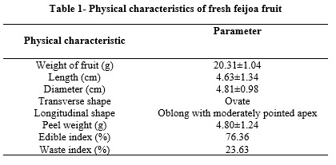

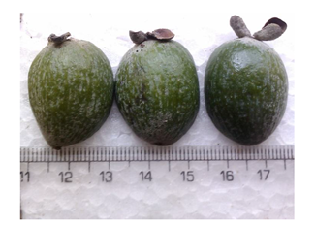

Figure 1- longitudinal and transverse diameters of fresh feijoa fruit

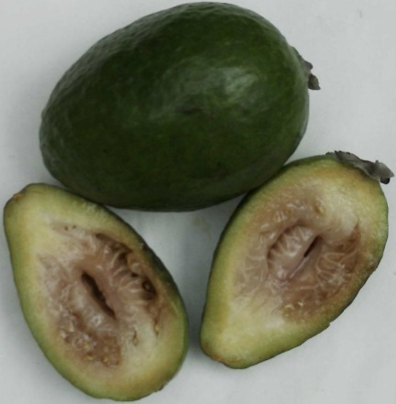
Figure 2- Cut overripe feijoa fruit showing browning

The parameter hardness can be related to the force performed by mastication that takes part during eating. With respect to the results obtained, it was possible to see that rupture of the skin from the flesh side required a lower force (10.9 N) when compared with the same action from the skin side (13.8 N) which means that drying makes the product softer. From the results presented in Table 2, it can be observed that hot air drying had a small effect on cohesiveness compared with the fresh fruit. Regarding chewiness, it diminished greatly with drying, as a result of the variation observed previously in hardness. Many studies indicate that this firming effect of precooking can be attributed to the action of pectin-esterase on the cell-wall materials, particularly pectic substances, thereby resulting in deesterification of pectin molecules and the subsequent formation of calcium bridges between free carboxyl groups of adjacent molecules (LEVI et al. 1988; Pressey et al. 1971; Saladié et al. 2007).
The average values of the color parameters for feijoa in fresh, and after air drying are presented in Table 2 for L* (brightness), a* (redness), b* (yellowness). In general, the air drying at 60 ◦C produced no remarkable changes in the color parameters of feijoa, as compared with the fresh feijoa. However, L* (lightness) of dried fruit was significantly reduced.
Similar results were observed by (Guiné and Barroca 2012; Lin and Chang 2005; Quek et al. 2007) who studied on physicochemical characteristic of fruits.

3-2- Chemical characteristics
Table 3 summarized chemical characteristics of fresh and dried feijoa. It is evident from these finding that Iodine contents of both fresh and dried fruit was high (181-183 ppm) which means feija fruit is an excellent source of iodine. Carbohydrate content increased during drying because of condensation. Changes in ash content, fat and protein were not significant (P>0.05) showing relatively good thermal stability of these compounds.

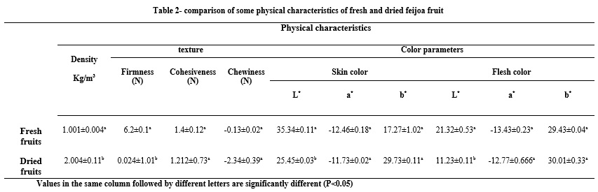

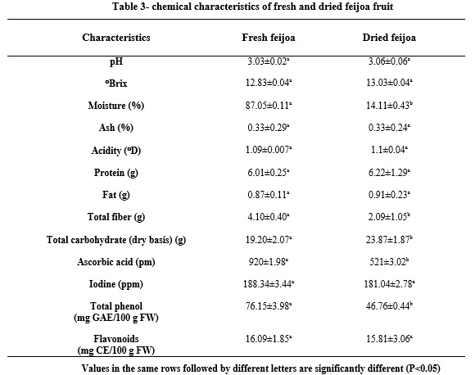

The average ascorbic acid content of fresh, whole feijoa 920 ppm whereas after drying, this content felt to 521 ppm, representing a decrease of about 43.3% in the nutrient content. As seen, the ascorbic acid content is considerably affected from the drying. In fact, ascorbic acid highly sensitive to heat. Similar results were reported for several fruits and vegetables like guava (Uddin et al. 2002), pear (Mrad et al. 2012), pineapple (Ramallo and Mascheroni 2012), tomato (Demiray et al. 2013), pepper (Di Scala and Crapiste 2008) and kiwifruit (Kaya et al. 2010). The recommended daily intake (RDI) of ascorbic acid is about 30 mg/day for adults and 17 mg/day for children (Levine et al. 2001). With these fruits therefore, Tanzanian could be considered as good sources of ascorbic acid for purposes of human nutrition.
The concentration of total fiber was decreased by drying processing. Previous studies showed that heat stability of fibers varies in different food, times, temperatures and pressures. The fluctuations of each component of dietary fiber contents (total, soluble and insoluble) can be different, as well (Chang and Morris 1990). For example, (Wennberg et al. 2006) reported that 5 min boiling of treated white cabbage with acetic acid decreased 9.7-11, 4.9-14 and 6-19% of total, insoluble and soluble fiber, respectively. Whereas, (Manzi et al. 2004) observed that 10 minutes cooking of commercial mushrooms resulted in 42, 29 and 46% increases in the total, insoluble and soluble fiber, respectively.
Phenols are important components due to their hydroxyl groups and scavenging properties and may have a direct relation with antioxidant activity (Bidchol et al. 2011). According to Table 1 a significant (P<0.05) difference between total phenol contents of these three extracts were observed. The highest amount of total phenols was given by fresh fruit, dried fruit the least total phenolic content. This result concurred with the reports of Rhim et al. who reported that most drying methods have an undesired effect on antioxidant activity (Rhim et al. 2009). Shahidi and Naczk also reported that drying, in general, is regarded as unfavorable due to the possibility of inducing oxidative decomposition either enzymatically by polyphenol oxidase and glycosidase or by thermal degradation of phenolic compounds (Naczk and Shahidi 2004).

4- Conclusion
The results of this study indicate that feijoa fruit is a signiﬁcant source of phenol compounds, ﬂavonoids, and ascorbic acid; therefore, feijoa could be considered a good source of natural antioxidants. Moreover, many physicochemical characteristics of dried feijoa fruit remained practically constant after drying. Finally, the results of the present study can be seen as a valuable tool to evaluate drying process of feijoa, in order to retain most of health promoting characteristics.

Refrences
- Al-Harthy A-AS (2010) Postharvest treatments to extend the storage life of feijoa (Acca sellowiana): a thesis presented in partial fulfilment of the requirements for the degree of Doctor of Philosophy in Food Technology at Massey University, Palmerston North, New Zealand.
- Basile A, Conte B, Rigano D, Senatore F & Sorbo S (2010) Antibacterial and antifungal properties of acetonic extract of Feijoa sellowiana fruits and its effect on Helicobacter pylori growth. Journal of medicinal food. 13(1), 189-195.
- Beyhan Ö, Elmastas M & Gedikli F (2010) Total phenolic compounds and antioxidant capacity of leaf, dry fruit and fresh fruit of feijoa (Acca sellowiana, Myrtaceae). Journal of Medicinal Plants Research. 4(11), 1065-1072.
- Bidchol AM, Wilfred A, Abhijna P & Harish R (2011) Free radical scavenging activity of aqueous and ethanolic extract of Brassica oleracea L. var. italica. Food and Bioprocess Technology. 4(7), 1137-1143.
- Bontempo P, Mita L, Miceli M, Doto A, Nebbioso A, De Bellis F, Conte M, Minichiello A, Manzo F & Carafa V (2007) Feijoa sellowiana derived natural Flavone exerts anti-cancer action displaying HDAC inhibitory activities. The international journal of biochemistry & cell biology. 39(10), 1902-1914.
- Bose TK & Mitra SK (1990) Fruits: tropical and subtropical. Naya Prokash.
- Canhoto JM & Cruz GS (1996) Feijoa sellowiana Berg (Pineapple Guava). In: Bajaj YPS (ed) Trees IV, vol 35. Biotechnology in Agriculture and Forestry. p^pp 155-171. Springer Berlin Heidelberg.
- Chang MC & Morris WC (1990) Effect of Heat Treatments on Chemical Analysis of Dietary Fiber. Journal of food science. 55(6), 1647-1650.
- Clerici MTPS & Carvalho-Silva LB (2011) Nutritional bioactive compounds and technological aspects of minor fruits grown in Brazil. Food Research International. 44(7), 1658-1670.
- Demiray E, Tulek Y & Yilmaz Y (2013) Degradation kinetics of lycopene, β-carotene and ascorbic acid in tomatoes during hot air drying. LWT-Food Science and Technology. 50(1), 172-176.
- Di Majo D, La Guardia M, Giammanco S, La Neve L & Giammanco M (2008) The antioxidant capacity of red wine in relationship with its polyphenolic constituents. Food Chemistry. 111(1), 45-49.
- Di Scala K & Crapiste G (2008) Drying kinetics and quality changes during drying of red pepper. LWT-Food Science and Technology. 41(5), 789-795.
- Guiné RP & Barroca MJ (2012) Effect of drying treatments on texture and color of vegetables (pumpkin and green pepper). Food and Bioproducts Processing. 90(1), 58-63.
- Hardy P & Michael B (1970a) Volatile components of feijoa fruits. Phytochemistry. 9(6), 1355-1357.
- Hardy PJ & Michael BJ (1970b) Volatile components of feijoa fruits. Phytochemistry. 9(6), 1355-1357.
- Kaya A, Aydın O & Kolaylı S (2010) Effect of different drying conditions on the vitamin C (ascorbic acid) content of Hayward kiwifruits (Actinidia deliciosa Planch). Food and Bioproducts Processing. 88(2), 165-173.
- LEVI A, BEN‐SHALOM N, PLAT D & REID DS (1988) Effect of blanching and drying on pectin constitutents and related characteristics of dehydrated peaches. Journal of food science. 53(4), 1187-1190.
- Levine M, Wang Y, Padayatty SJ & Morrow J (2001) A new recommended dietary allowance of vitamin C for healthy young women. Proceedings of the National Academy of Sciences. 98(17), 9842-9846.
- Lin C-H & Chang C-Y (2005) Textural change and antioxidant properties of broccoli under different cooking treatments. Food Chemistry. 90(1), 9-15.
- Malik A & Singh Z (2005) Pre-storage application of polyamines improves shelf-life and fruit quality of mango. Journal of horticultural science & biotechnology. 80(3), 363-369.
- Manzi P, Marconi S, Aguzzi A & Pizzoferrato L (2004) Commercial mushrooms: nutritional quality and effect of cooking. Food Chemistry. 84(2), 201-206.
- Monforte MT, Fimiani V, Lanuzza F, Naccari C, Restuccia S & Galati EM (2014) Feijoa sellowiana Berg Fruit Juice: Anti-Inflammatory Effect and Activity on Superoxide Anion Generation. Journal of medicinal food. 17(4), 455-461.
- Moxon R & Dixon E (1980) Semi-automatic method for the determination of total iodine in food. Analyst. 105(1249), 344-352.
- Mrad ND, Boudhrioua N, Kechaou N, Courtois F & Bonazzi C (2012) Influence of air drying temperature on kinetics, physicochemical properties, total phenolic content and ascorbic acid of pears. Food and Bioproducts Processing. 90(3), 433-441.
- Naczk M & Shahidi F (2004) Extraction and analysis of phenolics in food. Journal of chromatography A. 1054(1), 95-111.
- Pasquariello MS, Mastrobuoni F, Di Patre D, Zampella L, Capuano LR, Scortichini M & Petriccione M (2015a) Agronomic, nutraceutical and molecular variability of feijoa (Acca sellowiana (O. Berg) Burret) germplasm. Scientia Horticulturae. 191, 1-9.
- Pasquariello MS, Mastrobuoni F, Di Patre D, Zampella L, Capuano LR, Scortichini M & Petriccione M (2015b) Agronomic, nutraceutical and molecular variability of feijoa (Acca sellowiana (O. Berg) Burret) germplasm. Scientia Horticulturae. 191(0), 1-9.
- Pressey R, Hinton D & Avants J (1971) Development of polygalacturonase activity and solubilization of pectin in peaches during ripening. Journal of food science. 36(7), 1070-1073.
- Quek SY, Chok NK & Swedlund P (2007) The physicochemical properties of spray-dried watermelon powders. Chemical Engineering and Processing: Process Intensification. 46(5), 386-392.
- Ramallo L & Mascheroni R (2012) Quality evaluation of pineapple fruit during drying process. Food and Bioproducts Processing. 90(2), 275-283.
- Rhim J-W, Xi Y, Jeong W-C, Ham K-S, Chung H-S & Kim E-S (2009) Effect of Drying Method on Antioxidant Activity of Jiwhang (Rehmannia glutinosa). Food Science and Biotechnology. 18(6), 1464-1469.
- Rodríguez K, Ah‐Hen K, Vega‐Gálvez A, López J, Quispe‐Fuentes I, Lemus‐Mondaca R & Gálvez‐Ranilla L (2014) Changes in bioactive compounds and antioxidant activity during convective drying of murta (Ugni molinae T.) berries. International Journal of Food Science & Technology. 49(4), 990-1000.
- Saladié M, Matas AJ, Isaacson T, Jenks MA, Goodwin SM, Niklas KJ, Xiaolin R, Labavitch JM, Shackel KA & Fernie AR (2007) A reevaluation of the key factors that influence tomato fruit softening and integrity. Plant Physiology. 144(2), 1012-1028.
- Schotsmans WC, East A, Thorp G & Woolf AB (2011) Feijoa (Acca sellowiana [Berg] Burret). In: Yahia EM (ed) Postharvest Biology and Technology of Tropical and Subtropical Fruits. p^pp 115-135e. Woodhead Publishing.
- Sestras R, Tamas E & Sestras A (2006) Morphological and genetic peculiarities of fruits in several winter apple varieties which confer resistance to damage. Agronomy Research. 4(1), 55-62.
- Skinner M & Hunter D (2013) Bioactives in fruit: health benefits and functional foods. John Wiley & Sons.
- Sun-Waterhouse D, Wang W, Waterhouse GN & Wadhwa S (2013) Utilisation Potential of Feijoa Fruit Wastes as Ingredients for Functional Foods. Food and Bioprocess Technology. 6(12), 3441-3455.
- Taylor TM, Gaysinsky S, Davidson PM, Bruce B & Weiss J (2007) Characterization of Antimicrobial-bearing Liposomes by ζ-Potential, Vesicle Size, and Encapsulation Efficiency. Food Biophysics. 2(1), 1-9.
- Uddin M, Hawlader M, Ding L & Mujumdar A (2002) Degradation of ascorbic acid in dried guava during storage. Journal of Food Engineering. 51(1), 21-26.
- Varga a & Molnar J (2000) Biological activity Of feijoa peel extracts. Anticancer research. 20, 4323-4330.
- Vuotto ML, Basile A, Moscatiello V, De Sole P, Castaldo-Cobianchi R, Laghi E & Ielpo MTL (2000) Antimicrobial and antioxidant activities of Feijoa sellowiana fruit. International Journal of Antimicrobial Agents. 13(3), 197-201.
- Wennberg M, Ekvall J, Olsson K & Nyman M (2006) Changes in carbohydrate and glucosinolate composition in white cabbage (Brassica oleracea var. capitata) during blanching and treatment with acetic acid. Food Chemistry. 95(2), 226-236.
- Weston RJ (2010) Bioactive products from fruit of the feijoa (Feijoa sellowiana, Myrtaceae): A review. Food Chemistry. 121(4), 923-926.
- Zhishen J, Mengcheng T & Jianming W (1999) The determination of flavonoid contents in mulberry and their scavenging effects on superoxide radicals. Food Chemistry. 64(4), 555-559.

10/17/2016

