Investigating of the Effect aromatic water of Citrus Aurantium flowers on the Anxiety-Like Behavior and locomotor Activity in the Male Rats

Manoochehr Yousefi^{1*}, Araz Nazari²

^{1*.}Department of Animal Science, Faculty of Agriculture, Higher Educational Complex, Saravan, Iran
^{2.}MSc of physical education and Sport sciences, Higher Educational complex of Saravan, Iran
*Email: manouchehr.yousefi2001@gmail.com

Abstract: Introduction: Anxiety is a common disorder that a lot of people suffer from it and accompanies physiologic symptoms such as tachycardia, perspiration disorders, lack of sense and sometimes paralysis of limbs etc. Method: In this study, anxiolytic effects of aromatic water of Citrus Aurantium flowers in male rats were assessed compare to the control group. In order to do this, 14 male rats weighing 250 to 350 grams were applied. The rats were divided into two groups of control and experimental each including 7 rats. For 2 weeks before test the experimental group had free access to aromatic water of Citrus Aurantium flowers without any drinking water and the control group had free access to distilled water of course free access to food for two groups had established. Then, the behavior of rats was tested in order to increase physical activities and the curiosity of the rats in 5 minutes in an elevated plus-maze. The obtained results were analyzed using independent sample t-test through SPSS. Findings: The study revealed that although aromatic water of Citrus Aurantium flowers did not have anxiolytic effects on male rat, it only had significant sedative effects.
[Manoochehr Yousefi, Araz Nazari. Investigating of the Effect aromatic water of Citrus Aurantium flowers on the Anxiety-Like Behavior and locomotor Activity in the Male Rats. Researcher 2016;8(9):51-55]. ISSN 1553-9865 (print); ISSN 2163-8950 (online). http://www.sciencepub.net/researcher. 5. doi:10.7537/marsrsj080916.05.

Keywords: elevated plus-maze, anxiety, rat

Introduction
Anxiety and stress disorders are among the most common of all chronic diseases. The prevalences of these disorders are increasing in many countries, and these disorders have a much earlier age of onset than other chronic conditions (Kessler & Greenberg, 2002). Since the introduction of benzodiazepines in the 1960s, they have been the most commonly prescribed treatment for anxiety, remaining the mainstay of pharmacological treatment in anxiety disorders. However, they have prominent side effects, such as sedation, myorelaxation, ataxia, and amnesia, and they can cause pharmacological dependence(LADER & MORTON, 1991). Thus, new therapies for the treatment of anxiety disorders are necessary, and the study of medicinal plants could provide new therapeutic options(Faustino, ALMEIDA, & Andreatini, 2010). Citrus Aurantium, commonly known as sour orange or bitter orange (local name in Iran: Nareng) is produced in Northern and Southern Iran. Traditionally, Citrus aurantium is used as an alternative medicine in some countries to treat anxiety, insomnia and as an anticonvulsant, suggesting depressive action upon the central nervous system (Carvalho-Freitas & Costa, 2002). Thus, In the sudy anxiolytic and tranquilizing effect of aromatic water of Citrus Aurantium was investigated.
Method
This was an experimental study in which 14 male rats weighing 250 to 350 grams were randomly selected and tested. All animals were housed under standard environmental conditions of temperature, relative humidity and light (22±2 °C, 60—70% humidity,12 h light: 12 h dark cycle The animals are divided into two groups of experimental and control, each including 7 rats. Food and water were given ad libitum of course 2 weeks before test The experimental group is fed with aromatic water of Citrus Aurantium without any drinking water for the period of two weeks and control group was fed with distilled water. Both groups during peiod of 2 weeks had free access to food. Elevated plus-maze device was applied which is a standard model for testing anxiety level in rodents. This device is made up of wood and includes two open arms (each 5×10 cm) and two closed arms (each 50× 10 × 40 cm) and a central plate (10 ×10 cm). Open arms are across from each other and so are the closed arms and are located 50 cm above the floor of the room. This is an experimental non-conditional anxiety testing model and does not require any animal training and learning(Miladi-Gorji, Vafaei, Rashidy-Pour, Taherian, & Jarrahi, 2007; MILADI, RASHIDIPOUR, VAFAEI, & TAHERIAN, 2008). In the day of the test, the animals were transferred to the laboratory in the morning, and then in order to test the anxiety level, the animal was located in an elevated plus-maze (in the plate and across from the open arm) and the important anxiety testing indices including the number of entrances to open and closed arms and the time of staying in open and closed arms were tested and recorded for 5 minutes (Miladi-Gorji et al., 2007; MILADI et al., 2008; Pellow, Chopin, File, & Briley, 1985; Pellow & File, 1986; Tsuda, Suzuki, Misawa, & Nagase, 1996; Zhang & Schulteis, 2008). The total number of entrances into two arms are considered as a locomotor activity(Clément et al., 2007). independent sample t-test was the statistical measure in order to analyze of data. Significance level of P˂0.05 was considered for the experimental groups.
Findings of the study
According to figure 1, the data show that the number of entrances into open arms and also the period they stayed in open arms was reduced in experimental group of rats compared to the control group. Therefore, the results obtained from independent sample t-test indicated a significant difference (P˂0.01) in the total number of entrances among the two groups. The increasing entrances into closed arms and also the increasing entrances into open and closed arms for both groups also indicate their locomotor activities. The findings of the study depict that the experimental group is physically less active than the control group.
Tables and diagrams

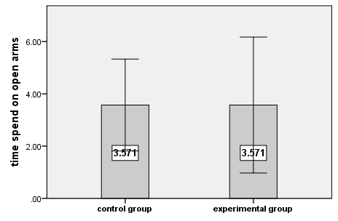
Diagram 1: indicates the time spent in the open arms

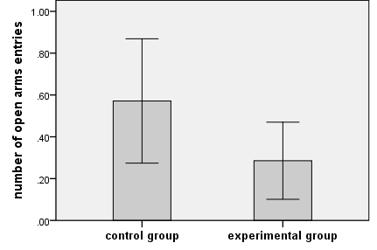
Diagram 2: shows the number of entrances on the open arms

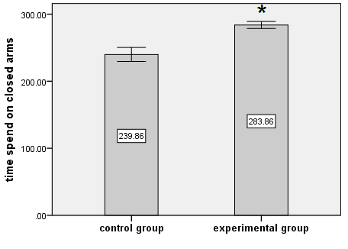
Diagram 3: shows that the period of staying in closed arms is significantly more than the control group (P˂0.05) using independent sample t-test
*: shows the significant difference than the control group (P˂0.01)

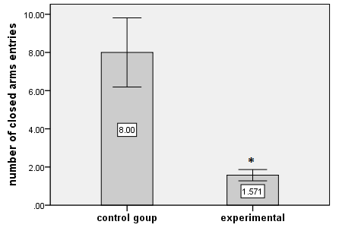
Diagram 4: depicts that the number of entrances into closed arms in the experimental group is significantly less than the control group (P˂0.05 using independent sample t-test
*: shows a significant difference than the control group (P˂0.01)

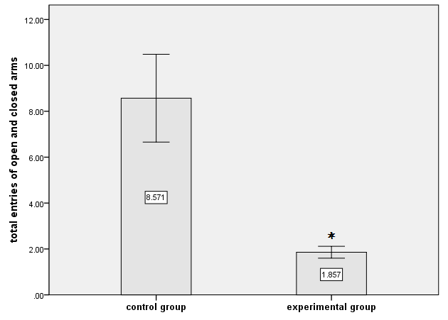
Diagram 5: reveals that the total number of entrances into open and closed arms in the experimental groups is less than the control group (P˂0.05) using independent sample t-test
*: shows a significant difference than the control group (P˂0.01)

Discussion
The findings of the study show that the rats in the experimental group spent less time in open arms than the control groups. In other words, they searched less than the control group inside the arm of elevated plus-maze. Also, the number of entrances of rats of experimental group into open and closed arms was less than the control group and there was a significant difference between the total numbers of entrances into each of the two arms among the groups which indicates a reduction of locomotor activities of the animal(Clément et al., 2007). The reduction in locomotor activities is dependent on sedative properties of the materials present in aromatic water of Citrus Aurantium. The previous findings of the experiments on essential oil and extract of Citrus Aurantium show that it has anxiolytic and sedative effects but the reason why these anxiolytic effect were not observed in this study is that excessive sedative effects of long-term consumption led to reduction in locomotor activities and finally resulted in the reduction of entrances into open arms and so the period of staying in closed arms significantly increased in the experimental group. another study reveal, the excessive expression of glyoxalase 1 and glutathione reductase 1 genes in the brain of the rats with their role in the metabolism of oxidative stress, lead to the increase in anxiety-like behaviors(Hovatta et al., 2005). Considering that Citrus Aurantium consist of some anti-oxidants, it probably has anxiolytic behavior by controlling the above-mentioned genes. flavonoids are strong anti-oxidants and they have capable of pharmaceutical and biochemical actions. Perhaps the sedative effect of Citrus Aurantium is due to having flavonoid compositions or might be due to the Adenosine present in this plant. The inhibitory neuromodulator, adenosine, is a promising candidate for a sleep-inducing factor: its concentration is higher during wakefulness than during sleep, it accumulates in the brain during prolonged wakefulness, and local perfusions as well as systemic administration of adenosine and its agonists induce sleep and decrease wakefulness. Adenosine receptor antagonists, caffeine and theophylline, are widely used as stimulants of the central nervous system to induce vigilance and increase the time spent awake. Our hypothesis is that adenosine accumulates in the extracellular space of the basal forebrain during wakefulness, increasing the sleep propensity. The increase in extracellular adenosine concentration decreases the activity of the wakefulness-promoting cell groups, especially the cholinergic cells in the basal forebrain. When the activity of the wakefulness-active cells decreases sufficiently sleep is initiated. During sleep the extracellular adenosine concentrations decrease, and thus the inhibition of the wakefulness-active cells also decreases allowing the initiation of a new wakefulness period.(Porkka-Heiskanen, 1999). The presence of Citrus Aurantium might increase the tranquilizing stat so that these effects dominate its anxiolytic effects.

Results
It seems that aromatic water of Citrus Aurantium might have more sedative effects. Using little amounts of Citrus Aurantium might have anxiolytic effects; hence, further research is suggested on this issue.

References:
- Carvalho-Freitas, M. I. R., & Costa, M. (2002). Anxiolytic and sedative effects of extracts and essential oil from Citrus aurantium L. Biological and Pharmaceutical Bulletin, 25(12), 1629-1633.
- Clément, Y., Joubert, C., Kopp, C., Lepicard, E. M., Venault, P., Misslin, R.,... Chapouthier, G. (2007). Anxiety in mice: a principal component analysis study. Neural plasticity, 2007.
- Faustino, T. T., ALMEIDA, R. d., & Andreatini, R. (2010). Plantas medicinais no tratamento do transtorno de ansiedade generalizada: uma revisão dos estudos clínicos controlados. Rev Bras Psiquiatr, 32(4), 429-436.
- Hovatta, I., Tennant, R. S., Helton, R., Marr, R. A., Singer, O., Redwine, J. M.,... Lockhart, D. J. (2005). Glyoxalase 1 and glutathione reductase 1 regulate anxiety in mice. Nature, 438(7068), 662-666.
- Kessler, R. C., & Greenberg, P. E. (2002). The economic burden of anxiety and stress disorders. Neuropsychopharmacology: The fifth generation of progress, 67, 982-992.
- LADER, M., & MORTON, S. (1991). Benzodiazepine problems. British Journal of Addiction, 86(7), 823-828.
- Miladi-Gorji, H., Vafaei, A., Rashidy-Pour, A., Taherian, A., & Jarrahi, M. (2007). Emami abarghoii M, Sadegi H. Anxiolytic Effects of the aqueous extracts of Portulaca Oleracea in mice. J. Medicinal Plants, 19(5), 23-28.
- MILADI, G. H., RASHIDIPOUR, A., VAFAEI, A. A., & TAHERIAN, A. A. (2008). The role of morphine dependence on the level of anxiety in Rat.
- Pellow, S., Chopin, P., File, S. E., & Briley, M. (1985). Validation of open: closed arm entries in an elevated plus-maze as a measure of anxiety in the rat. Journal of neuroscience methods, 14(3), 149-167.
- Pellow, S., & File, S. E. (1986). Anxiolytic and anxiogenic drug effects on exploratory activity in an elevated plus-maze: a novel test of anxiety in the rat. Pharmacology Biochemistry and Behavior, 24(3), 525-529.
- Porkka-Heiskanen, T. (1999). Adenosine in sleep and wakefulness. Annals of medicine, 31(2), 125-129.
- Tsuda, M., Suzuki, T., Misawa, M., & Nagase, H. (1996). Involvement of the opioid system in the anxiolytic effect of diazepam in mice. European journal of pharmacology, 307(1), 7-14.
- Zhang, Z., & Schulteis, G. (2008). Withdrawal from acute morphine dependence is accompanied by increased anxiety-like behavior in the elevated plus maze. Pharmacology Biochemistry and Behavior, 89(3), 392-403.

9/25/2016

