Results Of Research On Astrometeorology

Gangadhara Rao Irlapati

H.No.5-30-4/1, Saibaba Nagar, Jeedimetla, Hyderabad – 500 055, Telangana State, INDIA
Email ID: scientistgangadhar@gmail.com

Abstract: Astrometeorology is thousands of years old based on astronomical positions that allegedly directly affect the weather on the earth. I have conducted many researches in the field of Astrometeorology and invented some related discoveries & inventions which may also be useful in understanding the extent of the use of Astrometeorology.
[Gangadhara Rao Irlapati. Results Of Research On Astrometeorology. Researcher 2016;8(9):13-44]. ISSN 1553-9865 (print); ISSN 2163-8950 (online). http://www.sciencepub.net/researcher. 3. doi:10.7537/marsrsj080916.03.

Key Words: Astrometeorology, Monsoons, Cyclones, Indian Monsoon Time Scale.

Introduction:
I have conducted many scientific researches on the Indian Monsoon during the period of 1980-91, and invented the Indian Monsoon Time Scale which can help to study the past, present and future movements of the Indian Monsoon. In 1991, Sri G.M.C. Balayogi, Member of Parliament (Lok Sabha) recommended the Indian Monsoon Time Scale to the India Meteorological Department for implementation in the services of the country. In 1994, the cabinet secretary of India recommended the Indian Monsoon Time Scale to the Ministry of Science & Technology, Govt of India for implementation. In 1996, Many consultations were made with the parliament house, president of India and other VVIPS of India. In 2005, consultations were made with the India Meteorological Department about the Indian Monsoon Time Scale for further research and development in the services of the country. In 2009, the Secretary, Minister of science and technology was also recommended the Indian monsoon Time scale to the Indian Institute of tropical Meteorology for research and development.
Indian Monsoon Time Scale: The Indian Monsoon Time Scale-a chronological sequence of events arranged in between time and weather with the help of a scale for studying the past, present and future movements of monsoon of India and its relationship with rainfall and other weather problem and natural calamities.
Prepare the Indian Monsoon Time Scale having 365 horizontal days March 21st to next year March 20th of a required period comprising of a large time and weather have been taken and framed into a square graphic scale. The main weather events if any have been entering on the scale as per date and month of the each and every year. If we have been managing the scale in this manner continuously we can study the past, present and future movements of the Indian Monsoon.
For example, I have prepared the Indian Monsoon Time Scale by Preparing the Scale having 365 horizontal days from 1st April to next year March 31st of 128 years from 1888 to 2016 for the required period comprising of large time and weather have been taken and framed into a square graphic scale. The monsoon pulses in the form of low pressure systems over the Indian region have been entering on the scale in stages by 1 for low, 2 for depression, 3 for storm, 4 for severe storm and 5 for severe storm with core of hurricane winds pertaining to the date and month of the each and every year. If we have been managing the scale in this manner continuously, we can study the past’s present’s and future’s of the India monsoon and its relationship with rainfall and other weather problems & natural calamities in India.
Analysis: The Indian Monsoon Time Scale reveals many secrets of the monsoon & its relationship with rainfall & other weather problems and natural calamities. For example, some bands, clusters and paths of low pressure systems along with the main paths of the Indian Monsoon (South-west monsoon and north-east monsoon) clearly seen in the map of the Indian monsoon it have been some cut-edge paths passing through its systematic zigzag cycles in ascending and ascending order which causes heavy rains & floods in some years and droughts & famines in another years according to their travel. For example, during 1871-1990’s the main path of the Indian monsoon was rising over June, July, August and creating heavy rains and floods in most years. During 1900-1920’s it was falling over August, September and causing low rainfall in many years, During 1920-1965’s, it was rising again over July, August, September and resulting good rainfall in more years. During 1965-2004’s it was falling over September and causing low rainfall and droughts in many years. At present it is rising upwards over June, July, August, and will be resulting heavy rains & floods in coming years during 2004-2060. The tracking date of main path & other various paths such as south-east monsoon and north-west monsoon etc., of the Indian Monsoon denotes the onset of the monsoon, monsoon pulses or low pressure systems. And also we can find out many more secrets of the Indian monsoon such as droughts, famines, cyclones, heavy rains, floods, real images of the Indian Monsoon, and onset & withdrawals of south east monsoon and north-west monsoon etc. by keen study of the Indian Monsoon Time Scale.
Principle: This is an Astrogeophysical/ Astrometeorological Phenomenon of effects of astronomical bodies and forces on the earth’s geophysical atmosphere. The cause is unknown however the year to year change of movement of axis of the earth inclined at 23 ½ degrees from vertical to its path around the sun does play a significant role in formation of clusters, bands & paths of the Indian Monsoon and Stimulates the Indian weather. The inter-tropical convergence zone at the equator follows the movement of the sun and shifts north of the equator merges with the heat low pressure zone created by the rising heat of the sub-continent due to the direct and converging rays of the summer sun on the Indian Sub-continent and develops into the monsoon trough and maintain monsoon circulation.
Experiments Carriedout: Many experiments were carried out on the Indian Monsoon Time Scale and Successfully proved out in practice.
Publications: Many journals announced the Indian Monsoon Time Scale In 2004, a news commentary was published in the popular daily Vartha. The journal of environmental & ecology announced the Indian Monsoon Time Scale and Global Monsoon Time Scale in 2015.
Conclusions: We can make many more modifications thus bringing many developments in the Indian Monsoon Time Scale.
Indian Weather Time Scale: I have conducted many extensive researches on the astronomical forces and its effects on the earth climate particularly on various regions of the India. The variations in the solar cycle affects and stimulate the earth climate. The moon affects and stimulate the ocean tides and atmosphere too. The movement of axis of the earth inclined at 23 ½ degrees from vertical to its path around the sun affects and stimulate the earth weather and leads to formation of monsoons and seasons etc. So the astronomical forces affect and stimulate the earth climate it may be more or less but it is true. These scales may be taken as a part of scientific study of astronomical forces & its effects on the earth climate.
In the time and scale of the universe some things from astronomy to atom including living beings have been repeating once in every certain time or period. For example, the south and north magnetic poles have been shifting in every certain period. The sun spots have been repeating once in every eleven years. The lunar and solar eclipses have also been occurring once in every 18.6 years. The seasons such as winter, autumn etc. also have been repeating once in every year in the same month of the year. The periodical menses in the females repeating once in every month.
On the basis of the said universal facts, I have prepared a time scale with 21 blocks, each block containing certain prescribed cycle of years in which similar calendar years repeating one after another that leads similar weather conditions of those previous years to future years likely repeating every year approximately. The rainfall of the years, have been entering in the scale in percentages or as it is pertaining to month, season, annual wise of the each and every year. If we managing the scale in this manner continuously, we may assuming the weather conditions of the anterior years on the basis of the posteriors years weather. On the basis of the principle, we can assume that a considerable, of course it may be little chance of predication for an ensuing years by study the data of earlier years.
I have prepared a model Indian weather time scale along with hundreds of additional scales (1617 scales, 12 months, 4 seasons, 50 regions & 150 above years were studied) in which all weather conditions such as rainfall, temperature, cyclones, river water etc of all homogeneous regions sub-divisions of India were studied and analyzed elaborately.
Studies Carried Out:
Firstly, see the Indian weather forecasting study model time scale. In this scale, the June, July, August and September months of the summer monsoon season were taken in a table in which the each month is also divided into three parts the Telangana, Rayalaseema and Coastal Andhra regions. The monthly wise rainfall data of the months of the regions from 1870 to till available years are taken in the form of percentages or as it is and entering in the scale pertaining to the region wise of the each and every year. If we managing the scale in this manner continuously, we may assuming the weather conditions of the anterior years on the basis of the posterior years weather.
Example for assuming the dry season or suppose to predict the rainfall situation in the summer season of the ensuing year 2019: study the 7th cycle in which wet conditions in 10 years and dry conditions in 14 years were occurred in the month of June: wet conditions in 2 years and dry conditions in 22 years were occurred in the month of July: wet conditions in 4 years and dry conditions in 20 years were occurred in the month of August and wet conditions in 8 years and dry conditions in 16 years were occurred in the month of September. On the whole, wet conditions in 24 times and dry conditions in 72 times repeated in the summer monsoon season of the 7th cycle (As a result, there were dry conditions occurred in the 2002 year also). Therefore it is a considerable chance to predict that a dry season will be repeated in the ensuing year of 2019.
Example for assuming the wet season or suppose to predict the rainfall situation in the summer season of the ensuing year 2022: study the 10th cycle in which wet conditions in 13 years and dry conditions in 8 years were occurred in the month of June: wet conditions in 13 years and dry conditions in 8 years were occurred in the month of July: wet conditions in 9 years and dry conditions in 12 years were occurred in the month of August and wet conditions in 19 years and dry conditions in 2 years were occurred in the month of September. On the whole, wet conditions in 54 times and dry conditions 30 times were repeated in the summer monsoon season of the 10th cycle. As a result, there were wet conditions occurred in the 2005 years also. Therefore, it is a considerable chance to predict that a wet season will be occurred in the ensuing year of 2022.
In the same manner, we can study the remaining all Indian weather time scales of all Indian Homogeneous regions and subdivisions, states and districts of India.
We can make many more modifications thus bringing many more developments in the Indian weather time scale and its all additional Indian weather time scale.

References:
- Mooley DA, Shukla J(1987); Charecteristics of the west ward-moving summer monsoon low pressure systems over the Indian region and their relationship with the monsoon rainfall. centre for ocean-land atmospheric interactions, university of Maryland, college park, MD.
- All india monthly and seasonal rainfall series,18711993, B. Parthasarathy, A. AMunot, D. R. Kothawale, Theoritical and applied climatology,1994, Springer.
- Das P. K. and B. L. Bose, 1958, Numerical study of movement of monsoon depression, Ind. journal of meteor. Geophysics.
- Analysis of variability and trends of extreme rainfall events over india using 104 years of gridded daily rainfall data, M. Rajeevan, J. Bhate, A. K. Jaswal, Geophysical Research letters, 2008, online library.
- Jadhav, S. K. and A. A. Munot,2004; statistical study of the low pressure systems during summer monsoon season over the Indian region, mausam,55,15-30.
- Clusturing of low pressure system during the Indian summer monsoon by intra seasonal oscillations, bn. goswani, rs. ajaya mohan, prince kxavier, and d. sengupta, centre for atmospheric and oceanic studies, Indian institute of science, bangolour, india.
- Composite structure of monsoon low pressure system and its relation to Indian rainfall, v. krishna murthy and rs. ajaya mohan, 2010, j. climate,23,4285-4305.
- Indian monsoon university of st Andrews www.Andrews.Ac.Uk/Dibz/Asia/Monsoon/Html.
- Indian monsoon /meteorology/britanica/.com www.britanica.com/science /indian monsoon.
- The global monsoon system: research and fore cast; caos.iisc.in/faculty/bng/iwm-iii-bng-overview.
- Climate predictron centre-global monsoon; www.cpc ncep.noaa.gov, climate.weather.
- The global monsoon system, www.wcrp-climate.org/documents/monsoon –factssheet.
- All india monthly and seasonal rainfall series, 1871-1993, b. parthasarathy, a. a munot, Drkothawale, theiritical and applied climatology, 1994, springer.
- Parthasarathy b, munot aa, kothawale dr, monthly and seasonal rainfall series for all india homogeneous regions and meteorological sub-divisions, 1871-1994, research report, iitm pune.
- Longest instrumental rainfall series of the Indian regions (1813-2006), Indian institute of tropical meteonology, pune.
- All Indian data series-(imd) pune.
- Monthly rainfall data series-ministry of earth sciences, moes. gov. in.
- 114 years rainfall in india-interactive, india environmentportal. org. in/rainfall in india.
- www.ncdc.noaa.gov/data-access/numerical-weather-prediction.
- En.wikipedia.org/wiki/numerical- weather- prediction.
- The history of numerical weather prediction –NOAA;
- Fundamentals of numerical weather prediction/ ebooks.cambridge.org.
- Ken ring,the moon and lunar science predict weather.
- Moon predict weather lore / www.almanac.com/content/moon-lore-weather.
- Climate change, sunspots activity & lunar /cosmic cycles (www.the longerview.com.au/sunmoon-climate.html).
- Astrometeorology & agriculture by Robert nelson.
- Marvis. Dr. H. B. journal American(NY)1 oct 1938.
- Goss, M. J. geophysical reviews, march 1953.
- Jevons. w. s. nature,14 nov 1878.
- Hove, Jim Ten, astrological journal 15(3)17-23.
- Luby, w. A. popular Astronomy dec 1940.
- Nelson. J. H. cosmic pattern, their influence on man and his communications 1974 American federation of astrologers.
- Nelson J. H, RCA review, April 1951.
- Nelson JH, J. geocosmic research, summer 1974.
- Meteorology astrology (Astrometeorology) lewis. james. R, march 2003, astrology book 2003, p453.
- www.physics for ums.com/threads/astro-meteorology.

Appendices: (Indian Weather Time Scale)
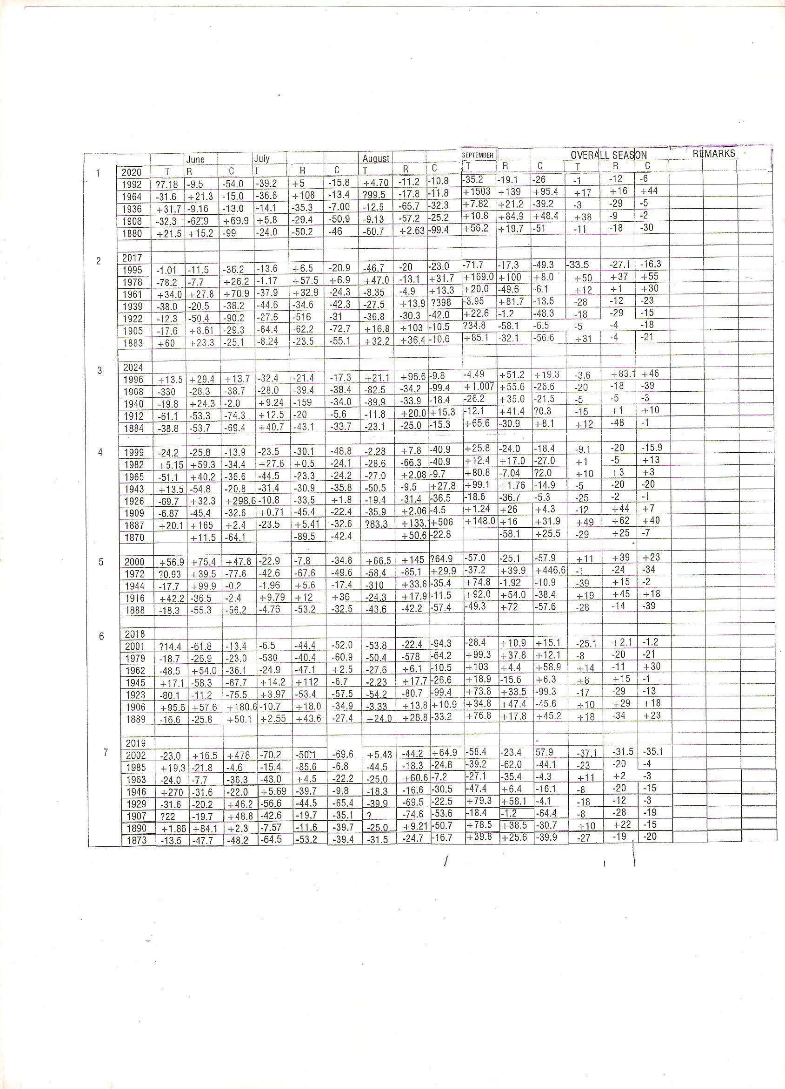

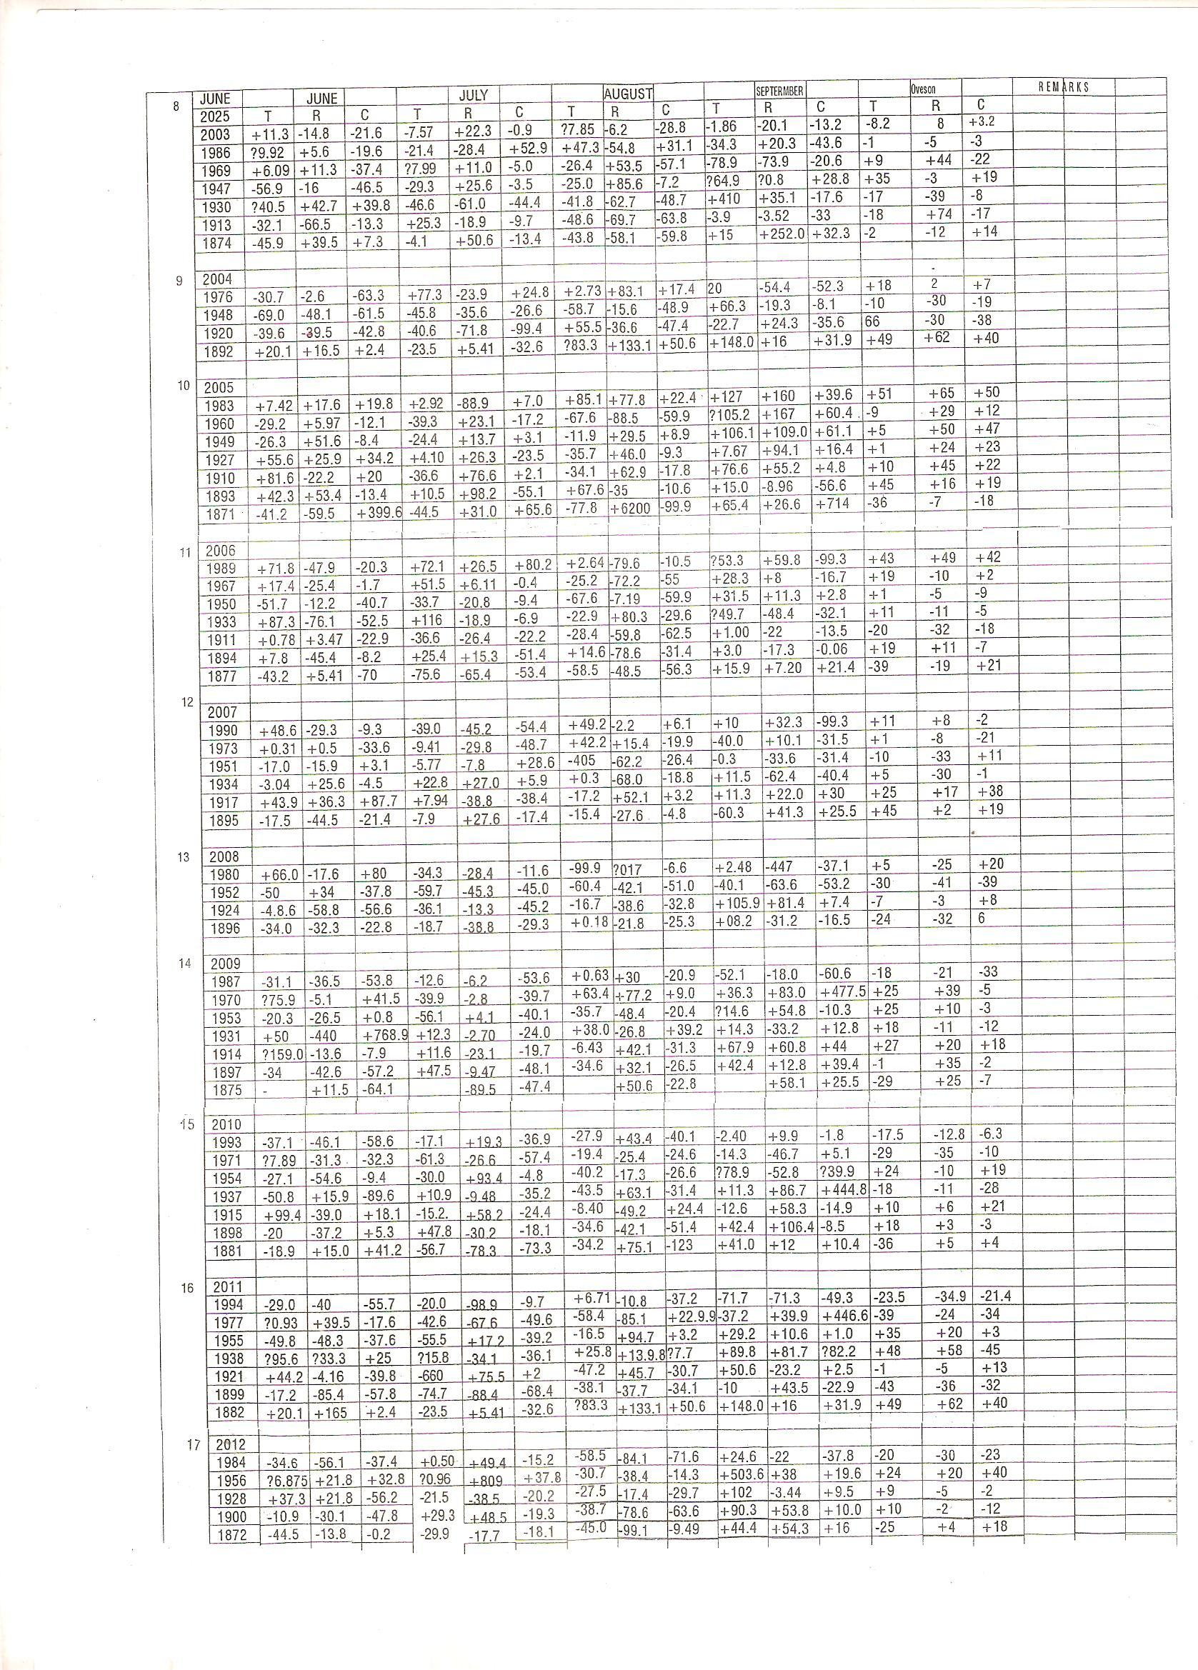

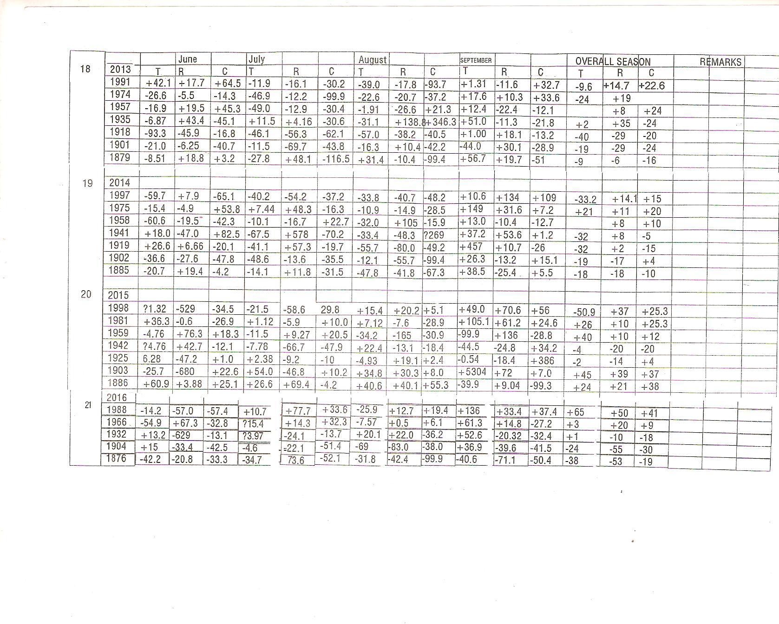

Appendices: (Indian Monsoon Time Scale)

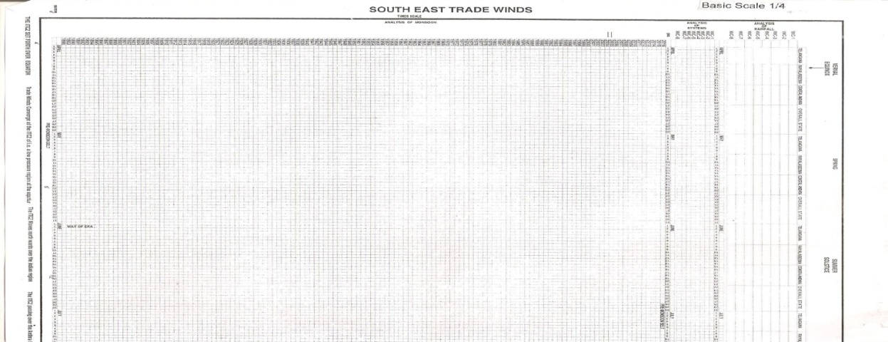
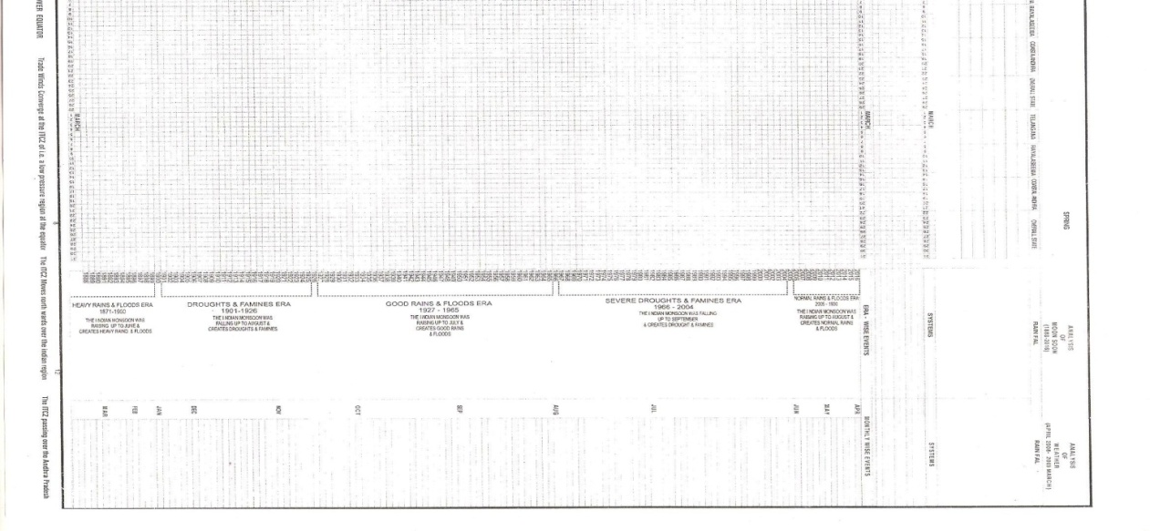

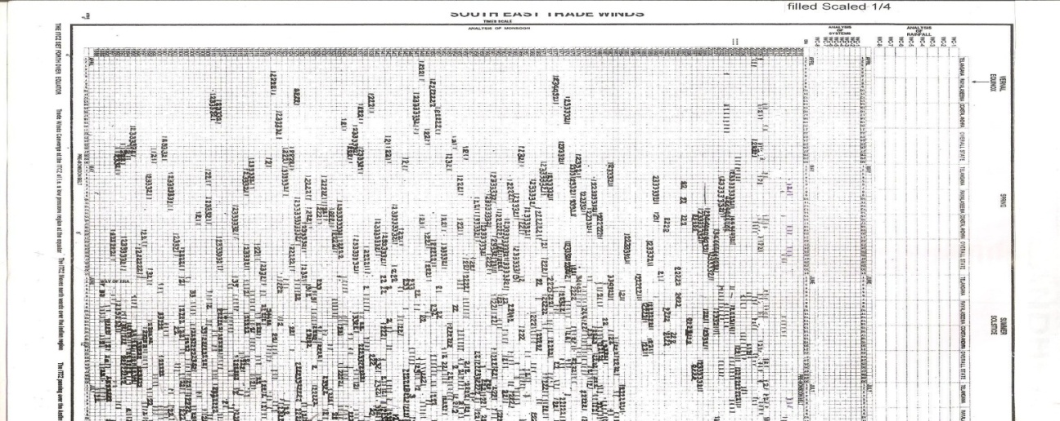
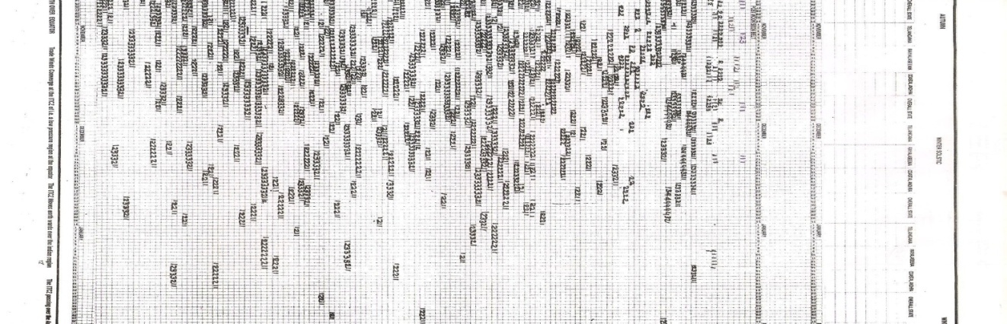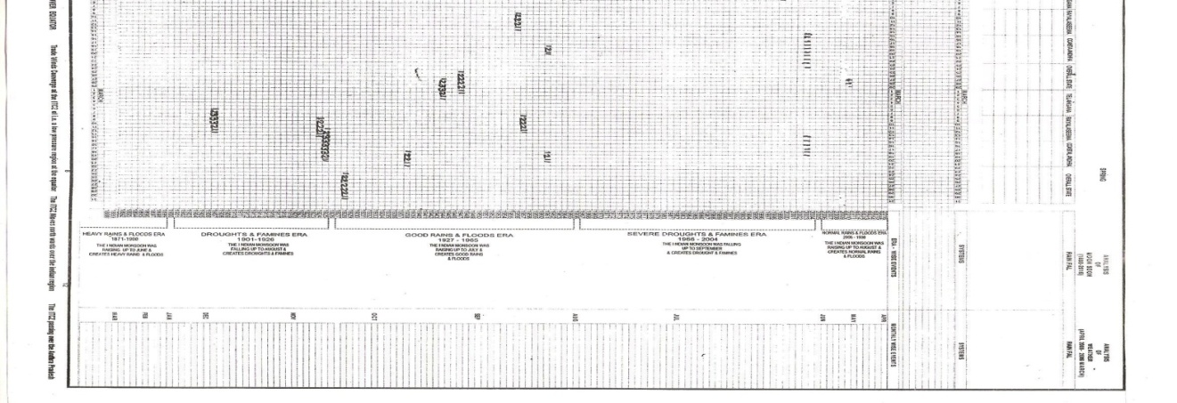

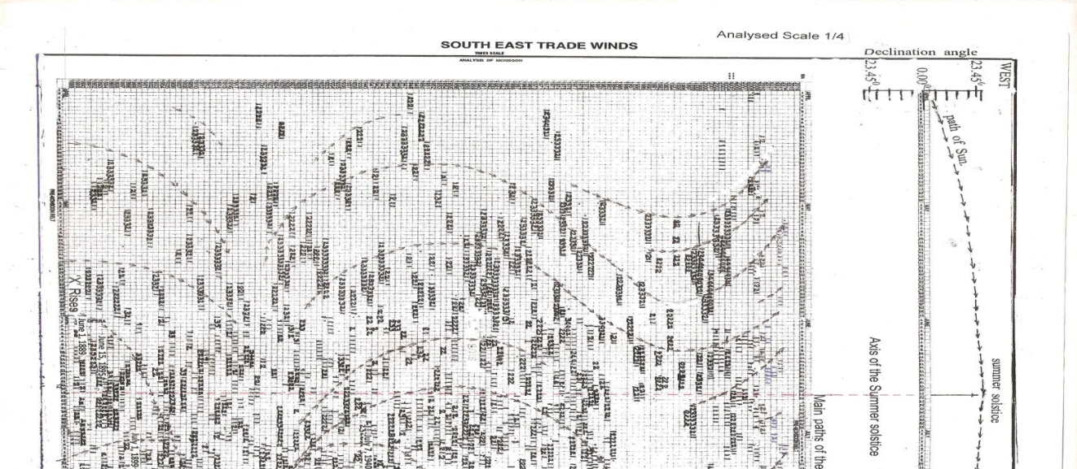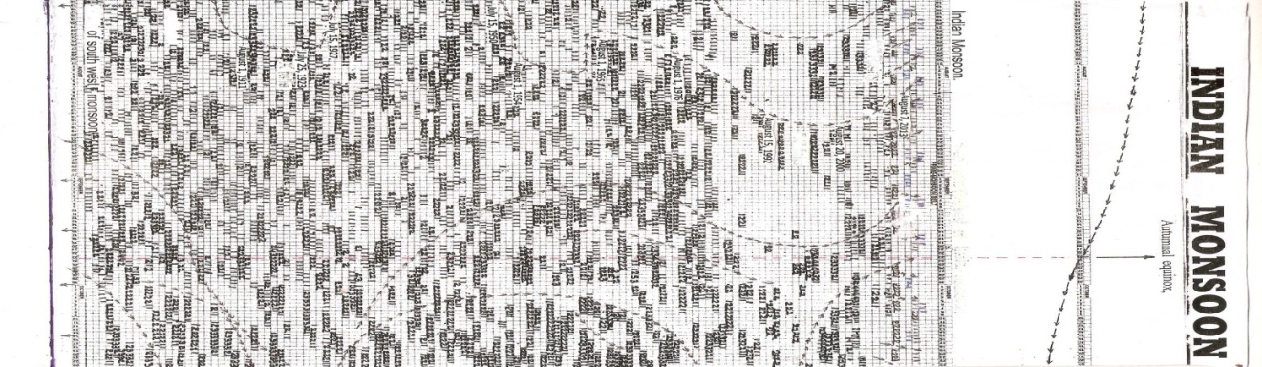
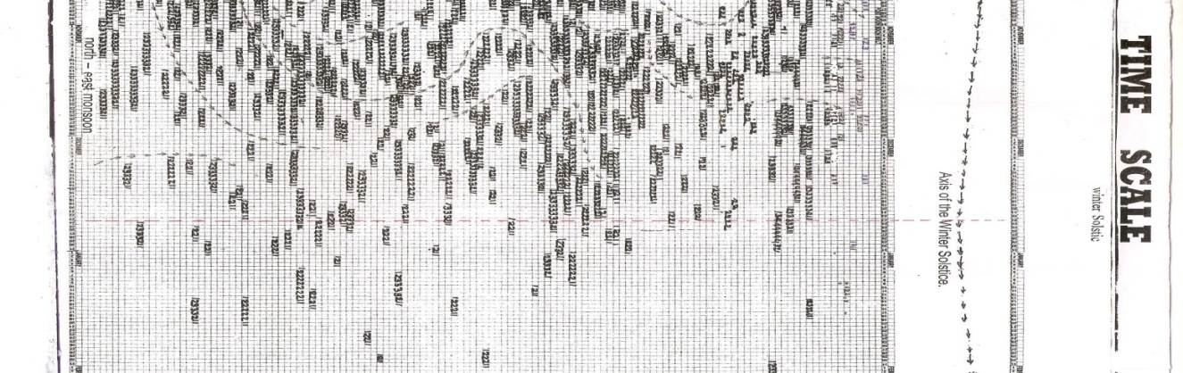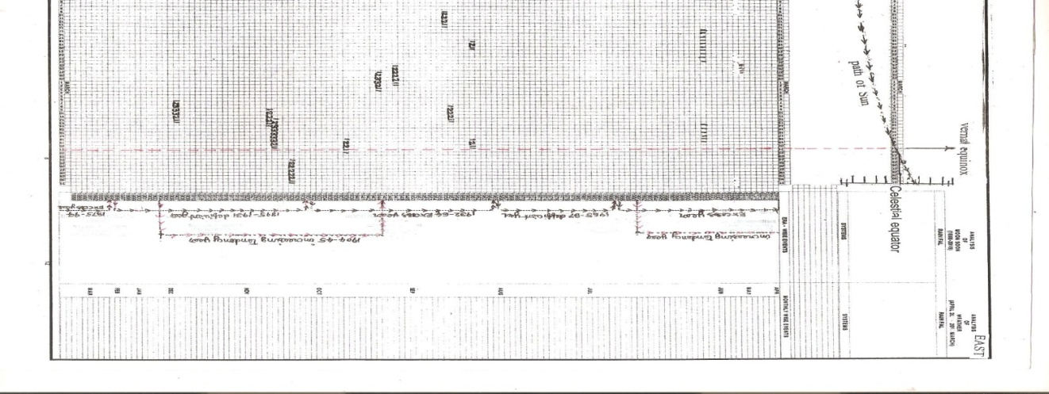

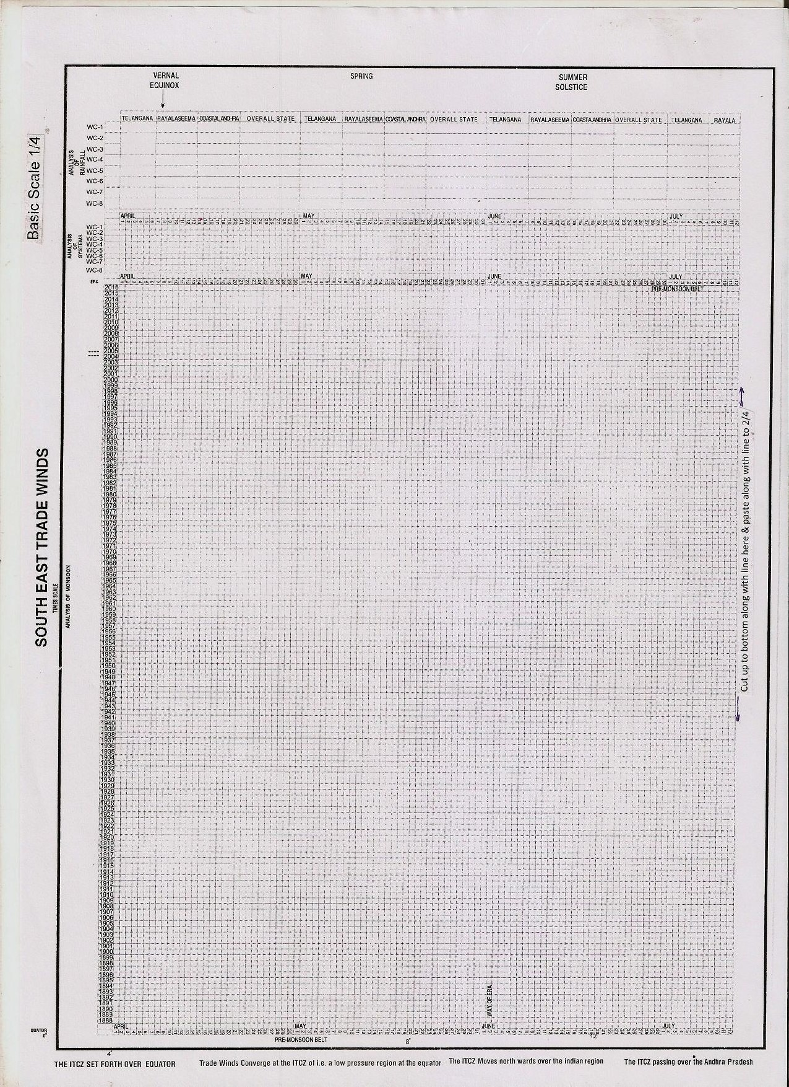
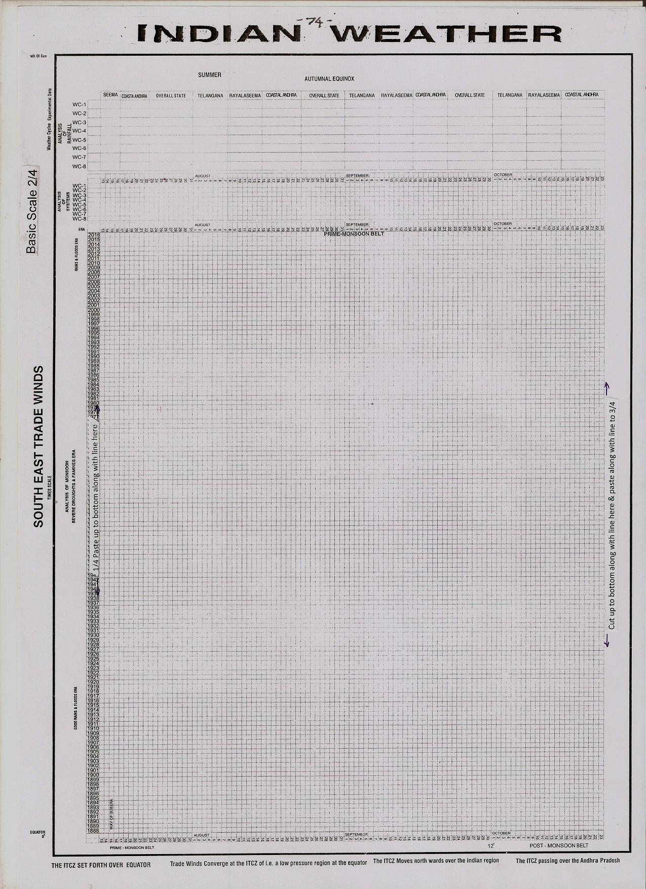
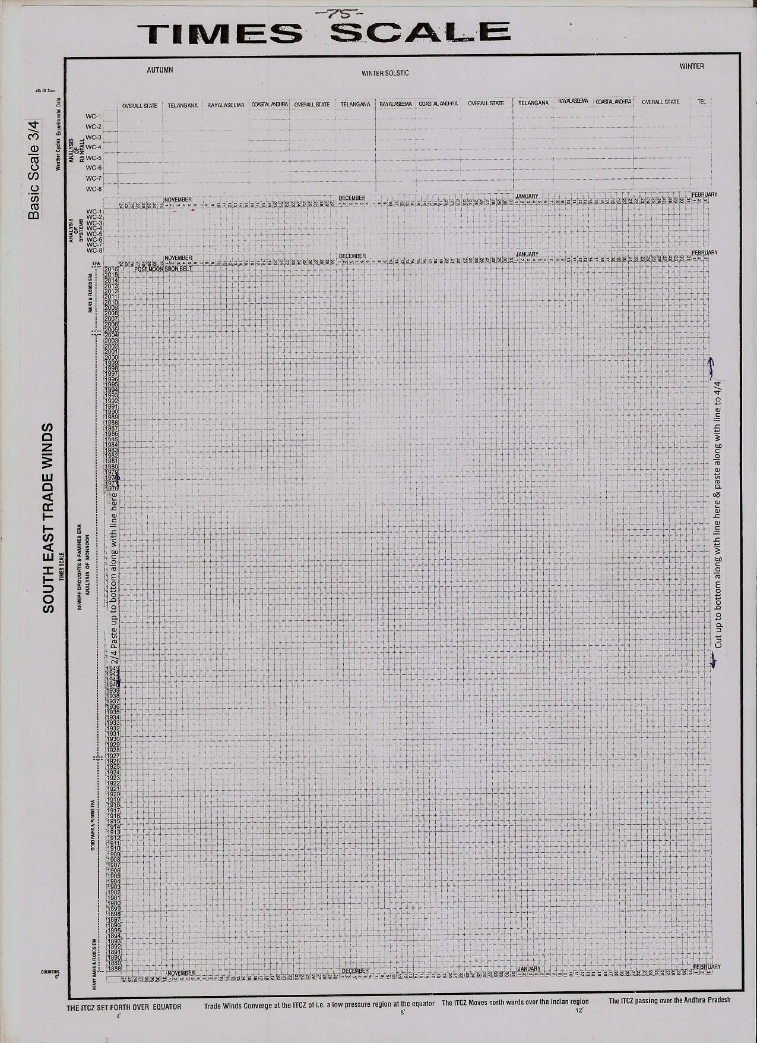
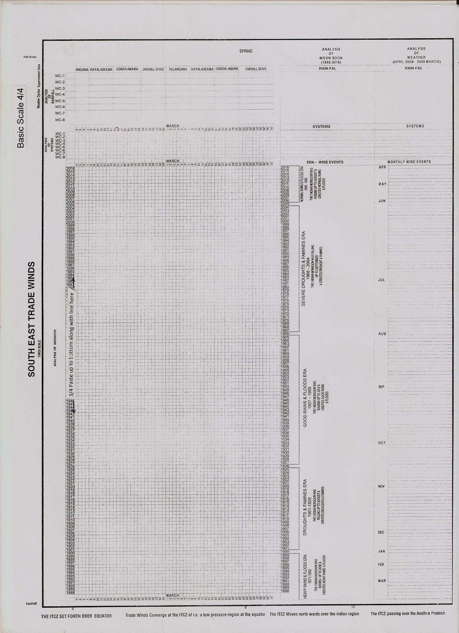
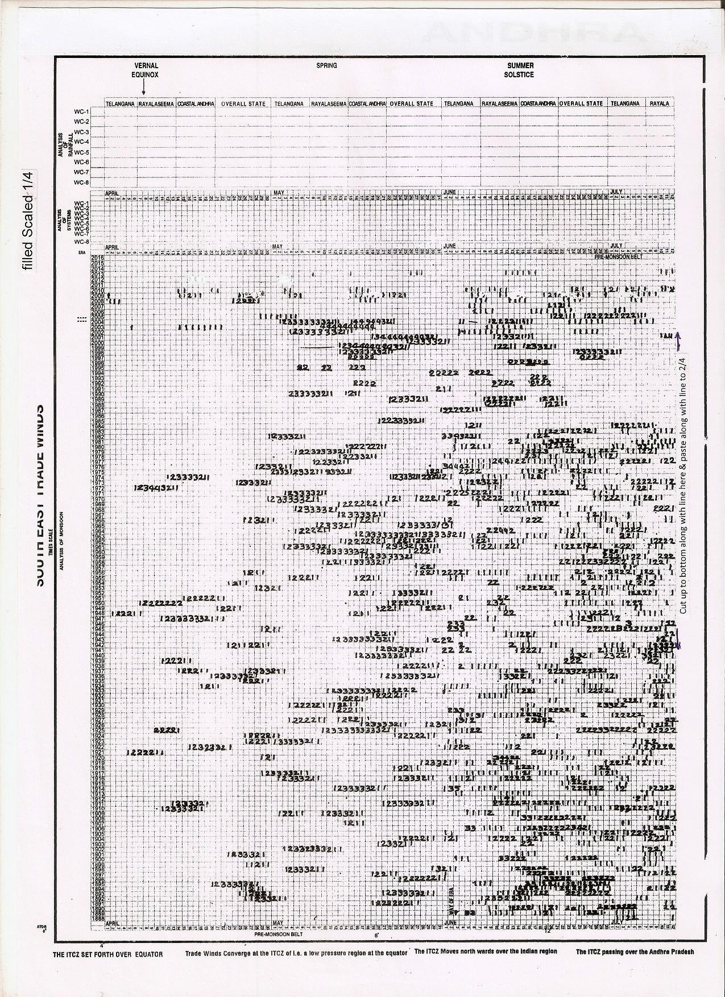
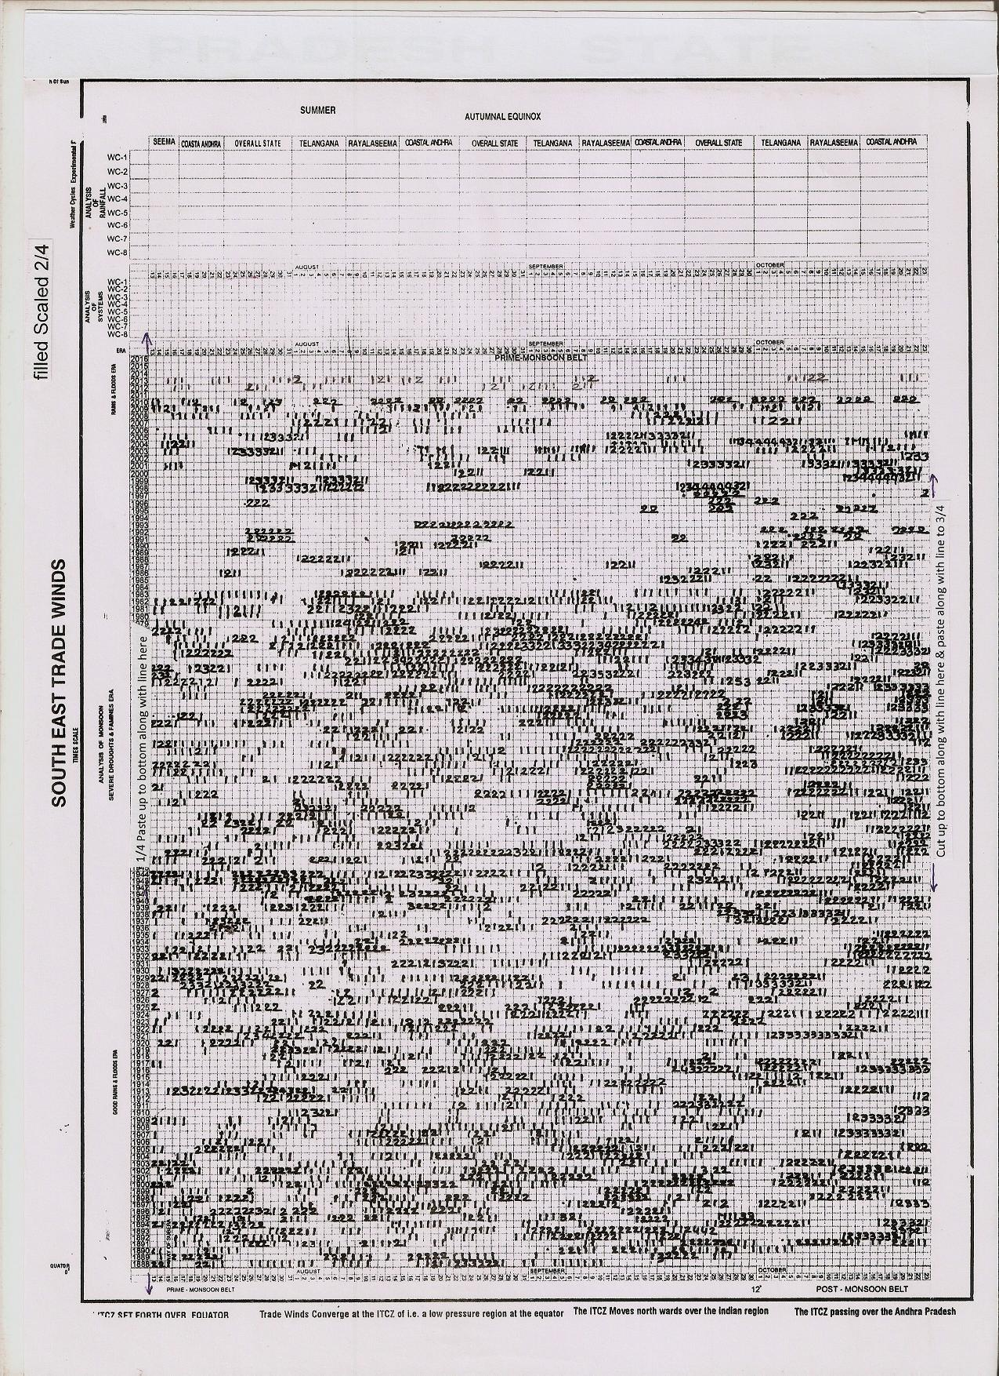
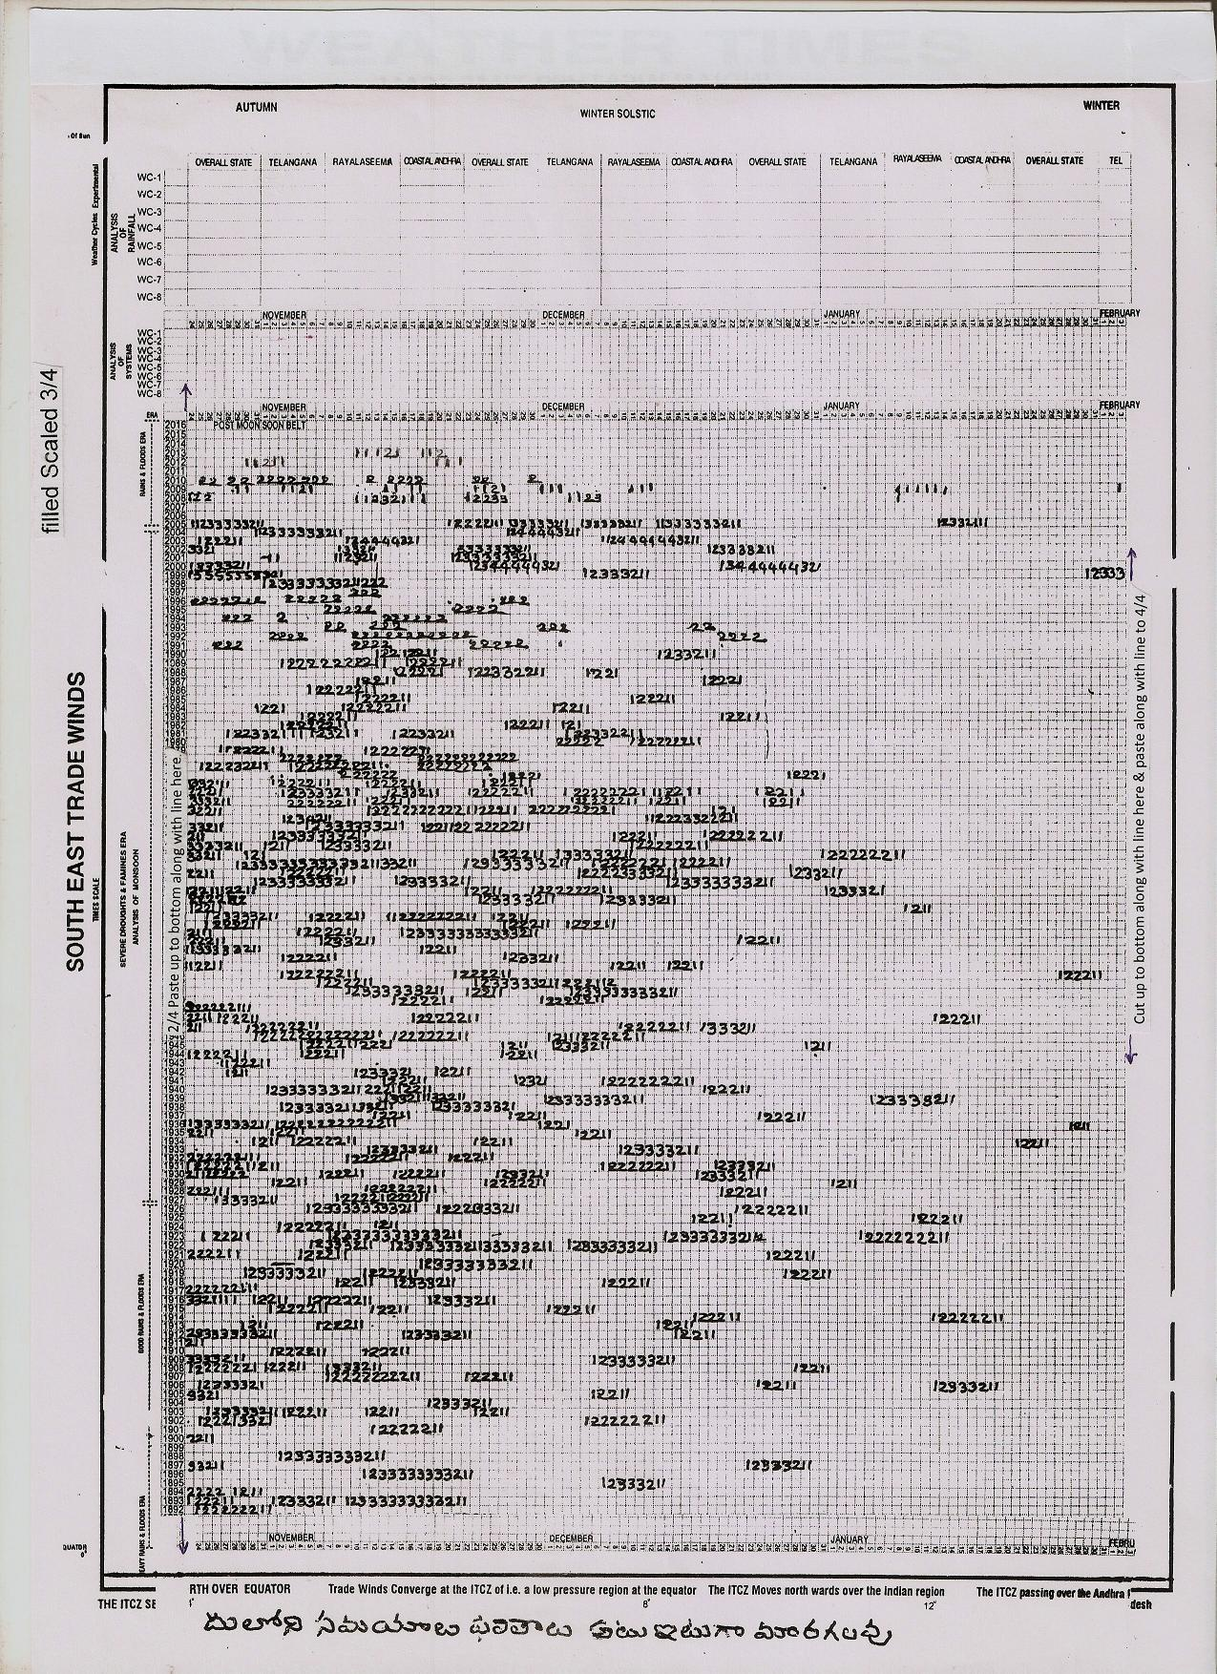
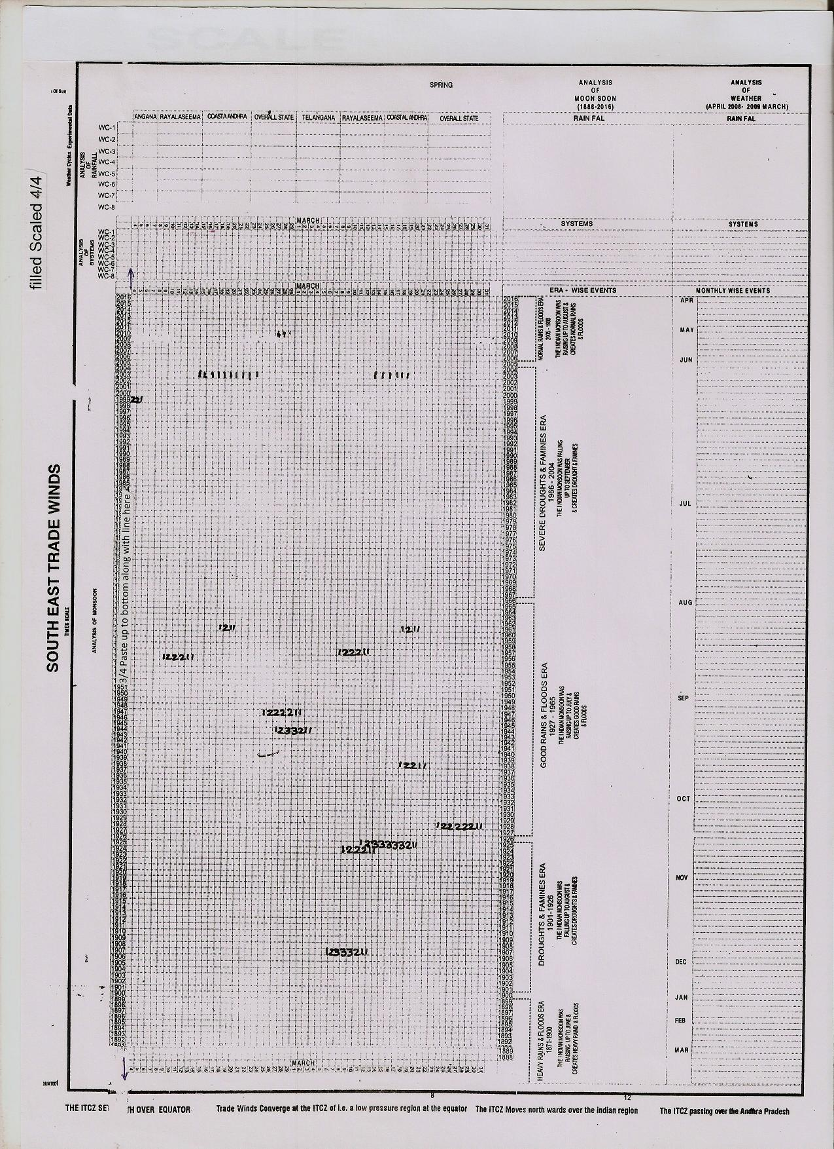
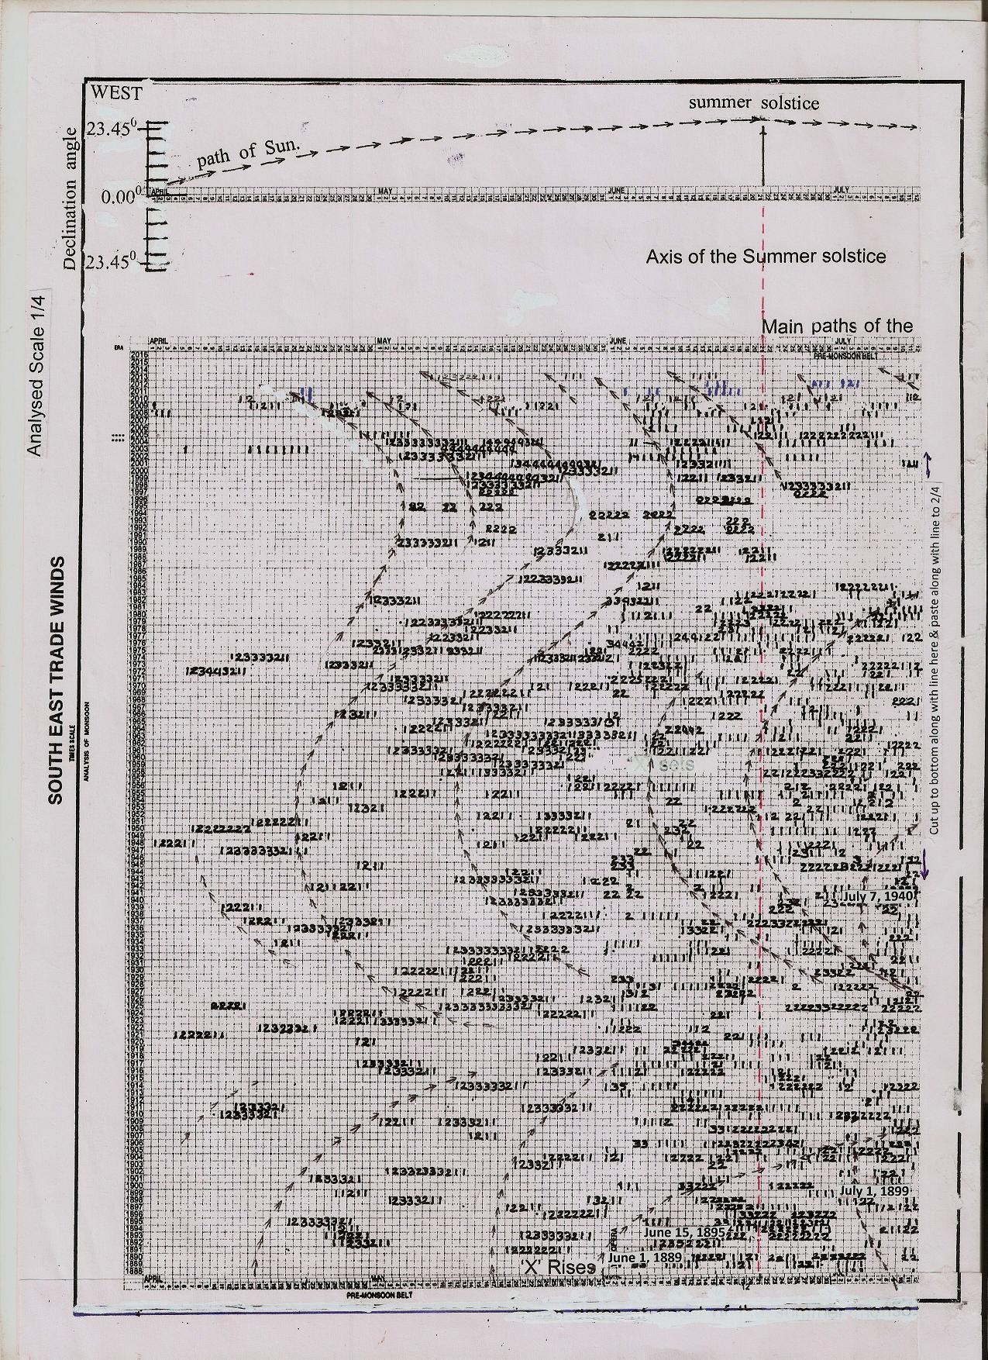
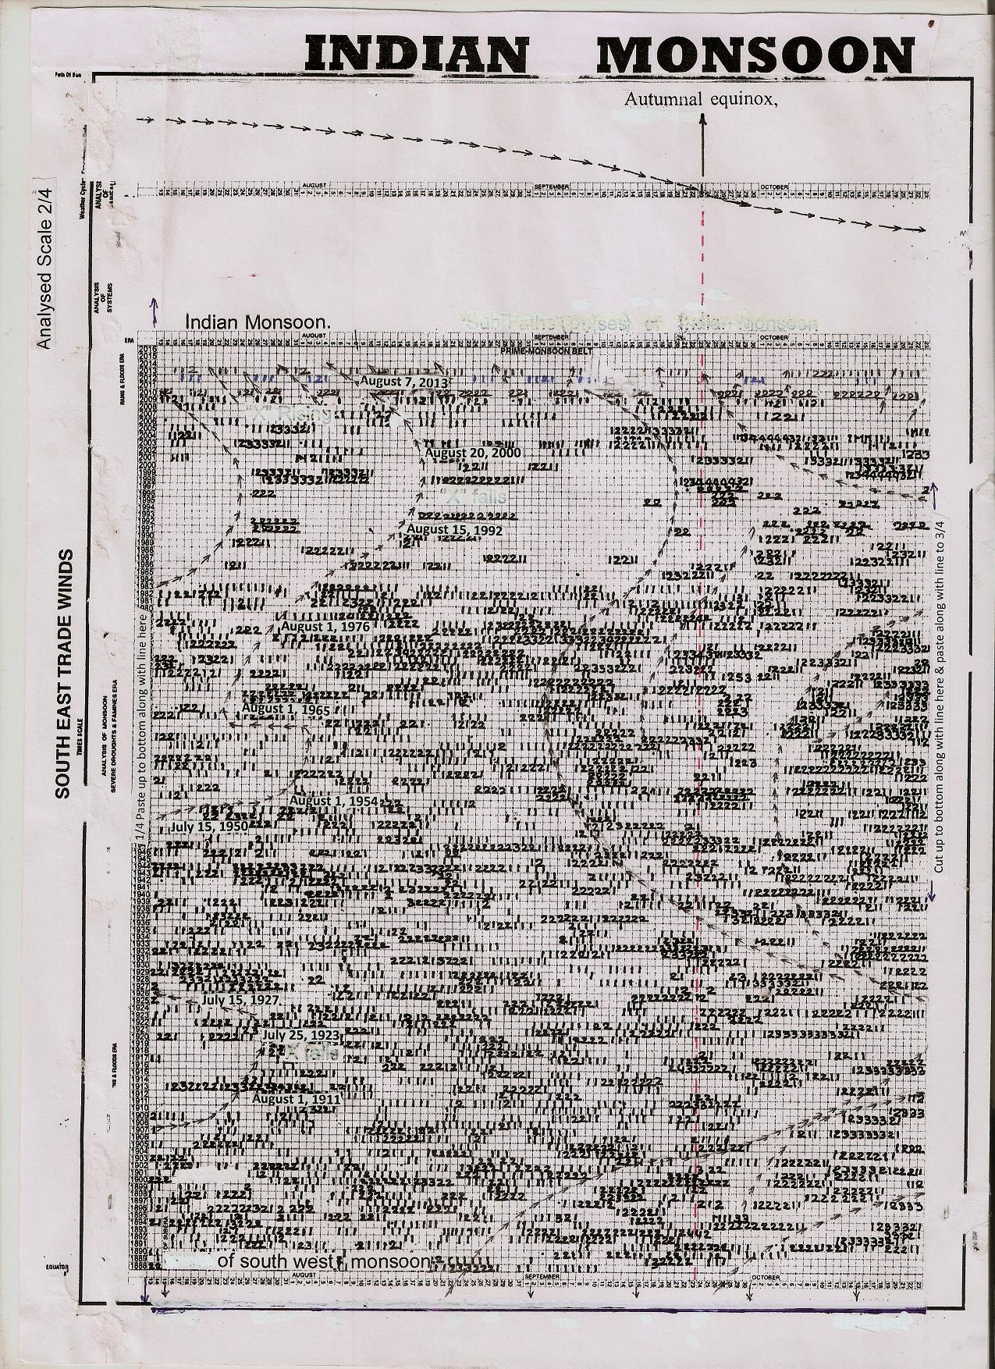
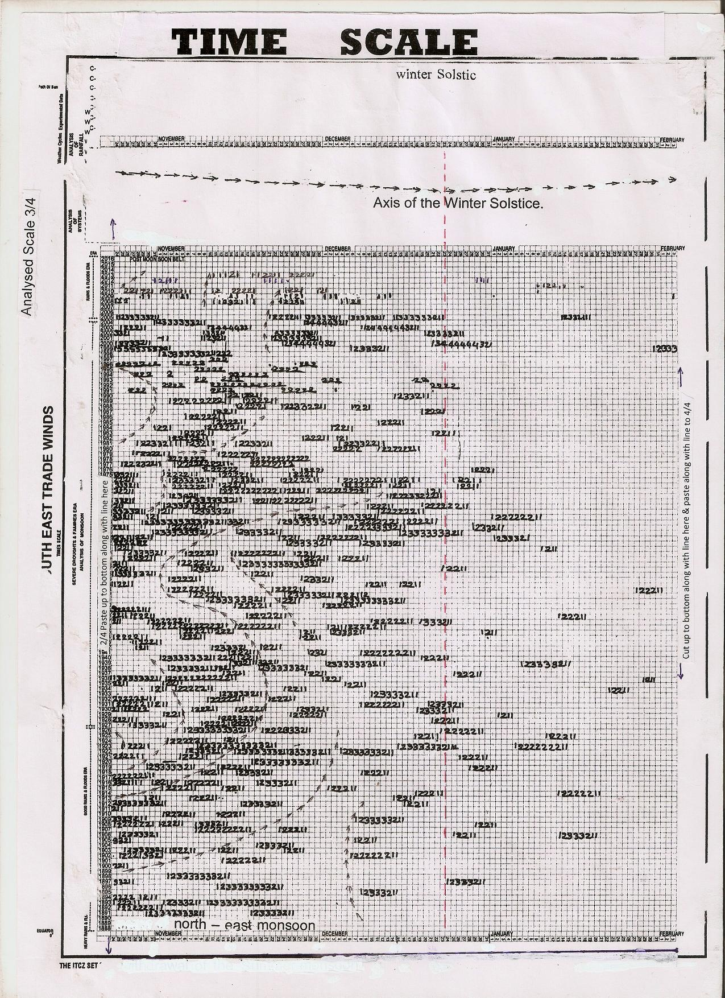
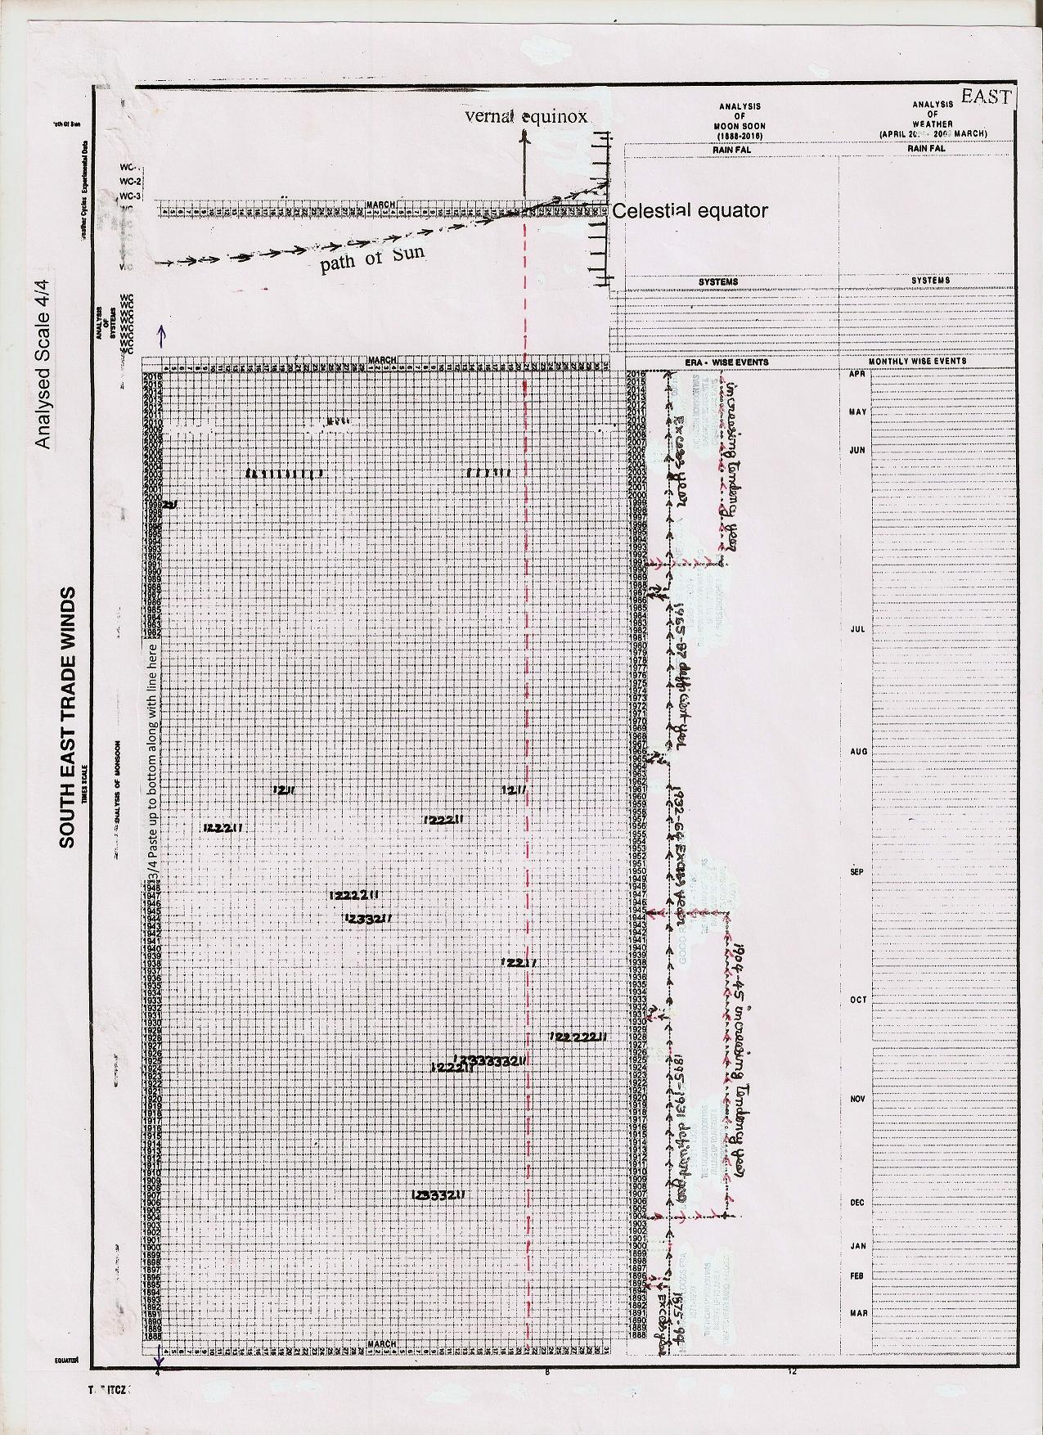
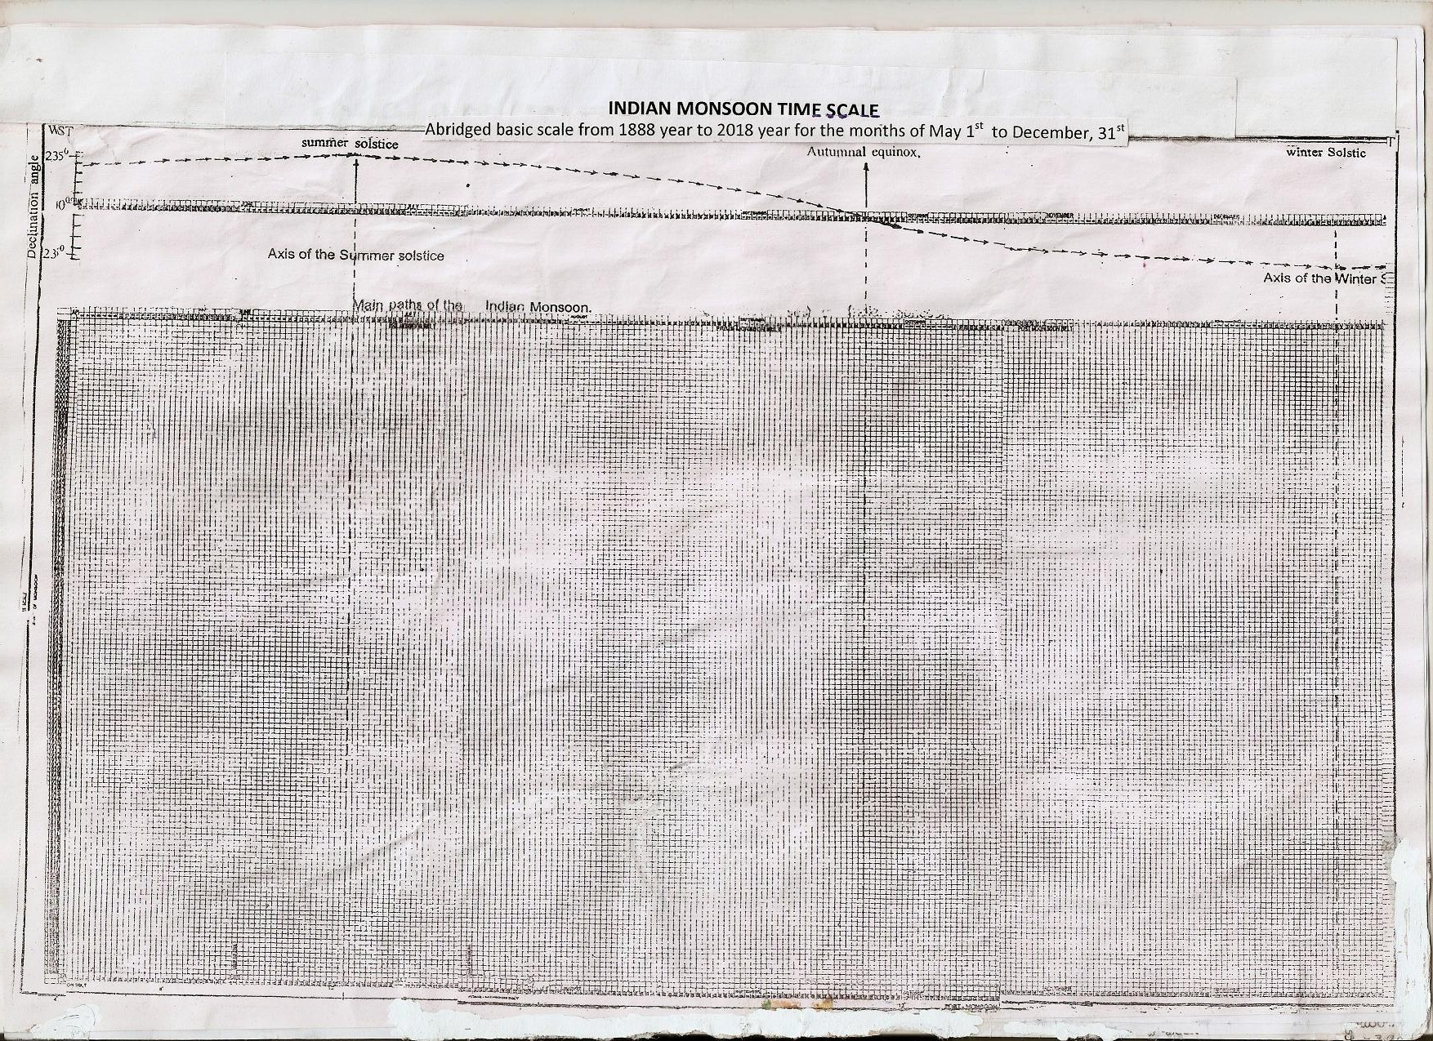
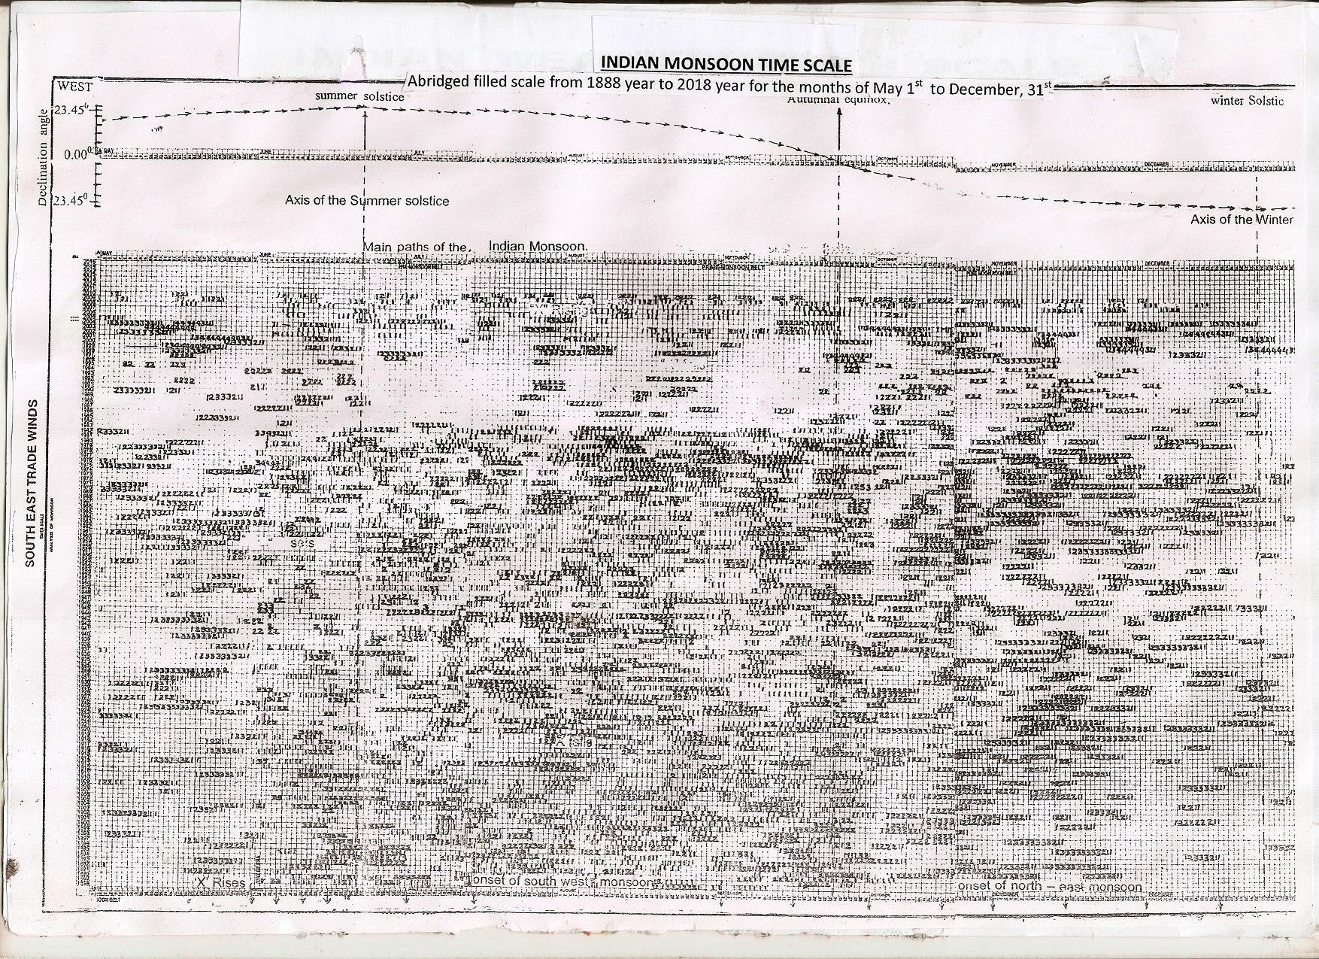
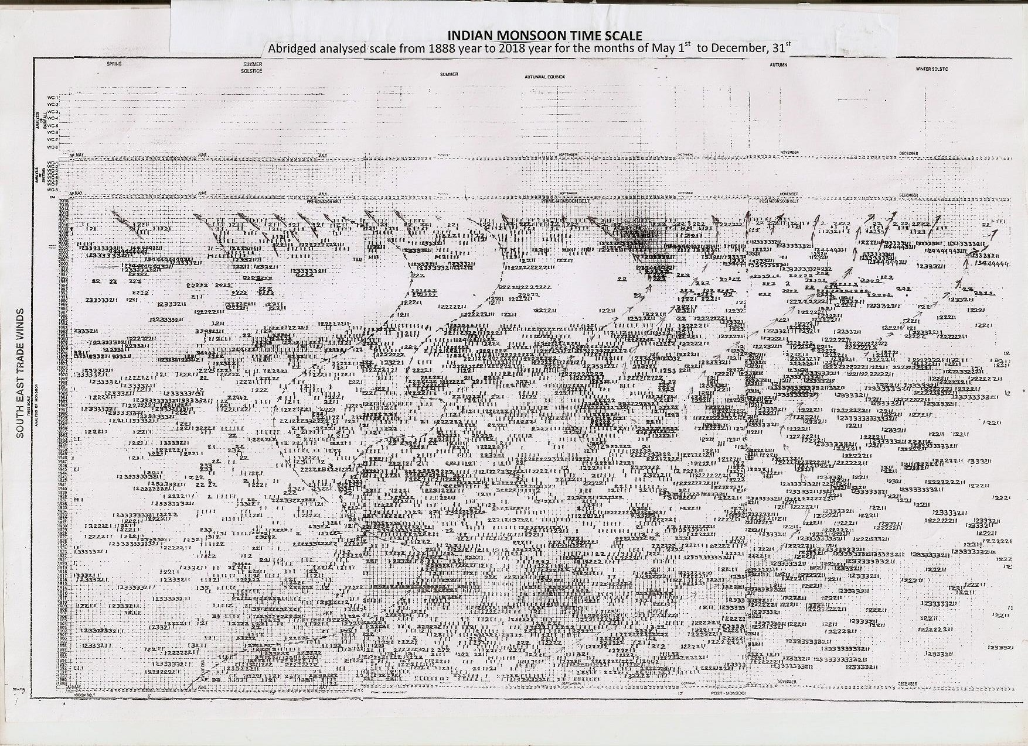
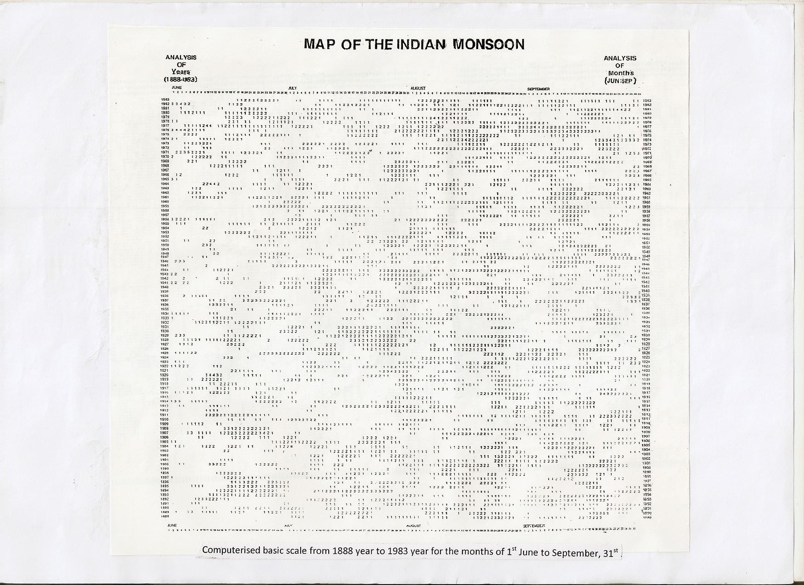

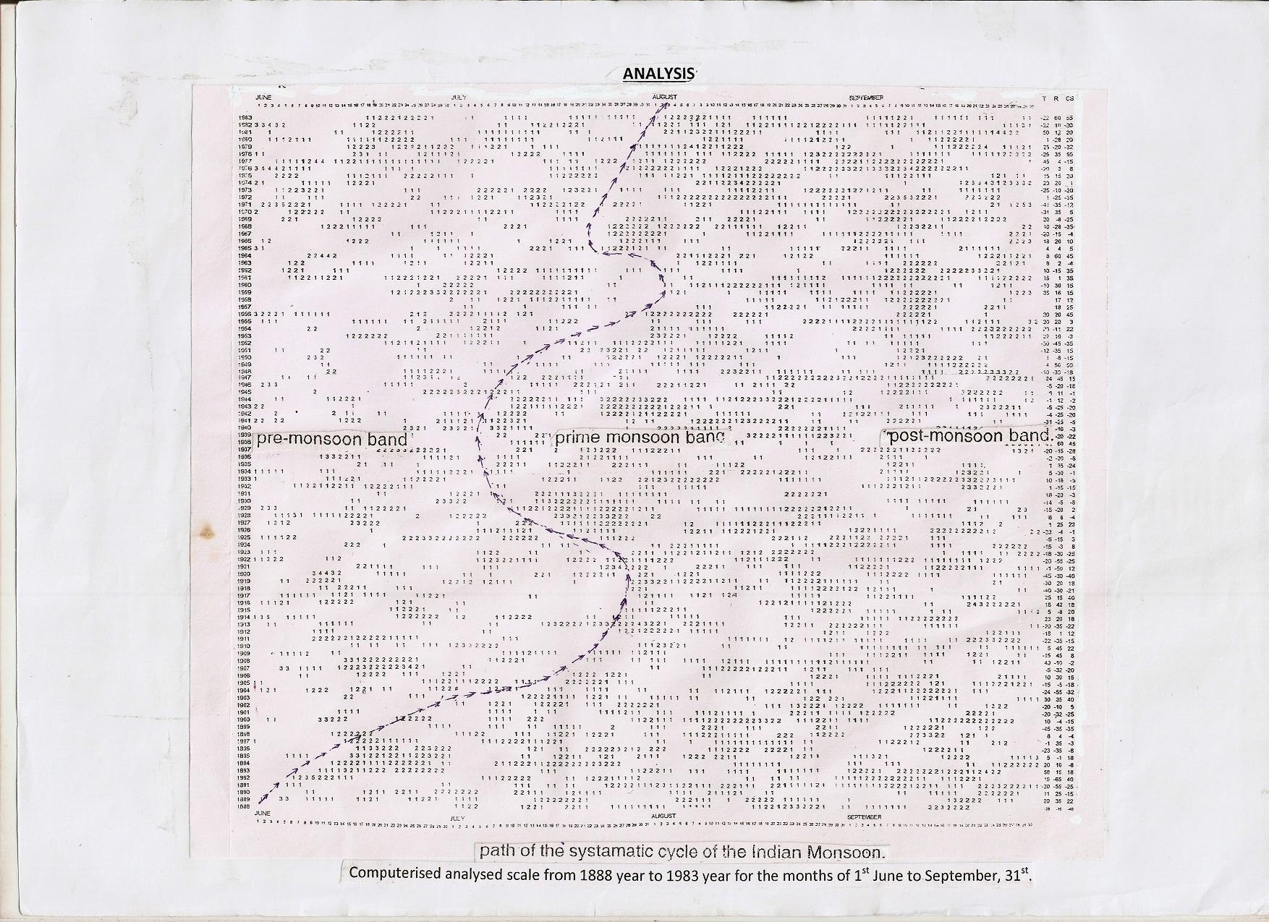

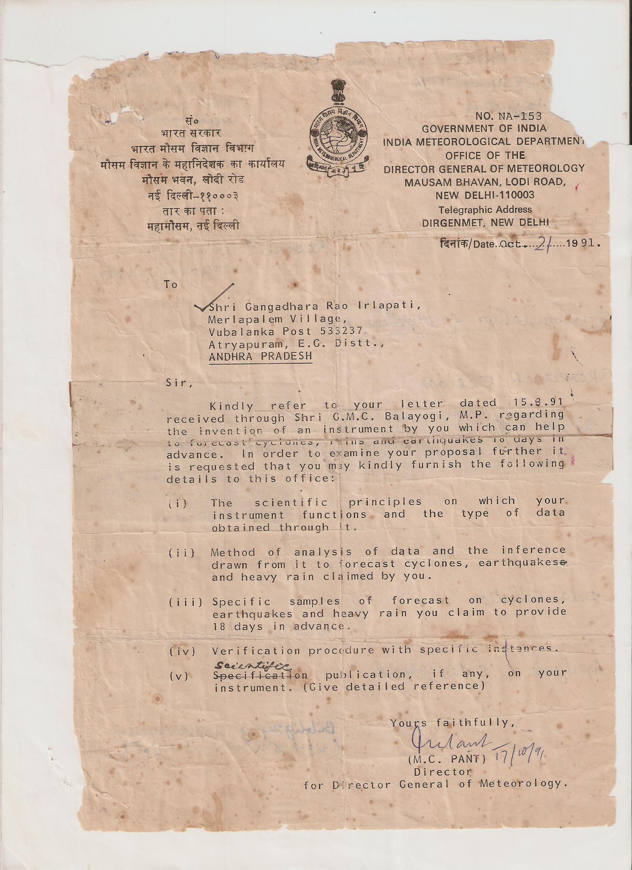
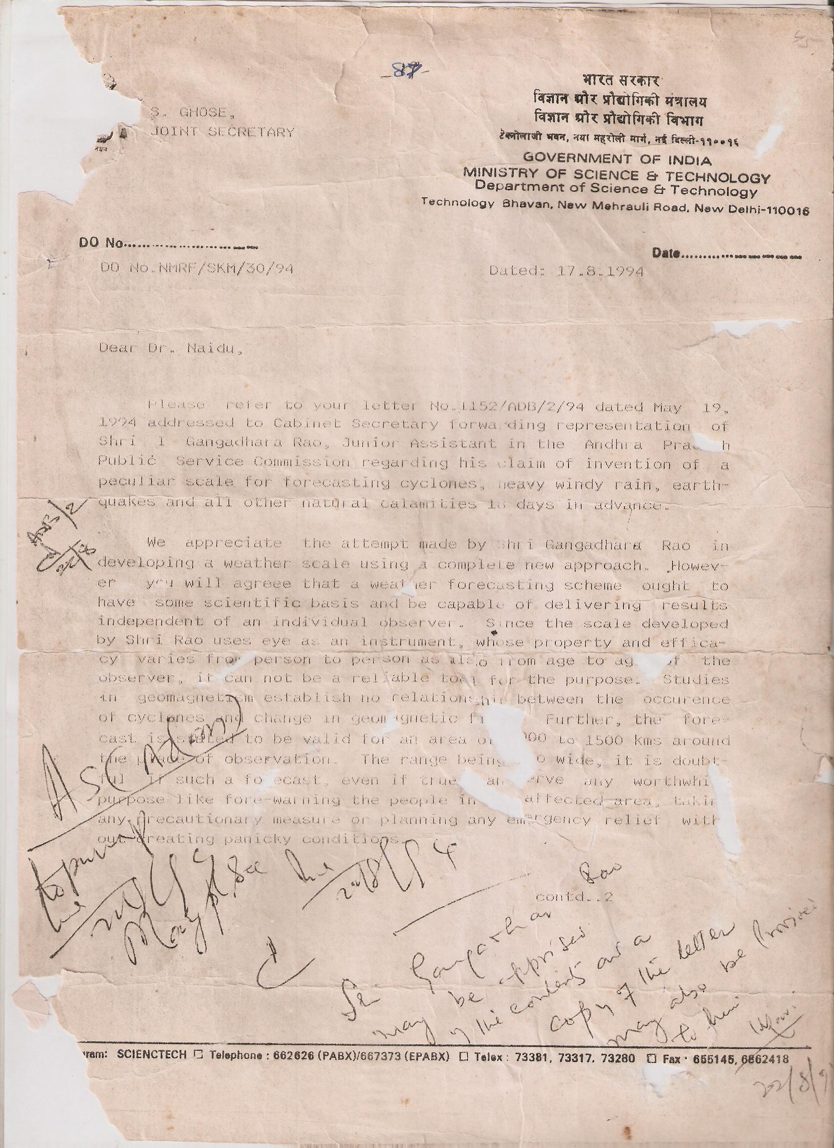
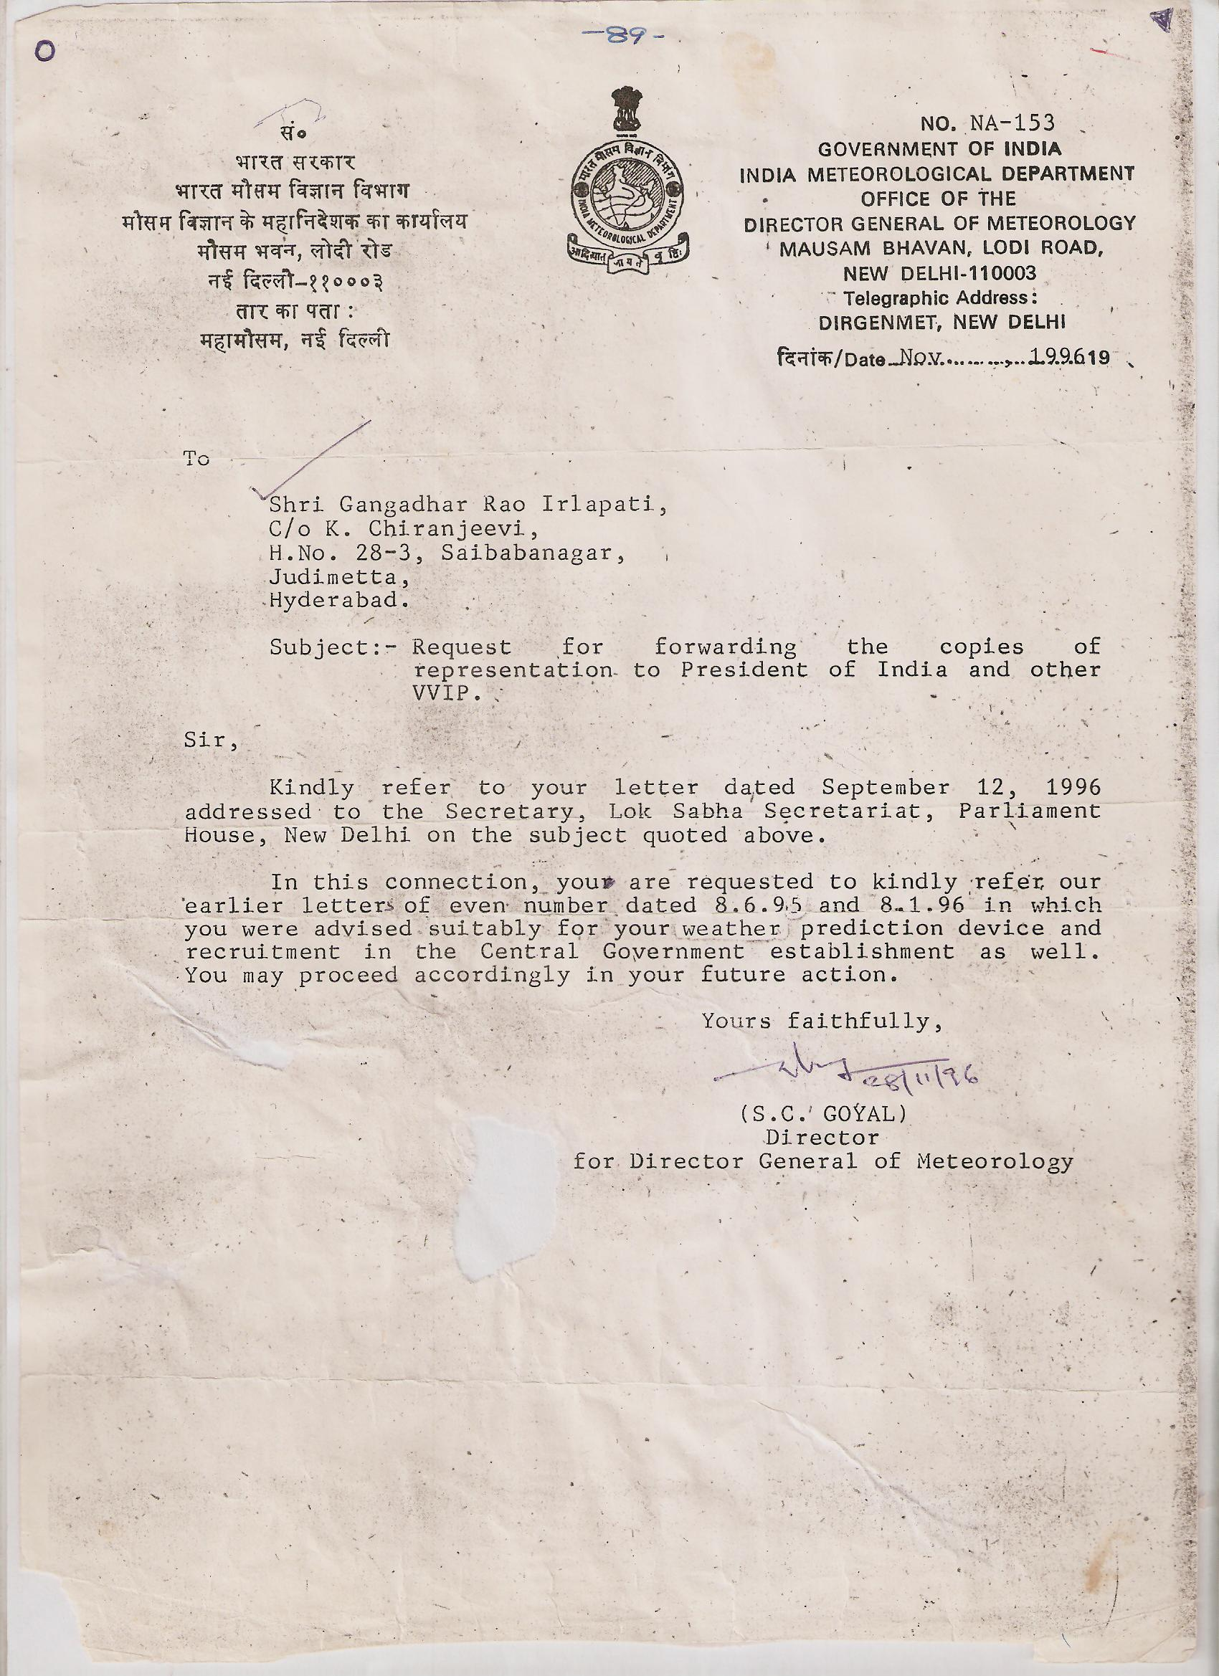
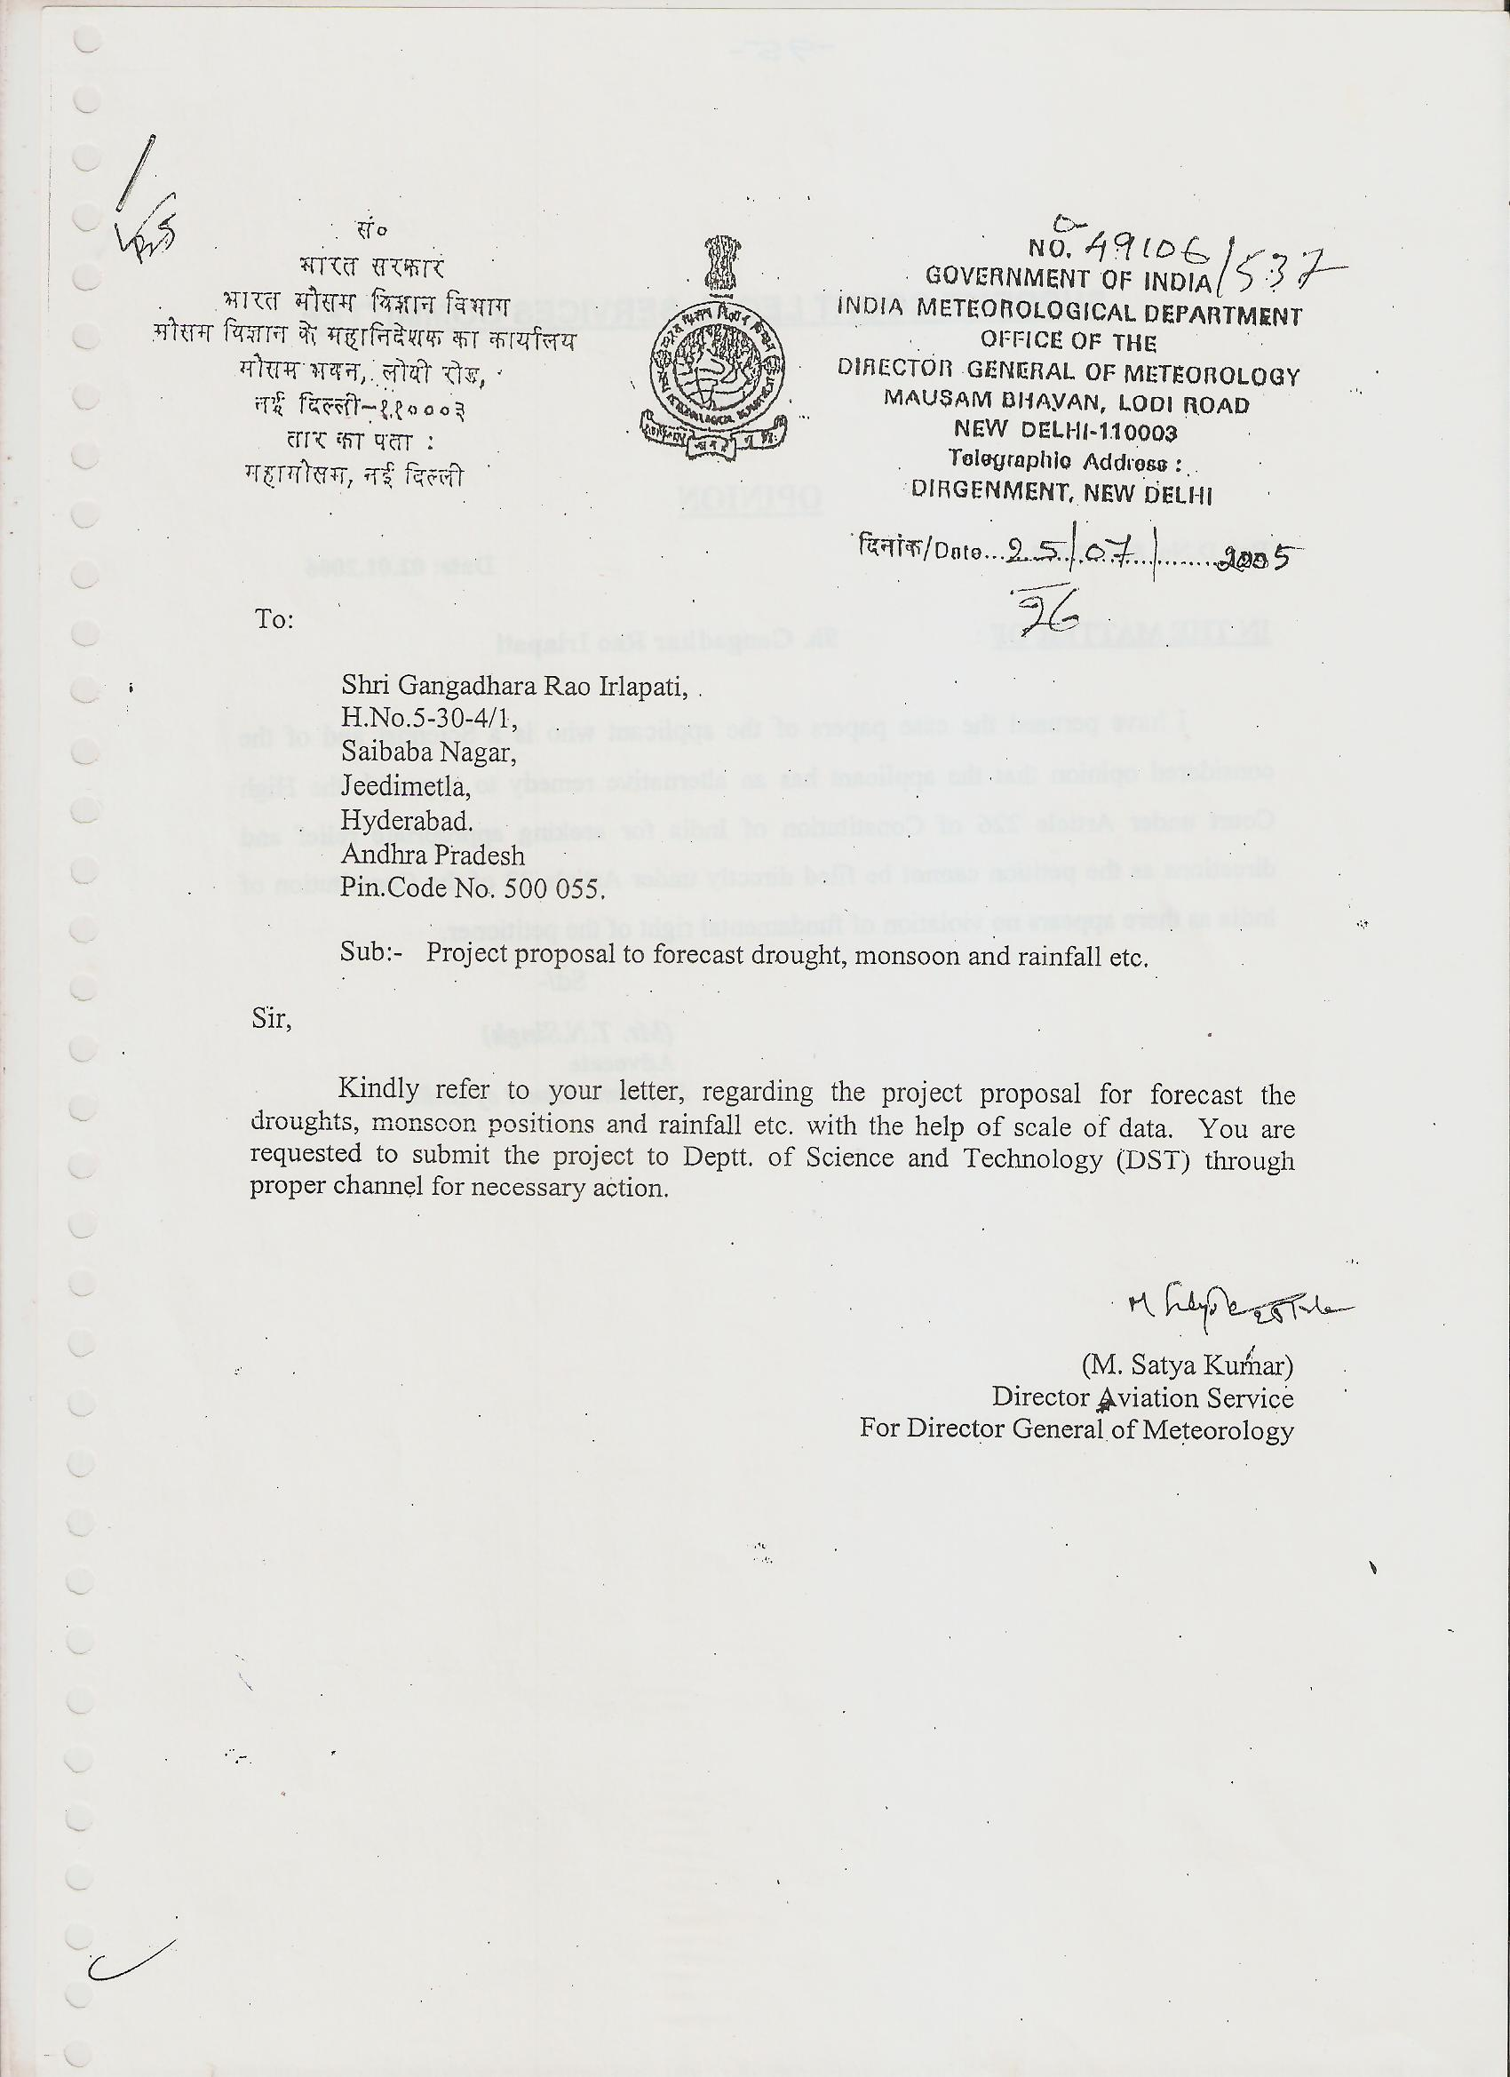
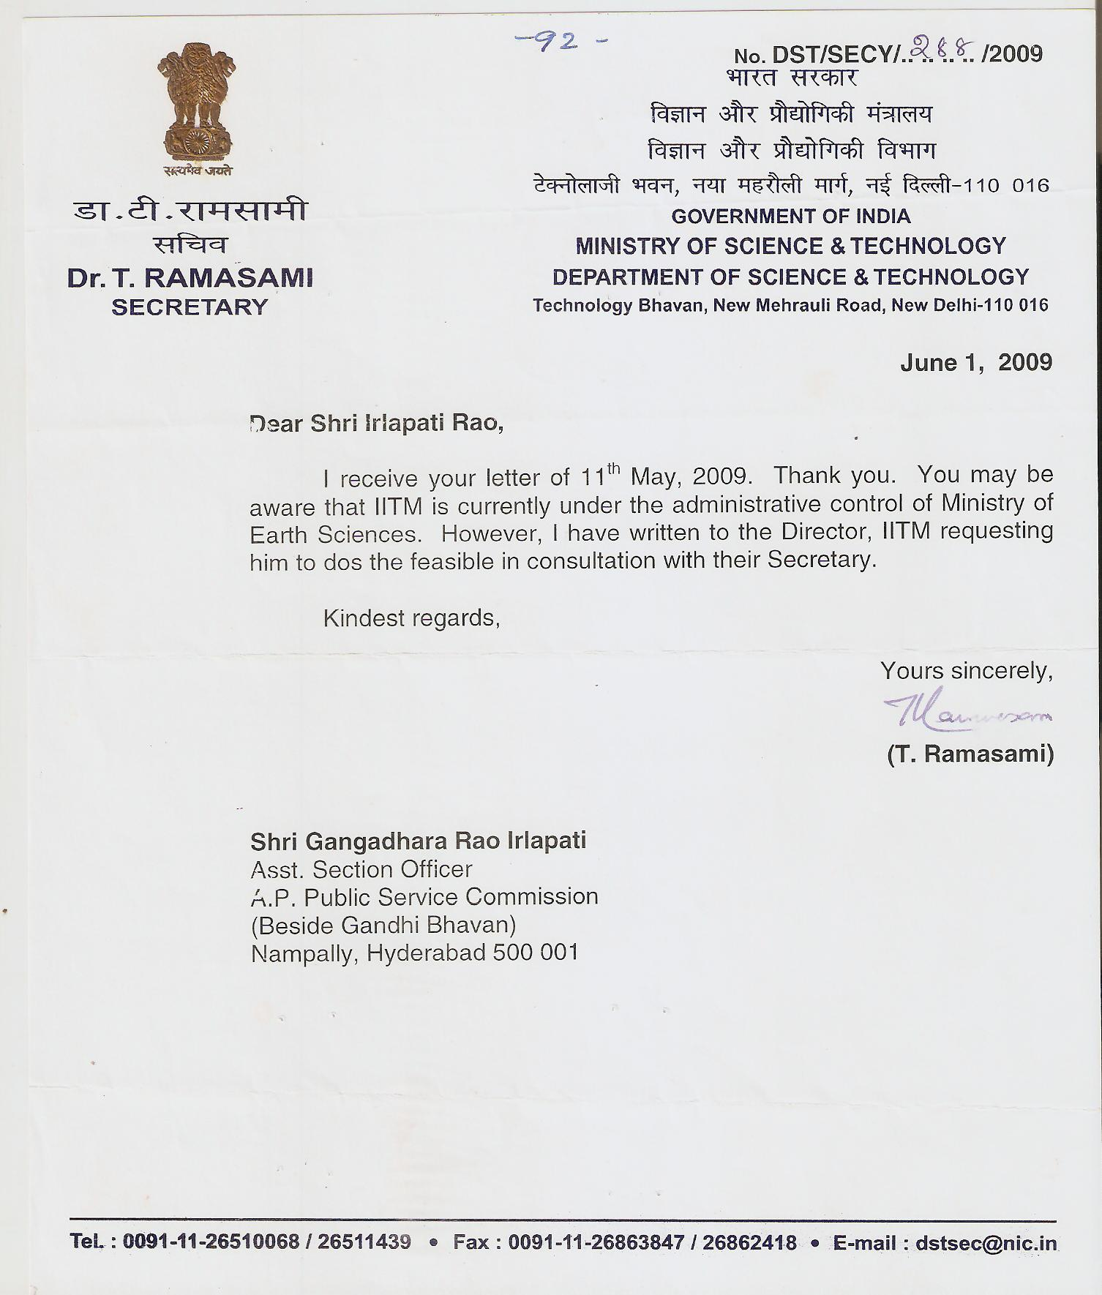

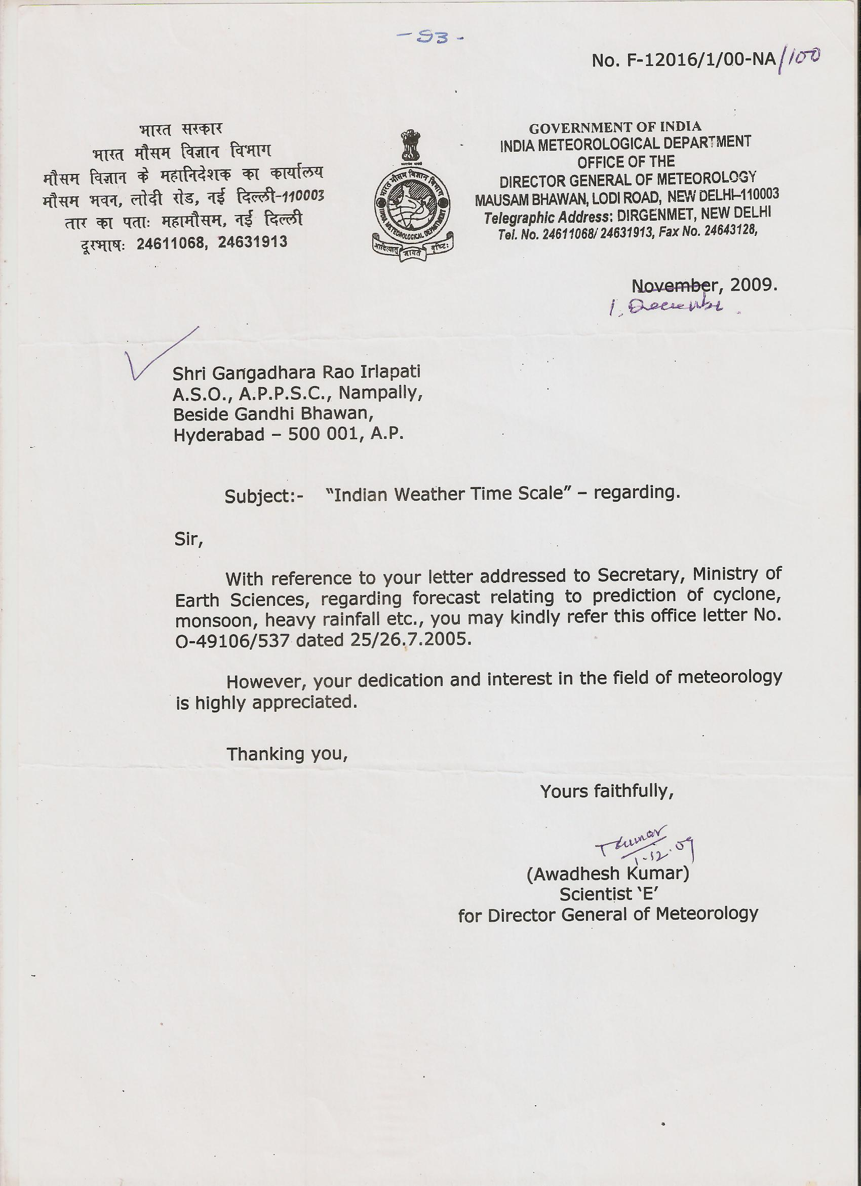

9/1/2016

