**The effect of heat treatment on the quality of Algerian honey**

Nair Samira

Geo-environment and Development Researches laboratory, University Mustapha Stambouli of Mascara, Algeria.

[falati22@yahoo.fr](mailto:falati22@yahoo.fr)

**Abstract:** Heating of honey could accelerate certain chemical reactions that lessen its quality during storage. The purpose of this study consists in assessing the effect of temporary heating of honey on the variation of its main quality characteristics. Samples of each honey were heated at 37°C, 55°C and 75°C; the physic-chemical properties (moisture contents, pH, free acidity, hyfroxymethylfurfural (HMF), diastase, glucose and coloring action) were determined. During the heating treatment, the color deepened and the hydroxymethylfurfural and free acidity increased, while there was a reduction in glucose contents with reduced water and amylase action. All reactions were greatly slowed down before this treatment, thus the heating applied determine certain changes on the level of the parameters of quality of the several of Algerian honey.

[Nair Samira. **The effect of heat treatment on the quality of Algerian honey.** *Researcher* 2016;8(9):1-6]. ISSN 1553-9865 (print); ISSN 2163-8950 (online). <http://www.sciencepub.net/researcher>. 1. doi:[10.7537/marsrsj080916.01](http://www.dx.doi.org/10.7537/marsrsj080916.01).

**Key words:** Algerian honey; physic-chemical properties; quality; thermal treatment

1. **Introduction**

Honey, a natural sweet substance produced by honeybees, from the nectars and honey dew (Codex Alimentations, 2001), has been used as a medicine during the ages and has recently been rediscovered mainly due to the development of bacterial resistance to conventional modern therapeutic agents (Kwakman and Zaat, 2102; Vallianou et al., 2014).

The composition of honey is variable, depending on its geographical floral origin, season and other external factors, such as environmental factors and treatment of beekeepers (El-Metwally, 2015). Honey contains a variety of approximately 180 compounds, such as sugars, proteins, free amino acids, essential minerals, vitamins and enzymes as well as a wide range of polyphenolic phytochemicals (Alvarez-Suarez et al., 2013). Many of these substances are unstable during storage. A heating has a negative consequence on honey due to the loss of those substances.

Honey is thermally treated before packaging for several reasons, the primary objective of thermal conventional honey processing is found to be essential for fast handling, to dissolve large sugar granules. Two stages of heating applied in honey industry are known as liquefaction and pasteurization which is to destroy the yeast and other spoilage microorganisms as well as preventing fermentation (Subramanian et al., 2007; Tosi et al., 2004).

As any biological product, honey is significantly influenced by storage time and heating, any processing of honey may result in product quality deterioration. Uncontrolled heating influences the parameters such as hydroxymethylfurfural (HMF) content and enzymatic activity and results in increasing or decreasing these parameters, respectively (Subramanian et al. 2007). The nutrients of honey such as sugars, proteins… etc. are also prone to thermal decomposition (Al-Diab and Jarkas, 2015).

This study was conducted in order to determine changes that occur in honey during heat treatment.

1. **Materials and methods**
   1. **Honey samples**

Four samples from different origin (jujube, mountain, orange, and multi flower) were collected among beekeepers from different regions of Algeria. Each honey samples were divided in two set subsamples: fresh and heated honey.

* 1. **Heat treatments**

Honey samples were thermally treated at 37°C, 55°C and 75°C for 24h. the honey samples were placed in test heated in a water bath.

* 1. **Physicochemical analysis**
     1. **Water content**

The water content of the honey samples was determined by measuring the reactive index (I.R) with a refractometer at 20°C according to the IHC method for honey (Bogdanov, 2002). The percentage (%) of water was determined using the tables of Chataway that relates the % of water with the I.R. the experimental results were expressed as g water /100g of sample.

* + 1. **HMF**

The determination of hydroxylmethylfufural in honey is based on the original method of Winkler (Bogdanov, 2002). To aliquot parts of a honey solution, solutions of p-toluidine and barbituric acid are added and the resultant colo is measured against a blank in 1cm cuvettes at 550nm.

* + 1. **Glucose content**

The different samples of honey underwent enzymatic assay where the glucose content was calculated by the determination of the glucose standard via spectrophotometric analysis (Outlaw et Tarczynski, 1988). In the glucose oxidase method, the glucose is oxidized by oxygen to gluconic acid with glucose oxidase catalysis, thus producing hydrogen peroxide which, in turn, oxidizes a colorless chromogen to a dye in a catalyzed secondary reaction.

* + 1. **Diastase number**

Diastase number (DN), was determined spectrophometrically according to the schade method (Schade et al., 1958). The unit of diastase activity is defined as the quantity of enzyme which will convert 0.01g of starch (g) during 1h at 40°C per 1g of honey. A standard solution of starch, capable of developing, with iodine, a colour in defined range of intensity, is acted upon by the enzyme in sample under standard conditions. The diminution in the blue color is measured at intervals. A plot of absorbance against time, or a regression equation, is used to determine the time tx required to reach the specified absorbance, 0.235. DN is calculated as 300 divided by tx (Bogdanov, 2002).

* + 1. **Free acidity and pH**

For acidity, 10 g of honey was dissolved in 75ml distilled water and titrated with 0.1N NaOH to pH 8.3, pH values were measured by digital pH-meter. Free acidity in méq/kg honey was calculated as follows; ml of 0.1 M NaOH *10 (AOAC, 1990).

* + 1. **Color intensity**

Absorbance of honey diluted with distilled water measured at 420nm as indication of honey color (Ahmida1 et al., 2013); (Singh and Bath, 1997).

* 1. **Statistical analysis**

Minitab software was used for the analysis. All the experiments were conducted in triplicate. Data were evaluated by one-way ANOVA.

1. **Results and discussion**

The measured values of physicochemical properties of fresh honeys are shown in table 1. Water content, a parameter related to the maturity degree (Kucuk et al., 2007), is between 17.4% and 21.98%, with an average of 18.58% indicating optimum harvesting and good degree of maturity. The majority of analyzed honeys except the sample 4 showed lower water conten to 18% which are the maximum allowed by the Codex Alimentarius (2001).

Quantitative analysis of simple sugars including glucose clearly shows that the glucose rate varies from one sample to another with an average of 38.21%.

Honey samples showed an appropriate diastase number with an average of 13.80% and their HMF content ranging from 23.5 to 36 mg/kg. Thus, all samples fell within the European Community regulations (Codex Alimentarius, 2001) and presented a high degree of freshness.

All honeys are acidic, having pH with an average of 4.76. The average values for free acidity in samples were between 24 and 43 meq/kg; our results was within limits (AOAC, 1990) (below (50meq/kg) indicating an absence of undesirable fermentations.

The color of the honey samples decreased in the order: 4 >2>1>3. Based on their absorbance at 420 nm, samples 4 and 2 which had the darkest colors among the samples investigated could be classified under Amber while the rest of the honey samples could be classified under Light Amber.

Table1. Physicochemical parameters of fresh honeys

|  |  |  |  |  |  |  |  |
| --- | --- | --- | --- | --- | --- | --- | --- |
| Samples | Miosture (%) | Glucose content (%) | Diastase number | HMF (mg/kg) | Freev acidity (méq/kg) | pH | Color intensity (D0) |
| S1 | 17,4 | 39,88 | 14,28 | 36 | 24 | 5,19 | 0,354 |
| S2 | 17,56 | 38,4 | 13,04 | 31,11 | 30 | 5,4 | 0,505 |
| S3 | 17,4 | 35,45 | 13,63 | 28,8 | 32 | 4,23 | 0,267 |
| S4 | 21,98 | 39,14 | 14,28 | 23,5 | 43 | 4,24 | 0,558 |
| Min | 17,4 | 35,45 | 13,04 | 23,5 | 24 | 4,23 | 0,267 |
| Max | 21,98 | 39,88 | 14,28 | 36 | 43 | 5,4 | 0,558 |
| Mean | 18,585 | 38,2175 | 13,8075 | 29,8525 | 32,25 | 4,765 | 0,421 |

Statistical analysis of the physicochemical parameters showed significant difference between control and processed honey in terms of free acidity, diastase number, HMF, glucose and water content. Color intensity, free acidity and HMF content increased in processed honey samples but water content, glucose and diastase were decreased.

The results of the water content of the studied after heating are shown in fig.1. Moisture was significantly (p = 0.001à different between control and processed honey. The figure showed that the water content decreased at 37°C and a sharp decrease was observed at higher temperatures. This decrease is strongly influenced by evaporative heat effect (Polus, 2007 et Cougnet, 2007).

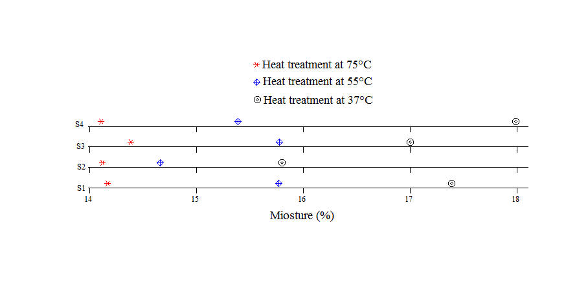

Figure 1: The effect of heat treatment on the water content of honey samples

Data in fig. 2 summarize the influence of heat treatment on the HMF of tested honey, significant changes (p = 0.002) of HMF started to happen at 55°C.

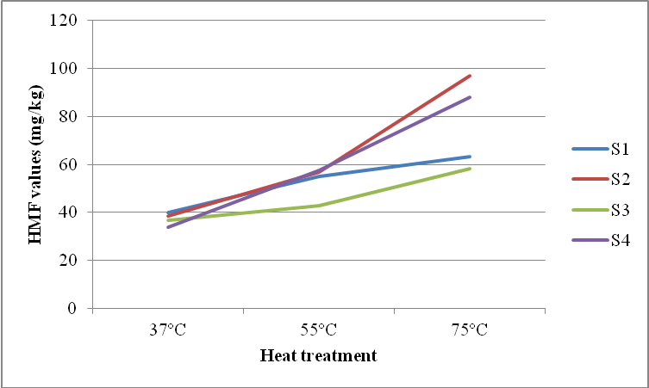

Figure 2: The ratio increase of HMF under the thermal treatment.

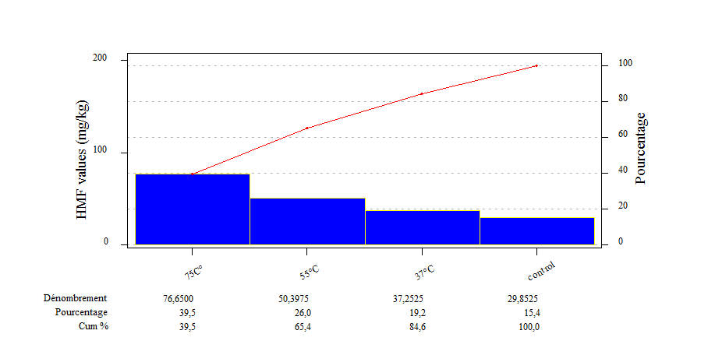

Figure 3: Pareto chart

The Pareto chart shows that 65.4% of the production of HMF is caused by heating at 75°C to 55°C (fig. 3). The increasing of HMF content under rising the temperature was also reported by (Mihaly Cozmuta et al., 2011); (Turhan, 2008) and (Tosi, 2008). The formation of HMF is a natural phenomenon that is slow at temperature room, but a thermal treatment of honey to high temperatures can cause a significant increase in HMF content (Predix, 2003). HMF was produced as a result of the action honey acidity on hexoses, and further accelerated at high temperature during processing (Coco et al., 1996).

Diastase number strongly decreases during heat treatment for all samples. We can note a significant difference (p = 0.00008) in DN under the influence of heat treatment. According to the results reported in fig. 4, diastase was reduced its activity at 55°C in samples 3 and 4. Reducing of DN under thermal treatment has been reported by Tosi (2008).

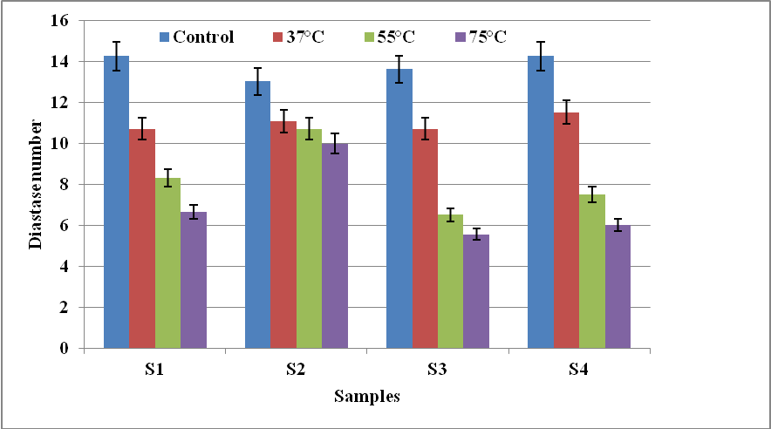

Figure 4: Variation of diastase activity under thermal treatment of honey.

Significant variation (p = 0.00003) in the free acidity, which is observed after heating (fig.5). From the results we have noticed that heating at 55°C for 24h period cause an important increase of acidity. In fact, all the samples, including sample 4 exceed the level of 50meq/kg.

So the increase of the acidity of honey is influenced by the temperature of the heating, which is a consistent result reported by Gonnet (1965). The change in acidity during the heat treatment is due to chemical reactions obtained between sugars and amino acids (Schweitzer, 2005).

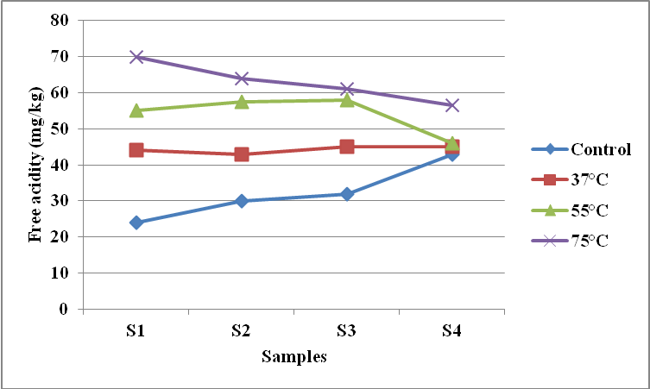

Figure 5: The effect of heat treatment on the free acidity of honey samples

Fig. 6 shows the variation of pH values of heated honey, for all samples, it is observed, that pH decreases rapidly in a linear fashion by increasing the heating temperature of the honey. So there is a linear relationship between pH and heating temperature (R2 = 0, 92).

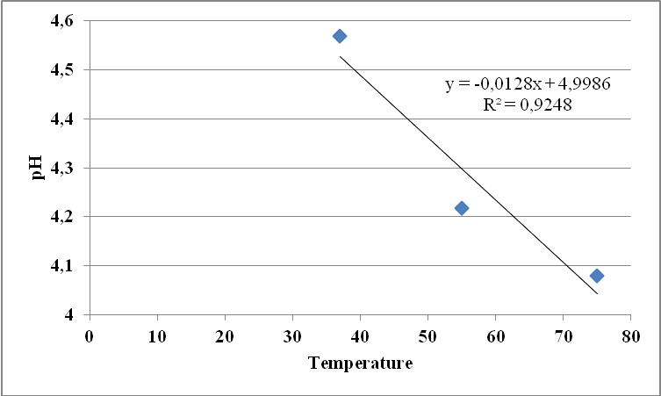

Figure 6: The relationship between pH and the heat treatment of the analyzed honeys

The glucose content of heated honey samples showed significant difference (p = 0.01). Fig. 7 shows that the decrease in the glucose concentration related to an increase in temperature with heating. This reduction explained by the degradation of glucose with the generation of another derivative HMF (Baduy, 1986; Espinoza-Mansilla et al, 1993).

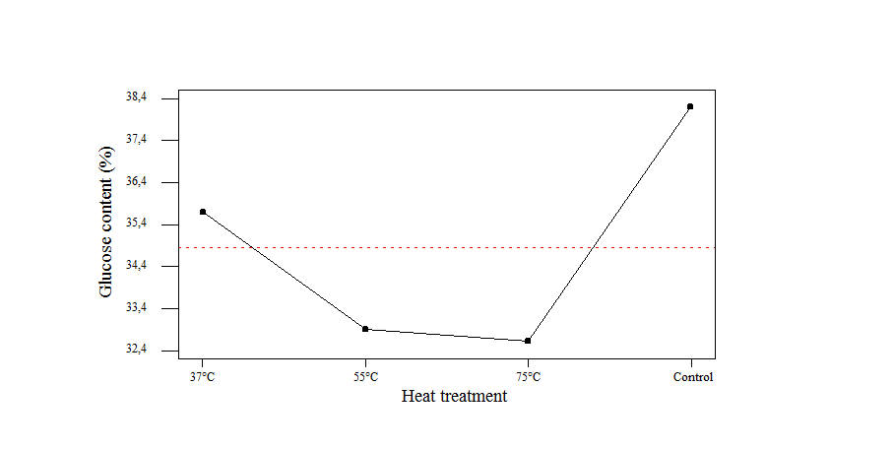

Figure 7: The Main effects plot - Average data (ANOVA) for glucose content of the different honeys analyzed

Changes in the color of honey samples under different heating temperatures are shown in fig. 8. The absorbance of heated honey strongly intensifies with increasing heating temperature. Generally, the darkening of honey is temperature sensitive and occurs more rapidly when honey is heated at high temperatures.

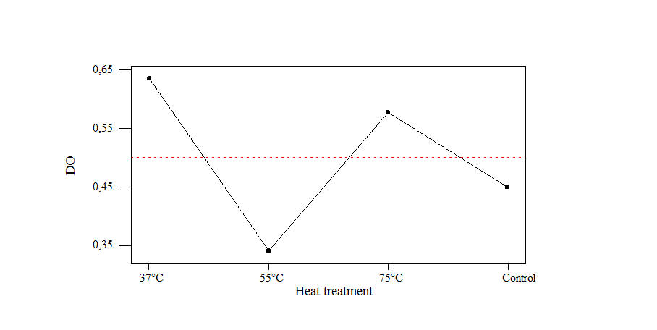

Figure 8: The Main effects plot - Average data (ANOVA) for DO of honey samples

Fig. 9 shows that when the absorbance of honey increases, pH decreases steadily during the heat treatment. The absorbance increase in parallel with the decrease in pH is consistent with previously published work of (Mancilla- Margalli and Lopez 2002). Is a characteristic of Maillard reactions (Apriyantono and Ames 1993).



Figure 9: pH changes and the absorbance of honey during heat treatment.

1. **Conclusion**

Heat treatment at 37°C, 55°C and 75°C during 24h applied to honey has a significant impact in terms of free acidity, diastase number, HMF, glucose and water content.

The action of temperature led to changes in the quality characteristics of honey. These changes were mainly attributed to degradation of carbohydrates (hexoses) and diastase activity. Loosing of diastase activity seems to be more sensitive to rising of the temperature, while producing of HMF is equally affected both by temperature. Together HMF and diastase activity are the international parameters used to control the limit for thermal treatment to honey.

**Acknowledgement**

I warmly thank all the institutions and individuals that made this investigation possible.

**Correspondence to:**

Nair Samira

University Mustapha Stambouli of Mascara,

Algeria.

Email: [falati22@yahoo.fr](mailto:falati22@yahoo.fr)

**References**

1. Codex Alimentations. Draft revised standard for standard for honey (at step 10 of the Codex procedure). Alinorm 2001; 01 (25):19–26.
2. Kwakman PHS, Zaat SAJ. Antibacterial components of honey. IUBMB Life 2012; 64:48-55.
3. Vallianou NG, Gounari P, Skourtis A, Panagos J, Kazazis C. Honey and its anti-inflammatory, anti-bacterial and anti-oxidant properties. General Med 2014; 2:132.
4. EL-Metwally AAE. Factors Affecting the Physical and Chemical Characteristics of Egyptian Beehoney. Ph. D. Thesis, Fac. Agric. Cairo Univ 2015; 320 p.
5. Alvarez-Suarez M, Jose, Giampieri, Francesca, Battino, Maurizio. Honey as a Source of Dietary Antioxidants: Structures, Bioavailability and Evidence of Protective Effects Against Human Chronic Diseases. [Current Medicinal Chemistry](http://www.ingentaconnect.com/content/ben/cmc;jsessionid=4p799ivbu9fwe.alexandra) February 2013; 20 (5): 621-638.
6. Subramanian R, Umeshhebbar H, Rastogi NK. Processing of Honey, A Review. International Journal of Food Properties 2007; 10:127-143.
7. Tosi E, Ré E, Lucero H, Bulacio L. Effect of honey high-temperature short-time heating on parameters related to quality, crystallisation phenomena and fungal inhibition. WT-Food Science and Technology 2004; 37: 669–678.
8. Al-Diab D, Bushra J. Effect of storage and thermal treatment on the quality of some local brands of honey from Latakia markets. Journal of Entomology and Zoology Studies2015; 3(3): 328-334.
9. Bogdanov S. Harmonised methods of the international honey commission. Swiss Bee Research Center, FAM, Liebefeld, CH-3003 Berne, 2002.
10. Outlaw WHJr, Tarczynski MC. In Methods of Enzymatic Analysis, (Bergmeyer, H. U. ed). VCH Verlagsgesellschaft mbH, Weinheim, Germany 1988; 6: 96-103.
11. Schade JE, Marsh GL, Eckert JE. Diastatic activity and hydroxymethylfurfural in honey and their usefulness in detecting heat adulteration. Food Res 1958; 23: 446-463.
12. AOAC, Official Methods of Analysis. 15éme Ed. Arlington, VA. Association of Official Analytical chemists. London, 1990.
13. Ahmida1 MHS, Elwerfali1 S, Agha1 A, Elagori1 M, Ahmida2 NHS. Physicochemical, Heavy Metals and Phenolic Compounds Analysis of Libyan Honey Samples Collected from Benghazi during 2009-2010. Food and Nutrition Sciences 2013; 4:1.
14. Singh N, Bath PK. Quality Evaluation of Different Types of Indian honey. Food Chemistry1997; 58 (1)-(2):129-133.
15. Küçük M, Kolaylıa S, Karaoğlu S, Ulusoy E, Baltacı C, Candan F. Biological activities and chemical composition of three honeys of different types from Anatolia. Food Chemistry 2007; 100: 526–534.
16. Polus P. Récolte et conditionnement du miel. Revue l'abeille de France 2007; 937 : 13.
17. Cougnet P. Guide nature et apiculture. Contrôler le facteur humidité dans la miellerie. Revue abeille et Cie 2007 ; 117 : 18.
18. Mihaly Cozmuta A, Mihaly Cozmuta L, Varga C, Marian M, Peter A. Effect of thermal processing on quality of polyfloral honey. Romanian Journal of Food Science 2011; 1(1): 45–52.
19. Tosi E, Martinet R, Ortega M, Lucero H, Re E. Honey diastase activity modified by heating. Food Chemistry 2008; 106: 883–887.
20. [Turhan](http://www.sciencedirect.com/science/article/pii/S0023643807003246) I, [Tetik](http://www.sciencedirect.com/science/article/pii/S0023643807003246) N, [Karhan](http://www.sciencedirect.com/science/article/pii/S0023643807003246) M, [Gurel](http://www.sciencedirect.com/science/article/pii/S0023643807003246) F, [Reyhan Tavukcuoglu](http://www.sciencedirect.com/science/article/pii/S0023643807003246) H. Quality of honeys influenced by thermal treatment. [LWT - Food Science and Technology](http://www.sciencedirect.com/science/journal/00236438) November 2008; [41(8](http://www.sciencedirect.com/science/journal/00236438/41/8)): 1396–1399.
21. Predrix JL. Critères de qualités du miel. Bulletin de liaison 2003 ; 41.
22. Coco FL, Valentini C, Sapra V, Ceccon L. High performance liquid chromatographic determination of 2-furaldehyde and 5- hydroxymethyl-2-furaldehyde in honey. J. Chromatogr. A 1996 ; 749: 95- 102.
23. Gonnet M. Les modifications de la composition chimique des miels au cours de la conservation. Ann Abeille 1965; 8 (2): 129-146.
24. Schweitzer P. Un miel étrange. L’abeille de France Décembre 2005; 920.
25. Badui DS. Química de los alimentos. Ed. Alhambra 1986.
26. Espinoza Mansilla A, Muñoz de la Peña, Salinas F. Semiautomatic determination of furanic aldehydes in food and pharmaceutical samples by a stopped-flow injection analysis method. J. of the AOAC International 1993.
27. [Mancilla-Margalli](http://pubs.acs.org/author/Mancilla-Margalli%2C+Norma+A) NA, [López](http://pubs.acs.org/author/L%C3%B3pez%2C+Mercedes+G) MG. Generation of Maillard Compounds from Inulin during the Thermal Processing of Agave tequilana Weber Var. azul. J. Agric. Food Chem 2002; 50 (4): 806–812.
28. Apriyantono, Ames. Xylose-lysine model systems: the effect of pH on the volatile reaction products. J.Sci. Food Agric1993; 61: 477-484.

8/26/2016