**Natural Radioactivity in drinking Water in Sudan (Khartoum region)**

1A. Abbasher, 2Dr. A. Alsalam A. Almaged, 3Dr O. A. lhabib

1 Technology experts company, Riyadh, Saudi Arabia

2 Faculty of engineering department of chemical engineering, Alneelain University, Khartoum, Sudan

3 Faculty of Engineering, Taif University, P.O. 888, Al-Taif, Saudi Arabia

**Abstract:** Water usually contains several natural radionuclide ‘radon, radium, uranium isotopes, etc. Their concentrations vary widely since they depend on the nature of the aquifer, ground water pH, etc. Aims in this research broad overview of the radioactivity in drinking water is presented, for limiting the presence of radioactivity in waters intended for human consumption, and draft of guidelines for the planning of campaigns to measure radioactivity in drinking water proposed by the Environmental Protection. This research it is contain nine water samples were analyzed for natural radioactive materials in drinking water in Sudan (Khartoum area). The concentration of radioactive element has been assessed for the water samples taken from different location in Sudan. The studies included of 226Ra+228Ra, 222Ra and 234U+238U concentrations indifferent type of water samples, (mineral, Nile River, wells water).The experimental setup was based on the electronic radon detector RAD7 for radon concentration, spectrum gamma detector HPGe for radium and instrument of alpha spectrometry for uranium. The measurements were carried out with a special kit of accessory vessels (vials) RAD7 H2O, which allows one to identify the total Ra226 and Ra228 activity concentration in small water samples of one Litter in the range going from less than 0.0pCi/L to greater than 37.9pCi/L, also the results of uranium concentration between the 0.21ppb and *9.8ppb* and maximum of radon concentration179.0 pCi/L.

[A. Abbasher, A. Alsalam A. Almaged, O. A. lhabib. **Natural Radioactivity in drinking Water in Sudan (Khartoum region).** *Researcher* 2016;8(8):30-35]. ISSN 1553-9865 (print); ISSN 2163-8950 (online). <http://www.sciencepub.net/researcher>. 7. doi:[10.7537/marsrsj080816.07](http://www.dx.doi.org/10.7537/marsrsj080816.07).

**Keywords:** Natural; Radioactivity; drinking; Water; Sudan

**1. Introduction**

Water is the most important source for life and makes up 70 - 75% of total body weight. While 70% of the world's surface is covered by water, only 0.3 % of the total water resources on earth are drinkable and suitable for daily use. This water content on radioactive materials, therefore the quality of water is very important. Radioactive nuclides in water usually enter the human body mainly through food or drinking water, inhalation being of importance only for the daughter products of 222Rn. High vales of uranium in drinking water and foodstuffs may lead to harmful effects in human beings[1]. The guideline levels for radioactivity in drinking-water recommended in the first edition of Guidelines for drinking-water quality, Studies of natural radiation background and exposure of human-beings are of great importance, for practical and scientific reasons. Study of the natural radiation background and dose levels is essential for the purpose of establishing a radiological reference base line. This is the first step in any local or national monitoring program. In the term of population dose, the natural radiation sources are the most significant [2]. The groundwater is a very important natural resource related directly to the survival of all living organisms and its quality, therefore cannot be compromised. Groundwater sources of drinking water may contain naturally occurring radionuclides from the uranium-238, uranium-235 and thorium-232 series, especially uranium, radium, and radon. The occurrence of radionuclide’s in groundwater depends on several factors; one of them is the presence of this radionuclide or its parent nuclides in the aquifer matrix [3]. The existence of radium in groundwater is controlled by many factors, including the decay of the dissolved parent isotopes, the desorption from aquifer surface, the alpha recoil and the water chemical composition [4]. Contrary to radium, uranium is more mobile under oxidizing conditions. In its reduced form, it is quite insoluble. The dominant process for moving U into the groundwater is mineral dissolution. Uranium is transported in groundwater as the uranyl ion, most commonly complexed by carbonate and phosphate ions or adsorbed on surfaces of ferric oxy hydroxides, clays and organic matter [5]. the concern over exposure of humans to radioactivity is an important driving factor behind the studies of environmental radiation and natural radioactivity levels in groundwater’s. These radioisotopes in ground waters enable us to understand their distribution in the environment and the resulting health consequences. [6].

**2. Material and Methods:**

**2.1 Sampling:-**

The water sampling was carried out according to the IAEA-295 technical report [7].Water samples were collected from nine local location in Sudan wells, Nile River and mineral water according to the details on the map site map 2.1in Khartoum –Sudan. The water was allowed to run in a continuous flow for a short period to eliminate any contamination from the water sources, and have a representative samples. For radioactivity measurements, sampling was often accompanied by samples treatment (acidification and/or filtration) in order to minimize any interference which could potentially affect the required analysis. Water samples were collected from the continuous flow, filtered with 0.45µ membrane filter, acidified with 11 M HCl at the rate of 10 ml per liter of sample immediately after filtration to avoid the adsorption of radionuclide’s on the walls of the container and growth of micro-organisms, and transferred to polyethylene bottles, for the chemical analysis, the water samples were collected in suitable bottles without the acidification step, and the pH and total dissolved solids (TDS) were monitored with a multi-parameter TDS and pH meter (Hach HQ40). Also, from this continuous flow, a radon sample was collected into a submerged glass bottle, and radon-222 was measured directly using a radon detector (RAD-7).

**2.1** **Sampling sites map (Figure 1)**

The sampling sites map is shown in Figure 1.

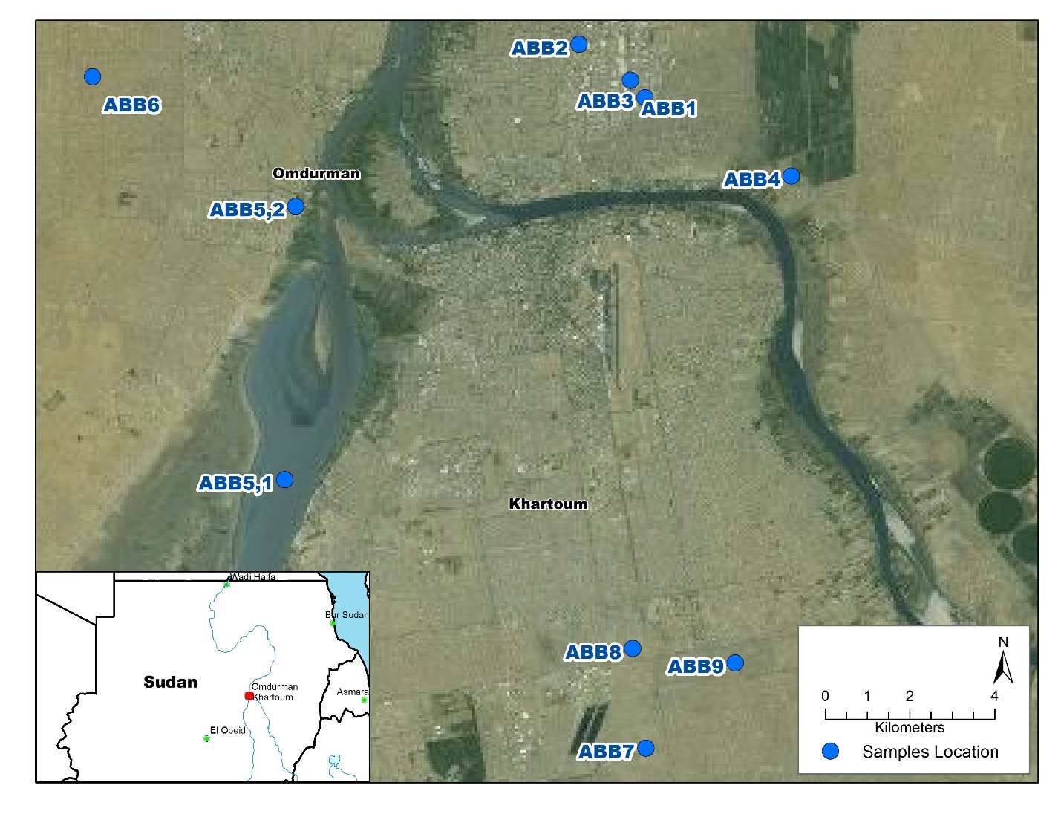

Figure 1. Sampling sites map

**2.2 Reagents and Materials:**

Materials and Apparatus Radium extractions were carried out using Purolite C-100 strong acid cation exchange resin. A package of 30 kg of the resin, in the Na form, was supplied by Veolia Water Company, Riyadh, KSA. Radium separation was conducted in a column mode using BIORAD Glass Econo columns of 0.9-cm diameter, together with polypropylene funnels and Teflon end fittings connected with plastic taps. Standard reference solutions of 226Ra and 228Ra were supplied by the National Institute of Standards and Technology (NIST), (SRM 4967A and SRM 4339B). Uranium isotopes were separated from other actinides using extraction chromatography resin UTEVA supplied by Triskem International Co., France. All gamma radioactivity measurements were carried out using a Canberra HPGe coaxial detector Model (GC4020) with relative photo-peak efficiencies of 40% for the 1332 keV line of 60Co. The germanium detector was connected to a Digital Spectrum Analysis model DSA-1000. The alpha spectrometric analysis were carried out using a Canberra Alpha Analyst, with a chamber containing a passivated implanted planar silicon (PIPS) detector with an active area of 450 mm2. The efficiency of the detector was calibrated against a standard alpha multi-source (67970-121, Analytics Co.) using the certified activity of the measured radionuclides. The radon measurements were carried out using a silicon semiconductor detector (RAD7) supplied by Durridge Co. All other acids and reagents used in this study were of analytical grade.

**2.3 Radioanalyses and Measurements**

Water samples were analyzed for radium isotopes (226Ra and 228Ra) following the procedure described by A. ElSharkawy et al, 2013 [8], where 4 liters of the water samples were allowed to pass through a strong cation exchange resin. The resin was transferred to standard counting containers and the containers were tightly sealed for four weeks to allow secular equilibrium between 226Ra, 228Ra and their decay products. The efficiency calibration of the germanium detector for the radium isotopes (Ra-226 and Ra-228) measurements was carried out using standard resin samples. Known activity resins were prepared by spiking water (DDW) samples with known amounts of 226Ra and 228Ra. The spiked resin samples containing a known amount of the radionuclides of interest were used to provide an identical matrix with a known activity, and all other conditions were followed typically (flow rate, resin volume, counting time, geometry). The 226Ra activities were determined via its daughters 214Pb and 214Bi through the gamma energy lines 295.22, 351.93 and 609.31 keV. The 228Ra activities were determined through the gamma energy lines of 338.32 and 911.2 keV. The calculated specific activities were basically performed using a comparison method:

$$A_{unk}=\frac{A_{std}}{{CR}_{std}}.{CR}_{unk}$$

**Where:**

Aunkis the calculated activity of the sample

Astdis the activity of the standard resin

CRstd is the counting rate for the standard resin

CRunk is the counting rate of the unknown sample

Uranium extractions from water were carried out following Eichrom method ACW-01, where the 234U and 238U were determined by the radiochemical separation of the isotopes using calcium phosphate co-precipitation to concentrate and remove actinides from aqueous samples. Uranium isotopes were separated from other actinides using extraction chromatography, and followed by the electrochemical deposition of those isotopes on a stainless steel disc using a specially designed electrodeposition cell. Finally, the samples were counted using an alpha detector. A 232U tracer was used to monitor chemical recoveries and correct results to improve precision and accuracy [8, 9].

Errors were propagated due to nuclear counting statistics (σN), tracer (σS) and volume (σV), and the combined total uncertainty was calculated according to the following equation:

$$σ_{T}=\sqrt{{\left(σN\right)}^{2}{+ \left(σW\right)}^{2}+ {\left(σS\right)}^{2}}$$

**2.4 Quality Assurance and** **Validation**

Quality assurance is one of the most important requirements for laboratories undertaking, radioanalytical techniques. It is especially important for research laboratories, dealing with environmental and occupational monitoring, because there is an increasing demand for assessment of data quality in these applications. The data from these measurements are used not only for assessment of effective doses (health effects) but also for supervising and control of radiation hazards. Also, proficiency tests were carried out with the International Atomic Energy Agency, IAEA-CU-2010, IAEA-TEL-2011-03, IAEA-TEL-2014-03. Errors were propagated due to nuclear counting statistics, tracer and volume.

The precision and accuracy of the data must be assured to ensure that decisions concerning environmental or occupational impact are based on data of known reliability. Each laboratory providing environmental radiation measurements should have an internal quality assurance system in operation to ensure that instrumentation is calibrated properly and applied analytical procedures are being carried out consistently. Such a program also includes the validation of applied methods of the legal regulations.(10)

To carry out validation a number of tools were used. They are summarized as follows:

• Blank samples (Pure reagents, Matrices without an analyst)

• Spiked samples

• Samples analyzed with other procedures.

**3. Results and discussion**

**3.1 Radium Isotopes in Water Samples**

The average activity concentrations of 226Ra and 228Ra in the selected regions are represented in Figure 2. As shown in Figure 2, the average activity concentration of 226 Ra is 8.01pCi/L, ranging from 0.0 to 33.5pCi/L, while the average activity concentration of 228Ra is 4.5pCi/L, ranging from 0.0 to 19.3pCi/L. Some water samples have shown a relatively higher 228Ra activity in sample number ABB1, this sample is mineral water treat by Coagulation system on that time of sampling, radium anomalies were recorded in the confined zone of the that system of water treatment, where the reducing conditions are prevailed, which is the prohibited condition for radium to be released from rock into groundwater and system we used one treated. On the other hand, the activity concentration of radium 228Ra increases sharply in the confined part of Saq aquifer, where high negative values of oxidation reduction potential is prevailed (Minatome, 1984) (11). The relatively higher 226 Ra activities in in last three samples (ABB7, ABB8A and ABB9) related for levels on top of aquifer in this region, the tree sample in Converge at the sites, providing radium to groundwater by dissolution in this case on this wells the water used without treatment, Here lies the problem.

**3.2 Uranium Isotopes in Water Samples**

The average activity concentrations of 234U and 238 U in the selected regions are represented in Figure 3. The average activity concentration of 234 U is 28.6 mBq/L, ranging from 0.0 to 141.0mBq/L, while the average activity concentration of 238U is 22.1mBq/L, ranging from 0.0 to 121.9mBq/L. The obtained results showed a relatively maximum values of both isotopes in the sample number ABB1, this the them sample it gave high concertation in results of Ra226 investigation. Otherwise all the uranium (234U/ 238U) activity results in the investigated samples had an average concertation of radioactive contamination insafelimit, as a result of some processes which include Due to the low levels of radionuclide’s typically found in drinking-water supplies, acute health effects of radiation are not a concern for drinking-water supplies (9).

**3.3 Radon in Water Samples**

The average activity concentration of Rn-222 is 51.1 pCi/L, ranging from 00.0 to 179.0 pCi/L. all of water samples have values unexceed the maximum contaminant level proposed by EPA for drinking water (300 pCi/l) [12]. Radon concentrations in groundwater are highly variable, where there are many factors affect the presence of 222Rn in groundwater, such as the uranium and radium content in the aquifer rock. Also the time of measuring from sampling (Figure 4).

**Figire 2. Activity concentrations of Ra-226 and Ra-228 in some groundwater (wells, mineral water and Nile River) from different regions in Sudan-Khartoum area.**

**Figure 3. Activity concentrations of 234U and 238U in some groundwater (wells, mineral water and Nile river) from different regions in Khartoum - Sudan.**

**Figure 4. Activity concentrations of Ra-222 in some groundwater (wells, mineral water and Nile River) from different regions in Khartoum - Sudan.**

**4. CONCLUSION**

Surveillance monitoring in different regions of the Sudan – (Khartoum area) has been carried out to determine the activity levels of radium isotopes (226Ra and 228Ra), 222Rn and uranium isotopes (234U and 238U) in groundwater samples collected from ten different sample (wells, mineral water and Nile River) from Khartoum area. The average activity concentration of 226Ra is 8.01pCi/L, ranging from 0.0 to 33.5 pCi/L, while the average activity concentration of 228Ra is 4.5pCi/L, ranging from 0.0 to 19.3 pCi/L. The relatively higher values of radium activities were found in well in southern Khartoum addition to the factory used water treat by Coagulation system on that time of sampling, which may be explained by the nature and properties of the aquifers. The average activity concentration of 222Rn is 51.1pCi/L, ranging from 0.0 to 179.0 pCi/L. all samples of water results have values on range permitted the maximum contaminant level proposed by EPA for drinking water (300 pCi/l). The average activity concentration of 234U is 28.6mBq/L, ranging from 0.0 to 141.0 mBq/L, while the average activity concentration of 238U is 22.1mBq/L, ranging from 0.0 to 121.9 mBq/L. Theactivity levels of radium isotopes (226Ra and 228Ra) & 222Rn and uranium isotopes (234U/238U) in the investigated samples, the data obtained may serve as a reference or baseline radiological map for the natural radioactivity levels in these regions in case of any future studies.

**Acknowledgements:**

Gratefully acknowledgment for administration of Technology Experts Co supporting this research, thankfully acknowledged extended for their staff colleagues also in Technology Expert slab for cooperation for samples measurements and analyses.

**References**

1. Majdi H. Saad, JumaaYousif Tamboul, Mohamed Yousef. Uranium content measurement in drinking water for some region in Sudan using Laser Flourometry Technique. Life Science Journal. Vol.11(1), 2014.
2. Y. Kulaif, “Águamineral”, <https://sistemas.dnpm.gov.br/publicacao/mostra_imagem.asp?IDBancoArquivoArquivo>=5452, (2010).
3. Szabo, Z., & Zapecza, O.S.(1991). Geologic and geochemical factors controlling uranium, radium- 226, and radon-222 in ground water. Newark Basin, New Jersey. Field studies of radon rocks, soils, and water: U.S. Geological Survey Bulletin 1971, p. 243- 265.
4. Forte, M., & Bagnato, L., & Caldognetto, E., & Risica, S., & Trotti, F., & Rusconi., R. (2010) Radium isotopes in Estonian groundwater: measurements, analytical correlations, population dose and a proposal for a monitoring strategy. J. Radiol. Prot. 30, p.761–780.
5. François Gainon, & Heinz Surbeck, & François Zwahlen. (2005). Natural radionuclides in groundwater as pollutants and as useful tracers. Swiss Centre for Hydrogeology, University of Neuchatel, Switzerland.
6. Michael Schubert, & Christoph Schüth, & Nils Michelsen, & Randolf Rausch, & Mohammed Al-Saud. (2011) Investigation and Treatment of Natural Radioactivity in Large-Scale Sandstone Aquifer Systems. International Journal of Water Resources and Arid Environments, 1(1), 25-32.
7. IAEA, “Measurement of Radionuclide's in Food and the Environment”. IAEA Technical Reports Series No. 295, Vienna 1989.
8. El-Sharkawy, Y.Y. Ebaid, W.C. Burnett and S. K.Al Daihan. A rapid and inexpensive method for 226Ra and 228Ra measurements of high TDS groundwaters. [Applied Radiation and Isotopes.](http://www.ncbi.nlm.nih.gov/pubmed/23542120) Vol.77:89-93, 2013.
9. Horwitz, E.P., et al. (1993) Separation and Preconcentration of Actinides from Acidic Media by Extraction Chromatography,” Analytica Chimica Acta. 281, 361-372.
10. IAEA, Analytical Methodology for the Determination of Radium Isotopes in Environmental Samples, Vienna 2010.
11. Evaluation of the Radiological Consequences of the Use of Underground Waters in the Qassim and Tabuk Areas. (1984). Minatome. S.A., Ref. PC/YA/1692/86.
12. EPA - Environmental Protection Agency. (1991). "National primary drinking water regulations, radionuclides", n. 138, Washington D.C. - A Comparative Analysis of Uranium Ore using Laser Fluorimetric and Gamma Spectrometry Techniques. M. Madbouly, M.H. Nassef, A.M. Diab and S.A. El-Mongy. Journal of Nuclear and Radiation Physics, Vol. 4, No. 2, 2009, pp. 75-81.

8/24/2016