Effect of Temperature and kinetic Properties on K₂FeO₄ Removal of COD and BOD by Oxidation of Landfill Leachate and Sewage.

Osu, Charles I*. and Chukwu Uche J.

*Department of Pure and Industrial Chemistry, University of Port Harcourt, P.M.B 5323. Port Harcourt, Rivers State, Nigeria.Telephone: +2348037783246. E-mail:charsike@yahoo.com; Charles.osu@uniport.edu.ng

Abstract: Removal of Chemical oxygen demand (COD) and Biochemical oxygen demand (BOD) by oxidation of landfill leachate and sewage using K₂FeO₄.The kinetic studies were investigated at different temperatures. Ferrate oxidized the landfill leachate and sewage and was effective within 30minutes for all the temperature investigated. The results obtained for COD reduction during treatment ranged from 24.25 to 80.15 % LFLA, 16.52 to 81.72 %, LFLB; 40.57 to 93.85 %, LFLC; 27.36 to 78.75 %, SWA; 25.58 to 78.26 %, SWB and 22.26 to 81.43 % SWC. The oxidation of the samples by the removal of BOD ranged from 24.95 to 65.82%, LFLA; 31.95 to 76.10%, LFLB; 21.19 to 69.99%, LFLC; 29.27 to 71.18% SWA; 15.04 to 65.39 SWB and 54.10 to 74.05%, SWC. In this investigation, the percentage removal increases as the temperature increases. Results revealed that COD and BOD removal efficiency, affected by temperature. Increasing operating temperature had a favorable effect on the COD and BOD removal. The temperature dependence of the kinetic parameters for the process was calculated using the Arrhenius equation. The Arrhenius plot gives a better R² values for all the samples with range from 0.8279 to 0.9893 for COD and 0.8575 to 0.9803 for BOD. Positive E_{a} indicate that higher solution temperatures favor the oxidation, and the process is endothermic.
[Osu Charles I. and Chukwu Uche J. Effect of Temperature and kinetic Properties on K₂FeO₄ Removal of COD and BOD by Oxidation of Landfill Leachate and Sewage. Researcher 2016;8(7):82-85]. ISSN 1553-9865 (print); ISSN 2163-8950 (online). http://www.sciencepub.net/researcher. 12. doi:10.7537/marsrsj080716.12.

Keywords: Leachate, Sewage, Ferrate, Oxidation, Temperature, COD, BOD.

1. Introduction
Leachate is defined as the liquid generated as a consequence of rainwater percolation through waste’s cells and the inherent water content of wastes (Shafieiyoun et al., 2011). Leachate is one of the main problems in the landfill sites due to its considerable amounts of organic matter, ammonia and total kjeldahl nitrogen heavy metals, chlorinated organic compounds and inorganic salts (Aygun et al., 2012).
The common feature of all AOP’S is the use of reactive free radicals mainly hydroxyl radicals, which can be generated by various methods, including processes with H₂O₂ or ozone or light-induced reactions. Potassium ferrate is the chemical compound with the formula K₂FeO_{4.} This salt is paramagnetic and is a rare example of an iron (vi) compound. Iron has the oxidation state +2 or +3 (Fe²⁺ or Fe³⁺). Reflecting its high oxidation state, FeO₄²⁻ is a powerful oxidizing agent.
K₂FeO₄ has attracted interest for application in “green chemistry” because the by –products of its use, iron oxides, are environmentally innocuous. In contrast, some related oxidants such as chromate are considered environmentally hazardous. However, the main difficult with the use of K₂FeO₄ is that it is often too reactive, as indicated by the fact that it decomposes in contact with water (Holleman and Wiberg, 2001). K₂FeO₄ + 4H₂O → 3O₂ + 2Fe₂O₃ + 8KOH.
K₂FeO₄ decomposes with evolution of O₂ in acidic water. At high temperature, aqueous solutions are stable. Because the side products of its redox reactions are rust-like iron oxides K₂FeO₄ has been described as a “green oxidant. Conveniently, the resulting reaction product is iron (III) oxy-hydroxide an excellent flocculants (Hollemman and Wiberg; Green, 2001). K₂FeO₄ has also attracted attention as a potential cathode material in a “super iron battery it is also used as bleeding stopper for fresh wounds, being also a good disinfectant. Ferrate oxidizes organic compounds and reduces to ferric which, in turn, leads to precipitation as ferric oxide/hydroxide promoting physical removal of organic compounds (Graham et al., 2004).
This study is to assess the effect of temperature on performance of K₂FeO₄ for the removal of COD and BOD by the oxidation of landfill leachate and sewage.

2. Material and Methods
Sample collection and preparation
The leachate samples were collected from three different locations and were labeled LFLA, LFLB and LFLC which represent Obehe Landfill site (Abia, Nigeria), Oba landfill (Onitsha, Nigeria) and Asaba landfill (Delta, Nigeria) respectively. Sewage samples were also collected from septic tanks in three locations, labeled SWA, SWB and SWC which represent Port Harcourt, Aba and Onitsha respectively.
Sample analyses:
The samples were taken to the laboratory in sealed plastic bottle, stored at -4 ^{O}C before analyses. The initial pH of the sample was determined by a pH meter, the COD and BOD were determined at 298 K following standard methods for the examination of water and wastewater (APHA –AWWA-WEF, 1995).
Effect of temperature on the oxidations:
Concentrations of 10 mg K₂FeO₄ was added to a 100 ml leachate and sewage sample. After rapid mixing for 5 min at 150 rpm at adjusted pH 8.5 using Ca(OH)₂. 50 ml 2 M H₂O₂ was added to oxidation process, and slow mixing for 30 min at 60 rpm at 288 K, the sample was withdrawn by using a plastic syringe from a point about 2 cm below the top of liquid level at the beaker in order to determine the COD and BOD. Temperature was varied among 293, 298, 303, 308, and 313 K after addition of K₂FeO₄ and H₂O₂. After rapid mixing for 5 min at 200 rpm and slow mixing for 30 min at 60 rpm, supernatant is sampled to determine COD and BOD.

3. Results

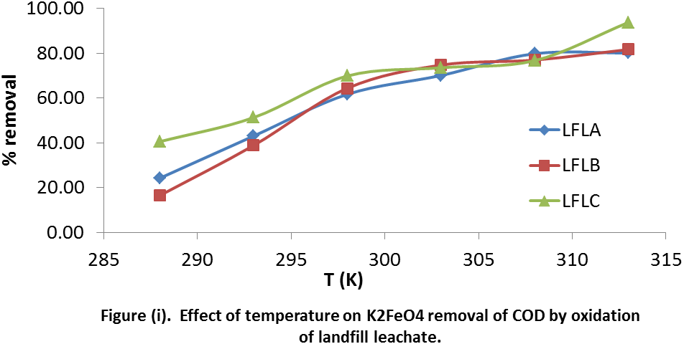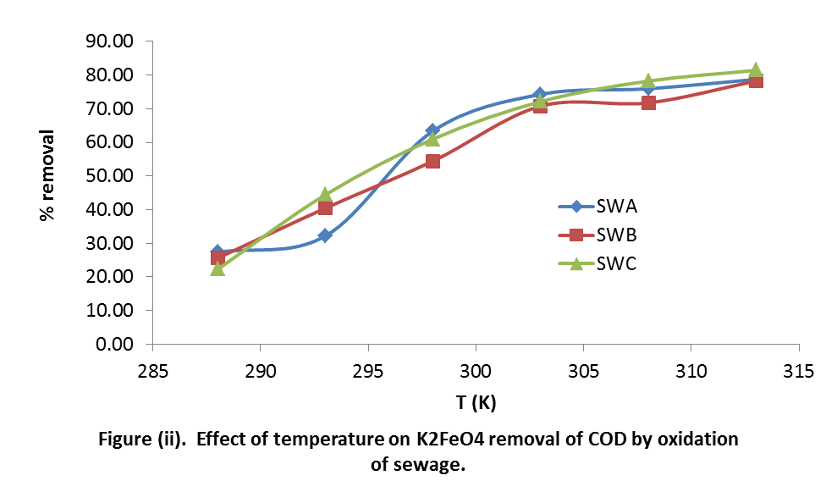

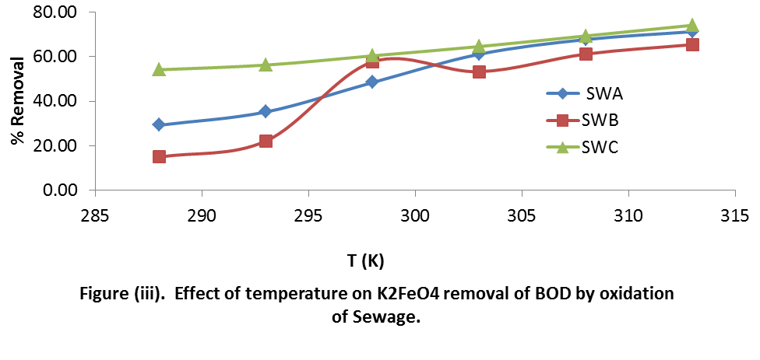
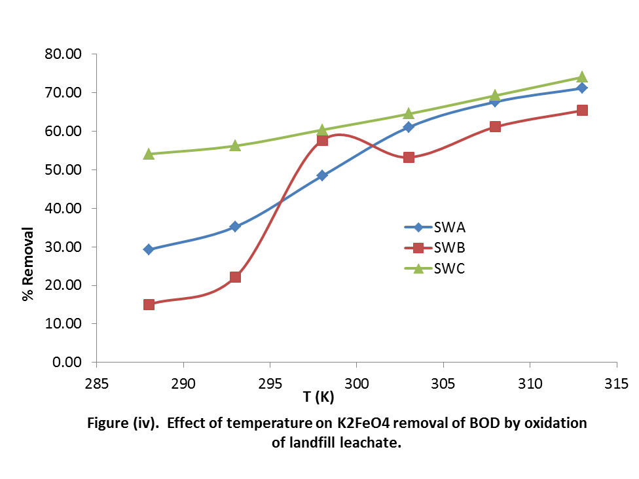

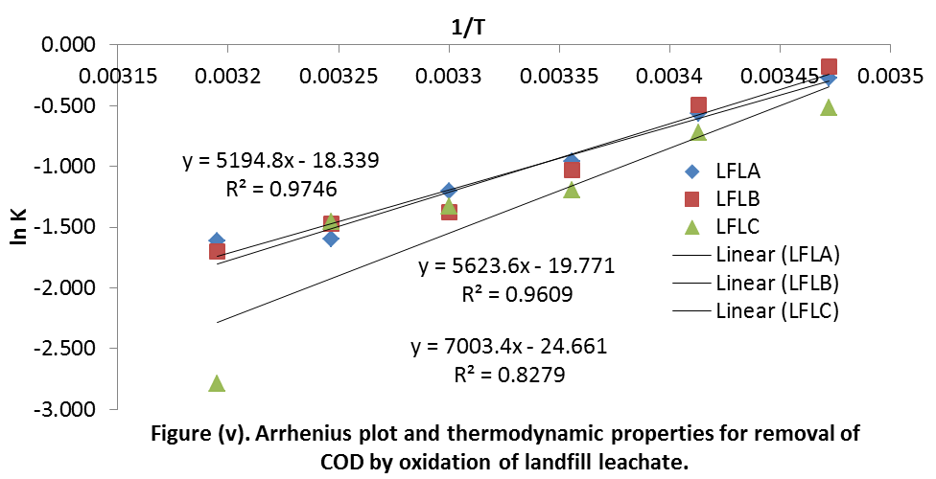

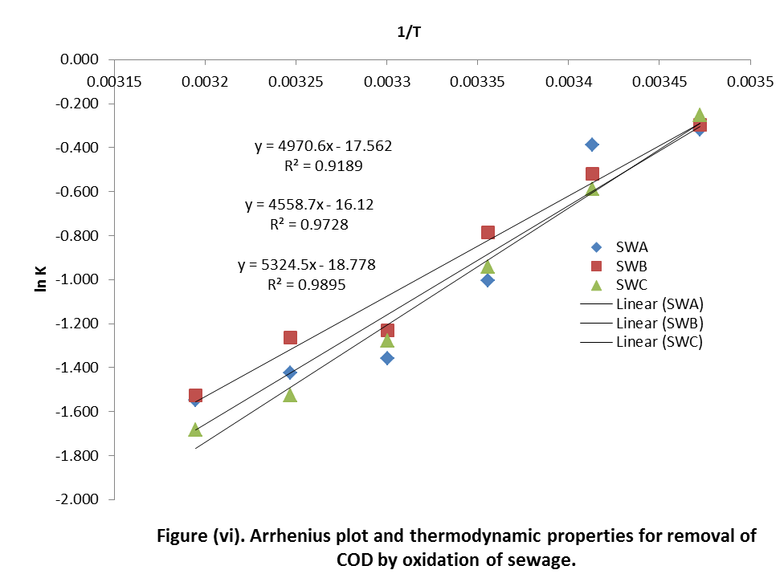

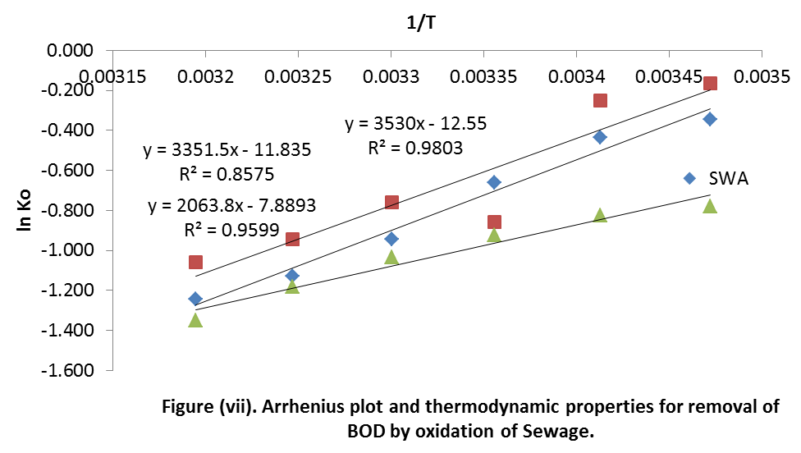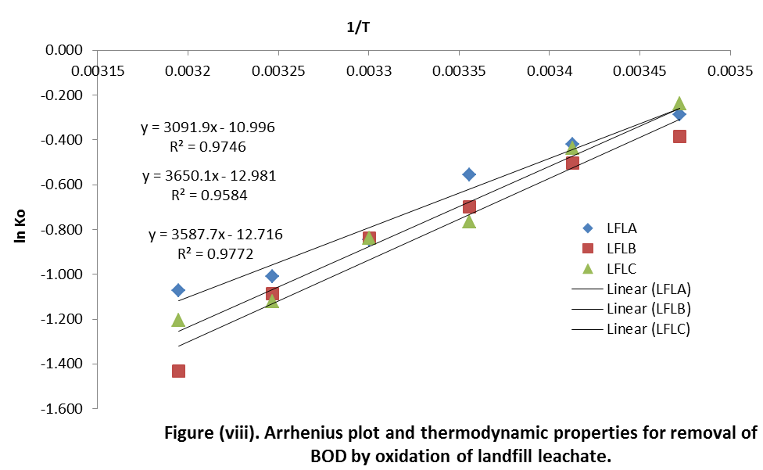

Table 1. R² values and kinetic parameters for removal of COD by oxidation of landfill leachate.
Samples | ln A | A (gL-¹min-¹) | R² | E_{a} (KJ Mol⁻¹)
LFLA | -18.339 | 1.085 X 10⁻⁰⁸ | 0.9746 | 1.16 X 10⁵
LFLB | -19.771 | 2.592 X 10⁻⁰⁹ | 0.9609 | 1.25 X 10⁵
LFLC | -24.661 | 1.949 X 10⁻¹¹ | 0.8279 | 1.57 X 10⁵
SWA | -17.562 | 2.360 X 10⁻⁰⁸ | 0.9189 | 1.11 X 10⁵
SWB | -16.120 | 9.980 X 10⁻⁰⁸ | 0.9728 | 1.02 X 10⁵
SWC | -18.778 | 6.995 X 10⁻⁰⁹ | 0.9895 | 1.19 X 10⁵

Table 2. R² values and kinetic parameters for removal of BOD by oxidation of landfill leachate.
Samples | ln A | A (gL-¹min-¹) | R² | E_{a} (KJ Mol⁻¹)
LFLA | -10.996 | 1.68 X 10⁻⁰⁵ | 0.9746 | 7.91 X 10⁴
LFLB | -12.981 | 2.30 X 10⁻⁰⁶ | 0.9584 | 7.51 X 10⁴
LFLC | -12.716 | 3.00 X 10⁻⁰⁶ | 0.9772 | 4.62 X 10⁴
SWA | -12.550 | 3.55 X 10⁻⁰⁶ | 0.9803 | 6.93 X 10⁴
SWB | -11.835 | 7.25 X 10⁻⁰⁶ | 0.8575 | 8.18 X 10⁴
SWC | -7.8893 | 3.75 X 10⁻⁰⁴ | 0.9599 | 8.04 X 10⁴

4. Discussions.
The results for the removal of BOD and COD by oxidation of landfill leachate and sewage using K₂FeO₄ at different temperature was presented in figure (i) to (iv). COD reduction during treatment ranged from 24.25 to 80.15 % LFLA, 16.52 to 81.72 %, LFLB; 40.57 to 93.85 %, LFLC; 27.36 to 78.75 %, SWA; 25.58 to 78.26 %, SWB and 22.26 to 81.43 % SWC. The oxidation of the samples by the removal of BOD ranged from 24.95 to 65.82%, LFLA; 31.95 to 76.10%, LFLB; 21.19 to 69.99%, LFLC; 29.27 to 71.18% SWA; 15.04 to 65.39 SWB and 54.10 to 74.05%, SWC. In this investigation, the percentage removal increases as the temperature increases. Temperature is one of the factors influencing catalytic oxidation reaction rate. Results revealed that COD and BOD removal efficiency, affected by temperature. Increasing operating temperature had a favourable effect on the COD and BOD removal similar to results of Zhang et al., 2005; Aygun et al., 2012, Amuda, 2006.
The temperature dependence of the kinetic parameters for the process was calculated (figure v to viii) using the Arrhenius equation ln K = lnA – {E_{a}/RT} (Sun et al., 2009). Where K is the rate constant which controls process, A is the Arrhenius constant, T is the solution temperature in K, E_{a} is the activation energy (KJmol⁻¹) and R is the ideal gas constant (0.082 KJmol⁻¹K⁻¹). The values for the activation energy and Arrhenius constant were presented in table 1 and 2. The Arrhenius plot (figure 5 to 8) gives a better R² values for all the samples with range from 0.8279 to 0.9893 for COD and 0.8575 to 0.9803 for BOD. Sample LFLC had a lower R² (0.8279) for COD and SWB (0.8575) for BOD. Positive E_{a} indicate that higher solution temperatures favor the oxidation, and the process is endothermic.

Conclusion
In this paper effect of K₂FeO₄ in chemical oxygen demand (COD) and biochemical oxygen demand (BOD) load reduction of landfill leachate and sewage was investigated. The effect of temperature and kinetic parameters were calculated. It was observed the technique was a fast and efficient procedure and about 70 to 80 percent removal efficiency was obtained in 30mins for total COD removal and 60 to 70 percent removal was achieved in 30 min of reaction. Temperature increase had positive effects on both COD and BOD removal by oxidation of landfill leachate and sewage. The kinetic study carried out at temperatures ranging from 288 to 313 K and Arrhenius constant and activation energy was calculated using Arrhenius plot.

Corresponding Author:
Dr. Osu Charles I.
Department of Pure and Industrial Chemistry
University Of Port Harcourt, P.M.B 5323. Port Harcourt, Rivers State, Nigeria
Telephone: +2348037783246
E-mail:charsike@yahoo.com; Charles.osu@uniport.edu.ng

References
- Amuda, O S (2006). Removal of COD and Colour from Sanitary Landfill Leachate by using Coagulation – Fenton’s Process. J. Appl. Sci. Environ. Mgt.,Vol. 10 (2) 49 – 53.
- AWWA, APHA, WEF (1993). Standard methods for the examination of water and waste water 19th Edition, Washington DC.
- Aygun, A., Yilmaz, T., Nas, B, Berktay, A. (2012).Effect Of Temperature on Fenton Oxidation of Young Landfill Leachate: Kinetic Assessment And Sludge Properties. Global Nest Journal, Vol 14, No 4, Pp 487-495.
- Graham, N., Jiang, C., Li, X., Jiang, J., and Ma, J. (2004) “The influence of pH on the degradation of phenol and chlorophenols by potassium ferrate.” Chemosphere, 56(10) 949-956.
- Green, J. R. (2001). “Potassium Ferrate” Encyclopedia of Reagents for Organic Synthesis, John Wiley. doi:10.1002/047084289X.rp21.
- Holleman, A. F.; Wiberg, E. "Inorganic Chemistry" Academic Press: San Diego, 2001. ISBN 0-12-352651-5.
- Prashant K. Lalwani, Malu D. Devadasan (2013). Reduction Of Cod And Bod By Oxidation: A Cetp Case Study International Journal of Engineering Research and Applications (IJERA) Vol. 3, Issue 3, pp.108-112.
- Shafieiyoun1, S. Ebadi, T., Nikazar , M. (2011). Organic Load Removal Of Landfill Leachate By Fenton Process Using Nano Sized Zero Valent Iron Particles. 2nd International Conference on Environmental Science and Technology IPCBEE vol.6 ; IACSIT Press, Singapore.104 -108.

Sun S.P., Li C.J., Sun J.H., Shi S.H., Fan M.H., Zhou Q., (2009). Decolorization of an azo dye Orange G in aqueous solution by Fenton oxidation process: effect of system parameters and kinetic study. J Hazard Mater. 2009 Jan 30;161(2-3):1052-7.
- Zhang H., Choi H.J., Huang C.P., (2005). Optimization of Fenton process for the treatment of landfill leachate, Journal of Hazardous Materials, 125(1-3), 166-174.

7/25/2016

