**Distribution of *Gracillaria* species (*Gracillaria edulis*, Rhodophyta) in SriLanka**

Prof P. Vinobaba, Dr. (Ms). Kumudu, Ganeshamoorthy Umakanthan

Department of Zoology, Eastern University Sri Lanka

Department Fisheries and Aquaculture University of Ruhuna Sri Lanka

**Abstract**: This paper reviews the taxonomical literature of the *Gracilaria* *edulis* algae from Sri Lanka, and provides information about their ecology and distribution based on an intensive regime of local collection. Its aim was to find out name, even if on a preliminary basis, for local gracilarioid taxa. Mainly four species of *Gracilaria* are reported in the Sri Lanka, including one unidentified *Gracilaria corticata* and mostly abundant *Gracilaria* *edulis* in Puttalam, Jaffna, Trincomalee and Mannar. Sri Lanka has an extremely rich and diverse seaweed flora with a wide variety of marine habitats. Increased commercial interest in these seaweed resources has been the stimulus for Biochemical studies.

[P. Vinobaba, Kumudu, Ganeshamoorthy Umakanthan. **Distribution of *Gracillaria* species (*Gracillaria edulis*, Rhodophyta) in SriLanka.** *Researcher* 2016;8(6):50-58]. ISSN 1553-9865 (print); ISSN 2163-8950 (online). <http://www.sciencepub.net/researcher>. 9. doi:[10.7537/marsrsj080616.09](http://www.dx.doi.org/10.7537/marsrsj080616.09).

**Key words:** Taxonomy, distribution, Rhodophyseae, Gracilariales, Sri Lanka, species, *Gracillaria edulis*, Rhodophyta

**Introduction**

Seaweeds are known as benthic marine algae which are the group of plants live either in Brackish or marine water environment. In the marine water Seaweeds are found in the coastal region between low tide to high tide and in the sub-tidal region up to a depth where photosynthetic light is available. Seaweeds contain photosynthetic pigments and with the help of sunlight and nutrient present in the seawater, they photosynthesize and produce food like the land plants. Plant pigments, light, exposure, depth, temperature, tides and the shore characteristic combine to create different environment that determine the distribution and variety among seaweeds. It is classified as green (Chlorophyta), brown (Phaeophyta) and red (Rhodophyta) according to the photosynthetic pigments, storage food products, cell wall component, fine structure of the cell and flagella (Jayasuriya.P.M.A.,1989). Seaweeds are similar in form with the higher vascular plants but the structure and function of the parts significantly differ from the higher plants. Seaweeds do not have, stem, leaves, true roots and whole body of the plant is called thallus that consists of the holdfast, stipe and blade. The most significant difference of seaweeds from the higher plants is that their sex organs and sporangia are usually one celled or if multi-cellular, their gametes and spores are not enclosed within a wall formed by a layer of sterile or non reproductive cells. *Gracilaria* *edulis*is exclusively marine Red algae. It varies in size and shape. They are either epiphytes, grows as crust on the rocks or shells as a large fleshy, branched or blade like thalli (Fig 1).







*Figure 1. Gracilaria species from different coast of India.( Sahu.n 2013)*

Sri Lanka has a coastline of approximately 1700 km along which many varieties of seaweeds are found. About 320 species belonging to different families have been identified by several workers (Durairatnam, 1961; Barton, 1903; and Boergesen, 1936).

In 1952 the Ceylon Fisheries Research station initiated the first systematic survey of the island's coastal waters for seaweeds with a view to utilizing those of economic importance. These investigations (Durairatnam., 1961) revealed that there were many species of algae on the west coast, but very few on the east coast (Fig. 2). The most common seaweeds found in Sri Lanka are the brown seaweeds belonging to the genus *Sargassum.sp* They grow on rocks and other soiled objects but easily break loose from their attachment during heavy monsoons and are washed ashore. Some float about in the ocean in large masses. Extensive beds of seaweeds are found in Jaffna, Palk Strait, Gulf of Mannar, Pearl bank off Silarathurai and along the southwest coast of Sri Lanka extending from Ambalangoda to Galle. The extent of the beds and intensity of growth diminish progressively from north to south along the west coast.

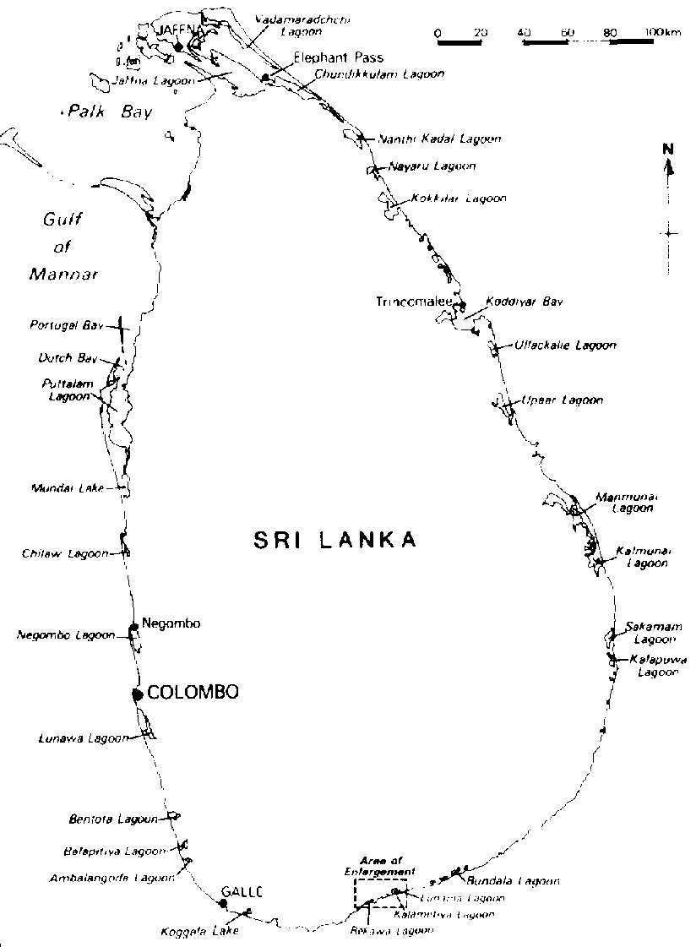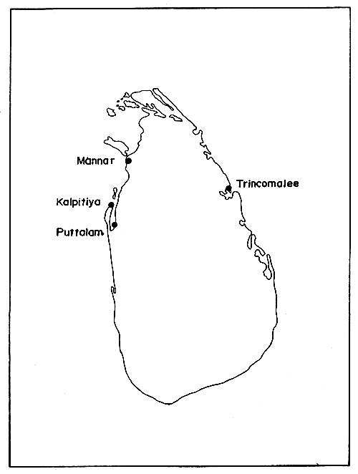

**Figure 2.** The distribution of commercially **Figure 3**. Locations where seaweeds are important algae beds in the coast part of Sri Lanka collected for commercial purposes

Duraitarnam and Medcof (1955) discovered two species of seaweeds, *Gracilaria* *edulis* and *G*. *verrucosa,* known as Ceylon moss. Large quantities of these seaweeds were found in Kalpitiya, Trincomalee and Mannar (Fig. 3).Sri Lanka has a rich marine algal flora along its coastal belt. Marine macro algal flora of Sri Lanka comprise of 396 species within 147 genera and 56 families (Silva *et al*. 1996). *Gracilaria sp*, belong to the phylum Rhodophyta an agar yielding red seaweed (Usitalo, J. 1986), isgeographically distributed between 50° North latitude and 50° South latitude. In the eastern coast of Sri Lanka, *Gracilaria* *verrucosa* and *Gracilaria* *edulis* were recorded (Durairatnam, M. 1961and Pahalawattearachchi, 2003)

*Gracilaria* *edulis* farming is considered as an alternative livelihood for fishermen around the coastal region in Sri Lanka. There are several benefits arises from this species such as medical and food wise. For example it is used as raw material for the production of agar and also consumed in the form of porridge from coastal people in Sri Lanka especially muslim people. (Subasinghe And Jayasuriya, 1989). Seaweeds are among promising prducts to be produced from marine ecosystems. The alternatives of the seaweed can be explained from the prespectives profit land and people.

*Gracilaria. sp*. have been exported from Sri Lanka since 1800s (Duraitarnam, 1933). Exports to England of dried bleached “Ceylon moss” (Gracilaria spp.) was some 5,700 lbs in 1831 and 15,000 lbs in 1840 where it was sold at 09 d/lbs. In 1930's Ceylon moss was reported from Gulf of Mannar, Puttalan Lagoon (Fig. 3) and from Ponparippu to Kallar (Deraniyagala, 1933).

The most detailed survey of Tanzanian *Gracilaria.sp* was made by Jaasund (1976) with a more comprehensive list of species and nomenclatural update given by Silva *et al*., (1996). However, neither of these publications provide detailed information on the distribution of the species in Sri Lanka. *Gracilaria.sp* in Tanzania is mentioned in other studies (Mshigeni & Wevers, 1979; Semesi, 1979; Buriyo, 1999; Mwandya *et al*., 2001; Mmochi *et al*., 2002; Msuya & Neori, 2002),. This paper reviews the literature pertinent to Gracilaria specimens revealed that the taxonomy of this genus in Sri Lanka remains uncertain. The above account on the taxonomic problems of the genus in Sri Lanka justified the present study, involving extensive sampling from a wide range of habitats, in order to compare the morphology, and anatomy features to arrive at a better identification of the local species. The genus *Gracilaria* 150 currently recognized species is an important component of the flora on most tropical to cool temperate shores. Many of the species, however, are poorly defined, minimally described and inadequately illustrated. (Bird *et al*., 1986, Reading and Schneider 1986, Abbott *et al.,* 1991) have shown that these features are not reliable for infrageneric discrimination. Species identification within the Gracilariaceae therefore remains problematic. From the eighteenth century until 1930, collections of seaweeds in South Africa were made primarily by visiting plant collectors and studied by European phycologists (Bolton, 1999). A large collection was made by Tyson (1851–1920) which was studied by Delf and Michell, (1921). Becker collected prolifically at the Kowie, Eastern Cape, from 1890–1910 (Bolton 1999). Seaweeds were an integral part of the large-scale ecological and biogeographical studies of Stephenson and colleagues, culminating in a list of 280 ‘species and major varieties’ with distributions (Stephenson, 1948). Working with Stephenson, Papenfuss made his prime goal the elucidation of the seaweed flora of South Africa. Papenfuss intended to produce a seaweed flora of South Africa and part of it exists in manuscript, but it was not completed(Bolton 1999).

Recently there have been shown to be two Gracilariopsis species in South Africa in studies based on molecular data (Govender 2001, Iyer 2002, Iyer *et al*., 2005). The most common species is *Gs*. *longissima* (Gmelin) Steentoft, Irvine et Farnham, whereas a newly described species, *Gs*. *Funicularis* Iyer, Bolton et Coyne occurs primarily in Namibia, with an isolated population in the De Mond estuary (Iyer *et al*., 2005).Molecular studies (Iyer 2002) have demonstrated that the present descriptions of species of the Gracilariaceae in South Africa are misleading. Morphological plasticity within species and erroneous interpretations are the major contributing factors. Hence there is a need for a comprehensive reappraisal and revision of these species to be carried out. This study aims to provide a taxonomic and bio geographical analysis of members of the Gracilariaceae occurring in Sri Lanka.

**2.Materials And Methods**

2.1 Field Collection And Specimen Processing

Material necessary for seaweed collection such are Polyethylene bags, Knife or scalpel, Labeling materials (pen/pencil, labels, marker pens etc.), Rubber bands, Field note book, Long rope (about 50 m long), Regifoam, Quadrant 0.25 m 2 / 1 m2, Mono pan balance, GPS N20233(Taiwan, Garmin GPS72H), Dry preservation(herbarium) Material required for preparing herbarium is as follows: Plastic trays, Forceps, Specimen mounting paper (herbarium sheets), Cheese cloth, Blotting paper, Herbarium wooden press, Painting brush, Pencils, knife, Polyethylene bags.

Specimens were collected from various habitats in the intertidal and upper subtidal zones along the coastal regions of Sri Lanka (Fig. 3). In each region four to six locations (depending on the size and ecological diversity) were surveyed for *Gracilaria* species at least twice in different seasons (southeast and northeast monsoon), between March 2015 to september 2015. The collected specimens were preserved in 5% formaldehyde. This will give more time for seaweed collection and to observe seaweeds in the natural habitat. It is important to make notes on the description of the site location, topography, associated flora and fauna and other related parameters.

To prepare a quantitative assessment of the marine vegetation in a given area, a line or belt transect is laid perpendicular to the coast from high tide to the low tide with the help of long rope (Fig. 1). Sampling points along the rope will be marked depending on the gradient and the expanse of the intertidal area. In case the intertidal area is small, sampling points will be marked at 5 m intervals along the rope and if intertidal area is quite large the sampling point will be marked at 10 or 20 m along the rope. A quadrant measuring 0.25 m 2 area is placed at the sampling points in triplicate covering an area of 5 m 2 on either side of the sampling points. Seaweed species present within the quadrant are collected (collect complete plant as far as possible along with the hold fast). Seaweed specimen will be removed by hand but those specimens that are closely adhering to the substrate such as crustose and mat forming seaweeds can be removed with the help of knife or scalpel. The specimens that grow close to the rocks can be removed with the rocks using geologist’s pick axe or any other similar tools.

-All the collected specimen will be counted species wise and number of individuals in each species should be noted for quantitative assessment of abundance, density, frequency, species richness, percentage cover etc. with statistical consideration.

-All the collected specimen from the quadrant will be weighed to estimate standing crop biomass.

-Collected material should be kept in the polyethylene bags/containers with proper labeling for further preservation and identification at the later stage in the laboratory.

Wet preservation: All the adhering materials such as sand particles and other debris as well as epiphytes remove from the seaweeds before preservation. A solution of 5 -10 % formaldehyde in seawater prepare to preserve the seaweed sample. Before adding the preservative, water from the polyethylene bags / containers drain and sufficient preservative add. Fumes of the formaldehyde will help to fix and preserve the seaweed material. Polyethylene bags tie with rubber bands properly to prevent leakage during transportation. All the bags / containers will be properly labelled with date of collection, locality and time and transport to the laboratory for further identification.

*Gracilaria* *edulis* (Gracilariaceae, Rhodopyhta) were identified and collected randomly in the field from various localities around Sri Lanka. Photographs show the sampling collection sites in Sri Lanka (Fig.3).The collected specimens were kept in an ice-box while transported back to the laboratory. The specimens were stored at -20ºC immediately upon arrival at lab before further processing. The collected specimens were cleaned with seawater and distilled water. Mud or dirt, entangling epiphytes, epizoites, fungi and extraneous materials were removed by successive washing in seawater with the final rinse in distilled water to remove excessive salt. The cleaned specimens were blotted and left to dry in a clean airconditioned room.

Correct labelling of the sample is important as it ensures sample identification. Clean, secure, water proof, non-smearing and with necessary information will be have in the labeling. It ensures that label should not get detached during the storage and transportation. Pens/ pencils use for labeling will be non-smearing and maintain permanent legible mark. Label will contain, date, locality, sample code etc.

For the Identification of seaweed species only through practice of handling and distinguishing the plants in the natural habitat will help a great deal in learning seaweed identification. Taxonomic identification key should be followed to identify the seaweed specimen. The taxonomic description of the specimen and anatomical characteristic of the specimen to be identified should be referred from the books, monograph, reference herbaria etc. Once identify the specimen tentatively following the key, should compare it with the herbarium from reference center. Some of the seaweed species, particularly, filamentous are difficult to identify. In such cases chemo taxonomy or genetic approach could be employed for further studies later. Later, may once again get it confirmed from the experts in the field. List of the other institutes where seaweed species can be identified are as follows. 1. Departments of Zoology, Eastern University, Sri Lanka, 2. Methodologies and field guide to the dominant species ABC Taxa by Coppejans.E (2009).

For the Quantitative assessment of abundance density and cover of the *Gracilaria* *edulis* were calculated as D = n/A where D = density, n = total number of individuals of the species, A = total area sampled, C=a/A,where C = cover, a = total area covered by species, A = total area sampled.

Field data sheet was maintained for accurate records of the field sample collection. All information was recorded in the field data sheet. The field data sheet includes the date, time and locality of sample collection. Data sheet include other important information pertaining to the ecological parameters. Field notes will be recorded detailing the condition of sampling and any unusual observations during the sampling. These notes will be helped great deal during the processing of the sample and interpretation of the data.

Key to the gracilarioid species

(modified from E. Oliveira, unpub. data)

1. a. Thallus membranaceous, strap-shaped .... 2

b. Thallus cylindrical to flattened ................ 4

2. a. With tooth-like marginal proliferations

.................................................. *G. millardetii*

b. Thallus margin smooth ............................. 3

3. a. Well branched and regularly bifurcated,

width mostly uniform throughout the thallus

................................................... *G*. *corticata.*

b. Irregularly branched, thallus width varying

from base to apex ....................... *G*. *truncata*.

4. a. Thallus completely cylindrical ................. 5

b. Thallus compressed to flattened, at least

partially ......................................................... 8

5. a. Thallus usually with regular constrictions,

sausage-like .............................. *G*. *salicornia*.

b. Thallus always without constrictions ....... 6

6. a. Plants shorter (5–10 cm) and thicker (2–3

mm), with curved unilateral branches ...........

...................................................... *G*. *arcuata*.

b. Plants longer and thinner, without unilateral

branching ...................................................... 7

**7. a. Plants up to 20 cm long, irregularly branched,**

**on rocky shores .............................. *G*. *edulis*.**

b. Plants up to 150 cm long, irregularly

branched ............................... Gracilaria ? sp.

8. a. Plants erect, cylindrical or partially

compressed .................................... *G*. *cornea*.

b. Plants prostrate, compressed, attached to the

substrate at several points ..............................

.............................................. *G*. *canaliculata*

**Results And Discussion**

*Gracilaria* *edulis* Attached on small rocks in intertidal pools, but also present along tidal streams or small channels and is normally solitary. Plants may be more than 20 cm high, cylindrical, 1–2 mm in diameter, red or greenish in color, with irregular branching; basal branches may be partially buried in the sand. Two morphological forms have been recognized. One is long, up to 30 cm, pale red or greenish, solitary and less branched with a distinctive central growing axis. It grows in clear, exposed, sandy tidal pools and tidal streams/channels. The second form is much branched, up to 20 cm high, greenish to brownish-red in color. This form was collected mostly from areas with somewhat turbid water, on sand-muddy substrate, along tidal streams. This morphotype resembles more closely the illustration of Jaasund (1976). Specimens deposited in the herbarium, at the Department of Zoology, Eastern University, Sri Lanka collected from Kalpitiya, Puttalam and identified as *Gracilaria edulis* also belong to that species.

**Nomenclature Details of Macro‑algae**

Division: Rhodophyta

Subdivision: Eurhodophytina

Class: Florideophyceae

Subclass: Rhodymeniophycidae

Order: Gracilariales

Family: Gracilariaceae

Genus: Gracilaria

Species: *Gracilaria edulis* (S.G. Gmel.) P.C. Silva 1952: 293

Authority: Ganeshamoorthy Umakanthan

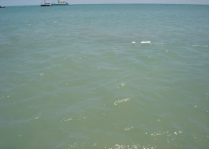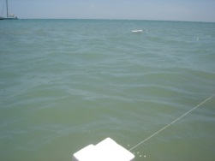

*GPS N20233 (Taiwan, Garmin GPS72H) Sampling sites (Line Transect method)*

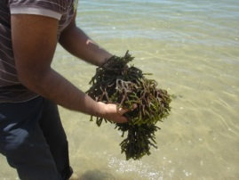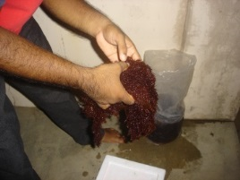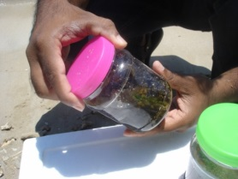

*Fresh specimen of Gracilaria edulis* *Sample collection in different sites in Sri Lanka*

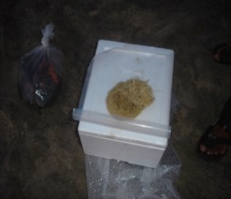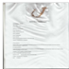

*Dry specimen of Gracilaria edulis Herbarium of Gracilaria edulis*

Regarding sample collection, only one beach in Kalpitiya Puttalam district of northwestern province was collected *Gracilaria. sp* on a very large scale. Seeding is by spreading thalli into approximately 400 m2 earth lagoon located in or near the mangrove forest and allowed to grow naturally. There is a water level at about 60–80 cm deep during low tide. Local farmers have reported that the production is about 7 tons (dried) per hectare per year. (Anon., 1999).

The taxonomy of *Gracilaria. sp* is enormously difficult since many taxonomic features form continuous rather than discrete characters, and one must compile tables listing various attributes before deciding whether, upon a balance of probability, it is one species or another.

Apart from formalin-preserved plants, material was also dried and pressed for preservation as herbarium sheets. These are now lodged in Department of Zoology Herbarium at the Eastern University, Sri Lanka under collection numbers 0893–0901.These herbarium sheets will enable subsequent investigators to independently identify (and, if necessary, update the nomenclature for) the particular plants reported on here.

Five species of *Gracilaria* were found during the survey. Most abundant was *Gacilaria edulis*, and all lifecycle stages were found among collections from Kalpitiya and Mannar. Also present alongside *G. salicornia* at Mannar and Jaffna, but smaller and less abundant, was a so-far unidentified species of G. *hikkaduwensis*.This species was also quite abundant on hikkaduwa.

This is the first time was searched the *Gracilaria* *edulis* by me and Chamara diver from Matara in the Batticaloa region as a result there is no *Gracilaria* species around the Batticaloa from Passikudah to Kallar. *Gracilaria* *edulis* has a different growth habit from *G*. *maramae*, despite often living in the same environment. It has more branching, but short inter-node distances, making plants smaller and bushier than *G*. *maramae*. Its colour is also different, being more of an olive or khaki hue than the more translucent and golden-looking *G*. *maramae*. *G*. *edulis* often forms a turf of tightly inter-locking plants on hard substrates, while *G*. *maramae* will be individual plants growing in sand-bottomed pools.

A third species of *Gracilaria* was found as two small and isolated plants, one at Batticaloa and one at Puttlam near Kalpitiya beach Point. These plants have a very thick thallus for a *Gracilaria* (5 mm) and in outward appearance resemble a small Kappaphycus plant. The plant from Muaivuso is definitely a Gracilaria judging from the structure of its branching And jelly body. It has been tentatively identified as *G. salicornia*.

However the *G. edulis* material from the Kinniya site was all either tetrasporic or sterile, so identification was made using representative material previously collected from another site (Mannar) which included all life history stages. Specimens of the *Gracilaria* species found at Sri Lanka have been deposited in the Department of Zoology based at the Eastern University, Sri Lanka, with the following catalogue numbers 0893, to 0901.

**Table 1. Seedling grows sites. (Passikudah sites)**

|  |  |  |  |
| --- | --- | --- | --- |
| Month | Temperature (°C) | Salinity (%) | Fresh weight (g) |
| March | 33 | 31 | 26.3 |
| April | 33 | 31.51 | 27.1 |
| May | 32 | 32 | 29.1 |
| June | 31.58 | 32.6 | 26.2 |
| July | 31.89 | 32.8 | 25.0 |
| August | 30.68 | 33.7 | 24.2 |

**Table 2. Seedling grows sites. (Palameenmadu sites)**

|  |  |  |  |
| --- | --- | --- | --- |
| Month | Temperature (°C) | Salinity (%) | Fresh weight (g) |
| March | 33 | 23 | 29.5 |
| April | 33 | 23.8 | 33.2 |
| May | 32 | 24 | 35.2 |
| June | 31.58 | 25.5 | 32.0 |
| July | 31.89 | 25.8 | 28.1 |
| August | 30.68 | 25.6 | 26.6 |

**Table 3. *Gracilaria* *sp* cultivation**

|  |  |  |
| --- | --- | --- |
| *Gracilaria sp* collection areas | Fresh weight(Kg) for 10m2 | Kg/m2 |
| Kalpitiya (Puttalam) | 38.7 | 3.87 |
| Trincomalee | 28.2 | 2.82 |
| Mannar | 5.5 | 0.55 |

**Distribution of Gracilarioid algae along the coast of Sri Lanka. (Fig.5)**

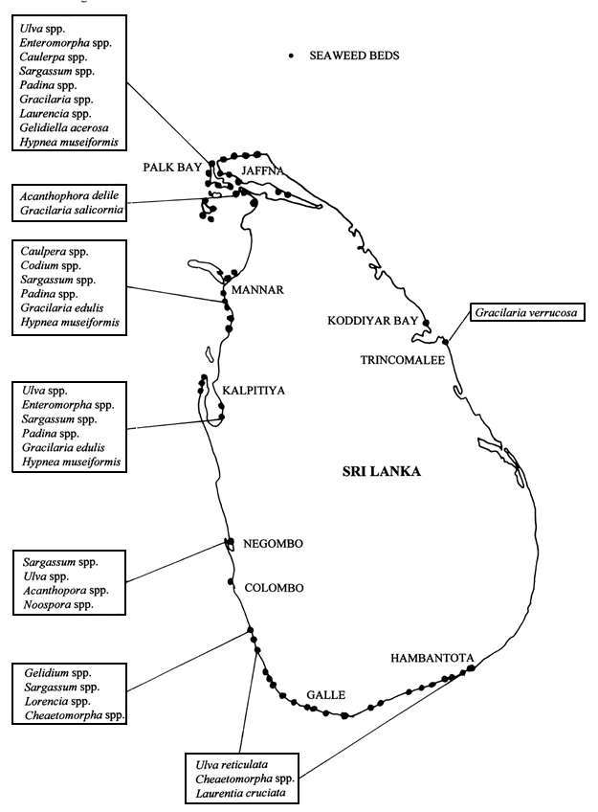

***Distribution of Gracilarioid algae in Sri Lanka. P.M.A Jayasuriya., (1991)***

***Gracilaria species in Sri Lanka***

|  |  |  |  |  |  |  |  |
| --- | --- | --- | --- | --- | --- | --- | --- |
| Region / Districts | Province | *G. corticata* | *G. Hikkaduwensis* | *G. Salicornia* | *G. edulis* | *G. vericosa* | *G. maramae* |
|  |  |  |  |  | √ | √ |  |
| Mannarr | Northern |  |  |  | √ | √ |  |
| Kalpitiya  (Puttalam) | North western | √ | √ | √ | √ | √ |  |
| Trincomalee | East |  |  |  | √ |  |  |
| Jaffna | North |  |  |  | √ |  |  |
| Hikkaduwa | Southern |  | √ |  |  |  |  |
| Batticaloa | Eastern |  |  | √ |  |  |  |

Sources from coppejans E. (2009), Questionaire survey from Matara Divers in Sri Lanka, identification of species by G. Umakanthan

Chart 1. Seedling grows sites. (Passikudah Sites) Chart 1.1. Seedling grows sites. (Passikudah Sites)

Chart 2. Seedling grows sites.(Palameenmadu Sites) Chart 2.1. Seedling grows sites. (Palameenmadu Sites)

Pie Chart 3. *Gracilaria sp* cultivation in Sri Lanka

Review of above information which areas are the best, and typically the north western part of the Sri Lanka, because it offered the best chance to make it successful. There must be a salinity level, and that can be brought by there not being too many rivers flowing into the sea at those points, because river water which is fresh water reduces the salinity level. But Mannar area where there were no rivers. Then the second requirement was the ocean temperature that shows warm water needs to grow seaweeds very well. The other requirement was the ocean wave movement because certain varieties don't grow if the water is static.

Batticaloa has the lowest diversity of *Gracilaria*.*sp* or not identified. Puttalam rock shore in Kalpitiya region, with its gently sloping topography, provides various microhabitats and is colonised by a rich flora including six *Gracilaria* species. Kalpitiya is having flatuation water current between lagoon and sea due to this total number of Gracilaria.sp cultivation is higher than the other two sites.(Table:3 & Pie chart:3). Trincomalee in Kinniya region also has rocky beach, with a gently sloping topography and rich flora, which includes six *Gracilaria* species. Mannar has mangrove-sheltered places with tidal streams,which provide habitats for *G. edulis* and *Gracilaria* *vericosa*.

March, April, and May and September, October, and November were months of maximum available. In winter and summer that means December to February it was only small amount that is 1.5% of total collection. (Niyas, n.d). In the course of this experiment, temperature ranged from 30–34°C. The recorded growth rates were lowest at 30°C (lowest temperature) and 34°C (highest temperature). Thus 32°C may be considered as the temperature range most favorable for growth. (Table 2 & 3)

Collected *Gracilaria* *sp* were cultured in two areas Palameenmadu and Passikudah with different salinities by using ropes and stone. In the result Chart 1 & 2 show the maximum growth of *Gracilaria* *sp* in salinity of Passikudah was 32 % that of Palameenmadu was 24 %. In this culture experiments and measurement of the effect of salinity on growth rate were concurrently conducted. (Table 2 & 3)。

After few month of experimentation the best algal growth was obtained in Palameenmadu, where yield in weight of *Gracilaria edulis* was 1.4 times higher than that in Passikudah. This clearly shows that salinity is an especially important factor influencing the growth of this seaweed. Results obtained from those two sites indicate that growth high at 24% salinity. Much lower or higher salinity was unfavourable for growth.

**Summary**

In the present paper are given full descriptions of the species of *Gracilaria* *edulis* and Gracilariopsis known to occur in Sri Lanka. An analytical key to all of these species is also given. The following data reported herein are worthy of special mention. Six species and one forma of *Gracilaria* are given distribution herein first time. East and west coast of Sri Lanka of the following two species are observed herein: *Gracilaria edulis*, and *Gracilaria vericosa*.In view of the economic importance of Gracilaria plants, some brief considerations on their use are offered on the basis of the latest statistics

**References**

1. Abboti, I.A. and G.J. Hollenber (1976) Marine algae of California. Publ. Stanford University Press. Stanford California pp. 827.
2. Buriyo, A.S. (2004) Taxonomic challenges and Distribution of Gracilarioid algae (Gracilariales, Rhodophyta) in Tanzania. *Western Indian Ocean J. Mar. Sci*. Vol. 3, No. 2, pp. 135–141.
3. Chapman, V.J. (1970) Seaweeds and their uses. Methuen & Co. I1 New Fetter Lane. London E C4.
4. Coppejans E et al., (2009) Methodologies and fid guide to the dominant species: *Srilankan seaweeds.* Vol (6). Ghent University: ISBN 1784-1291.
5. Dhargalkar, V.K (2004) Seaweeds- a field manual*. National Institute of Oceanography Dona Paula, Goa.*pp1-42.
6. Durairatnam, M. (1961) Contribution to the study of marine algae of Ceylon. Bull. *Fish. Res, Sln. Ceylon*. 10: 5 - 117.
7. Dwson E. and Michael S. Foster (1982) Seashore plants of California. University of California pres, Berkley Los Angeles London.
8. Fritsch, F.E. (1965) The structure and reproduction of the algae Cambridge university press Vo. I & II pp. 937.
9. Iyer. R (2004). Morphological and taxonomic studies of Gracilaria and Gracilariopsis species (Gracilariales, Rhodophyta) from South Africa. *South African Journal of Botany* 70(4): 521–539.
10. Jayasuriya. P.M.A (1991) The species composition, abundance and the distribution of seagrass communities in Puttalam Lagoon. *Vidyodaya J. Sci.* 93-102.
11. Taylor, W.R. (1957). Marine algae of the Northern coast of North America, Publ. The university of Michigan Press, Vol. I & II pp. 870.
12. Untawale, A.G., V.K. Dhargalkar and V.V. Agadi (1983) List of marine algae from India. NIO Publ. pp 1- 46.
13. Sahu N (2013). Study of Morphology and Agar Contents in Some Important Gracilaria Species of Indian Coasts. *American Journal of Plant Sciences*, 4, 52-59.
14. Srivasan, K.S. (1969) Phycologia Indica, Icons of Indian Marinine Algae. Botanical Survey of India, Calcutta. pp 52.
15. Ohmi, H., Species of Gracilaria and Gracilariopsis from Japan and adjacent waters. Faculty of Fisheries, Hokkaido University, Hakodate, Japan.pp1-88.
16. Oza, R.M. & S.H. Zaidi (2001) A revised checklist of Indian marine algae. CSMCRI, Bhavnagar publication pp. 1- 296.

6/22/2016