**Vector control of permanent magnet synchronous motor using fuzzy algorithm**

Najmeh Ghasemi1, Seyed Mohsen Naderi2

1. MSc in Power Engineering, Heris Islamic Azad University, East Azerbaijan Province, Iran

2. BA Petrochemical, Islamic Azad University, Shahreza Branch, Isfahan Province, Iran

**Abstract:** This article is focused on the control of permanent magnet synchronous motor function. Usually with a variety of non-linear controller proportional-integral controller is used to control the motors. However, the controller is sensitive to changes in speed and load disturbance and parameter changes. Conventional methods to overcome this problem manually adjust the controller parameters. It results in a Ziegler- Nichols method used to set the PI controller coefficients, but this method cannot always be effective. In order to overcome these problems, the fuzzy controller for controlling PMSM motors is used. The performance of the control authorities in tracking different speeds using MATLAB Simulink simulation is studied. In this study 49 inference rule is intended to fuzzy logic controller system has been shown to improve dynamic performance. The results of the simulations show that the fuzzy controller in many cases have better performance than conventional controllers.

[Najmeh Ghasemi, Seyed Mohsen Naderi. **Vector control of permanent magnet synchronous motor using fuzzy algorithm.** *Researcher* 2016;8(6):32-41]. ISSN 1553-9865 (print); ISSN 2163-8950 (online). <http://www.sciencepub.net/researcher>. 7. doi:[10.7537/marsrsj08061607](http://www.dx.doi.org/10.7537/marsrsj08061607).

**Keywords:** PMSM motors, fuzzy Control, PI controller, Fuzzy Logic Controller for PMSM motors

**1. Introduction**

The introduction of modern magnetic materials with high energy density to the development of machines with exciter field was PM in 1950. Replacement of electro-magnetic poles by the PM motor winding requires a power supply voltage is compressed by DC car. Unlike conventional synchronous machines, Electro-magnetic field poles have been replaced with poles PM and by doing it slip rings have been avoided. With the advancement of high power transistors and rectifiers controlled switching silicon, in the years after 1990, electric commutators for mechanical commutators were replaced inverter. These two developments led to the development of Brushea DC machines (brushless) and PMSM. PMSM electric motors are that extensively in motor control applications in low to medium power systems used such as robotic, household applications, Adjustable speed drives and electric ships.

It is widely used in numerous benefits compared to conventional engines. The lack of external rotor reduces rotor losses and PMSM is very efficient and has high torque to inertia ratio and fast response thus gives. In addition to the winding rotor brush has been removed, much lower maintenance costs. Replacement rotor windings with PM, Smaller and more compact structure and therefore provides high power density. PMSM rotor heat loss in the effect on car performance, Is negligible. In recent years, demand for PMSM drives in industrial applications has risen sharply. This is due to the inherent advantages of these Machines such as High power density, Low inertia, Effective performance and high rate capability.

Despite all these advantages, PMSM to a nonlinear multivariable control structure coupled with a need to design complex nonlinear. This drives PMSM control functions in different applications is very sensitive to changes in system load parameters. Because these changes are a dominant factor in stimulating the PMSM is harmful, the optimal control speed is very important parameter variation and load disturbance.

Intimate conventional vector controlled PMSM system of proportional-integral controllers use a fixed interest. However PMSM control performance still possible impact of uncertainties that Sometimes as a result of changes in model parameters is unpredictable, external load disturbance and nonlinear dynamics model of plant. The controller parameters must be online and be updated continuously.

In the past decade advanced control theory have been used to solve this problem such as Model Reference Adaptive Control (MRAC), Sliding Mode Control and Self-tuning controllers PI. Design all the controllers require precise mathematical model of excitation system that in practice it is difficult to obtain. Intelligent application of computational methods such as fuzzy logic control can be attractive solution in terms of Drivers speed control. In this research, suggested a Fuzzy logic for vector control of PMSM If the structure of the monitored parameters ensures robustness against changes. Accordingly, the following objectives have been pursued:

1. PMSM drive system specification and modeling study

2. Development of fuzzy logic-based speed control of PMSM drive system nonlinear model

3. Track speed and torque control of PMSM motor load simulation using MATLAB Simulink vector control that is done.

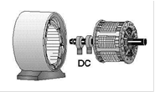

Figure 1: schematic diagram of synchronous motor

A permanent magnet synchronous motor is basically a common AC engine with distributed windings in stator slots, so the flux created by the stator current is nearly sinusoidal [6].

High speed performance (high speed effect) is a different characteristic than the previous one in permanent magnet synchronous motors. If a speed changes limit needs to become greater than the primary speed range in the flux produced by a permanent magnet, the produced flux consumption (rate) by the stator winding is reduced. The capability and efficiency of the flux weakening depend on the direct axial inductance, maximum reverser current and the heat capacity of both the motor and the inverter. The structure of a narrow cylindrical rotor with prominent surface permanent magnet is in such a shape that somehow creates a very low direct axial inductance. Thus, this structure limits the maximum speed [13].

3. Categories of the permanent magnet motors and their structure

A) PMs Magnet: PMs are magnetized along with or in a specific direction, like radial, parallel or otherwise. The extension of magnetization heavily affects the quality of the density distribution of air gap pressure and indirectly affects the power density in a certain range of PMs. PM Motors can be classified into two radial and parallel magnetic categories according to the direction of magnetization. Radial magnet is along with the rotor radius but parallel magnet is parallel to the edge of the rotor.

B) The flux direction: PMSM field can be comprehensively classified based on the direction of the field flux as follows:

1. The radial field. The flux direction is along with the machine radius.

2. The axial field. The flux direction is parallel to the rotor shaft.

PM machines are conventional radial field since the axial field machines have fewer applications due to their high power density and that is why they are chosen as the topic of this study. The flux of the field in the direction of the motor is in a form of the radial magnet and then it is in a perpendicular form to the motor radius in parallel magnet.

C) Distribution of the flux density: PM motors are classified based on the distribution of the flux density and also form of the current simulating them. They are PMSM and PM brushless BLDC engines.

Generally, PMSM has EMF in sinusoidal form (the induction voltage in the stator by the rotor motion) and also developed for the improvement of the sinusoidal reverse EMF waveforms. BLDC has EMF in trapezoidal shape and has been developed for reverse EMF waveforms progress and it has a rectangular distribution of the magnetic density in the air gap. Rectangular current waveform is concentrated on the stator winding.

D) Permanent magnet radial field motors: in PMSM, magnets can be placed in different forms on the rotor. Based on the location, they are called surface permanent magnet motors (SPM) or interior permanent magnet synchronous motors. Surface mounted PM engines have surface mounted permanent magnet rotor. Each PM is mounted on the outer surface layers of the rotor. This mode provides high air gap flux density because it directly and without any intermediary encounters the air gap.

4. Profile of PMSM Setup

PMSMs could not launch and they cannot simply set up by applying AC power to the stator winding just with special attention because the net torque on the rotor is zero, except when the rotor winding around synchronous speed is applied to a spinning slider winding with proper stimulation. To do so, several modes have been created for starting PMSM. Starting from an unknown rotor mode can lead to reverse rotation or may cause the launch to run into problem. These happenings are dangerous in many cases. So, when data of the initial rotor position is not available, proper launching method for safe operation must be applied. In accordance with various suggested designs in the studies, launching methods could be classified according to the principles of the fundamental functions as follows:

1. To launch with regard to the previously specified rotor position that could be established by a suitable feeding.

2. To launch with open loop (V/F).

3. Rotor position estimation in standing mode by specified algorithms.

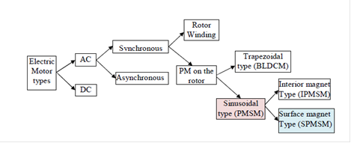

Figure 2: Summary of AC machines category.

5. Why PMSM?

Because of numerous benefits that PMSM has got, they have made it more practical compared to inductive and DC motors. These advantages include: High power density, high torque ratio to inertia, high efficiency, low noise, long-life consumption, application in high speeds and low thermal losses. However, these rotors have some disadvantages such as complicated controlling, rotor magnet maintenance problem, possible losses of the rotor magnet and as a result reduction of the produced torque.

6. PMSM application

These motors have many applications that include:

Motion and remote-control robots, self-guided ships, Locational tablets, microfilm/printers devices, plotters, washing machines, blowers, compressors, heaters, air conditioners and so on.

7. Vector-control methods of permanent magnet synchronous motors.

A) Vector control of permanent magnet synchronous motor with surface magnetism:

- Vector control originating from the flux of the motor rev.

- Vector control along with the flux of the stator rev.

B) Vector control of synchronous motor with internal magnet [8].

8. Fuzzy controllers

Recently, fuzzy logic has emerged as an attractive filed in control studies. It is the most important principle in fuzzy logic of fuzzy controllers’ structure that uses linguistic knowledge of experts [4].

As it is observed in figure 3, a fuzzy controller consists of four parts that two parts of them do the conversion act: 1. Fuzzy-making (fuzzy-maker) (convert 1), 2. Data base, 3. Inference engine 4. Fuzzy-reducer, (convert 2).

Fuzzy-making makes fuzzy the input variables (actual signals). Therefore, all input signals take the fuzzy form. In simple words, fuzzy-making convert the numerical variables to the linguistic variables or fuzzy variables. This conversion is done by membership functions. In a conventional fuzzy logic controller, the number and shape of membership functions are initially set up by the user. Membership functions have values ​​between 0 and 1, and specify the degree of a quantity belongs to the fuzzy set. If belongs of one quantity to one fuzzy set is absolutely known then its belonging degree to the fuzzy complex is 1 (in other words, this quantity fully belongs of the fuzzy set), but if a quantity does not belong to any fuzzy set, so its belonging degree to the fuzzy set is zero.

The database contains basic information and linguistic rules. Data base information is provided which is necessary to determine the rules. The database (expert rules) provides the main purpose of the control by set of linguistic control rules.

In other words, the database contains rules that have been provided by the experts. Fuzzy logic controller converts input signals by certified rules to output signals. The database consists of a set of IF-THEN rules. Some methods forming principal database are the following:

To apply the knowledge and experience of an expert individual to estimate the goals of the controller, to model the control function, to model the process, to use a self-organizing fuzzy controller and artificial neural network application.

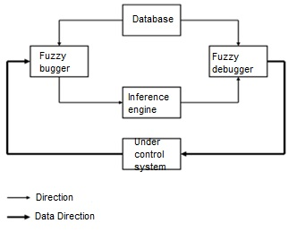

Figure 3: Diagram block of a control system including a fuzzy controller

Inference engine is the main process of a fuzzy logic controller and has the ability to simulate the human based decisions on fuzzy idea and also it has an ability to conclude the performance of fuzzy control using the fuzzy logic rules. In other words, all input parameters are converted to the related language of variables by fuzzy-maker and then inference engine evaluates set of IF-THEN rules contained in the database and then results in a linguistic value are obtained from this evaluation after that converted to the real output by fuzzy remover.

The second conversion is done by fuzzy remover and fuzzy value in the inference engine output is converted to the actual and numerical value by membership functions. Several samples exist for fuzzy removing but because of easy application and simple algorithm, the average method of center is being used.

When the classic controller (PI or PID) is being used, input of the signal controller has error one. For example, in a PI controller speed, input is speed error, which is the difference similar between the desired speed and actual speed.



But when a fuzzy logic controller is being used the controller will have more than one entry. In most cases, the controller has two error inputs (E) and (CE) changes:



Fuzzy controller which is used here has both speed error and error change. The fuzzy controllers are also possible with higher input. Purpose of the fuzzy controller is to obtain suitable output signal (CU) according to E and CE. Then, the overall output of the output changes can be calculated using the following formula:



As it is observed here, output of the fuzzy controller is the output changes which are added at any moment with the output of the previous moment. Of course, application of another fuzzy controller is possible that instead of acquiring the output changes to turn directly the output itself. As previously mentioned database is the heart of a fuzzy logic controller and includes rules to obtain the better results. Generally, in a database, IF-THEN linguistic rules are being used.

IF (E is A and CE is B) THEN (CU is C)

Where A, B and C are the fuzzy sets for error, error changes and output changes, respectively.

It should not be forgotten that a classic controller with constant coefficients (for example, PID controller) cannot obtain three main objectives for the fuzzy controller. PI and PID classic controllers used in the AC drive system are usually regulated based on the trial and error method. Of course, several ways exist for initial regulation of the controller parameters that the most common ones are based on the most Ziegler - Nickels method. Although, these methods are often very time consuming and controllers with constant coefficients cannot have acceptable dynamic performance in the working conditions. Performance is often reduced due to the nonlinearity of the machine and changes in the parameters. Adaptive controllers can be employed to solve this problem, but the convergence problem may arise. The purpose of the optimization of the system driver would be obtaining the lowest uplifting, the lowest rise and settling time. It is not generally possible to obtain all these factors at the same time but using some criterion may achieve the best possibility.

9. Vector control simulation of PMSM motors

In this section in order to have the permanent magnet synchronous motor vector control method, so that MATLAB Simulink software is performed. In Electric Drive / AC library, the following schematic can be used. This Schematic consists of six main blocks. PMSM (Permanent Magnet Synchronous Motor), a three phase inverter and a three-phase diode rectifier model are available in SimPower System Library. More information about these three blocks is available in the Userguide related to SimPower. Speed Control model of vector control Brakingchaper is also selected from the above library. The circuit schematic is shown below.

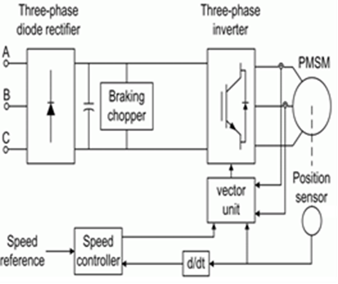

Figure 4: Circuit schematic or driving a permanent magnet synchronous motor.

The applied model is a discrete one and simulation results 1us, TimeStep is obtained. In order to simulate the digital controller of the control system there are different sampling time:

- Speed controller sampling time

- Vector controller sampling time

Speed controller sampling time must be a multiple of the vector controller sampling time. The above sampling time must also be a multiple of TimeStep simulation as well. The direct component of the stator current in a vector controller block is set to zero because the fluxes of the rotor is supplied from a permanent magnet. Here, the Tabs which are filled in simulating software are the typical numbers being used.

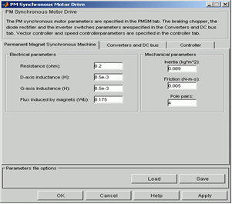

Figure 5: The parts which are filled as typical in simulation.

The convert parts are as follows:

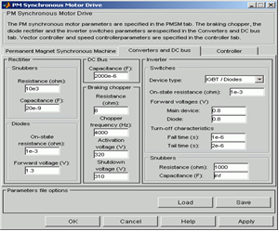

Figure 6: Schematic section “Converter and DC bus tab” and its completion method.

10. Structure of PI speed controller

Many PMSM controllers in industrial application have adopted PI fixed interest scheme, this fixed interest plan under certain operating conditions has good performance but its function degrades in other operating conditions. In addition, appropriate PI benefits usually obtained using time consuming trial and error approach. In figure (7), diagram block of PI controller for permanent magnet synchronous motors is shown.

To better analyzing the suggested controller, first permanent magnet motor are being both evaluated and simulated using PI controller and its results are being compared with the proposed controller and then reasons for the proposed system are given. The reason for using PI controllers is for this purpose that because other suggested methods in other studies for controlling these motors used to compare their proposed method with PI controller and has stated their system superiority in comparison with this controller and thus we compare our proposed controller with other controllers in order to validate the stability and reliability of our proposed controller.

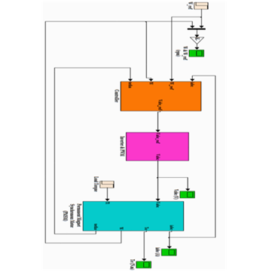

Figure 7: diagram Block of a PI controller for permanent magnet synchronous motors.

These regulators are PI integral - proportional type and coefficients of these regulators must be selected in such a way that in response to speed the minimum value for dropsy times, maximum mutation and steady error are achieved, while the torque ripple is being reduced.

The integral ­ retention in this controller causes an increase in the ring share in low frequencies, and consequently followed the slow inputs with fewer errors and will also follow the stepping input without ever lasting error. Of course, the existence of integral ­ retention causes a significant reduction of the phase and much more oscillatory state to the stepping response of closed-loop system.

The high reliability of the controller and its robustness against environmental changes and disturbances are the issues which are stated in the field of permanent magnet synchronous motors. This goal has led to the use of fuzzy methods, neural network and genetic algorithm. Among these methods, the fuzzy method because of being based on conceptual rules and having good resistance against motor parameters, it has got special position among other controllers and moreover its performance and advantages have been discussed in various studies.

11. Structure of the fuzzy controller for PMSM

Many PMSM controllers for industrial applications use PI control scheme with fixed sharing. These structures may be operated appropriately in normal conditions, but by changing the conditions, their performance may be affected. Besides, providing a proper share for PI controller is a trial and error process. In order to increase the efficiency of PMSM drive system, an adaptive controller based on fuzzy logic can be presented that structure of this controller is shown in figure (8). For this fuzzy controller, fuzzy rules matrix and membership functions are shown in table 1 and figure (9), respectively.

Fuzzy speed controller output, the reference value of the vertical current is and inputs es1 and es2 can be calculated as follows:



1. es1 (n) = ωr (n) - ωr (n)
2. es2 (n) = ωr (n-1) - ωr (n)

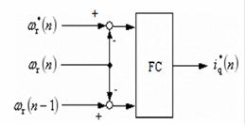

Figure 8: Fuzzy controller

Inputs are the approximate value of disturbed voltage observer df (n) و qf (n). All input and output variables normalized to [-1, 1]. Fuzzy membership functions of input variable and output variables of the fuzzy controller are shown in figure (9) and table (1) indicates the relevant fuzzy logic rule. In real time by using the reference speed and the actual speed, es1 and es2 can be calculated and according to the speed fuzzy controller, the new values of axial-vertical current reference are achieved. With the advent of parameter variation and external disturbance, vertical-axial reference values and direct-axial voltage could be verified by the output observer of the turbulent voltage. Table 1 shows an example of possible control rule base. The columns are indicative of the gradient of the error variation and the rows show the error. Each pair of show the output level *NB* toward *PB* corresponding to *u*.



Table (1): Fuzzy rules

|  |  |  |  |  |  |  |  |
| --- | --- | --- | --- | --- | --- | --- | --- |
| PB | PM | PS | ZO | NS | NM | NB |  |
| ZO | ZO | NS | NM | NM | NB | NB | NB |
| PS | ZO | NS | NS | NM | NB | NB | NM |
| PS | PS | ZO | NS | NM | NM | NM | NS |
| NM | PM | PS | ZO | NS | NM | NM | ZO |
| PM | PM | PS | PS | ZO | NS | NS | PS |
| PB | PM | PM | PM | PS | ZO | NS | PM |
| PB | PB | PM | PM | PM | ZO | ZO | PB |

Here, we have *NB* as large negative, *NM* average negative, *ZR* zero, *PM* average positive and *PB* as large positive in terms of fuzzy sets. Connection of input membership functions, logical methods and fuzzy reverse methods are necessary for mapping continuity. In this paper, the triangular membership function, logical maximum - minimum method and fuzzy reducer technique of gravity center are being used. Of course, they have been frequently used in many other studies.



Figure 9: Membership Functions.

Diagram block of the proposed PMSM drive is shown in figure 10. Figure 11 also shows the PMSM parameters.

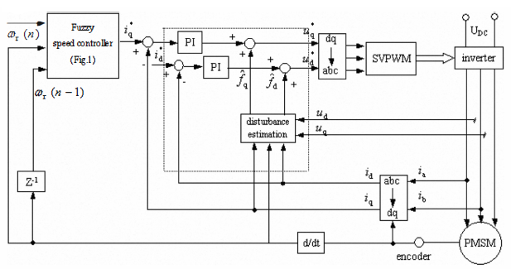

Figure 10: Diagram block of the overall PMSM drive based on the proposed control scheme.

Table 2: PMSM parameters

|  |  |
| --- | --- |
| 440 | Rated voltage UN (V) |
| 1800 | Rated speed (r/min) |
| 90 | Rated current (A) |
| 06/0 | Stator resistance Rs (Ω) |
| 562/2 | d-axis ststor inductance Ld (mH) |
| 080/3 | q-axis ststor inductance Lq (mH) |
| 69/0 | Rotor flux linkage ᴪf (Wb) |

12. Results and Discussion

Due to the structure of the fuzzy control on the permanent magnet synchronous motor control that was presented in the previous section, simulation results of the mentioned PMSM controller were compared with the results of the PI controller in order to better understand the measures of performance improvement with this controller. The parameters that are used in this simulation have explained in previous section in detail.

Analysis of PMSM motor speed under PI and fuzzy controllers:

In figures 11 and 12 PMSM engine speed are presented under similar conditions for two types of PI and fuzzy controllers, respectively. As it is observed, the results indicate that using fuzzy controller of PMSM motor speed is associated with less variation and in less time speed it reaches to the state of the steady and stable operation. This controller in cases that the stable and fixed speed with less variation is required, can be very beneficial.



Figure 11: Speed- time of PI controller.



Figure 12: Speed - time with fuzzy controller.

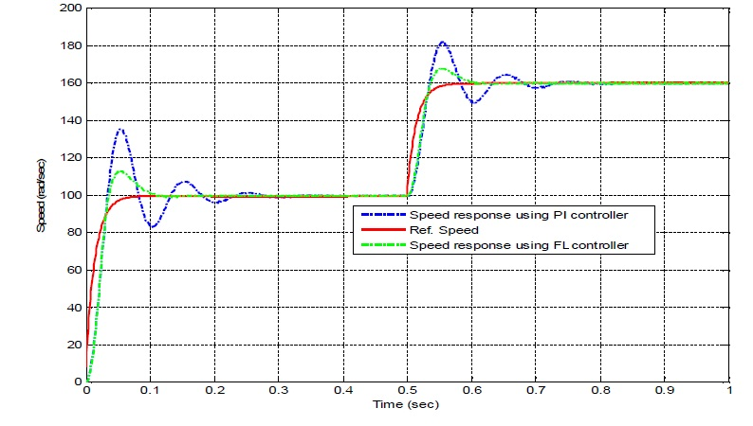

Figure 13: Reference speed and speed response at two levels of speed.

In figure (13), the motor speed response is shown for two desired stepping speed. First, the desired speed is 100 radians per second and then after a half-second the desired speed has reached the fixed speed in 160 radians per second. The results of previous speed analysis are the same as here. Fuzzy controller with fewer rises, but in a time less than PI controller may reach to the desired speed .

Analysis of PMSM engine torque under PI and fuzzy controllers:

Under constant load, the analysis of PMSM motor torque is performed using two types of fuzzy and proportional-integral controllers and the results are presented in figures 14 and 15. The results which were obtained from speed analysis, was same as the torque. In both cases when launching, the torque is increased and after some time the value of the torque is reduced and reached to its final amount. Comparison of these two types indicates a state that torque peak with proportional-integral controller is less than the fuzzy controller but instead using fuzzy controller of the torque when launching reaches immediately to its steady state. The torque variation is also less using fuzzy controller but with proportional-integral controller the variation is higher.



Figure 14: Electric torque - time with PI controller.



Figure 15: Electric torque - time with fuzzy controller.

Analysis of PMSM motor current under PI and fuzzy controllers:

The simulation results with the assumptions performed in the previous section are presented in figures 16 and 17. As it is observed, at first currents of two axes are not sinusoidal and after receiving the control commands from proportional-integral and fuzzy controllers, they come in sinusoidal mode in steady state. With regard to the speed and torque analysis, the fuzzy controller in less time reach the current of the axes to the steady mode and of course it is clear that the time peak gets more amount in launching time than the fuzzy controller. The above analyses reveal that fuzzy controller obtains better results in all proposed analyses.



Figure 16: The current axes of time d-q with PI controller.



Figure 17: the axes current of time d-q with fuzzy controller.

**Conclusion**

PMSM servo system is a complex, time-varying and nonlinear system. High reliability of the controller and its robustness against environmental changes and disturbances are of the issues that are proposed in the field of permanent magnet synchronous motors. Results of the conventional proportional - integral controllers did not prove the high precision of these engines. Fuzzy control is very efficient in a complex, non-linear and time-varying systems and also has no need to control goal model. Fuzzy method because of being based on conceptual rules and having good resistance to changes in engine parameters it presents enhanced performance for reaching the optimal state. In this paper, in order to improve the dynamic performance of the permanent magnet synchronous motor (PMSM), a new controller based on fuzzy logic is being presented. The simulation results show that the proposed method has resistance in different situations such as external disturbances and motor parameters variations. The fuzzy controllers rapidly resolve load confusion without any additional voltage and no negligible steady state error. The current is retained by a saturation function within its acceptable maximum and torque-flux is being kept in their steady mode.

Simulation studies clearly demonstrated the superiority of the fuzzy control function, because it is inherently compatible. From response characteristics arise that in the presence of load disturbances and uncertain parameters it has high performance and this logic is used for controlling systems with unknown model. The speed control using fuzzy logic gives quick dynamic response with low over voltage and no negligible steady-state error. Analysis, stability and convergence to equilibrium point have also been investigated. Also applying fuzzy controller in this scheme causes to improve the dynamic performance of vector control. Because in PI controller, after about 0.01 seconds the motor reaches to final amount of its speed but fuzzy controller reaches the final speed less than the time mentioned above. As it is observed, vector control with both fuzzy and PI method properly causes the speed tracking, and the torque of reference load, so that the quality of this tracking gives better results using fuzzy approach. Simulation results showed that PMSM drive with proposed control scheme has unique advantages such as simple structure, capability and quick tracking, improving dynamic performance, improving drive system and so on.

**Acknowledgements:**

Authors are grateful to Pars Special Energy Economic Zone, University of Applied Science and Technology (Asaluyeh Branch) and International University, PNU of Asaluyeh for support to carry out this work**.**

**References:**

1. Khurram, Position and speed sensorless control of permanent magnet synchronous motor, Ph. D. dissertation, Michigan State University, East Lansing, MI, 2001.
2. E.H. Mamdani, "Application of fuzzy algorithms for control of simple dynamic plant," Proc. IEE, vol. 121, no. 12, pp. 1585-1588, Dec. 1974.
3. Yang Vi, D. Mahinda Vilathgamuwa, M. A. Rahman, "Implementation of an Artificial-Neural-Network-Based Real­ Time Adaptive Controller for an Interior Permanent-Magnet Motor Drive," IEEE Transactions on Energy Conversion, vol. 2, 2003, pp. 96-104.
4. Dan Sun and Yikang He, "Fuzzy logic direct torque control for permanent magnet synchronous motors," Proceedings of the 5th world congress on intelligent control and automation, Hangzhou, P.R. China, June 2004, pp. 4401-4405.
5. Oyas Wahyunggoro, Nordin B Saad, “Development of Fuzzy-Logic-Based Self Tuning PI Controller for Servomotor” 10th Intl. Conf. on Control, Automation, Robotics and Vision, December 2008, PP 1545-1550.
6. K. Bose, Modern Power Electronics and AC drives, (Prentice-Hall, 2002).
7. Jun Liu and Pusheng Wu, "Application of fuzzy control in direct torque control of permanent magnet synchronous motor," Proceedings of the 5th world congress on intelligent control and automation, Hangzhou, P .R. China, June 2004, pp. 4573-4576.
8. T. Tagaki and M. Sugeno, "Fuzzy identification of systems and its applications to modeling and control, "IEEE Trans. Systems, Man and Cybernetics, vol. SMC-15, pp. 116-1322, Jan/Feb 1985.
9. R. Krishnan, Permanent Magnet Synchronous and Brushless DC Motor Drives, Electrical and Computer Engineering Department, Virginia Tech Blacksburg, Virginia, U.S.A., CRC Press Taylor & Francis Group, 2010.

6/17/2016