Energy resources in Ahmednagar: Current situation and need for alternative strategies

¹Kelkar Gautam, ²Rathod V. R.

¹Research Scholar, ²Assiociate Professor
School of Earth Sciences, Swami Ramanand Teerth Marathwada University, Vishnupuri, Nanded 431606 (Maharashtra) India.
E-mail: gautam.kelkar20@gmail.com; Mobile No: +919890960155

Abstract: Ahmednagar is one of the fastest growing cities in Maharashtra. Ahmednagar is facing challenges of energy crises. Energy demand of Ahmednagar is continuously increasing. Poor and inadequate access to spotless, reliable and affordable energy is now considered a major concern for sustainable development. This article considers Ahmednagar challenge in this area, examines the energy access situation, and analyses measures pursued to improve it. The article argues that the current focus on rural electrification is unlikely to resolve the energy access problem, due to the low penetration of electricity in the energy mix of the poor. The article also argues that strategies based on energy market reform, promotion of renewable technologies and correct price signals are unlikely to succeed in changing the situation, as acceptance of this policy prescription is rather low. Instead, a bottom-up, holistic, long-term approach is suggested that integrates energy access with economic development, and relies on selective market intervention, local resources and local governance. The information generated in this study can help appropriately assess the conservational benefits providing useful inputs for urban planners.
[Kelkar Gautam, Rathod V. R. Energy resources in Ahmednagar: Current situation and need for alternative strategies. Researcher 2016;8(5):15-18]. ISSN 1553-9865 (print); ISSN 2163-8950 (online). http://www.sciencepub.net/researcher. 3. doi:10.7537/marsrsj08051603.

Key words: Access Energy, Poverty, Public policy, Alternative strategy, Millennium Development Goals.

1. Introduction
Urbanization was the driving force for the faster economic growth that India experienced during the 1990s. Estimates of urban areas’ contribution to the gross domestic product are on the order of 50 to 60 %, well above the level of urbanization itself 28 % in 2001. India’s overall demographic figures of rural-urban divide do not reveal that a sizeable part of the country has reached much higher levels of urbanization than the national average. However, rapid urbanization and under-investment in urban infrastructure have resulted in serious environmental and health problems in India’s cities. India houses about a third of the world’s population without access to electricity and about 40% of those without access to modern energy, Ailawadi and Bhattacharyya (2006).
The urban population of India has rapidly increased in recent years. In 1961 about 79 million persons lived in urban areas of the country, by 2001, their number had gone up to over 285 million, an increase of over 350 percent in the last four decades, which will increase to over 400 million by the year 2011 and 533 million by the year 2021. In 1991 there were 23 metropolitan cities which have increased to 35 in 2001 Yannawar Vyankatesh (2015). Although no Millennium Development Goals (MDGs) and targets were set for energy, its critical role in achieving sustainable development has been well recognized, most recently at the Johannesburg Summit, Bhattacharyya, (2006).
The study region has been selected for present study due to various reasons. Firstly, region has diversified relief and amount of rainfall and soil types. Secondly dry region lies in east, irrigated region in north and tribal dominant population dominant in west in study region. Thirdly north part has sugarcane cultivation in study region and fourthly researcher belongs to this study region hence familiar with study area.
Ahednagar district is located partially in higher Godavari basin and partially in Bhima basin occupying in central west part in Maharashtra state. It extends from 180 10' to 200 00' north latitudes and 730 30' to 750 37' east longitudes (Fig.-1.1). It is flanked by Igatpuri, Sinnar and Yeola talukas in Nashik district in north, Vajapur, Gangapur and Paithan talukas of Aurangabad district and Georai, Beed and Ashti talukas of Beed district in east, Bhum and Paranda talukas in Osmanabad district and Karmala takuka in Solapur district in south, Junnar, Shirur, Daund and Indapur talukas of Pune district and Murbad, Sahapur talukas of Thane district in west.
This study is focused on energy resources and rising energy demand in Ahmednagar district. Start from beginning the energy demand in city as well as from industrial area has been rapidly increasing.

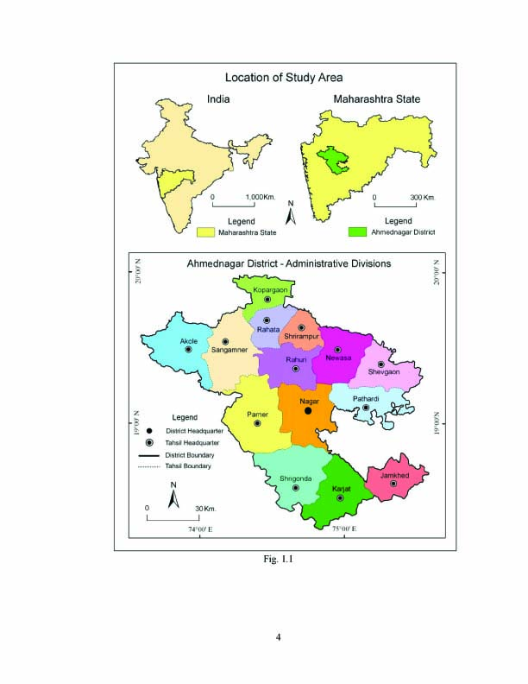
Figure 1. showing location map of study area

2. The energy access problem
The global scene commonly cited figures indicate that about 2 billion people across the globe lack access to clean cooking energy and about 1.7 billion people are without electricity (WEA, 2000). The origin of these figures is not easy to find. WEA (2000) does not elaborate on the source of its estimate nor the evaluation process. However, national energy balances give more emphasis to the supply of business energies than to where these are used and by whom. Although conventional energies play an important role in many developing countries, statistics are not reliable and household surveys are not common.
According to IEA (2002), which provides detailed country specific information, about 1.64 billion (27% of the world’s population) did not have energy access in 2000. It can be observed that half of those lacking electricity access reside in South Asia, another 30% in sub-Saharan Africa, and a further 15% in East Asia. Only 5% reside outside these areas, and about 85% of those lacking electricity access live in rural areas.
A quicker guise at these three areas shows that: They grip about 60% of the world’s population, but their combined GDP in 2000 was only about 8% of the world’s GDP. 28 countries in these regions have more than 10 million people without electricity access; more than two thirds of them were being concentrated in 12 countries (CSD, 2001). India alone houses more than 35% of the world’s population without electricity. Most of these countries have low per capita GDP compared with the world average. In terms of per capita electricity consumption, the situation is even worse with average per capita consumption ranging between 1% and 15% of the world average. IEA (2002) estimates that about 2.39 billion people use biomass for cooking and heating for their daily needs.

3. Energy access in Ahmednagar
Ahmednagar occupies an important position in the Maharashtra, Indian energy access problem; a more detailed analysis of the current situation is warranted. Lack of reliable information on energy access, use of the same indicators to imply different things and a common presumption that the access problem is a rural one hinder a systematic analysis. We have used data from various sources to generate a comprehensive, overall image.
Fortunately, two recent sources have provided a wealth of information on energy access in Ahmednagar. The first is a report by the National Sample Survey Organization (NSSO, 2001), which contains comprehensive statistics on energy use by Indian households. World Bank (2003) and Pachauri and Spreng (2004) trust on this report for their analysis of access to clean fuel by the poor. The other source is Census 2001, which has generated a vast amount of information on various aspects of India’s population, including energy use. Both NSSO (2001) and Census 2001 provide information on use of energy for cooking and lighting separately.
Energy consumption for cooking means household, small scale industries and big industries, agriculture and common lighting are as shown below in table and graphs from last five years.

Table 1. Year wise energy consumption paten of last five years
Year | Household | Small Scale Industries | Big Industries | Agriculture | Common Lighting | Total
2010-11 | 951806 | 1013623 | 977808 | 2604329 | 69897 | 5617463
2011-12 | 649222 | 664293 | 643453 | 1407766 | 43567 | 3408301
2012-13 | 615515 | 627804 | 609940 | 1333537 | 41194 | 3227990
2013-14 | 633981 | 646637 | 628240 | 1373544 | 42429 | 3324831

Table 2. Year wise energy demand per capita per day of last five years
Sr. No. | Year | Electricity uses / capita / day | New Connection Establishment
1 | 2010-11 | 2968.97 | 51.93
2 | 2011-12 | 1607.70 | 33.96
3 | 2012-13 | 1534.81 | 32.20
4 | 2013-14 | 0.73 | 39.97

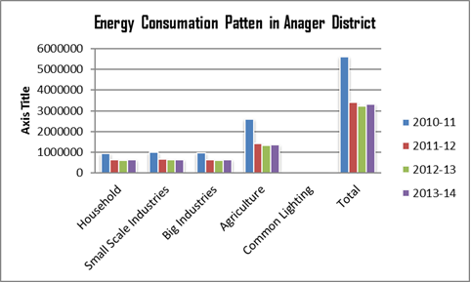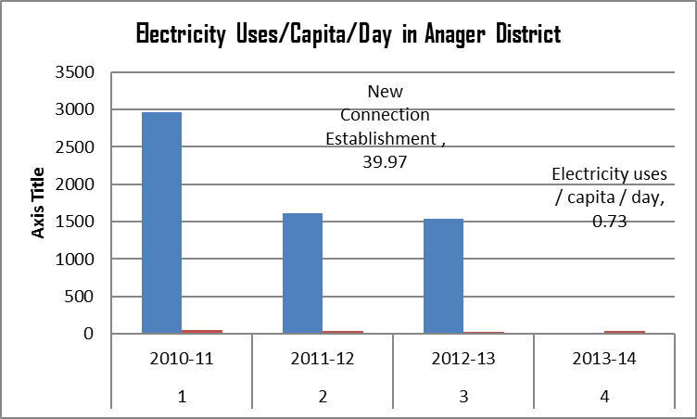
Figure 2. Comparison of simulation and experimental Figure 3. Comparison of simulation and experimental
results of water content results of substrate concentration

4. Need for some alternative strategies
So far, the article has highlighted the fact that, despite several schemes to promote commercial or clean energies in India, access has remained unsatisfactory. The discussion now turns to some basic factors determining energy use by the poor, and examines the need for an alternative strategy.
As outlined above, Ahmednagar energy policies so far have failed to address the access problem in its entirety. This article has argued that recent efforts towards rural electrification are also unlikely to resolve the problem. This failure to address the real issues at hand calls for alternative strategies. Also, being part of a global system influences national thinking and policies. The global emphasis of the 1990s was on the three R’s: energy sector Reforms, Right prices and Renewable energy technologies. Not immune to outside influences, India partially pursued these principles. However, the 3Rs face obvious contradictions and limitations when addressing energy access issues, as discussed underneath.

5. Outline of an alternative strategy
Particular the diversity of Ahmednagar’s energy use, resource availability and other conditions, appropriate local solutions should be identified, rather than global measures. The policy objective should be to promote innovative solutions, rather than prescribing templates to be adopted. Thus, each decentralized unit at the block level in rural areas, the municipal level in urban areas must identify its own solutions by:
Creating opportunities for poor households to increase their cash income. Developing local energy markets based on available energy resources, needs, capacities, strengths and constraints, and adopting appropriate supply mechanisms and organizational structures suited to local needs. Applying selective and judicious market interventions to render energy affordable while ensuring financial viability, as supply cannot be sustained unless it is financially viable. Ensuring that the local community participates in decision making and implementation of policy.

6. Conclusion
Access to clean and affordable energy for the poor is a central aspect of sustainable development. Ahmednagar houses a large number of poor people without access to clean energy. That such a deplorable situation exists, despite sustained efforts by the Government and energy utilities, indicates that current strategies are not effective. This article has argued that rural electrification policies to date are unlikely to resolve the energy access problem, as electricity constitutes only a minor component of the energy mix of the poor.
It is suggested that alternative long-term strategies are required and a bottom-up, holistic approach is recommended to integrate development efforts with energy access initiatives in order to increase cash income of poor households and render energy supply more affordable through the judicious use of policy instruments. Further work is required to develop a more detailed framework and outline institutional arrangements for the implementation of such a plan.

Acknowledgement:
We are thankful to the School of Earth Sciences, Swami Ramanand Teerth Marathwada University, Nanded for providing laboratory and library facilities. And Jamkhed Mahavidhayala, Jamkhed, Ahmednagar.

Correspondence to:
Kelkar Gautam
Research Scholar,
School of Earth Sciences, Swami Ramanand Teerth Marathwada University, Nanded 431606, India.
Mobile No: +919890960155
Emails: gautam.kelkar20@gmail.com

References
- Ailawadi VS and Bhattacharyya SC, 2006. Access to energy services by the poor in India: Current situation and need for alternative strategies, Natural Resources Forum Vol. 30, pp. 2–14.
- Bhattacharyya, S.C., 2006. Renewable energies and the poor: Niche or nexus? Energy Policy, 34(6): 659–63.
- Census of India, 2001. Director of census operation, Maharashtra.
- Census of India, District Census Handbook, Ahmednagar District, 2011.
- Census of India, District Census Handbook, Ahmednagar District, 2001.
- CSD, 2001. Energy and sustainable development: Options and strategies for action on key issues. United Nations Commission on Sustainable Development, 9th session. United Nations, New York, 17 December.
- DFID, 2002. Energy for the poor: Underpinning the Millennium Development Goals. Department for International Development, London. http://www.dfid.gov.uk/pubs/files/ energyforthepoor.pdf, last visited on 4 October 2004.
- District Social and Economic Summery (DSA) Ahmednagar 2011. District numerical office, economical and numerical department, Maharashtra, Ahmednagar.
- District Social and Economic Summery (DSA) Ahmednagar 2012. District numerical office, economical and numerical department, Maharashtra, Ahmednagar.
- District Social and Economic Summery (DSA) Ahmednagar 2013. District numerical office, economical and numerical department, Maharashtra, Ahmednagar.
- District Social and Economic Summery (DSA) Ahmednagar 2014. District numerical office, economical and numerical department, Maharashtra, Ahmednagar.
- Energy and sustainable development: Options and strategies for action on key issues. United Nations Commission on Sustainable Development, 9th session. United Nations, New York, 17 December.
- IEA, 2002. World Energy Outlook. International Energy Agency, Paris. KERC, 2000. Tariff order for 2000–2001. Karnataka Electricity Regulatory Commission, Bangalore. http://www.kerc.org/ TARRIF%20%20ORDER%20%202000.pdf, last visited on 25 March 2004.
- NSSO, 2001. Energy used by Indian households, 1999–2000. NSS 55th round. National Sample Survey Organization, Government of India. http://mospi.nic.in/rept%20%20 pubn/ftest.asp?rept_id=464&type=NSSO, last visited on 4 May 2005.
- Pachauri, S., Spreng, D., 2004. Energy use and energy access in relation to poverty. Economic and Political Weekly, 17 January: 271–278.
- WEA, 2000. Energy and the challenge of sustainability. World Energy Assessment 2000, United Nations Development Programme (UNDP), New York.
- World Bank, 2003. Access of the poor to clean household fuels in India. ESMAP, the World Bank, Washington, DC.
- Yannawar Vyankatesh B, 2015. The Nanded Information System, Lap Lambert Academic publishing, Germany.

5/11/2016

